Optics: Lenses and Mirrors — Student Notes
Unit: Waves — Lesson 09 Name: _______________________ Date: __________ Period: ____

Learning Targets
By the end of today’s 42 minutes I can:
- Identify a converging lens / concave mirror and its focal point.
- Draw principal rays to locate an image and label it real or virtual.
- Use 1/f = 1/dₒ + 1/dᵢ to solve for f, dₒ, or dᵢ.

Key Vocabulary
- focal length — _______________________________________________
- converging lens — _______________________________________________
- image — _______________________________________________

Guided Notes
Focal point and focal length. Parallel rays hitting a converging lens (or concave mirror) meet at the __________ point. The distance to it is the __________ length, f.
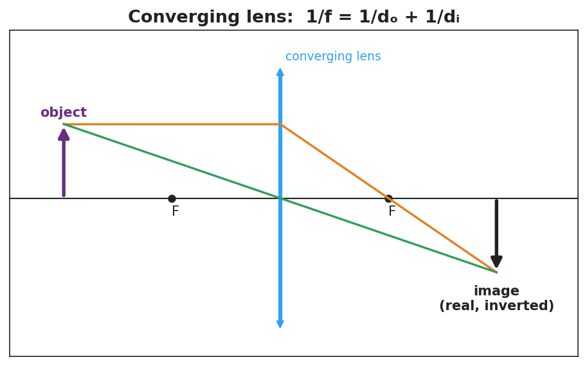
Converging-lens ray diagram: object beyond F → real, inverted image.
Three principal rays (converging lens):
- A ray parallel to the axis refracts through the far __________.
- A ray through the __________ of the lens goes straight.
- Where the rays cross is the __________.
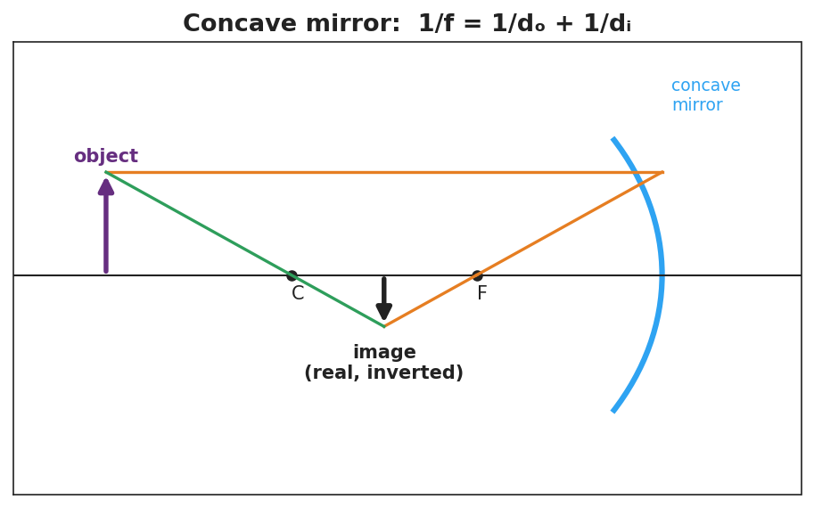
Concave-mirror ray diagram: object beyond C → real, inverted image.
Real vs. virtual images.
- Object beyond the focal length → image is __________ and inverted; can be __________ on a screen.
- Object inside the focal length → image is __________ and upright; can only be __________ through the lens (magnifier).
The thin-lens / mirror equation (reference table):
1/f = 1/dₒ + 1/dᵢ

Worked Example
Problem. A converging lens has f = 10 cm. An object sits dₒ = 30 cm away. Find the image distance.
Solution. 1. 1/dᵢ = 1/f − 1/dₒ = 1/10 − 1/30. 2. Common denominator: 3/30 − 1/30 = __________ /30 = 1/15. 3. dᵢ = __________ cm. 4. Since dₒ > f, the image is __________ and inverted. ✓

Summary
Finish the sentence (Because / But / So):
A magnifying glass can make an image either upright or upside-down because __________________________________________, but __________________________________________, so __________________________________________.

