Optics: Lenses and Mirrors — Student Worksheet
Unit: Waves — Lesson 09 Name: _______________________ Date: __________ Period: ____

Phenomenon
Hold a magnifying glass close to this page — the print looks bigger and right-side-up. Now hold it far from a window — the image flips upside down and shrinks. Same lens, two totally different images. Eyeglasses, magnifiers, and curved mirrors all do this kind of thing.
Driving question: What decides whether a lens makes an image big-and-upright or small-and-upside-down?

Notice & Wonder
I notice… | I wonder…
Turn & Talk #1: What decides whether the image is big-and-upright or small-and-upside-down?

Initial Model
Draw a lens with a candle on the left. Sketch where the image forms when the candle is far from the lens, then when it is very close. Label which image is upside-down.

Investigation
Work in a group with a converging lens, a screen, a light source, and oPhysics.
Trial | Object distance dₒ | Image distance dᵢ | Real or virtual? | Upright or inverted?
1. Object far (beyond F)
2. Object inside F
3. Concave mirror, object far
Use these ray diagrams to trace your three principal rays:
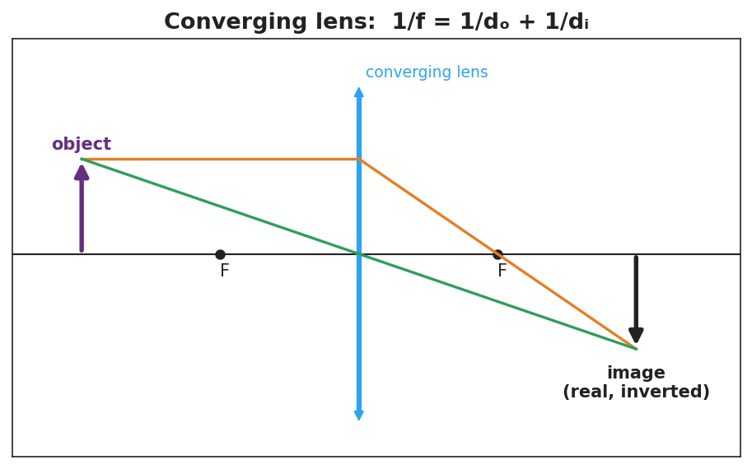
Converging-lens ray diagram: object beyond F → real, inverted image; 1/f = 1/dₒ + 1/dᵢ.
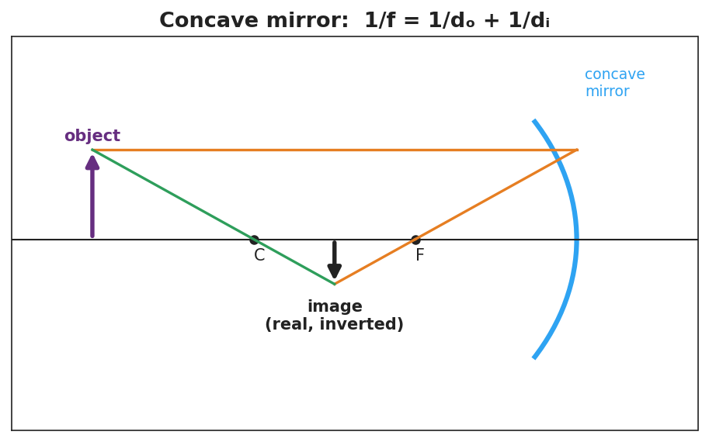
Concave-mirror ray diagram: object beyond C → real, inverted image; 1/f = 1/dₒ + 1/dᵢ.
Key question: When the object was inside the focal length, could you catch the image on the screen? What does that tell you about the image?

Make It Make Sense
- An object is 30 cm from a converging lens with f = 10 cm. Use 1/f = 1/dₒ + 1/dᵢ to find the image distance.
- Why can’t you project a magnifying glass’s enlarged image onto a wall?
- A converging lens and a concave mirror are both called “converging.” What do they have in common?

Vocabulary in Action
Use each term in a sentence about today’s phenomenon.
- focal length: _______________________________________________
- converging lens: _______________________________________________
- image: _______________________________________________

Revise Your Model
Return to your candle sketch. Re-draw both cases with the three principal rays. Label one image real, inverted and one virtual, upright, and mark the focal point F.

Exit Ticket
A converging lens has a focal length of 12 cm. An object is placed 36 cm from the lens.
- Use 1/f = 1/dₒ + 1/dᵢ to find the image distance. Show your work.
- Is the image real or virtual? Upright or inverted?
- If the object is moved to 6 cm (inside the focal length), can the image be projected on a screen? Why or why not?

