Digital Technologies and Information — Student Notes
Unit: Waves — Lesson 10 Name: _______________________ Date: __________ Period: ____

Learning Targets
By the end of today’s 42 minutes I can:
- Distinguish an analog signal from a digital signal.
- Explain how sampling and bits represent a wave.
- Evaluate why digital transmission and storage resist noise and copy perfectly.

Key Vocabulary
- analog signal — _______________________________________________
- digital signal — _______________________________________________
- bit — _______________________________________________

Guided Notes
Analog vs. digital.
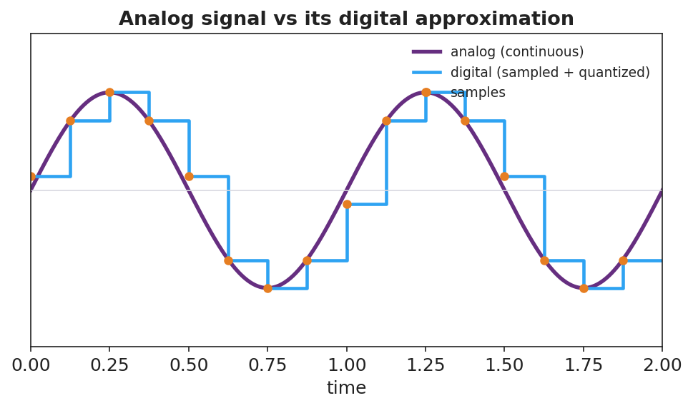
Analog sine wave overlaid with its sampled, quantized digital version.
- Analog — a __________ signal that can take any value (vinyl groove, sound in air).
- Digital — a signal stored as __________ (sampled) values, each rounded to a level and written as __________.
Sampling. To digitize a wave you measure it at regular __________ and store each measurement.
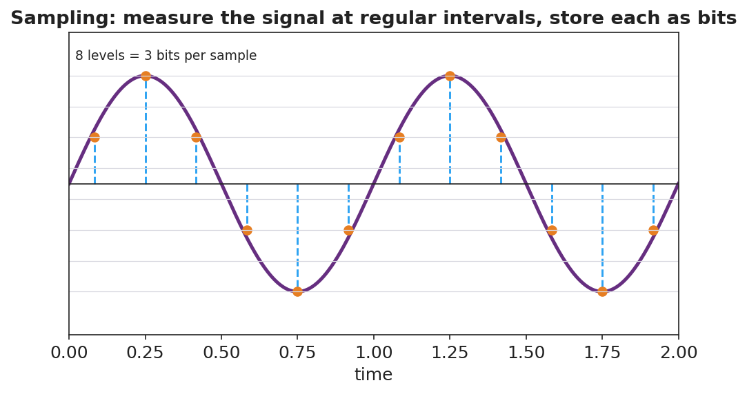
Sampling: a wave measured at regular intervals, 8 levels = 3 bits.
- More samples per second + more bits per sample → __________ fidelity.
- A bit is a single __________ or __________; 3 bits give 2³ = __________ levels.
Why digital wins (HS-PS4-2, Stability and Change).
- Noise on a digital signal can be __________ back to the nearest level → copies stay identical.
- Noise on an analog signal becomes part of the signal and __________ up with each copy.
- Digital is also easy to __________, compress, and error-check.
Trade-off: digital loses the detail __________ the samples unless you sample fast enough.

Worked Example
Problem. A sound is sampled with 3 bits per sample. (a) How many levels is that? (b) Why does adding a 4th bit improve the recording?
Solution. 1. 3 bits → 2³ = __________ levels. 2. A 4th bit → 2⁴ = __________ levels, so each sample is rounded to a __________ value → higher fidelity. 3. More bits trade larger __________ for better quality. ✓

Summary
Finish the sentence (Because / But / So):
A streamed song stays crisp but a vinyl record gets scratchier because __________________________________________, but __________________________________________, so __________________________________________.

