Digital Technologies and Information — Student Worksheet
Unit: Waves — Lesson 10 Name: _______________________ Date: __________ Period: ____

Phenomenon
A vinyl record gets scratchier every time it’s played, and a copy of a copy of a photocopy turns to mush. But you can stream the same song a million times, or copy a PDF endlessly, and the last copy is identical to the first.
Driving question: Why does a digital copy survive perfectly while an analog copy degrades?

Notice & Wonder
I notice… | I wonder…
Turn & Talk #1: What is it about storing something as numbers (digital) that lets it survive copying perfectly?

Initial Model
Draw a smooth wave (analog). Now show how you would store it using only a few measured points (samples). What information do you lose? What do you gain?

Investigation
Work in your random group of 3 at a vertical surface. Use graph paper and Javalab.
Task | What we did | What we found
1. Sample + round an analog wave
2. Twice as many samples
3. Add noise to both, then “clean”
4. List 2 advantages of digital
Compare your stair-step to these:
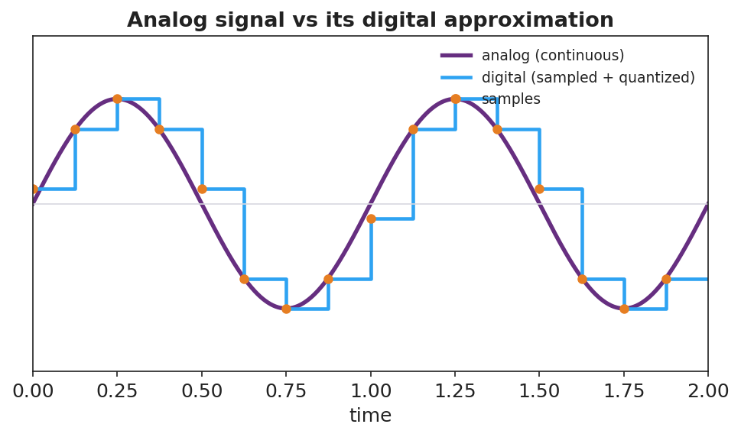
Analog sine wave overlaid with its sampled, quantized digital version.
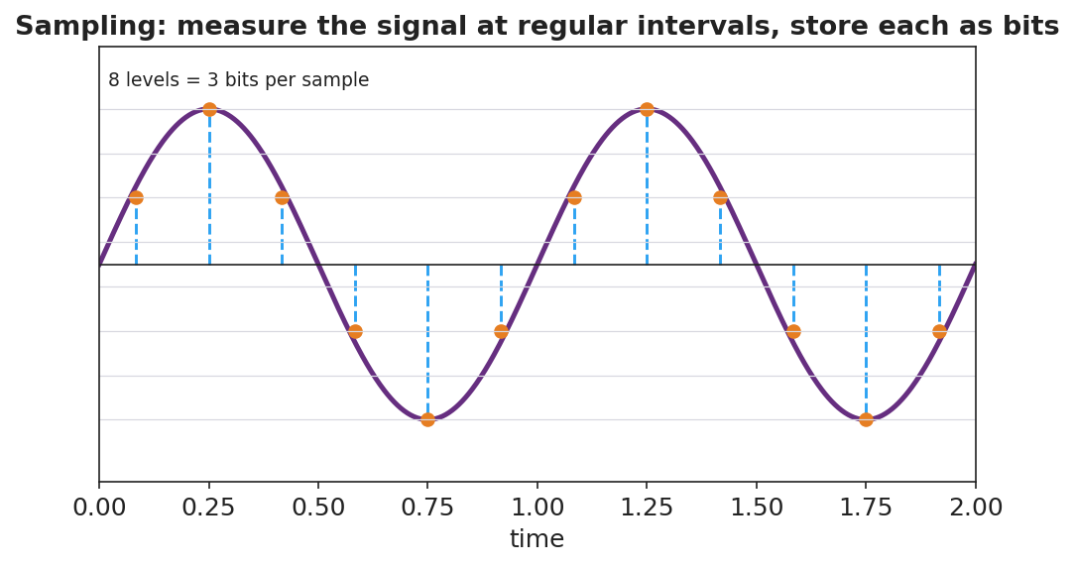
A sampling diagram: a wave measured at regular intervals, each sample stored at a discrete level (8 levels = 3 bits).
Key question: After you added noise, which signal could you clean back to the original exactly — analog or digital? Why?

Make It Make Sense
- Define analog and digital signals in your own words.
- Why does a digital photo copied 100 times look identical, but a photocopied photo degrades?
- Name one disadvantage of digital — what gets lost when you sample a smooth wave?

Vocabulary in Action
Use each term in a sentence about today’s phenomenon.
- analog signal: _______________________________________________
- digital signal: _______________________________________________
- bit: _______________________________________________

Revise Your Model
Return to your sampled wave. Label the smooth curve analog and the stair-step digital. Add a one-sentence evaluation: why is digital better for sending a song across the world?

Exit Ticket
A friend says, “Records sound warmer, so analog must be better in every way.”
- Define analog and digital signals.
- Give two advantages of digital for transmitting and storing music.
- Evaluate the friend’s claim: name one thing analog might do well and one clear advantage of digital they’re overlooking.

