The Photoelectric Effect — Student Notes
Unit: Modern Physics — Lesson 01 Name: _______________________ Date: __________ Period: ____

Learning Targets
By the end of today’s 42 minutes I can:
- Describe light as a stream of energy packets (photons) whose energy depends on frequency.
- Explain why electrons are ejected only above a threshold frequency, no matter the brightness.
- Use E = h·f to calculate a photon’s energy.

Key Vocabulary
- photon — _______________________________________________
- photoelectric effect — _______________________________________________
- threshold frequency — _______________________________________________

Guided Notes
Big idea: Light is not only a wave — it also arrives in __________ packets called photons.
- The energy of one photon: E = h·f, where h = __________ J·s (Planck’s constant) and f is the __________.
- Higher frequency → __________ energy per photon. (Violet photons carry more energy than red photons.)
- Brightness = how __________ photons arrive each second (the number), not how much energy each one has.
The photoelectric effect (one photon, one electron):
- One photon hits one __________. If that single photon’s energy is high enough, the electron is __________.
- The lowest frequency that can eject any electron is the threshold frequency.
  - Below threshold: __________ electrons leave, no matter how bright.
  - Above threshold: raising brightness adds __________ electrons; raising frequency adds __________ to each electron.
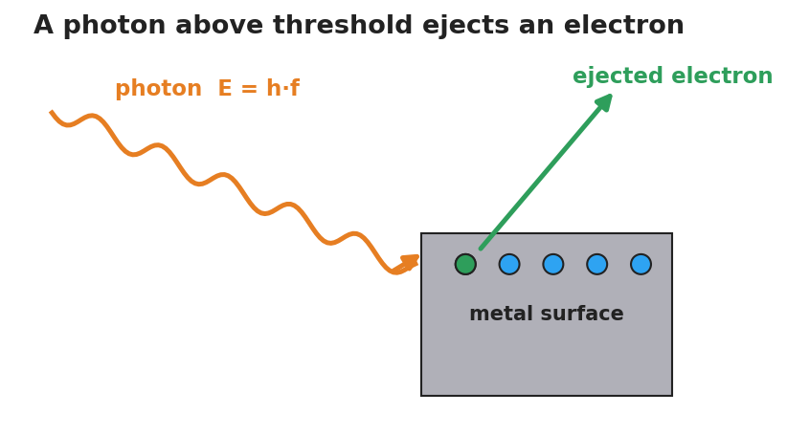
A single photon of energy E equals h times f strikes a metal surface and ejects one electron.
The graph below shows it: no electron energy below the threshold frequency f₀, then a straight line rising with frequency.
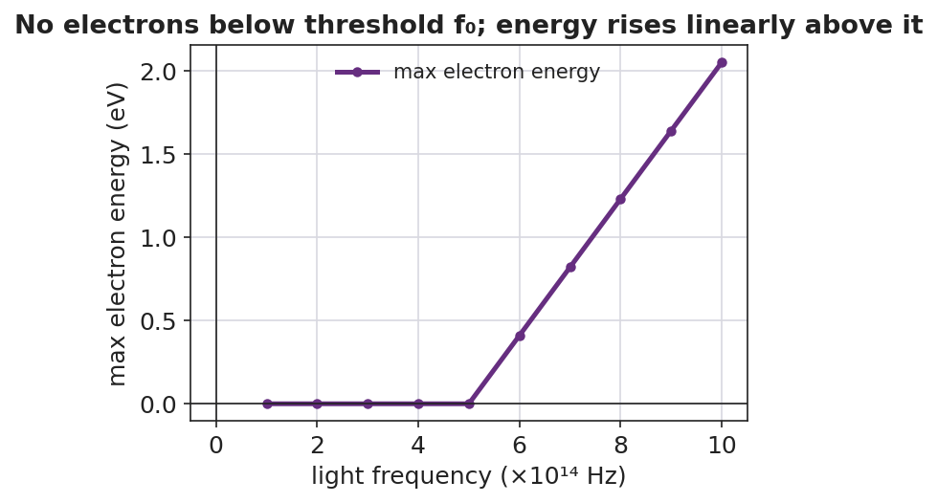
Graph of maximum ejected-electron energy versus light frequency: zero below the threshold frequency, then rising linearly above it.

Worked Example
Problem. Find the energy of one photon of green light with frequency 5.5×10¹⁴ Hz. (h = 6.63×10⁻³⁴ J·s.)
Solution. 1. Write the formula: E = h·f. 2. Substitute: E = (6.63×10⁻³⁴ J·s)(5.5×10¹⁴ Hz). 3. Multiply: E = __________ J ≈ 3.6×10⁻¹⁹ J. 4. A violet photon (higher f) would have __________ energy; a red photon (lower f) would have __________ energy.

Summary
Finish the sentence (Because / But / So):
A very bright red light cannot eject electrons because __________________________________________, but a dim violet light can because __________________________________________, so __________________________________________.

