Models of the Atom — Student Notes
Unit: Modern Physics — Lesson 02 Name: _______________________ Date: __________ Period: ____

Learning Targets
By the end of today’s 42 minutes I can:
- Put the atomic models in order and state what each one got right.
- Explain how the gold-foil experiment gave evidence for a nucleus.
- Explain why a scientific model changes over time.

Key Vocabulary
- nucleus — _______________________________________________
- electron — _______________________________________________
- atomic model — _______________________________________________

Guided Notes
Big idea: An atomic model is a picture of the atom that scientists __________ whenever new evidence appears.
The progression (oldest → newest):
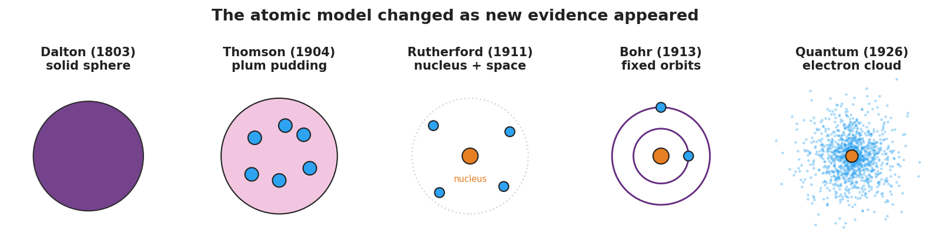
Five-panel progression of atomic models: Dalton solid sphere, Thomson plum pudding, Rutherford nucleus, Bohr orbits, and the quantum electron cloud.
- Dalton — the atom is a tiny, solid __________ (no inside parts).
- Thomson — discovered the __________ (negative); pictured them stuck in a positive “pudding.”
- Rutherford — the gold-foil experiment showed the atom is mostly __________ space with a tiny, dense, positive __________.
- Bohr — electrons travel in fixed __________ around the nucleus (sets up Lesson 03).
- Quantum — electrons are best described as a __________ cloud (probability), not fixed paths.
The gold-foil evidence:
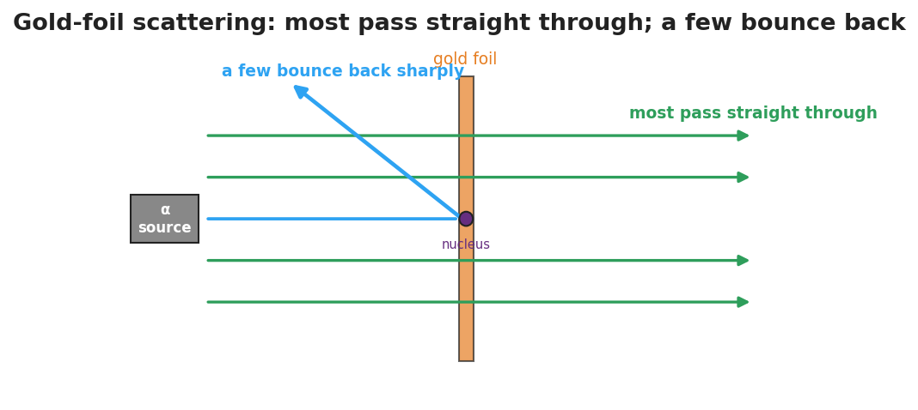
Gold-foil scattering: most alpha particles pass straight through while a few bounce sharply off the tiny dense nucleus.
- Most alpha particles passed __________ through → the atom is mostly empty.
- A few bounced sharply __________ → there is a tiny, dense, positive __________.

Worked Example
Problem. A classmate says, “The newest model proves all the old models were wrong, so they were useless.” How would you correct this using the idea of evidence?
Solution. 1. Each model was the __________ explanation for the evidence available at that time. 2. A model changes when new __________ appears that the old model cannot explain. 3. So the old models were not useless — each one __________ the next. (Thomson’s electron survived into every later model.)

Summary
Finish the sentence (Because / But / So):
Scientists believed the atom was a soft “plum pudding” because __________________________________________, but the gold-foil experiment showed __________________________________________, so __________________________________________.

