Energy-Level Diagrams and Spectra — Student Notes
Unit: Modern Physics — Lesson 03 Name: _______________________ Date: __________ Period: ____

Learning Targets
By the end of today’s 42 minutes I can:
- Explain that electrons occupy fixed energy levels and emit a photon when they drop.
- Relate the size of an electron’s jump to the frequency (color) of the emitted photon.
- Explain why each element makes a unique line spectrum and how that identifies stars.

Key Vocabulary
- energy level — _______________________________________________
- photon emission — _______________________________________________
- line spectrum — _______________________________________________

Guided Notes
Big idea: Electrons in an atom can only have certain fixed energies, called energy levels — like steps on a ladder, not a ramp.
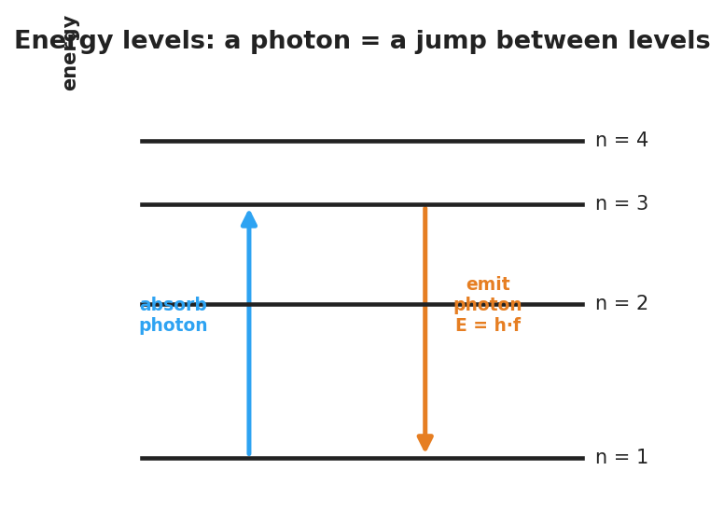
Energy-level diagram: an electron absorbs a photon to jump up and emits a photon E = h·f when it drops down between discrete levels.
- To jump up a level, an electron must absorb a photon.
- To drop down a level, an electron __________ a photon — this is photon emission.
- The photon’s energy equals the size of the __________: E = h·f.
- A bigger drop → bigger energy gap → __________ frequency → bluer color.
- A smaller drop → smaller gap → __________ frequency → redder color.
Why a line spectrum:
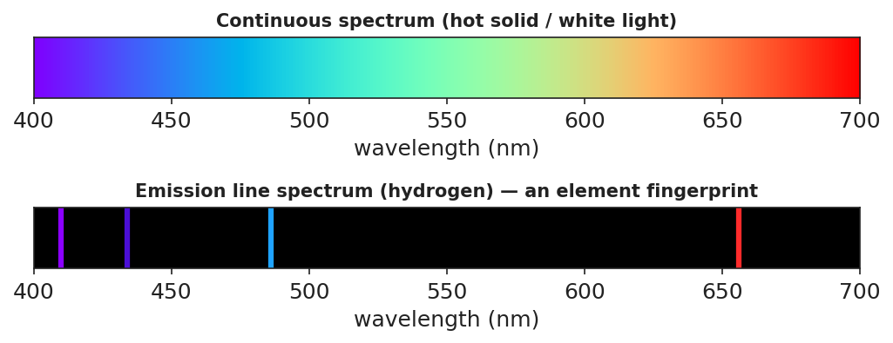
Top: a continuous rainbow from white light. Bottom: hydrogen’s line spectrum — a few bright lines on black.
- Because levels are fixed, only certain jumps — and only certain photon colors — are __________.
- Each element has its own set of gaps, so each makes its own unique line spectrum (a __________).
- Astronomers match a star’s line spectrum to known elements to learn what the star is __________ of. (This is part of the evidence behind the Big Bang explanation.)

Worked Example
Problem. In an atom, electron drops A (n = 5 → n = 1) and B (n = 2 → n = 1) both emit photons. Which photon has the higher frequency?
Solution. 1. Compare the energy gaps: drop A is the __________ jump, so the bigger gap. 2. A bigger gap means a __________-energy photon. 3. Since E = h·f, a higher-energy photon has a __________ frequency (bluer). 4. So **drop ___** emits the higher-frequency photon.

Summary
Finish the sentence (Because / But / So):
White light makes a smooth, continuous rainbow, because __________________________________________, but glowing hydrogen makes only a few sharp lines because __________________________________________, so __________________________________________.

