Energy-Level Diagrams and Spectra — Student Worksheet
Unit: Modern Physics — Lesson 03 Name: _______________________ Date: __________ Period: ____

Phenomenon
Sunlight through a diffraction grating spreads into a smooth, continuous rainbow — every color. But a glowing tube of hydrogen gas through the same grating shows only a few sharp colored lines — always the same ones. Helium glows with a completely different set of lines.
Driving question: Why does a glowing gas emit only certain colors, and how can that fingerprint tell us what a distant star is made of?

Notice & Wonder
I notice… | I wonder…
Turn & Talk #1: A rainbow has every color, but hydrogen shows only a few. Using the idea of electron energy levels, why would only certain colors come out?

Initial Model
Draw a few horizontal lines as electron “energy steps.” Show an electron and use an arrow to show what you think it does to release light.

My idea: _______________________________

Investigation
Work the problems at your board. Use these figures.
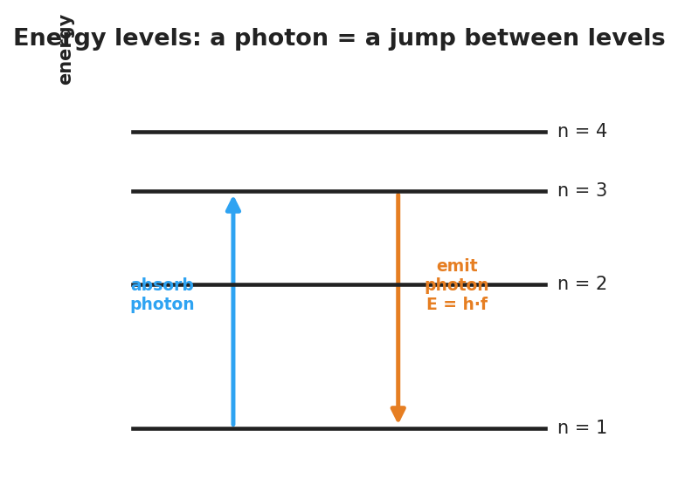
Energy-level diagram: an electron absorbs a photon to jump up and emits a photon E = h·f when it drops down between discrete levels.
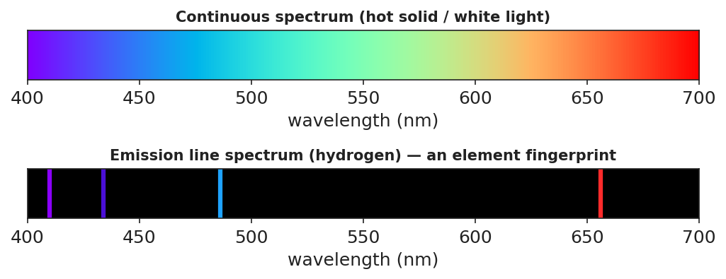
Top: a continuous rainbow from white light. Bottom: hydrogen’s emission line spectrum — a few bright lines on black.
- An electron drops from n = 3 to n = 1. Draw the arrow. Does it emit or absorb a photon? _______________
- Which drop releases a higher-energy (bluer) photon: n = 4 → n = 2, or n = 3 → n = 2? Why?
- Match each drop to a colored line (biggest drop ↔ highest-frequency line):
Electron drop | Size of energy gap | Line color (predict)
n = 4 → n = 1
n = 3 → n = 2
n = 2 → n = 1
- Two unknown gases show different line patterns. Could they be the same element? Explain.
Key question: If electrons can only sit on certain energy levels, how many different photon colors can a single element emit?

Make It Make Sense
- White light makes a continuous rainbow, but glowing hydrogen makes only a few sharp lines. Explain why, using energy levels.
- A big electron drop and a small electron drop both emit photons. Which photon has the higher frequency (bluer color)? Why?
- How can astronomers know what a distant star is made of without going there?

Vocabulary in Action
Use each term in a sentence about today’s phenomenon.
- energy level: _______________________________________________
- photon emission: _______________________________________________
- line spectrum: _______________________________________________

Revise Your Model
Return to your energy-step drawing. Label which arrow direction emits a photon and which color comes from the biggest drop. Connect one line in the spectrum strip to one jump in your diagram.

Exit Ticket
- White light makes a continuous rainbow, but glowing hydrogen makes only a few sharp lines. Explain why, using energy levels.
- An electron drops from n = 4 → n = 1 (a big drop) and from n = 2 → n = 1 (a small drop). Which emitted photon has the higher frequency? Why?
- How can astronomers tell what a distant star is made of?

