Energy-Level Diagrams and Spectra — Teacher Guide

Cover
Unit: Modern Physics — Lesson 03: Energy-Level Diagrams and Spectra East Meadow Schools × Valley Stream Central High School District Strategy chips: BTC

Curated Resources (from East Meadow Scope & Sequence)

NYSSLS Standards
This lesson develops the model that supports the HS-ESS1-2 connection: “Construct an explanation of the big bang theory based on astronomical evidence of light spectra, motion of distant galaxies, and composition of matter (Energy and Matter)” — specifically the connection to wavelength and frequency of light and the formation of stars. Because each element emits a unique set of wavelengths, astronomers read the line spectra in starlight to identify what distant stars are made of. The lesson also extends Lesson 01 (photons, E = h·f) and Lesson 02 (the Bohr model).

Phenomenon
- Gas-discharge tubes: hydrogen, helium, and neon tubes each glow a different color and, through a diffraction grating, show only a few sharp colored lines — not a full rainbow: https://www.youtube.com/watch?v=byp3KFwMjW8

Javalab / Labs
- ophysics hydrogen spectrum / energy levels: https://ophysics.com/modern2.html
- “H Spectrum” lab: measure hydrogen’s visible emission lines through a grating and match them to energy-level jumps.

Assessments
- Exit ticket below (why a line spectrum, and how it fingerprints an element). The energy-level / spectrum matching at the boards in Phase 2 is the formative check.

Lesson Overview
Duration | 42 minutes (1 period)
NYSSLS link | HS-ESS1-2 connection (light spectra → composition of stars; star formation)
CCC focus | Energy and Matter / Patterns — discrete energy levels produce a repeatable pattern of emitted wavelengths.
Strategy chips | BTC (random groups + vertical non-permanent surfaces, thin-slice problems)
Materials | Vertical whiteboards/windows + markers; diffraction gratings + discharge tubes if available (or the ophysics sim); the energy-level handout; reference table (E = h·f).
Safety | Discharge tubes use high voltage — teacher-operated only; the simulation is the safe default.
Prior knowledge | Photons and E = h·f (Lesson 01); the Bohr model with electrons in fixed levels (Lesson 02); visible-light color ↔ wavelength/frequency.
Lesson objectives — students can:
- Explain that electrons occupy discrete energy levels and that a photon is emitted or absorbed when an electron jumps between them.
- Relate the size of an energy jump to the frequency/wavelength (color) of the emitted photon.
- Explain why each element produces a unique line spectrum and how astronomers use it to identify stars.

Phase 1 · Engage (0 – 10 min)

0–2 min · Opening Connection (SEL)
Whip-around (one sentence, pass allowed): “Name something you can recognize instantly from just a tiny clue — a ringtone, a logo, a friend’s footsteps.” Park these; you’ll call back to “elements have a fingerprint” in Phase 3.

2–7 min · Phenomenon hook — discharge tubes vs. a rainbow
Teacher actions. Show a hydrogen tube (or sim) through a grating: only a few sharp colored lines. Then show white light through the same grating: a full continuous rainbow. Switch to helium: a different set of lines.
Sample teacher language:
“Sunlight through this grating gives a smooth rainbow — every color. But this glowing hydrogen gives only four sharp lines, always the same four. Helium gives a totally different set. Why would a glowing gas pick only certain colors?”
Anticipated student responses:
- “The gas only makes some colors.” — capture only certain colors.
- “Each gas has its own pattern.” — gold; we’ll name this a fingerprint.
- “It’s about the electrons.” — capture; connect to Bohr’s levels from Lesson 02.

7–10 min · Notice & Wonder + Turn-and-Talk #1
“Turn and talk: a rainbow has every color, but hydrogen shows only a few. Using last lesson’s idea of electron levels, why would only certain colors come out?”
Target seed: electrons can only sit on certain “steps,” so only certain jumps — and only certain photon energies/colors — are possible.

Bridge to Phase 2
Each student writes a one-sentence initial model: “A glowing gas emits only certain colors because ______.”

Phase 2 · Explore (10 – 30 min)

10–13 min · Initial Model (silent / individual)
Prompt:
“Draw a few horizontal lines as electron ‘energy steps.’ Show an electron and use an arrow to show what you think it does to release light.”

13–30 min · Investigation — BTC at the boards
Form visibly random groups of 3 (cards). Each group works a vertical surface through a thin-sliced problem set (reveal one at a time):
- Here is an energy-level diagram. An electron drops from n = 3 to n = 1. Draw the arrow. Does it absorb or emit a photon?
- Which drop releases a higher-energy (bluer) photon: n = 4 → n = 2, or n = 3 → n = 2? Why?
- Match three given drops to three colored lines on a spectrum strip (biggest drop ↔ highest-frequency line).
- Two unknown gases show different line patterns. Could they be the same element? Explain.
Teacher facilitation language:
“Bigger jump down — bigger energy gap — what does that do to the photon’s frequency? Its color?” “If the steps are fixed, how many different photon energies are even possible?” “Defend it to the group at the next board — do they agree which line is the biggest drop?”
Anchor with the energy-level diagram and the spectrum strip:
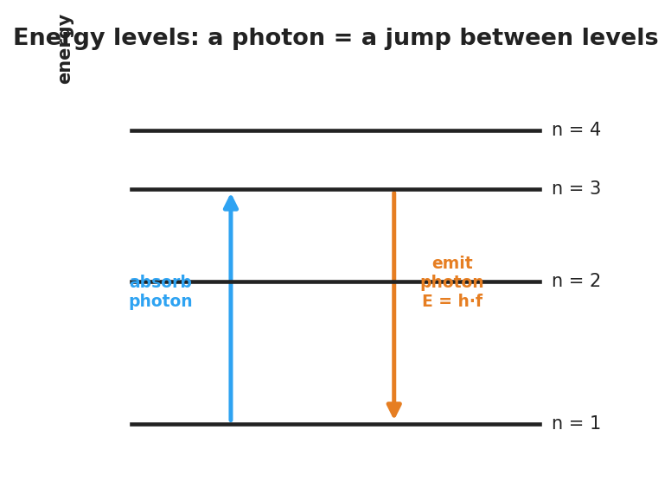
Energy-level diagram: an electron absorbs a photon to jump up and emits a photon E = h·f when it drops down between discrete levels.
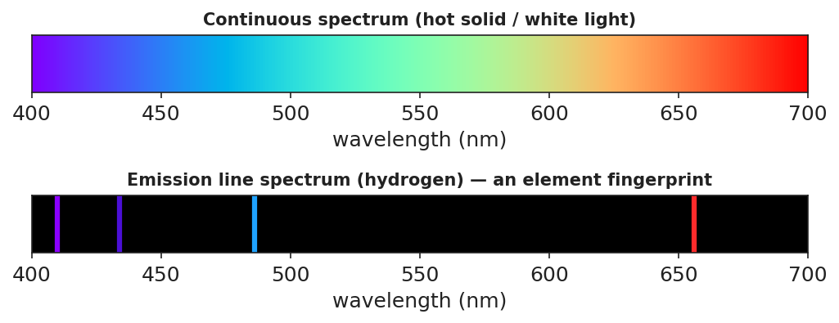
Top: a continuous rainbow spectrum from white light. Bottom: hydrogen’s emission line spectrum — a few bright colored lines on black, an element fingerprint.

Teacher facilitation during Explore
- What to look for — groups connecting bigger energy gap → higher frequency → bluer line.
- What to resist — don’t hand out the term “line spectrum” yet; let the pattern emerge.
- What to redirect — “the gas just glows that color” → it glows specific colors because only specific jumps exist.

Phase 3 · Explain (30 – 36 min)

30–33 min · Consensus
“Why only a few lines, and why always the same few for a given gas?”
Target consensus:
“Electrons can only occupy fixed energy levels, so only certain jumps are possible. Each jump emits a photon whose energy — and color — equals the gap. The set of gaps is unique to each element, so each element shows the same fixed set of lines.”

33–36 min · Vocabulary introduction (≤ 3 terms)
Sample teacher language:
“Each allowed electron ‘step’ is an energy level. When an electron drops to a lower level, it releases a photon — that’s photon emission, and E = h·f for that photon equals the energy gap. The full set of sharp colored lines a glowing element produces is its line spectrum — its fingerprint.”

Discussion prompts to deploy here
- “How can astronomers know a distant star contains hydrogen without ever visiting it?”
  - Sample student response: “The starlight shows hydrogen’s exact line pattern — its fingerprint — so we know hydrogen is there.”
- “Why is a star’s light evidence used in the Big Bang explanation?”
  - Sample student response: “Spectra tell us what stars are made of and (with shifts) how they move — evidence for how matter and the universe formed.”

Phase 4 · Elaborate (36 – 39 min)

36–38 min · Revise the model
“Return to your energy-step drawing. Add labels: which arrow direction emits a photon, and which color comes from the biggest drop? Connect one line in the spectrum strip to one jump in your diagram.”

38–39 min · Return to the phenomenon
“In one sentence, explain why hydrogen shows only a few lines, using energy level and line spectrum.”
Target: “Hydrogen’s electrons can only jump between fixed energy levels, so only a few photon energies are possible — producing hydrogen’s unique line spectrum.”

Phase 5 · Evaluate (39 – 42 min)

39–42 min · Exit Ticket + Closing Reflection
“(a) White light makes a continuous rainbow, but glowing hydrogen makes only a few sharp lines. Explain why, using energy levels. (b) An electron drops from n = 4 → n = 1 (a big drop) and from n = 2 → n = 1 (a small drop). Which emitted photon has the higher frequency? Why? (c) How can astronomers tell what a distant star is made of?”
Expected: (a) electrons occupy only discrete levels, so only certain jumps/photon energies (colors) are possible; (b) the n = 4 → n = 1 drop — larger energy gap → higher-frequency photon (E = h·f); (c) by matching the star’s line spectrum to known element fingerprints. See Answer_Key.docx.
Closing Reflection (SEL, 30 seconds):
“What clicked for you at the boards today, and who helped it click?”

Common Misconceptions
- Misconception: “Atoms can emit any color of light.” → Correction: Only colors matching the gaps between fixed energy levels are emitted, so each element gives a few specific lines.
- Misconception: “Bigger energy jump = redder light.” → Correction: Bigger energy gap = higher-energy photon = higher frequency = bluer light (E = h·f).
- Misconception: “Line spectra and continuous rainbows are the same thing.” → Correction: A hot solid/white light gives a continuous spectrum; a glowing low-density gas gives discrete lines.

Access & Differentiation
- ELL/ENL supports: Sentence frame: *“When an electron drops to a ___ energy level, it ___ a photon; a bigger drop makes a ___-frequency color.”* Word box: {lower, emits, higher, energy level, line spectrum}. Pair jump with a stair-step hand gesture.
- IEP/SPED supports: Provide a pre-drawn energy-level diagram with the arrows already drawn; students label “emit/absorb” and “bigger/smaller gap.” Offer color chips to physically match to spectrum lines.
- Extensions: Give students hydrogen’s four visible wavelengths and have them order the jumps by energy, then research why these are called the Balmer series.

Strategy Spotlight
BTC (Building Thinking Classrooms). Use visibly random groups of three and vertical non-permanent surfaces so thinking is public and mobile. Deliver the problems as a thin-sliced sequence — each problem a small step harder than the last — and circulate without giving answers, redirecting groups to defend their reasoning to the next board. The vertical surfaces let you see, in one glance, which groups have connected “bigger gap → bluer line,” so you know exactly when to pull the class to consensus.

NYSSLS Observation Checklist Crosswalk
# | Checklist item | Where it appears in this lesson
1 | Local/relatable phenomenon | Phase 1 — discharge tubes vs. rainbow; starlight fingerprints
2 | Turn and Talk (2–3×) | Phase 1 (TT#1 — why only some colors), Phase 3 (consensus discussion)
3 | Students develop questions/models/procedures | Phase 1 (initial model), Phase 2 (board work), Phase 4 (revise model)
4 | CCC defined and used | Lesson Overview · Energy and Matter / Patterns, restated in Phase 3
5 | ENL — ≤ 3 vocab, second half | Phase 3 — vocabulary at 33–36 min (energy level / photon emission / line spectrum)
6 | Revisit phenomenon with evidence | Phase 4 — re-explain hydrogen lines; starlight in Phase 3
7 | ENL/SPED supports | Access & Differentiation block
8 | Assessment check | Phase 5 — Exit Ticket (line spectra + starlight)

Companion Materials
- Student_Worksheet.docx — the 5E student investigation with the board-work problems (hand out at start of Phase 2)
- Student_Notes.docx — guided note-guide for energy-level jumps and the worked example
- Answer_Key.docx — answers to “Make It Make Sense” prompts and the Exit Ticket

Key Vocabulary (max 3)
- energy level — one of the fixed, allowed energies an electron can have in an atom (its allowed “steps”)
- photon emission — the release of a photon when an electron drops to a lower energy level; the photon’s energy equals the gap (E = h·f)
- line spectrum — the unique set of sharp colored lines a glowing element emits; it acts as the element’s fingerprint

