The Standard Model — Student Notes
Unit: Modern Physics — Lesson 04 Name: _______________________ Date: __________ Period: ____

Learning Targets
By the end of today’s 42 minutes I can:
- Name the two families of fundamental particles that build all matter.
- Explain that protons and neutrons are made of quarks, and forces are carried by bosons.
- Use the Standard-Model chart as a model that organizes particles.

Key Vocabulary
- quark — _______________________________________________
- lepton — _______________________________________________
- fundamental particle — _______________________________________________

Guided Notes
Big idea: All matter is built from a small set of fundamental particles — particles with no smaller parts inside.
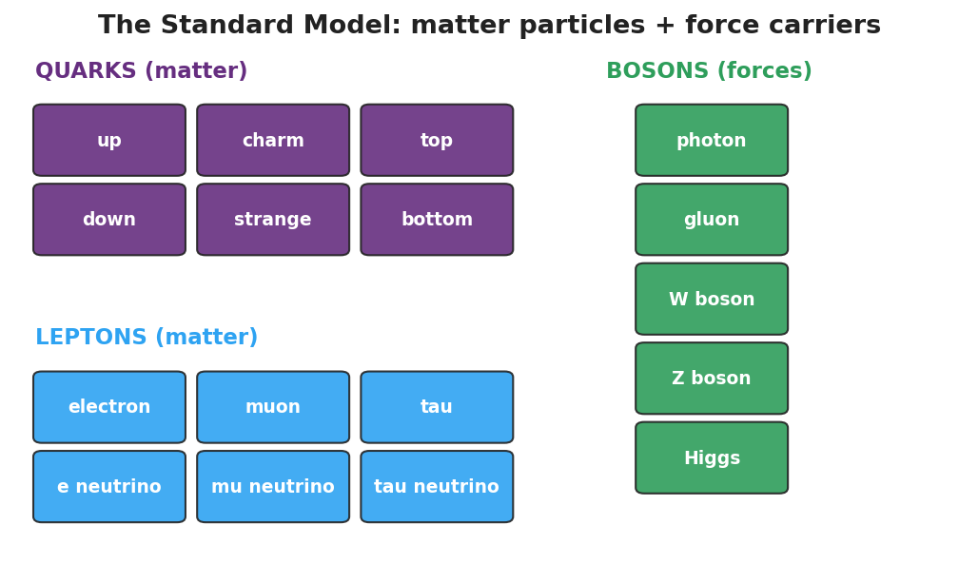
Standard-Model chart: a grid of quarks and leptons (matter particles) plus bosons (force carriers).
- Matter particles come in two families: quarks and __________.
- Quarks join together to build protons and __________.
- Leptons include the familiar __________ (which is already fundamental).
- Forces between matter particles are carried by bosons (for example, the __________ carries the electromagnetic force).
Building a proton (and a neutron):
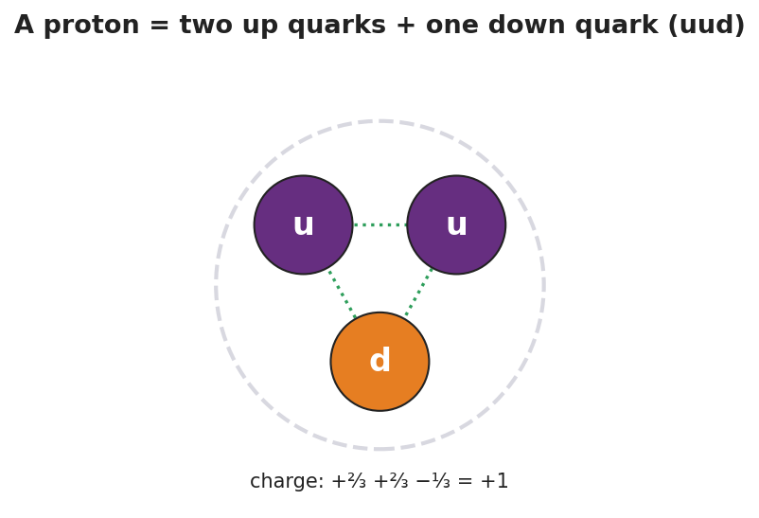
A proton drawn as two up quarks and one down quark (uud); charges +2/3, +2/3, −1/3 add to +1.
- Proton = up + up + down → charge (+⅔) + (+⅔) + (−⅓) = __________.
- Neutron = up + down + down → charge (+⅔) + (−⅓) + (−⅓) = __________.
- So a proton is not fundamental — it is made of __________.
The Standard Model organizes particles the way the __________ table organizes elements.

Worked Example
Problem. Is an electron a fundamental particle? Is a proton? Explain how you know.
Solution. 1. An electron is a __________ — it has no smaller parts inside, so it is fundamental. 2. A proton is made of three __________ (up, up, down), so it has smaller parts inside. 3. Therefore the proton is not __________; only its quarks are.

Summary
Finish the sentence (Because / But / So):
A proton is not a fundamental particle because __________________________________________, but an electron is fundamental because __________________________________________, so __________________________________________.

