The Standard Model — Student Worksheet
Unit: Modern Physics — Lesson 04 Name: _______________________ Date: __________ Period: ____

Phenomenon
Zoom in on a chair: it’s made of atoms. An atom is a nucleus plus electrons. The nucleus is protons and neutrons. So what is a proton made of? Scientists kept zooming — and found that the zoom finally stops at a small set of particles that everything else is built from.
Driving question: What are the smallest building blocks of matter, and how do scientists organize them?

Notice & Wonder
I notice… | I wonder…
Turn & Talk #1: Scientists found a small set of particles that everything is built from. Why might it help to organize them into a chart, like the periodic table?

Initial Model
Draw a proton. If you think it has smaller parts inside, draw them and label what you would call them.

My idea: _______________________________

Investigation
Use the particle cards and the figures below.
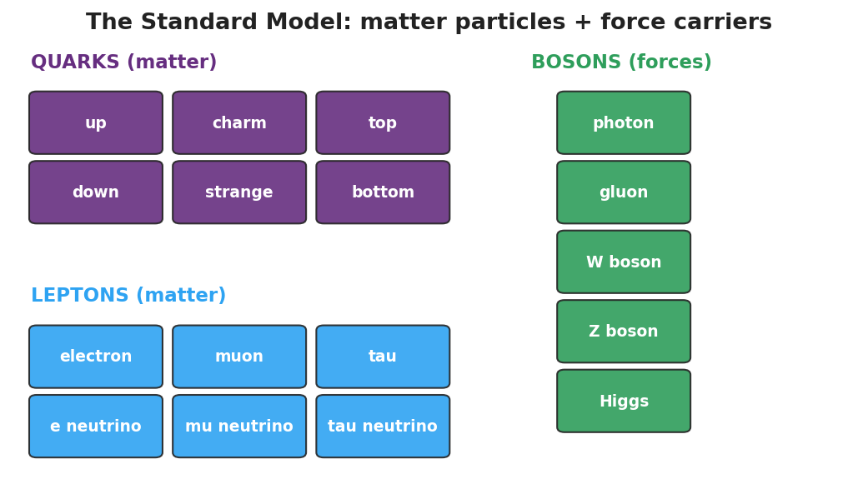
Standard-Model chart: a grid of quarks and leptons (matter particles) plus bosons (force carriers).
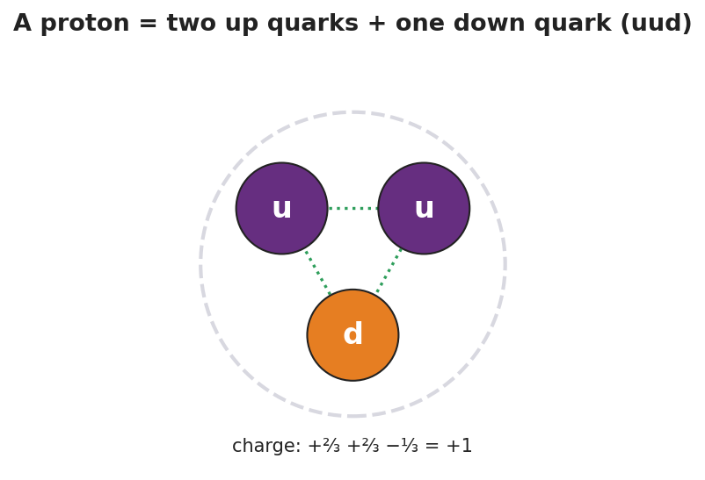
A proton drawn as two up quarks and one down quark (uud); charges +2/3, +2/3, −1/3 add to +1.
- Sort the cards into matter particles and force carriers (bosons).
- Within matter, separate the quarks from the leptons.
Card | Matter or force carrier? | If matter: quark or lepton?
up
down
electron
neutrino
photon
- Build a proton from quark cards and check the charge adds up.
Particle | Quarks | Charges added | Total charge
Proton | up + up + down | (+⅔) + (+⅔) + (−⅓)
Neutron | up + down + down | (+⅔) + (−⅓) + (−⅓)
Key question: Which of your cards is already fundamental — has nothing smaller inside?

Make It Make Sense
- A proton is made of two up quarks and one down quark. Is a proton a fundamental particle? Explain.
- How is the Standard-Model chart similar to the periodic table?
- The electron is not made of quarks. Which family does it belong to, and what does that tell you about it?

Vocabulary in Action
Use each term in a sentence about today’s phenomenon.
- quark: _______________________________________________
- lepton: _______________________________________________
- fundamental particle: _______________________________________________

Revise Your Model
Return to your Initial Model of a proton. Redraw it using quark cards (up, up, down) and check that the charges add to +1. Label which particles are fundamental.

Exit Ticket
- Name the two families of fundamental matter particles.
- A proton is made of two up quarks and one down quark. Is a proton a fundamental particle? Explain.
- The electron belongs to which family — quarks or leptons?

