The Standard Model — Teacher Guide

Cover
Unit: Modern Physics — Lesson 04: The Standard Model East Meadow Schools × Valley Stream Central High School District Strategy chips: HOCHMAN

Curated Resources (from East Meadow Scope & Sequence)

NYSSLS Standards
This is a conceptual model-building lesson anchored to the SEP Developing and Using Models. The Standard Model is the modern answer to “what is everything made of?” — it organizes all known matter particles (quarks and leptons) and force carriers (bosons) into a single chart, exactly as the periodic table organizes elements. It extends the atomic-structure work of Lesson 02 (electrons and nuclei) down to the next level and sets up the nuclear changes of Lesson 05 (protons and neutrons are made of quarks).

Phenomenon
- Cassiopeia Project: “The Standard Model” — a clear visual tour of quarks, leptons, and the forces between them: https://www.youtube.com/watch?v=Unl1jXFnzgo
- The driving puzzle: if atoms are made of protons, neutrons, and electrons — what are those made of?

Javalab / Labs
- Particle Adventure (interactive Standard Model explorer): https://www.particleadventure.org/

Assessments
- Exit ticket below (classify particles; build a proton from quarks). The “build-a-particle” sort in Phase 2 is the formative check.

Lesson Overview
Duration | 42 minutes (1 period)
NYSSLS link | SEP: Developing and Using Models (organizing matter; supports HS-PS1-8 in Lesson 05)
CCC focus | Systems and System Models / Patterns — a small set of fundamental particles, organized like a periodic table, builds everything.
Strategy chips | HOCHMAN (Because/But/So + appositive on quark / lepton)
Materials | Projector for the Cassiopeia clip; particle cards (quarks u/d, electron, neutrino, photon, gluon); the Standard-Model chart handout; whiteboards.
Safety | None — video and paper-based.
Prior knowledge | Atoms = protons + neutrons + electrons (Lessons 02–03); the periodic table as an organizing tool.
Lesson objectives — students can:
- State that all matter is built from two families of fundamental particles: quarks and leptons.
- Explain that protons and neutrons are made of quarks (a proton = up-up-down) and that forces are carried by bosons.
- Use the Standard-Model chart as a model that organizes particles, the way the periodic table organizes elements.

Phase 1 · Engage (0 – 10 min)

0–2 min · Opening Connection (SEL)
Whip-around (one sentence, pass allowed): “What is the smallest ‘building block’ you can think of that bigger things are made from?” (Lego bricks, pixels, letters in words.) Park these; you’ll call back to “a few blocks build everything” in Phase 3.

2–7 min · Phenomenon hook — “what is everything made of?”
Teacher actions. Play the Cassiopeia Standard Model clip (first few minutes). Pose the chain: a chair → atoms → protons, neutrons, electrons → and then?
Sample teacher language:
“We zoomed in: the chair is atoms, the atom is a nucleus plus electrons, the nucleus is protons and neutrons. So I’ll keep zooming — what is a proton made of? Is there a bottom to this, or does it go forever?”
Anticipated student responses:
- “Smaller protons.” / “It goes forever.” — reframe: scientists found it does bottom out.
- “Quarks!” (if seen before) — capture; we’ll organize them.
- “Electrons are already smallest.” — affirm partly: electrons are fundamental; protons are not.

7–10 min · Notice & Wonder + Turn-and-Talk #1
“Turn and talk: scientists found a small set of particles that everything is built from. Why might it help to organize them into a chart, like the periodic table?”
Target seed: a chart reveals patterns and families, and shows what’s fundamental vs. built-from-parts.

Bridge to Phase 2
Each student writes a one-sentence initial model: “I think a proton is made of ______.”

Phase 2 · Explore (10 – 30 min)

10–13 min · Initial Model (silent / individual)
Prompt:
“Draw a proton. If it has smaller parts inside, draw them and label what you’d call them.”

13–30 min · Investigation — build-a-particle sort
Groups get particle cards and the Standard-Model chart. Tasks:
- Sort the cards into matter particles (quarks + leptons) and force carriers (bosons).
- Within matter, separate quarks (up, down, …) from leptons (electron, neutrino).
- Build a proton and a neutron from quark cards. (Proton = up + up + down; neutron = up + down + down.) Check the charges add up (+⅔ +⅔ −⅓ = +1 for the proton; +⅔ −⅓ −⅓ = 0 for the neutron).
- Where does the familiar electron sit? (It’s a lepton — already fundamental, not made of quarks.)
Teacher facilitation language:
“Add the quark charges in your proton — do they land on +1?” “Which of your cards is already fundamental — has nothing smaller inside?” “What’s the boson’s job? It’s not matter — it carries a force between matter particles.”
Anchor with the chart and the proton diagram:
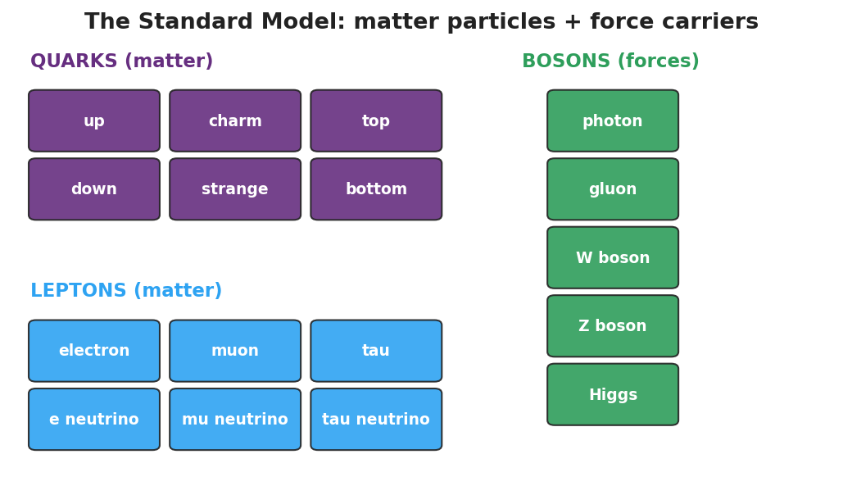
Standard-Model chart: a grid of quarks and leptons (matter particles) plus bosons (force carriers).
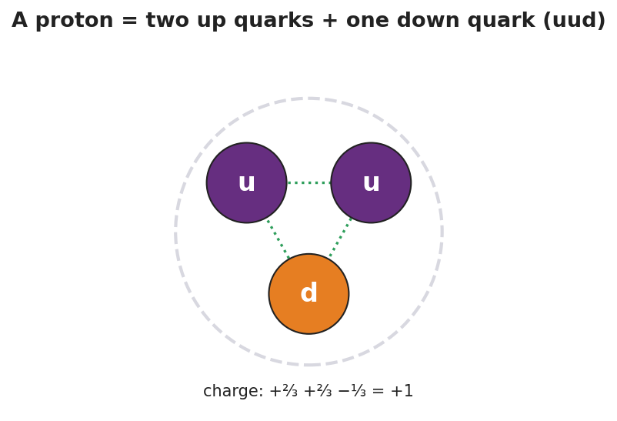
A proton drawn as two up quarks and one down quark (uud); the charges +2/3, +2/3, and −1/3 add to +1.

Teacher facilitation during Explore
- What to look for — groups checking that quark charges sum to the right particle charge.
- What to resist — don’t over-detail the second/third generations or color charge; keep it to the organizing idea.
- What to redirect — “electrons are made of quarks” → no, electrons are leptons, already fundamental.

Phase 3 · Explain (30 – 36 min)

30–33 min · Consensus
“What is the smallest level we found, and how is it organized?”
Target consensus:
“Everything is built from a small set of fundamental particles: quarks make up protons and neutrons, and leptons include the electron. Forces between them are carried by bosons. The Standard-Model chart organizes them the way the periodic table organizes elements.”

33–36 min · Vocabulary introduction (≤ 3 terms)
Sample teacher language:
“A quark is a fundamental matter particle; protons and neutrons are each made of three quarks. A lepton is the other family of matter particles — the electron is a lepton. Both quarks and leptons are fundamental particles: as far as we know, they have no smaller parts inside.”

Discussion prompts to deploy here
- “How is the Standard Model like the periodic table?”
  - Sample student response: “Both organize the basic pieces into families that show patterns; the table organizes elements, the Standard Model organizes the particles inside them.”
- “Why isn’t a proton on the chart of fundamental particles?”
  - Sample student response: “A proton is made of quarks, so it’s not fundamental — only its quarks are.”

Phase 4 · Elaborate (36 – 39 min)

36–38 min · Hochman Because/But/So + revise the model
Students complete the stem (modeled, then independent):
“A proton is not a fundamental particle because ______, but an electron is because ______, so the truly fundamental matter particles are the ______ and the ______.”
Coach the appositive: “A quark, a fundamental building block of protons and neutrons, carries a fractional charge.”

38–39 min · Return to the phenomenon
“Restate the ‘what is everything made of?’ chain in one sentence using quark and fundamental particle.”
Target: “Everything is built from fundamental particles — quarks (which make protons and neutrons) and leptons (like the electron).”

Phase 5 · Evaluate (39 – 42 min)

39–42 min · Exit Ticket + Closing Reflection
“(a) Name the two families of fundamental matter particles. (b) A proton is made of two up quarks and one down quark. Is a proton a fundamental particle? Explain. (c) The electron belongs to which family — quarks or leptons?”
Expected: (a) quarks and leptons; (b) no — it is made of smaller particles (quarks), so it is not fundamental; (c) leptons. See Answer_Key.docx.
Closing Reflection (SEL, 30 seconds):
“What’s one question about the universe you now want to ask?”

Common Misconceptions
- Misconception: “Protons and neutrons are the smallest particles.” → Correction: They are made of quarks; quarks (and leptons like the electron) are the fundamental particles.
- Misconception: “Electrons are made of quarks too.” → Correction: Electrons are leptons — already fundamental, with no quarks inside.
- Misconception: “Bosons are matter.” → Correction: Bosons are force carriers (like the photon), not matter particles.

Access & Differentiation
- ELL/ENL supports: Sentence frame: “A ___ is a fundamental particle, but a ___ is made of smaller parts, so the ___ is fundamental and the ___ is not.” Word box: {quark, proton, electron, lepton, fundamental}. Pair fundamental with “can’t break it smaller” and a closed-fist gesture.
- IEP/SPED supports: Provide pre-grouped card sets (matter vs. force already separated); students only build the proton/neutron. Give a partially completed chart to fill the last few tiles.
- Extensions: Have students build a neutron (udd), verify its zero charge, and explain why a free neutron’s beta decay (Lesson 05) changes a down quark into an up quark.

Strategy Spotlight
HOCHMAN (literacy). The Because/But/So in Phase 4 forces students to coordinate a contrast — fundamental (electron/quark) vs. composite (proton) — in one complex sentence, the heart of the lesson’s conceptual distinction. Model one, then release. The appositive drill — “A quark, a fundamental building block of protons and neutrons, carries a fractional charge” — gives students a compact academic structure for defining a new term in place, transferable to any content area.

NYSSLS Observation Checklist Crosswalk
# | Checklist item | Where it appears in this lesson
1 | Local/relatable phenomenon | Phase 1 — “what is everything made of?” zoom-in from a chair to quarks
2 | Turn and Talk (2–3×) | Phase 1 (TT#1 — why organize into a chart), Phase 3 (consensus discussion)
3 | Students develop questions/models/procedures | Phase 1 (initial model), Phase 2 (build-a-particle sort), Phase 4 (revise model)
4 | CCC defined and used | Lesson Overview · Systems and System Models / Patterns, restated in Phase 3
5 | ENL — ≤ 3 vocab, second half | Phase 3 — vocabulary at 33–36 min (quark / lepton / fundamental particle)
6 | Revisit phenomenon with evidence | Phase 4 — restate the “what is everything made of?” chain
7 | ENL/SPED supports | Access & Differentiation block
8 | Assessment check | Phase 5 — Exit Ticket (classify particles; proton from quarks)

Companion Materials
- Student_Worksheet.docx — the 5E student investigation with the build-a-particle sort (hand out at start of Phase 2)
- Student_Notes.docx — guided note-guide for the particle families and the worked example
- Answer_Key.docx — answers to “Make It Make Sense” prompts and the Exit Ticket

Key Vocabulary (max 3)
- quark — a fundamental matter particle; protons and neutrons are each built from three quarks (a proton is up-up-down)
- lepton — the other family of fundamental matter particles; the electron is a lepton
- fundamental particle — a particle with no smaller parts inside, as far as we know (quarks and leptons are fundamental; protons are not)

