Fusion, Fission, and Radioactive Decay — Student Notes
Unit: Modern Physics — Lesson 05 Name: _______________________ Date: __________ Period: ____

Learning Targets
By the end of today’s 42 minutes I can:
- Tell apart fission, fusion, and radioactive decay by how the nucleus changes.
- Explain why nuclear changes release enormous energy (E = mc², scale only).
- Connect fusion to star formation and decay to uses like carbon dating.

Key Vocabulary
- fission — _______________________________________________
- fusion — _______________________________________________
- radioactive decay — _______________________________________________

Guided Notes
Big idea: In a nuclear change, the nucleus itself changes, and a tiny amount of mass becomes a huge amount of energy.
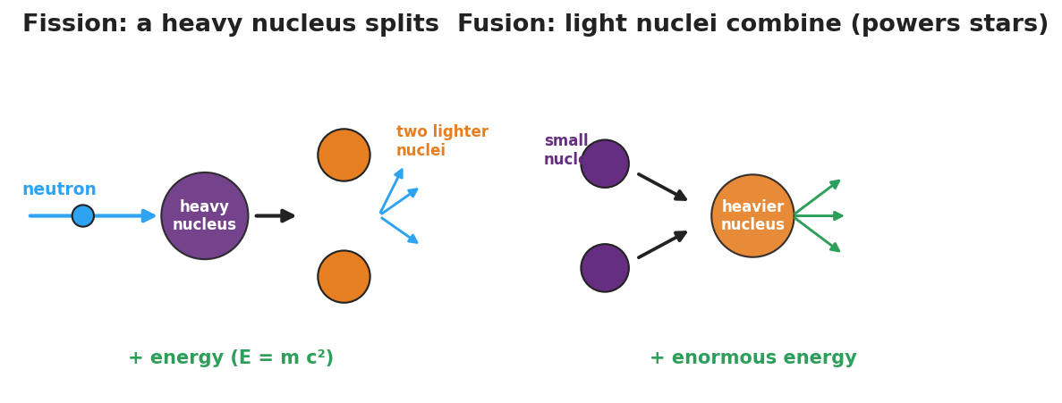
Side-by-side diagram: fission (a neutron splits a heavy nucleus into two lighter nuclei plus neutrons and energy) and fusion (light nuclei combine into a heavier nucleus plus enormous energy).
- Fission — a heavy nucleus __________ into lighter nuclei (+ extra neutrons + energy). Used in nuclear __________ plants.
- Fusion — light nuclei __________ into a heavier nucleus (+ enormous energy). Powers the __________ and forms elements in stars.
Radioactive decay — an unstable nucleus emits radiation on its own:
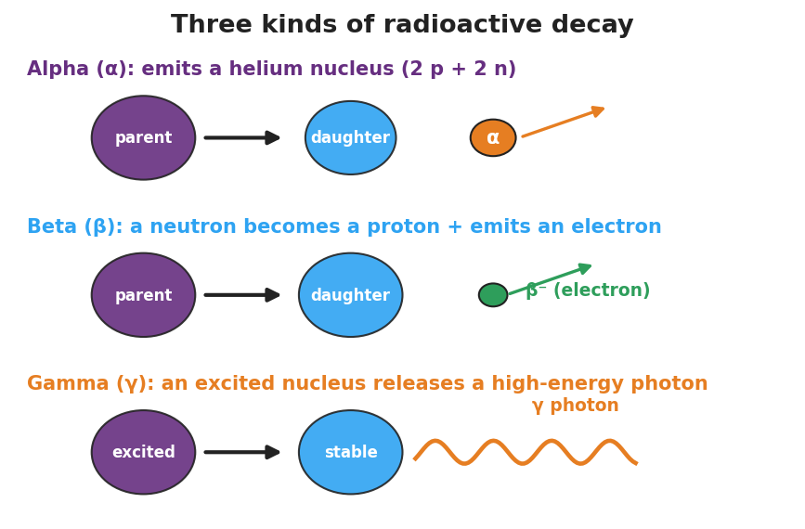
Diagram of alpha, beta, and gamma decay.
- Alpha (α) — emits a __________ nucleus (2 protons + 2 neutrons).
- Beta (β) — a neutron becomes a proton and emits an __________.
- Gamma (γ) — emits a high-energy __________ (no change in protons/neutrons).
Why so much energy? A small amount of __________ is converted to energy. Because E = mc² and c (the speed of light) is __________, even a tiny mass gives an enormous energy — far more than burning fuel. (Scale idea only — no calculation.)

Worked Example
Problem. A campfire lasts one night, but the Sun has shone for billions of years. Why can the Sun outlast any chemical fire?
Solution. 1. A campfire is a __________ reaction (rearranging atoms/bonds) — relatively little energy. 2. The Sun runs on nuclear __________ — combining hydrogen nuclei into heavier ones. 3. A tiny amount of mass turns into energy, and E = mc² (huge c) makes that energy __________ — so the Sun’s fuel lasts far longer.

Summary
Finish the sentence (Because / But / So):
A campfire burns out in one night because __________________________________________, but the Sun has shone for billions of years because __________________________________________, so __________________________________________.

