Fusion, Fission, and Radioactive Decay — Student Worksheet
Unit: Modern Physics — Lesson 05 Name: _______________________ Date: __________ Period: ____

Phenomenon
A campfire burns out overnight. The Sun has blazed for about five billion years — and is barely halfway done. No chemical fire could last that long. The same word, nuclear, shows up in the Sun, in power plants, and in carbon-14 dating of ancient bones.
Driving question: Where does nuclear energy come from, why is it so enormous, and how does the nucleus change in each case?

Notice & Wonder
I notice… | I wonder…
Turn & Talk #1: The same word — nuclear — covers the Sun, power plants, and carbon dating. Predict how the nucleus might change differently in each.

Initial Model
Draw a nucleus (protons + neutrons). Show one way you think it could change to release energy.

My idea: _______________________________

Investigation
Rotate through the three stations. Use the figures below.
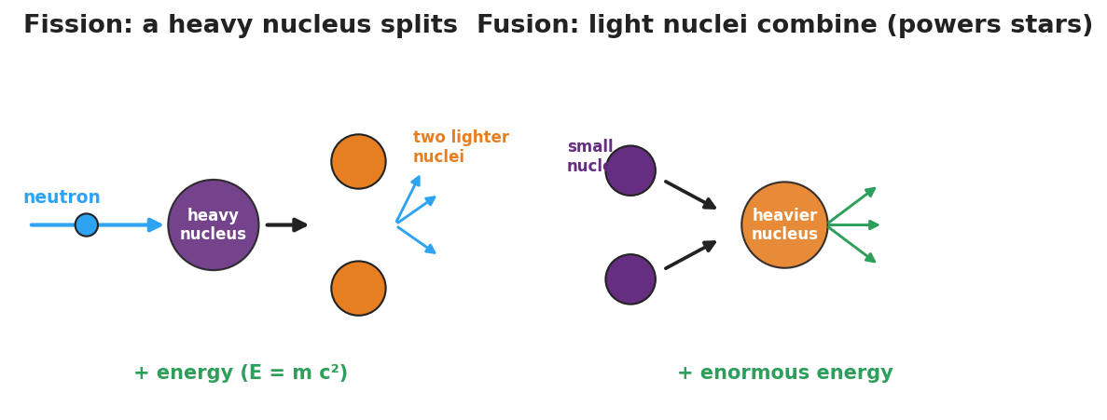
Side-by-side diagram: fission, where a neutron splits a heavy nucleus into two lighter nuclei plus more neutrons and energy; and fusion, where light nuclei combine into a heavier nucleus plus enormous energy.
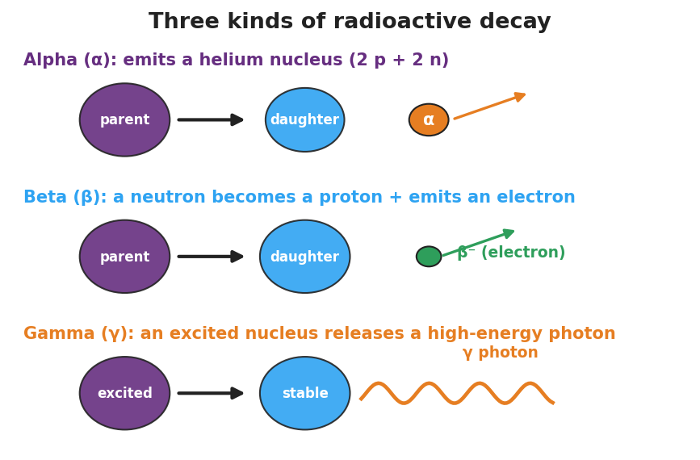
Diagram of alpha, beta, and gamma decay: alpha emits a helium nucleus, beta emits an electron as a neutron becomes a proton, and gamma releases a high-energy photon.
Station | What happens to the nucleus? | Splits, combines, or emits? | Where do you see it in the real world?
1. Fission
2. Fusion
3. Radioactive decay (α / β / γ)
Key question: What do all three nuclear changes have in common?

Make It Make Sense
- A heavy uranium nucleus is hit by a neutron and breaks into two lighter nuclei. Is this fission, fusion, or decay? How do you know?
- The Sun combines hydrogen nuclei into helium. Which process is this, and what does it have to do with how stars and elements form?
- Why is the energy released by a nuclear change so much larger than the energy from burning fuel? (Use E = mc² as a scale idea — no calculation.)

Vocabulary in Action
Use each term in a sentence about today’s phenomenon.
- fission: _______________________________________________
- fusion: _______________________________________________
- radioactive decay: _______________________________________________

Revise Your Model
Return to your Initial Model. Redraw it as one of the three changes — fission, fusion, or decay — and label where the enormous energy comes from (mass → energy, E = mc², scale only).

Exit Ticket
- A heavy uranium nucleus is struck by a neutron and splits into two lighter nuclei. Is this fission, fusion, or decay?
- The Sun combines hydrogen nuclei into helium. Which process is this, and what does it have to do with star formation?
- Why is the energy from a nuclear change so much larger than the energy from burning fuel? (Use E = mc² as a scale idea — no calculation.)

