Gram Formula Mass — Student Notes
Unit: Safety and Measurement — Lesson 06 Name: _______________________ Date: __________ Period: ____

Learning Targets
By the end of today’s 42 minutes I can:
- Read the atomic mass of any element from the Periodic Table and identify its unit (g/mol).
- Compute the gram formula mass of a compound by summing (atomic mass × subscript) for each element in the formula.
- State the unit of gram formula mass (g/mol) and explain what it means physically: the mass of one mole (6.02 × 10²³ formula units) of a substance.
- Explain, using Scale, Proportion, and Quantity, why a mole of one element may have very different mass than a mole of another, even though both contain the same number of atoms.

Key Vocabulary
- gram formula mass — _______________________________________________ _______________________________________________
- molar mass — _______________________________________________ _______________________________________________
- mole — _______________________________________________ _______________________________________________

Guided Notes
The big idea — Scale, Proportion, and Quantity: Mass scales with the __________ of atom and the __________ of atoms per formula unit. A mole always contains the same __________ of particles, but the __________ of one mole depends on what kind of particles they are.
The gram formula mass — how it works:
To find the gram formula mass of a compound:
- Identify every __________ in the chemical formula.
- Find the __________ of each element from the Periodic Table (unit: g/mol).
- Multiply each atomic mass by the __________ for that element.
- __________ all the products.
The result is the gram formula mass — the mass in grams of __________ of that substance.
The unit of gram formula mass: __________ (read as “grams per mole”)
The Hochman appositive definition:
Gram formula mass — _________________________ — is found by _________________________.
The figure — mass of one mole for four common substances:
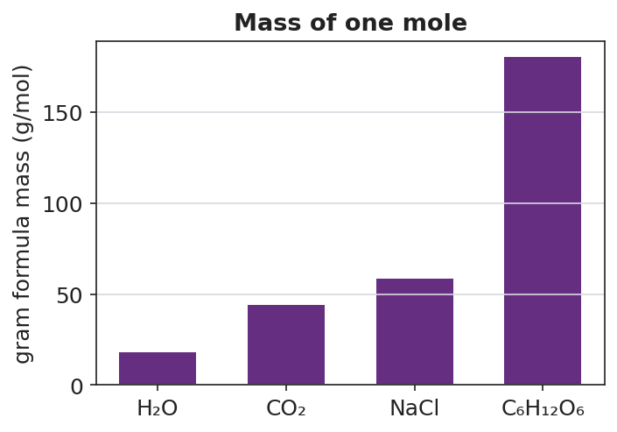
Bar chart titled ‘Mass of one mole’ showing gram formula mass (g/mol) for four substances: H₂O at 18 g/mol, CO₂ at 44 g/mol, NaCl at 58.5 g/mol, and C₆H₁₂O₆ at 180 g/mol; bars are displayed in increasing order from left to right; the y-axis is labeled ‘Gram formula mass (g/mol)’ and the x-axis labels each substance by formula; a dashed horizontal reference line marks 44 g/mol at CO₂ for comparison.
From the figure above, fill in the blanks:
- Substance with the smallest gram formula mass: ___________ (___ g/mol)
- Substance with the largest gram formula mass: ___________ (___ g/mol)
- H₂O and CO₂ each have ___ atoms per molecule, but different masses because _______________________________________________
Add-up table format (use this for every GFM calculation):
Element | Atomic mass (g/mol) | Subscript | Mass contribution
(element symbol) | (from Periodic Table) | (from formula) | atomic mass × subscript
GFM |  |  | sum of all products

Worked Example
Scenario: A student needs to calculate the gram formula mass of CaCl₂.
Step 1 — Identify the elements and their subscripts:
Formula: CaCl₂ → Elements: ___________ and ___________
Subscripts: Ca = ___ Cl = ___
Step 2 — Look up each atomic mass from the Periodic Table:
Ca = ___________ g/mol Cl = ___________ g/mol
Step 3 — Multiply each atomic mass by its subscript:
Element | Atomic mass (g/mol) | Subscript | Mass contribution
Ca | ___ | 1 | ___
Cl | ___ | 2 | ___
Step 4 — Sum all mass contributions:
GFM = ___ + ___ = ___________ g/mol
Step 5 — Appositive sentence:
The gram formula mass of calcium chloride — ___ g/mol — is found by adding ___ (for Ca) and ___ (for 2 × Cl).
Step 6 — Because / But / So
The subscript 2 on Cl is multiplied by the atomic mass of Cl because _______________________________________________, but _______________________________________________, so _______________________________________________.
Check your reasoning: “because” should explain why subscript matters; “but” should acknowledge what you would get if you forgot it; “so” should state the correct GFM.

Summary
Complete the appositive sentence:
Gram formula mass — _________________________ — is found by _________________________.
Complete the Because / But / So sentence:
A mole of gold has more mass than a mole of carbon because __________________________________________, but __________________________________________, so __________________________________________.
Reminder: The subscript in a formula tells you how many atoms of that element are in one formula unit. Each atom contributes its full atomic mass — so you always multiply atomic mass by subscript before adding.
Key reference (from the 2025 NYS Reference Tables): Avogadro’s number: 6.02 × 10²³ particles/mol Atomic masses: Periodic Table (Reference Table S)

