Gram Formula Mass — Student Worksheet
Unit: Safety and Measurement — Lesson 06 Name: _______________________ Date: __________ Period: ____

Phenomenon
Three containers are on the demonstration table. Each one holds exactly one mole — 6.02 × 10²³ formula units — of a different substance: water, table salt, and sugar. The water weighs 18 grams. The salt weighs 58.5 grams. The sugar weighs 180 grams. Same count. Very different masses on the balance.
Driving question: Why do equal numbers of atoms (or formula units) of different substances have such different masses?

Notice & Wonder
I notice… | I wonder…
Turn & Talk #1: Look at the bar chart your teacher is projecting. CO₂ and H₂O each have 3 atoms per molecule — but their bars are very different heights (44 vs. 18 g/mol). In one sentence, why might two molecules with the same number of atoms have such different masses?

Initial Model
Before your teacher names the process: use the Periodic Table to find the atomic mass of each element in H₂O and add them up. H appears twice (subscript 2), O appears once.
Your add-up table:
Element | Atomic mass (g/mol) | Subscript | Mass contribution (atomic mass × subscript)
H |  | 2
O |  | 1
Total GFM
- What is the total mass you calculated for one mole of H₂O? _______________ g/mol
- Does your answer match the bar chart for H₂O? _______________
- What two pieces of information from the Periodic Table and formula did you need? _______________________________________________

Investigation

Part 1 — ABCs: Predict before you calculate
Before calculating anything, rank the four substances on the bar chart by predicted gram formula mass (smallest to largest). Use only what you know about the formulas — which elements sound heavier? Which formulas have more atoms?
My prediction (1 = smallest mass, 4 = largest mass):
Substance | Formula | My predicted rank
Water | H₂O
Carbon dioxide | CO₂
Table salt | NaCl
Table sugar | C₆H₁₂O₆
After you complete Part 2, return and check: was your prediction correct? What surprised you?
After checking: _______________________________________________

Part 2 — GFM calculations
Calculate the gram formula mass of each compound. Use the Periodic Table. Show every row.
Compound A: H₂O (confirm your Initial Model here)
Element | Atomic mass (g/mol) | Subscript | Mass contribution
H |  | 2
O |  | 1
GFM |  |  | ___ g/mol
Compound B: CaCl₂
Element | Atomic mass (g/mol) | Subscript | Mass contribution
Ca |  | 1
Cl |  | 2
GFM |  |  | ___ g/mol
Compound C: C₆H₁₂O₆
Element | Atomic mass (g/mol) | Subscript | Mass contribution
C |  | 6
H |  | 12
O |  | 6
GFM |  |  | ___ g/mol
Now check your GFM for C₆H₁₂O₆ against the bar chart. Does it match? _______________

Part 3 — Reading the bar chart
Look at figures/molar_masses.png:
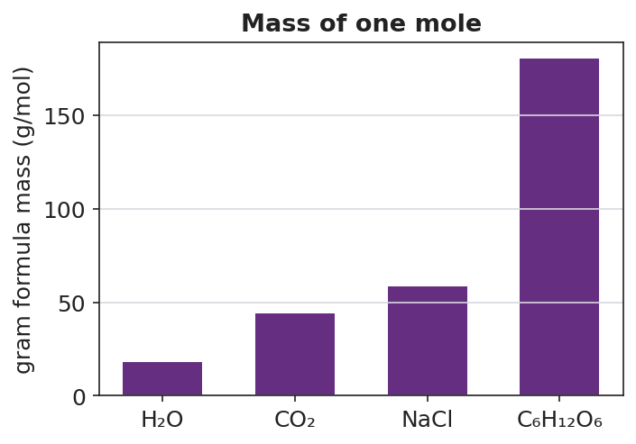
Bar chart titled ‘Mass of one mole’ showing gram formula mass (g/mol) for four substances: H₂O at 18 g/mol, CO₂ at 44 g/mol, NaCl at 58.5 g/mol, and C₆H₁₂O₆ at 180 g/mol; bars are displayed in increasing order from left to right; the y-axis is labeled ‘Gram formula mass (g/mol)’ and the x-axis labels each substance by formula; a dashed horizontal reference line marks 44 g/mol at CO₂ for comparison.
- Which substance has the largest gram formula mass? _______________
- Which two substances have the most similar gram formula masses? _______________
- CO₂ has a higher bar than H₂O. Both molecules have three atoms. Use what you found in Part 2 to explain why CO₂ has a higher gram formula mass than H₂O.

Make It Make Sense
For each compound below, calculate the gram formula mass. Show your complete add-up table. These are the same compounds you practiced in the Investigation — confirm your work here.
1. H₂O
Element | Atomic mass (g/mol) | Subscript | Mass contribution
H |  | 2
O |  | 1
GFM |  |  | ___ g/mol
2. CaCl₂
Element | Atomic mass (g/mol) | Subscript | Mass contribution
Ca |  | 1
Cl |  | 2
GFM |  |  | ___ g/mol
3. C₆H₁₂O₆
Element | Atomic mass (g/mol) | Subscript | Mass contribution
C |  | 6
H |  | 12
O |  | 6
GFM |  |  | ___ g/mol

Vocabulary in Action
Use each term in a sentence about today’s investigation. Do not copy the definition — describe something you actually did or observed.
- gram formula mass: _______________________________________________ _______________________________________________
- molar mass: _______________________________________________ _______________________________________________
- mole: _______________________________________________ _______________________________________________

Revise Your Model
Return to your Initial Model (H₂O add-up table). Add vocabulary labels:
- Draw a box around the step where you multiplied atomic mass × subscript. Label it “contribution of each element.”
- Circle the final total. Label it with the correct unit: _______________
- Write a revised appositive sentence for the result you calculated:
The gram formula mass of water — ___ g/mol — is found by _______________________________________________
Then finish this Because / But / So sentence:
A mole of gold has far more mass than a mole of carbon because __________________________________________, but __________________________________________, so __________________________________________.

Exit Ticket
(a) Calculate the gram formula mass of CO₂. Show the atomic mass × subscript add-up.
Element | Atomic mass (g/mol) | Subscript | Mass contribution
C
O
GFM |  |  | ___ g/mol
(b) Calculate the gram formula mass of NaOH. Show the atomic mass × subscript add-up.
Element | Atomic mass (g/mol) | Subscript | Mass contribution
Na
O
H
GFM |  |  | ___ g/mol
(c) In one sentence, explain why a mole of gold (Au) has more mass than a mole of carbon (C), even though both contain the same number of atoms.

