Physics — Unit 00: Math in Science (Review)
Table of Contents

Unit 0 · Math in Science

Math in Science — Unit Plan

Cover
Unit: Math in Science (Unit 00 — course opener) East Meadow Schools × Valley Stream Central High School District 4 lessons · ~4 instructional periods (42 min each) Format: DOCX (Teacher Guide · Student Worksheet · Student Notes · Answer Key per lesson)

Unit Scope (from East Meadow Scope & Sequence)
This is the quantitative-readiness unit that opens the physics course. Before students meet a single force or wave, they build the math toolkit every later unit reuses: rearranging formulas, resolving vectors with trig, reading graphs and slopes, writing numbers in scientific notation, estimating by order of magnitude, and converting units. It carries no NYSSLS performance expectation of its own; instead it develops the science and engineering practice “Using Mathematics and Computational Thinking” that threads through every HS-PS standard. It feeds directly into Kinematics (slopes of motion graphs, vector components) and Forces (Fnet = m·a rearrangements, units of the newton).
# | Lesson | Core idea
01 | Algebra and Trigonometry for Physics | Isolate a variable; resolve a slant into components with SOH-CAH-TOA
02 | Graphing and Interpreting Data | Independent vs. dependent variable; line of best fit; slope as a proportionality constant
03 | Scientific Notation and Fermi Estimates | Powers of ten; scientific notation; order-of-magnitude estimation
04 | Units, Prefixes, and Dimensional Analysis | SI units; metric prefixes; factor-label conversion and unit checking

Pacing Calendar
Day | Lesson | Phenomenon anchor | Strategy
1 | 01 Algebra & Trig | Angled zipline/ramp — find height and run | Hochman
2 | 02 Graphing & Data | Pi / Lid Lab — slope of C vs. d is π | Active Learning
3 | 03 Scientific Notation & Fermi | Scale of the Universe; basketballs in the gym | BTC
4 | 04 Units & Dimensional Analysis | Mixed-unit recipe / road sign | Hochman
Double-period days (every other day) let the Pi/Lid Lab (Lesson 02) and the Fermi board work (Lesson 03) run long.

Strategy Rotation
- HOCHMAN (literacy): Lessons 01, 04 — kernel sentences and Because/But/So on the rearrangement rule (01); appositive definitions and Because/But/So on why units must match (04).
- ACTIVE LEARNING: Lesson 02 — hands-on lid measurement plus the Slow Reveal Graphs discourse routine; students generate the data that yields π.
- BTC (Building Thinking Classrooms): Lesson 03 — visibly random groups, vertical non-permanent surfaces, and a thin-sliced scientific-notation sequence building to an open Fermi estimate.
SEL (Opening Connection + Closing Reflection), ELL/SPED supports, and a Curated Resources block appear in every lesson.

NYSSLS Coverage Matrix
This unit develops a science and engineering practice rather than a content performance expectation, so the matrix maps the practice and crosscutting concept onto each lesson.
Practice / CCC | Description | Lessons
SEP: Using Mathematics and Computational Thinking | Rearrange relationships, compute, and represent quantities — prerequisite to every HS-PS performance expectation | 01, 02, 03, 04
SEP: Analyzing and Interpreting Data | Read graphs, draw best-fit lines, extract slopes | 02
CCC: Scale, Proportion, and Quantity | Proportional relationships; powers of ten; rescaling units | 01, 02, 03, 04
CCC: Patterns | A straight-line graph reveals and names a proportional pattern | 02
Feeds → HS-PS2-1, HS-PS3, HS-PS4 | Quantitative tools reused throughout Kinematics, Forces, Energy, and Waves | all

Vocabulary Scope
Three terms maximum per lesson, introduced in the second half (NYSSLS observation item 5).
Lesson | Terms
01 | isolate (a variable) · sine · right triangle
02 | independent variable · dependent variable · slope
03 | scientific notation · order of magnitude · exponent
04 | SI unit · metric prefix · dimensional analysis

Algebra and Trigonometry for Physics — Teacher Guide

Cover
Unit: Math in Science — Lesson 01: Algebra and Trigonometry for Physics East Meadow Schools × Valley Stream Central High School District Strategy chips: HOCHMAN

Curated Resources (from East Meadow Scope & Sequence)

NYSSLS Standards
This is a foundational math-skills lesson with no single NYSSLS performance expectation of its own. It builds the science and engineering practice “Using Mathematics and Computational Thinking,” which is woven through every HS-PS standard in the course — students cannot reach HS-PS2-1 (Newton’s Second Law), HS-PS3 (energy), or any quantitative target without first being able to rearrange a formula and resolve a vector. The crosscutting concept in focus is Scale, Proportion, and Quantity: a relationship like v = d / t expresses how one quantity changes in proportion to another, and trig lets us scale a slanted distance into its horizontal and vertical parts.

Phenomenon
- Zipline / ramp at an angle — students see a cable strung from a high anchor to a low one and ask: how high is the top, and how far does the rider travel across the ground? https://www.youtube.com/results?search_query=zipline+physics
- PhET “Trig Tour” (sine/cosine on a triangle and circle): https://phet.colorado.edu/en/simulations/trig-tour

Javalab / Labs
- Javalab “Vector composition and decomposition” (resolve a vector into components): https://javalab.org/en/vector_composition_en/
- Optional: tape an angled “zipline” string across the room and measure the rise and run directly to confirm the trig.

Assessments
- PhET Trig Tour has a built-in self-check. The Exit Ticket below (find the height and run of an angled cable) is the formative check for this lesson.

Lesson Overview
Duration | 42 minutes (1 period)
NYSSLS link | Practice: Using Mathematics and Computational Thinking (supports all HS-PS)
CCC focus | Scale, Proportion, and Quantity — formulas express proportional relationships; trig scales a slant into components
Strategy chips | HOCHMAN (Because/But/So + kernel sentences on the rearrangement rule)
Materials | Whiteboards/markers; calculators (degree mode); a length of string + protractor (optional live zipline); printed right-triangle handout
Safety | If stringing a physical zipline, keep it low and clear walkways. No other hazards.
Prior knowledge | Middle-school algebra (solving one-step equations); the idea of a right triangle. No prior trig assumed.
Lesson objectives — students can:
- Isolate a chosen variable in a one- or two-step physics formula (e.g., rearrange v = d / t into d = v t and t = d / v).
- Identify the opposite, adjacent, and hypotenuse sides of a right triangle relative to a given angle.
- Use sine (and cosine/tangent via SOH-CAH-TOA) to find the height and horizontal run of an angled cable or ramp.

Phase 1 · Engage (0 – 8 min)

0–3 min · Opening Connection (SEL)
Quick whole-class check-in. Prompt: “Think of a time you had to rearrange a plan to make it work — same pieces, different order. Share one in a sentence.” This primes the idea that rearranging an equation keeps the same relationship, just solved for a different piece.

3–8 min · Phenomenon hook — the angled zipline
Teacher actions. Show the zipline image (or the string strung across the room). The cable runs from a high anchor down to a low platform at an angle.
Sample teacher language:
“Here’s the only thing the installer measured: the cable is 26 meters long and it leaves the top tower at 18 degrees below horizontal. The town inspector needs two numbers the installer never measured — how high is the top tower, and how far across the ground does the rider travel. We’re going to get both numbers without climbing anything.”
Anticipated student responses:
- “Just measure it.” — reframe: “The cable is up in the air; we only have the length and the angle. That’s all we ever get in physics.”
- “Use the Pythagorean theorem.” — affirm, then push: “That needs two sides; we have one side and an angle. Trig is the tool for one-side-plus-angle.”
- “Is it a triangle?” — yes; name it as a right triangle and bridge to Phase 2.

Bridge to Phase 2
Every student leaves Phase 1 able to sketch the cable as a right triangle and label which number they were given (the slanted side, the hypotenuse) and which two they need.

Phase 2 · Explore (8 – 26 min)

8–14 min · Skill A — Isolating a variable (algebra)
Put v = d / t on the board. Do not give the rearranged forms yet. Pose three race questions:
“If a sprinter runs at v for time t, how far did she go? Solve for d.” “If we know the distance and the speed, how long did it take? Solve for t.”
Let students try on whiteboards. Circulate. The move to name is isolate the variable: do the same operation to both sides until the wanted variable is alone.
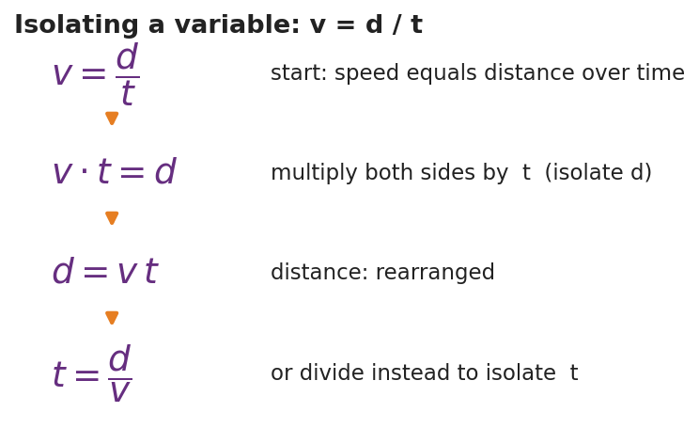
Isolating a variable in v = d / t
Teacher facilitation language:
“Whatever I do to the left side I do to the right side — that keeps the equation balanced. To free d, what’s currently happening to it? It’s being divided by t, so I undo that by multiplying both sides by t.”
Anticipated student responses:
- “d = v / t?” — common error; check units (m/s ÷ s gives m/s², not meters). Redirect to multiply, not divide.
- “d = v t.” — confirm and have them state the kernel sentence aloud (see Phase 4).

14–26 min · Skill B — Right-triangle trig (SOH-CAH-TOA)
Hand out / project the labeled right triangle. Define opposite, adjacent, hypotenuse relative to the angle.
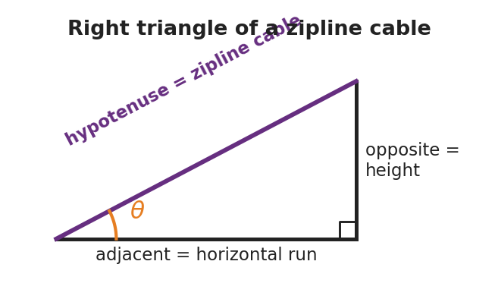
Right triangle of a zipline cable
Run the Javalab vector tool or PhET Trig Tour so students see sine change as the angle changes. Then give them the zipline numbers (hypotenuse = 26 m, angle = 18°) and ask them to find the height (opposite) and run (adjacent).
Teacher facilitation during Explore:
- What to look for — students correctly tagging which side is opposite the 18° angle (the height) before reaching for a button on the calculator.
- What to resist — supplying “use sine” too early; let them test which ratio uses the hypotenuse.
- What to redirect — calculators in radian mode (answers will be wildly off); have them confirm sin 30° = 0.5 as a mode check.

Phase 3 · Explain (26 – 34 min)

26–30 min · Turn-and-Talk + class consensus
“Which trig ratio connects the side you want to the side you were given? Talk it through with your partner using the words opposite and hypotenuse.”
Target consensus:
“The height is the side opposite the angle and we were given the hypotenuse, so we use sine: sin θ = opposite / hypotenuse. The run is adjacent, so it uses cosine.”

30–34 min · Vocabulary introduction (≤ 3 terms)
Sample teacher language:
“Three words make today portable to every future lesson. To isolate a variable means to get it alone on one side of the equation. A right triangle is any triangle with one 90° corner — every ramp, cable, and resolved vector becomes one. And sine is the ratio of the side opposite an angle to the hypotenuse — sin θ = opp / hyp.”

Discussion prompts to deploy here
- “We solved v = d / t for d. If a problem instead gives you d and v, which form do you grab, and why?”
  - Sample student response: “t = d / v, because t is the unknown and I isolate it by dividing.”
- “On the zipline, why is the height the opposite side and the ground-run the adjacent side?”
  - Sample student response: “Opposite is across from the angle; adjacent is the one touching the angle along the ground.”

Phase 4 · Elaborate (34 – 39 min)

34–37 min · HOCHMAN Because/But/So + kernel sentence
Have students compress today’s rule into a kernel sentence and then expand it.
*“Write a kernel sentence: ‘Sine relates two sides.’ Now expand it with Because / But / So: Sine relates the opposite side to the hypotenuse because , but , so ___.”*
Target: “…because that ratio stays fixed for a given angle, but it does not involve the adjacent side, so I use cosine when I need the run instead.”

37–39 min · Return to the phenomenon
“Give the inspector both numbers in one sentence each, with units.”
Target: height ≈ 26 × sin 18° ≈ 8.0 m; run ≈ 26 × cos 18° ≈ 24.7 m.

Phase 5 · Evaluate (39 – 42 min)

39–42 min · Exit Ticket + Closing Reflection
“A wheelchair ramp is 5.0 m long (the slanted hypotenuse) and rises at 10° above the ground. (a) Rearrange v = d / t to solve for t. (b) Which side of the ramp triangle is the rise — opposite or adjacent to the 10° angle? (c) Find the rise (height) of the ramp.”
Expected: (a) t = d / v; (b) opposite; (c) height = 5.0 × sin 10° ≈ 0.87 m. See Answer_Key.docx.
Closing Reflection (SEL, 30 seconds):
“Which felt harder today — rearranging the equation or choosing the trig ratio? Name one thing that made the harder one click.”

Common Misconceptions
- Misconception: “To solve v = d / t for d, divide by t.” → Correction: d is already divided by t; undo division by multiplying both sides by t, giving d = v t. Unit-check it: (m/s)(s) = m.
- Misconception: “Opposite and adjacent are fixed sides of the triangle.” → Correction: They are defined relative to the chosen angle; the same leg can be opposite for one angle and adjacent for another.
- Misconception: “sin, cos, and tan are interchangeable.” → Correction: Pick the ratio that uses the two sides you have/want — SOH-CAH-TOA tells you exactly which.
- Misconception (silent killer): calculator left in radians. → Correction: confirm sin 30° = 0.5 before trusting any answer.

Access & Differentiation
- ELL/ENL supports: Sentence frame: *“To isolate , I both sides by ___.”* Pair each trig word with a gesture (sine = hand sweeping up the opposite rise). Provide a SOH-CAH-TOA reference card with a picture, not just letters.
- IEP/SPED supports: Provide the right triangle pre-drawn and pre-labeled so students focus only on choosing the ratio. Offer a two-column “operation / result” organizer for the rearrangement so each algebra step has its own line. Allow a formula card with d = v t and t = d / v already shown for the trig portion.
- Extensions: Ask students to derive the third unknown — the angle itself — from two measured sides using the inverse sine (sin⁻¹), and to verify their zipline answers with the Pythagorean theorem (8.0² + 24.7² ≈ 26²).

Strategy Spotlight
HOCHMAN (sentence-level literacy). Today’s chip is the Because/But/So expansion plus the kernel sentence in Phase 4. The goal is precision, not volume: students compress the trig rule into a single kernel sentence (“Sine relates two sides”), then stretch it with the three conjunctions so they have to articulate the limits of the rule (when sine does not apply). Keep it to one tight paragraph; collect a few aloud and reward the most precise, not the longest.

NYSSLS Observation Checklist Crosswalk
# | Checklist item | Where it appears in this lesson
1 | Local/relatable phenomenon | Phase 1 — angled zipline; Phase 5 — wheelchair ramp
2 | Turn and Talk (2–3×) | Phase 3 (which ratio?), Phase 4 (Because/But/So share)
3 | Students develop questions/models/procedures | Phase 2 — sketch the triangle, choose the ratio, derive the rearrangement
4 | CCC defined and used | Lesson Overview · Scale, Proportion, and Quantity, applied in Phase 2
5 | ENL — ≤ 3 vocab, second half | Phase 3 — vocabulary at 30–34 min (isolate / right triangle / sine)
6 | Revisit phenomenon with evidence | Phase 4 — give the inspector the height and run
7 | ENL/SPED supports | Access & Differentiation block
8 | Assessment check | Phase 5 — Exit Ticket (ramp rise + rearrangement)

Companion Materials
- Student_Worksheet.docx — the 5E student investigation (hand out at start of Phase 2)
- Student_Notes.docx — guided note-guide for the rearrangement steps and the trig worked example
- Answer_Key.docx — answers to “Make It Make Sense” prompts and the Exit Ticket

Key Vocabulary (max 3)
- isolate (a variable) — to use inverse operations on both sides of an equation until the wanted variable stands alone (e.g., v = d / t → d = v t)
- sine — the trig ratio of the side opposite an angle to the hypotenuse: sin θ = opposite / hypotenuse
- right triangle — a triangle with one 90° angle; its longest side (opposite the right angle) is the hypotenuse

Algebra and Trigonometry for Physics — Student Worksheet
Unit: Math in Science — Lesson 01 Name: _______________________ Date: __________ Period: ____

Phenomenon
A zipline cable runs from a tall tower down to a low platform. The installer measured only two things: the cable is 26 m long and it leaves the top at 18° below horizontal. The town inspector needs two numbers nobody measured — how high is the top tower, and how far across the ground does the rider travel.

Right triangle of a zipline cable
Driving question: How can we find a height and a distance we can’t reach, using only a length and an angle?

Notice & Wonder
I notice… | I wonder…
Turn & Talk #1: What did the installer give us, and what is missing? Which shape could this cable make with the ground and the tower?

Initial Model
Sketch the zipline as a triangle. Label the 26 m cable and the 18° angle. Mark which side is the height of the tower and which side is the ground run. Write a one-sentence guess for how you might find the height.

My guess: ______________________________________

Investigation
Part A — Rearranging an equation. Start from the speed formula v = d / t.
I want to solve for… | What is happening to that variable now | What I do to both sides | Rearranged formula
d
t
Part B — Right-triangle trig. Using the triangle (hypotenuse = 26 m, angle = 18°):
I want | Which side is it (opp / adj / hyp)? | Which ratio (SOH-CAH-TOA)? | Value
height (rise)
ground run
Key question: Why does the height use the hypotenuse, and which trig function uses opposite ÷ hypotenuse?

Make It Make Sense
- Rearrange a = (v − u) / t to solve for v (the final speed).
- A ramp’s slanted top is 5.0 m long (the hypotenuse) and tilts 10° above the ground. Which side is the rise — opposite or adjacent to the 10° angle?
- Using question 2, find the rise (height) of the ramp.

Vocabulary in Action
Use each term in a sentence about today’s phenomenon.
- isolate (a variable): _______________________________________________
- sine: _______________________________________________
- right triangle: _______________________________________________

Revise Your Model
Return to your Initial Model sketch. Fill in the actual height and ground run of the zipline, with units. Then rewrite your one-sentence method using the word sine.
Height = __________ Ground run = __________ My method: _____________________________________

Exit Ticket
A wheelchair ramp is 5.0 m long (the slanted hypotenuse) and rises at 10° above the ground.
- Rearrange v = d / t to solve for t.
- Which side of the ramp triangle is the rise — opposite or adjacent to the 10° angle?
- Find the rise (height) of the ramp. Show the ratio you used.

Algebra and Trigonometry for Physics — Student Notes
Unit: Math in Science — Lesson 01 Name: _______________________ Date: __________ Period: ____

Learning Targets
By the end of today’s 42 minutes I can:
- Isolate a chosen variable in a physics formula (rearrange v = d / t into d = v t and t = d / v).
- Label the opposite, adjacent, and hypotenuse sides of a right triangle for a given angle.
- Use sine, cosine, or tangent (SOH-CAH-TOA) to find a missing side of a right triangle.

Key Vocabulary
- isolate (a variable) — _______________________________________________
- sine — _______________________________________________
- right triangle — _______________________________________________

Guided Notes
Golden rule of rearranging: whatever I do to one side of an equation, I do to the __________ side. I undo an operation with its __________ (multiply undoes divide; subtract undoes add).
Starting from v = d / t:
- To isolate d: d is being __________ by t, so __________ both sides by t → d = __________.
- To isolate t: get t out of the bottom, then __________ → t = __________.

Isolating a variable in v = d / t
Right-triangle trig — SOH-CAH-TOA. For an angle θ:
- Sin θ = __________ / hypotenuse
- Cos θ = adjacent / __________
- Tan θ = opposite / __________
The opposite side is across from θ; the adjacent side touches θ; the hypotenuse is the longest side, across from the __________ angle.

Right triangle of a zipline cable

Worked Example
Problem. A zipline cable is 26 m long (the hypotenuse) and leaves the top at 18° below horizontal. Find the tower height (the rise).
Solution. 1. The height is the side __________ the 18° angle, and I was given the __________. 2. Opposite over hypotenuse means I use __________: sin 18° = height / 26. 3. Solve: height = 26 × sin 18° = 26 × 0.309 ≈ __________ m. 4. (Run = 26 × cos 18° ≈ 24.7 m — the adjacent side.)

Summary
Finish the sentence (Because / But / So):
I can find a height I cannot reach because __________________________________________, but __________________________________________, so __________________________________________.

Algebra and Trigonometry for Physics — Answer Key

Cover
Unit: Math in Science — Lesson 01: Algebra and Trigonometry for Physics East Meadow Schools × Valley Stream Central HSD Strategy chip: HOCHMAN

Make-It-Make-Sense Answers
- Start from a = (v − u) / t. Multiply both sides by t: a t = v − u. Add u to both sides: v = u + a t. · Rubric: multiplies by t AND adds u → full credit; stopping at a t = v − u earns partial. · Practice: Using Mathematics and Computational Thinking.
- The rise is the side opposite the 10° angle (it is across from the angle, not touching it along the ground). · Rubric: “opposite” with a one-phrase justification. · CCC: Scale, Proportion, and Quantity.
- Opposite over hypotenuse → use sine: rise = 5.0 × sin 10° = 5.0 × 0.1736 ≈ 0.87 m. · Rubric: correct ratio (sine) AND answer 0.85–0.88 m with units. Accept 0.9 m if rounding is shown. · Common error: using cosine (gives 4.9 m) — that is the ground run, not the rise.

Exit Ticket Answer
- t = d / v. From v = d / t, multiply both sides by t to get v t = d, then divide both sides by v.
- The rise is the side opposite the 10° angle.
- sin 10° = rise / 5.0, so rise = 5.0 × sin 10° ≈ 0.87 m. (Calculator in degree mode: sin 10° ≈ 0.174.)
Tolerance/rubric: (a) must show t = d / v; (b) “opposite”; (c) names sine AND gives 0.85–0.88 m with units. 1 point each. The most common error is radian mode — an answer near 0.43 m signals it. Practice: Using Mathematics and Computational Thinking; CCC: Scale, Proportion, and Quantity.

Closing Reflection (rubric)
Closing reflection is formative, not graded. Award full credit for any honest response. Look for: - A clear choice of which task was harder (rearranging vs. choosing the ratio) - One specific reason the harder task started to click (a step, a gesture, a peer’s phrasing)

Graphing and Interpreting Data — Teacher Guide

Cover
Unit: Math in Science — Lesson 02: Graphing and Interpreting Data East Meadow Schools × Valley Stream Central High School District Strategy chips: ACTIVE LEARNING

Curated Resources (from East Meadow Scope & Sequence)

NYSSLS Standards
This is a foundational math-skills lesson with no single NYSSLS performance expectation of its own. It develops the science and engineering practice “Using Mathematics and Computational Thinking” (and “Analyzing and Interpreting Data”), which every quantitative HS-PS standard depends on — a slope is how students will later read acceleration off a velocity graph (HS-PS2) or a spring constant off a force graph (HS-PS3). The crosscutting concept in focus is Patterns: a straight line through data reveals a proportional relationship, and its slope is the constant that names that pattern.

Phenomenon
- “Pi / Lid Lab” — students measure the circumference and diameter of many round lids; plotted together, the points fall on a line whose slope is π.
- Slow Reveal Graphs — reveal a graph piece by piece to build interpretation skills: https://slowrevealgraphs.com/

Javalab / Labs
- Graphing Pi / Lid Lab (this lesson’s investigation): collect circumference vs. diameter for 5–6 round objects; plot and find the slope.
- Slow Reveal Graphs routine as the Engage warm-up: https://slowrevealgraphs.com/
- Desmos or graph paper for the line of best fit.

Assessments
- Slow Reveal Graphs includes discussion checks. The Exit Ticket below (read a slope and name the relationship) is the formative check for this lesson.

Lesson Overview
Duration | 42 minutes (1 period)
NYSSLS link | Practices: Using Mathematics & Computational Thinking; Analyzing & Interpreting Data (supports all HS-PS)
CCC focus | Patterns — a straight-line graph reveals a proportional relationship; the slope names it
Strategy chips | ACTIVE LEARNING (hands-on lid measurement + Slow Reveal discourse)
Materials | 5–6 round lids/cans per group; string or flexible tape measures; rulers; graph paper or Desmos; whiteboards
Safety | No hazards. Remind students not to roll cans off the desks.
Prior knowledge | Plotting an (x, y) point; the idea of “per” (miles per hour). No formal slope formula assumed.
Lesson objectives — students can:
- Identify the independent variable and dependent variable in an investigation and place each on the correct axis.
- Draw a line of best fit through scattered data and explain why it is not connect-the-dots.
- Calculate the slope (rise / run) of the best-fit line and interpret it as the constant of a proportional relationship.

Phase 1 · Engage (0 – 8 min)

0–3 min · Opening Connection (SEL)
Quick check-in. Prompt: “Name a time a picture (a chart, a map, a meme) explained something faster than words could.” This frames a graph as a fast-reading tool, not a chore.

3–8 min · Phenomenon hook — Slow Reveal + the lid question
Teacher actions. Run one Slow Reveal Graphs slide (reveal axes first, then points, then the line). Then hold up two round lids of very different sizes.
Sample teacher language:
“Here’s a wild claim: if I measure the distance around any of these lids and the distance across it, those two numbers are locked together by the same multiplier — every lid, big or small. Same multiplier. We’re going to catch that multiplier on a graph.”
Anticipated student responses:
- “Bigger lid, bigger everything.” — affirm; that’s a pattern, and we’ll make it exact.
- “The multiplier is pi!” — great early guess; have them prove it from data, not memory.
- “How do you measure around a circle?” — wrap string, then straighten it — a measurement procedure they design.

Bridge to Phase 2
Every student leaves Phase 1 with a prediction in one sentence: “As the diameter goes up, the circumference will , and the graph will look like .”

Phase 2 · Explore (8 – 26 min)

8–12 min · Set the variables (whole class)
Together, decide what we change and what we measure. We choose which lids to grab (diameter), and the circumference responds. Name the roles now so the graph is set up correctly.
Teacher facilitation language:
“Which number are we choosing, and which one just comes along for the ride? The one we choose goes on the bottom axis.”

12–26 min · Investigation — the Pi / Lid Lab (groups of 3–4)
Each group measures diameter (ruler) and circumference (string then ruler) for 5–6 lids, records a data table, and plots all points on one graph. Then they draw a single straight line of best fit — close to as many points as possible, NOT dot-to-dot — and compute its slope from a slope triangle.
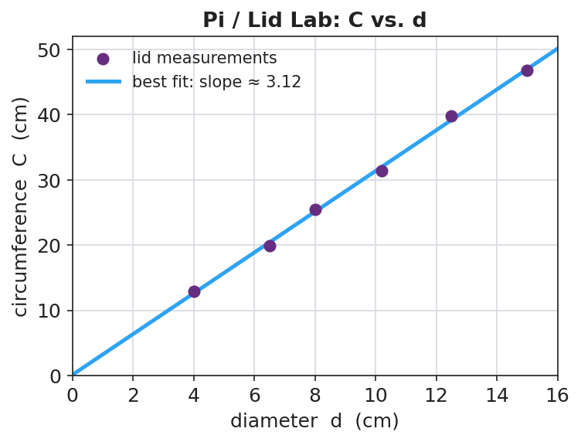
Pi / Lid Lab: circumference vs. diameter
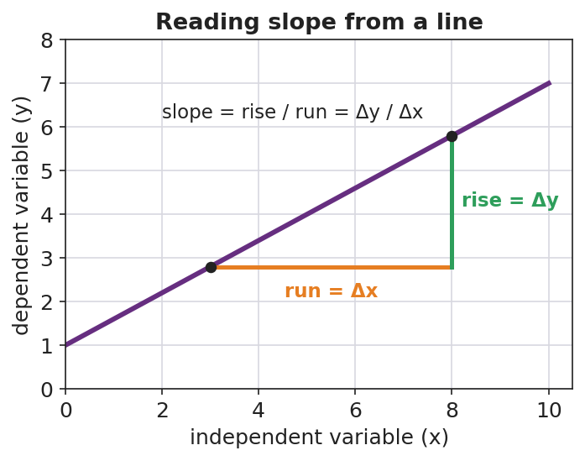
Reading slope from a line
Teacher facilitation during Explore:
- What to look for — best-fit lines that pass through the cloud, with roughly equal points above and below, and that pass near the origin.
- What to resist — handing out the slope formula before they’ve drawn the triangle; let the rise/run come from their own line.
- What to redirect — groups connecting dots zig-zag style (“that’s not a measured law, that’s tracing your errors”); groups forcing the line through the first point only.

Phase 3 · Explain (26 – 34 min)

26–30 min · Turn-and-Talk + class consensus
Post several groups’ slopes on the board (they will cluster near 3.1–3.2).
“Compare your slope to your neighbors’. Why did everyone — with different lids — land near the same number?”
Target consensus:
“The graph is a straight line through the origin, so circumference is proportional to diameter. The slope is the constant multiplier, and it’s about 3.14 — that’s π.”

30–34 min · Vocabulary introduction (≤ 3 terms)
Sample teacher language:
“Three words make every future graph readable. The independent variable is the one we choose — it goes on the x-axis (here, diameter). The dependent variable responds — it goes on the y-axis (circumference). And the slope is rise over run: how much y changes for each step in x. When the line is straight through the origin, that slope is the proportionality constant — for us, π.”

Discussion prompts to deploy here
- “If you’d plotted circumference on the x-axis instead, what would the slope have been?”
  - Sample student response: “About 1/π ≈ 0.32, because the axes are swapped — slope is y-over-x.”
- “Why is a best-fit line more trustworthy than connecting the dots?”
  - Sample student response: “It averages out our measurement errors instead of treating each wobble as real.”

Phase 4 · Elaborate (34 – 39 min)

34–37 min · Active Learning — predict from the line
“Without measuring, use your best-fit line to predict the circumference of a lid 20 cm across. Mark it on the graph and read it off. Then check: 20 × your slope. Do they match?”
This makes the line a tool, not a decoration — interpolation/extrapolation.

37–39 min · Return to the phenomenon
“State the locked-together rule in one sentence with the word slope.”
Target: “Circumference = slope × diameter, and the slope is π ≈ 3.14, so C = πd — the same multiplier for every lid.”

Phase 5 · Evaluate (39 – 42 min)

39–42 min · Exit Ticket + Closing Reflection
“A class plots a stretched spring’s length (cm) versus the mass hung on it (g). The line is straight and rises from 12 cm at 0 g. (a) Which is the independent variable and which is the dependent variable? (b) The line rises 8 cm over a run of 200 g. What is the slope, with units? (c) What does that slope tell you in plain words?”
Expected: (a) mass = independent (x), length = dependent (y); (b) slope = 8 cm / 200 g = 0.04 cm/g; (c) the spring stretches 0.04 cm for every extra gram. See Answer_Key.docx.
Closing Reflection (SEL, 30 seconds):
“Whose idea in your group changed how you drew or read the line today? Name them.”

Common Misconceptions
- Misconception: “Connect the dots to show the relationship.” → Correction: A best-fit line averages out measurement error; connect-the-dots treats every wobble as a real effect.
- Misconception: “The independent variable goes wherever there’s room.” → Correction: Independent (what you choose) goes on the x-axis; dependent (what responds) on the y-axis — always.
- Misconception: “Slope is just ‘how steep,’ no units.” → Correction: Slope is rise/run with units (e.g., cm per gram) and it carries the physical meaning of the relationship.
- Misconception: “A steeper line means a bigger y-value.” → Correction: Steepness is the rate of change, not the size of any single value.

Access & Differentiation
- ELL/ENL supports: Sentence frame: *“When the ___ goes up by , the goes up by ___.”* Color-code the axes (x = “I choose,” y = “it responds”). Provide a labeled slope-triangle card. Pre-teach “per” as “for each.”
- IEP/SPED supports: Provide a pre-labeled grid with axis titles and a scale already chosen, so students plot only. Offer a partially drawn best-fit line and have them compute the slope from a marked triangle. Reduce to 4 lids if measuring is slow.
- Extensions: Ask students to find the y-intercept of the spring graph and explain its physical meaning (the unstretched length), then write the full equation y = mx + b for their data.

Strategy Spotlight
ACTIVE LEARNING. Today’s chip pairs a hands-on measurement lab with a Slow Reveal discourse routine. Students generate the data that produces π rather than being told the value — the proportional pattern emerges from their own messy points, which is exactly why the best-fit line conversation lands. Keep groups small (3–4) so everyone measures, and require every group to post a slope so the class can see the pattern converge. The Slow Reveal warm-up trains the interpretation move (axes → points → line) you want them to use on their own graph.

NYSSLS Observation Checklist Crosswalk
# | Checklist item | Where it appears in this lesson
1 | Local/relatable phenomenon | Phase 1 — round lids; Phase 5 — stretched spring
2 | Turn and Talk (2–3×) | Phase 3 (why same slope?), Phase 4 (predict from the line)
3 | Students develop questions/models/procedures | Phase 2 — design the measuring method, plot, draw best fit
4 | CCC defined and used | Lesson Overview · Patterns, applied in Phase 3 consensus
5 | ENL — ≤ 3 vocab, second half | Phase 3 — vocabulary at 30–34 min (independent / dependent / slope)
6 | Revisit phenomenon with evidence | Phase 4 — state C = πd from the measured slope
7 | ENL/SPED supports | Access & Differentiation block
8 | Assessment check | Phase 5 — Exit Ticket (spring slope + interpretation)

Companion Materials
- Student_Worksheet.docx — the 5E student investigation with the lid data table (hand out at start of Phase 2)
- Student_Notes.docx — guided note-guide for variables, best fit, and the slope worked example
- Answer_Key.docx — answers to “Make It Make Sense” prompts and the Exit Ticket

Key Vocabulary (max 3)
- independent variable — the quantity you choose or change; it goes on the x-axis (here, the lid’s diameter)
- dependent variable — the quantity that responds and is measured; it goes on the y-axis (here, the circumference)
- slope — the rise divided by the run of a line (Δy / Δx); for a line through the origin it is the proportionality constant

Graphing and Interpreting Data — Student Worksheet
Unit: Math in Science — Lesson 02 Name: _______________________ Date: __________ Period: ____

Phenomenon
Your teacher claims that for any round lid, the distance around it and the distance across it are locked together by the same multiplier — big lid or small lid, same number. Today you will catch that multiplier on a graph.
Driving question: What single number connects the circumference of a circle to its diameter, and how does a graph reveal it?

Notice & Wonder
I notice… | I wonder…
Turn & Talk #1: As the lids get bigger across, what happens to the distance around them? What shape do you predict the graph will be?

Initial Model
Sketch the graph you expect before measuring. Label the axes. Predict in one sentence what the line will look like and whether it passes through the origin (0, 0).
My prediction: _________________________________

Investigation
Set the variables: Which quantity do you choose (independent, x-axis)? __________ Which responds (dependent, y-axis)? __________
Measure 5–6 lids. Use string to find the circumference, then straighten it against a ruler.
Lid | Diameter, d (cm) | Circumference, C (cm)
1
2
3
4
5
6
Plot all points. Draw one straight line of best fit (not dot-to-dot). Build a slope triangle on it.

Pi / Lid Lab: circumference vs. diameter
Slope: rise = __________ run = __________ slope = rise / run = __________
Key question: Why did your slope come out near 3.14 even though your lids were all different sizes?

Make It Make Sense
- A graph plots distance (y) versus time (x) for a walker. Which variable is independent and which is dependent?
- A best-fit line rises 6 units over a run of 3 units. What is its slope?
- Two lines are drawn on the same axes. Line A is steeper than Line B. What does the steeper slope mean about how fast y changes?

Vocabulary in Action
Use each term in a sentence about today’s lid investigation.
- independent variable: _______________________________________________
- dependent variable: _______________________________________________
- slope: _______________________________________________

Revise Your Model
Compare the graph you predicted to the graph you measured. Was it a straight line? Did it pass through the origin? Rewrite the locked-together rule as an equation using your slope.
Measured rule: C = __________ × d

Exit Ticket
A class plots a stretched spring’s length (cm) versus the mass hung on it (g). The line is straight and starts at 12 cm when 0 g is hung.
- Which is the independent variable and which is the dependent variable?
- The line rises 8 cm over a run of 200 g. What is the slope, including units?
- Explain in plain words what that slope tells you about the spring.

Graphing and Interpreting Data — Student Notes
Unit: Math in Science — Lesson 02 Name: _______________________ Date: __________ Period: ____

Learning Targets
By the end of today’s 42 minutes I can:
- Identify the independent and dependent variable and put each on the correct axis.
- Draw a line of best fit and explain why it beats connect-the-dots.
- Calculate a slope (rise / run) with units and say what it means.

Key Vocabulary
- independent variable — _______________________________________________
- dependent variable — _______________________________________________
- slope — _______________________________________________

Guided Notes
Which axis? The variable I choose (the __________ variable) goes on the __________-axis. The variable that responds and I measure (the __________ variable) goes on the __________-axis.
Line of best fit: a single straight line drawn close to as many points as possible, with about equal points __________ and below it. It is NOT __________-to-__________, because that would treat measurement error as real.
Slope: slope = rise / run = Δy / Δ__________ . Always include __________ (e.g., cm per gram). When a line is straight through the origin, the slope is the __________ constant.

Reading slope from a line

Worked Example
Problem. Lid data gives a straight line through the origin. Between two points, the circumference rises 31.4 cm while the diameter runs 10.0 cm. Find the slope and interpret it.
Solution. 1. slope = rise / run = 31.4 cm / __________ cm. 2. slope = __________ (no length unit left — cm / cm cancels). 3. The line passes through the __________, so this slope is the proportionality constant: C = __________ × d. 4. That constant ≈ 3.14, which is __________. So C = πd.

Pi / Lid Lab: circumference vs. diameter

Summary
Finish the sentence (Because / But / So):
A straight-line graph through the origin shows a proportional relationship because __________________________________________, but __________________________________________, so __________________________________________.

Graphing and Interpreting Data — Answer Key

Cover
Unit: Math in Science — Lesson 02: Graphing and Interpreting Data East Meadow Schools × Valley Stream Central HSD Strategy chip: ACTIVE LEARNING

Make-It-Make-Sense Answers
- Time is independent (x-axis) — it ticks on its own and we choose when to read it; distance is dependent (y-axis) — it responds to how far the walker has gone. · Rubric: both roles correct AND on the correct axes. · Practice: Analyzing & Interpreting Data.
- slope = rise / run = 6 / 3 = 2. · Rubric: 2, shown as rise over run. · CCC: Patterns.
- The steeper line (A) means y changes faster — a larger increase in y for each step in x (a greater rate of change). · Rubric: connects steepness to rate of change, not to the size of a single value. · Common error: “A has bigger numbers” — steepness is about the rate, not the height.

Exit Ticket Answer
- Mass is the independent variable (x-axis); length is the dependent variable (y-axis).
- slope = rise / run = 8 cm / 200 g = 0.04 cm/g.
- The spring stretches 0.04 cm for every extra gram hung on it — that is its stretch rate. (The 12 cm start is its unstretched length, the y-intercept.)
Tolerance/rubric: (a) both roles + correct axes; (b) 0.04 cm/g with units (accept 0.04 cm per gram); (c) “0.04 cm per gram of stretch” in plain words. 1 point each. Practice: Using Mathematics & Computational Thinking; CCC: Patterns.

Closing Reflection (rubric)
Closing reflection is formative, not graded. Award full credit for any honest response. Look for: - A specific peer named (or a self-acknowledgment) - A concrete idea that changed how they drew or read the line (e.g., “best fit, not dot-to-dot”)

Scientific Notation and Fermi Estimates — Teacher Guide

Cover
Unit: Math in Science — Lesson 03: Scientific Notation and Fermi Estimates East Meadow Schools × Valley Stream Central High School District Strategy chips: BTC

Curated Resources (from East Meadow Scope & Sequence)

NYSSLS Standards
This is a foundational math-skills lesson with no single NYSSLS performance expectation of its own. It develops the science and engineering practice “Using Mathematics and Computational Thinking,” which underpins every HS-PS standard — students will write charge in coulombs (HS-PS3), wavelengths in meters (HS-PS4), and astronomical distances (HS-ESS1) in scientific notation, and they will sanity-check answers by order of magnitude. The crosscutting concept in focus is Scale, Proportion, and Quantity: scientific notation is the language for comparing sizes that span dozens of powers of ten, from an atom to a galaxy.

Phenomenon
- “Scale of the Universe” interactive — zoom from quarks to the observable universe: https://htwins.net/scale2/
- Fermi question: “How many basketballs would fill the gym?” — a quantity nobody could ever count directly, estimated to the nearest power of ten.

Javalab / Labs
- Fermi estimation station (this lesson’s investigation): groups estimate “how many basketballs fill the gym” using only reasonable round numbers.
- “Scale of the Universe” as the Engage zoom: https://htwins.net/scale2/
- Powers of Ten classic film (Eames) as an optional extension: https://www.youtube.com/watch?v=0fKBhvDjuy0

Assessments
- The Exit Ticket below (convert to scientific notation + a one-step Fermi estimate) is the formative check for this lesson.

Lesson Overview
Duration | 42 minutes (1 period)
NYSSLS link | Practice: Using Mathematics and Computational Thinking (supports all HS-PS)
CCC focus | Scale, Proportion, and Quantity — comparing sizes across many powers of ten
Strategy chips | BTC (random groups + vertical non-permanent surfaces on a thin-sliced task)
Materials | Whiteboards / windows / vertical surfaces + markers; visibly random grouping cards; a basketball + the room dimensions; calculators
Safety | No hazards.
Prior knowledge | Place value; multiplying by 10; exponents as repeated multiplication.
Lesson objectives — students can:
- Write a large or small number in scientific notation (a number from 1–10 times a power of ten) and convert back to standard form.
- Use the exponent to count how many places the decimal moves and to compare two numbers’ sizes.
- Make an order-of-magnitude (Fermi) estimate of a quantity that cannot be counted directly, and express it as a power of ten.

Phase 1 · Engage (0 – 8 min)

0–3 min · Opening Connection (SEL)
Quick check-in. Prompt: “Name something so big or so small you can’t really picture it (a national debt, a virus, the number of stars).” This legitimizes the discomfort of huge/tiny numbers — the exact problem scientific notation solves.

3–8 min · Phenomenon hook — Scale of the Universe + the gym question
Teacher actions. Project “Scale of the Universe” and zoom from an atom out to a galaxy. Then point around the room: “How many basketballs would fill this gym?”
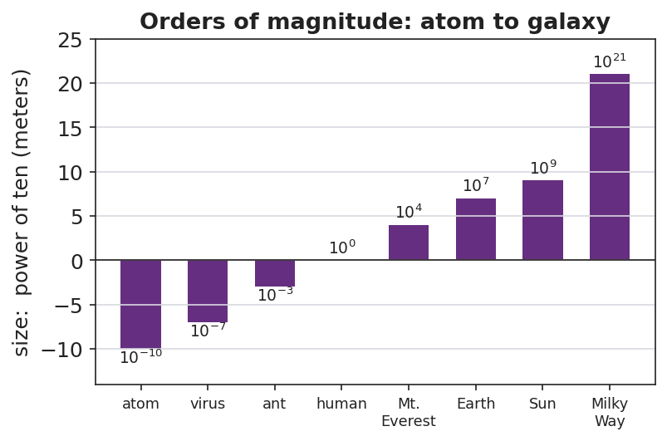
Orders of magnitude: atom to galaxy
Sample teacher language:
“Watch the exponent in the corner as I zoom — it jumps from negative ten to positive twenty. Nobody could write all those zeros and stay sane. Now: how many basketballs fill this gym? You will never count them — but by the end of class you’ll name the right power of ten, and you’ll defend it.”
Anticipated student responses:
- “A million? A billion?” — capture the guesses; we’ll see whose power of ten survives.
- “That’s impossible to know.” — reframe: “We don’t need exact; we need the right order of magnitude — the right power of ten.”
- “Just measure the gym and divide.” — yes — name that as the Fermi strategy.

Bridge to Phase 2
Every student leaves Phase 1 able to state the goal in one sentence: “Find the power of ten for the number of basketballs, not the exact count.”

Phase 2 · Explore (8 – 26 min)

8–14 min · Skill — scientific notation (BTC thin-slice at the boards)
Visibly random groups, markers, vertical surfaces. Feed a thin-sliced sequence (each step a small notch harder), one at a time:
- Write 3,000 as ___ × 10^? → 3 × 10³
- Write 47,000. Write 0.006. Write 250,000.
- Convert back: 5.2 × 10⁴ = ? ; 8 × 10⁻³ = ?
- Which is bigger: 9 × 10⁵ or 2 × 10⁶? (compare exponents first)
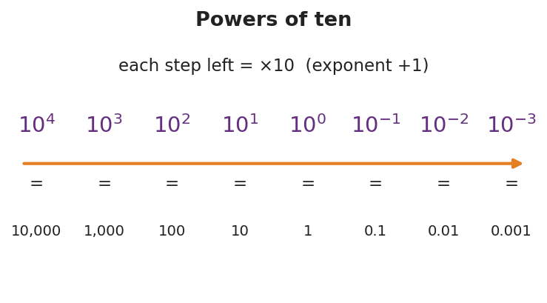
Powers of ten
Teacher facilitation language (BTC):
“I’m not answering ‘is this right?’ — convince your group at the board. When you’ve got it, signal and I’ll feed the next slice.”

14–26 min · Investigation — the Fermi gym estimate
Same boards. Groups estimate how many basketballs fill the gym using only round numbers: gym ≈ L × W × H; basketball ≈ a 0.24 m sphere (round its volume to ~10⁻² m³). Divide, then round the answer to a single power of ten and write it in scientific notation.
Teacher facilitation during Explore:
- What to look for — groups rounding aggressively (24 cm → 0.25 m → volume ~0.01 m³) instead of chasing decimals.
- What to resist — demanding the “real” answer; the win is a defensible power of ten.
- What to redirect — groups adding/subtracting exponents wrong; have them write each factor in scientific notation first, then combine.

Phase 3 · Explain (26 – 34 min)

26–30 min · Turn-and-Talk + class consensus
Post each group’s power of ten (they’ll cluster around 10⁴–10⁵).
“Compare your exponent to the next group’s. You don’t have to match exactly — but you should be within about one power of ten. Why is that ‘close enough’ in physics?”
Target consensus:
“Exact counts are impossible, but the order of magnitude — the power of ten — tells us if an answer is reasonable. Tens of thousands of basketballs, not hundreds and not billions.”

30–34 min · Vocabulary introduction (≤ 3 terms)
Sample teacher language:
“Three words run the rest of physics. Scientific notation writes any number as a value from 1 to 10 times a power of ten. The exponent is that power — it counts how many places the decimal moved, and it’s how we compare sizes fast. And the order of magnitude is just the power of ten itself — the level a quantity lives on, like 10⁴ for our basketballs.”

Discussion prompts to deploy here
- “9 × 10⁵ vs. 2 × 10⁶ — which is bigger and how do you know at a glance?”
  - Sample student response: “2 × 10⁶, because its exponent is bigger — one whole order of magnitude up.”
- “Why write 0.000006 as 6 × 10⁻⁶ instead of leaving it?”
  - Sample student response: “Fewer zeros to miscount, and the −6 instantly tells me how small it is.”

Phase 4 · Elaborate (34 – 39 min)

34–37 min · A second Fermi slice
“Estimate how many heartbeats you’ve had in your whole life. Round everything; give the answer as one power of ten in scientific notation.”
Target reasoning: ~70 beats/min × ~5×10⁵ min/yr × ~15 yr ≈ 5×10⁸ → order of magnitude 10⁸–10⁹.

37–39 min · Return to the phenomenon
“State the gym answer in scientific notation and name its order of magnitude in one sentence.”
Target: “About 3 × 10⁴ basketballs — order of magnitude 10⁴ — tens of thousands, because the gym’s volume is roughly ten thousand times a basketball’s.”

Phase 5 · Evaluate (39 – 42 min)

39–42 min · Exit Ticket + Closing Reflection
“(a) Write 84,000 and 0.00072 in scientific notation. (b) Which is larger: 4 × 10⁷ or 9 × 10⁶? How do you know? (c) Fermi: about how many grains of rice fill a coffee mug? Give your answer as a single power of ten and one sentence of reasoning.”
Expected: (a) 8.4 × 10⁴ and 7.2 × 10⁻⁴; (b) 4 × 10⁷ (bigger exponent); (c) ~10⁴ grains (mug ≈ 300 mL, a grain ≈ 0.02 mL → ~15,000 ≈ 10⁴), reasoning accepted if within one order. See Answer_Key.docx.
Closing Reflection (SEL, 30 seconds):
“Fermi estimates feel uncomfortable because there’s no single ‘right’ answer. Name one way being okay with ‘close enough’ could help you outside physics class.”

Common Misconceptions
- Misconception: “Scientific notation can start with any number, like 30 × 10².” → Correction: The leading number must be from 1 up to (not including) 10; 30 × 10² = 3 × 10³.
- Misconception: “A negative exponent means the number is negative.” → Correction: A negative exponent means small (between 0 and 1), not negative; 6 × 10⁻³ = 0.006, still positive.
- Misconception: “10⁶ is twice 10³ because 6 is twice 3.” → Correction: Each step up is ×10; 10⁶ is a thousand times 10³ (three orders of magnitude bigger).
- Misconception: “A Fermi estimate is wrong if it isn’t exact.” → Correction: The goal is the right order of magnitude; being within one power of ten is a success.

Access & Differentiation
- ELL/ENL supports: Sentence frame: “The number ___ equals ___ × 10 to the , so its order of magnitude is .” Provide the powers-of-ten chart as a reference. Pair “order of magnitude” with the zoom gesture from the Scale of the Universe demo.
- IEP/SPED supports: Provide a decimal-place counting strip (arrows showing the decimal hop) for conversions. Give the Fermi task with the round numbers pre-listed so students only divide and round the exponent. Allow calculator for the arithmetic.
- Extensions: Have students multiply two numbers in scientific notation (e.g., (3 × 10⁴)(2 × 10⁵)) by multiplying the leading numbers and adding the exponents, then estimate the mass of all the air in the room.

Strategy Spotlight
BTC (Building Thinking Classrooms). Today uses the three core BTC moves: visibly random groups, vertical non-permanent surfaces (whiteboards/windows), and a thin-sliced task fed one slice at a time. The thin-slicing matters most here — scientific notation fails quietly when students skip a difficulty notch, so each prompt rises just one step (whole thousands → arbitrary numbers → small numbers → comparisons). Refuse to be the answer key (“convince your group”); release the next slice only when a group signals understanding. The Fermi estimate is the rich task the slicing builds toward — open enough that no two boards look identical, bounded enough that all land within an order of magnitude.

NYSSLS Observation Checklist Crosswalk
# | Checklist item | Where it appears in this lesson
1 | Local/relatable phenomenon | Phase 1 — basketballs in the gym; Phase 4 — lifetime heartbeats
2 | Turn and Talk (2–3×) | Phase 3 (compare exponents), Phase 4 (heartbeat estimate share)
3 | Students develop questions/models/procedures | Phase 2 — design the Fermi division and round to a power of ten
4 | CCC defined and used | Lesson Overview · Scale, Proportion, and Quantity, applied in Phase 3
5 | ENL — ≤ 3 vocab, second half | Phase 3 — vocabulary at 30–34 min (scientific notation / order of magnitude / exponent)
6 | Revisit phenomenon with evidence | Phase 4 — state the gym answer in scientific notation
7 | ENL/SPED supports | Access & Differentiation block
8 | Assessment check | Phase 5 — Exit Ticket (conversion + comparison + Fermi)

Companion Materials
- Student_Worksheet.docx — the 5E student investigation with the Fermi gym task (hand out at start of Phase 2)
- Student_Notes.docx — guided note-guide for notation rules and the Fermi worked example
- Answer_Key.docx — answers to “Make It Make Sense” prompts and the Exit Ticket

Key Vocabulary (max 3)
- scientific notation — a way to write any number as a value from 1 to 10 multiplied by a power of ten (e.g., 8.4 × 10⁴)
- order of magnitude — the power of ten a quantity is closest to; the “level” of its size (e.g., 10⁴ basketballs)
- exponent — the power that ten is raised to; it counts how many places the decimal moves and lets you compare sizes

Scientific Notation and Fermi Estimates — Student Worksheet
Unit: Math in Science — Lesson 03 Name: _______________________ Date: __________ Period: ____

Phenomenon
In “Scale of the Universe” you zoom from an atom (about 10⁻¹⁰ m) all the way out to a galaxy (about 10²¹ m) — dozens of powers of ten. Then your teacher asks a number nobody could ever count: how many basketballs would fill this gym?

Orders of magnitude: atom to galaxy
Driving question: How do scientists write — and estimate — numbers far too big or too small to count?

Notice & Wonder
I notice… | I wonder…
Turn & Talk #1: What number do you guess for the basketballs in the gym? Is it closer to a thousand, a million, or a billion?

Initial Model
Write your gym guess as a normal number AND circle the power of ten you think it lives near (10³, 10⁴, 10⁵, 10⁶). You will test this guess by the end of class.
My guess: __________ Power of ten: __________

Investigation
Part A — Scientific notation warm-up. Fill in the blanks.
Standard form | Scientific notation
3,000
47,000
0.006
 | 5.2 × 10⁴
 | 8 × 10⁻³

Powers of ten
Part B — Fermi: basketballs in the gym. Use only round numbers.
- Gym volume ≈ length × width × height = __________ × __________ × __________ ≈ __________ m³
- One basketball ≈ a sphere about 0.24 m across ≈ __________ m³ (round to ~0.01 m³)
- Number of basketballs ≈ gym volume ÷ ball volume ≈ __________
- Rounded to one power of ten, in scientific notation: __________
Key question: Why is the power of ten a more honest answer here than an exact count?

Make It Make Sense
- Write 920,000 and 0.00045 in scientific notation.
- Which is larger: 7 × 10⁴ or 3 × 10⁵? Explain how you can tell quickly.
- A bacterium is about 10⁻⁶ m long and a person is about 10⁰ m (1 m) tall. How many orders of magnitude separate them?

Vocabulary in Action
Use each term in a sentence about today’s phenomenon.
- scientific notation: _______________________________________________
- order of magnitude: _______________________________________________
- exponent: _______________________________________________

Revise Your Model
Compare your gym answer to your Initial Model guess. Was your power of ten too high, too low, or right? Write the final answer in scientific notation and name its order of magnitude.
Final: __________ basketballs ≈ __________ (order of magnitude 10^___)

Exit Ticket
- Write 84,000 and 0.00072 in scientific notation.
- Which is larger: 4 × 10⁷ or 9 × 10⁶? How do you know?
- Fermi estimate: about how many grains of rice would fill a coffee mug? Give your answer as a single power of ten and one sentence of reasoning.

Scientific Notation and Fermi Estimates — Student Notes
Unit: Math in Science — Lesson 03 Name: _______________________ Date: __________ Period: ____

Learning Targets
By the end of today’s 42 minutes I can:
- Write large and small numbers in scientific notation and convert them back.
- Use the exponent to compare the sizes of two numbers.
- Make an order-of-magnitude (Fermi) estimate and express it as a power of ten.

Key Vocabulary
- scientific notation — _______________________________________________
- order of magnitude — _______________________________________________
- exponent — _______________________________________________

Guided Notes
The form: scientific notation is (a number from 1 to 10) × 10^(exponent). The leading number must be at least 1 and less than __________.
Moving the decimal:
- Big numbers → exponent is __________ (positive). 47,000 = 4.7 × 10^___ (decimal moved __________ places left).
- Small numbers → exponent is __________ (negative). 0.006 = 6 × 10^___ (decimal moved __________ places right).

Powers of ten
Comparing sizes: the number with the larger __________ is bigger. Each step in the exponent is a factor of __________. So 10⁶ is __________ times bigger than 10³.
Order of magnitude = the power of ten a quantity is nearest. It answers “what level of size?” not “exactly how many?”

Worked Example
Problem (Fermi). About how many basketballs fill a gym? Use only round numbers.
Solution. 1. Gym ≈ 30 m × 20 m × 10 m = __________ m³ = 6 × 10³ m³. 2. One basketball ≈ a 0.24 m sphere ≈ 0.01 m³ = 1 × 10⁻² m³. 3. Number ≈ gym ÷ ball = (6 × 10³) ÷ (1 × 10⁻²). Divide leading numbers, __________ the exponents: 6 × 10^(3 − (−2)) = 6 × 10^. 4. Answer ≈ 6 × 10⁵ → order of magnitude _______. (Hundreds of thousands — a defensible estimate.)

Orders of magnitude: atom to galaxy

Summary
Finish the sentence (Because / But / So):
I can estimate a number too big to count because __________________________________________, but __________________________________________, so __________________________________________.

Scientific Notation and Fermi Estimates — Answer Key

Cover
Unit: Math in Science — Lesson 03: Scientific Notation and Fermi Estimates East Meadow Schools × Valley Stream Central HSD Strategy chip: BTC

Make-It-Make-Sense Answers
- 920,000 = 9.2 × 10⁵; 0.00045 = 4.5 × 10⁻⁴. · Rubric: leading number 1–10 AND correct exponent (sign + size). Reject 92 × 10⁴ or 0.45 × 10⁻³. · Practice: Using Mathematics & Computational Thinking.
- 3 × 10⁵ is larger. Compare exponents first: 5 beats 4, a whole order of magnitude, so the leading numbers don’t matter. · Rubric: correct choice AND “bigger exponent” reasoning. · CCC: Scale, Proportion, and Quantity.
- From 10⁻⁶ to 10⁰ is 6 orders of magnitude (count the exponent steps: −6 up to 0). · Rubric: 6, by subtracting exponents. · Common error: answering “1,000,000” — that’s the factor, the question asks for the number of orders.

Exit Ticket Answer
- 84,000 = 8.4 × 10⁴; 0.00072 = 7.2 × 10⁻⁴.
- 4 × 10⁷ is larger — its exponent (7) is bigger than 6, one full order of magnitude up, so it outweighs the larger leading digit of 9 × 10⁶.
- ~10⁴ grains. Sample reasoning: a mug ≈ 300 mL and a grain of rice ≈ 0.02 mL, so 300 ÷ 0.02 ≈ 15,000 ≈ 10⁴. Any answer of 10³–10⁵ with reasoning is full credit.
Tolerance/rubric: (a) both correct, leading number 1–10; (b) 4 × 10⁷ with exponent reasoning; (c) a single power of ten in the 10³–10⁵ range with one sentence of round-number reasoning. 1 point each. Practice: Using Mathematics & Computational Thinking; CCC: Scale, Proportion, and Quantity.

Closing Reflection (rubric)
Closing reflection is formative, not graded. Award full credit for any honest response. Look for: - A genuine connection between “close enough / order of magnitude” and a real-world judgment (budgeting time, money, packing, etc.)

Units, Prefixes, and Dimensional Analysis — Teacher Guide

Cover
Unit: Math in Science — Lesson 04: Units, Prefixes, and Dimensional Analysis East Meadow Schools × Valley Stream Central High School District Strategy chips: HOCHMAN

Curated Resources (from East Meadow Scope & Sequence)

NYSSLS Standards
This is a foundational math-skills lesson with no single NYSSLS performance expectation of its own. It develops the science and engineering practice “Using Mathematics and Computational Thinking,” required everywhere in HS-PS — students must report acceleration in m/s², energy in joules, and current in amperes, and they must catch a wrong answer by noticing the units don’t work out. The crosscutting concept in focus is Scale, Proportion, and Quantity: metric prefixes rescale a base unit by powers of ten, and dimensional analysis keeps a quantity’s meaning intact while its units change.

Phenomenon
- A recipe / road sign with mixed units that must be reconciled — e.g., a European recipe in grams and milliliters, or a speed-limit sign in km/h that a US driver reads as mph.
- NIST “SI Units” primer for the base units and prefixes: https://www.nist.gov/pml/owm/metric-si/si-units

Javalab / Labs
- Unit-conversion station (this lesson’s investigation): convert a mixed-unit recipe or trip so every quantity shares one system.
- Optional: measure a hallway in meters, then convert to cm, mm, and km to feel the prefix ladder.

Assessments
- The Exit Ticket below (a prefix conversion + a factor-label conversion with a unit check) is the formative check for this lesson.

Lesson Overview
Duration | 42 minutes (1 period)
NYSSLS link | Practice: Using Mathematics and Computational Thinking (supports all HS-PS)
CCC focus | Scale, Proportion, and Quantity — prefixes rescale by powers of ten; units carry meaning
Strategy chips | HOCHMAN (appositive + Because/But/So on the role of units)
Materials | A mixed-unit recipe or road sign (projected/printed); metric prefix reference; calculators; whiteboards
Safety | No hazards.
Prior knowledge | Powers of ten (Lesson 03); multiplying fractions; the idea of canceling.
Lesson objectives — students can:
- Name the SI units for length, mass, and time (meter, kilogram, second) and the quantities they measure.
- Convert between units using a metric prefix (k, c, m, μ, M) by moving the decimal the right number of places.
- Use dimensional analysis (the factor-label method) to convert a compound unit (e.g., km/h → m/s) and check that the units cancel correctly.

Phase 1 · Engage (0 – 8 min)

0–3 min · Opening Connection (SEL)
Quick check-in. Prompt: “Tell us about a time a misunderstanding about ‘how much’ or ‘how big’ caused a problem (a recipe, a road trip, a measurement).” This sets up that units, not just numbers, carry meaning.

3–8 min · Phenomenon hook — the mixed-unit recipe / road sign
Teacher actions. Project a recipe that lists “250 g flour, 0.2 L milk, 15 mL oil, bake at 180 °C” next to US measuring cups and an oven in °F — or a “100 km/h” sign next to a US speedometer in mph.
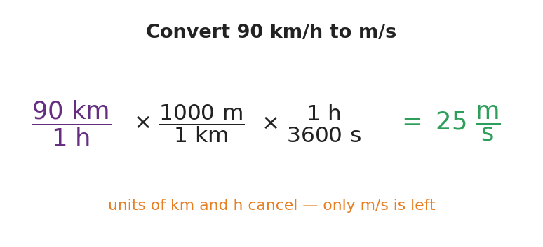
Convert 90 km/h to m/s with factor-label
Sample teacher language:
“This recipe and your kitchen don’t speak the same language. The recipe says 250 grams; your scoop says cups. The sign says 100 kilometers per hour; your speedometer says miles. Same physical amount — different units. Today we become the translators, and we’ll do it so carefully the units themselves tell us when we’re right.”
Anticipated student responses:
- “Just look it up / use Siri.” — affirm the instinct, then: “Siri doesn’t show its work, and on the Regents you do — let’s see the machinery.”
- “Grams and cups aren’t the same thing.” — exactly; one’s mass, one’s volume — units track what kind of quantity.
- “Kilo means a thousand, right?” — yes, capture it; that’s the prefix ladder.

Bridge to Phase 2
Every student leaves Phase 1 able to state the goal: “Rewrite every quantity in one consistent system without changing the actual amount.”

Phase 2 · Explore (8 – 26 min)

8–14 min · Skill A — SI base units and the prefix ladder
Establish the three core SI units: meter (length), kilogram (mass), second (time). Then build the prefix ladder — each rung is a power of ten.
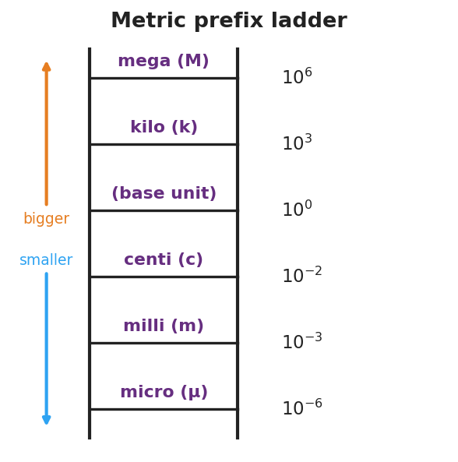
Metric prefix ladder
Teacher facilitation language:
“Going up a prefix means a bigger unit, so it takes fewer of them — 1500 m is only 1.5 km. Each rung is the decimal hopping by powers of ten. How many places, and which way?”
Anticipated student responses:
- “1 km = 100 m?” — common slip; kilo is 10³ = 1000, not 100.
- “Micro is the tiny one.” — yes, μ = 10⁻⁶; pair it with a gesture.

14–26 min · Skill B — dimensional analysis (factor-label)
Model converting 90 km/h → m/s by multiplying by “1” written as a ratio (1000 m / 1 km)(1 h / 3600 s) so the unwanted units cancel. Then groups convert the recipe / road-trip quantities.

Convert 90 km/h to m/s with factor-label
Teacher facilitation during Explore:
- What to look for — students writing the conversion factor so the old unit lands on the bottom and cancels.
- What to resist — letting them “just multiply by 1000” from memory; insist on writing the labeled ratio so the units do the checking.
- What to redirect — answers where km didn’t cancel (unit ends up km·m/h); have them flip the offending factor.

Phase 3 · Explain (26 – 34 min)

26–30 min · Turn-and-Talk + class consensus
“When you multiply by (1000 m / 1 km), why are you allowed to — and how do you know which way to write it? Use the word cancel.”
Target consensus:
“1000 m equals 1 km, so that ratio equals 1 — multiplying by 1 doesn’t change the amount, only the units. We write it with km on the bottom so the km we started with cancels, leaving meters.”

30–34 min · Vocabulary introduction (≤ 3 terms)
Sample teacher language:
“Three words make every conversion safe. An SI unit is the agreed scientific unit for a quantity — meter, kilogram, second. A metric prefix — like kilo or milli — rescales that unit by a power of ten. And dimensional analysis is the factor-label method: you multiply by ratios that equal 1 so the unwanted units cancel and the units of your answer prove it’s right.”

Discussion prompts to deploy here
- “How is multiplying by (1 h / 3600 s) different from just dividing by 3600?”
  - Sample student response: “It’s the same arithmetic, but the labeled ratio shows the hours cancel, so I can’t lose track of the units.”
- “If my answer for a speed comes out in km·m/h, what went wrong?”
  - Sample student response: “A factor was upside down — km didn’t cancel. Flip it so the unwanted unit is on the bottom.”

Phase 4 · Elaborate (34 – 39 min)

34–37 min · HOCHMAN appositive + Because/But/So
Have students define a unit with an appositive, then expand with the conjunctions.
“Write one sentence with an appositive: ’A newton, , is the SI unit of force.’ Then expand: Units must match before you add or compare because , but , so .”
Target appositive: “A newton, the push that gives 1 kg an acceleration of 1 m/s², is the SI unit of force.” Target B/B/S: “…because numbers without matching units are meaningless, but a prefix or factor-label step can rescale them, so I convert first, then compute.”

37–39 min · Return to the phenomenon
“Pick one recipe or road-sign quantity. State it in the US system in one sentence, and name how you knew your conversion was right.”
Target: e.g., “100 km/h ≈ 62 mph, and I knew it was right because the km and h units canceled, leaving mi/h.”

Phase 5 · Evaluate (39 – 42 min)

39–42 min · Exit Ticket + Closing Reflection
“(a) Convert 2.5 km to meters. (b) Convert 45 mm to meters (use the prefix). (c) Convert 72 km/h to m/s using the factor-label method, and circle the units that cancel.”
Expected: (a) 2,500 m; (b) 0.045 m; (c) 72 × (1000 m / 1 km) × (1 h / 3600 s) = 20 m/s, with km and h canceling. See Answer_Key.docx.
Closing Reflection (SEL, 30 seconds):
“Where else in your life would ‘check that the units make sense’ have saved you a mistake? Name one.”

Common Misconceptions
- Misconception: “kilo means 100.” → Correction: kilo = 10³ = 1000; centi = 10⁻², milli = 10⁻³.
- Misconception: “To convert km/h to m/s, just multiply by 1000.” → Correction: You must convert both the km (→ m) and the h (→ s); 90 km/h = 25 m/s, not 90,000 m/s.
- Misconception: “Units are just labels you tack on at the end.” → Correction: Units carry the meaning and the math; if they don’t cancel correctly, the number is wrong.
- Misconception: “Bigger prefix → bigger number of units.” → Correction: A bigger unit needs fewer of them — 1500 m is only 1.5 km.

Access & Differentiation
- ELL/ENL supports: Sentence frame: “To go from ___ to , I multiply by so the ___ cancels.” Provide the prefix ladder as a wall reference. Pre-teach “cancel” with a visual (crossing out matching units top and bottom).
- IEP/SPED supports: Provide a fill-in factor-label scaffold with the unit slots pre-drawn (just numbers to place). Offer a prefix-conversion arrow strip (places + direction). Limit Exit Ticket to parts (a) and (b) if needed.
- Extensions: Have students convert a compound unit they’ll meet later — e.g., g/cm³ to kg/m³ — and predict before computing whether the number gets bigger or smaller, justifying with the prefixes.

Strategy Spotlight
HOCHMAN (sentence-level literacy). Today’s chip is the appositive plus the Because/But/So expansion in Phase 4. Defining a unit with an appositive (“A newton, the push that…, is the SI unit of force”) forces students to pack a precise definition into a single clause — the exact skill the Regents constructed-response rewards. The Because/But/So then makes them articulate why units must match and what to do about it, turning a procedure into reasoning. Keep responses to one sentence each and collect the most precise appositives aloud.

NYSSLS Observation Checklist Crosswalk
# | Checklist item | Where it appears in this lesson
1 | Local/relatable phenomenon | Phase 1 — mixed-unit recipe / road sign; Phase 4 — km/h ↔ mph
2 | Turn and Talk (2–3×) | Phase 3 (why multiply by a ratio?), Phase 4 (appositive + B/B/S share)
3 | Students develop questions/models/procedures | Phase 2 — build the factor-label chain so units cancel
4 | CCC defined and used | Lesson Overview · Scale, Proportion, and Quantity, applied in Phase 2
5 | ENL — ≤ 3 vocab, second half | Phase 3 — vocabulary at 30–34 min (SI unit / metric prefix / dimensional analysis)
6 | Revisit phenomenon with evidence | Phase 4 — convert a recipe/road-sign quantity and justify
7 | ENL/SPED supports | Access & Differentiation block
8 | Assessment check | Phase 5 — Exit Ticket (prefix + factor-label conversions)

Companion Materials
- Student_Worksheet.docx — the 5E student investigation with the recipe/road-trip conversion (hand out at start of Phase 2)
- Student_Notes.docx — guided note-guide for prefixes and the factor-label worked example
- Answer_Key.docx — answers to “Make It Make Sense” prompts and the Exit Ticket

Key Vocabulary (max 3)
- SI unit — the agreed international scientific unit for a quantity: meter (length), kilogram (mass), second (time)
- metric prefix — a word/symbol (k, c, m, μ, M) that rescales a base unit by a power of ten (kilo = 10³, milli = 10⁻³)
- dimensional analysis — the factor-label method: multiplying by ratios equal to 1 so unwanted units cancel, leaving the desired units

Units, Prefixes, and Dimensional Analysis — Student Worksheet
Unit: Math in Science — Lesson 04 Name: _______________________ Date: __________ Period: ____

Phenomenon
A recipe reads “250 g flour, 0.2 L milk, bake at 180 °C” — but your kitchen has measuring cups and an oven in °F. A road sign says “100 km/h” — but your speedometer reads mph. Same physical amounts, different units. Today you become the translator.

Convert 90 km/h to m/s with factor-label
Driving question: How do we change a quantity’s units without changing the actual amount — and how do the units themselves prove we did it right?

Notice & Wonder
I notice… | I wonder…
Turn & Talk #1: Which numbers in the recipe/sign are in units your kitchen or car can’t read? What would you need to “translate” them?

Initial Model
Pick one quantity from the recipe or the road sign. Write what you’d have to do to express it in the US system. Do you think the number will get bigger or smaller? Why?

Investigation
Part A — The prefix ladder. Fill in the power of ten and convert.

Metric prefix ladder
Prefix | Power of ten | Example conversion
kilo (k) |  | 3 km = __________ m
centi (c) |  | 250 cm = __________ m
milli (m) |  | 45 mm = __________ m
micro (μ) |  | 1 m = __________ μm
Part B — Factor-label conversion. Convert 90 km/h to m/s. Write each factor as a ratio equal to 1 and cancel units.
90 km/h × ( ______ m / 1 km ) × ( 1 h / ______ s ) = __________ m/s
Key question: Which units cancel, and how does that tell you the answer is in the right units?

Make It Make Sense
- Convert 5,000 m to kilometers. Did the number get bigger or smaller, and why?
- Convert 3.2 m to centimeters.
- A student converts 72 km/h and gets an answer in km·m/h. What went wrong, and how should they fix it?

Vocabulary in Action
Use each term in a sentence about today’s phenomenon.
- SI unit: _______________________________________________
- metric prefix: _______________________________________________
- dimensional analysis: _______________________________________________

Revise Your Model
Return to the quantity you chose in your Initial Model. Convert it now, showing your factor-label or prefix step. Was your “bigger or smaller” prediction right?
Converted value: __________ Prediction correct? __________

Exit Ticket
- Convert 2.5 km to meters.
- Convert 45 mm to meters (use the prefix).
- Convert 72 km/h to m/s using the factor-label method. Circle the units that cancel.

Units, Prefixes, and Dimensional Analysis — Student Notes
Unit: Math in Science — Lesson 04 Name: _______________________ Date: __________ Period: ____

Learning Targets
By the end of today’s 42 minutes I can:
- Name the SI units for length, mass, and time and what each measures.
- Convert with a metric prefix (k, c, m, μ, M) by moving the decimal.
- Use dimensional analysis (factor-label) to convert a compound unit and check that units cancel.

Key Vocabulary
- SI unit — _______________________________________________
- metric prefix — _______________________________________________
- dimensional analysis — _______________________________________________

Guided Notes
SI base units: length → __________ (m); mass → __________ (kg); time → __________ (s).
Prefix ladder (each rung is a power of ten):
- kilo (k) = 10^___ ; centi (c) = 10^___ ; milli (m) = 10^___ ; micro (μ) = 10^___ ; mega (M) = 10^___ .
- A bigger unit needs __________ of them: 1500 m = __________ km.

Metric prefix ladder
Factor-label rule: multiply by a ratio that equals __________ (because the top and bottom are the same amount). Write the unwanted unit on the __________ so it __________ . The units of your answer prove it is right.

Convert 90 km/h to m/s with factor-label

Worked Example
Problem. Convert 90 km/h to m/s.
Solution. 1. Start with 90 km/h. I need to change km → m and h → s. 2. Multiply by (1000 m / 1 km) so __________ cancels, leaving meters on top. 3. Multiply by (1 h / 3600 s) so __________ cancels, leaving seconds on the bottom. 4. 90 × 1000 ÷ 3600 = __________ m/s. The leftover units are exactly __________, so it’s correct.

Summary
Finish the sentence (Because / But / So):
I can change a quantity’s units without changing the amount because __________________________________________, but __________________________________________, so __________________________________________.

Units, Prefixes, and Dimensional Analysis — Answer Key

Cover
Unit: Math in Science — Lesson 04: Units, Prefixes, and Dimensional Analysis East Meadow Schools × Valley Stream Central HSD Strategy chip: HOCHMAN

Make-It-Make-Sense Answers
- 5,000 m = 5 km. The number got smaller because a kilometer is a bigger unit, so it takes fewer of them for the same length. · Rubric: 5 km AND the “bigger unit → fewer of them” reasoning. · Practice: Using Mathematics & Computational Thinking.
- 3.2 m = 320 cm (centi = 10⁻² m, so 1 m = 100 cm; move the decimal two places right). · Rubric: 320 cm with units. · CCC: Scale, Proportion, and Quantity.
- The answer came out as km·m/h because a conversion factor was written upside down — the km did not cancel. Fix: write the factor as (1000 m / 1 km) so km sits on the bottom and cancels, and (1 h / 3600 s) so h cancels. · Rubric: identifies the inverted factor AND states the correct orientation. · Common error: blaming the arithmetic instead of the unit orientation.

Exit Ticket Answer
- 2.5 km = 2.5 × 1000 = 2,500 m.
- 45 mm = 45 × 10⁻³ = 0.045 m (milli = 10⁻³; move the decimal three places left).
- 72 km/h × (1000 m / 1 km) × (1 h / 3600 s) = (72 × 1000) ÷ 3600 = 20 m/s. The km cancels with the km on the bottom of the first ratio, and the h cancels with the h on the top of the second ratio, leaving m/s.
Tolerance/rubric: (a) 2,500 m; (b) 0.045 m (accept 4.5 × 10⁻² m); (c) 20 m/s AND km + h circled/identified as the canceling units. 1 point each. Practice: Using Mathematics & Computational Thinking; CCC: Scale, Proportion, and Quantity.

Closing Reflection (rubric)
Closing reflection is formative, not graded. Award full credit for any honest response. Look for: - A concrete real-world situation where a unit check would have caught a mistake (cooking, driving, shopping by weight, medication dosing, etc.)

