Physics — Unit 02: Forces (Review)
Table of Contents

Unit 2 · Forces

Forces — Unit Plan

Cover
Unit: Forces East Meadow Schools × Valley Stream Central High School District 6 lessons · ~6 instructional periods (42 min each) Format: DOCX (Teacher Guide · Student Worksheet · Student Notes · Answer Key per lesson)

Unit Scope (from East Meadow Scope & Sequence)
This unit develops Newton’s three laws and the common forces that act in everyday and engineered systems. It builds directly on Kinematics (velocity and acceleration as changes in motion) and sets up Momentum & Impulse and Energy.
# | Lesson | Core idea
01 | Newton’s First Law and Inertia | Motion persists unless a net force acts; inertia scales with mass
02 | Newton’s Second Law and Net Force | Fnet = m·a — net force causes acceleration
03 | Newton’s Third Law (Action and Reaction) | Forces come in equal, opposite pairs acting on different objects
04 | Friction | Static vs. kinetic friction; Ff = μ·FN
05 | Centripetal Force and Circular Motion | Center-directed net force; Fc = m·v²/r
06 | Universal Gravitation | Fg = G·m₁·m₂/r²; inverse-square pattern

Pacing Calendar
Day | Lesson | Phenomenon anchor | Strategy
1 | 01 First Law / Inertia | Tablecloth pull; ISS floating objects | Restorative Circle (unit opener)
2 | 02 Second Law / Net Force | Slingshot launches different masses | Hochman
3 | 03 Third Law | Balloon/rocket recoil; rolling-chair push-off | Active Learning
4 | 04 Friction | Sneaker drag on different surfaces | BTC
5 | 05 Centripetal / Circular | Bucket of water swung in a circle; motorcycle lean | Active Learning
6 | 06 Universal Gravitation | Why the Moon stays in orbit | Hochman
Double-period days (every other day) allow the investigation phases of Lessons 04–05 to run long with a lab.

Strategy Rotation
- HOCHMAN (literacy): Lessons 02, 06 — Because/But/So expansion and appositives on the key relationships (Fnet = m·a, the inverse-square law).
- ACTIVE LEARNING: Lessons 03, 05 — force-pair hunt / station work and the predict-and-test stopper-on-a-string.
- BTC (Building Thinking Classrooms): Lesson 04 — random groups + vertical non-permanent surfaces on a friction thin-slice.
- RESTORATIVE CIRCLE: Lesson 01 — unit-opening circle (“hard to start, hard to stop”).
SEL (Opening Connection + Closing Reflection), ELL/SPED supports, and a Curated Resources block appear in every lesson.

NYSSLS Coverage Matrix
PE | Description | Lessons
HS-PS2-1 | Newton’s Second Law — net force, mass, acceleration (Cause and Effect) | 01 (baseline), 02 (core), 04, 05
HS-PS2-2 | Conservation of momentum (Systems and System Models) | 01, 03 (thread; developed fully in the Momentum unit)
HS-PS2-3 | Minimize force in a collision — engineering design (Cause and Effect) | 04
HS-PS2-4 | Newton’s Law of Gravitation & Coulomb’s Law (Patterns) | 06 (gravitation; Coulomb in Electrostatics)

Vocabulary Scope
Three terms maximum per lesson, introduced in the second half (NYSSLS observation item 5).
Lesson | Terms
01 | inertia · net force · balanced forces
02 | net force · acceleration · newton
03 | action–reaction pair · force pair · interaction
04 | friction · static friction · kinetic friction
05 | centripetal force · centripetal acceleration · radius
06 | gravitational force · inverse-square law · mass

Newton’s First Law and Inertia — Teacher Guide

Cover
Unit: Forces — Lesson 01: Newton’s First Law and Inertia East Meadow Schools × Valley Stream Central High School District Strategy chips: RESTORATIVE CIRCLE

Curated Resources (from East Meadow Scope & Sequence)

NYSSLS Standards
The Forces unit opens the study of HS-PS2 (forces and motion). The 1st-Law/Inertia row threads toward HS-PS2-1 (Newton’s Second Law: net force, mass, acceleration) by first establishing the zero-net-force baseline — what motion looks like when forces are balanced. It also seeds HS-PS2-2 (conservation of momentum) by introducing the idea that an object’s state of motion persists unless acted on.

Phenomenon
- Tablecloth pull — dishes stay put while the cloth is yanked out: https://youtu.be/eOKFWZ-5lQc
- NASA astronauts and floating objects on the ISS (Khan Academy): https://www.khanacademy.org/science/physics/forces-newtons-laws/newtons-laws-of-motion/a/what-is-newtons-first-law

Javalab / Labs
- Moment of inertia (3D): https://javalab.org/en/moment_of_inertia_3d_en/

Assessments
- Khan Academy: “What is Newton’s first law?” check-for-understanding set (link above). Exit ticket below serves as the formative check.

Lesson Overview
Duration | 42 minutes (1 period)
NYSSLS link | HS-PS2-1 (baseline) → HS-PS2-2 (thread)
CCC focus | Cause and Effect — a change in motion requires a cause (a net force). No net force → no change.
Strategy chips | RESTORATIVE CIRCLE (unit opener)
Materials | Index cards or coins; a smooth cloth/placemat per table; small cups (empty); a rolling cart or toy car; whiteboards/markers.
Safety | Use empty/unbreakable cups for the tablecloth demo. Clear walkways for the cart.
Prior knowledge | Kinematics — velocity and acceleration as changes in motion; the vector idea (size + direction).
Lesson objectives — students can:
- State Newton’s First Law in their own words: an object keeps its velocity (including zero) unless a net force acts on it.
- Explain a real situation using inertia and the idea of balanced (zero net) forces.
- Predict whether an object’s motion will change, given whether the forces on it are balanced or unbalanced.

Phase 1 · Engage (0 – 12 min)

0–3 min · Opening Connection (SEL) — Restorative Circle (unit opener)
This is the first lesson of a new unit, so open with a brief restorative circle. Pass a talking piece. Prompt: “Name one thing that is hard to get started — and one thing that is hard to stop — in your daily life.” Keep it to one sentence each; no cross-talk. This both builds community and plants the inertia metaphor you’ll name later.

3–8 min · Phenomenon hook — the tablecloth pull
Teacher actions. Set 2–3 empty cups (or stacked coins/index cards) on a smooth cloth at the table edge. Pull the cloth straight out, fast and level. The cups barely move. Run the ISS clip as a second case if time allows.
Sample teacher language:
“Watch the cups, not my hand. I’m going to take the cloth away and I want you to tell me what the cups do — and why they don’t come flying with it.”
Anticipated student responses:
- “The cups stayed because you pulled too fast for them to react.” — surface; closer to the truth than they realize.
- “Magic / a trick.” — reframe: “It’s a trick your physics plays, not me.”
- “The cups want to stay still.” — capture the word stay; we’ll sharpen “want” into “tend to.”

8–12 min · Notice & Wonder + Turn-and-Talk #1
Capture two columns on the board. Then:
“Turn to your partner: why did the cups stay put when the cloth left? Use the word motion in your answer.”
Take 2–3 responses. Desirable insight: the cups had no sideways push on them, so their motion (at rest) didn’t change. Leave it open if no one lands it.

Bridge to Phase 2
Every student should leave Phase 1 with a one-sentence initial model: “The cups stayed because ______.”

Phase 2 · Explore (12 – 32 min)

12–17 min · Initial Model (silent / individual)
Prompt on the board:
“Draw the cup on the cloth. Draw an arrow for every push or pull acting on the cup while the cloth is pulled out. Then write one sentence predicting whether the cup speeds up, slows down, or stays the same.”
This surfaces students’ intuitions about forces before any vocabulary.

17–32 min · Investigation — start it, stop it, keep it going
Stations (or whole-class with the cart/toy car):
- At rest stays at rest — flick the cloth out from under a coin stack; vary speed. When does the stack move?
- In motion stays in motion — give the cart a push on a smooth floor vs. carpet. Where does it travel farther? Why?
- Change of motion — what do you have to do to make the moving cart speed up, slow down, or turn?
Teacher facilitation language:
“What did you have to add to change how it was moving?” “On the smooth floor, what’s still slowing it down — is it truly nothing?” “If we removed every push and rub, what would the cart do forever?”
Use the free-body diagram below to make the “balanced forces” idea visible while students model the resting coin/cup: gravity down, the table’s normal force up, and a net force of zero.
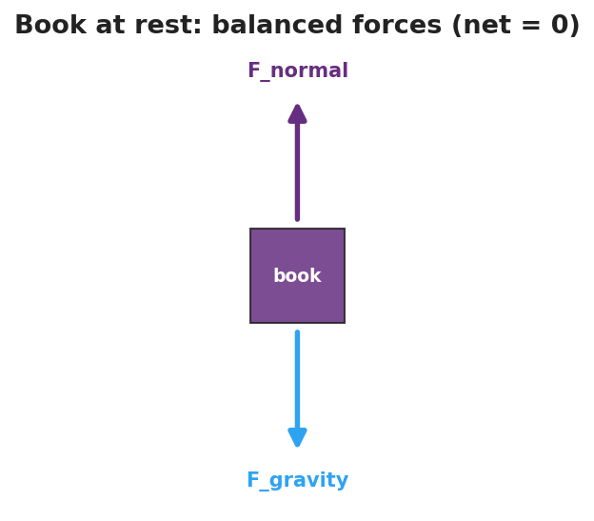
Free-body diagram of a book resting on a table: gravity pulls down, the normal force pushes up, and the two are balanced so the net force is zero.

Teacher facilitation during Explore
- What to look for — students connecting “it kept going farther on the smooth floor” to “less friction means less force to change its motion.”
- What to resist — don’t supply “inertia” or “net force” yet; let the carts and coins do the teaching.
- What to redirect — students who say “it stopped on its own” should be asked to name what stopped it (friction is a force, not “nothing”).

Phase 3 · Explain (32 – 37 min)

32–35 min · Turn-and-Talk #2 + class consensus
“Across all three stations, what did it always take to change how something was moving?”
Target consensus:
“An object keeps doing what it’s doing — staying still or moving at a steady speed in a straight line — unless a push or pull changes it. The bigger the mass, the harder it is to change.”

35–37 min · Vocabulary introduction (≤ 3 terms)
Sample teacher language:
“That tendency to keep its motion is called inertia — and more mass means more inertia. When all the forces on an object cancel out, we say the net force is zero — the forces are balanced — and the motion does not change. That’s exactly Newton’s First Law.”

Discussion prompts to deploy here
- “A book rests on the table. Name the two forces on it and explain why it doesn’t sink or fly up.”
  - Sample student response: “Gravity pulls down, the table pushes up. They’re balanced, so net force is zero and it stays still.”
- “Why is it harder to push a full cart than an empty one into motion?”
  - Sample student response: “More mass means more inertia, so it takes more force to change its motion.”

Phase 4 · Elaborate (37 – 40 min)

37–39 min · Revise the model
“Return to your cup drawing. Re-label the arrows: are the sideways forces on the cup balanced or unbalanced while the cloth slides under it? Use the words inertia and net force in your revised one-sentence explanation.”

39–40 min · Return to the phenomenon
“Why does a seatbelt matter the instant a car stops short? Answer in one sentence using inertia.”
Target: “Your body keeps moving forward (inertia) because the sudden stop acted on the car, not yet on you — the belt supplies the force that changes your motion.”

Phase 5 · Evaluate (40 – 42 min)

40–42 min · Exit Ticket + Closing Reflection
“A hockey puck slides across the ice at a steady speed in a straight line. (a) What is the net force on the puck? Explain. (b) Name the force that eventually slows it down. (c) On a frictionless rink with no air, what would the puck do? Why?”
Expected: (a) zero — constant velocity means balanced forces; (b) friction (ice + air resistance); (c) move forever at the same velocity, because no net force means no change in motion. See Answer_Key.docx.
Closing Reflection (SEL, 30 seconds):
“What is one thing today that changed how you think? Who helped you make sense of it?”

Common Misconceptions
- Misconception: “Motion needs a continuous force to keep going.” → Correction: Constant velocity needs zero net force; force is needed only to change motion.
- Misconception: “Heavier objects stop sooner because they ‘want’ to.” → Correction: Objects have no will; more mass means more inertia — more force needed to change its motion.
- Misconception: “A moving object stops ‘on its own.’” → Correction: Something (friction, air resistance) exerts a force to stop it; in their absence it would not stop.

Access & Differentiation
- ELL/ENL supports: Sentence frame: “The ___ stayed/kept moving because the net force was , so its motion did not .” Word-choice box: {balanced, unbalanced, inertia, net force, change, mass}. Pair the word inertia with a gesture (hand resisting a push).
- IEP/SPED supports: Provide pre-drawn force-arrow diagrams; students label “balanced” vs. “unbalanced” rather than drawing from scratch. Offer the cart demo as a hands-on alternative to writing.
- Extensions: Have students explain why it is harder to start a loaded shopping cart moving than an empty one, and harder to stop it, in terms of mass and inertia.

Strategy Spotlight
RESTORATIVE CIRCLE (unit opener). Today’s opening uses a circle to launch the Forces unit. Use a talking piece, one-sentence responses, and equity of voice (everyone speaks or passes). The prompt — what’s hard to start, hard to stop — is chosen so you can call back to it in Phase 3 (“that ‘hard to start, hard to stop’ feeling has a name: inertia”). Keep the circle to ~2–3 minutes; the goal is community plus a shared metaphor, not a long discussion.

NYSSLS Observation Checklist Crosswalk
# | Checklist item | Where it appears in this lesson
1 | Local/relatable phenomenon | Phase 1 — tablecloth pull; seatbelt in Phase 4
2 | Turn and Talk (2–3×) | Phase 1 (TT#1 — why cups stay), Phase 3 (TT#2 — what changes motion)
3 | Students develop questions/models/procedures | Phase 1 (initial model), Phase 2 (station investigation), Phase 4 (revise model)
4 | CCC defined and used | Lesson Overview · Cause and Effect, restated in Phase 2
5 | ENL — ≤ 3 vocab, second half | Phase 3 — vocabulary at 35–37 min (inertia / net force / balanced forces)
6 | Revisit phenomenon with evidence | Phase 4 — seatbelt + cup re-labeling
7 | ENL/SPED supports | Access & Differentiation block
8 | Assessment check | Phase 5 — Exit Ticket (hockey puck)

Companion Materials
- Student_Worksheet.docx — the 5E student investigation (hand out at start of Phase 2)
- Student_Notes.docx — guided note-guide for vocabulary and the worked example
- Answer_Key.docx — answers to “Make It Make Sense” prompts and the Exit Ticket

Key Vocabulary (max 3)
- inertia — an object’s tendency to resist a change in its motion; more mass means more inertia
- net force — the single force equivalent to all forces on an object added together (as vectors)
- balanced forces — forces whose net force is zero, so the object’s motion does not change

Newton’s First Law and Inertia — Student Worksheet
Unit: Forces — Lesson 01 Name: _______________________ Date: __________ Period: ____

Phenomenon
Your teacher pulls a cloth out from under a stack of cups — and the cups barely move. In a video from the International Space Station, a tool let go in mid-air just floats in place.
Driving question: What decides whether an object’s motion changes or stays the same?

Notice & Wonder
I notice… | I wonder…
Turn & Talk #1: Why did the cups stay put when the cloth was pulled away? Use the word motion in your answer.

Initial Model
Draw the cup sitting on the cloth. Draw an arrow for every push or pull acting on the cup while the cloth is yanked out. Then predict: does the cup speed up, slow down, or stay the same?

My prediction: _______________________________

Investigation
When an object stays at rest, the forces on it are balanced. The diagram below shows a book on a table — use it as a model for the resting coin/cup in Station 1.

Free-body diagram of a book on a table: the downward pull of gravity and the upward normal force are equal, so the net force is zero.
Complete each station. Record what you observe and what it tells you.
Station | What I did | What happened | What it tells me
1. Cloth + coin stack
2. Cart on smooth floor vs. carpet
3. Changing the cart’s motion
Key question: In every station, what did it take to change how something was moving?

Make It Make Sense
- A book lies still on a table. Gravity pulls it down. What second force acts on it, and why doesn’t the book move?
- Two students push a box from opposite sides with equal force. What is the net force, and what does the box do?
- Why is it harder to get a fully loaded backpack moving than an empty one?

Vocabulary in Action
Use each term in a sentence about today’s phenomenon.
- inertia: _______________________________________________
- net force: _______________________________________________
- balanced forces: _______________________________________________

Revise Your Model
Return to your Initial Model. Were the sideways forces on the cup balanced or unbalanced while the cloth slid underneath? Rewrite your explanation using inertia and net force.

Exit Ticket
A hockey puck slides across the ice at a steady speed in a straight line.
- What is the net force on the puck? Explain.
- Name the force that eventually slows it down.
- On a frictionless rink with no air, what would the puck do, and why?

Newton’s First Law and Inertia — Student Notes
Unit: Forces — Lesson 01 Name: _______________________ Date: __________ Period: ____

Learning Targets
By the end of today’s 42 minutes I can:
- State Newton’s First Law in my own words.
- Explain a real situation using inertia and balanced forces.
- Predict whether motion will change, given balanced or unbalanced forces.

Key Vocabulary
- inertia — _______________________________________________
- net force — _______________________________________________
- balanced forces — _______________________________________________

Guided Notes
Big idea (Newton’s First Law): An object keeps its velocity — staying at rest, or moving at a __________ speed in a __________ line — unless a __________ force acts on it.
- “Velocity” includes zero velocity → an object at rest stays at __________.
- Inertia depends on __________: more mass → __________ inertia → harder to change its motion.
- If forces are balanced, net force = __________, and motion does __________ change.
- If forces are unbalanced, net force ≠ 0, and motion __________ change (this is Lesson 02).
Force diagram — book on a table (fill the arrows):
- Down: __________ (gravity)
- Up: __________ (table pushing up, the normal force)
- Net force = __________ → the book stays __________.

Free-body diagram of a book on a table with a downward gravity arrow and an equal upward normal-force arrow, showing the net force is zero.
When the net force is zero, velocity does not change. A moving object simply keeps its velocity — a flat line on a velocity–time graph:
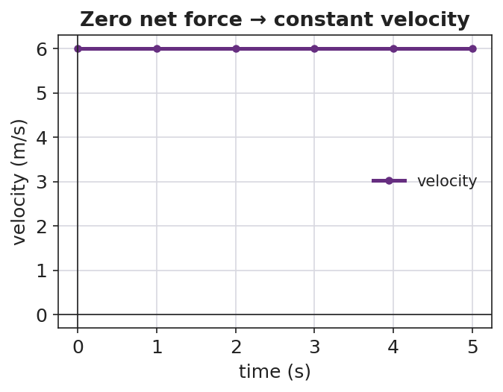
Velocity–time graph showing a horizontal line at constant velocity, illustrating that zero net force means no change in velocity.

Worked Example
Problem. A 1,200 kg car and a 60 kg shopping cart are both at rest. Which is harder to push into motion, and why?
Solution. 1. Both are at rest, so both currently have __________ net force. 2. To start moving, each needs an __________ force. 3. The __________ has more mass → more __________ → it needs a much larger force to get the same change in motion. The car is far harder to start.

Summary
Finish the sentence (Because / But / So):
An object at rest tends to stay at rest because __________________________________________, but __________________________________________, so __________________________________________.

Newton’s First Law and Inertia — Answer Key

Cover
Unit: Forces — Lesson 01: Newton’s First Law and Inertia East Meadow Schools × Valley Stream Central HSD

Make-It-Make-Sense Answers
- The table pushes up on the book (the normal force) with the same size as gravity pulling down. The two forces are balanced, so the net force is zero and the book stays at rest. · Rubric: names the normal force AND states net force = 0 → full credit. · NYSSLS: HS-PS2-1
- The net force is zero (equal and opposite pushes cancel), so the box stays at rest — or, if already moving, keeps moving at constant velocity. · Rubric: net force = 0 AND correct motion outcome. · NYSSLS: HS-PS2-1
- The loaded backpack has more mass, therefore more inertia, so it takes a larger force to produce the same change in motion. · Rubric: links mass → inertia → larger force. · NYSSLS: HS-PS2-1

Exit Ticket Answer
- Zero net force. Constant speed in a straight line = constant velocity = no change in motion, which means the forces are balanced.
- Friction (between puck and ice) plus a small amount of air resistance.
- It would keep moving forever at the same velocity — with no net force, there is nothing to change its motion (Newton’s First Law).
Tolerance/rubric: (a) must state zero AND justify via constant velocity; (b) friction (air resistance optional); (c) “constant velocity forever” + “no net force.” 1 point each. NYSSLS: HS-PS2-1.

Closing Reflection (rubric)
Closing reflection is formative, not graded. Award full credit for any honest response. Look for: - A genuine shift-in-thinking statement in answer 1 - Naming a peer or self-acknowledgment in answer 2

Newton’s Second Law and Net Force — Teacher Guide

Cover
Unit: Forces — Lesson 02: Newton’s Second Law and Net Force East Meadow Schools × Valley Stream Central High School District Strategy chips: HOCHMAN

Curated Resources (from East Meadow Scope & Sequence)

NYSSLS Standards
This lesson is the heart of HS-PS2-1: “Analyze data to support the claim that Newton’s second law of motion describes the mathematical relationship among the net force on a macroscopic object, its mass, and its acceleration.” It builds directly on Lesson 01 (Newton’s First Law), where students established the zero-net-force baseline — motion does not change when forces are balanced. Here we ask the next question: when the net force is not zero, how much does the motion change? The answer is the proportional, mathematical relationship F_net = m·a. On the 2025 Physics Reference Table this appears as a = F_net / m. The lesson also seeds HS-PS2-2 (momentum) by treating force as the agent of change in motion.

Phenomenon
- Slingshot launch: the same rubber band, pulled back the same distance, launches three different-size balls (ping-pong, golf, steel) — the light ball rockets away while the heavy one barely leaves. Same pull, different acceleration.
- Alternate (no slingshot needed): an empty cart vs. a loaded cart given the same push — the loaded cart accelerates far less.

Javalab / Labs
- Force and movement simulation: https://javalab.org/en/force_movement_en/
- oPhysics force-and-motion / inclined plane: https://ophysics.com/f1.html

Assessments
- HS-PS2-1 cluster task “The Gyro Drop” — students analyze acceleration data from a drop ride to argue the F_net = m·a relationship.
- HS-PS2-1 cluster task “Newton’s 2nd Law” — data-analysis cluster on net force, mass, and acceleration. The Exit Ticket below is the formative check for this lesson.

Lesson Overview
Duration | 42 minutes (1 period)
NYSSLS link | HS-PS2-1 (core) → HS-PS2-2 (thread)
CCC focus | Cause and Effect — net force is the cause; acceleration is the effect. Bigger cause → bigger effect; bigger mass → smaller effect.
Strategy chips | HOCHMAN (Because/But/So sentence expansion on F_net = m·a)
Materials | Rubber band/slingshot frame; ping-pong, golf, and steel balls (or 3 graduated masses); a rolling cart; objects to load the cart; whiteboards/markers; the 2025 Reference Table.
Safety | Launch balls into a soft target or open floor only — never toward people. Keep walkways clear for the cart.
Prior knowledge | Lesson 01 — net force, balanced/unbalanced forces, inertia; Kinematics — acceleration as the rate of change of velocity.
Lesson objectives — students can:
- State Newton’s Second Law in words and as the equation F_net = m·a (equivalently a = F_net / m).
- Predict how acceleration changes when net force or mass changes, and justify it with the equation.
- Solve a quantitative problem: given any two of F_net, m, and a, find the third, with units in newtons.

Phase 1 · Engage (0 – 10 min)

0–3 min · Do Now + Opening Connection
Post the Do Now: “In one sentence, what does it take to change how fast something is moving? (Hint from yesterday: balanced or unbalanced?)” Take one or two responses to surface the bridge from Lesson 01: it takes an unbalanced (net) force.

3–8 min · Phenomenon hook — the slingshot launch
Teacher actions. Hold the slingshot frame steady. Pull the same rubber band back the same distance each time and launch the ping-pong ball, then the golf ball, then the steel ball into a soft target. The light ball flies fast and far; the heavy one barely moves.
Sample teacher language:
“Same band, same pull every time — so the same push. Watch how differently each ball takes off. What is the pull doing differently to each one?”
Anticipated student responses:
- “The heavy one is harder to move.” — capture; we will sharpen “harder to move” into less acceleration.
- “You pulled the light one harder.” — correct gently: “Same pull every time — that’s the whole point.”
- “The big ball weighs more so it goes slower.” — capture “more mass → less change in motion.”

8–10 min · Notice & Wonder + Turn-and-Talk #1
Two columns on the board. Then:
“Turn to your partner: the push was the same on all three, so what made the light ball speed up so much more? Use the word mass in your answer.”
Target insight to listen for (leave open if no one lands it): same force, but less mass means more speeding-up.

Bridge to Phase 2
Every student leaves Phase 1 with a one-sentence initial model: “The light ball sped up more because ______.”

Phase 2 · Explore (10 – 30 min)

10–15 min · Initial Model (silent / individual)
Prompt on the board:
“Draw the three balls leaving the slingshot. Draw one arrow for the push (same size on each) and a second arrow for how fast each speeds up. Then write one sentence predicting which ball speeds up the most and why.”
This surfaces the proportional intuition before any equation.

15–30 min · Investigation — Javalab force-and-movement sim
Open https://javalab.org/en/force_movement_en/ (or the loaded/empty cart if running hands-on). Students work the worksheet table in two rounds:
- Hold mass constant, change force. Double the applied force. Record what happens to acceleration.
- Hold force constant, change mass. Double the mass. Record what happens to acceleration.
Teacher facilitation language:
“When you doubled the force and kept the mass the same — what did the acceleration do?” “Now keep the force the same and double the mass — which way did the acceleration go?” “Can you write that as a fraction? Acceleration equals what, over what?”
As the data accumulates, sketch (or project) the acceleration-vs-net-force relationship. A straight line through the origin is the visual proof that a is proportional to net force:
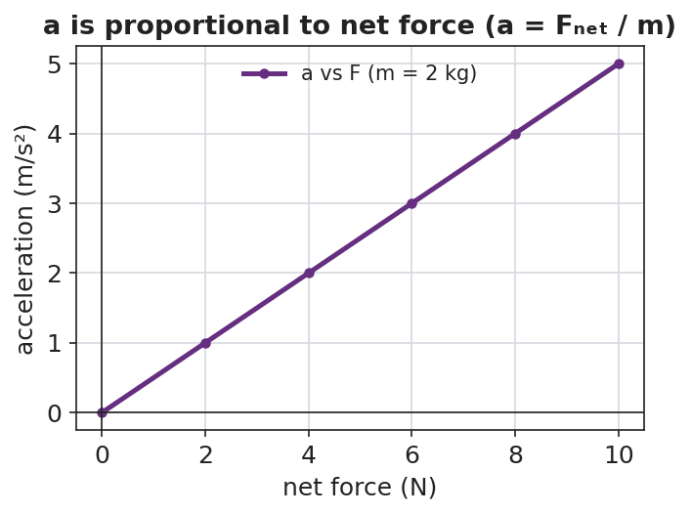
Line graph of acceleration versus net force: a straight line through the origin, showing acceleration is directly proportional to net force.
The reason a cart accelerates at all is that its forces are unbalanced — the applied push beats friction, leaving a net force in the direction of motion:
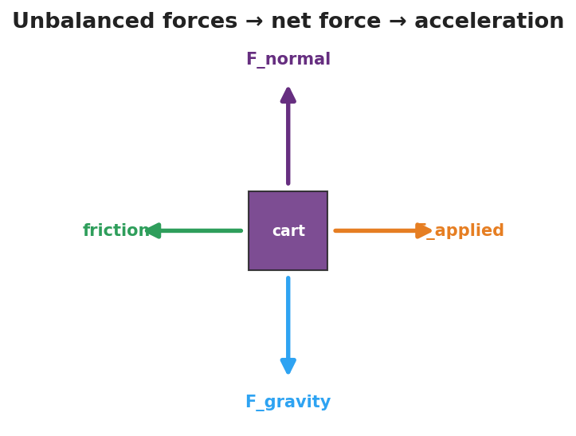
Free-body diagram of a cart with the applied force larger than friction, plus balanced vertical forces, leaving an unbalanced net force that causes acceleration.

Teacher facilitation during Explore
- What to look for — students seeing acceleration double when force doubles (direct), and acceleration halve when mass doubles (inverse).
- What to resist — don’t hand them F_net = m·a yet; let the data build the pattern so the equation names what they already found.
- What to redirect — students who change force and mass at once should isolate one variable per trial (controlled investigation).

Phase 3 · Explain (30 – 36 min)

30–33 min · Turn-and-Talk #2 + class consensus
“Put your two patterns into one rule. Acceleration goes ___ when force goes up, and ___ when mass goes up.”
Target consensus:
“Acceleration is bigger when the net force is bigger, and smaller when the mass is bigger. Acceleration = net force ÷ mass.”

33–36 min · Vocabulary introduction (≤ 3 terms)
Sample teacher language:
“The single push left over after we combine all forces is the net force. The speeding-up or slowing-down it produces is the acceleration. And we measure force in newtons — one newton is exactly the force that gives a 1 kg mass an acceleration of 1 m/s². Put it together and you get Newton’s Second Law: F_net = m·a, or a = F_net / m on your Reference Table.”

Discussion prompts to deploy here
- “If you push two carts with the same net force but one has twice the mass, how do their accelerations compare?”
  - Sample student response: “The heavy one has half the acceleration — mass is on the bottom of the fraction.”
- “A 2 kg ball accelerates at 3 m/s². What net force acted on it?”
  - Sample student response: “F = m·a = 2 × 3 = 6 newtons.”

Phase 4 · Elaborate (36 – 40 min)

36–39 min · Revise the model + HOCHMAN sentence expansion
Students return to the three-ball drawing and re-label arrows using net force and acceleration. Then run the Hochman move (see Strategy Spotlight) — complete the Because/But/So expansion of F_net = m·a:
“The steel ball accelerated the least because ____, but ____, so ____.”

39–40 min · Return to the phenomenon
“Why does a loaded delivery truck take longer to speed up than an empty one, even with the same engine force? Answer in one sentence using net force, mass, and acceleration.”
Target: “Same net force, but more mass, so the acceleration is smaller (a = F_net / m).”

Phase 5 · Evaluate (40 – 42 min)

40–42 min · Exit Ticket + Closing Reflection
“A net force of 12 N acts on a 4 kg cart. (a) Find the cart’s acceleration. Show F_net = m·a (or a = F_net / m). (b) If the mass were doubled to 8 kg with the same 12 N, what is the new acceleration? (c) In one sentence, explain what happened to the acceleration and why.”
Expected: (a) a = 12/4 = 3 m/s²; (b) a = 12/8 = 1.5 m/s²; (c) doubling the mass halved the acceleration because acceleration is inversely proportional to mass. See Answer_Key.docx.
Closing Reflection (SEL, 30 seconds):
“What is one thing today that changed how you think about force and motion? Who helped you make sense of it?”

Common Misconceptions
- Misconception: “More force always means more speed.” → Correction: More net force means more acceleration (rate of change of velocity), not automatically more speed at a given instant.
- Misconception: “Heavy and light objects accelerate the same under the same push.” → Correction: For the same net force, more mass gives less acceleration — mass is in the denominator (a = F_net / m).
- Misconception: “Each separate force has its own acceleration.” → Correction: Only the single net force (all forces combined) determines the acceleration.

Access & Differentiation
- ELL/ENL supports: Sentence frame: *“When the net force ___ and the mass stays the same, the acceleration ___.”* Word-choice box: {net force, mass, acceleration, newton, doubles, halves}. Pair acceleration with a “speeding-up” hand gesture; pair newton with the 1 kg → 1 m/s² mental image.
- IEP/SPED supports: Provide the equation triangle (F_net on top; m and a on the bottom) so students can cover the unknown to see the operation. Offer a pre-built data table for the Javalab sim so students focus on the pattern, not table setup.
- Extensions: Have students use the Javalab sim to find the net force that gives a 5 kg object an acceleration of 4 m/s² (answer 20 N), then predict and verify the acceleration for the same force on a 10 kg object.

Strategy Spotlight
HOCHMAN (Because/But/So sentence expansion). Sentence-level writing makes abstract equations precise. In Phase 4, students expand a single kernel sentence — “The steel ball accelerated the least” — using the three Hochman conjunctions, each forcing a different kind of reasoning:
- because → a cause (“…because it has the most mass and a = F_net / m”)
- but → a contrast (“…but the net force on it was the same as on the other balls”)
- so → a consequence (“…so dividing the same net force by a larger mass gives a smaller acceleration”)
Model one example aloud, then have students write their own for a different ball. Collect a few to check that “because” names the cause (mass), not just restates the claim — this is the comprehension signal you are looking for, and it maps directly onto the Cause-and-Effect CCC.

NYSSLS Observation Checklist Crosswalk
# | Checklist item | Where it appears in this lesson
1 | Local/relatable phenomenon | Phase 1 — slingshot launch; loaded truck in Phase 4
2 | Turn and Talk (2–3×) | Phase 1 (TT#1 — why the light ball sped up more), Phase 3 (TT#2 — one combined rule)
3 | Students develop questions/models/procedures | Phase 1 (initial model), Phase 2 (controlled sim investigation), Phase 4 (revise model)
4 | CCC defined and used | Lesson Overview · Cause and Effect, restated in Phase 2 and Phase 4
5 | ENL — ≤ 3 vocab, second half | Phase 3 — vocabulary at 33–36 min (net force / acceleration / newton)
6 | Revisit phenomenon with evidence | Phase 4 — three-ball re-labeling + loaded-truck prompt
7 | ENL/SPED supports | Access & Differentiation block
8 | Assessment check | Phase 5 — Exit Ticket (12 N on a 4 kg cart)

Companion Materials
- Student_Worksheet.docx — the 5E student investigation (hand out at start of Phase 2)
- Student_Notes.docx — guided note-guide for vocabulary and the worked example
- Answer_Key.docx — answers to “Make It Make Sense” prompts and the Exit Ticket

Key Vocabulary (max 3)
- net force — the single force equivalent to all forces on an object combined (as vectors); the cause of acceleration
- acceleration — the rate at which an object’s velocity changes; equal to net force divided by mass (a = F_net / m)
- newton — the SI unit of force; 1 N = 1 kg·m/s², the force that accelerates a 1 kg mass at 1 m/s²

Newton’s Second Law and Net Force — Student Worksheet
Unit: Forces — Lesson 02 Name: _______________________ Date: __________ Period: ____

Phenomenon
Your teacher pulls the same rubber band back the same distance every time — so the push is the same — and launches three different balls: a ping-pong ball, a golf ball, and a steel ball. The light ball rockets away. The heavy steel ball barely leaves.
Driving question: If the push is the same every time, what decides how much each object speeds up?

Notice & Wonder
I notice… | I wonder…
Turn & Talk #1: The push was the same on all three balls, so what made the light ball speed up so much more? Use the word mass in your answer.

Initial Model
Draw the three balls leaving the slingshot. Draw one arrow for the push (same size on each ball) and a second arrow for how fast each one speeds up. Then predict which ball speeds up the most and why.

My prediction: _______________________________

Investigation
Use the force-and-movement simulation (https://javalab.org/en/force_movement_en/) or the cart your teacher provides. Run two rounds and record what happens.
Round 1 — keep the mass the same, change the force.
Trial | Net force (N) | Mass (kg) | Acceleration (what happened?)
A
B (double the force)
Round 2 — keep the force the same, change the mass.
Trial | Net force (N) | Mass (kg) | Acceleration (what happened?)
C
D (double the mass)
Key questions:
- When you doubled the net force (same mass), the acceleration ______________.
- When you doubled the mass (same force), the acceleration ______________.
If you plot your Round 1 data, it should look like the graph below — a straight line through the origin, because acceleration is directly proportional to net force.

Line graph of acceleration versus net force showing a straight line through the origin.

Make It Make Sense
- A 2 kg ball is pushed with a net force of 6 N. What is its acceleration? Show your work using a = F_net / m.
- Two carts get the same net force, but Cart B has twice the mass of Cart A. How do their accelerations compare?
- A net force of 20 N gives a cart an acceleration of 4 m/s². What is the mass of the cart?

Vocabulary in Action
Use each term in a sentence about today’s phenomenon.
- net force: _______________________________________________
- acceleration: _______________________________________________
- newton: _______________________________________________

Revise Your Model
Return to your Initial Model. Re-label your arrows using the words net force and acceleration. Then finish this Because / But / So sentence:
The steel ball accelerated the least because __________________________________________, but __________________________________________, so __________________________________________.

Exit Ticket
A net force of 12 N acts on a 4 kg cart.
- Find the cart’s acceleration. Show F_net = m·a (or a = F_net / m).
- If the mass were doubled to 8 kg with the same 12 N net force, what is the new acceleration?
- In one sentence, explain what happened to the acceleration and why.

Newton’s Second Law and Net Force — Student Notes
Unit: Forces — Lesson 02 Name: _______________________ Date: __________ Period: ____

Learning Targets
By the end of today’s 42 minutes I can:
- State Newton’s Second Law in words and as the equation F_net = m·a.
- Predict how acceleration changes when the net force or the mass changes.
- Solve for F_net, m, or a given the other two, using units of newtons.

Key Vocabulary
- net force — _______________________________________________
- acceleration — _______________________________________________
- newton — _______________________________________________

Guided Notes
Big idea (Newton’s Second Law): The net force on an object equals its mass times its __________: F_net = m·a. On the 2025 Reference Table this is written a = F_net / __________.
- Acceleration is directly proportional to net force: more net force → __________ acceleration (same mass).
- Acceleration is inversely proportional to mass: more mass → __________ acceleration (same net force).
- The unit of force is the newton (N). One newton = 1 __________ · m/s² — the force that gives a 1 kg mass an acceleration of 1 m/s².
- Connection to Lesson 01: if the net force is zero, then a = __________, and the motion does not change.
Cause and Effect: the net force is the __________ (cause); the acceleration is the __________ (effect).
Because acceleration is directly proportional to net force, a graph of acceleration vs. net force is a straight line through the origin:

Line graph of acceleration versus net force: a straight line through the origin, illustrating that acceleration is directly proportional to net force.

Worked Example
Problem. A net force of 15 N acts on a 3 kg cart. Find the cart’s acceleration.
Solution. 1. Write the equation: a = F_net / m. 2. Substitute the values: a = 15 N / 3 kg. 3. Solve: a = 5 m/s². 4. Check the units: N / kg = (kg·m/s²) / kg = m/s². ✓
Try it: If the net force stays 15 N but the mass doubles to 6 kg, the new acceleration is __________ m/s². (It should be half of the answer above.)

Summary
Finish the sentence (Because / But / So):
A heavier object accelerates less than a lighter one under the same push because __________________________________________, but __________________________________________, so __________________________________________.

Newton’s Second Law and Net Force — Answer Key

Cover
Unit: Forces — Lesson 02: Newton’s Second Law and Net Force East Meadow Schools × Valley Stream Central HSD

Make-It-Make-Sense Answers
- a = F_net / m = 6 N / 2 kg = 3 m/s². · Rubric: correct equation set-up AND answer with units (m/s²) → full credit; equation only → partial. · NYSSLS: HS-PS2-1
- Cart B has twice the mass, so with the same net force its acceleration is half that of Cart A (acceleration is inversely proportional to mass). · Rubric: states “half” AND links to mass in the denominator. · NYSSLS: HS-PS2-1
- m = F_net / a = 20 N / 4 m/s² = 5 kg. · Rubric: rearranges F_net = m·a correctly AND reports 5 kg. · NYSSLS: HS-PS2-1

Exit Ticket Answer
- a = F_net / m = 12 N / 4 kg = 3 m/s². (Equivalently F_net = m·a → 12 = 4·a → a = 3 m/s².)
- a = 12 N / 8 kg = 1.5 m/s².
- The acceleration was cut in half (3 → 1.5 m/s²) because doubling the mass — with the same net force — halves the acceleration; acceleration is inversely proportional to mass (a = F_net / m).
Tolerance/rubric: (a) 3 m/s² with correct set-up and units; (b) 1.5 m/s²; (c) must state acceleration halved AND give the reason (more mass, same force → less acceleration). 1 point each. NYSSLS: HS-PS2-1.

Closing Reflection (rubric)
Closing reflection is formative, not graded. Award full credit for any honest response. Look for: - A genuine shift-in-thinking statement about force, mass, and acceleration in answer 1 - Naming a peer or self-acknowledgment in answer 2

Newton’s Third Law (Action and Reaction) — Teacher Guide

Cover
Unit: Forces — Lesson 03: Newton’s Third Law (Action and Reaction) East Meadow Schools × Valley Stream Central High School District Strategy chips: ACTIVE LEARNING

Curated Resources (from East Meadow Scope & Sequence)

NYSSLS Standards
The Scope & Sequence row “3rd Law — Action/Reaction” names no single performance expectation; instead it supports HS-PS2-1 and HS-PS2-2 by establishing the foundational idea that forces always come in pairs. Before students can quantify net force (HS-PS2-1) or reason about momentum transfer in collisions (HS-PS2-2), they must accept that a force is one side of an interaction between two objects — never something one object “has” alone. This lesson builds that base.

Phenomenon
- Newton’s Third Law demo short (rolling-chair / push-off): https://youtube.com/shorts/FMWxvYpGRBI
- Backup options if no screen: a balloon rocket strung on fishing line across the room, or two students on rolling chairs pushing apart.

Javalab / Labs
- Balloon rocket on fishing line (low-cost build); rolling-chair push-off; or a force-pair card sort (action card ↔ reaction card matching) used as the Phase 2 station task.

Assessments
- The Exit Ticket below serves as the formative check for this lesson. No separate quiz; look for the action–reaction language students produce in the force-pair hunt and on the exit ticket.

Lesson Overview
Duration | 42 minutes (1 period)
NYSSLS link | Supports HS-PS2-1 and HS-PS2-2 (forces come in pairs)
CCC focus | Systems and System Models — every force acts between two objects in a system; you cannot draw one without naming both.
Strategy chips | ACTIVE LEARNING
Materials | Balloons; fishing line + straws + tape (balloon rocket); 2 rolling chairs; force-pair card-sort sets (one per pair); whiteboards/markers; a screen for the short.
Safety | Spotters for rolling-chair push-off on a clear, flat floor; no racing. Keep balloon line clear of faces.
Prior knowledge | Lesson 01 (inertia, net force) and Lesson 02 (unbalanced forces cause acceleration); forces as vectors (size + direction).
Lesson objectives — students can:
- State Newton’s Third Law: for every action force there is an equal-in-magnitude, opposite-in-direction reaction force.
- Identify both members of an action–reaction pair and the two different objects each acts on.
- Explain why an action–reaction pair does not cancel (the two forces act on different objects, never on the same one).

Phase 1 · Engage (0 – 12 min)

0–3 min · Opening Connection (SEL)
Quick whip-around (one sentence, pass allowed): “Name a time you pushed on something and it pushed you back — a wall, a friend, a door.” Capture two or three; you’ll call back to “it pushed me back” in Phase 3.

3–8 min · Phenomenon hook — the push-off
Teacher actions. Play the Third-Law short, or stage it live: two students of clearly different sizes sit in rolling chairs, facing, soles touching. On your count, one student pushes the other away. Ask the class to watch both students.
Sample teacher language:
“Only one of them pushed. Watch carefully — who moves? Don’t answer who you expect; tell me who actually rolls.”
Anticipated student responses:
- “They both rolled apart!” — exactly the catch; only one pushed, yet both moved.
- “The lighter one rolled faster / farther.” — good, hold it; we’ll explain it with equal forces + different masses.
- “He pushed back too.” — capture this; sharpen “he pushed back” into “the floor/chair/other student pushed back.”

8–12 min · Notice & Wonder + Turn-and-Talk #1
Two columns on the board. Then:
“Turn to your partner: if only one person pushed, why did both people move? Use the word force in your answer.”
Take 2–3 responses. Desired surfacing: the second student pushed back without trying — there were two forces, on two people. Leave open if no one lands it.

Bridge to Phase 2
Each student writes a one-sentence initial model: “Both students moved because ______.”

Phase 2 · Explore (12 – 32 min)

12–16 min · Initial Model (silent / individual)
Prompt on the board:
“Draw the two students at the moment of the push. Draw an arrow for every push acting in the system, and label which object each arrow acts on. Predict how the two pushes compare in size.”
This surfaces the misconception early: many will draw only one arrow, or two arrows on the same person.

16–32 min · Active-Learning investigation — the Force-Pair Hunt (3 stations)
Students rotate in pairs through three active stations. At each, they must name both forces and both objects, then write the pair as “A pushes B → B pushes A back, equal and opposite.”
- Balloon rocket — tape an inflated balloon to a straw threaded on fishing line; release. The balloon pushes air backward; the air pushes the balloon forward.
- Rolling-chair push-off — push a partner away (spotted). You push partner forward; partner pushes you backward — both roll.
- Force-pair card sort — match each action card (“swimmer pushes water back”) to its reaction card (“water pushes swimmer forward”); flag the two different objects on each pair.
Teacher facilitation language:
“Name the two objects before you name the force. Who pushes whom?” “Where’s the second arrow? A push always has a partner pushing back.” “Both arrows here — are they on the same object or two different ones?”

Teacher facilitation during Explore
- What to look for — students naming two objects per pair and writing both forces as equal and opposite.
- What to resist — don’t hand them “they cancel” or “they don’t cancel” yet; let the card sort and the chairs force the question of which object each force acts on.
- What to redirect — any pair drawing both arrows on one object: “If both acted on the balloon, what’s pushing the air?”

Phase 3 · Explain (32 – 37 min)

32–35 min · Turn-and-Talk #2 + class consensus
“Across all three stations, what was always true about the two forces and the two objects?”
Target consensus:
“Every push (or pull) is one half of an interaction between two objects. The two forces are equal in size and opposite in direction, and they act on different objects — so they never cancel on either object.”
Project the diagram below to anchor the consensus: the two arrows are the same length (equal size), point opposite ways, and sit on two different bodies (A and B) — which is exactly why they don’t cancel.
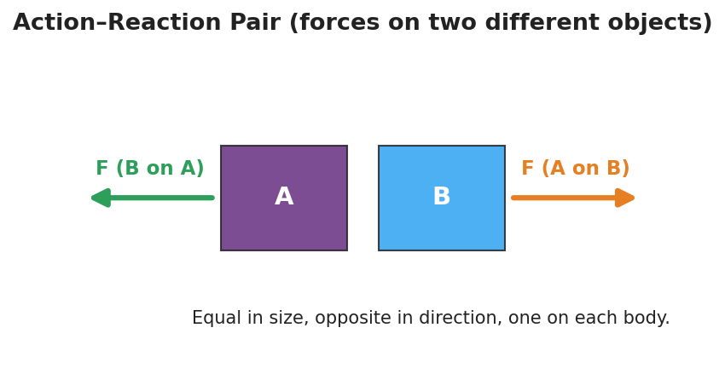
Action–reaction pair: object A and object B side by side, with an equal-length force arrow pushing right on B and an equal-length force arrow pushing left on A.

35–37 min · Vocabulary introduction (≤ 3 terms)
Sample teacher language:
“When two objects push on each other, that’s an interaction. The two forces it produces are a force pair — also called an action–reaction pair. Newton’s Third Law says they are always equal in size and opposite in direction. The key: they act on two different objects, so they do not cancel.”

Discussion prompts to deploy here
- “You walk forward. Name the action–reaction pair and the two objects.”
  - Sample student response: “My foot pushes the ground backward; the ground pushes me forward. Two objects — me and the ground.”
- “A gun recoils when fired. Why?”
  - Sample student response: “The gun pushes the bullet forward; the bullet pushes the gun back — equal and opposite, on two different objects.”

Phase 4 · Elaborate (37 – 40 min)

37–39 min · Revise the model
“Return to your push-off drawing. Make sure you have two arrows, equal in length, pointing opposite ways, each labeled with the object it acts on. In one sentence, explain why they do NOT cancel.”
Target: “They act on two different people, so neither person feels a zero net force — that’s why both roll.”

39–40 min · Return to the phenomenon
“Why did the lighter student roll faster if the two forces were equal? Answer in one sentence.”
Target: “The forces are equal, but equal force on less mass gives more acceleration (Lesson 02) — so the lighter student speeds up more.”

Phase 5 · Evaluate (40 – 42 min)

40–42 min · Exit Ticket + Closing Reflection
“A swimmer pushes off the pool wall and glides forward. (a) Name the action–reaction pair. State which object each force acts on. (b) The two forces are equal and opposite — so why doesn’t the swimmer stay still? (c) True or false: action and reaction forces cancel each other out. Explain.”
Expected: (a) swimmer pushes wall back / wall pushes swimmer forward — forces act on two different objects (swimmer, wall); (b) the two forces act on different objects, so the swimmer feels only the wall’s forward push — not zero; (c) False — they act on different objects, so they cannot cancel on a single object. See Answer_Key.docx.
Closing Reflection (SEL, 30 seconds):
“What is one idea today that pushed back on what you used to think? Who helped you make sense of it?”

Common Misconceptions
- Misconception: “Action and reaction forces cancel, so nothing moves.” → Correction: They act on different objects; forces only cancel when they act on the same object. Each object feels its own single force.
- Misconception: “The bigger / stronger object pushes harder.” → Correction: The forces in a pair are always equal in magnitude, no matter the masses. Different accelerations come from different masses, not different forces.
- Misconception: “The action happens first, then the reaction.” → Correction: The two forces are simultaneous — they are two descriptions of one interaction, not a cause followed by an effect in time.

Access & Differentiation
- ELL/ENL supports: Sentence frame: “___ pushes , so pushes ___ back, equal and opposite.” Word-choice box: {action–reaction pair, force pair, interaction, equal, opposite, different objects}. Pair interaction with a two-hands-pushing gesture.
- IEP/SPED supports: Pre-printed force-pair cards with the two objects already named; students draw and label the second arrow rather than building the whole diagram. Offer the balloon rocket as a hands-on alternative to writing.
- Extensions: Have students explain how a rocket accelerates in the vacuum of space with nothing to “push against” — the rocket pushes exhaust gas out; the gas pushes the rocket forward (the pair needs no air).

Strategy Spotlight
ACTIVE LEARNING — the Force-Pair Hunt (Phase 2). Rather than lecturing the law, students rotate in pairs through three hands-on stations (balloon rocket, rolling-chair push-off, force-pair card sort) and produce the physics themselves. The non-negotiable structure: at every station each pair must (1) name the two objects, (2) draw two arrows, and (3) write the pair as “A pushes B → B pushes A back, equal and opposite.” Movement, manipulation, and a required written product at each stop keep every student accountable and surface the “do they cancel?” question through experience before you ever name it. Budget ~5 min per station; ring a timer for clean rotations.

NYSSLS Observation Checklist Crosswalk
# | Checklist item | Where it appears in this lesson
1 | Local/relatable phenomenon | Phase 1 — rolling-chair push-off; walking/recoil/swimmer in Phases 3–5
2 | Turn and Talk (2–3×) | Phase 1 (TT#1 — why both moved), Phase 3 (TT#2 — two forces, two objects)
3 | Students develop questions/models/procedures | Phase 1 (initial model), Phase 2 (force-pair hunt stations), Phase 4 (revise model)
4 | CCC defined and used | Lesson Overview · Systems and System Models, restated in Phase 2 (“name both objects”)
5 | ENL — ≤ 3 vocab, second half | Phase 3 — vocabulary at 35–37 min (action–reaction pair / force pair / interaction)
6 | Revisit phenomenon with evidence | Phase 4 — push-off re-labeling + lighter-student-rolls-faster
7 | ENL/SPED supports | Access & Differentiation block
8 | Assessment check | Phase 5 — Exit Ticket (swimmer push-off)

Companion Materials
- Student_Worksheet.docx — the 5E student investigation (hand out at start of Phase 2)
- Student_Notes.docx — guided note-guide for vocabulary and the worked example
- Answer_Key.docx — answers to “Make It Make Sense” prompts and the Exit Ticket

Key Vocabulary (max 3)
- action–reaction pair — the two forces produced by one interaction; equal in magnitude and opposite in direction, acting on two different objects
- force pair — another name for an action–reaction pair; the two forces are always reported together
- interaction — the mutual push or pull between two objects; a force is one half of an interaction, never something a single object has alone

Newton’s Third Law (Action and Reaction) — Student Worksheet
Unit: Forces — Lesson 03 Name: _______________________ Date: __________ Period: ____

Phenomenon
Two students sit facing each other in rolling chairs, soles of their shoes touching. On a count, only one of them pushes. Both students roll apart.
Driving question: If only one person pushed, why did both people move?

Notice & Wonder
I notice… | I wonder…
Turn & Talk #1: If only one person pushed, why did both people move? Use the word force in your answer.

Initial Model
Draw the two students at the moment of the push. Draw an arrow for every push acting in the system, and label which object each arrow acts on. Then predict how the two pushes compare in size.

My prediction (sizes of the pushes): _______________________

Investigation
Rotate through the three stations (the Force-Pair Hunt). At each one, name the two objects, draw the two arrows, and write the pair. Use the diagram below as your model — equal-length arrows, pointing opposite ways, one on each object.

Action–reaction pair: two objects A and B, with equal-length force arrows pointing in opposite directions, one drawn on each object.
Station | The two objects | Force pair: “A pushes B → B pushes A back” | Equal & opposite?
1. Balloon rocket
2. Rolling-chair push-off
3. Force-pair card sort
Key question: In every station, what was true about the two forces and the two objects?

Make It Make Sense
- You walk forward across the floor. Name the action–reaction pair and state which object each force acts on.
- A rocket has no air to push against in space. How does it still speed up? Name the force pair.
- A small student and a large student push off in rolling chairs. The forces on each other are equal — so why does the smaller student roll away faster?

Vocabulary in Action
Use each term in a sentence about today’s phenomenon.
- action–reaction pair: _______________________________________________
- force pair: _______________________________________________
- interaction: _______________________________________________

Revise Your Model
Return to your Initial Model. Make sure you have two arrows, equal in length, pointing opposite ways, each labeled with the object it acts on. Then explain, in one sentence, why the two forces do NOT cancel.

Exit Ticket
A swimmer pushes off the pool wall and glides forward.
- Name the action–reaction pair. State which object each force acts on.
- The two forces are equal and opposite — so why doesn’t the swimmer stay still?
- True or false: action and reaction forces cancel each other out. Explain.

Newton’s Third Law (Action and Reaction) — Student Notes
Unit: Forces — Lesson 03 Name: _______________________ Date: __________ Period: ____

Learning Targets
By the end of today’s 42 minutes I can:
- State Newton’s Third Law in my own words.
- Identify both members of an action–reaction pair and the two objects each force acts on.
- Explain why an action–reaction pair does not cancel.

Key Vocabulary
- action–reaction pair — _______________________________________________
- force pair — _______________________________________________
- interaction — _______________________________________________

Guided Notes
Big idea (Newton’s Third Law): For every action force there is an equal-in-__________ , opposite-in-__________ reaction force.
- A force is always one half of an interaction between __________ objects.
- The two forces in a force pair are equal in __________ and opposite in __________.
- The two forces act on __________ (same / different) objects.
- Because they act on different objects, an action–reaction pair does NOT __________.
Force pair — student pushes off a wall (fill the arrows):
- Action: the student pushes the wall __________.
- Reaction: the wall pushes the student __________.
- These two forces act on __________ different objects: the __________ and the __________.
Same forces, different motion: If two people push off with equal forces, the one with __________ mass speeds up __________ (recall Lesson 02: a = F/m).
The two forces in a pair are vectors of the same length pointing in opposite directions:
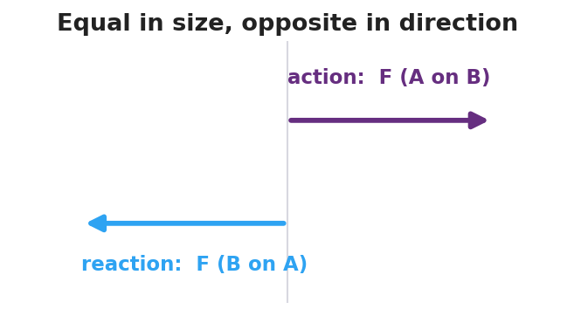
Two vectors of equal length pointing in opposite directions, labeled action force A on B and reaction force B on A.

Worked Example
Problem. A swimmer pushes backward on the water with a force of 200 N and glides forward. Identify the action–reaction pair and explain why the swimmer moves forward.
Solution. 1. Action: the swimmer pushes the water __________ with 200 N. 2. Reaction: the water pushes the swimmer __________ with __________ N (equal and opposite). 3. The two forces act on __________ different objects — the water and the swimmer. 4. The forward push acts on the __________, so the swimmer accelerates forward. The forces do not cancel because they are on __________ objects.

Summary
Finish the sentence (Because / But / So):
When the swimmer pushes the water backward, the water pushes the swimmer forward because __________________________________________, but __________________________________________, so __________________________________________.

Newton’s Third Law (Action and Reaction) — Answer Key

Cover
Unit: Forces — Lesson 03: Newton’s Third Law (Action and Reaction) East Meadow Schools × Valley Stream Central HSD

Make-It-Make-Sense Answers
- Action: your foot pushes the ground backward; Reaction: the ground pushes you forward. The two forces act on two different objects — you and the ground — and the forward push on you is what moves you. · Rubric: names both forces AND identifies the two different objects → full credit. · Supports HS-PS2-1
- The rocket pushes its exhaust gas backward; the gas pushes the rocket forward — an action–reaction pair that needs no air to push against. · Rubric: states the rocket–gas force pair, not “pushes against air.” · Supports HS-PS2-2
- The two forces are equal in magnitude, but the smaller student has less mass, so the same force produces a greater acceleration (a = F/m). Equal forces, unequal masses → unequal motion. · Rubric: equal forces AND links smaller mass → larger acceleration. · Supports HS-PS2-1

Exit Ticket Answer
- Action: the swimmer pushes the wall backward; Reaction: the wall pushes the swimmer forward. The two forces act on two different objects — the swimmer and the wall.
- The two forces act on different objects, so they do not cancel on the swimmer. The swimmer feels only the wall’s forward push, which is a real net force forward, so the swimmer accelerates.
- False. Action and reaction forces act on two different objects, so they can never cancel on a single object. Forces only cancel when they act on the same object.
Tolerance/rubric: (a) names both forces and both objects; (b) “different objects → swimmer feels only the forward force”; (c) False + “different objects.” 1 point each. Supports HS-PS2-1 / HS-PS2-2.

Closing Reflection (rubric)
Closing reflection is formative, not graded. Award full credit for any honest response. Look for: - A genuine shift-in-thinking statement in answer 1 (e.g., realizing forces never act alone) - Naming a peer or self-acknowledgment in answer 2

Friction — Teacher Guide

Cover
Unit: Forces — Lesson 04: Friction East Meadow Schools × Valley Stream Central High School District Strategy chips: BTC

Curated Resources (from East Meadow Scope & Sequence)

NYSSLS Standards
This lesson sits in HS-PS2 (forces and motion). Friction is the anchoring force for HS-PS2-3 — “Apply scientific and engineering ideas to design, evaluate, and refine a device that minimizes the force on a macroscopic object during a collision.” Friction is the everyday way students feel a contact force, so it also reinforces HS-PS2-1 (friction is one of the forces summed into the net force). The CCC focus is Cause and Effect: changing a surface or the normal force causes a measurable change in the friction force.

Phenomenon
- Sneaker Lab — drag a sneaker across tile, carpet, and sandpaper with a spring scale; the pull needed is different every time even though the sneaker never changed.
- The “stuck book” — a heavy book will not slide no matter how gently you push, then suddenly breaks loose and slides easily once you push hard enough.

Javalab / Labs
- oPhysics — Friction (block on a surface, vary μ and FN): https://ophysics.com/f1.html
- PhET — Forces and Motion: Basics (Friction tab): https://phet.colorado.edu/sims/html/forces-and-motion-basics/latest/forces-and-motion-basics_all.html
- Sneaker Lab — spring scale + one sneaker dragged at constant speed over three surfaces; record the scale reading (= friction force) for each.

Assessments
- Exit ticket below serves as the formative check (one conceptual item, one numeric Ff = μ·FN item). PhET “Friction” tab gives an informal check during Explore.

Lesson Overview
Duration | 42 minutes (1 period)
NYSSLS link | HS-PS2-3 (anchor) · HS-PS2-1 (friction in Fnet)
CCC focus | Cause and Effect — changing the surfaces or the normal force causes a change in the friction force.
Strategy chips | BTC (Building Thinking Classrooms — random groups + VNPS thin-sliced task)
Materials | One sneaker per group; spring scales (0–10 N); tile/carpet/sandpaper samples; known masses; chart paper at standing height + markers; deck of playing cards; whiteboards.
Safety | Keep spring scales below their max rating. Tape sandpaper down so it does not slide.
Prior knowledge | Newton’s First Law (balanced forces, net force); the normal force as the surface’s upward push (Lesson 01/03).
Lesson objectives — students can:
- Describe friction as a contact force that opposes relative motion (or attempted motion).
- Distinguish static friction (varies up to a maximum, before sliding) from kinetic friction (roughly constant, while sliding).
- Use Ff = μ·FN to explain and calculate how friction depends on the surfaces (μ) and the normal force (FN).

Phase 1 · Engage (0 – 10 min)

0–3 min · Opening Connection (SEL)
Quick whip-around, one sentence each: “Name a time something would not budge — and then suddenly gave way.” (A stuck jar lid, a desk dragged across the floor.) This plants the static-vs-kinetic “breakaway” feeling you will name in Phase 3.

3–7 min · Phenomenon hook — the Sneaker Lab preview + the stuck book
Teacher actions. Hook a spring scale to one sneaker. Drag it slowly across the tile and read the scale aloud. Move to carpet, then sandpaper, same sneaker, same constant speed — the readings climb. Then set a heavy book flat and push it sideways gently: nothing. Push harder: still nothing. Push harder still — it breaks loose and slides.
Sample teacher language:
“Same sneaker, same speed — but the scale reads a different number on each surface. The sneaker didn’t change. What did?”
Anticipated student responses:
- “Carpet is rougher, so it grabs more.” — surface; the word we will sharpen is friction.
- “The book is too heavy to move.” — capture, then complicate: “But I did move it — what changed right before it slid?”
- “You finally pushed hard enough.” — gold; this is the static-friction maximum.

7–10 min · Notice & Wonder + Turn-and-Talk #1
Two columns on the board. Then:
“Turn to your partner: why does the same sneaker need a different pull on each surface? Use the word force.”
Take 2–3 responses. Desirable insight: something between the surfaces pushes back against the motion, and rougher pairings push back more. Leave it open if no one lands it.

Bridge to Phase 2
Every student leaves Phase 1 with a one-sentence initial model: “The pull was different because ______.”

Phase 2 · Explore (10 – 32 min)

10–13 min · Initial Model (silent / individual)
Prompt on the board:
“Draw the sneaker being dragged. Draw an arrow for the pull (spring scale) and an arrow for whatever pushes back. Predict: which surface needs the biggest pull, and why?”
This surfaces force intuitions before any vocabulary.

13–30 min · Investigation — BTC: random groups + vertical non-permanent surfaces
Form visibly random groups of 3 (deal playing cards; same suit = same group). Each group works a chart-paper station at standing height. Hand each station the same thin-sliced task card (four levels, hardest last):
- Level 1. Drag the sneaker at constant speed on each of the three surfaces. Record each scale reading. Rank the surfaces.
- Level 2. Pile known masses on the sneaker. On one surface, how does the scale reading change as you add weight? Plot pull vs. weight.
- Level 3. Push the sneaker without it moving, then just hard enough to start it sliding. Compare the “just before it moves” reading to the “while sliding” reading. Which is bigger?
- Level 4. Your data shows pull ÷ weight is about the same for a given surface. Give that ratio a name and predict the pull for a weight you have not tested.
Teacher facilitation language (walk, do not solve):
“What stays the same and what changes between your two surfaces?” “Right before it slips, is the scale still climbing or holding steady?” “What does pull ÷ weight tell you that the raw pull doesn’t?”
As students drag the sneaker, the free-body diagram below names the forces in play: the applied pull, the friction force opposing it, and the balanced normal/gravity pair.
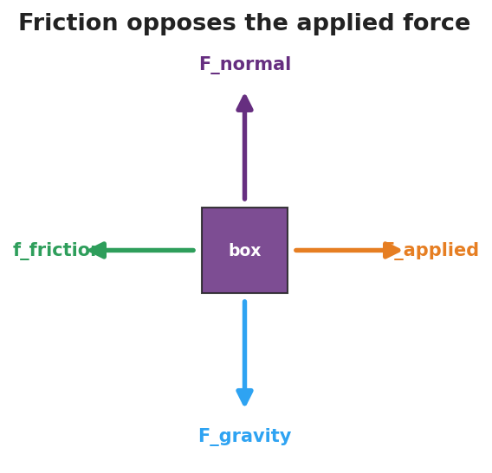
Free-body diagram of a box being dragged: applied force to the right, friction opposing to the left, normal force up, and gravity down.
The Level-3 “breakaway” pattern shows up clearly when friction force is plotted against applied force — it climbs through the static region to a peak, then drops to a steadier kinetic plateau:
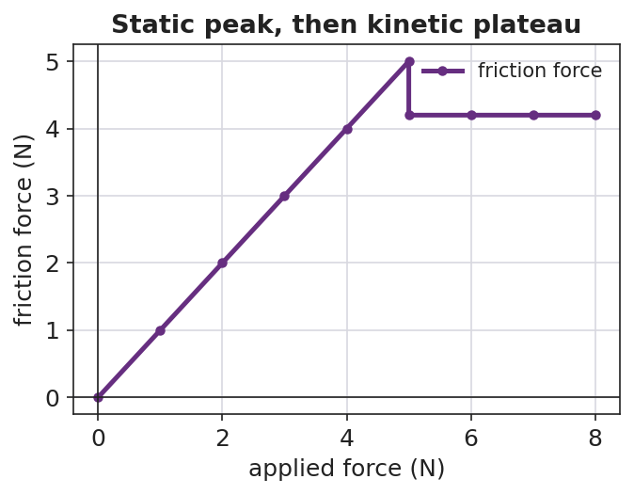
Line graph of friction force versus applied force: a rising static region up to a peak, then a lower, flat kinetic plateau once the object is sliding.

Teacher facilitation during Explore
- What to look for — groups noticing the reading climbs before the book/sneaker breaks loose, then drops and steadies once sliding.
- What to resist — don’t supply “μ” or “kinetic” yet; let the spring scales do the teaching.
- What to redirect — groups who say “heavier = more friction, always” should test it and articulate it as more normal force, more friction (Ff depends on FN, not mass directly).

30–32 min · Gallery check
Groups rotate one station clockwise. “What’s the same in their data? What’s different?” Surface the two big patterns: the breakaway (static peak > sliding) and the constant ratio (pull ÷ normal force).

Phase 3 · Explain (32 – 37 min)

32–35 min · Class consensus
“Across every station, what always pushed back on the sneaker, and what made that push bigger or smaller?”
Target consensus:
“A contact force pushes back against the motion. It’s bigger on rougher surface pairings and bigger when you press the surfaces together harder. Right before something slides, that push reaches a maximum; once it’s sliding, the push is steady and a bit smaller.”

35–37 min · Vocabulary introduction (≤ 3 terms)
Sample teacher language:
“That push-back is friction. Before an object slides, it’s static friction — it grows to match your push, up to a maximum. Once it slides, it’s kinetic friction — roughly constant. Your ‘pull ÷ weight’ ratio is the coefficient of friction, μ, and the Reference Table gives us Ff = μ·FN: friction equals μ times the normal force.”

Discussion prompts to deploy here
- “Why is it harder to start sliding a desk than to keep it sliding?”
  - Sample student response: “Static friction has a bigger maximum than kinetic friction, so the first push has to beat the bigger one.”
- “Two boxes on the same floor; one is heavier. Which needs more force to slide, and why?”
  - Sample student response: “The heavier one — more normal force, so Ff = μ·FN is larger.”

Phase 4 · Elaborate (37 – 40 min)

37–39 min · Revise the model
“Return to your sneaker drawing. Label the push-back arrow ‘friction.’ Add a sentence: when is it static, when is it kinetic, and what two things set its size? Use Ff = μ·FN.”

39–40 min · Return to the phenomenon (HS-PS2-3 thread)
“A phone in a padded case hits the floor. In one sentence using friction and normal force, why does a grippy case help it stop without sliding off the table edge first?”
Target: a grippy case raises μ, so even a small normal force gives enough friction to keep the phone from sliding — the design minimizes the force the phone takes by controlling how it stops.

Phase 5 · Evaluate (40 – 42 min)

40–42 min · Exit Ticket + Closing Reflection
“(a) A crate sits still while you push it gently and it does not move. Name the force opposing your push and say whether it is static or kinetic. Explain. (b) A 200 N crate sits on a floor with μ = 0.30 between the crate and the floor. Calculate the kinetic friction force on the crate as it slides. Show Ff = μ·FN. (c) Cause and Effect: name one change that would make the friction force larger.”
Expected: (a) static friction, because the crate is not sliding — it grows to match the push up to a maximum; (b) Ff = μ·FN = 0.30 × 200 N = 60 N; (c) a rougher surface (larger μ) or pressing it down harder / adding weight (larger FN). See Answer_Key.docx.
Closing Reflection (SEL, 30 seconds):
“Whose idea at your station changed how you think about friction today?”

Common Misconceptions
- Misconception: “Friction depends on how big the contact area is.” → Correction: For these surfaces, friction depends on μ and the normal force (Ff = μ·FN), not on contact area.
- Misconception: “Friction depends on speed.” → Correction: Kinetic friction is roughly constant regardless of sliding speed at this level.
- Misconception: “Heavier always means more friction.” → Correction: It’s the normal force that matters; more weight usually means more normal force, but tilt or extra downward push can change FN independent of mass.
- Misconception: “Static and kinetic friction are the same.” → Correction: Static friction varies up to a maximum (usually larger); kinetic friction is steady once sliding.

Access & Differentiation
- ELL/ENL supports: Sentence frame: *“Friction is ___ when the object is not moving and ___ when it slides; it gets bigger when ___ or ___.”* Word-choice box: {static, kinetic, rougher, normal force, opposes, μ}. Pair friction with a rubbing-hands gesture.
- IEP/SPED supports: Provide a pre-labeled force diagram (pull arrow + friction arrow) so students label “static/kinetic” rather than draw from scratch. Provide the Ff = μ·FN equation pre-printed with FN and μ boxes to fill.
- Extensions: Have students design a “minimize the force” pad (HS-PS2-3) and argue, using μ and FN, why their surface choice slows an object most gently.

Strategy Spotlight
Building Thinking Classrooms — random groups + vertical non-permanent surfaces (17 min) — see Phase 2, Investigation. The full process: visibly random groups of 3 by playing-card suit; chart-paper stations at standing height; one thin-sliced task card per station with four progressively harder tasks (Level 1 → 4). Teacher circulates and asks questions but does not solve. After ~17 minutes, rotate one station clockwise: “What’s the same in their data? What’s different?” — surface the breakaway (static peak > kinetic) and the constant pull ÷ normal-force ratio (μ).
The strategy works because visibly random groups signal that anyone can think with anyone, and the vertical non-permanent surface keeps thinking public and erasable, so groups take risks and the next group can verify the data on the wall.

NYSSLS Observation Checklist Crosswalk
# | Checklist item | Where it appears in this lesson
1 | Local/relatable phenomenon | Phase 1 — Sneaker Lab + stuck book; phone case in Phase 4
2 | Turn and Talk (2–3×) | Phase 1 (TT#1 — why different pull), Phase 2 (gallery check), Phase 3 (consensus)
3 | Students develop questions/models/procedures | Phase 1 (initial model), Phase 2 (BTC thin-sliced task), Phase 4 (revise model)
4 | CCC defined and used | Lesson Overview · Cause and Effect, restated in Phase 2 and Exit Ticket (c)
5 | ENL — ≤ 3 vocab, second half | Phase 3 — vocabulary at 35–37 min (friction / static / kinetic)
6 | Revisit phenomenon with evidence | Phase 4 — phone case + sneaker re-labeling with Ff = μ·FN
7 | ENL/SPED supports | Access & Differentiation block
8 | Assessment check | Phase 5 — Exit Ticket (crate, numeric Ff = μ·FN)

Companion Materials
- Student_Worksheet.docx — the 5E student investigation (hand out at start of Phase 2)
- Student_Notes.docx — guided note-guide for vocabulary and the worked example
- Answer_Key.docx — answers to “Make It Make Sense” prompts and the Exit Ticket

Key Vocabulary (max 3)
- friction — a contact force that opposes relative motion (or attempted motion) between two surfaces; on the Reference Table, Ff = μ·FN
- static friction — friction on an object that is not yet sliding; it varies to match the applied force up to a maximum
- kinetic friction — friction on an object that is already sliding; it is roughly constant

Friction — Student Worksheet
Unit: Forces — Lesson 04 Name: _______________________ Date: __________ Period: ____

Phenomenon
Your teacher drags the same sneaker at the same speed across tile, then carpet, then sandpaper — and the spring scale reads a different number every time. Then a heavy book will not slide at all… until one harder push, and it suddenly breaks loose and slides.
Driving question: What decides how hard friction pushes back — and why does an object suddenly “let go”?

Notice & Wonder
I notice… | I wonder…
Turn & Talk #1: Why does the same sneaker need a different pull on each surface? Use the word force.

Initial Model
Draw the sneaker being dragged. Draw an arrow for the pull (spring scale) and an arrow for whatever pushes back. Then predict which surface needs the biggest pull, and why.

My prediction: _______________________________

Investigation
Work at your group’s chart-paper station. Complete each level in order. The free-body diagram below shows the forces on the sneaker as you pull it — friction always points opposite your pull.

Free-body diagram of a box being dragged: an applied force pulling right, a friction force pushing left, the normal force up, and gravity down.
Level | What I did | What happened | What it tells me
1. Drag on 3 surfaces
2. Add weight, one surface
3. Just-before-sliding vs. while-sliding
4. Pull ÷ weight ratio
Key question: What two things make the friction force bigger or smaller?

Make It Make Sense
- Why is it harder to start a desk sliding than to keep it sliding once it moves?
- Two boxes sit on the same floor; one is heavier. Which needs more force to slide, and why?
- The same sneaker reads a bigger pull on sandpaper than on tile. What about the sandpaper makes friction larger?

Vocabulary in Action
Use each term in a sentence about today’s phenomenon.
- friction: _______________________________________________
- static friction: _______________________________________________
- kinetic friction: _______________________________________________

Revise Your Model
Return to your Initial Model. Label the push-back arrow friction. Add one sentence: when is it static, when is it kinetic, and what two things set its size? Use Ff = μ·FN.

Exit Ticket
- You push a crate gently and it does not move. Name the force opposing your push and say whether it is static or kinetic. Explain.
- A 200 N crate sits on a floor with μ = 0.30 between the crate and the floor. Calculate the kinetic friction force as it slides. Show Ff = μ·FN.
- Cause and Effect: name one change that would make the friction force larger.

Friction — Student Notes
Unit: Forces — Lesson 04 Name: _______________________ Date: __________ Period: ____

Learning Targets
By the end of today’s 42 minutes I can:
- Describe friction as a contact force that opposes motion.
- Tell static friction apart from kinetic friction.
- Use Ff = μ·FN to explain and calculate the friction force.

Key Vocabulary
- friction — _______________________________________________
- static friction — _______________________________________________
- kinetic friction — _______________________________________________

Guided Notes
Big idea: Friction is a __________ force that opposes the relative motion (or attempted motion) of two surfaces touching each other.
- Friction always points __________ the direction the object moves or tries to move.
- Static friction acts when the object is __________ sliding. It grows to match your push, up to a __________ value.
- Kinetic friction acts when the object __________ sliding. It is roughly __________ (it does not change much with speed).
- It is usually harder to start an object sliding than to keep it sliding, because the static maximum is __________ than the kinetic friction.

Line graph of friction force versus applied force: friction rises with the applied force through the static region up to a peak, then drops to a flat kinetic plateau once the object slides.
The equation (2025 Reference Table):
Ff = μ·FN
- Ff = the __________ force (newtons, N)
- μ = the __________ of friction (no units) — depends on the two __________
- FN = the __________ force (the surface’s push up on the object, in N)
So friction gets bigger when: μ is __________ (rougher pairing) OR FN is __________ (pressed together harder).

Worked Example
Problem. A 50 N wooden block slides across a tabletop. The coefficient of kinetic friction between the block and the table is μ = 0.20. What is the kinetic friction force on the block?
Solution. 1. On a flat surface, the normal force equals the weight, so FN = __________ N. 2. Write the equation: Ff = μ·FN = __________ × __________. 3. Ff = __________ N, pointing __________ to the block’s motion.
Check: If we doubled the block’s weight to 100 N, the friction force would __________ to __________ N — because Ff depends on FN.

Summary
Finish the sentence (Because / But / So):
A heavy desk will not slide when you push it gently because __________________________________________, but __________________________________________, so __________________________________________.

Friction — Answer Key

Cover
Unit: Forces — Lesson 04: Friction East Meadow Schools × Valley Stream Central HSD

Make-It-Make-Sense Answers
- Static friction has a larger maximum than kinetic friction. Starting the desk means overcoming the bigger static maximum; once it slides, only the smaller, roughly constant kinetic friction opposes you. · Rubric: names static > kinetic AND links to start vs. keep moving. · NYSSLS: HS-PS2-1
- The heavier box needs more force. More weight means a larger normal force (FN), and since Ff = μ·FN, larger FN means larger friction. · Rubric: links weight → normal force → larger Ff. · NYSSLS: HS-PS2-3
- Sandpaper is rougher, so the pairing has a larger coefficient of friction (μ). With the same normal force, a larger μ gives a larger Ff = μ·FN. · Rubric: names rougher surface → larger μ. · NYSSLS: HS-PS2-3

Exit Ticket Answer
- Static friction. The crate is not sliding, so the friction is static — it grows to match your push (up to its maximum), keeping the net force zero so the crate stays at rest.
- Ff = μ·FN = 0.30 × 200 N = 60 N. (On a flat floor FN equals the 200 N weight.)
- Cause and Effect: any one of — use a rougher surface (larger μ), add weight / press it down harder (larger FN). Either correctly increases Ff = μ·FN.
Tolerance/rubric: (a) must say static AND justify “not sliding”; (b) must show Ff = μ·FN with the answer 60 N (full credit for correct setup + answer; half for setup only); (c) any change that raises μ or FN. 1 point each. NYSSLS: HS-PS2-3 (and HS-PS2-1).

Closing Reflection (rubric)
Closing reflection is formative, not graded. Award full credit for any honest response. Look for: - A genuine attribution of an idea to a peer at the BTC station - Evidence the student can name one factor (μ or FN) that changes friction

Centripetal Force and Circular Motion — Teacher Guide

Cover
Unit: Forces — Lesson 05: Centripetal Force and Circular Motion East Meadow Schools × Valley Stream Central High School District Strategy chips: ACTIVE LEARNING

Curated Resources (from East Meadow Scope & Sequence)

NYSSLS Standards
This row of the Forces unit names no specific Performance Expectation, but it directly supports HS-PS2-1 (a net force causes acceleration). The twist students must confront: an object moving in a circle at constant speed is still accelerating, because its velocity direction keeps changing. The net force that produces that acceleration points toward the center of the circle. The CCC focus is Cause and Effect — a center-directed (centripetal) force is the cause, and center-directed acceleration (a curved path) is the effect.

Phenomenon
- Motorcycle “lowside” crash in a curve — the moment grip is lost, the bike stops turning and slides straight: https://www.youtube.com/watch?v=wRXOf-9YJU0
- Water stays in a bucket swung in a vertical circle: https://youtu.be/Zulw5bQ18Kk
- A ball or rubber stopper swung overhead on a string (live demo).

Javalab / Labs
- Circular Motion Labs — swing a rubber stopper on a string, vary radius and speed, and feel the tension change: https://javalab.org/en/circular_motion_en/
- oPhysics circular motion simulation (force vectors on a revolving object): https://ophysics.com/r1.html

Assessments
- Exit ticket below serves as the formative check (quantitative, uses Fc = m·v²/r).

Lesson Overview
Duration | 42 minutes (1 period)
NYSSLS link | Supports HS-PS2-1 (net force → acceleration, here center-directed)
CCC focus | Cause and Effect — a center-seeking net force causes a curved path; remove it and the path goes straight.
Strategy chips | ACTIVE LEARNING (swing-and-predict stopper stations)
Materials | Rubber stoppers on ~1 m strings (or beaded keychains); a few washers/weights; stopwatch; safety goggles; open floor space; whiteboards/markers.
Safety | Goggles on for all swinging. Clear a wide radius; swing in a vertical or horizontal plane away from faces. Inspect strings for fraying.
Prior knowledge | Velocity is a vector (size + direction); acceleration is any change in velocity (Lessons 01–04); net force causes acceleration.
Lesson objectives — students can:
- Explain why an object in uniform circular motion is accelerating even though its speed is constant.
- Identify the real force (tension, friction, gravity, normal) that acts as the centripetal force in a given situation.
- Use Fc = m·v²/r to relate force, mass, speed, and radius, and predict how each change affects the others.

Phase 1 · Engage (0 – 10 min)

0–3 min · Opening Connection (SEL)
Quick whip-around, one sentence each (pass allowed): “Name a time you felt like you were being thrown outward — a car turn, a spinning ride, a sharp bike turn.” You are deliberately collecting the feeling of being thrown outward; you will name and overturn it as the centrifugal misconception in Phase 3.

3–8 min · Phenomenon hook — the lowside crash
Teacher actions. Play the motorcycle lowside clip (pause the instant the tire loses grip). Replay in slow motion. Ask students to track the direction the bike travels the moment grip is lost.
Sample teacher language:
“Watch the curve. The rider is turning — turning — and the instant the tire loses grip, which way does the bike go? Not more curved. Watch.”
Anticipated student responses:
- “It shoots straight off the road.” — exactly; capture straight.
- “It slides outward / centrifugal force throws it out.” — capture this; we will test it. “Outward, or just straight ahead? Hold that thought.”
- “The road was slippery, so it lost the force keeping it turning.” — gold; “What force was that?”

8–10 min · Notice & Wonder + Turn-and-Talk #1
Two-column board capture. Then:
“Turn to your partner: while the bike was successfully turning, something had to keep pulling it into the curve. What was it, and which way did it point?”
Target seed: something pointed inward (toward the center of the curve) — friction from the tires. Leave open if no one lands it.

Bridge to Phase 2
Every student leaves with a one-sentence initial model: “The bike kept turning because ______, and it went straight when ______.”

Phase 2 · Explore (10 – 30 min)

10–14 min · Initial Model (silent / individual)
Prompt on the board:
“Draw the bike on the curved road from above. Draw an arrow showing the force that keeps it turning. Then predict: if that force vanishes, draw the dotted path the bike takes.”
This surfaces the inward-vs-outward intuition before any vocabulary.

14–30 min · Investigation — swing it, feel it, let it go (ACTIVE LEARNING)
Goggles on. Stopper-on-a-string stations (rotate or run as a carousel):
- Which way is the pull? Swing the stopper in a horizontal circle overhead at steady speed. Which way does your hand pull on the string — toward you (center) or away? What is the string doing to the stopper?
- Let it go. On a count, release the string mid-swing (point it at an open wall, not a person). Which way does the stopper fly — outward along the radius, or straight along a tangent? Repeat and watch carefully.
- Speed and radius. Swing faster: does the string pull harder or softer? Choke up to a shorter radius at the same speed: harder or softer? Add a washer (more mass): harder or softer?
Teacher facilitation language:
“Feel your hand. Are you pulling the stopper in or pushing it out?” “When you let go, did it curve outward — or go straight in the direction it was already heading?” “Faster swing — what happens to the tension you feel? Shorter string — what happens?”
The diagram below captures both station discoveries at once: the velocity points along the tangent (the direction the stopper flies when released), while the centripetal force points toward the center (the inward pull your hand feels).
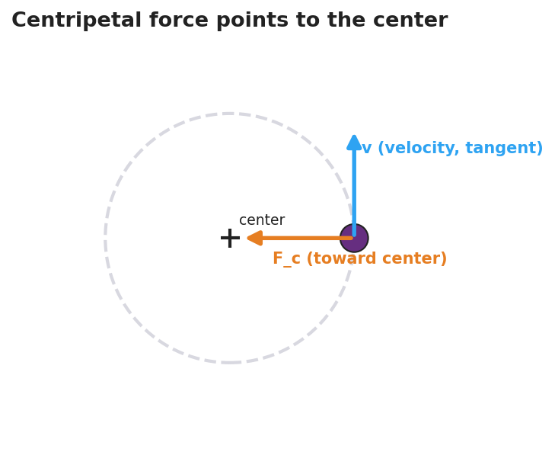
Diagram of an object on a circular path: a velocity arrow drawn tangent to the circle and a centripetal force arrow pointing inward toward the center.

Teacher facilitation during Explore
- What to look for — students reporting the released stopper flies off on a tangent (straight), not radially outward; and that faster/shorter/heavier all increase the felt tension.
- What to resist — don’t supply “centripetal” yet; let their hands feel the inward pull.
- What to redirect — students who insist the stopper flew “outward” should re-run station 2 and sight along the path; it leaves on the tangent line.

Phase 3 · Explain (30 – 36 min)

30–33 min · Turn-and-Talk #2 + class consensus
“Across every station, which way did the force point — and what happened the instant we removed it?”
Target consensus:
“The string always pulled the stopper toward the center. The speed was steady, but the direction kept changing — so the velocity changed — so it was accelerating. Remove the force and it flies off straight (tangent), because nothing is changing its direction anymore.”

33–36 min · Vocabulary introduction (≤ 3 terms) + the misconception
Sample teacher language:
“That inward, center-seeking pull is the centripetal force — centripetal literally means ‘center-seeking.’ It produces a centripetal acceleration pointed at the center, because the velocity direction is changing. How sharp the turn is depends on the radius. And here’s the key: there is no ‘centrifugal force’ throwing you out. That outward feeling is just your inertia — your body wanting to go straight while the car/string curves you in. The only real force is the inward one.”
Name the real provider each time: tension (string), friction (tires, the lowside), gravity (orbit, top of a vertical loop), normal force (a banked turn or the bucket bottom).

Discussion prompts to deploy here
- “When you swing the bucket of water overhead, why doesn’t the water fall out at the top?”
  - Sample student response: “It’s moving fast and wants to go straight; the bucket bottom pushes it inward (toward the center) faster than gravity could pull it out, so it stays in.”
- “A car turns left. Which way does the passenger feel thrown, and which way is the real force?”
  - Sample student response: “You feel thrown right (outward), but that’s inertia — the real force, friction, pushes the car left, toward the center.”

Phase 4 · Elaborate (36 – 40 min)

36–38 min · Revise the model
“Return to your bike drawing. Label the inward arrow ‘centripetal force (friction)’ and label the straight dotted release path ‘tangent — inertia, no net force.’ Write one revised sentence using centripetal force and radius.”

38–40 min · Quick quantitative reasoning (Fc = m·v²/r)
“From the Reference Table, Fc = m·v²/r. In station 3 you doubled the speed. What happened to the tension?”
Target: “It got about four times as hard, because v is squared.” Follow up: “Shorter radius at the same speed?” → “Harder, because r is in the denominator.” Tie directly back to what their hands felt.

Phase 5 · Evaluate (40 – 42 min)

40–42 min · Exit Ticket + Closing Reflection
“A 0.20 kg ball is swung in a horizontal circle of radius 0.50 m at a constant speed of 3.0 m/s. (a) Is the ball accelerating? Explain in one sentence. (b) Calculate the centripetal force on the ball. Show the equation and units. (c) A student says a ‘centrifugal force’ pushes the ball outward. Is the student correct? Explain.”
Expected: (a) Yes — direction (and so velocity) is changing. (b) Fc = m·v²/r = 0.20 · (3.0)² / 0.50 = 3.6 N, directed toward the center. (c) No — the only real force is the inward (centripetal) tension; the outward feeling is inertia, not a force. See Answer_Key.docx.
Closing Reflection (SEL, 30 seconds):
“What is one thing today that changed how you think about turning or spinning? Who helped you see it?”

Common Misconceptions
- Misconception: “A ‘centrifugal force’ throws objects outward in a turn.” → Correction: There is no outward force. Objects tend to go straight (inertia); the only real force is the inward centripetal force that curves the path. The outward “throw” is a feeling, not a force.
- Misconception: “Constant speed means no acceleration.” → Correction: Acceleration is any change in velocity; in a circle the direction changes constantly, so there is centripetal acceleration even at constant speed.
- Misconception: “Centripetal force is a new, separate kind of force.” → Correction: It is always provided by a real, familiar force — tension, friction, gravity, or normal force — acting toward the center.
- Misconception: “Released objects fly outward along the radius.” → Correction: They leave on the tangent, continuing in the straight-line direction they had at the instant of release.

Access & Differentiation
- ELL/ENL supports: Sentence frame: *“The ___ pulls the object toward the , so the object’s changes and it accelerates ___.”* Word-choice box: {center, tension, friction, gravity, direction, inward, tangent}. Pair centripetal with a hand-pulling-inward gesture.
- IEP/SPED supports: Provide a pre-drawn circle with the center marked; students draw and label only the inward arrow and the tangent release line. Offer the swing demo as a hands-on alternative to written explanation. Pre-fill the Fc equation with values to plug in.
- Extensions: Have students explain a banked highway curve or a satellite in orbit, naming which real force is centripetal, and reason about how doubling the radius changes Fc at fixed speed.

Strategy Spotlight
ACTIVE LEARNING (predict-and-test stations). Today’s core is a hands-on, predict-then-feel investigation. Students physically swing a stopper and (1) feel whether their hand pulls inward or outward, and (2) predict the release path, then test it by letting go. The “let it go” moment is the lesson’s hinge: students who expect a curved/outward exit watch the stopper leave on a tangent, which directly dismantles the centrifugal-force misconception through their own observation rather than teacher assertion. Keep predictions written before each test (commitment increases the conceptual payoff), insist on goggles, and have each group sight along the release path to confirm “straight, not outward.” Time-box each station to ~5 minutes.

NYSSLS Observation Checklist Crosswalk
# | Checklist item | Where it appears in this lesson
1 | Local/relatable phenomenon | Phase 1 — motorcycle lowside crash; bucket/string in Phase 3
2 | Turn and Talk (2–3×) | Phase 1 (TT#1 — what keeps it turning), Phase 3 (TT#2 — direction of force)
3 | Students develop questions/models/procedures | Phase 1 (initial model), Phase 2 (swing-and-release stations), Phase 4 (revise model)
4 | CCC defined and used | Lesson Overview · Cause and Effect, restated in Phases 2–3
5 | ENL — ≤ 3 vocab, second half | Phase 3 — vocabulary at 33–36 min (centripetal force / centripetal acceleration / radius)
6 | Revisit phenomenon with evidence | Phase 4 — re-label bike drawing with tangent + centripetal arrow
7 | ENL/SPED supports | Access & Differentiation block
8 | Assessment check | Phase 5 — quantitative Exit Ticket (Fc = m·v²/r)

Companion Materials
- Student_Worksheet.docx — the 5E student investigation (hand out at start of Phase 2)
- Student_Notes.docx — guided note-guide for vocabulary and the worked example
- Answer_Key.docx — answers to “Make It Make Sense” prompts and the Exit Ticket

Key Vocabulary (max 3)
- centripetal force — the net inward, “center-seeking” force that keeps an object moving in a circle; always provided by a real force (tension, friction, gravity, or normal force): Fc = m·v²/r
- centripetal acceleration — the center-directed acceleration of an object in circular motion, caused by its constantly changing velocity direction: ac = v²/r
- radius — the distance from the center of the circle to the object; smaller radius means a sharper turn and (at fixed speed) a larger required force

Centripetal Force and Circular Motion — Student Worksheet
Unit: Forces — Lesson 05 Name: _______________________ Date: __________ Period: ____

Phenomenon
A motorcycle leans into a curve, turning smoothly — until the tire loses grip. The instant it does, the bike does not curve harder. It shoots straight off the road. In another clip, a bucket of water is swung in a full vertical circle and the water never spills, not even at the top.
Driving question: What force keeps something moving in a circle — and what happens the instant that force is gone?

Notice & Wonder
I notice… | I wonder…
Turn & Talk #1: While the bike was successfully turning, something kept pulling it into the curve. What was it, and which way did it point?

Initial Model
Draw the bike on the curved road from above. Draw an arrow for the force that keeps it turning. Then, with a dotted line, show the path the bike takes if that force suddenly vanishes.

My prediction: _______________________________

Investigation
Goggles on. Complete each station with your stopper-on-a-string. Record what you observe. The diagram below shows what to look for: the velocity points along the tangent, and the force that keeps the stopper turning points toward the center.

Diagram of an object moving on a circular path with a tangent velocity arrow and an inward centripetal force arrow pointing to the center.
Station | What I did | What happened | What it tells me
1. Which way is the pull?
2. Let it go (release mid-swing)
3. Change speed, radius, mass
Key question: When you let go of the string, did the stopper fly outward along the radius or straight along a tangent? Which way did your hand pull the whole time?

Make It Make Sense
- A ball swings in a circle at a steady speed. A classmate says, “It’s not accelerating because the speed never changes.” Are they right? Explain.
- Name the real force that acts as the centripetal force in each case: (a) a car rounding a flat curve, (b) the Moon orbiting Earth, (c) water at the bottom of the swung bucket.
- You swing the stopper twice as fast at the same radius. Using Fc = m·v²/r, does the string tension stay the same, double, or quadruple? Explain.

Vocabulary in Action
Use each term in a sentence about today’s phenomenon.
- centripetal force: _______________________________________________
- centripetal acceleration: _______________________________________________
- radius: _______________________________________________

Revise Your Model
Return to your Initial Model. Label the inward arrow as the centripetal force (and name what really provides it). Label the dotted release path as the tangent path the bike takes due to inertia when there is no net force. Rewrite your explanation using centripetal force and radius.

Exit Ticket
A 0.20 kg ball is swung in a horizontal circle of radius 0.50 m at a constant speed of 3.0 m/s.
- Is the ball accelerating? Explain in one sentence.
- Calculate the centripetal force on the ball. Show the equation and units.
- A student says a “centrifugal force” pushes the ball outward. Is the student correct? Explain.

Centripetal Force and Circular Motion — Student Notes
Unit: Forces — Lesson 05 Name: _______________________ Date: __________ Period: ____

Learning Targets
By the end of today’s 42 minutes I can:
- Explain why an object moving in a circle at constant speed is still accelerating.
- Identify the real force that acts as the centripetal force in a situation.
- Use Fc = m·v²/r to relate force, mass, speed, and radius.

Key Vocabulary
- centripetal force — _______________________________________________
- centripetal acceleration — _______________________________________________
- radius — _______________________________________________

Guided Notes
Big idea: An object moving in a circle at constant speed is still __________, because its velocity __________ keeps changing (velocity is a vector — size and direction).
- The acceleration points toward the __________ of the circle. We call it centripetal acceleration: ac = v² / __________.
- The net force that causes it also points toward the __________. We call it the centripetal force: Fc = m · v² / __________.
- “Centripetal” means __________-seeking.
- The centripetal force is always provided by a real force. Match them:
  - Ball on a string → __________
  - Car on a flat curve → __________
  - Moon orbiting Earth → __________
  - Object at the bottom of a swung bucket → __________ force
The misconception (cross it out in your head):
- There is no “centrifugal force” throwing you outward. That outward feeling is just your __________ — your body trying to go __________ (in a straight line / tangent) while something curves you inward.
- If the centripetal force disappears, the object flies off on a __________ (straight line), not outward along the radius.
How the numbers behave (from Fc = m·v²/r):
- Double the speed v → force becomes about __________ times bigger (v is squared).
- Smaller radius r → __________ force needed (sharper turn is harder).
- More mass m → __________ force needed.
Because Fc depends on v², a graph of centripetal force vs. v² is a straight line — the force grows fast as speed increases:
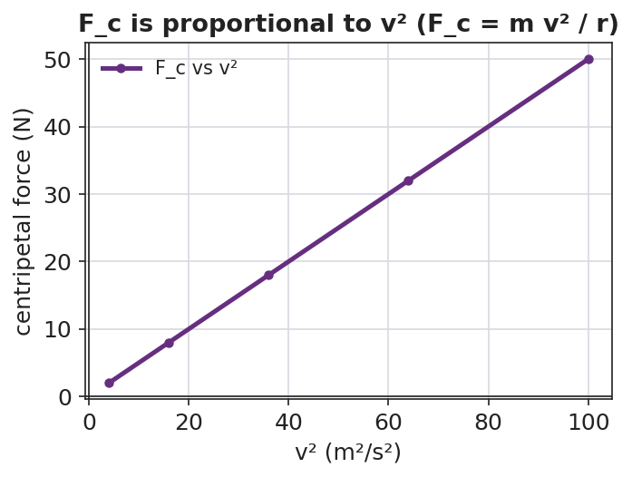
Line graph of centripetal force versus velocity squared: a straight line through the origin, showing centripetal force is proportional to v squared.

Worked Example
Problem. A 0.50 kg toy car rounds a circular track of radius 2.0 m at a constant speed of 4.0 m/s. Find the centripetal force on the car and state its direction.
Solution. 1. Write the equation (2025 Reference Table): Fc = m · v² / r. 2. Substitute: Fc = (0.50 kg) · (4.0 m/s)² / (2.0 m). 3. Compute the top: (4.0)² = 16, so 0.50 · 16 = 8.0; then 8.0 / 2.0 = __________ N. 4. Direction: toward the __________ of the circle. 5. What provides it here? The __________ between the tires and the track.

Summary
Finish the sentence (Because / But / So):
An object moving in a circle at constant speed is still accelerating because __________________________________________, but __________________________________________, so __________________________________________.

Centripetal Force and Circular Motion — Answer Key

Cover
Unit: Forces — Lesson 05: Centripetal Force and Circular Motion East Meadow Schools × Valley Stream Central HSD

Make-It-Make-Sense Answers
- The classmate is wrong. Acceleration is any change in velocity, and velocity is a vector (size and direction). In a circle the direction changes every instant, so the velocity changes and the ball is accelerating — toward the center — even though its speed is constant. · Rubric: states acceleration = change in velocity AND identifies the changing direction → full credit. · NYSSLS: HS-PS2-1

  - Friction between the tires and the road. (b) Gravity (Earth’s gravitational pull on the Moon). (c) The normal force from the bottom of the bucket pushing the water inward (toward the center). · Rubric: one real force named correctly per case. · NYSSLS: HS-PS2-1
- The tension quadruples (becomes about 4× as large). In Fc = m·v²/r the speed v is squared, so doubling v multiplies the force by 2² = 4. · Rubric: “quadruples” AND cites v² → full credit. · NYSSLS: HS-PS2-1

Exit Ticket Answer
Given: m = 0.20 kg, r = 0.50 m, v = 3.0 m/s.
- Yes, it is accelerating. Its speed is constant but its velocity direction is changing, so its velocity is changing — that is acceleration (directed toward the center).
- Fc = m·v²/r = (0.20 kg)(3.0 m/s)² / (0.50 m) = (0.20)(9.0) / (0.50) = 1.8 / 0.50 = 3.6 N, directed toward the center of the circle.
- No, the student is not correct. There is no real “centrifugal force.” The only real force is the inward (centripetal) tension in the string. The outward feeling is the ball’s inertia — its tendency to travel straight (tangent) while the string curves it inward — not a force.
Tolerance/rubric: (a) must say “yes” AND justify via changing direction; (b) correct setup with v² and a numeric answer of 3.6 N toward the center (accept minor rounding), units required; (c) “no” AND identifies inertia / absence of a real outward force. 1 point each. NYSSLS: HS-PS2-1.

Closing Reflection (rubric)
Closing reflection is formative, not graded. Award full credit for any honest response. Look for: - A genuine shift-in-thinking statement (e.g., “I used to think a force throws you outward, but really it pulls you in / you just go straight”). - Naming a peer or a self-acknowledgment for who helped them see it.

Universal Gravitation — Teacher Guide

Cover
Unit: Forces — Lesson 06: Universal Gravitation East Meadow Schools × Valley Stream Central High School District Strategy chips: HOCHMAN

Curated Resources (from East Meadow Scope & Sequence)

NYSSLS Standards
This lesson targets HS-PS2-4 — “Use mathematical representations of Newton’s Law of Gravitation and Coulomb’s Law to describe and predict the gravitational and electrostatic forces between objects.” The CCC focus is Patterns: the same inverse-square mathematical pattern governs both gravity and electric force, so the structure students master here transfers directly to Coulomb’s Law in the later Electrostatics unit. Today the focus is gravitation; name the parallel pattern but do not teach Coulomb’s Law yet.

Phenomenon
- PhET Gravity Force Lab (basics) — drag two masses and watch the attraction change with mass and distance: https://phet.colorado.edu/en/simulations/gravity-force-lab-basics
- Anchoring question: Why doesn’t the Moon fall down onto Earth? / Why do astronauts feel weightless in orbit even though Earth’s gravity still acts on them? (Khan Academy): https://www.khanacademy.org/science/physics/centripetal-force-and-gravitation/gravity-newtonian/a/what-is-gravity

Javalab / Labs
- PhET Gravity Force Lab Basics — students drag two masses, increase a mass and watch the force arrows grow; double the separation and watch the force shrink to one-quarter: https://phet.colorado.edu/en/simulations/gravity-force-lab-basics

Assessments
- Exit ticket below serves as the formative check (numeric inverse-square reasoning). See Answer_Key.docx.

Lesson Overview
Duration | 42 minutes (1 period)
NYSSLS link | HS-PS2-4 (gravitation; parallels Coulomb’s Law)
CCC focus | Patterns — the inverse-square relationship is a repeating mathematical pattern across gravity and, later, electric force.
Strategy chips | HOCHMAN (sentence-level literacy: Because/But/So + appositive on the inverse-square law)
Materials | Projector + PhET Gravity Force Lab Basics (one device per pair if possible); 2025 Reference Tables; whiteboards/markers; calculators.
Safety | None — simulation and pencil-and-paper.
Prior knowledge | Weight as a force (Fg = mg), the difference between a force and a property, vectors as size + direction.
Lesson objectives — students can:
- State the law of universal gravitation in their own words: every mass attracts every other mass, and the pull depends on the masses and the distance between them.
- Use Fg = G·m₁·m₂/r² (2025 Reference Table) to calculate or compare gravitational forces.
- Apply the inverse-square law as a pattern: when distance doubles, the force drops to one-quarter.
- Distinguish mass (an unchanging amount of matter) from weight (the gravitational force on that mass).

Phase 1 · Engage (0 – 10 min)

0–3 min · Do Now / Opening Connection
Post the Do Now: “You weigh about 1/6 as much on the Moon as on Earth — but a scale that counts atoms would read exactly the same. How can both be true?” Take one or two responses; do not resolve it. This seeds the mass-vs-weight distinction you’ll name in Phase 3.

3–8 min · Phenomenon hook — Why doesn’t the Moon fall?
Teacher actions. Show the Moon-orbit image or the Khan clip. Pose the anchoring question.
Sample teacher language:
“Earth’s gravity reaches all the way to the Moon — it’s what holds the Moon in orbit. So why doesn’t the Moon just fall down onto us like a dropped ball?”
Anticipated student responses:
- “The Moon is too far away for gravity to reach.” — surface; we’ll show gravity does reach, just weaker with distance.
- “There’s no gravity in space.” — common misconception; flag it, address in Phase 3.
- “It’s moving sideways fast enough to keep missing Earth.” — excellent; capture it.

8–10 min · Notice & Wonder + Turn-and-Talk #1
Capture two columns. Then:
“Turn to your partner: name two things that might change how strongly two objects pull on each other.”
Target: how much stuff (mass) each has, and how far apart they are. Leave open if no one lands it.

Bridge to Phase 2
Every student leaves with a one-sentence initial model: “Two objects pull harder when ______.”

Phase 2 · Explore (10 – 28 min)

10–14 min · Initial Model (silent / individual)
Prompt on the board:
“Draw two spheres. Draw an arrow showing the pull each feels from the other. Then predict: if I make one sphere heavier, what happens to the arrows? If I move them farther apart, what happens?”
This surfaces intuition before any formula.

14–28 min · Investigation — PhET Gravity Force Lab Basics
Pairs (or whole-class projection) work the simulation:
- Mass test — keep distance fixed; double mass 1. What happens to the force? (It doubles.)
- Distance test — keep masses fixed; double the separation. What happens to the force? (It drops to one-quarter, not one-half — the surprise.)
- Pattern hunt — triple the distance. Predict first, then check. (Force → one-ninth.)
Teacher facilitation language:
“Predict before you drag. Doubling the distance — half the force, or something else?” “Force fell to one-quarter, not one-half. What did we square — the masses or the distance?” “Are the two arrows on the two masses equal or unequal? Even when the masses are very different?”
The “÷4, then ÷9” surprise is the inverse-square law. Project the graph below so students see the force falling off steeply — not linearly — as distance grows:
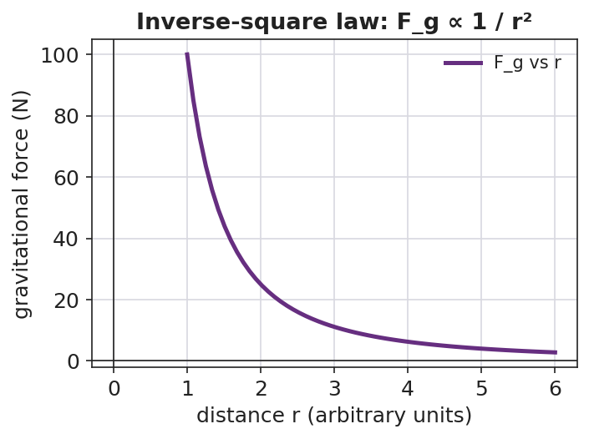
Line graph of gravitational force versus distance r: a steep inverse-square curve that falls off rapidly as r increases.
And no matter how different the two masses are, the pulls are equal in size and opposite in direction (a Newton’s-third-law cameo):
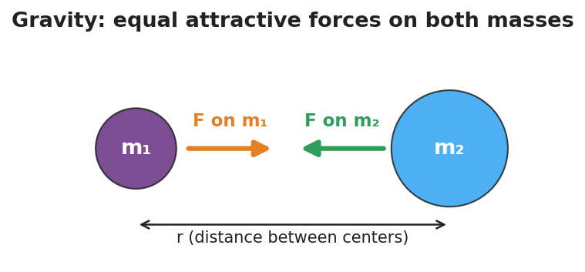
Two masses m1 and m2 separated by distance r, each feeling an equal-length attractive force arrow pointing toward the other.

Teacher facilitation during Explore
- What to look for — students noticing the force changes with the square of distance, and that the two pulls are always equal-and-opposite (Newton’s Third Law cameo).
- What to resist — don’t write Fg = Gm₁m₂/r² yet; let the simulation reveal the ÷4 pattern first.
- What to redirect — students who say “double distance, half force” should re-run the ×3 distance trial and confront the ÷9 result.

Phase 3 · Explain (28 – 35 min)

28–31 min · Turn-and-Talk #2 + class consensus
“What pattern did distance follow? Say it as a rule.”
Target consensus:
“More mass means more pull. But the distance matters in a stronger way — squaring it. Double the distance and the force isn’t halved, it’s quartered.”

31–35 min · Vocabulary + the equation (≤ 3 terms)
Sample teacher language:
“The pull every mass feels from every other mass is the gravitational force. The rule that the force falls with the square of the distance is the inverse-square law. And the amount of matter that sets how strong the pull is — and never changes — is mass.”
Write the Reference-Table equation and unpack it:
Fg = G·m₁·m₂ / r², where G = 6.67×10⁻¹¹ N·m²/kg². Near Earth’s surface this same gravitational force is what we call weight: Fg = mg, with g ≈ 9.81 m/s².

Discussion prompts to deploy here
- “Why is weight on the Moon smaller but mass the same?”
  - Sample student response: “Mass is how much matter you have — unchanged. Weight is the gravitational force, and the Moon’s smaller mass pulls less, so weight drops to about 1/6.”
- “Earth pulls the Moon; does the Moon pull Earth equally?”
  - Sample student response: “Yes — the two forces are equal and opposite, even though Earth is far more massive.”

Phase 4 · Elaborate (35 – 39 min)

35–37 min · Hochman Because/But/So
Project the stem and build it together (see Strategy Spotlight):
*“The gravitational force between two objects depends on their masses because , but it depends even more sharply on distance because , so ___.”*

37–39 min · Return to the phenomenon
“Now answer the Do Now and the Moon question in one sentence each, using gravitational force and inverse-square law.”
Target: Astronauts in orbit do feel Earth’s gravity — they are in continuous free fall, circling Earth, so they float; and the Moon stays in orbit because gravity pulls it inward while its sideways speed keeps it from falling straight down.

Phase 5 · Evaluate (39 – 42 min)

39–42 min · Exit Ticket + Closing Reflection
“Two satellites pull on each other with a gravitational force of 8 N. (a) Their masses stay the same, but the distance between them doubles. What is the new force? Show your reasoning. (b) Is the amount of matter (mass) in each satellite changed by moving them apart? Explain.”
Expected: (a) 8 N ÷ 4 = 2 N (inverse-square: double r → divide force by 2² = 4); (b) no — mass is unchanged; only the gravitational force changed. See Answer_Key.docx.
Closing Reflection (SEL, 30 seconds):
“What is one thing today that changed how you think about gravity or weight? Who helped you make sense of it?”

Common Misconceptions
- Misconception: “There is no gravity in space, so astronauts float.” → Correction: Earth’s gravity reaches far into space (it holds the Moon!). Orbiting astronauts float because they are in continuous free fall around Earth, not because gravity is absent.
- Misconception: “Mass and weight are the same thing.” → Correction: Mass is the unchanging amount of matter (kg); weight is the gravitational force on that mass (N) and depends on local g. Same mass on the Moon, smaller weight.
- Misconception: “Double the distance halves the force.” → Correction: It is an inverse-square law — double the distance divides the force by 2² = 4.
- Misconception: “Only the smaller object is pulled.” → Correction: Both objects pull on each other with equal and opposite gravitational forces, regardless of size.

Access & Differentiation
- ELL/ENL supports: Sentence frame: “When the distance doubles, the gravitational force becomes ___ because the distance is ___ in the formula.” Word-choice box: {squared, one-quarter, mass, weight, attract, distance}. Pair inverse-square with a gesture (hands spreading apart while the other hand shrinks).
- IEP/SPED supports: Provide the PhET data table pre-labeled with columns (mass, distance, force); students fill values only. Offer the worked example with the substitution already set up so students complete the arithmetic.
- Extensions: Have students compute the actual gravitational force between two 50 kg students standing 1 m apart using Fg = Gm₁m₂/r², and explain why we never feel it (≈ 1.7×10⁻⁷ N — far too small).

Strategy Spotlight
HOCHMAN (sentence-level literacy). Today’s signature move is a Because/But/So expansion built around an appositive on the inverse-square law. First model the appositive in Phase 3 by renaming the key term: “The inverse-square law — the rule that squaring the distance shrinks the force — explains the Moon’s steady orbit.” The appositive (set off by dashes) forces students to define the term in-line, a Hochman comprehension check. Then in Phase 4, students complete the Because/But/So stem so that a single complex sentence captures the whole conceptual contrast: mass matters, but distance matters more sharply, so the inverse-square pattern dominates at large separations. Collect 2–3 finished sentences and read them aloud so the class hears the precise causal language.

NYSSLS Observation Checklist Crosswalk
# | Checklist item | Where it appears in this lesson
1 | Local/relatable phenomenon | Phase 1 — Moon orbit / Moon-weight Do Now
2 | Turn and Talk (2–3×) | Phase 1 (TT#1 — what affects pull), Phase 3 (TT#2 — name the distance pattern)
3 | Students develop questions/models/procedures | Phase 1 (initial model), Phase 2 (PhET investigation), Phase 4 (revise model)
4 | CCC defined and used | Lesson Overview · Patterns, restated in Phase 2 (inverse-square pattern)
5 | ENL — ≤ 3 vocab, second half | Phase 3 — vocabulary at 31–35 min (gravitational force / inverse-square law / mass)
6 | Revisit phenomenon with evidence | Phase 4 — Moon orbit + astronaut free fall, using PhET evidence
7 | ENL/SPED supports | Access & Differentiation block
8 | Assessment check | Phase 5 — Exit Ticket (8 N → 2 N inverse-square)

Companion Materials
- Student_Worksheet.docx — the 5E student investigation (hand out at start of Phase 2)
- Student_Notes.docx — guided note-guide for vocabulary and the worked example
- Answer_Key.docx — answers to “Make It Make Sense” prompts and the Exit Ticket

Key Vocabulary (max 3)
- gravitational force — the attractive force every mass exerts on every other mass; near Earth’s surface it is what we call weight (Fg = mg)
- inverse-square law — the pattern in which a force shrinks with the square of the distance, so doubling the distance divides the force by four
- mass — the unchanging amount of matter in an object (in kilograms), which sets how strongly it gravitates and is not the same as weight

Universal Gravitation — Student Worksheet
Unit: Forces — Lesson 06 Name: _______________________ Date: __________ Period: ____

Phenomenon
Earth’s gravity reaches all the way out to the Moon — it is exactly what holds the Moon in orbit. Yet the Moon never falls down onto Earth, and astronauts circling Earth float as if there were no gravity at all.
Driving question: What decides how strongly two objects pull on each other through gravity?

Notice & Wonder
I notice… | I wonder…
Turn & Talk #1: Name two things that might change how strongly two objects pull on each other.

Initial Model
Draw two spheres. Draw an arrow showing the pull each sphere feels from the other. Then predict:
- If I make one sphere heavier, what happens to the arrows? _______________________
- If I move the spheres farther apart, what happens to the arrows? _______________________

Investigation
Use the PhET Gravity Force Lab Basics simulation. Record what you observe.
Test | What I changed | Force before | Force after | What it tells me
1. Double mass 1 (distance fixed)
2. Double the distance (mass fixed)
3. Triple the distance (mass fixed)
Key question: When the distance doubled, did the force become one-half — or something else? What about when it tripled?

Your distance data should trace the curve below. Notice how steeply the force drops as the masses move apart — that is the inverse-square law.

Line graph of gravitational force versus distance, showing a steep inverse-square curve that falls off rapidly as distance increases.

Make It Make Sense
- Two objects pull on each other with a force of 12 N. Their masses stay the same, but you double the distance between them. What is the new force?
- Your mass is the same on Earth and on the Moon, but you would weigh about 1/6 as much on the Moon. Explain how both statements can be true.
- Earth pulls on the Moon. Does the Moon pull back on Earth? Is that pull bigger, smaller, or equal? Explain.

Vocabulary in Action
Use each term in a sentence about today’s phenomenon.
- gravitational force: _______________________________________________
- inverse-square law: _______________________________________________
- mass: _______________________________________________

Revise Your Model
Return to your Initial Model. Rewrite your prediction about distance using the words inverse-square law — be specific about what happens to the force when distance doubles.

Exit Ticket
Two satellites pull on each other with a gravitational force of 8 N.
- Their masses stay the same, but the distance between them doubles. What is the new force? Show your reasoning.
- Is the amount of matter (mass) in each satellite changed by moving them apart? Explain.

Universal Gravitation — Student Notes
Unit: Forces — Lesson 06 Name: _______________________ Date: __________ Period: ____

Learning Targets
By the end of today’s 42 minutes I can:
- State the law of universal gravitation in my own words.
- Use Fg = G·m₁·m₂/r² to calculate or compare gravitational forces.
- Apply the inverse-square law: when distance doubles, the force becomes one-quarter.
- Explain why mass stays the same even when weight changes.

Key Vocabulary
- gravitational force — _______________________________________________
- inverse-square law — _______________________________________________
- mass — _______________________________________________

Guided Notes
Big idea (universal gravitation): Every mass attracts every __________ mass. The pull is stronger when the masses are __________ and weaker when the distance between them is __________.

Two masses m1 and m2 a distance r apart, each pulled toward the other by an equal-length attractive force arrow.
The equation (2025 Reference Table):
Fg = G · m₁ · m₂ / r² where G = 6.67×10⁻¹¹ N·m²/kg²
- The bigger either mass, the __________ the gravitational force.
- The distance r is __________ in the formula → distance changes the force more sharply than mass does.
- Inverse-square law: double the distance → force becomes __________ (1/2² = 1/4). Triple the distance → force becomes __________ (1/3² = 1/9).

Line graph of gravitational force versus distance r showing the inverse-square falloff: the force drops steeply as r increases.
Mass vs. weight:
- Mass = the amount of matter (unit: __________). It does not change when you move to the Moon.
- Weight = the gravitational __________ on that mass near a surface: Fg = mg, with g ≈ __________ m/s² on Earth.
- On the Moon you have the same __________ but smaller __________.

Worked Example
Problem. Two probes pull on each other with a gravitational force of 36 N. Without changing their masses, mission control moves them three times as far apart. What is the new force?
Solution. 1. Only the distance changes, so use the inverse-square pattern. 2. Distance is multiplied by 3 → divide the force by 3² = __________. 3. New force = 36 N ÷ __________ = __________ N.
Check the pattern: if the distance had only doubled, the force would be 36 ÷ 2² = 36 ÷ 4 = 9 N.

Summary
Finish the sentence (Because / But / So):
The gravitational force between two objects depends on their masses because __________________________________________, but it depends even more sharply on distance because __________________________________________, so __________________________________________.

Universal Gravitation — Answer Key

Cover
Unit: Forces — Lesson 06: Universal Gravitation East Meadow Schools × Valley Stream Central HSD

Make-It-Make-Sense Answers
- The distance doubled while the masses stayed the same, so by the inverse-square law the force is divided by 2² = 4. New force = 12 N ÷ 4 = 3 N. · Rubric: divides by 4 (not 2) AND correct value → full credit. · NYSSLS: HS-PS2-4
- Mass is the amount of matter you have — it does not change when you travel to the Moon. Weight is the gravitational force on that mass (Fg = mg), and the Moon’s smaller mass produces a smaller g, so you weigh about 1/6 as much while your mass stays the same. · Rubric: defines mass as matter (unchanged) AND weight as gravitational force (smaller). · NYSSLS: HS-PS2-4
- Yes — the Moon pulls back on Earth with an equal and opposite force. Gravitational forces always come in equal pairs, no matter how different the two masses are. · Rubric: states the pull is equal (not smaller). · NYSSLS: HS-PS2-4

Exit Ticket Answer
- Distance doubled, masses unchanged, so divide by 2² = 4. New force = 8 N ÷ 4 = 2 N. (Inverse-square law.)
- No. Mass is the unchanging amount of matter in each satellite. Moving the satellites apart changes only the gravitational force between them, not their mass.
Tolerance/rubric: (a) must divide by 4 (not 2) AND give 2 N — show the 2² reasoning; (b) must distinguish mass (unchanged) from force (changed). 1 point each. NYSSLS: HS-PS2-4.

Closing Reflection (rubric)
Closing reflection is formative, not graded. Award full credit for any honest response. Look for: - A genuine shift-in-thinking statement in answer 1 (often: “I thought double distance meant half force” or “I thought there was no gravity in space”) - Naming a peer or self-acknowledgment in answer 2

