Physics — Unit 03: Momentum Impulse (Review)
Table of Contents

Unit 3 · Momentum & Impulse

Momentum & Impulse — Unit Plan

Cover
Unit: Momentum & Impulse East Meadow Schools × Valley Stream Central High School District 4 lessons · ~4 instructional periods (42 min each) Format: DOCX (Teacher Guide · Student Worksheet · Student Notes · Answer Key per lesson)

Unit Scope (from East Meadow Scope & Sequence)
This unit develops momentum as a conserved quantity and impulse as the agent that changes it. It builds directly on Forces (Newton’s three laws, net force, inertia) and on Kinematics (velocity as a vector), and it sets up Energy (kinetic energy bookkeeping in collisions). The arc moves from a single object’s momentum, to the impulse that changes it, to the conservation of total momentum in a system, and finally to classifying collisions by whether kinetic energy is conserved.
# | Lesson | Core idea | Reference-table formula
01 | Momentum | Momentum p = m·v is a vector; more mass or more speed → more momentum | p = m·v
02 | Impulse and the Impulse–Momentum Theorem | Impulse J = F·Δt = Δp; extending contact time reduces force | J = F·Δt = Δp
03 | Conservation of Momentum | Total momentum is conserved when external net force = 0; before = after | Σp_before = Σp_after
04 | Collisions: Elastic and Inelastic | Momentum conserved in both; KE conserved only in elastic | KE = ½mv²

Pacing Calendar
Day | Lesson | Phenomenon anchor | Strategy
1 | 01 Momentum | Newton’s cradle; loaded truck vs. bicycle at the same speed | Restorative Circle (unit opener)
2 | 02 Impulse / Impulse–Momentum Theorem | Egg drop onto pillow vs. plate; airbag; catching a ball | Hochman
3 | 03 Conservation of Momentum | Two carts colliding; skaters pushing apart | Active Learning
4 | 04 Collisions: Elastic and Inelastic | Newton’s cradle (≈elastic) vs. clay balls sticking (inelastic) | BTC
Double-period days (every other day) allow the investigation phases of Lessons 03–04 to run long with a cart-collision lab and a PhET station rotation.

Strategy Rotation
- RESTORATIVE CIRCLE: Lesson 01 — unit-opening circle (“something hard to stop once it got going”).
- HOCHMAN (literacy): Lesson 02 — Because/But/So expansion and an appositive on J = F·Δt = Δp (why airbags reduce force).
- ACTIVE LEARNING: Lesson 03 — predict-measure-reconcile with carts and a shared class data table; PhET total-momentum readout.
- BTC (Building Thinking Classrooms): Lesson 04 — visibly random groups + vertical non-permanent surfaces on a momentum-then-energy thin-slice.
SEL (Opening Connection + Closing Reflection), ELL/SPED supports, and a Curated Resources block appear in every lesson.

NYSSLS Coverage Matrix
PE | Description | CCC | Lessons
HS-PS2-2 | “Use mathematical representations to support the claim that the total momentum of a system of objects is conserved when there is no net force on the system.” | Systems and System Models | 01 (builds the quantity), 02, 03 (core), 04
HS-PS2-3 | “Apply scientific and engineering ideas to design, evaluate, and refine a device that minimizes the force on a macroscopic object during a collision.” | Cause and Effect | 02 (core), 04

Vocabulary Scope
Three terms maximum per lesson, introduced in the second half (NYSSLS observation item 5).
Lesson | Terms
01 | momentum · mass · velocity
02 | impulse · force · time interval
03 | conservation of momentum · system · collision
04 | elastic collision · inelastic collision · kinetic energy

Momentum — Teacher Guide

Cover
Unit: Momentum & Impulse — Lesson 01: Momentum East Meadow Schools × Valley Stream Central High School District Strategy chips: RESTORATIVE CIRCLE

Curated Resources (from East Meadow Scope & Sequence)

NYSSLS Standards
This unit opener for Momentum & Impulse launches the strand assessed by HS-PS2-2:
HS-PS2-2. “Use mathematical representations to support the claim that the total momentum of a system of objects is conserved when there is no net force on the system.” (Crosscutting Concept: Systems and System Models)
Lesson 01 builds the quantity that the rest of the unit conserves: momentum, p = m·v. Before students can argue that a system’s momentum is conserved (L03–L04), they must first be fluent that a single object’s momentum scales with both its mass and its velocity, and that momentum is a vector (it has direction). The Regents Reference Table relationship introduced today is p = m·v, with momentum measured in kg·m/s.

Phenomenon
- Newton’s cradle in slow motion — one ball in, one ball out: https://youtu.be/2UHS883_P60
- A loaded dump truck vs. a bicycle, both rolling at the same speed — which is harder to stop? (district anchor video / teacher demo with carts of different mass)

Javalab / Labs
- PhET Collision Lab — set two masses and speeds, read off momentum: https://phet.colorado.edu/en/simulations/collision-lab
- Javalab momentum simulation: https://javalab.org/en/momentum_en/

Assessments
- Exit Ticket below (computing and comparing momentum, identifying it as a vector) is the formative check. PhET “momentum” readout serves as a live self-check during Explore.

Lesson Overview
Duration | 42 minutes (1 period)
NYSSLS link | HS-PS2-2 (introduces the conserved quantity, momentum)
CCC focus | Systems and System Models — momentum is the quantity we will track through a system; today we build it for one object.
Strategy chips | RESTORATIVE CIRCLE (unit opener)
Materials | Newton’s cradle (or video); two dynamics carts of clearly different mass; a basketball and a tennis ball; whiteboards/markers; devices for PhET Collision Lab.
Safety | Roll carts on a clear, level surface; keep the cradle away from desk edges.
Prior knowledge | Kinematics — velocity as a vector (size + direction); Forces — mass and inertia.
Lesson objectives — students can:
- Calculate the momentum of an object using p = m·v and state its unit, kg·m/s.
- Explain that momentum is a vector — it points in the direction of the velocity.
- Predict and justify which of two objects has more momentum when mass or velocity differs.

Phase 1 · Engage (0 – 12 min)

0–3 min · Opening Connection (SEL) — Restorative Circle (unit opener)
This is the first lesson of a new unit, so open with a brief restorative circle. Pass a talking piece; one sentence each, no cross-talk. Prompt:
“Tell us about one moment when something was really hard to stop once it got going — it could be a feeling, a habit, a game, anything.”
This builds community and seeds the intuition that “hard to stop” depends on how big and how fast — the two ingredients of momentum you’ll name in Phase 3.

3–8 min · Phenomenon hook — Newton’s cradle + truck vs. bike
Teacher actions. Lift one ball of the Newton’s cradle; release; one ball swings out the far side. Then pose the truck-vs-bike comparison: “A dump truck and a bike are both rolling at 20 miles per hour toward you. You can only step out of the way of one. Which do you let pass — and why?”
Sample teacher language:
“Same speed for both. So what makes the truck the scarier one to be hit by? Hold that thought — we’re going to put a number on it today.”
Anticipated student responses:
- “The truck, because it’s way heavier.” — capture mass.
- “It would hurt more / it’s harder to stop.” — capture hard to stop; this is the everyday name for momentum.
- “But a bike going super fast could still hurt.” — excellent; this previews that speed matters too.

8–12 min · Notice & Wonder + Turn-and-Talk #1
Capture two columns on the board. Then:
“Turn to your partner: what two things seem to decide how hard something is to stop? Use the words mass and speed.”
Take 2–3 responses. Desired insight: both how much stuff is moving (mass) and how fast it moves (speed) matter. Leave it open if nobody combines them yet.

Bridge to Phase 2
Every student leaves Phase 1 with a one-sentence initial model: “Something is hard to stop when ______ and ______.”

Phase 2 · Explore (12 – 32 min)

12–17 min · Initial Model (silent / individual)
Prompt on the board:
“Rank these from easiest to hardest to stop: a tennis ball thrown gently, a tennis ball thrown hard, a bowling ball rolled gently, a bowling ball rolled hard. Write one sentence explaining the rule you used to rank them.”
This surfaces students’ intuition that mass and speed combine before any formula.

17–32 min · Investigation — PhET Collision Lab
Students open PhET Collision Lab (or watch a guided projection). Task card:
- Set Ball 1 to mass 1 kg, velocity 2 m/s. Read the momentum. Record it.
- Double the mass (2 kg, still 2 m/s). What happens to momentum?
- Go back to 1 kg, then double the velocity (1 kg, 4 m/s). What happens to momentum?
- Send Ball 1 to the left instead of the right. What changes about the momentum value? (Sign!)
Teacher facilitation language:
“When you doubled the mass, by what factor did momentum change? When you doubled the speed?” “What does the negative sign on the momentum tell you — is the ball slower, or is it going a different way?” “Write the rule the simulation is following before I tell you the formula.”

Teacher facilitation during Explore
- What to look for — students noticing momentum doubles when either mass or velocity doubles (proportional to both).
- What to resist — don’t give “p = mv” until Phase 3; let the readout teach the proportionality.
- What to redirect — students who ignore the sign should be asked, “Could two balls have the same speed but different momentum? What’s different?” (direction).

Phase 3 · Explain (32 – 37 min)

32–35 min · Turn-and-Talk #2 + class consensus
“Across all your trials, write the relationship between momentum, mass, and velocity as a word equation.”
Target consensus:
“Momentum equals mass times velocity. It grows if you add mass or add speed, and it points whichever way the object is moving.”

35–37 min · Vocabulary introduction (≤ 3 terms)
Sample teacher language:
“That ‘hard-to-stop’ quantity is momentum, symbol p. It equals mass times velocity: p = m·v, measured in kilogram-meters per second, kg·m/s. Because velocity is a vector, momentum is a vector too — it points the same direction the object moves.”
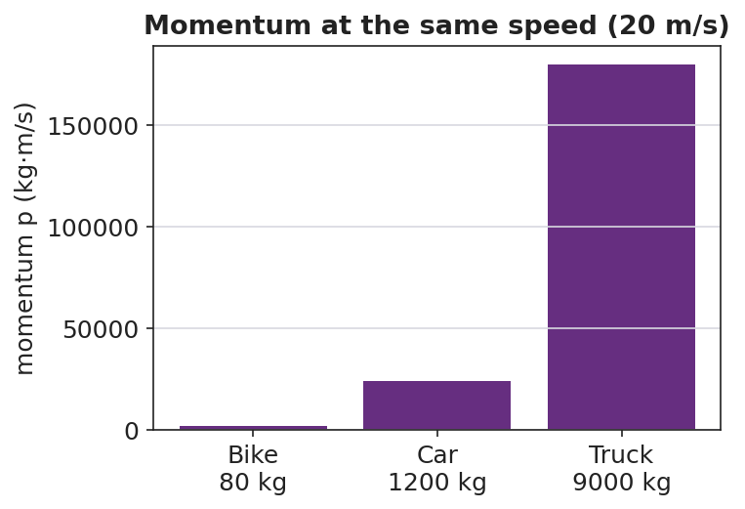
Momentum at the same speed for three vehicles
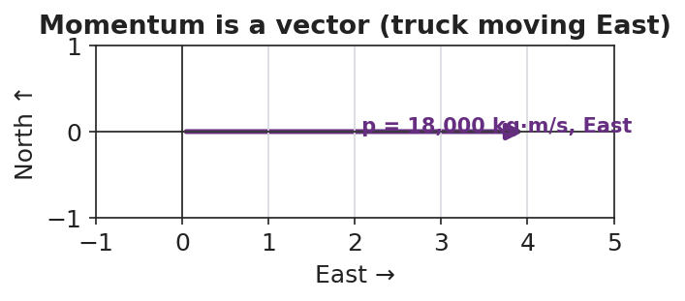
Momentum is a vector pointing the way the object moves

Discussion prompts to deploy here
- “A 1,200 kg car moves East at 20 m/s. Find its momentum and its direction.”
  - Sample student response: “p = 1,200 × 20 = 24,000 kg·m/s, East.”
- “Two objects have the same speed but different momentum. What must be different?”
  - Sample student response: “Their masses — more mass means more momentum at the same speed.”

Phase 4 · Elaborate (37 – 40 min)

37–39 min · Revise the model
“Return to your tennis-ball / bowling-ball ranking. Re-rank them by computing p = m·v for each (use tennis ball = 0.06 kg, bowling ball = 6 kg; gentle = 2 m/s, hard = 8 m/s). Does the math match your gut ranking?”

39–40 min · Return to the phenomenon
“Back to the truck and the bike at the same speed — in one sentence, use p = m·v to say why the truck is the dangerous one.”
Target: “At the same velocity, the truck’s far greater mass gives it far more momentum (p = m·v), so it is much harder to stop.”

Phase 5 · Evaluate (40 – 42 min)

40–42 min · Exit Ticket + Closing Reflection
“A 0.145 kg baseball is pitched West at 40 m/s. (a) Calculate its momentum, with units and direction. (b) A 0.045 kg golf ball is hit at 70 m/s. Show which ball has more momentum. (c) Is momentum a vector or a scalar? Give one reason.”
Expected: (a) p = 0.145 × 40 = 5.8 kg·m/s, West; (b) golf ball = 0.045 × 70 = 3.15 kg·m/s, so the baseball has more; (c) vector, because it has a direction (the same direction as the velocity). See Answer_Key.docx.
Closing Reflection (SEL, 30 seconds):
“What is one idea today that you understand better because of something a classmate said?”

Common Misconceptions
- Misconception: “Heavier always means more momentum.” → Correction: Only if speeds are equal; a light, fast object can out-momentum a heavy, slow one (p = m·v).
- Misconception: “Momentum is the same as speed.” → Correction: Speed ignores mass; momentum = mass × velocity and carries direction.
- Misconception: “Momentum has no direction.” → Correction: Momentum is a vector; it points the way the object moves, so opposite directions get opposite signs.

Access & Differentiation
- ELL/ENL supports: Sentence frame: *“The ___ has more momentum because its ___ (mass / velocity) is larger, so p = m·v is ___.”* Word-choice box: {mass, velocity, momentum, kg·m/s, direction, vector}. Pair momentum with a gesture (two hands pushing forward, “hard to stop”).
- IEP/SPED supports: Provide a pre-built p = m·v table with mass and velocity columns filled in; students compute only the product. Offer the cart demo as a hands-on alternative to the simulation.
- Extensions: Ask students to find a velocity at which a 0.045 kg golf ball would have the same momentum as a 0.145 kg baseball thrown at 40 m/s, and explain the trade-off between mass and speed.

Strategy Spotlight
RESTORATIVE CIRCLE (unit opener). Today’s opening uses a circle to launch the Momentum & Impulse unit. Use a talking piece, one-sentence responses, and equity of voice (everyone speaks or passes). The prompt — something hard to stop once it got going — is chosen so you can call it back in Phase 3 (“that ‘hard to stop’ feeling has a name and a formula: momentum, p = m·v”). Keep the circle to ~2–3 minutes; the goal is community plus a shared metaphor, not a long discussion.

NYSSLS Observation Checklist Crosswalk
# | Checklist item | Where it appears in this lesson
1 | Local/relatable phenomenon | Phase 1 — Newton’s cradle; truck vs. bike
2 | Turn and Talk (2–3×) | Phase 1 (TT#1 — what makes something hard to stop), Phase 3 (TT#2 — write the relationship)
3 | Students develop questions/models/procedures | Phase 1 (initial model), Phase 2 (PhET investigation), Phase 4 (revise model)
4 | CCC defined and used | Lesson Overview · Systems and System Models, restated in Phase 2
5 | ENL — ≤ 3 vocab, second half | Phase 3 — vocabulary at 35–37 min (momentum / mass / velocity)
6 | Revisit phenomenon with evidence | Phase 4 — re-rank with p = m·v; truck-vs-bike answer
7 | ENL/SPED supports | Access & Differentiation block
8 | Assessment check | Phase 5 — Exit Ticket (baseball / golf ball momentum)

Companion Materials
- Student_Worksheet.docx — the 5E student investigation (hand out at start of Phase 2)
- Student_Notes.docx — guided note-guide for vocabulary and the worked example
- Answer_Key.docx — answers to “Make It Make Sense” prompts and the Exit Ticket

Key Vocabulary (max 3)
- momentum — a measure of how hard an object is to stop; p = m·v, a vector measured in kg·m/s
- mass — the amount of matter in an object (kg); one of the two factors that set momentum
- velocity — how fast and in what direction an object moves (m/s); momentum points the same way

Momentum — Student Worksheet
Unit: Momentum & Impulse — Lesson 01 Name: _______________________ Date: __________ Period: ____

Phenomenon
In a Newton’s cradle, one ball swings in and one ball swings out — every time. Then your teacher asks: a dump truck and a bicycle are both rolling at the same speed toward you. You can only step out of the way of one.
Driving question: What makes one moving object harder to stop than another?

Notice & Wonder
I notice… | I wonder…
Turn & Talk #1: What two things seem to decide how hard a moving object is to stop? Use the words mass and speed.

Initial Model
Rank these from easiest to hardest to stop. Then write one sentence explaining the rule you used.
- a tennis ball thrown gently
- a tennis ball thrown hard
- a bowling ball rolled gently
- a bowling ball rolled hard
My ranking: ______________________________________ My rule: __________________________________________

Investigation
Open PhET Collision Lab. Complete each trial and record the momentum the simulation shows.
Trial | Mass (kg) | Velocity (m/s) | Momentum (kg·m/s)
1. Baseline | 1 | 2 (right)
2. Double the mass | 2 | 2 (right)
3. Double the velocity | 1 | 4 (right)
4. Send it left | 1 | 2 (left)
Key questions:
- When you doubled the mass, what happened to the momentum? ______________________
- When you doubled the velocity, what happened to the momentum? ______________________
- What did the negative sign in Trial 4 tell you? ______________________

Make It Make Sense
- A 1,200 kg car moves East at 20 m/s. Calculate its momentum, with units and direction.
- Two carts roll at the same speed, but Cart B has twice the mass of Cart A. How do their momenta compare?
- A golf ball and a baseball are thrown so they have the same momentum. The golf ball is lighter. What must be true about its speed? Explain.

Vocabulary in Action
Use each term in a sentence about today’s phenomenon.
- momentum: _______________________________________________
- mass: _______________________________________________
- velocity: _______________________________________________

Revise Your Model
Return to your tennis-ball / bowling-ball ranking. Compute p = m·v for each (tennis ball = 0.06 kg, bowling ball = 6 kg; gentle = 2 m/s, hard = 8 m/s). Does the math match your gut ranking? Rewrite your rule using p = m·v.

Exit Ticket
A 0.145 kg baseball is pitched West at 40 m/s.
- Calculate its momentum, with units and direction.
- A 0.045 kg golf ball is hit at 70 m/s. Show which ball has more momentum.
- Is momentum a vector or a scalar? Give one reason.

Momentum — Student Notes
Unit: Momentum & Impulse — Lesson 01 Name: _______________________ Date: __________ Period: ____

Learning Targets
By the end of today’s 42 minutes I can:
- Calculate momentum using p = m·v and state its unit, kg·m/s.
- Explain that momentum is a vector that points the way the object moves.
- Predict which of two objects has more momentum when mass or velocity differs.

Key Vocabulary
- momentum — _______________________________________________
- mass — _______________________________________________
- velocity — _______________________________________________

Guided Notes
Big idea: Momentum measures how hard a moving object is to __________.
- Reference-table formula: p = m · ____ .
- Symbol for momentum: __________ . Unit: __________ ( kg·m/s ).
- Momentum grows if you increase the __________ or the __________.
- Momentum is a vector: it points the same direction as the __________.
Sign and direction. If East is positive, an object moving West has a __________ momentum. Two objects with the same speed can have __________ momenta if they move in opposite directions.
Quick proportions. - Double the mass → momentum is __________ as big. - Double the velocity → momentum is __________ as big.


Momentum (p = m·v) compared for objects of different mass at the same speed — more mass means more momentum.

Worked Example
Problem. A 1,200 kg car moves East at 20 m/s. Find its momentum.
Solution. 1. Write the formula: p = m · ____ . 2. Substitute: p = (1,200 kg)(____ m/s). 3. Compute: p = __________ kg·m/s. 4. Direction: __________ (same as the velocity).

Summary
Finish the sentence (Because / But / So):
A truck and a bike can move at the same speed, because __________________________________________, but __________________________________________, so __________________________________________.

Momentum — Answer Key

Cover
Unit: Momentum & Impulse — Lesson 01: Momentum East Meadow Schools × Valley Stream Central HSD Strategy chip: RESTORATIVE CIRCLE

Make-It-Make-Sense Answers
- p = m·v = (1,200 kg)(20 m/s) = 24,000 kg·m/s, East. · Rubric: correct product AND direction (East). · NYSSLS: HS-PS2-2
- Cart B has twice the momentum of Cart A. Same velocity, so momentum is proportional to mass; double the mass → double the momentum. · Rubric: states 2× AND links to p = m·v with equal v. · NYSSLS: HS-PS2-2
- The golf ball must be moving faster. Since p = m·v is the same for both and the golf ball has less mass, its velocity must be larger to make up the difference. · Rubric: “faster” AND reasons from m·v held constant. · NYSSLS: HS-PS2-2

Exit Ticket Answer
- p = m·v = (0.145 kg)(40 m/s) = 5.8 kg·m/s, West.
- Golf ball: p = (0.045 kg)(70 m/s) = 3.15 kg·m/s. Since 5.8 > 3.15, the baseball has more momentum.
- Vector — momentum has a direction (the same direction as the velocity), not just a size.
Tolerance/rubric: (a) 5.8 kg·m/s with unit AND direction West; (b) golf ball 3.15 kg·m/s and correct comparison; (c) “vector” + a direction-based reason. 1 point each. NYSSLS: HS-PS2-2.

Closing Reflection (rubric)
Closing reflection is formative, not graded. Award full credit for any honest response. Look for: - A specific idea the student now understands better - Naming a peer whose comment helped (community-building goal of the opening circle)

Impulse and the Impulse–Momentum Theorem — Teacher Guide

Cover
Unit: Momentum & Impulse — Lesson 02: Impulse and the Impulse–Momentum Theorem East Meadow Schools × Valley Stream Central High School District Strategy chips: HOCHMAN

Curated Resources (from East Meadow Scope & Sequence)

NYSSLS Standards
This lesson is the engineering hinge of the unit, assessed by HS-PS2-3:
HS-PS2-3. “Apply scientific and engineering ideas to design, evaluate, and refine a device that minimizes the force on a macroscopic object during a collision.” (Crosscutting Concept: Cause and Effect)
The impulse–momentum theorem, J = F·Δt = Δp, is the physics that makes that design possible: for a fixed change in momentum, extending the contact time lowers the force. Airbags, crumple zones, and bending your knees on landing all trade time for force. The lesson also reinforces HS-PS2-2 by treating momentum change as the target quantity. Reference-Table relationships: p = m·v and J = F·Δt = Δp.

Phenomenon
- Egg drop onto a pillow vs. a plate — same drop, very different outcome: https://youtu.be/BLRfWtN3SQE
- Slow-motion airbag deployment / crash test: https://youtu.be/yQHDosNQGZk
- Catching a fast ball by pulling your hands back (teacher demo).

Javalab / Labs
- PhET Collision Lab (read force/time intuition by varying elasticity): https://phet.colorado.edu/en/simulations/collision-lab
- Javalab “impulse and momentum”: https://javalab.org/en/impulse_en/

Assessments
- Exit Ticket below (apply J = Δp; explain airbag in terms of Δt and force) is the formative check, scored with the Answer Key rubric.

Lesson Overview
Duration | 42 minutes (1 period)
NYSSLS link | HS-PS2-3 (design to minimize force) · HS-PS2-2 (momentum change)
CCC focus | Cause and Effect — extending contact time causes a smaller force for the same change in momentum.
Strategy chips | HOCHMAN (sentence-level literacy: Because/But/So + appositive on J = F·Δt = Δp)
Materials | Raw eggs, pillow + hard tray (over a tarp); a ball to catch; whiteboards; devices for PhET.
Safety | Egg drop over a covered/washable surface; wear closed-toe shoes; goggles optional.
Prior knowledge | Lesson 01 — momentum p = m·v; Forces — net force changes motion.
Lesson objectives — students can:
- Define impulse and use J = F·Δt = Δp to relate force, time, and change in momentum.
- Explain why extending the contact time reduces the force for a fixed change in momentum.
- Write a Hochman Because/But/So sentence connecting Δt and force in a safety device.

Phase 1 · Engage (0 – 12 min)

0–3 min · Opening Connection (SEL, 30 seconds)
Quick check-in (no circle today): “Thumbs up/middle/down — how ready do you feel after Lesson 01’s momentum formula?” Name that today we use that momentum to explain how airbags save lives.

3–8 min · Phenomenon hook — the egg drop
Teacher actions. Drop one egg onto a hard tray (it breaks) and an identical egg from the same height onto a pillow (it survives). Both eggs hit the surface with the same momentum and end at rest — the same change in momentum.
Sample teacher language:
“Same egg, same height, same speed at the bottom — so the change in momentum is identical. One survives. What was different about the stop?”
Anticipated student responses:
- “The pillow is soft.” — push for why soft helps: “what does soft do to the time of the stop?”
- “The pillow slows it down more gently / over more time.” — capture time; this is the key variable.
- “The hard tray stops it instantly.” — capture short time → big force.

8–12 min · Notice & Wonder + Turn-and-Talk #1
Two columns on the board. Then:
“Turn to your partner: both eggs had the same change in momentum, so what made the force on the egg so different? Use the word time.”
Target insight: the pillow stretches out the stopping time, so the force is smaller.

Bridge to Phase 2
Initial model sentence: “The pillow saves the egg because the stop took ______ time, so the force was ______.”

Phase 2 · Explore (12 – 32 min)

12–17 min · Initial Model (silent / individual)
Prompt on the board:
“Sketch two force-vs-time graphs for the same egg stopping: one on the tray, one on the pillow. Make them have the same total ‘push’ (area) but different shapes. Predict which has the taller spike.”
This surfaces the area-equals-impulse idea before it is named.

17–32 min · Investigation — catching a ball + PhET
Stations / whole-class:
- Catch a thrown ball two ways — once with stiff arms (hands stay still), once by pulling your hands back as you catch. Which sting less? Why?
- PhET Collision Lab — set one ball to hit a wall; compare a fast (elastic) bounce vs. a soft (inelastic) stop; relate the “harder hit” to a shorter interaction time.
- Read the graph — given the force-vs-time graphs below, students shade and compare the area (impulse) under each.
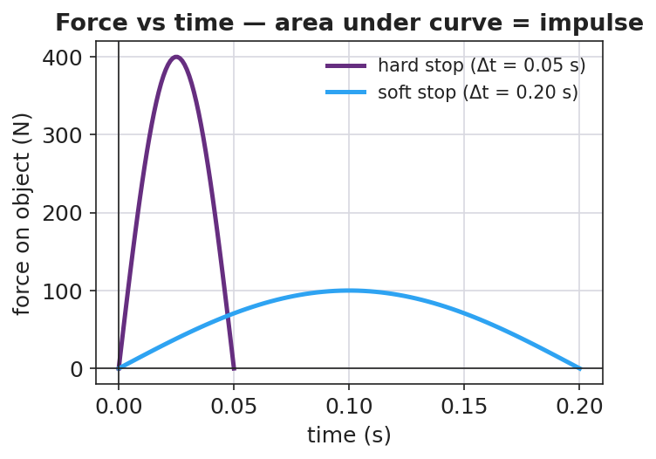
Force vs time for a hard stop and a soft stop (equal area = equal impulse)
Teacher facilitation language:
“When you pulled your hands back, did you change the ball’s momentum by a different amount — or just spread the stop over more time?” “Point to the area under each curve. If the areas are equal, what does that say about the impulse?” “Which graph has the dangerous spike — the tall narrow one or the low wide one?”

Teacher facilitation during Explore
- What to look for — students saying the area (impulse) is the same but the peak force differs.
- What to resist — don’t write J = F·Δt yet; let the graphs and the catch do the teaching.
- What to redirect — students who think the pillow “changes the momentum less” should compare end states: both eggs end at rest, so Δp is identical; only the time differs.

Phase 3 · Explain (32 – 37 min)

32–35 min · Turn-and-Talk #2 + class consensus
“Write a word equation linking force, the time it acts, and the change in momentum.”
Target consensus:
“Force times the time it acts equals the change in momentum. So for a fixed change in momentum, more time means less force.”

35–37 min · Vocabulary introduction (≤ 3 terms)
Sample teacher language:
“That product — force times the time interval it acts — is called impulse, symbol J. The impulse–momentum theorem says J = F·Δt = Δp: impulse equals the change in momentum. Rearranged, F = Δp / Δt — so stretching Δt shrinks the force for the same Δp. That is exactly what an airbag does.”
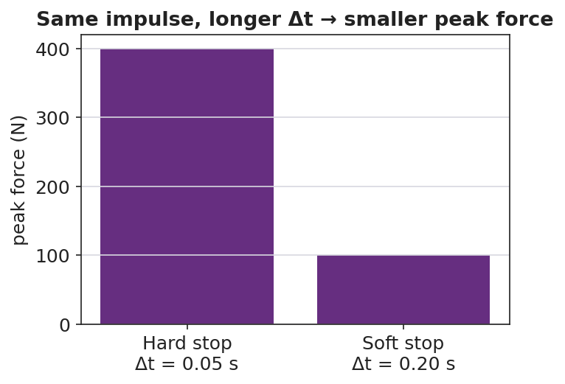
Same impulse, longer contact time gives a smaller peak force

Discussion prompts to deploy here
- “Why do crumple zones make a car safer even though the car is more damaged?”
  - Sample student response: “The crumple stretches out the collision time, so the force on the passengers is smaller (F = Δp/Δt).”
- “A boxer ‘rolls with the punch.’ How does that reduce the force?”
  - Sample student response: “Moving with the glove extends the contact time, so the same impulse delivers less force.”

Phase 4 · Elaborate (37 – 40 min)

37–39 min · Hochman Because/But/So + appositive
Today’s literacy move. On the board:
Sentence expansion. Finish all three for the airbag: “An airbag protects a driver because ______; but ______; so ______.” Appositive. Rewrite this into one sentence with an appositive naming impulse: “Impulse, ______, equals the change in momentum, so a longer contact time means a smaller force.”
Model one aloud, then have students draft. This is the Hochman thin-slice: precise sentences about J = F·Δt = Δp.

39–40 min · Return to the phenomenon
“In one Because/But/So sentence, explain why the egg on the pillow survives.”
Target: “Both eggs have the same change in momentum because they hit at the same speed and stop, but the pillow stretches the stopping time, so the force on the egg is small enough not to break it.”

Phase 5 · Evaluate (40 – 42 min)

40–42 min · Exit Ticket + Closing Reflection
“A 0.5 kg ball moving at 8 m/s is brought to rest. (a) Find the impulse needed to stop it (give units and direction). (b) If a glove stops it in 0.4 s, what average force does the glove apply? If a bare hand stops it in 0.05 s, what force? (c) Use J = F·Δt to explain, in one sentence, why the glove hurts less.”
Expected: (a) J = Δp = m·Δv = 0.5 × (0 − 8) = −4 kg·m/s, i.e. 4 N·s opposite the motion; (b) glove F = 4/0.4 = 10 N; bare hand F = 4/0.05 = 80 N; (c) same impulse over a longer time gives a smaller force. See Answer_Key.docx.
Closing Reflection (SEL, 30 seconds):
“Name one everyday object that secretly uses the impulse–momentum theorem to keep someone safe.”

Common Misconceptions
- Misconception: “A pillow reduces the change in momentum.” → Correction: Δp is the same (the egg still stops); the pillow reduces the force by extending the time.
- Misconception: “Impulse and force are the same thing.” → Correction: Impulse = force × time (J = F·Δt); a small force over a long time can equal a big force over a short time.
- Misconception: “More time means more force.” → Correction: For a fixed impulse, more time means less force (F = Δp/Δt).

Access & Differentiation
- ELL/ENL supports: Provide the Because/But/So frame pre-printed with the airbag context; word-choice box: {impulse, force, time interval, change in momentum, smaller, longer}. Pair impulse with the gesture of catching softly (hands drawing back).
- IEP/SPED supports: Give the force-vs-time graphs pre-shaded so students compare areas rather than draw them; provide the J = F·Δt formula triangle as a rearrangement scaffold.
- Extensions: Have students sketch and justify a force-vs-time graph for a phone dropped onto a rubber case vs. bare floor, predicting which has the larger peak force and why (HS-PS2-3 design link).

Strategy Spotlight
HOCHMAN (sentence-level literacy). Today’s literacy work lives in Phase 4: a Because/But/So sentence expansion and an appositive that names impulse precisely. The Hochman method keeps the writing at the sentence level — students are not writing paragraphs, they are building one accurate, complex sentence about J = F·Δt = Δp. Model one sentence aloud, require the appositive to define the term, and circulate to check that every Because/But/So clause is physically correct (Δp constant, Δt up, F down).

NYSSLS Observation Checklist Crosswalk
# | Checklist item | Where it appears in this lesson
1 | Local/relatable phenomenon | Phase 1 — egg drop; airbag; catching a ball
2 | Turn and Talk (2–3×) | Phase 1 (TT#1 — why the force differs), Phase 3 (TT#2 — word equation)
3 | Students develop questions/models/procedures | Phase 1 (initial model graphs), Phase 2 (catch + PhET), Phase 4 (revise)
4 | CCC defined and used | Lesson Overview · Cause and Effect, restated in Phase 3 (F = Δp/Δt)
5 | ENL — ≤ 3 vocab, second half | Phase 3 — vocabulary at 35–37 min (impulse / force / time interval)
6 | Revisit phenomenon with evidence | Phase 4 — Because/But/So egg-on-pillow sentence
7 | ENL/SPED supports | Access & Differentiation block
8 | Assessment check | Phase 5 — Exit Ticket (glove vs. bare hand force)

Companion Materials
- Student_Worksheet.docx — the 5E student investigation (hand out at start of Phase 2)
- Student_Notes.docx — guided note-guide for vocabulary and the worked example
- Answer_Key.docx — answers to “Make It Make Sense” prompts and the Exit Ticket

Key Vocabulary (max 3)
- impulse — the product of force and the time it acts, J = F·Δt; equals the change in momentum (Δp); unit N·s = kg·m/s
- force — a push or pull (N); for a fixed impulse, a smaller force results from a longer contact time
- time interval — Δt, how long a force acts (s); extending it reduces the force for the same impulse

Impulse and the Impulse–Momentum Theorem — Student Worksheet
Unit: Momentum & Impulse — Lesson 02 Name: _______________________ Date: __________ Period: ____

Phenomenon
Your teacher drops two identical eggs from the same height. One lands on a hard tray and shatters. The other lands on a pillow and survives. Both eggs hit moving at the same speed and end at rest.
Driving question: If both eggs had the same change in momentum, why did only one break?

Notice & Wonder
I notice… | I wonder…
Turn & Talk #1: Both eggs had the same change in momentum. What made the force on each egg so different? Use the word time.

Initial Model
Sketch two force-vs-time graphs for the same egg stopping: one landing on the tray, one on the pillow. Make the total “push” (area under the curve) the same, but the shapes different. Then predict which graph has the taller spike.
(sketch here)
My prediction: the taller spike is the ______ landing, because ______________________

Investigation
Complete each station. Record what you observe and what it tells you.
Station | What I did | What happened | What it tells me
1. Catch ball — stiff arms vs. pulling hands back
2. PhET Collision Lab — hard bounce vs. soft stop
3. Shade the area under each force-vs-time graph
Key questions:
- When you pulled your hands back, did you change the ball’s momentum by a different amount, or just spread the stop over more time? ______________________
- If the two graphs have the same area, what is the same about them? ______________________

Make It Make Sense
- An egg’s change in momentum stopping on a pillow is the same as on a tray. What single quantity does the pillow make bigger, and what does that do to the force?
- A crumple zone makes a car body more damaged in a crash but the people inside safer. Explain using J = F·Δt.
- A 0.5 kg ball moving at 8 m/s is caught and stopped. What impulse is needed to stop it? (Give units.)

Vocabulary in Action
Use each term in a sentence about today’s phenomenon.
- impulse: _______________________________________________
- force: _______________________________________________
- time interval: _______________________________________________

Revise Your Model
Return to your two graphs. Label the area under each as the impulse. Then finish the Because/But/So sentence:
Both eggs have the same change in momentum because ______________________, but ______________________, so ______________________.

Exit Ticket
A 0.5 kg ball moving at 8 m/s is brought to rest.
- Find the impulse needed to stop it (give units and direction).
- If a glove stops it in 0.4 s, what average force does the glove apply? If a bare hand stops it in 0.05 s, what force?
- Use J = F·Δt to explain, in one sentence, why the glove hurts less.

Impulse and the Impulse–Momentum Theorem — Student Notes
Unit: Momentum & Impulse — Lesson 02 Name: _______________________ Date: __________ Period: ____

Learning Targets
By the end of today’s 42 minutes I can:
- Use J = F·Δt = Δp to relate force, time, and change in momentum.
- Explain why a longer contact time means a smaller force for the same change in momentum.
- Write a Because/But/So sentence about a safety device using impulse.

Key Vocabulary
- impulse — _______________________________________________
- force — _______________________________________________
- time interval — _______________________________________________

Guided Notes
Big idea (impulse–momentum theorem): The impulse on an object equals its change in __________.
- Reference-table formula: **J = F · Δt = Δ____** .
- Symbol for impulse: __________ . Unit: N·s, which is the same as __________ .
- Rearranged for force: **F = Δp / Δ____** .
- For a fixed change in momentum: a longer Δt gives a __________ force.
Graph idea. On a force-vs-time graph, the area under the curve equals the __________. - A tall, narrow spike = __________ force, short time. - A low, wide bump = __________ force, long time. - If the two areas are equal, the __________ is equal.
Real devices that stretch Δt: airbag, crumple zone, bending your __________ on landing.


Force vs. time: the area under the curve is the impulse (J = F·Δt). The same impulse can come from a large force over a short time or a small force over a long time.

Worked Example
Problem. A 0.5 kg ball moving at 8 m/s is caught and stopped. Compare the force for a glove (Δt = 0.4 s) and a bare hand (Δt = 0.05 s).
Solution. 1. Impulse needed: J = Δp = m·Δv = (0.5)(0 − 8) = __________ kg·m/s (magnitude 4 N·s). 2. Glove: F = Δp / Δt = 4 / 0.4 = __________ N. 3. Bare hand: F = Δp / Δt = 4 / 0.05 = __________ N. 4. Same impulse, but the glove uses __________ time, so the force is __________.

Summary
Finish the sentence (Because / But / So):
An airbag protects a driver because __________________________________________, but __________________________________________, so __________________________________________.

Impulse and the Impulse–Momentum Theorem — Answer Key

Cover
Unit: Momentum & Impulse — Lesson 02: Impulse and the Impulse–Momentum Theorem East Meadow Schools × Valley Stream Central HSD Strategy chip: HOCHMAN

Make-It-Make-Sense Answers
- The pillow makes the contact time (Δt) bigger. Since J = F·Δt and the impulse (Δp) is fixed, a larger Δt means a smaller force on the egg, so it does not break. · Rubric: identifies Δt increase AND force decrease for fixed impulse. · NYSSLS: HS-PS2-3
- The crumple zone extends the collision time. The change in momentum is set by the crash, so by spreading it over more time the average force on the passengers drops (F = Δp/Δt) — that is what keeps the people safe even though the car is wrecked. · Rubric: links longer Δt → smaller force using J = F·Δt. · NYSSLS: HS-PS2-3
- J = Δp = m·Δv = (0.5 kg)(8 m/s) = 4 kg·m/s (4 N·s), directed opposite the ball’s motion. · Rubric: correct magnitude 4 N·s with unit. · NYSSLS: HS-PS2-2

Exit Ticket Answer
- J = Δp = m·Δv = (0.5 kg)(0 − 8 m/s) = −4 kg·m/s, i.e. 4 N·s opposite the motion.
- Glove: F = Δp/Δt = 4 / 0.4 = 10 N. Bare hand: F = 4 / 0.05 = 80 N.
- The impulse is the same, but the glove spreads it over a longer time, so by F = Δp/Δt the force is smaller — that is why it hurts less.
Tolerance/rubric: (a) 4 N·s with unit AND direction; (b) 10 N and 80 N (allow rounding); (c) “same impulse, longer time, smaller force.” 1 point each. NYSSLS: HS-PS2-3.

Closing Reflection (rubric)
Closing reflection is formative, not graded. Award full credit for any honest, physically reasonable example. Look for: - A real object/device that extends contact time (running shoe, helmet liner, trampoline, bubble wrap, etc.) - An implicit or explicit link to “longer time → smaller force”

Conservation of Momentum — Teacher Guide

Cover
Unit: Momentum & Impulse — Lesson 03: Conservation of Momentum East Meadow Schools × Valley Stream Central High School District Strategy chips: ACTIVE LEARNING

Curated Resources (from East Meadow Scope & Sequence)

NYSSLS Standards
This is the heart of the unit, the lesson the standard is written around:
HS-PS2-2. “Use mathematical representations to support the claim that the total momentum of a system of objects is conserved when there is no net force on the system.” (Crosscutting Concept: Systems and System Models)
Students used p = m·v (L01) and J = F·Δt = Δp (L02); here they combine them across a system. Because the forces two objects exert on each other are an equal-and-opposite pair (Newton’s Third Law), the impulses cancel, so the total momentum before a collision equals the total momentum after when no external net force acts: Σp_before = Σp_after.

Phenomenon
- Two dynamics carts colliding on a track (district anchor demo / video).
- Two ice skaters pushing off each other and gliding apart: https://youtu.be/5Y2bgFkWQqc

Javalab / Labs
- PhET Collision Lab — turn on the “momentum vectors” and “total” readout; verify total stays fixed: https://phet.colorado.edu/en/simulations/collision-lab
- Javalab “conservation of momentum”: https://javalab.org/en/conservation_of_momentum_en/

Assessments
- Exit Ticket below (compute an unknown final velocity using Σp_before = Σp_after) is the formative check, scored with the Answer Key rubric.

Lesson Overview
Duration | 42 minutes (1 period)
NYSSLS link | HS-PS2-2 (core)
CCC focus | Systems and System Models — define the system; when its external net force is zero, total momentum is constant.
Strategy chips | ACTIVE LEARNING (predict-measure-reconcile with carts; PhET station rotation)
Materials | Dynamics carts + track (or low-friction floor), masses, motion sensor or stopwatch + meterstick; rolling chairs / scooter boards (for the push-off); devices for PhET.
Safety | Clear the track path; spotters for any scooter-board push-off; no head-on cart launches toward people.
Prior knowledge | L01 momentum p = m·v (vector, signs); L02 impulse J = Δp; Newton’s Third Law (force pairs).
Lesson objectives — students can:
- State the law of conservation of momentum: a closed system’s total momentum is constant when the external net force is zero.
- Define the system and recognize a collision or push-off as an internal interaction.
- Use Σp_before = Σp_after to solve for an unknown velocity, tracking signs/direction.

Phase 1 · Engage (0 – 12 min)

0–3 min · Opening Connection (SEL, 30 seconds)
Quick partner greeting; name today’s goal: “We’ve measured momentum for one object — today we follow it through a whole system of objects and find something that never changes.”

3–8 min · Phenomenon hook — skaters push apart / carts collide
Teacher actions. Collide two carts of equal mass (one moving, one still) and let students watch the motion transfer. Then show two skaters at rest who push off and glide apart in opposite directions.
Sample teacher language:
“Before they push, the skaters’ total momentum is zero — nobody’s moving. After, both are gliding. Where did that momentum come from — and what’s the total now?”
Anticipated student responses:
- “They got momentum from pushing.” — capture that the push is internal to the system.
- “They go opposite ways.” — capture opposite signs.
- “The total is still zero because the two cancel.” — gold; if no one says it, leave it as the open question.

8–12 min · Notice & Wonder + Turn-and-Talk #1
Two columns on the board. Then:
“Turn to your partner: if the skaters started with zero total momentum, what is the total after they push apart? Use plus and minus signs.”
Target insight: equal and opposite momenta add to zero — the total didn’t change.

Bridge to Phase 2
Initial model sentence: “When the two carts interact, the total momentum of the system ______.”

Phase 2 · Explore (12 – 32 min)

12–17 min · Initial Model (silent / individual)
Prompt on the board:
“Draw two carts before and after a collision. Label each cart’s momentum arrow (size and direction) before and after. Predict: is the total (adding as vectors) the same before and after?”

17–32 min · Investigation — ACTIVE LEARNING: predict, measure, reconcile
Active-learning rotation. Each group predicts first, then measures:
- Equal-mass collision — one cart moving into a still cart of equal mass. Predict final velocities; measure with sensor/stopwatch.
- Unequal-mass collision — load one cart; repeat.
- Push-off — two carts (or students on scooter boards) at rest push apart; measure both speeds.
- PhET check — recreate each in Collision Lab; read the total momentum before and after.
Groups record total momentum before and after in a shared class table.
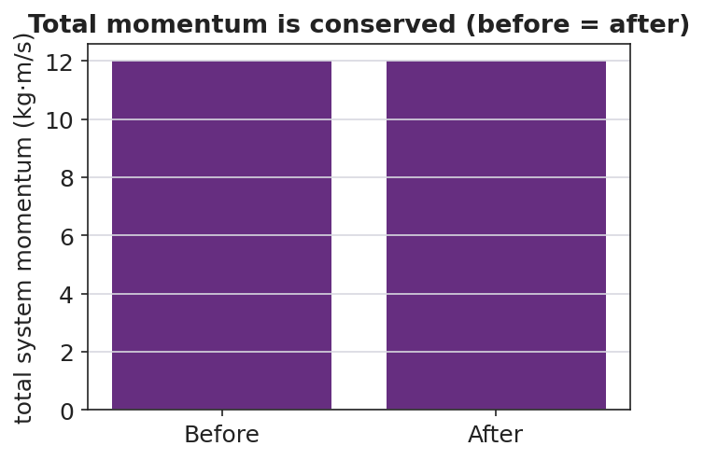
Total system momentum before vs after — equal
Teacher facilitation language:
“What did you predict for the total before you measured? Did the total change after the collision?” “Which momentum is positive and which is negative here? Add them as signed numbers.” “The carts pushed on each other — is that force inside or outside your system?”

Teacher facilitation during Explore
- What to look for — groups finding total before ≈ total after within measurement error.
- What to resist — don’t announce “conservation” until Phase 3; let the class data table reveal it.
- What to redirect — groups who say momentum “disappeared” in the push-off should add the signed values; opposite directions cancel to the original total.

Phase 3 · Explain (32 – 37 min)

32–35 min · Turn-and-Talk #2 + class consensus
“Look at the class data table. Write one sentence about the total momentum before vs. after every interaction.”
Target consensus:
“The total momentum of the system was the same before and after, as long as nothing from outside pushed on it.”

35–37 min · Vocabulary introduction (≤ 3 terms)
Sample teacher language:
“When we add up the momenta of every object we are tracking, that group is the system. A collision (or push-off) is an interaction inside the system. The law of conservation of momentum says: if the external net force on the system is zero, the total momentum is constant — Σp_before = Σp_after.”
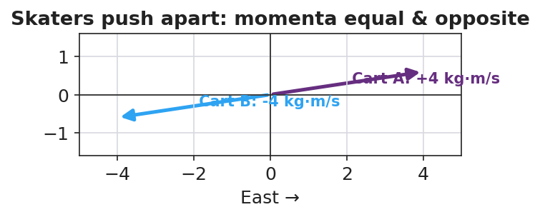
Skaters push apart: equal and opposite momenta sum to zero

Discussion prompts to deploy here
- “Why must we include both skaters in the system for the total to stay constant?”
  - Sample student response: “Because the push is internal; if we only watched one skater, an outside force (the other skater) acts on it.”
- “What outside force could break conservation on a real cart track?”
  - Sample student response: “Friction or a hand — those are external net forces.”

Phase 4 · Elaborate (37 – 40 min)

37–39 min · Revise the model
“Return to your before/after cart drawing. Write Σp_before = Σp_after with the actual signed momentum values. If one number was unknown, solve for it.”

39–40 min · Return to the phenomenon
“In one sentence, explain why the two skaters glide apart at different speeds if one is heavier — using conservation of momentum.”
Target: “Their momenta must stay equal and opposite to keep the total at zero, so the heavier skater moves slower (smaller v for larger m at equal p).”

Phase 5 · Evaluate (40 – 42 min)

40–42 min · Exit Ticket + Closing Reflection
“A 2 kg cart moving East at 3 m/s collides with a 1 kg cart at rest, and they stick together. (a) Find the total momentum of the system before the collision. (b) After they stick, what is the combined mass, and what is their velocity? (c) State the condition under which momentum is conserved.”
Expected: (a) Σp = (2)(3) + (1)(0) = 6 kg·m/s East; (b) combined mass 3 kg, v = 6/3 = 2 m/s East; (c) when the external net force on the system is zero (a closed/isolated system). See Answer_Key.docx.
Closing Reflection (SEL, 30 seconds):
“Whose prediction in your group was closest today, and what did you learn from comparing predictions to data?”

Common Misconceptions
- Misconception: “Momentum disappears in a push-off because it started at zero.” → Correction: Equal-and-opposite momenta add (as signed vectors) to the original total — still zero; nothing disappeared.
- Misconception: “The bigger object always ends up faster.” → Correction: For equal-and-opposite momenta, the larger mass moves slower (p = m·v).
- Misconception: “Momentum is always conserved, no matter what.” → Correction: Only when the external net force on the system is zero; friction or an outside push breaks it.

Access & Differentiation
- ELL/ENL supports: Sentence frame: *“The total momentum is the ___ before and after because the ___ force on the system is ___.”* Word-choice box: {system, collision, conservation of momentum, external, zero, equal}. Color-code East (+) and West (−) on the board.
- IEP/SPED supports: Provide the before/after table pre-labeled with mass and velocity columns; students fill momentum and the total only. Offer the PhET total-momentum readout as a check so the algebra is supported.
- Extensions: Have students predict and then verify the recoil speed of a “rocket” cart that ejects a mass, framing the ejected mass as part of the system.

Strategy Spotlight
ACTIVE LEARNING (predict–measure–reconcile). Today’s investigation is a structured active-learning rotation: every group commits to a prediction before each trial, then measures, then reconciles the gap. The cognitive work is in the reconciliation — students confront whether the total momentum really stayed constant. Keep groups accountable by collecting predictions in writing first, and build the shared class data table so the conservation pattern emerges from their numbers rather than from you. The closing reflection deliberately asks about prediction-vs-data to reinforce the move.

NYSSLS Observation Checklist Crosswalk
# | Checklist item | Where it appears in this lesson
1 | Local/relatable phenomenon | Phase 1 — colliding carts; skaters pushing apart
2 | Turn and Talk (2–3×) | Phase 1 (TT#1 — total after push-off), Phase 3 (TT#2 — total before vs. after)
3 | Students develop questions/models/procedures | Phase 1 (initial model), Phase 2 (predict-measure rotation), Phase 4 (revise)
4 | CCC defined and used | Lesson Overview · Systems and System Models, restated in Phase 2 (internal vs. external force)
5 | ENL — ≤ 3 vocab, second half | Phase 3 — vocabulary at 35–37 min (system / collision / conservation of momentum)
6 | Revisit phenomenon with evidence | Phase 4 — Σp_before = Σp_after with class data; heavier-skater answer
7 | ENL/SPED supports | Access & Differentiation block
8 | Assessment check | Phase 5 — Exit Ticket (stick-together collision)

Companion Materials
- Student_Worksheet.docx — the 5E student investigation (hand out at start of Phase 2)
- Student_Notes.docx — guided note-guide for vocabulary and the worked example
- Answer_Key.docx — answers to “Make It Make Sense” prompts and the Exit Ticket

Key Vocabulary (max 3)
- conservation of momentum — the total momentum of a system stays constant when the external net force on it is zero: Σp_before = Σp_after
- system — the set of objects whose momenta we add together; interactions inside it are internal forces
- collision — an interaction in which objects exert forces on each other for a short time (a push-off counts)

Conservation of Momentum — Student Worksheet
Unit: Momentum & Impulse — Lesson 03 Name: _______________________ Date: __________ Period: ____

Phenomenon
Two ice skaters stand still, facing each other, then push off. Both glide away in opposite directions. On a cart track, a moving cart hits a still cart and the motion transfers.
Driving question: When two objects interact, what happens to the total momentum of the system?

Notice & Wonder
I notice… | I wonder…
Turn & Talk #1: The skaters started with zero total momentum. What is the total after they push apart? Use plus and minus signs.

Initial Model
Draw two carts before and after a collision. Label each cart’s momentum arrow (size and direction) in both pictures. Predict: adding as vectors, is the total the same before and after?
(sketch here)
My prediction: ___________________________________

Investigation
You will predict first, then measure. Record the total momentum (add signed values) before and after each interaction.
Interaction | Predicted total before | Measured total before | Measured total after
1. Equal-mass collision
2. Unequal-mass collision
3. Push-off (start at rest)
4. PhET check
Key questions:
- Did the total momentum change after each interaction? ______________________
- The carts pushed on each other — was that force inside or outside your system? ______________________

Make It Make Sense
- Two skaters at rest push apart. The total before is zero. Explain why the total after is also zero, even though both are now moving.
- A 2 kg cart moving at 3 m/s East hits a still 1 kg cart and they stick. What outside force, if present, would stop momentum from being conserved?
- If two skaters of different mass push apart, which one moves faster? Justify with p = m·v and the idea that the total stays zero.

Vocabulary in Action
Use each term in a sentence about today’s phenomenon.
- conservation of momentum: _______________________________________________
- system: _______________________________________________
- collision: _______________________________________________

Revise Your Model
Return to your before/after cart drawing. Write Σp_before = Σp_after using your actual signed momentum values. If one value was unknown, solve for it here.
Σp_before = ____________________ = Σp_after = ____________________

Exit Ticket
A 2 kg cart moving East at 3 m/s collides with a 1 kg cart at rest, and they stick together.
- Find the total momentum of the system before the collision.
- After they stick, what is the combined mass, and what is their velocity?
- State the condition under which momentum is conserved.

Conservation of Momentum — Student Notes
Unit: Momentum & Impulse — Lesson 03 Name: _______________________ Date: __________ Period: ____

Learning Targets
By the end of today’s 42 minutes I can:
- State the law of conservation of momentum and the condition it requires.
- Define the system and identify a collision or push-off as an internal interaction.
- Use Σp_before = Σp_after to solve for an unknown velocity.

Key Vocabulary
- conservation of momentum — _______________________________________________
- system — _______________________________________________
- collision — _______________________________________________

Guided Notes
Big idea (conservation of momentum): The total momentum of a system stays __________ when the external net force on it is __________.
- Equation: Σp_before = Σp________ .
- The system is the set of objects whose momenta we __________ together.
- Forces the objects exert on each other are __________ forces; they come in equal-and-opposite pairs (Newton’s Third Law), so their impulses __________.
- Conservation breaks if an __________ net force (like friction or a hand) acts on the system.
Signs and direction. Momentum is a vector, so always add __________ values. If East is +, a momentum pointing West is __________.
Push-off from rest. Total before = 0, so total after must also = ____ . The two objects get __________ and opposite momenta.


Total momentum of the system before and after a collision is equal — momentum is conserved when no net external force acts.

Worked Example
Problem. A 2 kg cart moving East at 3 m/s collides with a 1 kg cart at rest and they stick together. Find their final velocity.
Solution. 1. Total before: Σp = (2)(3) + (1)(0) = __________ kg·m/s East. 2. After sticking, combined mass = __________ kg. 3. Conservation: Σp_before = Σp_after → 6 = (3)(v). 4. Solve: v = __________ m/s, directed __________.

Summary
Finish the sentence (Because / But / So):
Two skaters who push apart both start at rest because __________________________________________, but __________________________________________, so __________________________________________.

Conservation of Momentum — Answer Key

Cover
Unit: Momentum & Impulse — Lesson 03: Conservation of Momentum East Meadow Schools × Valley Stream Central HSD Strategy chip: ACTIVE LEARNING

Make-It-Make-Sense Answers
- The two skaters get equal and opposite momenta. Added as signed vectors, +p and −p sum to zero, the same total they started with — so the total is conserved even though both are now moving. · Rubric: states equal-and-opposite AND that they sum to the original zero. · NYSSLS: HS-PS2-2
- Friction (or anyone touching/pushing the carts) — any external net force on the system would prevent momentum from being conserved. · Rubric: names an external force; “friction” or “an outside push” accepted. · NYSSLS: HS-PS2-2
- The lighter skater moves faster. Their momenta have equal magnitude (to keep the total zero), and since p = m·v, the smaller mass needs a larger velocity for the same p. · Rubric: “lighter is faster” AND reasons from equal p with p = m·v. · NYSSLS: HS-PS2-2

Exit Ticket Answer
- Σp_before = (2 kg)(3 m/s) + (1 kg)(0) = 6 kg·m/s, East.
- Combined mass = 2 + 1 = 3 kg. Conservation: 6 = (3)(v) → v = 2 m/s, East.
- Momentum is conserved when the external net force on the system is zero (a closed/isolated system).
Tolerance/rubric: (a) 6 kg·m/s East; (b) 3 kg and 2 m/s East; (c) “external net force = zero” / “isolated system.” 1 point each. NYSSLS: HS-PS2-2.

Closing Reflection (rubric)
Closing reflection is formative, not graded. Award full credit for any honest response. Look for: - A specific comparison of a prediction to measured data - A statement of what the prediction-vs-data gap taught them (active-learning goal)

Collisions: Elastic and Inelastic — Teacher Guide

Cover
Unit: Momentum & Impulse — Lesson 04: Collisions: Elastic and Inelastic East Meadow Schools × Valley Stream Central High School District Strategy chips: BTC

Curated Resources (from East Meadow Scope & Sequence)

NYSSLS Standards
This closing lesson connects conservation to energy and to engineering design:
HS-PS2-2. “Use mathematical representations to support the claim that the total momentum of a system of objects is conserved when there is no net force on the system.” (Systems and System Models)
HS-PS2-3. “Apply scientific and engineering ideas to design, evaluate, and refine a device that minimizes the force on a macroscopic object during a collision.” (Cause and Effect)
Momentum is conserved in every collision (HS-PS2-2). What distinguishes collision types is kinetic energy: in an elastic collision KE is conserved; in an inelastic collision some KE is converted to heat, sound, and deformation (a perfectly inelastic collision is one where the objects stick together). Recognizing that inelastic collisions absorb energy is the physics behind crumple zones and helmets (HS-PS2-3). Reference-Table relationships in play: p = m·v, J = F·Δt = Δp, and KE = ½mv².

Phenomenon
- Newton’s cradle (≈ elastic — balls bounce, motion passes through): https://youtu.be/2UHS883_P60
- Two balls of clay thrown together and sticking (perfectly inelastic) — teacher demo.

Javalab / Labs
- PhET Collision Lab — the elasticity slider (0 % = perfectly inelastic/stick, 100 % = elastic); watch the KE bar vs. the momentum bar: https://phet.colorado.edu/en/simulations/collision-lab
- Javalab “elastic and inelastic collision”: https://javalab.org/en/collision_en/

Assessments
- Exit Ticket below (classify a collision; argue momentum conserved but KE not) is the formative check, scored with the Answer Key rubric.

Lesson Overview
Duration | 42 minutes (1 period)
NYSSLS link | HS-PS2-2 (momentum conserved in both) · HS-PS2-3 (energy absorption → safety design)
CCC focus | Cause and Effect — what causes kinetic energy to be lost, and how engineers use that.
Strategy chips | BTC (Building Thinking Classrooms: visibly random groups + vertical non-permanent surfaces)
Materials | Newton’s cradle; modeling clay; two superballs; whiteboards/VNPS around the room; deck of cards for random grouping; devices for PhET.
Safety | Throw clay only at the designated target; keep cradle clear of edges.
Prior knowledge | L01 p = m·v; L03 conservation of momentum; Energy unit — KE = ½mv².
Lesson objectives — students can:
- Distinguish elastic from inelastic collisions by whether kinetic energy is conserved.
- Argue that momentum is conserved in both collision types, while KE is conserved only in elastic ones.
- Identify a perfectly inelastic collision (objects stick) and connect energy absorption to safety design.

Phase 1 · Engage (0 – 12 min)

0–3 min · Opening Connection (SEL, 30 seconds) + BTC random groups
Form visibly random groups (deal cards) and send each to a vertical non-permanent surface (VNPS). Name today’s goal: “Two collisions both conserve momentum, but only one bounces back full of life — let’s find what’s different.”

3–8 min · Phenomenon hook — Newton’s cradle vs. clay
Teacher actions. Run the Newton’s cradle (balls click and pass motion cleanly). Then press two clay balls together so they stick and stop with a dull thud.
Sample teacher language:
“Both collisions kept momentum — we proved that last lesson. But listen: the cradle clicks and keeps bouncing; the clay goes thud and stops. Where did the clay’s motion energy go?”
Anticipated student responses:
- “The clay squished.” — capture deformation (energy went into changing shape).
- “It made a thud — sound.” — capture sound / heat.
- “The cradle didn’t lose energy.” — capture the elastic case.

8–12 min · Notice & Wonder + Turn-and-Talk #1
Two columns on the board. Then:
“Turn to your group: momentum is conserved in both. So what is different between the bouncy cradle and the sticky clay? Use the word energy.”
Target insight: the clay loses kinetic energy (to heat/sound/squish); the cradle keeps it.

Bridge to Phase 2
Initial model sentence: “Both collisions conserve momentum, but they differ in whether ______ is conserved.”

Phase 2 · Explore (12 – 32 min)

12–17 min · Initial Model (at the VNPS, as a group)
Prompt:
“At your board, draw before/after for the cradle and for the clay. Predict for each: is momentum conserved? Is kinetic energy conserved? Defend your prediction.”

17–32 min · Investigation — BTC thin-slice at the VNPS
The thin-slice problem, posed in escalating steps at the vertical surfaces (BTC):
- Compute momentum before and after for a given elastic collision (superballs) — confirm it’s conserved.
- Compute kinetic energy (KE = ½mv²) before and after the same elastic collision — is it conserved?
- Repeat both computations for a perfectly inelastic collision (clay sticks): a 2 kg ball at 4 m/s hits a 2 kg ball at rest and they move off together.
- PhET check — slide elasticity 100 % → 0 % and watch the KE bar drop while the total momentum bar stays fixed.
Groups graph their before/after results:
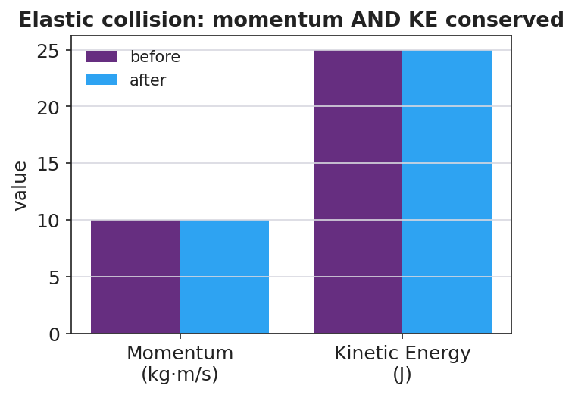
Elastic collision: momentum AND kinetic energy conserved
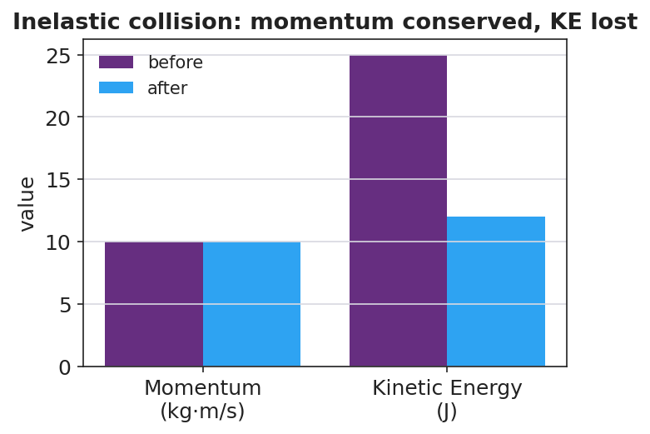
Inelastic collision: momentum conserved, kinetic energy lost
Teacher facilitation language (BTC — keep them thinking):
“Where did the missing kinetic energy go? It didn’t vanish — name three places.” “Is the momentum bar different before and after? Is the energy bar different?” “Build the next question for the group next to you.”

Teacher facilitation during Explore
- What to look for — groups finding momentum conserved in both, but KE lower after the inelastic collision.
- What to resist — don’t pre-label “elastic / inelastic”; let the KE numbers force the distinction.
- What to redirect — groups who think momentum is also lost in the clay collision should re-add signed momenta; only KE drops.

Phase 3 · Explain (32 – 37 min)

32–35 min · Turn-and-Talk #2 + class consensus
“Across both collisions, what was always conserved, and what was only sometimes conserved?”
Target consensus:
“Momentum was conserved in both collisions. Kinetic energy was conserved only in the bouncy one; in the sticky one some KE turned into heat, sound, and deformation.”

35–37 min · Vocabulary introduction (≤ 3 terms)
Sample teacher language:
“A collision where kinetic energy is conserved is elastic — like the cradle. A collision where kinetic energy is not conserved is inelastic; if the objects stick together it’s perfectly inelastic — like the clay. Momentum is conserved in both — only the energy bookkeeping changes.”
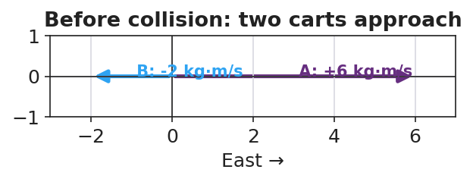
Before a collision: two carts approach with opposite momenta

Discussion prompts to deploy here
- “A car crash where the bumpers lock is which type? Where does the KE go?”
  - Sample student response: “Perfectly inelastic — KE goes into bending metal (deformation), heat, and sound.”
- “Why is an inelastic crumple zone safer than a perfectly elastic bumper?”
  - Sample student response: “It absorbs kinetic energy and extends the time, so less force reaches the passengers (HS-PS2-3).”

Phase 4 · Elaborate (37 – 40 min)

37–39 min · Revise the model
“Return to your VNPS before/after drawings. Label each collision elastic or inelastic, and annotate where any lost kinetic energy went. Confirm momentum is conserved in both with the numbers.”

39–40 min · Return to the phenomenon
“In one sentence, explain why the clay ‘thud’ and the cradle ‘click’ both conserve momentum but only one conserves kinetic energy.”
Target: “Both conserve momentum because no outside net force acts, but the clay is inelastic — its kinetic energy converts to heat, sound, and deformation — while the cradle is nearly elastic and keeps its kinetic energy.”

Phase 5 · Evaluate (40 – 42 min)

40–42 min · Exit Ticket + Closing Reflection
“A 2 kg ball moving at 4 m/s strikes a 2 kg ball at rest. They stick and move off together. (a) Find their combined velocity using conservation of momentum. (b) Compute the kinetic energy before and after. Is KE conserved? (c) Is this collision elastic or inelastic? Justify with your numbers, and name where the missing energy went.”
Expected: (a) Σp = (2)(4) = 8 = (4)(v) → v = 2 m/s; (b) KE_before = ½(2)(4²) = 16 J, KE_after = ½(4)(2²) = 8 J — not conserved; (c) inelastic (perfectly inelastic, they stick); missing 8 J went to heat, sound, and deformation. See Answer_Key.docx.
Closing Reflection (SEL, 30 seconds):
“What idea got clearer for you when you saw it written on the board by your group instead of in a notebook?”

Common Misconceptions
- Misconception: “Momentum is lost when objects stick together.” → Correction: Momentum is conserved in every collision with no external net force; only kinetic energy is lost in an inelastic one.
- Misconception: “Lost kinetic energy is destroyed.” → Correction: It is converted — to heat, sound, and deformation; total energy is still conserved.
- Misconception: “Elastic just means stretchy/bouncy in general.” → Correction: In physics, elastic specifically means kinetic energy is conserved in the collision.

Access & Differentiation
- ELL/ENL supports: Sentence frame: “This collision is ___ because the kinetic energy ___ conserved, but the momentum ___ conserved.” Word-choice box: {elastic, inelastic, kinetic energy, conserved, momentum, heat}. Pair elastic with a bounce gesture, inelastic with a “splat.”
- IEP/SPED supports: Provide the KE = ½mv² and p = m·v formulas with one worked substitution shown; students complete the parallel one. Offer a pre-built two-bar (momentum/energy) chart to fill rather than draw.
- Extensions: Have students design and justify a collision device (egg car / crumple bumper) that maximizes energy absorbed and extends Δt, citing HS-PS2-3 — then predict whether their device makes the collision more or less elastic.

Strategy Spotlight
BTC (Building Thinking Classrooms). Today uses two core BTC moves: visibly random groups (deal cards so students cannot self-sort) and vertical non-permanent surfaces (whiteboards on the walls). The investigation is a thin-slice sequence — momentum first, then energy, then a sticking case — posed in small escalating steps so every group can start and the cognitive load rises gradually. Keep yourself mobile, answer questions with questions (“where did the energy go?”), and have groups build the next question for a neighboring group. The closing reflection asks about the public-board experience to reinforce the practice.

NYSSLS Observation Checklist Crosswalk
# | Checklist item | Where it appears in this lesson
1 | Local/relatable phenomenon | Phase 1 — Newton’s cradle vs. sticking clay
2 | Turn and Talk (2–3×) | Phase 1 (TT#1 — what’s different), Phase 3 (TT#2 — always vs. sometimes conserved)
3 | Students develop questions/models/procedures | Phase 1 (initial model at VNPS), Phase 2 (BTC thin-slice), Phase 4 (revise)
4 | CCC defined and used | Lesson Overview · Cause and Effect, restated in Phase 3 (where KE goes)
5 | ENL — ≤ 3 vocab, second half | Phase 3 — vocabulary at 35–37 min (elastic / inelastic / kinetic energy)
6 | Revisit phenomenon with evidence | Phase 4 — label collisions + annotate energy on the VNPS
7 | ENL/SPED supports | Access & Differentiation block
8 | Assessment check | Phase 5 — Exit Ticket (stick-together: momentum vs. KE)

Companion Materials
- Student_Worksheet.docx — the 5E student investigation (hand out at start of Phase 2)
- Student_Notes.docx — guided note-guide for vocabulary and the worked example
- Answer_Key.docx — answers to “Make It Make Sense” prompts and the Exit Ticket

Key Vocabulary (max 3)
- elastic collision — a collision in which kinetic energy is conserved (e.g. a Newton’s cradle); momentum is conserved too
- inelastic collision — a collision in which kinetic energy is not conserved (some becomes heat/sound/deformation); momentum is still conserved. Perfectly inelastic = objects stick together
- kinetic energy — the energy of motion, KE = ½mv²; the quantity that distinguishes elastic from inelastic collisions

Collisions: Elastic and Inelastic — Student Worksheet
Unit: Momentum & Impulse — Lesson 04 Name: _______________________ Date: __________ Period: ____

Phenomenon
A Newton’s cradle clicks and the motion passes cleanly through — it keeps bouncing. Two balls of clay are pressed together and stop with a dull thud. Both collisions conserved momentum (you proved that last lesson).
Driving question: If both collisions conserve momentum, what is different between the bouncy one and the sticky one?

Notice & Wonder
I notice… | I wonder…
Turn & Talk #1: Momentum is conserved in both. What is different between the cradle and the clay? Use the word energy.

Initial Model
At your board, draw before/after for the cradle and for the clay. For each, predict: is momentum conserved? Is kinetic energy conserved? Defend your prediction.
Cradle — momentum: ______ kinetic energy: ______ Clay — momentum: ______ kinetic energy: ______ My reason: ___________________________________

Investigation
Work the thin-slice at your vertical board. Record before/after values.
Step | Momentum before | Momentum after | KE before | KE after
1–2. Elastic (superballs)
3. Inelastic — 2 kg @ 4 m/s hits 2 kg at rest, they stick
4. PhET: slide elasticity 100 % → 0 %
Key questions:
- Was momentum the same before and after in both collisions? ______________________
- Was kinetic energy the same before and after in both? ______________________
- Where did any missing kinetic energy go? Name three places. ______________________

Make It Make Sense
- Two balls of clay collide and stick. Momentum is conserved but kinetic energy is not. Where did the missing kinetic energy go?
- A car crash where the bumpers lock together is which type of collision? Justify.
- Why is an inelastic crumple zone safer for passengers than a perfectly elastic bumper that bounces back? (Hint: energy absorbed and contact time.)

Vocabulary in Action
Use each term in a sentence about today’s phenomenon.
- elastic collision: _______________________________________________
- inelastic collision: _______________________________________________
- kinetic energy: _______________________________________________

Revise Your Model
Return to your before/after drawings. Label each collision elastic or inelastic, annotate where any lost kinetic energy went, and confirm with numbers that momentum is conserved in both.

Exit Ticket
A 2 kg ball moving at 4 m/s strikes a 2 kg ball at rest. They stick and move off together.
- Find their combined velocity using conservation of momentum.
- Compute the kinetic energy before and after. Is kinetic energy conserved?
- Is this collision elastic or inelastic? Justify with your numbers, and name where the missing energy went.

Collisions: Elastic and Inelastic — Student Notes
Unit: Momentum & Impulse — Lesson 04 Name: _______________________ Date: __________ Period: ____

Learning Targets
By the end of today’s 42 minutes I can:
- Distinguish elastic from inelastic collisions by whether kinetic energy is conserved.
- Explain that momentum is conserved in both types of collision.
- Identify a perfectly inelastic collision and connect energy absorption to safety design.

Key Vocabulary
- elastic collision — _______________________________________________
- inelastic collision — _______________________________________________
- kinetic energy — _______________________________________________

Guided Notes
Big idea: Momentum is conserved in __________ collisions. Kinetic energy is conserved only in __________ collisions.
- Kinetic energy formula: KE = ½ m ____² .
- Elastic collision: KE is __________ (e.g. a Newton’s cradle).
- Inelastic collision: KE is __________ ; the lost energy becomes __________, sound, and deformation.
- Perfectly inelastic collision: the objects __________ together and move as one.
Bookkeeping check. In every collision with no external net force: - Σp_before ____ Σp_after (always true) - KE_before = KE_after only if the collision is __________.
Engineering link (HS-PS2-3). Crumple zones and helmets are designed to be __________ — they absorb kinetic energy and extend Δt, reducing the __________ on people.


In an elastic collision both momentum and kinetic energy are conserved; in an inelastic collision momentum is conserved but kinetic energy is not.

Worked Example
Problem. A 2 kg ball moving at 4 m/s strikes a 2 kg ball at rest. They stick together. Find the final velocity, then check kinetic energy.
Solution. 1. Momentum before: Σp = (2)(4) + (2)(0) = __________ kg·m/s. 2. After sticking, combined mass = __________ kg → 8 = (4)(v) → v = __________ m/s. 3. KE before = ½(2)(4²) = __________ J. 4. KE after = ½(4)(2²) = __________ J. 5. KE __________ conserved → the collision is __________.

Summary
Finish the sentence (Because / But / So):
Sticking clay and a Newton’s cradle both conserve momentum because __________________________________________, but __________________________________________, so __________________________________________.

Collisions: Elastic and Inelastic — Answer Key

Cover
Unit: Momentum & Impulse — Lesson 04: Collisions: Elastic and Inelastic East Meadow Schools × Valley Stream Central HSD Strategy chip: BTC

Make-It-Make-Sense Answers
- The missing kinetic energy is converted to heat, sound, and deformation (the clay squishing). It is not destroyed — total energy is conserved — but it is no longer kinetic. · Rubric: names at least two of heat/sound/deformation AND says energy is converted, not lost. · NYSSLS: HS-PS2-2
- Inelastic (perfectly inelastic, since the bumpers lock and the cars move together). Kinetic energy is lost to bending metal, heat, and sound; momentum is still conserved. · Rubric: “inelastic” AND a justification about KE loss / sticking. · NYSSLS: HS-PS2-2
- The inelastic crumple zone absorbs kinetic energy and extends the contact time, so the force on the passengers is smaller (F = Δp/Δt). A perfectly elastic bumper would bounce the car back, giving a larger change in momentum and a bigger force. · Rubric: links energy absorption AND longer Δt → smaller force. · NYSSLS: HS-PS2-3

Exit Ticket Answer
- Σp = (2 kg)(4 m/s) + (2 kg)(0) = 8 kg·m/s = (4 kg)(v) → v = 2 m/s (same direction as the first ball).
- KE_before = ½(2)(4²) = 16 J. KE_after = ½(4)(2²) = 8 J. KE is not conserved (16 J → 8 J).
- Inelastic (perfectly inelastic — they stick). The numbers show momentum conserved but KE halved; the missing 8 J went to heat, sound, and deformation.
Tolerance/rubric: (a) v = 2 m/s; (b) 16 J before, 8 J after, “not conserved”; (c) “inelastic/perfectly inelastic” + names where the 8 J went. 1 point each. NYSSLS: HS-PS2-2, HS-PS2-3.

Closing Reflection (rubric)
Closing reflection is formative, not graded. Award full credit for any honest response. Look for: - A specific idea that became clearer through working at the public vertical board - Acknowledgment of a groupmate’s contribution (BTC collaboration goal)

