Physics — Unit 04: Energy (Review)
Table of Contents

Unit 4 · Work, Energy & Power

Work, Energy & Power — Unit Plan

Cover
Unit: Work, Energy & Power East Meadow Schools × Valley Stream Central High School District 6 lessons · ~6 instructional periods (42 min each) Format: DOCX (Teacher Guide · Student Worksheet · Student Notes · Answer Key per lesson)

Unit Scope (from East Meadow Scope & Sequence)
This unit develops energy as the unifying currency of physics. It builds on Forces (work is done by a force through a displacement) and Kinematics (speed and height), and it sets up later units on momentum, electricity, and thermodynamics. Students first quantify the transfer of energy (work, power), then the two macroscopic stores of mechanical energy (kinetic = motion, potential = position), then the law that ties them together (conservation), and finally apply it all to real energy-conversion devices (efficiency and engineering design).
# | Lesson | Core idea
01 | Work | W = F·d; only the force component along the displacement does work; the joule
02 | Power | P = W/t = Fv; the watt; same work faster = more power
03 | Kinetic Energy | KE = ½mv²; energy of motion depends on v²
04 | Gravitational Potential Energy | PE = mgh; stored energy relative to a reference height
05 | Conservation of Energy | Mechanical energy KE + PE is constant without friction; PE ↔ KE
06 | Energy in Systems: Wheels to Watts | Energy transfer, useful vs. wasted, efficiency = useful ÷ input; design/refine a converter
Reference-table formulas used this unit: W = F·d; P = W/t = Fv; KE = ½mv²; PE = mgh; g ≈ 9.81 m/s².

Pacing Calendar
Day | Lesson | Phenomenon anchor | Strategy
1 | 01 Work | Lifting vs. carrying a heavy backpack | Hochman
2 | 02 Power | Two students climbing stairs at different speeds (stair-climb lab) | Active Learning
3 | 03 Kinetic Energy | Car stopping distance vs. speed | BTC
4 | 04 Gravitational PE | Roller-coaster lift hill / water tower (Javalab) | Hochman
5 | 05 Conservation of Energy | Skate park / pendulum / coaster (PhET + Javalab) | Active Learning
6 | 06 Energy in Systems (Wheels to Watts) | Regenerative braking / bike generator | BTC (NYS Investigation)
Double-period days (every other day) let the stair-climb lab (Lesson 02), the PhET exploration (Lesson 05), and the build-and-refine investigation (Lesson 06) run long.

Strategy Rotation
- HOCHMAN (literacy): Lessons 01, 04 — appositive definitions and Because/But/So on W = F·d (the zero-work case) and PE = mgh (the reference-height idea).
- ACTIVE LEARNING: Lessons 02, 05 — the stair-climb personal-power lab and the PhET Energy Skate Park predict-and-test with student-read energy bar graphs.
- BTC (Building Thinking Classrooms): Lessons 03, 06 — random groups + vertical non-permanent surfaces on the thin-sliced KE = ½mv² (v² discovery) and the Wheels-to-Watts design-and-refine task.
SEL (Opening Connection + Closing Reflection), ELL/SPED supports, and a Curated Resources block appear in every lesson.

NYSSLS Coverage Matrix
PE | Description | Lessons
HS-PS3-1 | Create a computational model to calculate the change in energy of one component in a system when the change in energy of the other component(s) and energy flows in/out are known (Systems and System Models) | 01 (foundation), 02, 05 (core), 06
HS-PS3-2 | Energy at the macroscopic scale = energy of motion of particles + energy of relative positions (Energy and Matter) | 03 (motion), 04 (position), 05 (synthesis)
HS-PS3-3 | Design, build, and refine a device that converts one form of energy into another (Energy and Matter) | 06

Vocabulary Scope
Three terms maximum per lesson, introduced in the second half (NYSSLS observation item 5).
Lesson | Terms
01 | work · joule · displacement
02 | power · watt · energy
03 | kinetic energy · mass · speed
04 | potential energy · height · gravitational field
05 | mechanical energy · conservation of energy · energy transformation
06 | efficiency · energy transfer · system

Work — Teacher Guide

Cover
Unit: Work, Energy & Power — Lesson 01: Work East Meadow Schools × Valley Stream Central High School District Strategy chips: HOCHMAN

Curated Resources (from East Meadow Scope & Sequence)

NYSSLS Standards
The Work, Energy & Power unit develops HS-PS3 (energy). This opening lesson defines the transfer mechanism — work — that the rest of the unit quantifies. It builds the vocabulary and the W = F·d relationship that make HS-PS3-1 possible: “Create a computational model to calculate the change in energy of one component in a system when the change in energy of the other component(s) and energy flows in and out of the system are known.” (Crosscutting Concept: Systems and System Models.) Work is the first “energy flow in/out” students will compute.

Phenomenon
- Lifting a loaded backpack straight up onto a high shelf vs. carrying the same backpack across a level hallway. https://www.youtube.com/watch?v=2WS1sErgcUI (Khan Academy: Work as the transfer of energy)
- The Physics Classroom — “Definition and Mathematics of Work”: https://www.physicsclassroom.com/class/energy/Lesson-1/Definition-and-Mathematics-of-Work

Javalab / Labs
- Javalab — Work and energy simulations index: https://javalab.org/en/category/energy_en/

Assessments
- The Physics Classroom check-set on the work equation (link above). The Exit Ticket below is the formative check; the constructed-response “Make It Make Sense” items map to HS-PS3-1.

Lesson Overview
Duration | 42 minutes (1 period)
NYSSLS link | HS-PS3-1 (foundation — work as an energy flow into/out of a system)
CCC focus | Systems and System Models — work is energy transferred into or out of a chosen system.
Strategy chips | HOCHMAN (Because/But/So + appositive on W = F·d)
Materials | A loaded backpack or textbook stack; a bathroom/spring scale (N) or known masses; meter stick; whiteboards/markers.
Safety | Lift with knees; keep walkways clear; do not drop masses on feet.
Prior knowledge | Forces — net force and the newton; displacement as a vector (size + direction).
Lesson objectives — students can:
- Define work as energy transferred when a force moves an object through a displacement, and state its unit, the joule.
- Calculate work with W = F·d, using only the component of force along the displacement.
- Explain why carrying a load horizontally at steady speed does zero work on the load, while lifting it does positive work.

Phase 1 · Engage (0 – 10 min)

0–3 min · Opening Connection (SEL)
Quick pair-share, one sentence each: “Name a time today your arms or legs felt tired even though you didn’t really go anywhere.” Hold a few responses (holding a sibling, carrying groceries, standing on the train). Plant the puzzle: being tired is not the same as doing physics “work.”

3–7 min · Phenomenon hook — lift it vs. carry it
Teacher actions. Hold a loaded backpack. (1) Lift it straight up from the floor to a high shelf. (2) Now carry it across the room at a steady walk, holding it at constant height.
Sample teacher language:
“Both made my arms tired. But a physicist would say I did work in only one of these. Watch where the bag moves compared to the direction I’m pushing or pulling on it.”
Anticipated student responses:
- “You did work both times — you were holding it!” — surface; honor the effort, then redirect to direction of motion.
- “The lift was harder so that’s the work one.” — closer; we will tie work to force and distance, not just effort.
- “When you carried it, it went sideways but you held it up.” — capture this; it is the seed of “force ⟂ motion.”

7–10 min · Notice & Wonder + Turn-and-Talk #1
Two columns on the board. Then:
“Turn to your partner: in which case did the force you applied point the same direction the bag actually moved? Use the words force and direction.”
Take 2–3 responses. Desirable insight: when lifting, your force (up) and the bag’s motion (up) line up; when carrying, your force is up but the motion is sideways.

Bridge to Phase 2
Every student leaves Phase 1 with an initial model sentence: “Work was done when ______ because ______.”

Phase 2 · Explore (10 – 28 min)

10–15 min · Initial Model (silent / individual)
Prompt on the board:
“Draw the backpack in each case. Draw one arrow for your force and one arrow for the bag’s displacement. Then predict: in which case did you do more work on the bag — and is one of them zero?”
This surfaces the alignment intuition before any equation.

15–28 min · Investigation — measure the work
Whole-class or small groups with one scale and a meter stick:
- Lift it. Read the weight (force, in N) needed to hold the load. Lift it a measured height h. Record F and d (= h). Compute W = F·d.
- Carry it. Walk the same load a measured horizontal distance at constant height. Ask: what is the vertical force you apply? What direction did the load move? How much of your force points along that motion?
- Vary the distance. Lift the same load 0.5 m, then 1.0 m, then 1.5 m. Tabulate W vs. d.
Project the figure as the data come in:
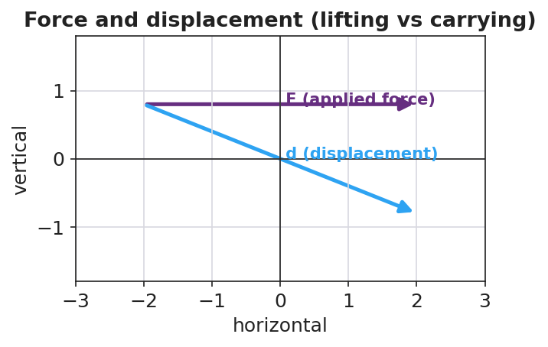
Force and displacement: lifting (force along motion) vs carrying (force perpendicular to motion)
Teacher facilitation language:
“When you carried it, which way did the bag move? Which way did your force point? Is any part of your push pointing along the walk?” “Double the lift height. What happened to the work? Predict before you compute.”
Anticipated student responses:
- “When I doubled the height, the work doubled.” — exactly; W is proportional to d at fixed F.
- “Carrying it, my force is up but it moved sideways, so… none of my force is along the motion?” — land this; that is zero work on the bag.

Teacher facilitation during Explore
- What to look for — students noting that only the part of the force along the displacement counts.
- What to resist — don’t hand them “joule” or the formula yet; let the scale and meter stick build it.
- What to redirect — “I was tired so I did work” → ask what direction did the object move relative to your force?

Phase 3 · Explain (28 – 35 min)

28–31 min · Turn-and-Talk #2 + class consensus
“Across both cases, what two things did it take to do work on the bag — and why was carrying it zero?”
Target consensus:
“Work happens when a force moves an object in the direction of the force. Lifting: force up, motion up — they line up, so work is done. Carrying at steady height: force up, motion sideways — the force is perpendicular to the motion, so it does zero work on the bag.”

31–35 min · Vocabulary introduction (≤ 3 terms) + HOCHMAN
Build the equation from the reference table: W = F·d (force × distance moved along the force). Units: a newton-meter is a joule (J).
Sample teacher language (Hochman appositive + Because/But/So):
“Write it as an appositive: Work, the energy transferred when a force moves an object through a displacement, is measured in joules. Now Because/But/So: Carrying the box does zero work on it because the upward force is perpendicular to the sideways motion, but my muscles still get tired, so ‘tired’ and ‘work’ are not the same thing in physics.”

Discussion prompts to deploy here
- “A waiter holds a tray steady while standing still. How much work does he do on the tray? Why?”
  - Sample response: “Zero — the tray doesn’t move, so d = 0, so W = 0.”
- “You push a 200 N crate 3 m across the floor. How much work?”
  - Sample response: “W = F·d = 200 × 3 = 600 J.”

Phase 4 · Elaborate (35 – 40 min)

35–38 min · Revise the model + apply the graph
“Return to your two drawings. Re-label each: is the force along the motion, or perpendicular to it? Compute the work for the lift. Then sketch how work changes as the lift distance grows.”
Project:
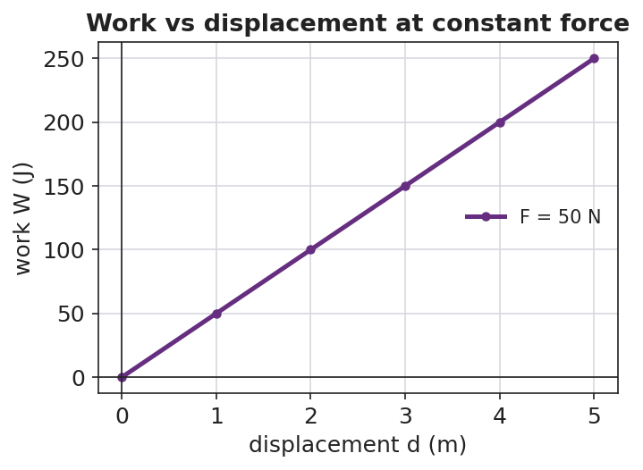
Work vs displacement at constant force is a straight line through the origin
Target: at constant force, work grows in direct proportion to distance — a straight line through the origin whose slope is the force.

38–40 min · Return to the phenomenon
“Explain to your partner, in one Because/But/So sentence, why carrying the backpack down the hall does zero work on it but lifting it onto the shelf does positive work.”

Phase 5 · Evaluate (40 – 42 min)

40–42 min · Exit Ticket + Closing Reflection
“A custodian pushes a 250 N mop bucket 8.0 m across a level floor at steady speed. (a) How much work does she do on the bucket? Show W = F·d. (b) She then holds the bucket still for 10 seconds. How much work does she do during those 10 seconds? Explain. (c) A student carries a 40 N lunch tray across the cafeteria at constant height. How much work is done on the tray, and why?”
Expected: (a) 250 × 8.0 = 2000 J; (b) zero — no displacement; (c) zero — the supporting force is perpendicular to the horizontal motion. See Answer_Key.docx.
Closing Reflection (SEL, 30 seconds):
“What is one everyday moment you’ll now describe differently because of today — and who helped you see it?”

Common Misconceptions
- Misconception: “If I get tired, I did work.” → Correction: Physics work requires the object to move in the direction of the force; holding something still does zero work (d = 0).
- Misconception: “Any force on a moving object does work.” → Correction: Only the component of force along the displacement does work; a perpendicular force does zero work.
- Misconception: “Carrying a box across a room does work on the box.” → Correction: At constant height the support force is vertical while motion is horizontal — they are perpendicular, so W = 0 on the box.

Access & Differentiation
- ELL/ENL supports: Sentence frame: “Work was done on the ___ because the force pointed ___ the motion, so energy was transferred.” Word box: {force, displacement, joule, along, perpendicular}. Pair perpendicular with an L-shaped hand gesture.
- IEP/SPED supports: Provide a pre-drawn two-panel diagram (lift / carry) with force and motion arrows already drawn; students only label “along” or “perpendicular” and circle which does work. Provide the W = F·d formula and a worked unit example on a reference card.
- Extensions: Introduce work done by a force at an angle (W = F·d·cosθ): predict and check the work when a sled rope is pulled at 30° vs. 0°.

Strategy Spotlight
HOCHMAN (literacy). Today’s writing moves are the appositive (defining work mid-sentence) and Because/But/So (explaining the zero-work case). Model the appositive aloud, then have students expand one kernel sentence — “Work is energy transferred” — into a full appositive definition. The Because/But/So in Phase 4 forces students to hold the “tired ≠ work” distinction in a single, precise sentence. Collect two or three on the board and revise for precision as a class.

NYSSLS Observation Checklist Crosswalk
# | Checklist item | Where it appears in this lesson
1 | Local/relatable phenomenon | Phase 1 — backpack lift vs. carry; custodian bucket in Phase 5
2 | Turn and Talk (2–3×) | Phase 1 (TT#1 — force vs. direction), Phase 3 (TT#2 — what makes work)
3 | Students develop questions/models/procedures | Phase 1 (initial model), Phase 2 (measure W = F·d), Phase 4 (revise model)
4 | CCC defined and used | Lesson Overview · Systems and System Models, applied in Phase 2
5 | ENL — ≤ 3 vocab, second half | Phase 3 — vocabulary at 31–35 min (work / joule / displacement)
6 | Revisit phenomenon with evidence | Phase 4 — re-label lift vs. carry with measured W
7 | ENL/SPED supports | Access & Differentiation block
8 | Assessment check | Phase 5 — Exit Ticket (mop bucket + lunch tray)

Companion Materials
- Student_Worksheet.docx — the 5E student investigation (hand out at start of Phase 2)
- Student_Notes.docx — guided note-guide for vocabulary and the worked example
- Answer_Key.docx — answers to “Make It Make Sense” prompts and the Exit Ticket

Key Vocabulary (max 3)
- work — energy transferred when a force moves an object through a displacement along the force; W = F·d
- joule — the SI unit of work and energy; one joule equals one newton-meter (1 J = 1 N·m)
- displacement — the change in an object’s position (size and direction); only motion along the force counts toward work

Work — Student Worksheet
Unit: Work, Energy & Power — Lesson 01 Name: _______________________ Date: __________ Period: ____

Phenomenon
Your teacher lifts a loaded backpack straight up onto a high shelf. Then your teacher carries the same backpack across the room at a steady height. Both make the arms tired — but a physicist says work was done in only one of them.
Driving question: What does it take to do work on an object, and why can a tiring task do zero work?

Notice & Wonder
I notice… | I wonder…
Turn & Talk #1: In which case did the applied force point the same direction the bag actually moved? Use the words force and direction.

Initial Model
Draw the backpack in each case. Draw one arrow for the force you apply and one arrow for the bag’s displacement (the way it actually moves).
Lifting (up onto shelf) | Carrying (across the room)
My prediction — which case does more work on the bag, and is one of them zero? _______________________________________________

Investigation
Use the scale (force, in newtons) and meter stick. Record your measurements.
Station | Force F (N) | Distance moved along the force d (m) | Work W = F·d (J)
1. Lift it straight up
2. Carry it sideways (force is up, motion is sideways)
3. Lift again — double the height

Force and displacement diagram
Key question: When you carried the bag, how much of your (upward) force pointed along the (sideways) motion? What does that make the work on the bag?

Make It Make Sense
- You push a 200 N crate 3.0 m across the floor in the direction of the push. How much work do you do on the crate? Show W = F·d.
- A waiter holds a tray perfectly still for 30 seconds. How much work does he do on the tray? Explain using the word displacement.
- Why does carrying a box across a level room at steady height do zero work on the box, even though your arms get tired?

Vocabulary in Action
Use each term in a sentence about today’s phenomenon.
- work: _______________________________________________
- joule: _______________________________________________
- displacement: _______________________________________________

Revise Your Model
Return to your two drawings. Re-label each arrow pair: is the force along the motion or perpendicular to it? Rewrite your explanation as one Because / But / So sentence using work and displacement.
Because _______________________________________________, but _______________________________________________, so _______________________________________________.

Exit Ticket
A custodian pushes a 250 N mop bucket 8.0 m across a level floor at steady speed.
- How much work does she do on the bucket? Show W = F·d.
- She then holds the bucket still for 10 seconds. How much work does she do during those 10 seconds? Explain.
- A student carries a 40 N lunch tray across the cafeteria at constant height. How much work is done on the tray, and why?

Work — Student Notes
Unit: Work, Energy & Power — Lesson 01 Name: _______________________ Date: __________ Period: ____

Learning Targets
By the end of today’s 42 minutes I can:
- Define work and state its unit, the joule.
- Calculate work with W = F·d, using only the force along the displacement.
- Explain why carrying a load horizontally does zero work on it.

Key Vocabulary
- work — _______________________________________________
- joule — _______________________________________________
- displacement — _______________________________________________

Guided Notes
Big idea: Work is energy __________ when a force moves an object through a __________.
- The formula (reference table): W = F·d, where F is the force in __________ and d is the distance moved __________ the force.
- The unit of work is the __________ (J). One joule = one __________·meter (1 J = 1 N·m).
- Only the part of the force that points __________ the displacement does work.
- If a force is __________ (at 90°) to the motion, it does __________ work.
- If the object does not move, d = __________, so W = __________.
Two cases (fill in):
 | Force direction | Motion direction | Work on object
Lifting a bag | up | up | __________ (positive / zero)
Carrying a bag at steady height | up | sideways | __________ (positive / zero)


Work vs. displacement at constant force: work (W = F·d) grows in proportion to how far the object moves along the force.

Worked Example
Problem. A mover pushes a crate with a steady 150 N force and the crate slides 4.0 m in the direction of the push. How much work is done on the crate?
Solution. 1. List what you know: F = __________ N, d = __________ m. 2. Use the reference-table formula: W = __________ × __________. 3. Compute: W = __________ J. 4. Units check: newtons × meters = __________ = joules. ✓

Summary
Finish the sentence (Because / But / So):
Carrying a box across a level room does zero work on the box because __________________________________________, but __________________________________________, so __________________________________________.

Work — Answer Key

Cover
Unit: Work, Energy & Power — Lesson 01: Work East Meadow Schools × Valley Stream Central HSD Strategy chip: HOCHMAN

Make-It-Make-Sense Answers
- W = F·d = 200 N × 3.0 m = 600 J. The force points the same direction the crate moves, so all of it does work. · Rubric: correct substitution AND 600 J with unit → full credit. · NYSSLS: HS-PS3-1
- Zero work. Work requires a displacement (W = F·d). The tray’s displacement is zero, so W = 0 regardless of how heavy it is or how long it is held. · Rubric: states W = 0 AND justifies via d = 0. · NYSSLS: HS-PS3-1
- While carrying, the supporting force points up but the box’s displacement is sideways (horizontal). The force is perpendicular to the motion, so the component of force along the displacement is zero — therefore zero work on the box. Tired muscles do not equal physics work. · Rubric: identifies perpendicular force/motion AND concludes W = 0. · NYSSLS: HS-PS3-1

Exit Ticket Answer
- W = F·d = 250 N × 8.0 m = 2000 J (2.0 × 10³ J).
- Zero work. During the 10 s of holding, the bucket does not move (d = 0), so W = F·d = 0.
- Zero work on the tray. The support force is vertical (up) while the tray moves horizontally; the force is perpendicular to the displacement, so it does no work.
Tolerance/rubric: (a) must show F·d and give 2000 J; (b) zero + “no displacement”; (c) zero + “force perpendicular to motion.” 1 point each. NYSSLS: HS-PS3-1.

Closing Reflection (rubric)
Closing reflection is formative, not graded. Award full credit for any honest response. Look for: - A genuine “I’ll describe this everyday moment differently” statement - Naming a peer or self-acknowledgment

Power — Teacher Guide

Cover
Unit: Work, Energy & Power — Lesson 02: Power East Meadow Schools × Valley Stream Central High School District Strategy chips: ACTIVE LEARNING

Curated Resources (from East Meadow Scope & Sequence)

NYSSLS Standards
Power is the rate of energy transfer — how fast work is done. It deepens HS-PS3-1: “Create a computational model to calculate the change in energy of one component in a system when the change in energy of the other component(s) and energy flows in and out of the system are known.” (CCC: Systems and System Models.) Once students can compute work (Lesson 01), power lets them quantify how quickly energy flows in or out of a system — the time dimension of every energy model.

Phenomenon
- Two students climbing the same staircase, one fast and one slow — same work, different power. https://www.youtube.com/watch?v=8jBJBwwTBc8 (Physics of stair-climbing power)
- The Physics Classroom — “Power”: https://www.physicsclassroom.com/class/energy/Lesson-1/Power

Javalab / Labs
- Stair-Climb Personal-Power Lab (this lesson) — students time a stair climb and compute their own power output. Javalab energy index for support sims: https://javalab.org/en/category/energy_en/

Assessments
- The Physics Classroom power problem set (link above). The Exit Ticket below is the formative check; the stair-climb data feed the “Make It Make Sense” items (HS-PS3-1).

Lesson Overview
Duration | 42 minutes (1 period)
NYSSLS link | HS-PS3-1 (rate of energy flow in/out of a system)
CCC focus | Systems and System Models — power is how fast energy enters or leaves a system.
Strategy chips | ACTIVE LEARNING (stair-climb lab, station data, predict-and-test)
Materials | A safe staircase or a step/box; stopwatches or phones; bathroom scale (to get weight in N); meter stick (step height); whiteboards.
Safety | One climber at a time; hand on rail; walk, do not run; spotter at base. No climbing for students who opt out — they time and record.
Prior knowledge | Work (W = F·d) and the joule from Lesson 01; weight = mass × g.
Lesson objectives — students can:
- Define power as the rate of doing work and state its unit, the watt.
- Calculate power with P = W/t (and recognize P = Fv for constant-speed motion).
- Explain why doing the same work in less time means more power, using stair-climb data.

Phase 1 · Engage (0 – 10 min)

0–3 min · Opening Connection (SEL)
Pair-share, one sentence: “Name something you do fast and something you do slow — and does doing it faster make it harder?” Surface a few (running vs. walking up stairs, sprinting to class). Plant the idea that speed of effort matters, not just total effort.

3–7 min · Phenomenon hook — two climbers, same stairs
Teacher actions. Two volunteers (or a video) climb the same staircase: one quickly, one slowly. Both reach the top.
Sample teacher language:
“Same stairs, same height, roughly the same body weight — so they did about the same work against gravity. But something is clearly different. What is it, and can we measure it?”
Anticipated student responses:
- “The fast one worked harder!” — reframe: did they do more work, or the same work faster?
- “The fast one is more powerful.” — capture the word powerful; we will define it precisely.
- “Time is the difference.” — exactly the variable we’ll add to work.

7–10 min · Notice & Wonder + Turn-and-Talk #1
Two columns. Then:
“Turn to your partner: if both climbers did the same work, what made the fast climber different? Use the word time.”
Desirable insight: same work ÷ less time = a bigger something. Leave the name for Phase 3.

Bridge to Phase 2
Each student leaves with an initial model sentence: “The faster climber was more ______ because ______.”

Phase 2 · Explore (10 – 28 min)

10–14 min · Initial Model (silent / individual)
Prompt:
“Write a formula in words for ‘how fast work is done.’ What would you divide by what? Predict whether a heavier climber or a faster climber has more of it.”

14–28 min · Investigation — Stair-Climb Personal-Power Lab
Active-learning rotation. Each student (who opts in) climbs a measured set of stairs; partners time and record. Compute personal power.
- Measure weight. Read weight on the scale; convert to newtons (N) — or use mass × g with g ≈ 9.81 m/s².
- Measure height. Height of the staircase (vertical rise only), in meters.
- Compute work. W = F·d = (weight in N) × (vertical height).
- Time the climb. t in seconds.
- Compute power. P = W/t, in watts.
- Compare fast vs. slow trials for the same climber.
Project as data arrive:
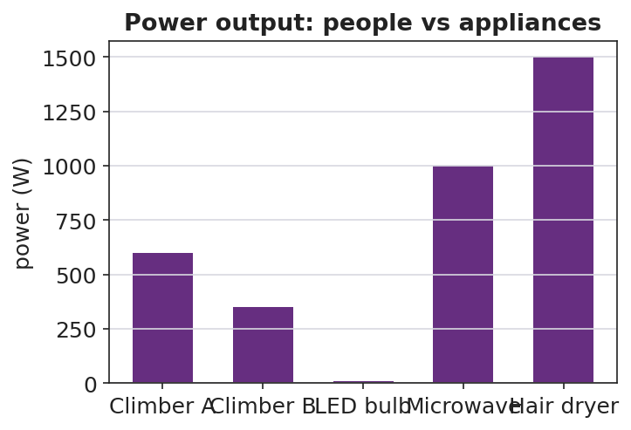
Power output of people vs household appliances
Teacher facilitation language:
“You climbed the same stairs twice. Same work? Then why is your power different?” “Whose power is bigger — and is it because of weight, height, or time? Isolate the variable.”
Anticipated student responses:
- “My second climb was faster, so my power went up even though the work was the same.” — exactly; P = W/t.
- “A heavier person doing the same climb in the same time has more power.” — yes; more work in the same time.

Teacher facilitation during Explore
- What to look for — students dividing work by time and getting watts; recognizing same-work/different-time.
- What to resist — don’t define “watt” until students need a name for W/t.
- What to redirect — “faster always means more work” → no, faster means same work in less time, so more power.

Phase 3 · Explain (28 – 35 min)

28–31 min · Turn-and-Talk #2 + class consensus
“From the lab: what single number tells us how fast work is done, and how did you compute it?”
Target consensus:
“Power is work divided by time, P = W/t. The same work done in less time is more power. For something moving at steady speed, power is also force times speed, P = Fv.”

31–35 min · Vocabulary introduction (≤ 3 terms)
From the reference table: P = W/t = Fv. The unit of power is the watt (W) — one watt is one joule per second (1 W = 1 J/s).
Sample teacher language:
“Power, the rate at which work is done, is measured in watts — joules per second. Energy is what gets transferred; power is how fast it’s transferred. Your stair climb was a few hundred watts; a hair dryer is over a thousand.”

Discussion prompts to deploy here
- “Two motors raise the same load the same height. Motor A takes 2 s, motor B takes 8 s. Which is more powerful, and by how much?”
  - Sample response: “A — same work, one-fourth the time, so four times the power.”
- “A 60 W bulb runs for 10 s. How much energy did it use?”
  - Sample response: “W = P·t = 60 × 10 = 600 J.”

Phase 4 · Elaborate (35 – 40 min)

35–38 min · Revise the model + read the graph
“Plot work vs. time for the fast climber and the slow climber. What does the slope of each line represent?”
Project:
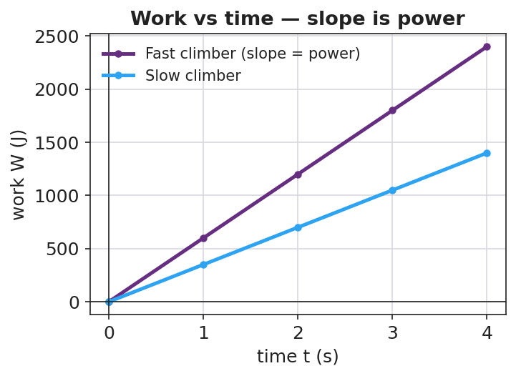
Work vs time: the slope of each line is the power
Target: the slope of a work-vs-time graph is the power; a steeper line = more power. Tie back to P = W/t.

38–40 min · Return to the phenomenon
“In one sentence, explain why the fast stair-climber is ‘more powerful’ than the slow one even though they did the same work. Use the words power and time.”

Phase 5 · Evaluate (40 – 42 min)

40–42 min · Exit Ticket + Closing Reflection
“An elevator does 48,000 J of work lifting a load. (a) If it takes 8.0 s, what is its power output? Show P = W/t. (b) A second elevator does the same 48,000 J in 16 s. How does its power compare? (c) A 700 N student runs up a 4.0 m staircase in 5.0 s. What is the student’s power output?”
Expected: (a) 6000 W; (b) half the power (3000 W) — same work, twice the time; (c) W = 700 × 4.0 = 2800 J, P = 2800/5.0 = 560 W. See Answer_Key.docx.
Closing Reflection (SEL, 30 seconds):
“What is one thing you can now measure about yourself that you couldn’t this morning — and who helped you figure it out?”

Common Misconceptions
- Misconception: “More power means more work.” → Correction: Power is the rate of work; the same work done faster is more power even though total work is unchanged.
- Misconception: “Power and energy are the same thing.” → Correction: Energy (joules) is the quantity transferred; power (watts) is how fast it transfers — joules per second.
- Misconception: “A watt is a unit of energy.” → Correction: A watt is a unit of power (1 W = 1 J/s); a watt-second is a joule of energy.

Access & Differentiation
- ELL/ENL supports: Sentence frame: *“The ___ climber has more power because they did the same work in ___ time, so P = W/t is ___.”* Word box: {power, watt, energy, rate, per second}. Build a “per second” gesture (tapping a beat).
- IEP/SPED supports: Provide a pre-built data table with labeled columns (weight, height, time) and the P = W/t formula with one row worked. Offer the timer/recorder role to students who opt out of climbing — full participation, no physical demand.
- Extensions: Convert personal power to horsepower (1 hp ≈ 746 W) and compare to a car engine; explore why sprinting up stairs cannot be sustained (peak vs. average power).

Strategy Spotlight
ACTIVE LEARNING. The whole lesson is built on student-generated data: each learner measures their own weight, height, and time, then computes their own power. The comparison that matters — same work, different time — emerges from their two trials, not from the teacher. Assign clear roles (climber, timer, recorder, calculator) so every student is doing physics, and rotate so opt-out students still own the math. The graph in Phase 4 turns their messy data into the clean “slope = power” idea.

NYSSLS Observation Checklist Crosswalk
# | Checklist item | Where it appears in this lesson
1 | Local/relatable phenomenon | Phase 1 — two students climbing the same stairs
2 | Turn and Talk (2–3×) | Phase 1 (TT#1 — what makes the fast climber different), Phase 3 (TT#2 — defining P = W/t)
3 | Students develop questions/models/procedures | Phase 1 (initial model), Phase 2 (stair-climb lab), Phase 4 (revise model)
4 | CCC defined and used | Lesson Overview · Systems and System Models, applied in Phase 2
5 | ENL — ≤ 3 vocab, second half | Phase 3 — vocabulary at 31–35 min (power / watt / energy)
6 | Revisit phenomenon with evidence | Phase 4 — work-vs-time slope; restate the two-climber result
7 | ENL/SPED supports | Access & Differentiation block
8 | Assessment check | Phase 5 — Exit Ticket (elevators + stair runner)

Companion Materials
- Student_Worksheet.docx — the 5E student investigation + stair-climb lab table (hand out at start of Phase 2)
- Student_Notes.docx — guided note-guide for vocabulary and the worked example
- Answer_Key.docx — answers to “Make It Make Sense” prompts and the Exit Ticket

Key Vocabulary (max 3)
- power — the rate at which work is done (energy transferred per unit time); P = W/t = Fv
- watt — the SI unit of power; one watt equals one joule per second (1 W = 1 J/s)
- energy — the capacity to do work, measured in joules; power tells how fast energy is transferred

Power — Student Worksheet
Unit: Work, Energy & Power — Lesson 02 Name: _______________________ Date: __________ Period: ____

Phenomenon
Two students climb the same staircase. One climbs fast, one climbs slowly. Both reach the top, so both did about the same work against gravity — but everyone agrees something is different.
Driving question: If two people do the same work, what makes one of them “more powerful,” and how do we measure it?

Notice & Wonder
I notice… | I wonder…
Turn & Talk #1: If both climbers did the same work, what made the fast climber different? Use the word time.

Initial Model
Write, in words, a formula for “how fast work is done.” What would you divide by what?
How-fast-work-is-done = ____________ ÷ ____________
My prediction — who has more of it, a heavier climber or a faster climber? Why? _______________________________________________

Investigation — Stair-Climb Personal-Power Lab
Roles: climber, timer, recorder, calculator. Walk, hold the rail, one at a time. Record two trials for the same climber.
Trial | Weight F (N) | Vertical height d (m) | Work W = F·d (J) | Time t (s) | Power P = W/t (W)
1 (normal pace)
2 (faster)

Power output: people vs appliances
Key question: Your two trials did the same work. Why was your power different? What changed?

Make It Make Sense
- Two motors raise the same load the same height. Motor A takes 2.0 s; motor B takes 8.0 s. Which motor is more powerful, and by what factor? Explain.
- A 60 W light bulb runs for 10 seconds. How much energy does it use? (Hint: rearrange P = W/t.)
- Your friend says, “The faster climber did more work.” Correct your friend using the words work, time, and power.

Vocabulary in Action
Use each term in a sentence about today’s phenomenon.
- power: _______________________________________________
- watt: _______________________________________________
- energy: _______________________________________________

Revise Your Model
Plot work vs. time for a fast climber and a slow climber. What does the slope of each line represent? Rewrite your explanation of “more powerful” in one sentence using power and time.

Work vs time — slope is power
The slope of a work-vs-time graph represents ____________. The fast climber is more powerful because _______________________________________________

Exit Ticket
An elevator does 48,000 J of work lifting a load.
- If it takes 8.0 s, what is its power output? Show P = W/t.
- A second elevator does the same 48,000 J in 16 s. How does its power compare to the first?
- A 700 N student runs up a 4.0 m staircase in 5.0 s. What is the student’s power output?

Power — Student Notes
Unit: Work, Energy & Power — Lesson 02 Name: _______________________ Date: __________ Period: ____

Learning Targets
By the end of today’s 42 minutes I can:
- Define power and state its unit, the watt.
- Calculate power with P = W/t (and recognize P = Fv).
- Explain why the same work done in less time means more power.

Key Vocabulary
- power — _______________________________________________
- watt — _______________________________________________
- energy — _______________________________________________

Guided Notes
Big idea: Power is the __________ at which work is done — how __________ energy is transferred.
- Reference-table formula: P = W/t = Fv, where W is __________ (J) and t is __________ (s).
- The unit of power is the __________ (W). One watt = one __________ per __________ (1 W = 1 J/s).
- Energy (joules) is the amount transferred; power (watts) is how __________ it is transferred.
- Same work in __________ time → __________ power.
- Rearranged: energy used = P × t, so a 100 W device for 5 s uses __________ J.
Slope of a work-vs-time graph = __________. A steeper line means __________ power.


Work vs. time: the slope of the line is power (P = W/t). A steeper line means the same work is done faster — more power.

Worked Example
Problem. A 600 N student climbs a 5.0 m staircase in 4.0 s. What is the student’s power output?
Solution. 1. Find the work: W = F·d = __________ N × __________ m = __________ J. 2. Use the power formula: P = W/t = __________ J ÷ __________ s. 3. Compute: P = __________ W. 4. Units check: joules ÷ seconds = __________ = watts. ✓

Summary
Finish the sentence (Because / But / So):
The fast climber and the slow climber did the same work because __________________________________________, but __________________________________________, so __________________________________________.

Power — Answer Key

Cover
Unit: Work, Energy & Power — Lesson 02: Power East Meadow Schools × Valley Stream Central HSD Strategy chip: ACTIVE LEARNING

Make-It-Make-Sense Answers
- Same work, but motor A takes 2.0 s and motor B takes 8.0 s — one-fourth the time. Since P = W/t, motor A has four times the power of motor B. · Rubric: identifies same work AND the 4× factor from the time ratio. · NYSSLS: HS-PS3-1
- Rearrange P = W/t → W = P·t = 60 W × 10 s = 600 J. · Rubric: correct rearrangement AND 600 J with unit. · NYSSLS: HS-PS3-1
- The faster climber did not do more work — both climb the same height, so both do the same work against gravity. The faster climber did that same work in less time, so they have more power (P = W/t). · Rubric: corrects “more work” to “same work, less time, more power.” · NYSSLS: HS-PS3-1

Exit Ticket Answer
- P = W/t = 48,000 J ÷ 8.0 s = 6000 W (6.0 kW).
- Same work in twice the time → half the power = 3000 W.
- Work first: W = F·d = 700 N × 4.0 m = 2800 J. Then P = W/t = 2800 J ÷ 5.0 s = 560 W.
Tolerance/rubric: (a) shows W/t and 6000 W; (b) 3000 W with “twice the time, half the power”; (c) computes W = 2800 J then P = 560 W. 1 point each. NYSSLS: HS-PS3-1.

Closing Reflection (rubric)
Closing reflection is formative, not graded. Award full credit for any honest response. Look for: - A genuine “something I can now measure about myself” statement - Naming a peer or self-acknowledgment

Kinetic Energy — Teacher Guide

Cover
Unit: Work, Energy & Power — Lesson 03: Kinetic Energy East Meadow Schools × Valley Stream Central High School District Strategy chips: BTC

Curated Resources (from East Meadow Scope & Sequence)

NYSSLS Standards
Kinetic energy names the energy of motion — the macroscopic “energy of motion of particles” half of HS-PS3-2: “Develop and use models to illustrate that energy at the macroscopic scale can be accounted for as a combination of energy associated with the motions of particles (objects) and energy associated with the relative positions of particles (objects).” (CCC: Energy and Matter.) It also supplies a quantity for HS-PS3-1 energy models: the moving component’s energy is ½mv².

Phenomenon
- Car stopping distance vs. speed — doubling speed roughly quadruples the stopping distance. https://www.youtube.com/watch?v=PIA1AfQfM4U (Stopping distance and speed)
- The Physics Classroom — “Kinetic Energy”: https://www.physicsclassroom.com/class/energy/Lesson-1/Kinetic-Energy

Javalab / Labs
- Javalab energy index (kinetic/potential sims for VNPS support): https://javalab.org/en/category/energy_en/

Assessments
- The Physics Classroom kinetic-energy problem set (link above). The Exit Ticket below is the formative check; the “Make It Make Sense” items map to HS-PS3-2.

Lesson Overview
Duration | 42 minutes (1 period)
NYSSLS link | HS-PS3-2 (energy of motion); supports HS-PS3-1
CCC focus | Energy and Matter — kinetic energy is the energy a moving object carries because of its motion.
Strategy chips | BTC (random groups, vertical non-permanent surfaces, a thin-sliced KE = ½mv² task)
Materials | Vertical whiteboards / wall surfaces + markers; calculators; visibly random grouping cards; the stopping-distance video.
Safety | Standard classroom movement protocols for VNPS rotation.
Prior knowledge | Work (W = F·d), the joule; speed/velocity from Kinematics.
Lesson objectives — students can:
- Define kinetic energy as the energy of motion and compute it with KE = ½mv².
- Explain why kinetic energy depends on the square of speed: doubling the speed multiplies KE by four.
- Use the v² relationship to reason about why fast cars need far more stopping distance.

Phase 1 · Engage (0 – 10 min)

0–3 min · Opening Connection (SEL)
Pair-share, one sentence: “Describe a time you (or a car) needed way more room to stop than you expected.” Surface a couple. Plant the puzzle that speed changes stopping distance more than people think.

3–7 min · Phenomenon hook — stopping distance vs. speed
Teacher actions. Play the stopping-distance clip (or show a stopping-distance table). At 20 mph vs. 40 mph, the stopping distance roughly quadruples, not doubles.
Sample teacher language:
“Speed only doubled — 20 to 40. So why does it take four times the distance to stop? The energy of motion isn’t growing the way you’d guess.”
Anticipated student responses:
- “Double the speed, double the distance.” — capture this prediction; the data will contradict it.
- “It’s heavier when it’s faster?” — no, mass is unchanged; the change is in speed.
- “Faster means way more energy somehow.” — yes; we’ll find the v² rule.

7–10 min · Notice & Wonder + Turn-and-Talk #1
Two columns. Then:
“Turn to your partner: if speed only doubled, why might the energy grow by more than double? Make a guess about the math.”

Bridge to Phase 2
Each student leaves with an initial model: “When the car’s speed doubles, its energy of motion ______ because ______.”

Phase 2 · Explore (10 – 28 min)

10–13 min · BTC setup — visibly random groups + VNPS
Form visibly random groups of 3 with cards. Each group claims a vertical non-permanent surface (whiteboard/wall). No sitting; thinking happens standing at the board.

13–28 min · Thin-sliced task — building KE = ½mv²
Reveal the task one slice at a time; let early groups race ahead. Give m = 1000 kg throughout so the v² pattern is unmasked.
- Compute KE at v = 10 m/s using KE = ½mv².
- Now v = 20 m/s (double). Compare to slice 1 — by what factor did KE grow?
- Now v = 30 m/s (triple). Factor?
- Generalize: “If speed becomes n times bigger, KE becomes ____ times bigger. Why?”
- Extension slice: two cars, same speed, one twice the mass — compare KE.
Project the building pattern when most groups reach slice 3:
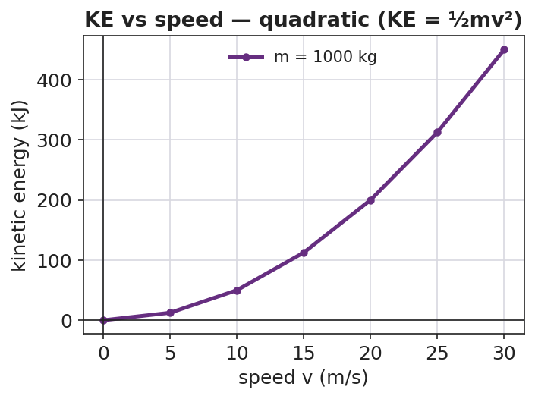
Kinetic energy vs speed is a quadratic curve
Teacher facilitation language (BTC — answer questions with questions):
“You doubled v and KE went up by four — where did the 4 come from in ½mv²?” “Will tripling the speed triple the energy? Test it on the board before you tell me.”
Anticipated student responses:
- “Doubling v gave 4× because we square the velocity!” — the target insight.
- “Tripling gives 9× — it’s n².” — generalization reached.

Teacher facilitation during Explore
- What to look for — groups connecting the v² in the formula to the 4×, 9× growth.
- What to resist — don’t confirm answers; bounce questions back; let groups check each other’s boards.
- What to redirect — groups computing 2× growth → “show me 20² vs 10² — is that doubling?”

Phase 3 · Explain (28 – 35 min)

28–31 min · Turn-and-Talk #2 + class consensus
“Tour two other boards. What is the rule connecting speed to kinetic energy?”
Target consensus:
“Kinetic energy is ½mv². Because the speed is squared, doubling the speed gives four times the KE, and tripling gives nine times. Mass matters too, but only to the first power.”

31–35 min · Vocabulary introduction (≤ 3 terms)
From the reference table: KE = ½mv², in joules. Name the terms.
Sample teacher language:
“Kinetic energy is the energy of motion. It grows with mass to the first power, but with speed squared — that v² is why a small jump in speed is a big jump in energy, and a big jump in stopping distance.”

Discussion prompts to deploy here
- “A 2.0 kg ball moves at 3.0 m/s. What is its KE?”
  - Sample response: “KE = ½(2.0)(3.0²) = ½(2.0)(9.0) = 9.0 J.”
- “Why is a highway speed limit so important for safety, in energy terms?”
  - Sample response: “A small speed increase squares into a large KE increase, so far more energy must be removed to stop — much longer stopping distance.”

Phase 4 · Elaborate (35 – 40 min)

35–38 min · Revise the model + the bar chart
“Return to your initial model. Using KE = ½mv², make a bar chart of KE at 1×, 2×, and 3× speed for the same car. Label each bar with the factor (1, 4, 9).”
Project:
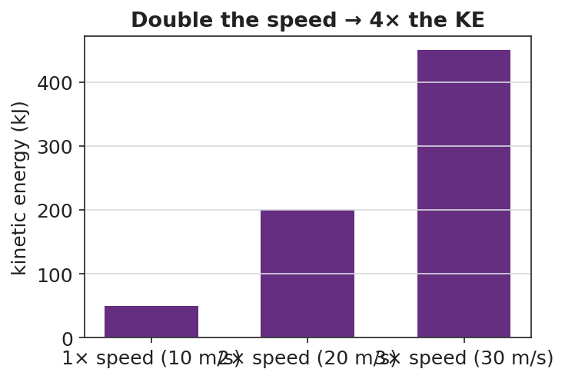
Kinetic energy at 1×, 2×, 3× speed — bars in ratio 1:4:9
Target: the bars are in the ratio 1 : 4 : 9, matching n².

38–40 min · Return to the phenomenon
“In one sentence, explain why a car at 40 mph needs about four times the stopping distance of a car at 20 mph. Use KE = ½mv².”

Phase 5 · Evaluate (40 – 42 min)

40–42 min · Exit Ticket + Closing Reflection
“A 1500 kg car travels at 10 m/s. (a) Calculate its kinetic energy. Show KE = ½mv². (b) The car speeds up to 20 m/s. What is its new KE, and by what factor did it change? (c) In one sentence, explain why doubling speed makes the car so much harder to stop.”
Expected: (a) 75,000 J; (b) 300,000 J — 4×; (c) KE depends on v², so doubling v quadruples KE, requiring 4× the work/distance to stop. See Answer_Key.docx.
Closing Reflection (SEL, 30 seconds):
“What is one idea your group cracked today that you couldn’t alone — and who pushed the thinking forward?”

Common Misconceptions
- Misconception: “Double the speed, double the kinetic energy.” → Correction: KE depends on v², so doubling speed quadruples KE.
- Misconception: “Mass affects KE the same way speed does.” → Correction: Mass is to the first power, speed is squared — speed has a far stronger effect.
- Misconception: “A stopped object has some kinetic energy.” → Correction: If v = 0, KE = ½m(0)² = 0; kinetic energy requires motion.

Access & Differentiation
- ELL/ENL supports: Sentence frame: *“When the speed becomes ___ times bigger, the kinetic energy becomes ___ times bigger because the speed is ___.”* Word box: {kinetic energy, mass, speed, squared, four times}. Provide a labeled ½mv² formula card.
- IEP/SPED supports: Pre-fill the m and v values in a table so the cognitive load is on the squaring and the pattern, not setup. Allow calculator use for v². Provide the bar chart pre-drawn for labeling.
- Extensions: Derive KE = ½mv² from work: a net force does work W = F·d on a mass, and with kinematics this equals ½mv². Explore why kinetic energy is always positive.

Strategy Spotlight
BTC (Building Thinking Classrooms). This lesson uses the three core BTC moves: visibly random groups (cards, no friend-clusters), vertical non-permanent surfaces (everyone standing and writing at boards), and a thin-sliced task (KE at 1×, 2×, 3× speed) that lets every group find an entry point and lets fast groups push to the n² generalization. Answer questions with questions; let groups verify against neighboring boards rather than against you. The v² pattern is discovered, not told.

NYSSLS Observation Checklist Crosswalk
# | Checklist item | Where it appears in this lesson
1 | Local/relatable phenomenon | Phase 1 — car stopping distance vs. speed
2 | Turn and Talk (2–3×) | Phase 1 (TT#1 — why energy grows more than double), Phase 3 (TT#2 — board tour consensus)
3 | Students develop questions/models/procedures | Phase 1 (initial model), Phase 2 (VNPS thin-sliced task), Phase 4 (revise model)
4 | CCC defined and used | Lesson Overview · Energy and Matter, applied in Phase 2
5 | ENL — ≤ 3 vocab, second half | Phase 3 — vocabulary at 31–35 min (kinetic energy / mass / speed)
6 | Revisit phenomenon with evidence | Phase 4 — 1:4:9 bar chart; restate stopping distance
7 | ENL/SPED supports | Access & Differentiation block
8 | Assessment check | Phase 5 — Exit Ticket (1500 kg car)

Companion Materials
- Student_Worksheet.docx — the 5E student investigation + thin-sliced task (hand out at start of Phase 2)
- Student_Notes.docx — guided note-guide for vocabulary and the worked example
- Answer_Key.docx — answers to “Make It Make Sense” prompts and the Exit Ticket

Key Vocabulary (max 3)
- kinetic energy — the energy an object has because of its motion; KE = ½mv², in joules
- mass — the amount of matter in an object (kg); kinetic energy is proportional to mass (first power)
- speed — how fast an object moves (m/s); kinetic energy is proportional to speed squared (v²)

Kinetic Energy — Student Worksheet
Unit: Work, Energy & Power — Lesson 03 Name: _______________________ Date: __________ Period: ____

Phenomenon
A car at 20 mph and the same car at 40 mph: the speed only doubled, but the distance needed to stop roughly quadruples. The energy of motion is not growing the way you’d expect.
Driving question: How does the energy of a moving object depend on its speed — and why does a small speed increase make it so much harder to stop?

Notice & Wonder
I notice… | I wonder…
Turn & Talk #1: If the speed only doubled, why might the energy of motion grow by more than double? Make a guess about the math.

Initial Model
Write your prediction before any calculating.
When the car’s speed doubles, I predict its energy of motion becomes ____________ times bigger, because _______________________________________________

Investigation — Thin-Sliced Task (at the board)
Use KE = ½mv² with m = 1000 kg for every slice. Work at your group’s board.
Slice | Speed v (m/s) | KE = ½mv² (J) | Factor vs. Slice 1
1 | 10 |  | 1
2 | 20 (double)
3 | 30 (triple)

KE vs speed — quadratic curve
Generalize: If the speed becomes n times bigger, the kinetic energy becomes ____________ times bigger. Why?

Make It Make Sense
- A 2.0 kg ball moves at 3.0 m/s. Calculate its kinetic energy. Show KE = ½mv².
- Two identical cars move down the road. Car A goes 15 m/s; car B goes 30 m/s. How many times more kinetic energy does car B have? Explain using v².
- Your friend says “double the speed, double the energy.” Use the formula to correct your friend.

Vocabulary in Action
Use each term in a sentence about today’s phenomenon.
- kinetic energy: _______________________________________________
- mass: _______________________________________________
- speed: _______________________________________________

Revise Your Model
Make a bar chart of KE at 1×, 2×, and 3× speed for the same car. Label each bar with its factor.

KE at 1×, 2×, 3× speed
The bars are in the ratio ____ : ____ : ____ . Revise your prediction: when speed doubles, KE becomes ____________ times bigger because _______________________________________________

Exit Ticket
A 1500 kg car travels at 10 m/s.
- Calculate its kinetic energy. Show KE = ½mv².
- The car speeds up to 20 m/s. What is its new kinetic energy, and by what factor did it change?
- In one sentence, explain why doubling the speed makes the car so much harder to stop.

Kinetic Energy — Student Notes
Unit: Work, Energy & Power — Lesson 03 Name: _______________________ Date: __________ Period: ____

Learning Targets
By the end of today’s 42 minutes I can:
- Define kinetic energy and compute it with KE = ½mv².
- Explain why KE depends on the square of speed.
- Use the v² rule to reason about stopping distance.

Key Vocabulary
- kinetic energy — _______________________________________________
- mass — _______________________________________________
- speed — _______________________________________________

Guided Notes
Big idea: Kinetic energy is the energy an object has because of its __________.
- Reference-table formula: KE = ½mv², where m is __________ (kg) and v is __________ (m/s). Unit: __________ (J).
- Kinetic energy depends on mass to the __________ power.
- Kinetic energy depends on speed __________ (the v² term).
- Because speed is squared: doubling v multiplies KE by __________; tripling v multiplies KE by __________.
- If an object is at rest (v = 0), its kinetic energy is __________.
Pattern table (m = 1000 kg):
Speed | KE | Factor
10 m/s | 50,000 J | 1
20 m/s | __________ J | __________
30 m/s | __________ J | __________


Kinetic energy vs. speed (KE = ½mv²): because KE depends on v², doubling the speed gives four times the kinetic energy.

Worked Example
Problem. A 1200 kg car is moving at 25 m/s. What is its kinetic energy?
Solution. 1. List knowns: m = __________ kg, v = __________ m/s. 2. Formula: KE = ½mv² = ½ × __________ × (__________)². 3. Square the speed first: (25)² = __________. 4. Multiply: KE = ½ × 1200 × 625 = __________ J.

Summary
Finish the sentence (Because / But / So):
A car at 40 mph needs about four times the stopping distance of a car at 20 mph because __________________________________________, but __________________________________________, so __________________________________________.

Kinetic Energy — Answer Key

Cover
Unit: Work, Energy & Power — Lesson 03: Kinetic Energy East Meadow Schools × Valley Stream Central HSD Strategy chip: BTC

Make-It-Make-Sense Answers
- KE = ½mv² = ½ × 2.0 kg × (3.0 m/s)² = ½ × 2.0 × 9.0 = 9.0 J. · Rubric: squares the speed first AND reports 9.0 J. · NYSSLS: HS-PS3-2
- Car B’s speed is double car A’s. Since KE ∝ v², doubling v gives four times the kinetic energy. (Check: A = ½m(15²) = ½m(225); B = ½m(30²) = ½m(900); 900/225 = 4.) · Rubric: answer is 4× AND justified by v². · NYSSLS: HS-PS3-2
- Doubling the speed does not double the energy — KE = ½mv² has speed squared, so doubling v gives 2² = four times the kinetic energy. · Rubric: corrects “double” to “four times” using the v² term. · NYSSLS: HS-PS3-2

Exit Ticket Answer
- KE = ½mv² = ½ × 1500 kg × (10 m/s)² = ½ × 1500 × 100 = 75,000 J (7.5 × 10⁴ J).
- KE = ½ × 1500 × (20)² = ½ × 1500 × 400 = 300,000 J (3.0 × 10⁵ J) — a factor of 4× (because speed doubled and KE ∝ v²).
- Kinetic energy depends on v², so doubling the speed quadruples the energy of motion; about four times as much work (and stopping distance) is needed to bring it to rest.
Tolerance/rubric: (a) shows ½mv² and 75,000 J; (b) 300,000 J AND the 4× factor; (c) ties the 4× difficulty to v². 1 point each. NYSSLS: HS-PS3-2.

Closing Reflection (rubric)
Closing reflection is formative, not graded. Award full credit for any honest response. Look for: - A genuine “my group cracked this together” statement - Naming a peer who pushed the thinking forward

Gravitational Potential Energy — Teacher Guide

Cover
Unit: Work, Energy & Power — Lesson 04: Gravitational Potential Energy East Meadow Schools × Valley Stream Central High School District Strategy chips: HOCHMAN

Curated Resources (from East Meadow Scope & Sequence)

NYSSLS Standards
Gravitational potential energy names the “energy associated with relative position” half of HS-PS3-2: “Develop and use models to illustrate that energy at the macroscopic scale can be accounted for as a combination of energy associated with the motions of particles (objects) and energy associated with the relative positions of particles (objects).” (CCC: Energy and Matter.) Together with Lesson 03 (KE = motion), PE = mgh completes the two-component macroscopic energy account and feeds the HS-PS3-1 energy model.

Phenomenon
- A roller-coaster lift hill / a water tower: stored energy that depends on height above the ground. https://www.youtube.com/watch?v=Anv2Rr-A3MI (Roller coaster energy)
- The Physics Classroom — “Potential Energy”: https://www.physicsclassroom.com/class/energy/Lesson-1/Potential-Energy

Javalab / Labs
- Javalab — Potential energy due to gravity (this lesson’s interactive): https://javalab.org/en/potential_energy_en/

Assessments
- The Physics Classroom potential-energy problem set (link above). The Exit Ticket below is the formative check; the “Make It Make Sense” items map to HS-PS3-2.

Lesson Overview
Duration | 42 minutes (1 period)
NYSSLS link | HS-PS3-2 (energy of relative position); supports HS-PS3-1
CCC focus | Energy and Matter — stored energy depends on an object’s position (height) relative to a reference.
Strategy chips | HOCHMAN (appositive + Because/But/So on PE = mgh and the reference height)
Materials | Computers/tablets for the Javalab sim; masses at different heights (book on desk vs. shelf); meter stick; whiteboards.
Safety | Keep raised masses secured; do not let objects fall on people or devices.
Prior knowledge | Work (W = F·d), the joule; weight = mass × g; g ≈ 9.81 m/s².
Lesson objectives — students can:
- Define gravitational potential energy as stored energy that depends on height and compute it with PE = mgh.
- Explain why PE is measured relative to a chosen reference height (ground, floor, table).
- Predict how PE changes when height or mass changes, and connect lift-hill height to a coaster’s stored energy.

Phase 1 · Engage (0 – 10 min)

0–3 min · Opening Connection (SEL)
Pair-share, one sentence: “Name the highest place you’ve ever climbed or stood — and how it felt to look down.” Surface a couple. Plant the intuition that height feels like stored “ready-to-fall” energy.

3–7 min · Phenomenon hook — the lift hill / water tower
Teacher actions. Show the slow climb up a roller-coaster lift hill (or a water tower). Pause at the top before the drop.
Sample teacher language:
“Nothing exciting happens on the way up — the chain just hauls the car higher. But every meter of height is storing something the coaster will spend on the way down. What is being stored, and what does it depend on?”
Anticipated student responses:
- “It’s storing speed for later.” — close; it stores energy that will become speed.
- “The higher it goes, the bigger the drop.” — capture height as the key variable.
- “A heavier car stores more.” — yes; mass matters too.

7–10 min · Notice & Wonder + Turn-and-Talk #1
Two columns. Then:
“Turn to your partner: what two things about the coaster car decide how much energy is stored at the top? Use the word height.”

Bridge to Phase 2
Each student leaves with an initial model: “Stored energy at the top depends on ______ because ______.”

Phase 2 · Explore (10 – 28 min)

10–14 min · Initial Model (silent / individual)
Prompt:
“Draw the coaster on the lift hill at three heights. Predict how the stored energy changes as the height doubles. Does it double? More? Less?”

14–28 min · Investigation — Javalab “Potential energy due to gravity”
Students use the Javalab sim (https://javalab.org/en/potential_energy_en/) and a desk/shelf comparison.
- Set a mass at height h; read/record PE. Double h; record again. What happened to PE?
- Keep h fixed; double the mass. What happened to PE?
- Move the reference line (floor → tabletop): does the same object now have a different PE? Why?
- Tabulate PE vs. h for a fixed mass.
Project as data come in:
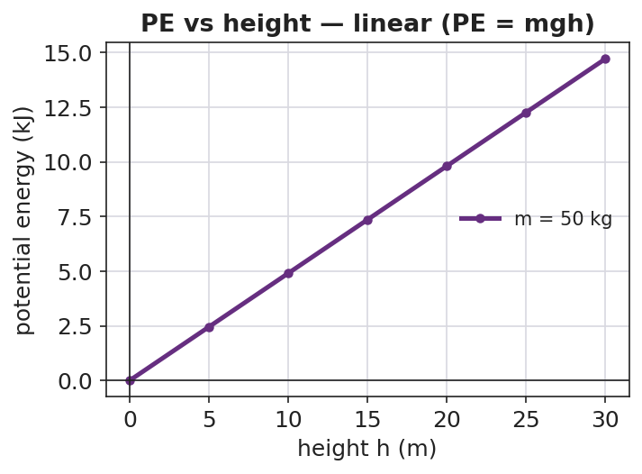
Gravitational PE vs height is a straight line through the origin
Teacher facilitation language:
“You doubled the height — what did the stored energy do? Now predict tripling before you test.” “When you moved the reference line, the object didn’t move — so why did the PE number change?”
Anticipated student responses:
- “Doubling the height doubled the PE — it’s a straight line.” — yes; PE ∝ h.
- “PE changed when we moved the zero line — so ‘height’ is measured from somewhere.” — land the reference-height idea.

Teacher facilitation during Explore
- What to look for — students seeing PE ∝ h (linear) and recognizing that PE is relative to a chosen zero.
- What to resist — don’t pre-state PE = mgh; let the sim build the proportionality.
- What to redirect — “PE is just height” → no, it’s mass × g × height; height alone isn’t energy.

Phase 3 · Explain (28 – 35 min)

28–31 min · Turn-and-Talk #2 + class consensus
“From the sim: what three things set the stored energy, and why does the reference height matter?”
Target consensus:
“Gravitational potential energy is mass × g × height: PE = mgh. It grows in a straight line with height. The height must be measured from a chosen reference — change the reference and the number changes, because PE is about relative position.”

31–35 min · Vocabulary introduction (≤ 3 terms) + HOCHMAN
From the reference table: PE = mgh, with g ≈ 9.81 m/s², in joules.
Sample teacher language (Hochman appositive + Because/But/So):
“Appositive: Gravitational potential energy, the energy stored because of an object’s height above a reference point, equals mgh. Because/But/So: We can call the floor ‘zero height’ because PE is measured relative to a reference, but if we chose the tabletop as zero the same book would have less PE, so PE depends on the reference we pick.”

Discussion prompts to deploy here
- “A 2.0 kg book sits on a 1.0 m table. What is its PE relative to the floor? (g ≈ 9.81)”
  - Sample response: “PE = mgh = 2.0 × 9.81 × 1.0 ≈ 19.6 J.”
- “Why does a water tower need to be tall?”
  - Sample response: “Height gives the water gravitational PE, which provides pressure to push water through the pipes.”

Phase 4 · Elaborate (35 – 40 min)

35–38 min · Revise the model + the bar chart
“Return to your three-height drawing. Using PE = mgh, make a bar chart of PE at several lift-hill heights for one car. What pattern do the bar heights follow?”
Project:
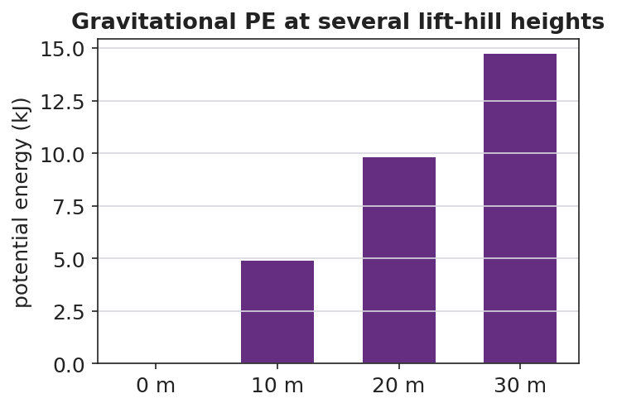
Gravitational PE at several lift-hill heights — bars grow in proportion to height
Target: bar heights are proportional to the lift-hill height — double the height, double the stored energy (a linear pattern).

38–40 min · Return to the phenomenon
“In one Because/But/So sentence, explain why the tallest lift hill stores the most energy — and why we always state PE relative to the ground.”

Phase 5 · Evaluate (40 – 42 min)

40–42 min · Exit Ticket + Closing Reflection
“A 500 kg roller-coaster car is hauled to the top of a 30 m lift hill. (Use g ≈ 9.81 m/s².) (a) Calculate its gravitational potential energy relative to the ground. Show PE = mgh. (b) If the lift hill were only 15 m, what would its PE be, and how does it compare? (c) Explain why your answer to (a) would change if we measured height from a platform halfway up instead of the ground.”
Expected: (a) ≈ 147,150 J; (b) ≈ 73,575 J — half; (c) PE depends on the reference height, so a higher zero gives a smaller h and thus a smaller PE. See Answer_Key.docx.
Closing Reflection (SEL, 30 seconds):
“What is one idea about ‘stored energy’ you’ll carry out of here — and who helped it click?”

Common Misconceptions
- Misconception: “Potential energy is just an object’s height.” → Correction: PE = mgh — it depends on mass and g as well as height; height alone is not energy.
- Misconception: “An object has one true potential energy.” → Correction: PE is measured relative to a chosen reference; change the reference and the PE value changes.
- Misconception: “Heavier objects always fall faster, so they store more PE per height.” → Correction: PE scales with mass (mgh), but in free fall all masses accelerate at g; the two ideas are separate.

Access & Differentiation
- ELL/ENL supports: Sentence frame: *“The object stores more potential energy when its ___ is greater, because PE = m·g·___.”* Word box: {potential energy, height, gravitational field, reference, stored}. Pair “stored” with a “loading-up” gesture.
- IEP/SPED supports: Provide the PE = mgh formula card with g ≈ 9.81 already filled in. Pre-label the reference line on the diagram. Allow the Javalab sim as a hands-on alternative to symbolic work.
- Extensions: Combine with Lesson 03: predict the speed at the bottom of the hill by setting the PE lost equal to KE gained (preview of conservation, Lesson 05).

Strategy Spotlight
HOCHMAN (literacy). The writing moves are the appositive (defining gravitational PE inside the sentence) and Because/But/So to capture the subtle reference-height idea — the place students most often lose precision. Model the appositive, then have students expand the kernel “PE is stored energy” into a full definition naming height and reference. The Because/But/So in Phase 4 forces them to articulate why the reference matters in one controlled sentence; collect and revise two or three as a class.

NYSSLS Observation Checklist Crosswalk
# | Checklist item | Where it appears in this lesson
1 | Local/relatable phenomenon | Phase 1 — roller-coaster lift hill / water tower
2 | Turn and Talk (2–3×) | Phase 1 (TT#1 — what sets stored energy), Phase 3 (TT#2 — PE = mgh + reference)
3 | Students develop questions/models/procedures | Phase 1 (initial model), Phase 2 (Javalab sim investigation), Phase 4 (revise model)
4 | CCC defined and used | Lesson Overview · Energy and Matter, applied in Phase 2
5 | ENL — ≤ 3 vocab, second half | Phase 3 — vocabulary at 31–35 min (potential energy / height / gravitational field)
6 | Revisit phenomenon with evidence | Phase 4 — PE-at-heights bar chart; restate lift hill
7 | ENL/SPED supports | Access & Differentiation block
8 | Assessment check | Phase 5 — Exit Ticket (500 kg coaster car)

Companion Materials
- Student_Worksheet.docx — the 5E student investigation + Javalab sim guide (hand out at start of Phase 2)
- Student_Notes.docx — guided note-guide for vocabulary and the worked example
- Answer_Key.docx — answers to “Make It Make Sense” prompts and the Exit Ticket

Key Vocabulary (max 3)
- potential energy — energy stored because of an object’s position; gravitational PE = mgh, in joules
- height — the vertical distance above a chosen reference point; the h in PE = mgh
- gravitational field — the region where gravity acts; its strength g ≈ 9.81 m/s² near Earth’s surface sets the g in PE = mgh

Gravitational Potential Energy — Student Worksheet
Unit: Work, Energy & Power — Lesson 04 Name: _______________________ Date: __________ Period: ____

Phenomenon
A roller-coaster car is slowly hauled up the lift hill. Nothing exciting happens on the way up — but every meter of height stores energy the coaster will spend on the way down. A water tower does the same thing with water.
Driving question: What is being stored as the car climbs, and what does the amount of stored energy depend on?

Notice & Wonder
I notice… | I wonder…
Turn & Talk #1: What two things about the coaster car decide how much energy is stored at the top? Use the word height.

Initial Model
Draw the coaster car on the lift hill at three heights.
My prediction — when the height doubles, the stored energy becomes ____________ times bigger, because _______________________________________________

Investigation — Javalab: Potential energy due to gravity
Open https://javalab.org/en/potential_energy_en/. Record what changes the stored energy.
Test | What I changed | PE before | PE after | Effect
1. Double the height
2. Double the mass
3. Move the reference line (zero)

Gravitational PE vs height
Key question: In test 3 the object did not move, yet the PE number changed. Why?

Make It Make Sense
- A 2.0 kg book sits on a 1.0 m table. What is its gravitational PE relative to the floor? Use PE = mgh with g ≈ 9.81 m/s².
- Two coaster cars sit at the same height. Car A is 400 kg; car B is 800 kg. Which has more PE, and by what factor? Explain.
- Why must we always state the reference height (the “zero”) when we report a potential energy?

Vocabulary in Action
Use each term in a sentence about today’s phenomenon.
- potential energy: _______________________________________________
- height: _______________________________________________
- gravitational field: _______________________________________________

Revise Your Model
Using PE = mgh, make a bar chart of PE at several lift-hill heights for one car. What pattern do the bar heights follow?

Gravitational PE at several heights
The bar heights follow this pattern: ____________ . Revise your prediction: when height doubles, PE becomes ____________ times bigger because _______________________________________________

Exit Ticket
A 500 kg roller-coaster car is hauled to the top of a 30 m lift hill. (Use g ≈ 9.81 m/s².)
- Calculate its gravitational potential energy relative to the ground. Show PE = mgh.
- If the lift hill were only 15 m, what would its PE be, and how does it compare to part (a)?
- Explain why your answer to (a) would change if we measured height from a platform halfway up instead of from the ground.

Gravitational Potential Energy — Student Notes
Unit: Work, Energy & Power — Lesson 04 Name: _______________________ Date: __________ Period: ____

Learning Targets
By the end of today’s 42 minutes I can:
- Define gravitational potential energy and compute it with PE = mgh.
- Explain why PE is measured relative to a reference height.
- Predict how PE changes when height or mass changes.

Key Vocabulary
- potential energy — _______________________________________________
- height — _______________________________________________
- gravitational field — _______________________________________________

Guided Notes
Big idea: Gravitational potential energy is energy __________ because of an object’s __________ above a reference point.
- Reference-table formula: PE = mgh, where m is __________ (kg), g ≈ __________ m/s², and h is __________ (m). Unit: __________ (J).
- PE grows in a __________ line with height: double the height → __________ the PE.
- PE also grows with __________: double the mass → __________ the PE.
- Height must be measured from a chosen __________. Change the reference → the PE value __________.
- g (the strength of the __________) is about 9.81 m/s² near Earth’s surface.
Pattern table (m = 50 kg, g ≈ 9.81):
Height | PE
10 m | ≈ __________ J
20 m | ≈ __________ J
30 m | ≈ __________ J


Gravitational potential energy vs. height (PE = mgh): PE increases in direct proportion to height above the reference level.

Worked Example
Problem. A 3.0 kg flowerpot sits on a balcony 5.0 m above the sidewalk. What is its gravitational PE relative to the sidewalk? (g ≈ 9.81 m/s²)
Solution. 1. List knowns: m = __________ kg, g ≈ __________ m/s², h = __________ m. 2. Formula: PE = mgh = __________ × __________ × __________. 3. Compute: PE ≈ __________ J. 4. The reference here is the __________; from the balcony floor the PE would be __________.

Summary
Finish the sentence (Because / But / So):
The tallest lift hill stores the most energy because __________________________________________, but __________________________________________, so __________________________________________.

Gravitational Potential Energy — Answer Key

Cover
Unit: Work, Energy & Power — Lesson 04: Gravitational Potential Energy East Meadow Schools × Valley Stream Central HSD Strategy chip: HOCHMAN

Make-It-Make-Sense Answers
- PE = mgh = 2.0 kg × 9.81 m/s² × 1.0 m ≈ 19.6 J (about 20 J) relative to the floor. · Rubric: correct substitution with g ≈ 9.81 AND ≈ 19.6 J. · NYSSLS: HS-PS3-2
- Both at the same height, so only mass differs. PE ∝ m, so car B (800 kg) has twice the PE of car A (400 kg). · Rubric: answer 2× AND justified by PE ∝ m. · NYSSLS: HS-PS3-2
- PE = mgh uses h measured from a reference. The same object has different h (and thus different PE) depending on where we call “zero,” because potential energy describes relative position, not an absolute property. · Rubric: states PE is relative to a chosen reference. · NYSSLS: HS-PS3-2

Exit Ticket Answer
- PE = mgh = 500 kg × 9.81 m/s² × 30 m = 147,150 J (≈ 1.47 × 10⁵ J) relative to the ground.
- PE = 500 × 9.81 × 15 = 73,575 J (≈ 7.36 × 10⁴ J) — exactly half, because PE is proportional to height.
- Measuring from a platform halfway up makes h smaller (15 m instead of 30 m), so the PE would be smaller; PE depends on the reference height we choose.
Tolerance/rubric: (a) shows mgh and ≈ 147,000 J; (b) ≈ 73,600 J AND “half”; (c) explains the reference-height dependence. 1 point each. Accept g = 9.8 (≈ 147,000 J / ≈ 73,500 J). NYSSLS: HS-PS3-2.

Closing Reflection (rubric)
Closing reflection is formative, not graded. Award full credit for any honest response. Look for: - A genuine “stored energy” idea the student is taking away - Naming a peer or self-acknowledgment

Conservation of Energy — Teacher Guide

Cover
Unit: Work, Energy & Power — Lesson 05: Conservation of Energy East Meadow Schools × Valley Stream Central High School District Strategy chips: ACTIVE LEARNING

Curated Resources (from East Meadow Scope & Sequence)

NYSSLS Standards
This lesson is the unit’s central computational payoff for HS-PS3-1: “Create a computational model to calculate the change in energy of one component in a system when the change in energy of the other component(s) and energy flows in and out of the system are known.” (CCC: Systems and System Models.) With no friction (no energy flow out), a drop in PE equals the gain in KE — students compute one component from the other. It also synthesizes HS-PS3-2 (energy = motion + relative position).

Phenomenon
- A skate park half-pipe / a pendulum / a roller coaster — energy trades between height and speed but the total stays the same. PhET Energy Skate Park: https://phet.colorado.edu/en/simulations/energy-skate-park-basics
- Javalab roller coaster: https://javalab.org/en/roller_coaster_en/

Javalab / Labs
- PhET Energy Skate Park Basics (bar-graph energy view): link above.
- Javalab roller coaster: link above.

Assessments
- PhET Energy Skate Park guided questions. The Exit Ticket below is the formative check; the “Make It Make Sense” items map to HS-PS3-1.

Lesson Overview
Duration | 42 minutes (1 period)
NYSSLS link | HS-PS3-1 (core — compute one energy component from another); HS-PS3-2 (synthesis)
CCC focus | Systems and System Models — with no energy flow out, total mechanical energy of the system is conserved.
Strategy chips | ACTIVE LEARNING (PhET/Javalab exploration, predict-and-test, energy bar-graph reading)
Materials | Computers/tablets (PhET + Javalab); a pendulum (string + mass) for a live demo; whiteboards.
Safety | Secure the pendulum mount; clear the swing path.
Prior knowledge | KE = ½mv² (Lesson 03), PE = mgh (Lesson 04), the joule.
Lesson objectives — students can:
- State conservation of energy: without friction, KE + PE (mechanical energy) stays constant.
- Describe the energy transformation PE ↔ KE as a skater/coaster/pendulum moves.
- Use conservation to compute a missing energy or speed: PE lost = KE gained.

Phase 1 · Engage (0 – 10 min)

0–3 min · Opening Connection (SEL)
Pair-share, one sentence: “Name something that trades back and forth — like effort and rest, or saving and spending.” Surface a couple, then frame: energy does the same trade between height and speed.

3–7 min · Phenomenon hook — the skate park / pendulum
Teacher actions. Release a pendulum from one side; it swings up to nearly the same height on the other side, again and again. (Or play a skate-park half-pipe clip.)
Sample teacher language:
“Watch how high it comes back. Almost exactly where it started — over and over. At the bottom it’s fast; at the top it’s stopped. Something is being traded. What, and is anything lost?”
Anticipated student responses:
- “It’s losing energy each swing.” — true with friction; we’ll isolate the frictionless ideal first.
- “Fast at the bottom, stopped at the top.” — capture the KE↔PE trade.
- “The energy turns into speed and back.” — exactly the transformation we’ll name.

7–10 min · Notice & Wonder + Turn-and-Talk #1
Two columns. Then:
“Turn to your partner: where is the pendulum fastest, where is it highest, and what does that tell you about where each kind of energy is biggest?”

Bridge to Phase 2
Each student leaves with an initial model: “As the pendulum swings down, its ______ energy turns into ______ energy because ______.”

Phase 2 · Explore (10 – 28 min)

10–13 min · Initial Model (silent / individual)
Prompt:
“Sketch the half-pipe (or pendulum). Mark TOP, MIDDLE, BOTTOM. At each point, predict whether KE and PE are HIGH, MEDIUM, or ZERO.”

13–28 min · Investigation — PhET Energy Skate Park + Javalab coaster
Active-learning exploration. Turn ON the energy bar-graph in PhET. With friction OFF first.
- Watch the KE and PE bars as the skater moves. At the top: which bar is tall? At the bottom?
- Read the total bar at top, middle, and bottom. Is it constant? Record three values.
- Turn friction ON. What now happens to the total over time? Where does the “missing” energy go?
- On the Javalab coaster, find a point where KE = PE and explain what that means.
Project to anchor the pattern:
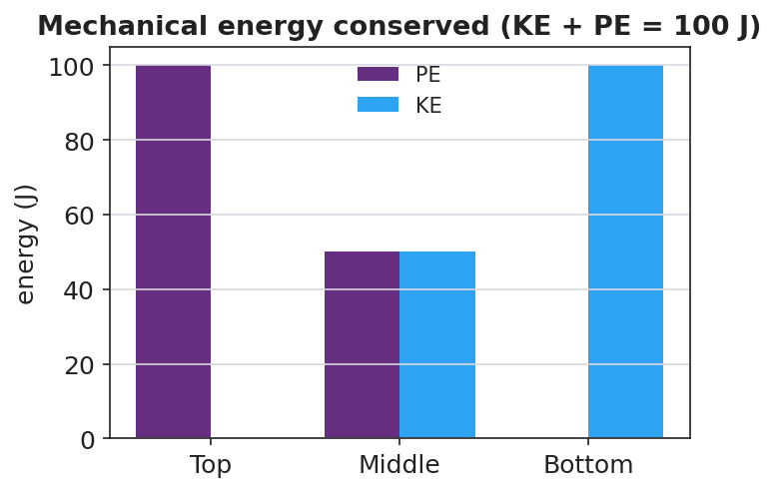
Stacked energy bar chart: PE and KE at top, middle, bottom sum to a constant 100 J
Teacher facilitation language:
“Add the two bars at each point. Do they sum to the same total? Predict the total at the middle before you look.” “With friction on, the total shrank — energy isn’t destroyed, so where did it go?”
Anticipated student responses:
- “PE plus KE is the same number everywhere — 100 J.” — the conservation insight.
- “With friction the total drops; it became heat.” — energy leaves the mechanical system as thermal energy.

Teacher facilitation during Explore
- What to look for — students summing KE + PE to a constant; locating the PE↔KE trade.
- What to resist — don’t state “conservation” before they sum the bars themselves.
- What to redirect — “energy disappeared” (friction case) → “energy is conserved overall; some left as heat — it’s not in the mechanical total anymore.”

Phase 3 · Explain (28 – 35 min)

28–31 min · Turn-and-Talk #2 + class consensus
“From the bar graphs: what is true about KE + PE without friction, and what does the skater’s motion do to those two energies?”
Target consensus:
“Without friction, mechanical energy (KE + PE) stays constant — energy is conserved. As the skater drops, PE transforms into KE; as it rises, KE transforms back into PE. With friction, some mechanical energy converts to heat, so the mechanical total drops, but total energy is still conserved.”

31–35 min · Vocabulary introduction (≤ 3 terms)
Define from the bar graphs.
Sample teacher language:
“The sum KE + PE is the mechanical energy. The rule that it doesn’t change without friction is conservation of energy. The swap from PE to KE and back is an energy transformation. So: PE lost = KE gained.”

Discussion prompts to deploy here
- “A 2.0 kg ball is dropped from 5.0 m. Ignoring friction, what is its KE just before it lands?”
  - Sample response: “PE lost = mgh = 2.0 × 9.81 × 5.0 ≈ 98 J, so KE ≈ 98 J at the bottom.”
- “Why does a pendulum eventually stop in the real world?”
  - Sample response: “Friction and air resistance transform some mechanical energy into heat each swing, so KE + PE slowly decreases.”

Phase 4 · Elaborate (35 – 40 min)

35–38 min · Revise the model + the cross-over graph
“Return to your TOP/MIDDLE/BOTTOM sketch. Now plot KE and PE vs. position along the track. Where do the curves cross, and what is true of their sum everywhere?”
Project:
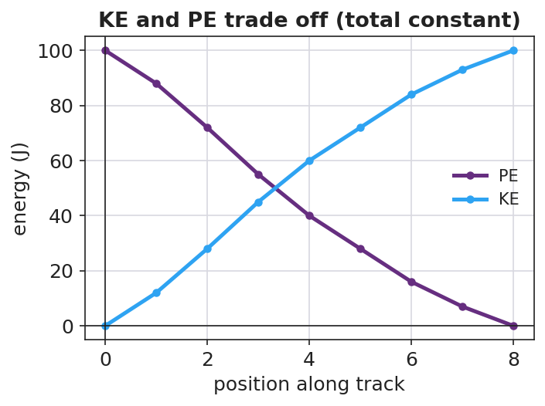
KE and PE vs position — the two curves cross while their sum stays constant
Target: the KE and PE curves are mirror images that cross where KE = PE; their sum is a flat line — the conserved mechanical energy.

38–40 min · Return to the phenomenon
“In one sentence, explain why the pendulum returns to (almost) the same height every swing, using conservation of energy and energy transformation.”

Phase 5 · Evaluate (40 – 42 min)

40–42 min · Exit Ticket + Closing Reflection
“A 0.50 kg cart starts at rest at the top of a frictionless track 2.0 m high. (Use g ≈ 9.81 m/s².) (a) What is its PE at the top? Show PE = mgh. (b) Using conservation of energy, what is its KE at the bottom? Explain. (c) On a real track with friction, would the KE at the bottom be more, less, or equal? Where does the difference go?”
Expected: (a) ≈ 9.81 J; (b) ≈ 9.81 J (PE lost = KE gained); (c) less — some energy transforms into heat. See Answer_Key.docx.
Closing Reflection (SEL, 30 seconds):
“Where did you see energy ‘trade’ today, and who helped you make sense of the swap?”

Common Misconceptions
- Misconception: “Energy gets used up / disappears.” → Correction: Energy is conserved; with friction it transforms into heat and leaves the mechanical total, but total energy is unchanged.
- Misconception: “At the bottom of the hill the cart has both maximum PE and maximum KE.” → Correction: At the lowest point PE is minimum and KE is maximum; they trade off.
- Misconception: “A pendulum can swing higher than it started.” → Correction: Without added energy, it can at most return to its starting height (conservation); friction makes it return lower.

Access & Differentiation
- ELL/ENL supports: Sentence frame: *“As the skater goes down, ___ energy turns into ___ energy, but the total (KE + PE) stays ___ because energy is ___.”* Word box: {mechanical energy, conservation of energy, energy transformation, constant, heat}. Use up/down hand gestures for PE/KE.
- IEP/SPED supports: Provide the PhET bar-graph screenshot with TOP/MIDDLE/BOTTOM pre-labeled; students fill HIGH/MEDIUM/ZERO. Provide the “PE lost = KE gained” relationship as a formula card.
- Extensions: Solve for speed at the bottom by setting mgh = ½mv² and canceling mass: v = √(2gh). Predict the skater’s speed at the bottom of a given hill and check in PhET.

Strategy Spotlight
ACTIVE LEARNING. Students discover conservation by manipulating the PhET skater and reading their own energy bar graphs — turning friction on and off to see the mechanical total hold, then leak. Require a prediction before each manipulation (predict-and-test), and have pairs report the total energy they measured at three points so the class sees the constant emerge from shared data, not from the teacher. The friction toggle is the key “aha”: energy is still conserved; it just left as heat.

NYSSLS Observation Checklist Crosswalk
# | Checklist item | Where it appears in this lesson
1 | Local/relatable phenomenon | Phase 1 — skate park / pendulum / coaster
2 | Turn and Talk (2–3×) | Phase 1 (TT#1 — fastest vs. highest), Phase 3 (TT#2 — KE + PE constant)
3 | Students develop questions/models/procedures | Phase 1 (initial model), Phase 2 (PhET/Javalab exploration), Phase 4 (revise model)
4 | CCC defined and used | Lesson Overview · Systems and System Models, applied in Phase 2 (friction on/off)
5 | ENL — ≤ 3 vocab, second half | Phase 3 — vocabulary at 31–35 min (mechanical energy / conservation / transformation)
6 | Revisit phenomenon with evidence | Phase 4 — KE/PE cross-over graph; restate pendulum return
7 | ENL/SPED supports | Access & Differentiation block
8 | Assessment check | Phase 5 — Exit Ticket (0.50 kg cart)

Companion Materials
- Student_Worksheet.docx — the 5E student investigation + PhET/Javalab guide (hand out at start of Phase 2)
- Student_Notes.docx — guided note-guide for vocabulary and the worked example
- Answer_Key.docx — answers to “Make It Make Sense” prompts and the Exit Ticket

Key Vocabulary (max 3)
- mechanical energy — the sum of an object’s kinetic and potential energy (KE + PE)
- conservation of energy — energy is never created or destroyed; without friction, mechanical energy stays constant
- energy transformation — the conversion of energy from one form to another, such as PE ↔ KE

Conservation of Energy — Student Worksheet
Unit: Work, Energy & Power — Lesson 05 Name: _______________________ Date: __________ Period: ____

Phenomenon
A pendulum released from one side swings up to almost the same height on the other side — over and over. At the bottom it moves fast; at the top it stops. A skate-park half-pipe and a roller coaster do the same trade between height and speed.
Driving question: What is being traded as something rises and falls, and does the total amount of energy stay the same?

Notice & Wonder
I notice… | I wonder…
Turn & Talk #1: Where is the pendulum fastest, where is it highest, and what does that tell you about where each kind of energy is biggest?

Initial Model
Sketch the half-pipe (or pendulum). Mark TOP, MIDDLE, BOTTOM. At each point, predict KE and PE as HIGH, MEDIUM, or ZERO.
Point | KE (high/med/zero) | PE (high/med/zero)
TOP
MIDDLE
BOTTOM

Investigation — PhET Energy Skate Park (+ Javalab coaster)
Open https://phet.colorado.edu/en/simulations/energy-skate-park-basics and turn ON the energy bar graph. Start with friction OFF.
Point | KE bar (J) | PE bar (J) | Total KE + PE (J)
Top
Middle
Bottom

Energy bar chart: PE + KE = constant
Now turn friction ON and watch over time.
Key question: With friction off, what is true about the total (KE + PE)? With friction on, the total shrinks — energy is never destroyed, so where did it go?

Make It Make Sense
- A 2.0 kg ball is dropped from 5.0 m. Ignoring friction, what is its KE just before it lands? Use PE lost = KE gained, with g ≈ 9.81 m/s².
- At the bottom of a frictionless hill, is the cart’s PE maximum or minimum? Is its KE maximum or minimum? Explain.
- Why does a real pendulum eventually stop, even though energy is conserved?

Vocabulary in Action
Use each term in a sentence about today’s phenomenon.
- mechanical energy: _______________________________________________
- conservation of energy: _______________________________________________
- energy transformation: _______________________________________________

Revise Your Model
Plot KE and PE vs. position along the track. Where do the two curves cross, and what is true of their sum everywhere?

KE and PE vs position — cross-over
The curves cross where ____________ . Their sum everywhere is ____________ . The pendulum returns to almost the same height because _______________________________________________

Exit Ticket
A 0.50 kg cart starts at rest at the top of a frictionless track 2.0 m high. (Use g ≈ 9.81 m/s².)
- What is its PE at the top? Show PE = mgh.
- Using conservation of energy, what is its KE at the bottom? Explain.
- On a real track with friction, would the KE at the bottom be more, less, or equal? Where does the difference go?

Conservation of Energy — Student Notes
Unit: Work, Energy & Power — Lesson 05 Name: _______________________ Date: __________ Period: ____

Learning Targets
By the end of today’s 42 minutes I can:
- State conservation of energy: without friction, KE + PE stays constant.
- Describe the energy transformation PE ↔ KE as an object rises and falls.
- Use conservation to find a missing energy or speed (PE lost = KE gained).

Key Vocabulary
- mechanical energy — _______________________________________________
- conservation of energy — _______________________________________________
- energy transformation — _______________________________________________

Guided Notes
Big idea: Mechanical energy is the sum KE + PE. Without friction, this total stays __________.
- Conservation of energy: energy is never __________ or __________ — it only changes form.
- As an object moves down, __________ energy transforms into __________ energy.
- As an object moves up, __________ energy transforms into __________ energy.
- So: PE lost = __________ gained (no friction).
- With friction, some mechanical energy transforms into __________, so KE + PE __________ — but total energy is still conserved.
At each point of a frictionless track (total = 100 J):
Point | PE | KE | Total
Top | 100 J | __________ | 100 J
Middle | 50 J | __________ | __________
Bottom | __________ | 100 J | __________


Energy bar chart at the top, middle, and bottom of a track: PE converts to KE while the total mechanical energy stays constant.

Worked Example
Problem. A 0.50 kg cart starts at rest at the top of a frictionless 2.0 m track. Find its KE and speed at the bottom. (g ≈ 9.81 m/s²)
Solution. 1. PE at top: PE = mgh = 0.50 × 9.81 × 2.0 = __________ J. 2. Conservation: PE lost = KE gained, so KE at bottom = __________ J. 3. Find speed from KE = ½mv²: __________ = ½ × 0.50 × v². 4. Solve: v² = __________ , so v = __________ m/s.

Summary
Finish the sentence (Because / But / So):
A frictionless pendulum returns to the same height every swing because __________________________________________, but __________________________________________, so __________________________________________.

Conservation of Energy — Answer Key

Cover
Unit: Work, Energy & Power — Lesson 05: Conservation of Energy East Meadow Schools × Valley Stream Central HSD Strategy chip: ACTIVE LEARNING

Make-It-Make-Sense Answers
- PE lost = mgh = 2.0 kg × 9.81 m/s² × 5.0 m ≈ 98 J. By conservation (PE lost = KE gained), KE just before landing ≈ 98 J. · Rubric: computes mgh AND equates to KE. · NYSSLS: HS-PS3-1
- At the bottom the height is least, so PE is minimum; all of it has transformed into motion, so KE is maximum. The two trade off. · Rubric: PE minimum AND KE maximum at the bottom. · NYSSLS: HS-PS3-2
- Energy is conserved, but friction and air resistance transform some mechanical energy into heat each swing. The mechanical total (KE + PE) decreases, so the pendulum returns a little lower until it stops. · Rubric: names transformation to heat AND that mechanical energy decreases. · NYSSLS: HS-PS3-1

Exit Ticket Answer
- PE = mgh = 0.50 kg × 9.81 m/s² × 2.0 m = 9.81 J (≈ 9.8 J).
- By conservation of energy on a frictionless track, PE lost = KE gained, so KE at the bottom = 9.81 J (≈ 9.8 J). All the PE became KE.
- Less. Friction transforms some mechanical energy into heat (and a little sound), so less KE reaches the bottom; total energy is still conserved.
Tolerance/rubric: (a) shows mgh and ≈ 9.8 J; (b) ≈ 9.8 J via PE lost = KE gained; (c) “less” + “energy goes to heat.” 1 point each. Accept g = 9.8 (≈ 9.8 J). NYSSLS: HS-PS3-1.

Closing Reflection (rubric)
Closing reflection is formative, not graded. Award full credit for any honest response. Look for: - A genuine description of where energy “traded” today - Naming a peer or self-acknowledgment

Energy in Systems: Wheels to Watts — Teacher Guide

Cover
Unit: Work, Energy & Power — Lesson 06: Energy in Systems (Wheels to Watts) East Meadow Schools × Valley Stream Central High School District Strategy chips: BTC

Curated Resources (from East Meadow Scope & Sequence)

NYSSLS Standards
This NYS Investigation lesson targets HS-PS3-3: “Design, build, and refine a device that works within given constraints to convert one form of energy into another form of energy.” (CCC: Energy and Matter.) Students track energy flow through a real conversion device, separate useful from wasted energy, compute efficiency, and refine the design — the full engineering cycle. It rests on the conservation idea (Lesson 05): the “wasted” energy is not destroyed, only converted to heat.

Phenomenon
- Regenerative braking / a bike generator powering a light — “Wheels to Watts”: motion → electricity. https://www.youtube.com/watch?v=q4_yTYHM8gc (How regenerative braking works)
- The Physics Classroom — energy transformation & efficiency overview: https://www.physicsclassroom.com/class/energy/Lesson-2/Mechanical-Energy

Javalab / Labs
- Wheels-to-Watts build (this lesson): a hand-crank or bike generator + small load (LED/buzzer). Javalab energy index for supporting sims: https://javalab.org/en/category/energy_en/

Assessments
- The Wheels-to-Watts design rubric (useful output vs. input, with a refinement). The Exit Ticket below is the formative check; “Make It Make Sense” items map to HS-PS3-3.

Lesson Overview
Duration | 42 minutes (1 period; pairs well with a double period for the build/refine)
NYSSLS link | HS-PS3-3 (design, build, refine an energy-conversion device)
CCC focus | Energy and Matter — energy flows through a system, splitting into useful output and wasted (heat) energy.
Strategy chips | BTC (random groups, VNPS for the efficiency/refinement reasoning)
Materials | Hand-crank or bike generator; LED/buzzer/small motor; multimeter (optional); VNPS boards + markers; random grouping cards; the regenerative-braking clip.
Safety | Secure the generator; keep fingers clear of moving wheels/cranks; low-voltage loads only.
Prior knowledge | Work, power (Lesson 02), and conservation of energy (Lesson 05).
Lesson objectives — students can:
- Trace energy transfer through a conversion device, separating useful output from wasted energy.
- Define and compute efficiency = useful output ÷ energy input (as a fraction or percent).
- Propose and justify a refinement that raises a device’s efficiency (HS-PS3-3).

Phase 1 · Engage (0 – 10 min)

0–3 min · Opening Connection (SEL)
Pair-share, one sentence: “Name something you do that ‘wastes’ effort no matter how careful you are.” Surface a couple. Frame: every machine wastes some energy too — the question is how much.

3–7 min · Phenomenon hook — regenerative braking / bike generator
Teacher actions. Play the regenerative-braking clip, or hand-crank a generator to light an LED. Note how warm the generator gets.
Sample teacher language:
“When this car brakes, instead of throwing away the motion as heat in the brake pads, it captures some of it as electricity. But not all of it — feel how warm this generator gets. Where does the rest of the energy go?”
Anticipated student responses:
- “It turns motion into electricity.” — capture the transformation.
- “Some becomes heat — the generator is warm.” — exactly the wasted-energy idea.
- “You can’t get all of it back.” — seeds efficiency < 100%.

7–10 min · Notice & Wonder + Turn-and-Talk #1
Two columns. Then:
“Turn to your partner: of all the energy you put into the crank, how much do you think comes out as useful electricity — all of it? Where does the rest go?”

Bridge to Phase 2
Each student leaves with an initial model: “Energy goes in as ______, comes out useful as ______, and is wasted as ______.”

Phase 2 · Explore (10 – 28 min)

10–13 min · BTC setup — random groups + VNPS
Form visibly random groups of 3. Claim a vertical non-permanent surface. Each group will track energy through the Wheels-to-Watts device and reason about efficiency at the board.

13–28 min · Investigation — Wheels to Watts (build → measure → refine)
Thin-sliced design task:
- Trace the flow. For the bike/hand generator + LED, label the energy at each stage: input (your motion / chemical from food) → useful (electrical/light) → wasted (heat, friction, sound).
- Quantify. Given an input of 100 J, decide where a realistic split goes (e.g., 75 J useful, 25 J wasted). Compute efficiency = useful ÷ input.
- Compare devices. Rank an incandescent bulb (~5%), an LED (~40%+), the bike generator (~75%) by efficiency. Why so different?
- Refine (HS-PS3-3). Propose ONE change to your device that would raise its efficiency (reduce friction, better gearing, less resistance). Predict the new efficiency and justify.
Project to anchor the input-vs-output idea:
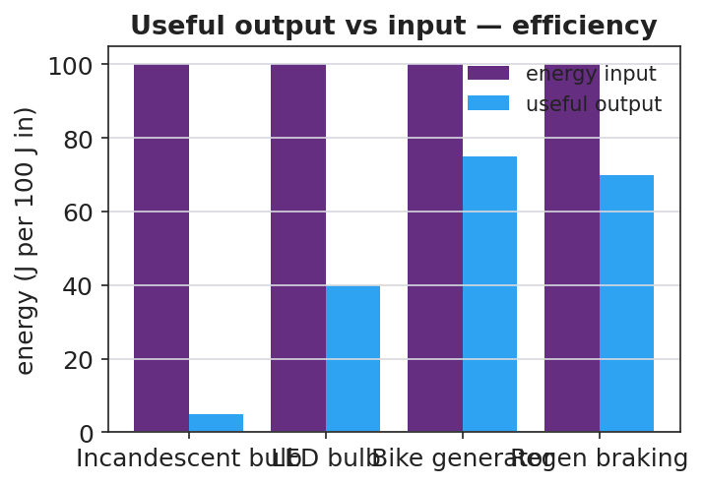
Useful output vs energy input for several devices — efficiency
Teacher facilitation language (BTC — bounce questions back):
“If 100 J go in and 75 J come out useful, where are the other 25 J — are they destroyed?” “Your refinement claims higher efficiency — what term in ‘useful ÷ input’ did your change improve, and how do you know?”
Anticipated student responses:
- “Efficiency is useful over input — 75/100 = 75%.” — target.
- “The wasted 25 J became heat; energy is conserved, it just isn’t useful.” — ties to Lesson 05.
- “Less friction → more useful output → higher efficiency.” — valid refinement reasoning.

Teacher facilitation during Explore
- What to look for — groups computing efficiency as a ratio and locating wasted energy as heat (not “lost”).
- What to resist — don’t grade refinements; ask groups to justify against another board.
- What to redirect — “energy is lost” → “conserved; it left the useful path as heat.”

Phase 3 · Explain (28 – 35 min)

28–31 min · Turn-and-Talk #2 + class consensus
“Tour another board. How did they compute efficiency, and what happened to the energy that wasn’t useful?”
Target consensus:
“A device transfers energy from one form to another. Efficiency = useful output ÷ energy input. The rest isn’t destroyed — it becomes heat (and a little sound/friction). No real device is 100% efficient.”

31–35 min · Vocabulary introduction (≤ 3 terms)
Define from the flow charts.
Sample teacher language:
“Efficiency is the fraction of input energy that comes out useful: useful ÷ input. Energy transfer is energy moving or changing form through the device. The whole crank-generator-LED setup is the system we’re analyzing — and across the whole system, energy is conserved.”

Discussion prompts to deploy here
- “A motor uses 200 J and delivers 150 J of useful work. What is its efficiency?”
  - Sample response: “150 / 200 = 0.75 = 75%.”
- “Why can no real device be 100% efficient?”
  - Sample response: “Friction and resistance always convert some energy to heat, so useful output is always less than input.”

Phase 4 · Elaborate (35 – 40 min)

35–38 min · Revise the model + the flow chart
“Return to your energy-flow sketch. Using a 100 J input, chart how much is useful vs. wasted for your refined device. Did your refinement raise the useful bar?”
Project:
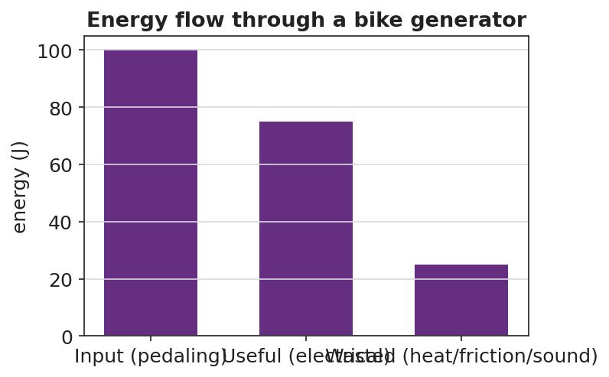
Energy flow through a bike generator: input splits into useful and wasted
Target: the input bar splits into a useful bar and a wasted (heat) bar; a good refinement shifts energy from the wasted bar to the useful bar, raising efficiency.

38–40 min · Return to the phenomenon
“In one sentence, explain why regenerative braking is better than normal braking in energy terms — and why it still can’t recover 100% of the car’s energy. Use efficiency and energy transfer.”

Phase 5 · Evaluate (40 – 42 min)

40–42 min · Exit Ticket + Closing Reflection
“A bike generator takes in 400 J of pedaling energy and delivers 300 J of useful electrical energy. (a) Calculate the efficiency. Show useful ÷ input. (b) Where did the other 100 J go? Did it disappear? (c) Propose ONE refinement that would raise the efficiency, and explain why it works.”
Expected: (a) 0.75 = 75%; (b) ~100 J became heat (friction in bearings/wires) and sound — conserved, not destroyed; (c) e.g., better bearings / less resistive wire → less heat → more useful output. See Answer_Key.docx.
Closing Reflection (SEL, 30 seconds):
“What is one place in your life you now see ‘wasted’ energy you’d want to capture — and who sharpened that idea for you?”

Common Misconceptions
- Misconception: “Wasted energy is destroyed.” → Correction: Energy is conserved; “wasted” energy is converted to heat/sound that isn’t useful — it still exists.
- Misconception: “A good machine can be 100% efficient.” → Correction: Friction and resistance always divert some energy to heat, so real efficiency is always below 100%.
- Misconception: “Efficiency is the useful energy in joules.” → Correction: Efficiency is a ratio (useful ÷ input), with no units; it’s often written as a percent.

Access & Differentiation
- ELL/ENL supports: Sentence frame: *“The device takes in ___ energy and gives out useful ___ energy; the rest becomes , so its efficiency is ÷ ___.”* Word box: {efficiency, energy transfer, system, useful, wasted, heat}. Use a “splitting” gesture for input → useful + wasted.
- IEP/SPED supports: Provide a pre-drawn energy-flow diagram with input/useful/wasted boxes to fill; provide the efficiency = useful ÷ input formula card and one worked percent. Offer a measuring/recording role on the build.
- Extensions: Build a multi-stage chain (generator → battery → motor) and compute the overall efficiency as the product of stage efficiencies; explain why long chains lose more.

Strategy Spotlight
BTC (Building Thinking Classrooms). The design-and-refine task is delivered as thin slices at vertical non-permanent surfaces with visibly random groups: trace the flow, compute efficiency, compare devices, then propose a refinement. The refinement slice is the HS-PS3-3 core — groups must justify a design change against the efficiency ratio, defending it to a neighboring board rather than to the teacher. Answer questions with questions (“where did the 25 J go?”) so the conservation-plus-efficiency reasoning is built by students.

NYSSLS Observation Checklist Crosswalk
# | Checklist item | Where it appears in this lesson
1 | Local/relatable phenomenon | Phase 1 — regenerative braking / bike generator
2 | Turn and Talk (2–3×) | Phase 1 (TT#1 — how much comes out useful), Phase 3 (TT#2 — board tour on efficiency)
3 | Students develop questions/models/procedures | Phase 1 (initial model), Phase 2 (build + measure + refine), Phase 4 (revise model)
4 | CCC defined and used | Lesson Overview · Energy and Matter, applied in Phase 2
5 | ENL — ≤ 3 vocab, second half | Phase 3 — vocabulary at 31–35 min (efficiency / energy transfer / system)
6 | Revisit phenomenon with evidence | Phase 4 — energy-flow chart; restate regenerative braking
7 | ENL/SPED supports | Access & Differentiation block
8 | Assessment check | Phase 5 — Exit Ticket (bike generator efficiency + refinement)

Companion Materials
- Student_Worksheet.docx — the 5E student investigation + Wheels-to-Watts design log (hand out at start of Phase 2)
- Student_Notes.docx — guided note-guide for vocabulary and the worked example
- Answer_Key.docx — answers to “Make It Make Sense” prompts and the Exit Ticket

Key Vocabulary (max 3)
- efficiency — the fraction of input energy that comes out as useful output; efficiency = useful ÷ input
- energy transfer — the movement or conversion of energy from one place or form to another
- system — the set of connected components being analyzed; energy is conserved across the whole system

Energy in Systems: Wheels to Watts — Student Worksheet
Unit: Work, Energy & Power — Lesson 06 Name: _______________________ Date: __________ Period: ____

Phenomenon
When a car with regenerative braking slows down, it captures some of its motion as electricity instead of throwing it all away as heat in the brakes. A bike generator does the same: your pedaling lights a bulb — but the generator gets warm. Not all of the energy makes it through. “Wheels to Watts.”
Driving question: When a device converts one form of energy into another, how much comes out useful, where does the rest go, and how can we make it better?

Notice & Wonder
I notice… | I wonder…
Turn & Talk #1: Of all the energy you put into the crank, how much do you think comes out as useful electricity? Where does the rest go?

Initial Model
Draw your Wheels-to-Watts device (generator → load). Label the energy at each stage.
Energy goes IN as ____________ , comes OUT useful as ____________ , and is WASTED as ____________ .

Investigation — Wheels to Watts (build → measure → refine)
Work at your group’s board.
Step | Result
1. Trace the flow (input → useful → wasted)
2. Split a 100 J input: ___ J useful, ___ J wasted
3. Efficiency = useful ÷ input =
4. Rank devices by efficiency (incandescent ~5%, LED ~40%, generator ~75%)
5. Refine: one change to raise efficiency, and your predicted new efficiency

Useful output vs input for several devices
Key question: If 100 J go in and 75 J come out useful, where are the other 25 J — are they destroyed?

Make It Make Sense
- A motor uses 200 J of electrical energy and delivers 150 J of useful work. What is its efficiency? Show useful ÷ input.
- An incandescent bulb is about 5% efficient; an LED is about 40% efficient. For every 100 J supplied, how much useful light energy does each give? Where does the rest go?
- Why can no real device be 100% efficient?

Vocabulary in Action
Use each term in a sentence about today’s phenomenon.
- efficiency: _______________________________________________
- energy transfer: _______________________________________________
- system: _______________________________________________

Revise Your Model
Using a 100 J input, chart how much is useful vs. wasted for your refined device. Did your refinement move energy from the wasted bar into the useful bar?

Energy flow through a bike generator
My refinement was ____________ . It raises efficiency because it reduces ____________ , which means more energy comes out as ____________ .

Exit Ticket
A bike generator takes in 400 J of pedaling energy and delivers 300 J of useful electrical energy.
- Calculate the efficiency. Show useful ÷ input.
- Where did the other 100 J go? Did it disappear?
- Propose ONE refinement that would raise the efficiency, and explain why it works.

Energy in Systems: Wheels to Watts — Student Notes
Unit: Work, Energy & Power — Lesson 06 Name: _______________________ Date: __________ Period: ____

Learning Targets
By the end of today’s 42 minutes I can:
- Trace energy transfer through a conversion device (useful vs. wasted).
- Define and compute efficiency = useful ÷ input.
- Propose a refinement that raises a device’s efficiency.

Key Vocabulary
- efficiency — _______________________________________________
- energy transfer — _______________________________________________
- system — _______________________________________________

Guided Notes
Big idea: A device transfers energy from one form to another, but only part of the input comes out __________.
- Efficiency = useful output ÷ energy input (a ratio, often written as a __________).
- Efficiency has no __________ (joules ÷ joules cancel).
- The energy that is not useful is not __________ — by conservation it becomes __________ (and a little sound).
- No real device is __________ % efficient, because __________ and resistance always divert energy to heat.
- A good refinement moves energy from the __________ bar into the __________ bar.
Energy split (100 J input):
Path | Energy
Input | 100 J
Useful output | __________ J
Wasted (heat) | __________ J
Efficiency = useful ÷ input | __________


Input energy vs. useful output energy: the ratio of useful output to input is the efficiency; the rest is transferred to the surroundings.

Worked Example
Problem. A bike generator takes in 500 J of pedaling energy and delivers 350 J of useful electrical energy. Find its efficiency and the wasted energy.
Solution. 1. Efficiency = useful ÷ input = __________ ÷ __________ . 2. Compute: efficiency = __________ = __________ %. 3. Wasted energy = input − useful = 500 − 350 = __________ J. 4. That wasted energy became __________ ; it was not destroyed (energy is conserved).

Summary
Finish the sentence (Because / But / So):
Regenerative braking is better than normal braking because __________________________________________, but __________________________________________, so __________________________________________.

Energy in Systems: Wheels to Watts — Answer Key

Cover
Unit: Work, Energy & Power — Lesson 06: Energy in Systems (Wheels to Watts) East Meadow Schools × Valley Stream Central HSD Strategy chip: BTC (NYS Investigation)

Make-It-Make-Sense Answers
- Efficiency = useful ÷ input = 150 J ÷ 200 J = 0.75 = 75%. · Rubric: correct ratio AND 75%. · NYSSLS: HS-PS3-3
- Incandescent: 5% of 100 J = 5 J of useful light; LED: 40% of 100 J = 40 J of useful light. The rest (95 J and 60 J) becomes heat. · Rubric: both useful values AND “rest becomes heat.” · NYSSLS: HS-PS3-3
- No real device is 100% efficient because friction and electrical resistance always convert some input energy into heat (and sound), so useful output is always less than input. · Rubric: names friction/resistance → heat → useful < input. · NYSSLS: HS-PS3-3

Exit Ticket Answer
- Efficiency = useful ÷ input = 300 J ÷ 400 J = 0.75 = 75%.
- The other 100 J became heat (friction in bearings, resistance in the wires) and a little sound. It did not disappear — energy is conserved; it just left the useful path.
- Any reasonable refinement that reduces wasted energy, e.g.: better/oiled bearings or smoother gearing (less friction), thicker/lower-resistance wire (less resistive heating), or a better-matched load. It works by shifting energy from the wasted (heat) path to the useful (electrical) output, raising useful ÷ input.
Tolerance/rubric: (a) shows the ratio and 75%; (b) “100 J → heat, not destroyed”; (c) a refinement that reduces friction/resistance AND a correct justification. 1 point each. NYSSLS: HS-PS3-3.

Closing Reflection (rubric)
Closing reflection is formative, not graded. Award full credit for any honest response. Look for: - A genuine “wasted energy I’d capture” example - Naming a peer or self-acknowledgment

