Physics — Unit 05: Thermodynamics (Review)
Table of Contents

Unit 5 · Thermal Energy & Conservation

Thermal Energy & Conservation (Thermodynamics) — Unit Plan

Cover
Unit: Thermal Energy & Conservation (Thermodynamics) East Meadow Schools × Valley Stream Central High School District 3 lessons · ~3 instructional periods (42 min each) Format: DOCX (Teacher Guide · Student Worksheet · Student Notes · Answer Key per lesson)

Unit Scope (from East Meadow Scope & Sequence)
This unit develops the particle model of thermal energy and the conservation of energy as heat transfers between objects. It builds on the Energy unit (kinetic energy; energy is conserved and transfers) and culminates in a calorimetry investigation that satisfies the unit anchor, HS-PS3-4. Students move from what temperature and thermal energy mean (Lesson 01), to which way heat flows and why energy spreads out (Lesson 02), to measuring and balancing that transfer quantitatively (Lesson 03).
# | Lesson | Core idea
01 | Thermal Energy and Temperature | Temperature = average particle KE; thermal energy = total particle KE (depends on amount of substance)
02 | Heat Transfer and the Second Law of Thermodynamics | Heat flows hot → cold to thermal equilibrium; conduction/convection/radiation; energy spreads to a more uniform distribution
03 | Calorimetry — Thermal Tales | Q = m·c·ΔT; in a closed system heat lost = heat gained; specific heat

Pacing Calendar
Day | Lesson | Phenomenon anchor | Strategy
1 | 01 Thermal Energy and Temperature | Sparkler vs. bathtub — which is “hotter,” which holds more energy? | Restorative Circle (unit opener)
2 | 02 Heat Transfer / Second Law | Penguin huddle; ice cube melting in a warm drink | Hochman
3 | 03 Calorimetry — Thermal Tales | Mix hot + cold water; predict the final temperature | Active Learning (NYS Investigation)
A double-period day on Day 3 lets the calorimetry investigation run long enough for multiple trials and the Q-balance analysis.

Strategy Rotation
- RESTORATIVE CIRCLE: Lesson 01 — unit-opening circle (“a time you felt surprisingly hot or cold”) that seeds the temperature-vs-thermal-energy distinction.
- HOCHMAN (sentence-level literacy): Lesson 02 — Because/But/So expansion on the direction of heat flow and the second law.
- ACTIVE LEARNING (NYS Investigation): Lesson 03 — students plan and conduct the Thermal Tales calorimetry lab and generate the heat lost = heat gained evidence.
SEL (Opening Connection + Closing Reflection), ELL/SPED supports, 2–4 figures, and a Curated Resources block appear in every lesson.

NYSSLS Coverage Matrix
PE | Description | Lessons
HS-PS3-4 | “Plan and conduct an investigation to provide evidence that the transfer of thermal energy when two components of different temperature are combined within a closed system results in a more uniform energy distribution among the components (second law of thermodynamics). (Systems and System Models).” | 01 (foundation), 02 (core — second law), 03 (investigation)
HS-PS3-2 | Energy as the motion of particles and energy stored in fields (Energy and Matter) | 01 (thread — temperature/thermal energy as particle KE)
HS-PS3-1 | Quantitative energy accounting within a system (Systems and System Models) | 03 (thread — Q = m·c·ΔT energy balance)

Vocabulary Scope
Three terms maximum per lesson, introduced in the second half (NYSSLS observation item 5).
Lesson | Terms
01 | temperature · thermal energy · kinetic energy
02 | heat · thermal equilibrium · second law of thermodynamics
03 | calorimetry · specific heat · heat

Thermal Energy and Temperature — Teacher Guide

Cover
Unit: Thermal Energy & Conservation (Thermodynamics) — Lesson 01: Thermal Energy and Temperature East Meadow Schools × Valley Stream Central High School District Strategy chips: RESTORATIVE CIRCLE

Curated Resources (from East Meadow Scope & Sequence)

NYSSLS Standards
This is the unit-opening lesson for HS-PS3 (Energy). It builds the particle-level meaning of temperature and thermal energy that the whole unit rests on, threading directly toward HS-PS3-4: “Plan and conduct an investigation to provide evidence that the transfer of thermal energy when two components of different temperature are combined within a closed system results in a more uniform energy distribution among the components (second law of thermodynamics). (Systems and System Models).” Today students do not yet measure transfer — they first establish what is being transferred (energy carried by moving particles) and why temperature alone does not tell you how much. It also connects back to the Energy unit’s HS-PS3-2 (energy as the motion of particles and energy stored in fields).

Phenomenon
- A sparkler glows at over 1,000 °C, yet you can hold it inches away unharmed; a warm bath at 40 °C would scald you if it were that hot. Which is “hotter,” and which holds more thermal energy? https://www.youtube.com/watch?v=A9eDRUd6lZk (sparkler chemistry/temperature)
- Particle motion simulation (PhET States of Matter) — heat a sample and watch the particles speed up: https://phet.colorado.edu/en/simulations/states-of-matter-basics

Javalab / Labs
- Javalab — Brownian motion / molecular motion (particles move faster as temperature rises): https://javalab.org/en/brownian_motion_en/
- Javalab — Temperature and molecular motion: https://javalab.org/en/temperature_en/

Assessments
- Exit Ticket below (sparkler vs. bathtub ranking) is the formative check.
- PhET States of Matter has an embedded temperature/speed observation that can serve as a quick check-for-understanding.

Lesson Overview
Duration | 42 minutes (1 period)
NYSSLS link | HS-PS3-4 (unit anchor — foundation) · HS-PS3-2 (energy of particles)
CCC focus | Energy and Matter — energy is carried by the motion of particles; the amount of matter changes how much energy a sample holds.
Strategy chips | RESTORATIVE CIRCLE (unit opener)
Materials | Sparkler image/clip (no live flame indoors); two beakers of room-temperature water (a small cup and a large container) plus thermometers; whiteboards/markers; particle-diagram handout.
Safety | Do not light a sparkler indoors — use the clip/photo. Water beakers are room temperature only.
Prior knowledge | Energy unit — kinetic energy depends on mass and speed; energy is conserved and can transfer.
Lesson objectives — students can:
- Define temperature as the average kinetic energy of the particles in a substance.
- Define thermal energy as the total kinetic energy of all the particles, which depends on temperature and the amount of substance.
- Explain how two objects can be at the same temperature yet hold very different amounts of thermal energy (a cup vs. a swimming pool).

Phase 1 · Engage (0 – 12 min)

0–3 min · Opening Connection (SEL) — Restorative Circle (unit opener)
This launches the Thermodynamics unit, so open with a brief restorative circle. Pass a talking piece. Prompt: “Tell us about a time you felt ‘hot’ or ‘cold’ in a way that surprised you — and one word for how it felt.” One sentence each, no cross-talk. This surfaces everyday sensory ideas about heat that we will sharpen into temperature and thermal energy.

3–8 min · Phenomenon hook — sparkler vs. bathtub
Teacher actions. Show the sparkler clip/photo (burning at ~1,000 °C) beside a photo of a warm bath (~40 °C). State the puzzle plainly.
Sample teacher language:
“This sparkler is over a thousand degrees — far hotter than this bath. So why can a kid hold the sparkler an inch away and be fine, but that water at the same thousand degrees would be a disaster? Which one is ‘hotter,’ and which one carries more energy?”
Anticipated student responses:
- “The sparkler is hotter but tiny, so it can’t hurt you much.” — capture this; it is exactly the thermal-energy-vs-temperature distinction in plain words.
- “The water has more stuff in it.” — name “amount of substance”; hold it for Phase 3.
- “Degrees just mean how hot something is.” — note it; we will refine “degrees” into average particle motion.

8–12 min · Notice & Wonder + Turn-and-Talk #1
Capture two columns on the board. Then:
“Turn to your partner: what is the difference between something being hot and something having a lot of heat energy? Use the word particles if you can.”
Take 2–3 responses. Desirable seed: the sparkler’s bits move fast but there are very few of them; the bath has slower-moving water but enormous amounts of it. Leave it open if no one lands it.

Bridge to Phase 2
Every student leaves Phase 1 with a one-sentence initial model: “The sparkler is hotter but the bath has more energy because ______.”

Phase 2 · Explore (12 – 32 min)

12–17 min · Initial Model (silent / individual)
Prompt on the board:
“Draw the particles inside the sparkler tip and inside the bathtub. Use arrows to show how fast each particle is moving and dots to show how many there are. Then write one sentence: which has faster particles, and which has more total particle motion?”
This surfaces intuitions about speed (temperature) vs. count × speed (thermal energy) before any vocabulary.

17–32 min · Investigation — particles, speed, and amount
Use the PhET States of Matter sim (projected or on devices) and the two beakers of room-temperature water.
- Speed = temperature. In PhET, add heat and watch the particles. Record: what happens to particle speed as the thermometer climbs? What happens when you cool it?
- Same temperature, different amounts. Measure the small cup and the large container of water — both read room temperature. Ask: if every particle in both is moving at the same average speed, which container has more total particle motion?
- Particle diagram. Give students this diagram and have them annotate which side is hotter and why:
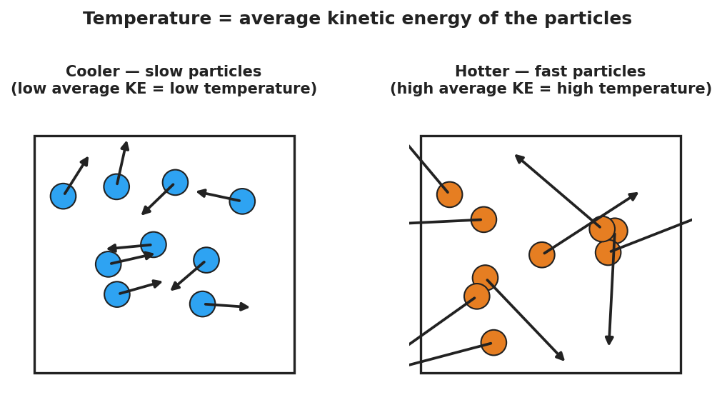
Slow particles (cool) vs fast particles (hot); average arrow length is the temperature
Teacher facilitation language:
“Heating it up — are the particles getting bigger, or moving faster?” “Both beakers are the same temperature. Same average speed. So why would the big one take far more energy to boil away?” “If I doubled the amount of water but kept the temperature the same, did the average particle speed change? Did the total energy change?”

Teacher facilitation during Explore
- What to look for — students separating how fast (per particle) from how many (total). That split is the whole lesson.
- What to resist — don’t say “temperature is average KE” yet; let the sim and beakers establish “faster = hotter, more particles = more total energy” first.
- What to redirect — students who say “more water is hotter” should be asked: “Both thermometers read the same. Is it hotter, or does it just hold more?”

Phase 3 · Explain (32 – 37 min)

32–35 min · Turn-and-Talk #2 + class consensus
“Across the sim and the beakers, what did temperature actually measure — and what did amount change?”
Target consensus:
“Temperature measures how fast the particles move on average. Thermal energy is the total motion of all the particles — so it depends on temperature and how much substance there is.”
Reinforce with the comparison chart:
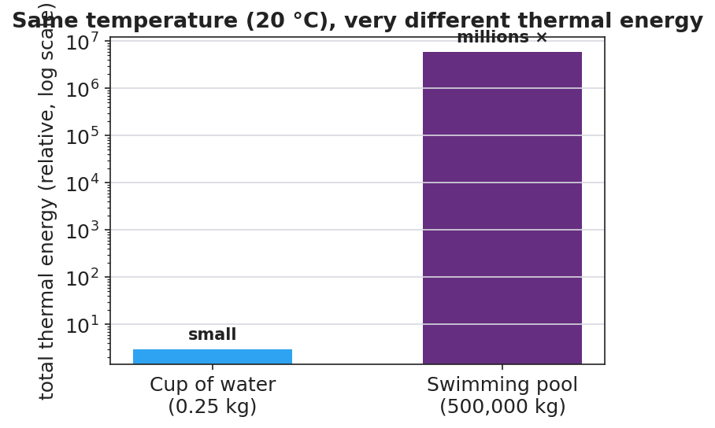
Cup and pool at the same temperature; the pool holds millions of times more thermal energy

35–37 min · Vocabulary introduction (≤ 3 terms)
Sample teacher language:
“The energy of motion is kinetic energy. Temperature is the average kinetic energy of the particles — how fast they move, on average. Thermal energy is the total kinetic energy of all the particles, so it grows with both temperature and the amount of substance. A cup and a pool can read the same temperature, but the pool has far more thermal energy.”

Discussion prompts to deploy here
- “A cup of tea and a backyard pool both read 30 °C. Which has more thermal energy, and why?”
  - Sample student response: “The pool — same average particle speed, but vastly more particles, so far more total kinetic energy.”
- “Why is the sparkler safe to hold even though it is hotter than the bath?”
  - Sample student response: “Its particles move fast (high temperature), but there are very few of them, so the total thermal energy delivered to your skin is tiny.”

Phase 4 · Elaborate (37 – 40 min)

37–39 min · Revise the model
“Return to your particle drawing. Re-label one side ‘high average KE = high temperature’ and use dots to show total amount. Rewrite your one-sentence explanation using the words temperature and thermal energy.”

39–40 min · Return to the phenomenon
“Why would a single drop of boiling water sting but not seriously burn, while a whole bathtub at the same 100 °C would be deadly? Answer in one sentence using temperature and thermal energy.”
Target: “Both are at the same temperature (same average particle speed), but the bathtub holds enormously more thermal energy because it has so many more particles — so it can transfer far more energy to you.”

Phase 5 · Evaluate (40 – 42 min)

40–42 min · Exit Ticket + Closing Reflection
“A lit sparkler tip is about 1,000 °C. A warm bath is about 40 °C. (a) Which has the higher temperature, and what does temperature measure about the particles? (b) Which one could transfer more thermal energy to your body, and why? (c) Two buckets of water read exactly 25 °C, but one holds 1 L and the other holds 50 L. Which has more thermal energy? Explain.”
Expected: (a) the sparkler — temperature is the average kinetic energy (average speed) of the particles; (b) the bath — far more particles means far more total thermal energy to transfer; (c) the 50 L bucket — same average particle speed but 50× as many particles, so much more total kinetic energy. See Answer_Key.docx.
Closing Reflection (SEL, 30 seconds):
“What is one idea today that changed how you think about ‘hot’? Who helped you make sense of it?”

Common Misconceptions
- Misconception: “Temperature and heat energy are the same thing.” → Correction: Temperature is the average particle motion; thermal energy is the total — it also depends on how much substance there is.
- Misconception: “A bigger/hotter object always has more energy.” → Correction: A tiny very-hot object (sparkler) can hold less thermal energy than a large cooler object (pool); amount of substance matters.
- Misconception: “Heating something makes its particles bigger.” → Correction: Particles do not grow; they move faster. Higher temperature = faster average particle motion.

Access & Differentiation
- ELL/ENL supports: Sentence frame: “The ___ has a higher temperature because its particles move , but the has more thermal energy because it has ___ particles.” Word-choice box: {faster, slower, more, fewer, average, total}. Pair temperature with a hand gesture (fingers wiggling fast vs. slow) and thermal energy with arms spread wide (lots of particles).
- IEP/SPED supports: Provide a pre-drawn two-box particle diagram; students add arrow lengths and dot counts rather than drawing from scratch. Offer the PhET slider as a hands-on alternative to writing.
- Extensions: Ask students to estimate, in words, how many times more thermal energy a 50 L pool of 25 °C water holds than a 1 L cup at the same temperature, and justify the ratio using “same average speed, 50× the particles.”

Strategy Spotlight
RESTORATIVE CIRCLE (unit opener). Today’s opening uses a circle to launch the Thermodynamics unit. Use a talking piece, one-sentence responses, and equity of voice (everyone speaks or passes). The prompt — a time you felt surprisingly hot or cold — is chosen so you can call it back in Phase 3 (“that surprise — something small but intensely hot, or something mild but huge — is exactly temperature vs. thermal energy”). Keep the circle to ~2–3 minutes; the goal is community plus a shared anchor, not a long discussion.

NYSSLS Observation Checklist Crosswalk
# | Checklist item | Where it appears in this lesson
1 | Local/relatable phenomenon | Phase 1 — sparkler vs. bathtub; boiling drop in Phase 4
2 | Turn and Talk (2–3×) | Phase 1 (TT#1 — hot vs. lots of energy), Phase 3 (TT#2 — temperature vs. amount)
3 | Students develop questions/models/procedures | Phase 1 (initial model), Phase 2 (PhET + beaker investigation), Phase 4 (revise model)
4 | CCC defined and used | Lesson Overview · Energy and Matter, restated in Phase 2
5 | ENL — ≤ 3 vocab, second half | Phase 3 — vocabulary at 35–37 min (temperature / thermal energy / kinetic energy)
6 | Revisit phenomenon with evidence | Phase 4 — boiling drop vs. bathtub + particle-diagram re-labeling
7 | ENL/SPED supports | Access & Differentiation block
8 | Assessment check | Phase 5 — Exit Ticket (sparkler/bath + two buckets)

Companion Materials
- Student_Worksheet.docx — the 5E student investigation (hand out at start of Phase 2)
- Student_Notes.docx — guided note-guide for vocabulary and the worked example
- Answer_Key.docx — answers to “Make It Make Sense” prompts and the Exit Ticket
- figures/particle_speed.png, figures/cup_vs_pool_energy.png — projection visuals

Key Vocabulary (max 3)
- temperature — a measure of the average kinetic energy of the particles in a substance (how fast they move, on average)
- thermal energy — the total kinetic energy of all the particles in a substance; depends on temperature and the amount of substance
- kinetic energy — the energy an object or particle has because of its motion

Thermal Energy and Temperature — Student Worksheet
Unit: Thermal Energy & Conservation — Lesson 01 Name: _______________________ Date: __________ Period: ____

Phenomenon
A lit sparkler burns at over 1,000 °C — yet a child can hold it inches away and be fine. A warm bath is only about 40 °C, but if it were ever 1,000 °C it would be deadly. Same idea, very different danger.

Slow particles versus fast particles
Driving question: What is the difference between something being hot and something holding a lot of energy?

Notice & Wonder
I notice… | I wonder…
Turn & Talk #1: What is the difference between a thing being hot and a thing having a lot of heat energy? Use the word particles.

Initial Model
Draw the particles inside the sparkler tip and inside the bathtub. Use arrow length to show how fast each particle moves and dots to show how many there are.
Sketch here:
Which has faster particles? __________ Which has more total particle motion? __________

Investigation
Use the particle simulation and the two beakers of room-temperature water.
Step | What I did | What I observed | What it tells me
1. Add heat in the sim
2. Cool it down in the sim
3. Small cup vs. large container (same temperature)
Key question: Both beakers read the same temperature. Why would the larger one take far more energy to boil away?

Make It Make Sense
- A cup of tea and a backyard pool both read 30 °C. Which has more thermal energy, and why?
- Why is a sparkler safe to hold even though it is far hotter than bathwater?
- If you double the amount of water but keep the temperature the same, what happens to the average particle speed? What happens to the total thermal energy?

Vocabulary in Action
Use each term in a sentence about today’s phenomenon.
- temperature: _______________________________________________
- thermal energy: _______________________________________________
- kinetic energy: _______________________________________________

Revise Your Model
Return to your Initial Model. Re-label one side “high average KE = high temperature” and use dots to show the total amount of substance. Rewrite your explanation using temperature and thermal energy.

Exit Ticket
A lit sparkler tip is about 1,000 °C. A warm bath is about 40 °C.
- Which has the higher temperature, and what does temperature measure about the particles?
- Which one could transfer more thermal energy to your body, and why?
- Two buckets of water read exactly 25 °C, but one holds 1 L and the other holds 50 L. Which has more thermal energy? Explain.

Thermal Energy and Temperature — Student Notes
Unit: Thermal Energy & Conservation — Lesson 01 Name: _______________________ Date: __________ Period: ____

Learning Targets
By the end of today’s 42 minutes I can:
- Define temperature as the average kinetic energy of the particles.
- Define thermal energy as the total kinetic energy of all the particles.
- Explain how two objects can be the same temperature but hold different amounts of thermal energy.

Key Vocabulary
- temperature — _______________________________________________
- thermal energy — _______________________________________________
- kinetic energy — _______________________________________________

Guided Notes
Big idea: Everything is made of particles that are always __________. The energy of that motion is __________ energy.
- Temperature measures the __________ kinetic energy of the particles → how __________ they move, on average.
- Heating a substance makes its particles move __________ (not bigger). Cooling makes them move __________.
- Thermal energy is the __________ kinetic energy of __________ the particles.
- Thermal energy depends on two things: the __________ (average speed) and the __________ of substance (how many particles).
Same temperature, different thermal energy:
- A cup and a swimming pool can both read 20 °C → the particles move at the same __________ speed.
- But the pool has far more __________, so it holds far more __________ energy.

Cup vs pool — same temperature, very different thermal energy

Worked Example
Problem. A 0.25 kg cup of tea and a 500,000 kg swimming pool both read 25 °C. Which holds more thermal energy, and why?
Solution. 1. Same temperature → the particles move at the same __________ speed (same average kinetic energy each). 2. Thermal energy = average KE × the __________ of particles. 3. The pool has about __________ times as many particles → far more __________ kinetic energy. The pool holds vastly more thermal energy, even though it is not hotter.

Summary
Finish the sentence (Because / But / So):
A sparkler is hotter than a bathtub because __________________________________________, but __________________________________________, so __________________________________________.

Thermal Energy and Temperature — Answer Key

Cover
Unit: Thermal Energy & Conservation (Thermodynamics) — Lesson 01: Thermal Energy and Temperature East Meadow Schools × Valley Stream Central HSD Strategy chip: RESTORATIVE CIRCLE

Make-It-Make-Sense Answers
- The pool has more thermal energy. Both are at 30 °C, so the particles move at the same average speed (same temperature). But the pool has enormously more particles, so the total kinetic energy — the thermal energy — is far greater. · Rubric: names “same average speed / same temperature” AND “more particles → more total energy” → full credit. · NYSSLS: HS-PS3-4 (foundation)
- The sparkler’s particles move very fast (high temperature), but there are very few of them, so the total thermal energy it can transfer to your skin is tiny. Bathwater has slower particles but a huge number of them. · Rubric: distinguishes high temperature from low total thermal energy. · NYSSLS: HS-PS3-2 / HS-PS3-4
- The average particle speed stays the same (temperature is unchanged). The total thermal energy doubles, because there are now twice as many moving particles. · Rubric: average speed unchanged AND total energy doubles. · NYSSLS: HS-PS3-2

Exit Ticket Answer
- The sparkler has the higher temperature. Temperature measures the average kinetic energy (average speed) of the particles.
- The bath could transfer more thermal energy. It holds far more particles, so its total thermal energy is much greater than the sparkler’s, even though each sparkler particle moves faster.
- The 50 L bucket has more thermal energy. Both read 25 °C (same average particle speed), but the 50 L bucket has about 50× as many particles, so its total kinetic energy is much larger.
Tolerance/rubric: (a) sparkler AND “average kinetic energy/average speed”; (b) bath AND “more particles → more total thermal energy”; (c) 50 L AND “same temperature, far more particles.” 1 point each. NYSSLS: HS-PS3-4 (foundation), HS-PS3-2.

Closing Reflection (rubric)
Closing reflection is formative, not graded. Award full credit for any honest response. Look for: - A genuine shift-in-thinking statement in answer 1 (e.g., “I used to think hotter always meant more energy”). - Naming a peer or self-acknowledgment in answer 2.

Heat Transfer and the Second Law of Thermodynamics — Teacher Guide

Cover
Unit: Thermal Energy & Conservation (Thermodynamics) — Lesson 02: Heat Transfer and the Second Law of Thermodynamics East Meadow Schools × Valley Stream Central High School District Strategy chips: HOCHMAN

Curated Resources (from East Meadow Scope & Sequence)

NYSSLS Standards
This lesson is the conceptual core of the unit’s anchor standard, HS-PS3-4: “Plan and conduct an investigation to provide evidence that the transfer of thermal energy when two components of different temperature are combined within a closed system results in a more uniform energy distribution among the components (second law of thermodynamics). (Systems and System Models).” Students establish the direction of spontaneous heat flow (hot → cold), the idea of thermal equilibrium, and the second law of thermodynamics as the statement that energy spreads toward a more uniform distribution. Lesson 03 then measures the transfer quantitatively with Q = m·c·ΔT.

Phenomenon
- Penguin huddle (BBC) — emperor penguins rotate through a tight huddle so warmth spreads and no one stays frozen on the outside: https://www.youtube.com/watch?v=4Py9eXIO_z0
- An ice cube melting in a warm drink — track the drink cooling and the ice warming until both reach one temperature.
- Heat pipe / metal spoon in hot soup — the handle warms even though only the bowl end touched the soup.

Javalab / Labs
- Javalab — Heat transfer / thermal equilibrium (two bodies at different temperatures reach equilibrium): https://javalab.org/en/heat_transfer_en/
- Javalab — Conduction, convection, radiation: https://javalab.org/en/heat_transfer_methods_en/

Assessments
- Exit Ticket below (spoon in soup + direction of heat flow) is the formative check.
- Javalab equilibrium sim has an observable “temperatures meet” endpoint usable as a quick check.

Lesson Overview
Duration | 42 minutes (1 period)
NYSSLS link | HS-PS3-4 (core — second law, uniform energy distribution)
CCC focus | Systems and System Models — within a closed system, energy redistributes from concentrated (hot) to spread-out (uniform).
Strategy chips | HOCHMAN (sentence-level literacy: Because/But/So)
Materials | Warm water + ice cubes + clear cups + thermometers (one set per group); metal spoon; penguin-huddle clip; heat-transfer-modes diagram; whiteboards.
Safety | Use warm (not scalding) tap water. Wipe spills to prevent slips.
Prior knowledge | Lesson 01 — temperature is average particle KE; thermal energy is total particle KE.
Lesson objectives — students can:
- Describe how heat flows spontaneously from a hotter object to a cooler one until they reach thermal equilibrium.
- Identify conduction, convection, and radiation as the three ways thermal energy transfers.
- State the second law of thermodynamics in their own words: in a closed system, thermal energy spreads to a more uniform distribution.

Phase 1 · Engage (0 – 12 min)

0–3 min · Opening Connection (SEL)
Quick whip-around (one sentence): “Name one thing you do to warm up or cool down — and say whether you are adding or letting go of energy.” This primes the direction-of-flow idea.

3–8 min · Phenomenon hook — the penguin huddle / ice in a drink
Teacher actions. Play ~60 seconds of the penguin-huddle clip; the birds on the cold edge rotate inward and warmth spreads through the group. Then drop an ice cube into a cup of warm water at each table and start a stopwatch.
Sample teacher language:
“Watch the penguins on the outside — they’re freezing. Watch what the huddle does about it. Now, in your cup: the water is warm and the ice is cold. In two minutes, what will the thermometer say? Will the ice ‘win,’ will the water ‘win,’ or something else?”
Anticipated student responses:
- “The water warms the ice up until they’re the same.” — capture “the same”; that is thermal equilibrium.
- “Cold flows into the water.” — gently flag: we will argue it is energy that flows (hot → cold), not “cold.”
- “The penguins share heat so nobody freezes.” — name it: energy spreads out to become more uniform.

8–12 min · Notice & Wonder + Turn-and-Talk #1
Two columns on the board. Then:
“Turn to your partner: which way does the energy move — from the warm water to the ice, or from the ice to the water? How do you know?”
Target seed: energy always moves from the hotter thing to the colder thing, never the other way on its own. Leave open if unresolved.

Bridge to Phase 2
Each student leaves with a one-sentence initial model: “The energy moves from ______ to ______ because ______.”

Phase 2 · Explore (12 – 32 min)

12–17 min · Initial Model (silent / individual)
Prompt on the board:
“Draw the warm water and the ice cube the instant they meet. Use arrows to show which way thermal energy flows. Predict the final temperature: closer to the ice, closer to the warm water, or in between?”

17–32 min · Investigation — tracking two temperatures to equilibrium
Each group measures two temperatures over time: the warm water and a cold-water (or melting-ice) sample, recording every 30 seconds.
- Direction. Which sample’s temperature goes down? Which goes up?
- Equilibrium. Do the two temperatures meet? What happens after they meet?
- Modes. Touch the metal spoon left in hot water (conduction); watch warm water rise in the cup (convection); feel warmth from a lamp without touching it (radiation). Use the diagram:
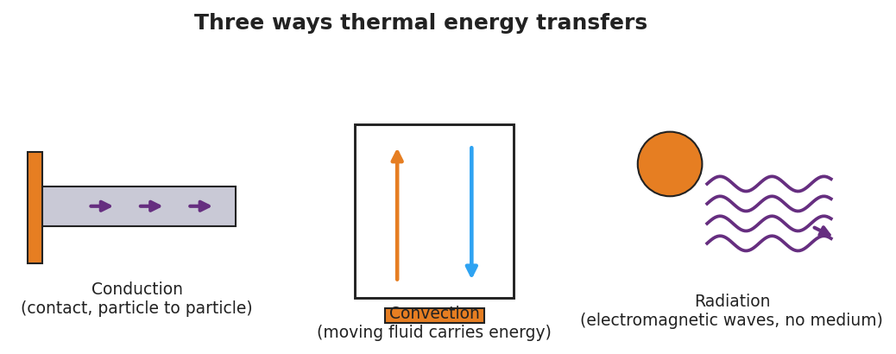
Conduction, convection, and radiation — three ways thermal energy transfers
Plot the class data as two converging curves:
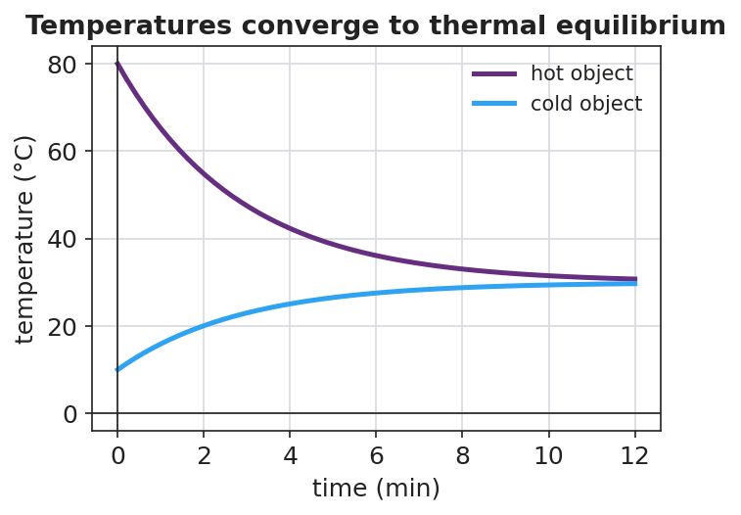
Two objects’ temperatures converging to thermal equilibrium
Teacher facilitation language:
“Tell me which thermometer is dropping and which is climbing. Now — do they ever cross, or do they meet and stop?” “Is ‘cold’ flowing into the water, or is energy flowing out of the water into the ice?” “Once they’re equal, does energy keep moving back and forth, or has it spread out evenly?”

Teacher facilitation during Explore
- What to look for — students noticing the two curves converge and then flatten at one shared temperature.
- What to resist — don’t name the second law yet; let the converging curves do the arguing.
- What to redirect — “cold flows in” → ask “What is actually moving — energy, or cold? Which direction?” Steer to “energy flows hot → cold.”

Phase 3 · Explain (32 – 37 min)

32–35 min · Turn-and-Talk #2 + class consensus
“Across every group, which way did the energy always flow, and where did the temperatures end up?”
Target consensus:
“Thermal energy always flows on its own from the hotter object to the cooler one, until both reach the same temperature — thermal equilibrium. The energy spreads out to become more uniform.”

35–37 min · Vocabulary introduction (≤ 3 terms)
Sample teacher language:
“The thermal energy that moves because of a temperature difference is called heat. It always flows from hot to cold until the objects reach thermal equilibrium — the same temperature. The rule that energy spontaneously spreads to a more uniform distribution is the second law of thermodynamics.”

Discussion prompts to deploy here
- “Why does the metal spoon handle get warm even though only the bowl end is in the soup?”
  - Sample student response: “Conduction — fast-moving particles at the hot end bump the next particles, passing energy along until the handle warms toward equilibrium.”
- “Why do the penguins rotate through the huddle?”
  - Sample student response: “So thermal energy spreads more uniformly through the group — no one stays at the cold edge; that’s the second law working for them.”

Phase 4 · Elaborate (37 – 40 min)

37–39 min · Revise the model — Hochman Because/But/So
This is the Hochman strategy lesson. Have every student expand one kernel sentence using all three conjunctions:
“Complete: ‘Thermal energy flows from the hot water into the ice because ____, but ____, so ____.’”
Model one on the board first, e.g.: “…because the hot water’s particles have more energy, but the flow stops once both are the same temperature, so the system reaches thermal equilibrium with energy spread evenly.”

39–40 min · Return to the phenomenon
“Use the second law to explain in one sentence why the penguin huddle keeps the whole group alive.”
Target: “Energy spreads from the warm inner birds outward to a more uniform distribution as they rotate, so no penguin stays cold enough to die — the second law made even.”

Phase 5 · Evaluate (40 – 42 min)

40–42 min · Exit Ticket + Closing Reflection
“You drop a warm metal spoon into a cup of cold water in an insulated (closed) container. (a) Which way does thermal energy flow, and why? (b) What is the final situation called, and how do the two temperatures compare then? (c) Name the heat-transfer mode that warms the spoon’s handle, and state the second law of thermodynamics in your own words.”
Expected: (a) from the warmer spoon to the cooler water — heat flows hot → cold; (b) thermal equilibrium — the spoon and water reach the same temperature; (c) conduction; second law: in a closed system energy spontaneously spreads to a more uniform distribution. See Answer_Key.docx.
Closing Reflection (SEL, 30 seconds):
“What is one thing today that changed how you think? Who helped you make sense of it?”

Common Misconceptions
- Misconception: “Cold flows into warm objects.” → Correction: Cold is not a substance. Thermal energy flows from hot to cold; “getting colder” means losing energy.
- Misconception: “Heat and temperature are the same.” → Correction: Heat is energy in transit due to a temperature difference; temperature is the average particle KE of one object.
- Misconception: “At equilibrium, energy stops moving entirely.” → Correction: Particles still move and exchange energy, but there is no net flow — the distribution is uniform.

Access & Differentiation
- ELL/ENL supports: Sentence frame: *“Thermal energy flows from the ___ object to the ___ object until they reach ___.”* Word-choice box: {hotter, cooler, thermal equilibrium, heat, uniform}. Pair equilibrium with two hands meeting at the same height.
- IEP/SPED supports: Provide a pre-labeled two-line graph axis; students draw the two converging curves rather than building the table from scratch. Offer the spoon-in-water station as a hands-on alternative to writing.
- Extensions: Ask students to explain why a closed thermos slows — but cannot stop — the approach to equilibrium, and which transfer modes a thermos is designed to block.

Strategy Spotlight
HOCHMAN (sentence-level literacy). Phase 4 uses the Hochman Because / But / So expansion on a single kernel sentence about heat flow. Model one complete expansion first, then require each student to produce one that is physics-correct (energy flows hot → cold; flow stops at equilibrium). The three conjunctions force cause (because), limitation (but), and consequence (so) — exactly the reasoning the second law demands. Keep it to one sentence; quality over quantity.

NYSSLS Observation Checklist Crosswalk
# | Checklist item | Where it appears in this lesson
1 | Local/relatable phenomenon | Phase 1 — penguin huddle / ice in a warm drink; spoon in soup in Phase 3
2 | Turn and Talk (2–3×) | Phase 1 (TT#1 — which way energy moves), Phase 3 (TT#2 — direction + endpoint)
3 | Students develop questions/models/procedures | Phase 1 (initial model), Phase 2 (two-temperature investigation), Phase 4 (revise model)
4 | CCC defined and used | Lesson Overview · Systems and System Models, restated in Phase 2
5 | ENL — ≤ 3 vocab, second half | Phase 3 — vocabulary at 35–37 min (heat / thermal equilibrium / second law)
6 | Revisit phenomenon with evidence | Phase 4 — penguin huddle re-explained + Because/But/So
7 | ENL/SPED supports | Access & Differentiation block
8 | Assessment check | Phase 5 — Exit Ticket (spoon in cold water)

Companion Materials
- Student_Worksheet.docx — the 5E student investigation (hand out at start of Phase 2)
- Student_Notes.docx — guided note-guide for vocabulary and the worked example
- Answer_Key.docx — answers to “Make It Make Sense” prompts and the Exit Ticket
- figures/approach_equilibrium.png, figures/heat_transfer_modes.png — projection visuals

Key Vocabulary (max 3)
- heat — thermal energy that flows from a hotter object to a cooler one because of a temperature difference
- thermal equilibrium — the state in which two objects in contact reach the same temperature and there is no net flow of thermal energy between them
- second law of thermodynamics — in a closed system, thermal energy spontaneously spreads to a more uniform (less concentrated) distribution

Heat Transfer and the Second Law of Thermodynamics — Student Worksheet
Unit: Thermal Energy & Conservation — Lesson 02 Name: _______________________ Date: __________ Period: ____

Phenomenon
Emperor penguins survive −40 °C winters by packing into a tight huddle and slowly rotating, so the warm birds in the center and the freezing birds on the edge keep trading places. Meanwhile, on your desk, an ice cube is melting in a cup of warm water.

Conduction, convection, and radiation
Driving question: Which way does thermal energy move when a hot thing and a cold thing meet — and where do they end up?

Notice & Wonder
I notice… | I wonder…
Turn & Talk #1: Does energy move from the warm water to the ice, or from the ice to the water? How do you know?

Initial Model
Draw the warm water and the ice cube the instant they meet. Use arrows to show which way thermal energy flows.
Sketch here:
My prediction — the final temperature will be: closer to the ice / closer to the warm water / in between (circle one)

Investigation
Measure both temperatures every 30 seconds and record them.
Time (s) | Warm-water temp (°C) | Cold/ice temp (°C)
0
30
60
90
120
Then sketch the two curves on the same axes (warm one starts high, cold one starts low):
[ graph space ]
Key question: Do the two temperatures cross, or do they meet and stop? What is that endpoint called?

Make It Make Sense
- Which way does thermal energy flow when a hot object touches a cold object? Why never the other way on its own?
- A metal spoon left in hot soup gets warm at the handle, even though only the bowl end touches the soup. Which transfer mode explains this?
- Why do the penguins keep rotating through the huddle? Use the idea that energy “spreads out.”

Vocabulary in Action
Use each term in a sentence about today’s phenomenon.
- heat: _______________________________________________
- thermal equilibrium: _______________________________________________
- second law of thermodynamics: _______________________________________________

Revise Your Model
Expand this kernel sentence using all three conjunctions (Because / But / So):
“Thermal energy flows from the hot water into the ice because _______________________________________________, but _______________________________________________, so _______________________________________________.”

Exit Ticket
You drop a warm metal spoon into a cup of cold water in an insulated (closed) container.
- Which way does thermal energy flow, and why?
- What is the final situation called, and how do the two temperatures compare then?
- Name the heat-transfer mode that warms the spoon’s handle, and state the second law of thermodynamics in your own words.

Heat Transfer and the Second Law of Thermodynamics — Student Notes
Unit: Thermal Energy & Conservation — Lesson 02 Name: _______________________ Date: __________ Period: ____

Learning Targets
By the end of today’s 42 minutes I can:
- Describe how heat flows from a hotter object to a cooler one until thermal equilibrium.
- Identify conduction, convection, and radiation as the three modes of heat transfer.
- State the second law of thermodynamics in my own words.

Key Vocabulary
- heat — _______________________________________________
- thermal equilibrium — _______________________________________________
- second law of thermodynamics — _______________________________________________

Guided Notes
Big idea: When two objects at different temperatures touch, thermal energy flows from the __________ object to the __________ object. It never flows the other way on its own.
- The energy moving because of a temperature difference is called __________.
- The flow continues until both objects reach the __________ temperature — this is __________.
- At equilibrium there is no __________ flow of energy (particles still move, but energy is spread evenly).
Three ways thermal energy transfers:
- Conduction — energy passes by __________ (particle to particle), e.g. a spoon handle warming.
- Convection — a moving __________ (liquid or gas) carries the energy, e.g. warm water rising.
- Radiation — energy travels as __________ waves and needs no medium, e.g. warmth from the Sun.

Conduction, convection, radiation
Second law of thermodynamics: In a __________ system, thermal energy spontaneously spreads to a more __________ distribution.

Two temperatures converging to equilibrium

Worked Example
Problem. A hot rock at 80 °C is placed in a sealed, insulated box with cool water at 10 °C. Describe what happens over time.
Solution. 1. Thermal energy flows from the __________ rock to the __________ water (hot → cold). 2. The rock’s temperature __________ and the water’s temperature __________. 3. They keep changing until both reach the __________ temperature → thermal equilibrium. 4. The energy that was concentrated in the rock is now spread more __________ across the system — the second law in action.

Summary
Finish the sentence (Because / But / So):
Thermal energy flows from the hot object to the cold object because __________________________________________, but __________________________________________, so __________________________________________.

Heat Transfer and the Second Law of Thermodynamics — Answer Key

Cover
Unit: Thermal Energy & Conservation (Thermodynamics) — Lesson 02: Heat Transfer and the Second Law of Thermodynamics East Meadow Schools × Valley Stream Central HSD Strategy chip: HOCHMAN

Make-It-Make-Sense Answers
- Thermal energy flows from the hotter object to the cooler object. It never flows the other way on its own because that is the second law of thermodynamics — energy spontaneously spreads toward a more uniform distribution, not toward a more concentrated one. · Rubric: states hot → cold AND that the reverse is non-spontaneous / second law. · NYSSLS: HS-PS3-4
- Conduction. Fast-moving particles at the hot (bowl) end collide with neighboring particles, passing energy along the metal until the handle warms. · Rubric: names conduction AND mentions particle-to-particle transfer. · NYSSLS: HS-PS3-4
- Rotating moves cold edge birds to the warm center and warm center birds to the edge, so thermal energy spreads more uniformly through the whole group instead of staying concentrated — keeping every penguin warm enough to survive. · Rubric: links rotation to a more uniform energy distribution. · NYSSLS: HS-PS3-4

Exit Ticket Answer
- Thermal energy flows from the warm spoon to the cold water — heat always flows from hotter to cooler.
- The final situation is thermal equilibrium: the spoon and the water reach the same temperature, and there is no further net flow of energy between them.
- The handle warms by conduction. Second law (student wording): in a closed system, thermal energy spreads out on its own to a more uniform distribution (energy goes from concentrated/hot to spread-out, never the reverse spontaneously).
Tolerance/rubric: (a) hot → cold (spoon → water); (b) “thermal equilibrium” AND “same temperature / no net flow”; (c) conduction AND a correct paraphrase of the second law. 1 point each. NYSSLS: HS-PS3-4.

Closing Reflection (rubric)
Closing reflection is formative, not graded. Award full credit for any honest response. Look for: - A genuine shift-in-thinking statement in answer 1 (e.g., “I used to think cold moved into things”). - Naming a peer or self-acknowledgment in answer 2.

Calorimetry — Thermal Tales — Teacher Guide

Cover
Unit: Thermal Energy & Conservation (Thermodynamics) — Lesson 03: Calorimetry — Thermal Tales East Meadow Schools × Valley Stream Central High School District Strategy chips: ACTIVE LEARNING

Curated Resources (from East Meadow Scope & Sequence)

NYSSLS Standards
This lesson is the investigation that fully satisfies the unit anchor, HS-PS3-4: “Plan and conduct an investigation to provide evidence that the transfer of thermal energy when two components of different temperature are combined within a closed system results in a more uniform energy distribution among the components (second law of thermodynamics). (Systems and System Models).” Students plan and conduct a calorimetry investigation: combine hot and cold water in a closed (insulated) cup, predict and measure the final temperature, and show with Q = m·c·ΔT that the heat lost by the hot water equals the heat gained by the cold water. This is the quantitative payoff of Lesson 02’s hot-to-cold flow.

Phenomenon
- Thermal Tales / mixing water — pour a measured mass of hot water into a measured mass of cold water in an insulated cup; predict the final temperature before you read the thermometer. Reference investigation framing (NYSED Investigating Energy / Thermal Energy tasks): https://www.nysed.gov/curriculum-instruction/science-learning-standards
- PhET Energy Forms and Changes — heat and mix substances, watch energy chunks move: https://phet.colorado.edu/en/simulations/energy-forms-and-changes

Javalab / Labs
- Calorimetry / “Thermal Tales” lab (this lesson) — hot + cold water mixing in a foam-cup calorimeter; heat lost = heat gained.
- Javalab — Specific heat / calorimetry: https://javalab.org/en/specific_heat_en/

Assessments
- Exit Ticket below (predict-the-final-temperature calculation) is the formative check.
- The completed calorimetry data table + Q-balance is a NYSSLS investigation artifact for HS-PS3-4.

Lesson Overview
Duration | 42 minutes (1 period; pairs well with a double-period day for a longer run)
NYSSLS link | HS-PS3-4 (investigation — plan, conduct, evidence; closed system; uniform distribution)
CCC focus | Energy and Matter / Systems and System Models — energy is conserved within a closed system; heat lost = heat gained.
Strategy chips | ACTIVE LEARNING (NYS Investigation)
Materials | Foam-cup calorimeters with lids; hot water (~80 °C) and cold water (~20 °C); graduated cylinders/balances; thermometers; stopwatch; whiteboards. NYS Reference Table (Q = m·c·ΔT; c_water = 4,186 J/kg·°C).
Safety | Hot water ~80 °C — pour carefully, no scalding water above that. Wipe spills immediately.
Prior knowledge | Lessons 01–02 — thermal energy is total particle KE; heat flows hot → cold to equilibrium.
Lesson objectives — students can:
- Use Q = m·c·ΔT to calculate the heat gained or lost by a water sample.
- Show that, in a closed system, the heat lost by the hot object equals the heat gained by the cold object.
- Plan and conduct a calorimetry investigation and predict the final equilibrium temperature.

Phase 1 · Engage (0 – 12 min)

0–3 min · Opening Connection (SEL)
Quick whip-around (one sentence): “Name one time you mixed something hot and something cold — and what you got.” (Coffee + ice, hot cocoa + cold milk, a bath you adjusted.) This anchors the predict-the-mix task.

3–8 min · Phenomenon hook — predict the mix
Teacher actions. Hold up a cup of hot water (~80 °C) and a cup of cold water (~20 °C), each the same amount. Before mixing, ask every student to commit to a prediction on a whiteboard.
Sample teacher language:
“Equal amounts: this one’s 80 degrees, this one’s 20. I pour them together in this insulated cup. Write down right now — what does the thermometer read after they mix? Don’t hedge. Commit to a number.”
Anticipated student responses:
- “100 — you add them.” — common error; surface it, we will refute with conservation.
- “50 — it’s the average.” — for equal masses this is right; ask them why the average works.
- “Somewhere in the middle, closer to whichever there’s more of.” — excellent; this previews unequal masses.

8–12 min · Notice & Wonder + Turn-and-Talk #1
Two columns on the board. Then:
“Turn to your partner: the hot water cools down and the cold water warms up. Is the energy that leaves the hot water the same amount the cold water gains? Why?”
Target seed: in a closed cup, no energy escapes — what the hot loses, the cold gains. Leave open if unresolved.

Bridge to Phase 2
Each student commits a predicted final temperature with one sentence of reasoning.

Phase 2 · Explore (12 – 32 min)

12–16 min · Initial Model + plan the investigation (Active Learning)
Prompt on the board:
“With your group, write the procedure: what will you measure (masses, starting temperatures), how will you keep the system closed, and how will you know when you’ve reached the final temperature?”
Groups draft a short plan; circulate and approve before they pour. This is the plan and conduct an investigation move of HS-PS3-4.

16–32 min · Investigation — the Thermal Tales calorimetry run
Each group:
- Measures and records the mass and starting temperature of the hot water and the cold water.
- Pours both into the foam-cup calorimeter, lids it, and records the temperature every 15 seconds until it levels off.
- Plots both samples meeting at the final temperature, and computes Q for each side.
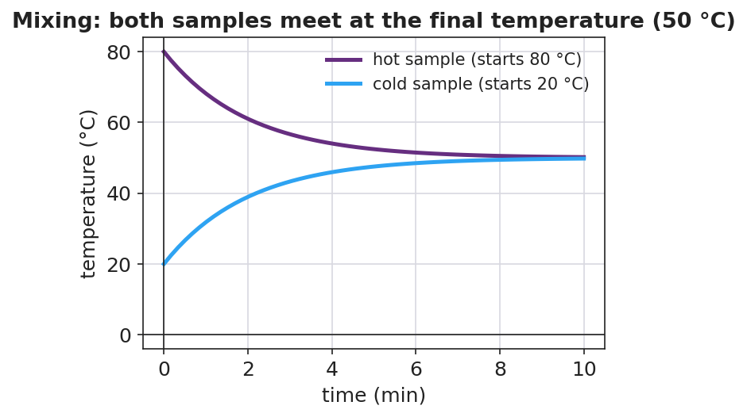
Hot and cold samples meeting at the final temperature
Then they test the conservation claim with Q = m·c·ΔT (c_water = 4,186 J/kg·°C from the Reference Table):
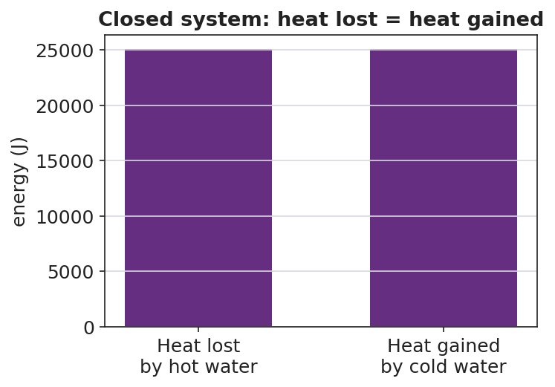
Heat lost by the hot water equals heat gained by the cold water
Teacher facilitation language:
“What’s your ΔT for the hot water? For the cold water? Now run Q = m·c·ΔT for each.” “Compare the two Q’s — are they close? If not, where did the missing energy go?” “Why did we use a foam cup with a lid instead of a metal beaker?”

Teacher facilitation during Explore
- What to look for — Q_lost ≈ Q_gained (within a few percent); students attributing the small gap to energy escaping the “closed” cup.
- What to resist — don’t hand them the final-temperature formula; let the measured equilibrium and the Q-balance teach it.
- What to redirect — groups whose Q’s are far apart: check ΔT signs and that masses (not volumes mislabeled) were used.

Phase 3 · Explain (32 – 37 min)

32–35 min · Turn-and-Talk #2 + class consensus
“Compare your hot-water Q to your cold-water Q. What’s the relationship, and what does it prove about the closed system?”
Target consensus:
“In a closed system the heat lost by the hot water equals the heat gained by the cold water — energy is conserved. Q = m·c·ΔT lets us calculate each side, and they balance.”

35–37 min · Vocabulary introduction (≤ 3 terms)
Sample teacher language:
“Measuring heat transfer this way — in an insulated cup — is called calorimetry. The ‘c’ in Q = m·c·ΔT is the specific heat: how much energy it takes to raise 1 kg of a substance by 1 °C. And heat, Q, is the thermal energy that moved from the hot sample into the cold one.”

Discussion prompts to deploy here
- “If you mix equal masses of hot and cold water, why is the final temperature the average?”
  - Sample student response: “Same mass and same c, so equal-size ΔT’s balance — the hot drops as much as the cold rises, landing in the middle.”
- “If you mixed a little hot water into a lot of cold water, where would the final temperature land?”
  - Sample student response: “Closer to the cold water — the large mass needs a big Q to change temperature, so it barely moves while the small hot sample drops a lot.”

Phase 4 · Elaborate (37 – 40 min)

37–39 min · Revise the model — predict an unequal mix
“Predict: 0.10 kg of 80 °C water poured into 0.30 kg of 20 °C water. Will the final temperature be above or below 50 °C? Justify with Q = m·c·ΔT (heat lost = heat gained).”
Target reasoning: below 50 °C — the larger cold mass dominates; setting m_hot·c·(80 − T_f) = m_cold·c·(T_f − 20) gives T_f = 35 °C.

39–40 min · Return to the phenomenon
“Use heat lost = heat gained to explain in one sentence why your mixed cup settled where it did.”
Target: “The hot water lost exactly as much thermal energy as the cold water gained, so the final temperature sat where those two Q’s balanced — at thermal equilibrium.”

Phase 5 · Evaluate (40 – 42 min)

40–42 min · Exit Ticket + Closing Reflection
“In an insulated cup you mix 0.20 kg of water at 80 °C with 0.20 kg of water at 20 °C. (c_water = 4,186 J/kg·°C.) (a) Using heat lost = heat gained, what is the final temperature? (b) Calculate the heat gained by the cold water with Q = m·c·ΔT. (c) How does that compare to the heat lost by the hot water, and what principle does that show?”
Expected: (a) 50 °C (equal masses → average); (b) Q = (0.20)(4,186)(50 − 20) = 25,116 J ≈ 2.5 × 10⁴ J; (c) equal in size to the heat lost by the hot water — conservation of energy in a closed system (heat lost = heat gained). See Answer_Key.docx.
Closing Reflection (SEL, 30 seconds):
“What is one thing today that changed how you think? Who helped you make sense of it?”

Common Misconceptions
- Misconception: “Mixing 80 °C and 20 °C water gives 100 °C.” → Correction: Temperatures do not add; energy is conserved. Equal masses average to 50 °C.
- Misconception: “The final temperature is always the average.” → Correction: Only when the masses (and specific heats) are equal. Unequal masses pull the result toward the larger sample.
- Misconception: “Heat and temperature are interchangeable in Q = m·c·ΔT.” → Correction: Q (joules) is energy transferred; ΔT (°C) is the temperature change. They are linked by mass and specific heat, not equal.

Access & Differentiation
- ELL/ENL supports: Sentence frame: *“The heat lost by the ___ water equals the heat gained by the ___ water, so the final temperature is ___.”* Word-choice box: {hot, cold, equal, conserved, specific heat}. Provide the Q = m·c·ΔT formula with each symbol labeled in the student’s home language where possible.
- IEP/SPED supports: Provide a partially worked Q calculation (masses and c filled in; student computes ΔT and multiplies). Offer a calculator and a two-row “lost / gained” table to organize the numbers. Group roles (timer, recorder, pourer) so every student has an entry point.
- Extensions: Have students mix a metal (e.g. a warmed steel nut) into cold water and solve for the metal’s specific heat from the calorimetry data — a true unknown-c determination.

Strategy Spotlight
ACTIVE LEARNING (NYS Investigation). Phase 2 hands students the plan and conduct responsibility required by HS-PS3-4: they write the procedure, choose what to measure, keep the system closed, and decide how they will know they reached the final temperature. The teacher approves plans but does not script them. Students then generate their own evidence (the Q-balance) rather than receiving it. Keep groups to 3–4 with clear roles so the hands-on time stays productive.

NYSSLS Observation Checklist Crosswalk
# | Checklist item | Where it appears in this lesson
1 | Local/relatable phenomenon | Phase 1 — predict the hot+cold water mix; everyday mixing in the SEL opener
2 | Turn and Talk (2–3×) | Phase 1 (TT#1 — lost = gained?), Phase 3 (TT#2 — compare the two Q’s)
3 | Students develop questions/models/procedures | Phase 2 — groups plan and conduct the calorimetry investigation (HS-PS3-4)
4 | CCC defined and used | Lesson Overview · Energy and Matter / Systems, restated in Phase 2
5 | ENL — ≤ 3 vocab, second half | Phase 3 — vocabulary at 35–37 min (calorimetry / specific heat / heat)
6 | Revisit phenomenon with evidence | Phase 4 — predict an unequal mix using heat lost = heat gained
7 | ENL/SPED supports | Access & Differentiation block
8 | Assessment check | Phase 5 — Exit Ticket (final temperature + Q calculation)

Companion Materials
- Student_Worksheet.docx — the 5E student investigation / calorimetry lab (hand out at start of Phase 2)
- Student_Notes.docx — guided note-guide for the formula and the worked example
- Answer_Key.docx — answers to “Make It Make Sense” prompts and the Exit Ticket
- figures/mixing_temps.png, figures/heat_lost_gained.png — projection visuals

Key Vocabulary (max 3)
- calorimetry — the measurement of heat transfer, usually by mixing substances in an insulated container and tracking temperature change
- specific heat — the energy needed to raise the temperature of 1 kg of a substance by 1 °C (the “c” in Q = m·c·ΔT)
- heat — the thermal energy (Q) transferred from a hotter object to a cooler one, measured in joules

Calorimetry — Thermal Tales — Student Worksheet
Unit: Thermal Energy & Conservation — Lesson 03 Name: _______________________ Date: __________ Period: ____

Phenomenon
Your teacher holds equal amounts of hot water (80 °C) and cold water (20 °C). They are about to be poured together into an insulated cup. What will the thermometer read after they mix?

Hot and cold samples meeting at one final temperature
Driving question: When hot and cold water mix in a closed cup, what decides the final temperature?
Reference Table formula: Q = m·c·ΔT (c_water = 4,186 J/kg·°C)

Notice & Wonder
I notice… | I wonder…
My prediction (commit to a number before mixing): final temperature = __________ °C
Turn & Talk #1: The hot water cools and the cold water warms. Is the energy that leaves the hot water the same amount the cold water gains? Why?

Initial Model
With your group, plan the investigation. Write your procedure:
- What will you measure (masses, starting temperatures)? ____________________
- How will you keep the system closed? ____________________
- How will you know you have reached the final temperature? ____________________

Investigation
Record your calorimetry run.
 | Hot water | Cold water
Mass m (kg)
Starting temp (°C)
Final temp T_f (°C)
ΔT = T_f − start (°C)
Q = m·c·ΔT (J)

Time (s) | Mixed temperature (°C)
0
15
30
45
60
Key question: Compare the size of Q for the hot water and the cold water. What is the relationship?

Make It Make Sense
- Why does mixing equal masses of hot and cold water give a final temperature in the middle (the average)?
- If you mixed a little hot water into a lot of cold water, would the final temperature land above or below the average? Why?
- Why did we use a foam cup with a lid instead of an open metal beaker?

Vocabulary in Action
Use each term in a sentence about today’s investigation.
- calorimetry: _______________________________________________
- specific heat: _______________________________________________
- heat: _______________________________________________

Revise Your Model
Predict: 0.10 kg of 80 °C water poured into 0.30 kg of 20 °C water. Will the final temperature be above or below 50 °C? Justify using Q = m·c·ΔT (heat lost = heat gained).

Exit Ticket
In an insulated cup you mix 0.20 kg of water at 80 °C with 0.20 kg of water at 20 °C. (c_water = 4,186 J/kg·°C.)
- Using heat lost = heat gained, what is the final temperature?
- Calculate the heat gained by the cold water with Q = m·c·ΔT.
- How does that compare to the heat lost by the hot water, and what principle does that show?

Calorimetry — Thermal Tales — Student Notes
Unit: Thermal Energy & Conservation — Lesson 03 Name: _______________________ Date: __________ Period: ____

Learning Targets
By the end of today’s 42 minutes I can:
- Use Q = m·c·ΔT to calculate the heat gained or lost by a sample.
- Show that, in a closed system, heat lost = heat gained.
- Plan and conduct a calorimetry investigation and predict the final temperature.

Key Vocabulary
- calorimetry — _______________________________________________
- specific heat — _______________________________________________
- heat — _______________________________________________

Guided Notes
The formula (Reference Table): Q = m · c · ΔT
- Q = __________ transferred, in joules (J)
- m = __________ of the substance, in kilograms (kg)
- c = __________ heat (for water, c = __________ J/kg·°C)
- ΔT = change in __________ = T_final − T_start (°C)
Closed-system rule: When a hot object and a cold object mix in an insulated container, no energy escapes, so:
heat __________ by the hot object = heat __________ by the cold object

Heat lost = heat gained
- For equal masses of the same substance, the final temperature is the __________ of the two starting temperatures.
- For unequal masses, the final temperature lands closer to the __________ (larger-mass) sample.

Hot and cold samples meeting at the final temperature

Worked Example
Problem. Mix 0.20 kg of water at 80 °C with 0.20 kg of water at 20 °C in an insulated cup. Find the final temperature and the heat transferred. (c = 4,186 J/kg·°C.)
Solution. 1. Equal masses of the same substance → final temperature is the __________ → T_f = __________ °C. 2. Heat gained by the cold water: Q = m·c·ΔT = (0.20)(4,186)(50 − 20) = __________ J. 3. Heat lost by the hot water: Q = (0.20)(4,186)(80 − 50) = __________ J. 4. The two Q’s are __________ in size → energy is conserved (heat lost = heat gained).

Summary
Finish the sentence (Because / But / So):
When hot water and cold water mix in a closed cup, the final temperature settles in between because __________________________________________, but __________________________________________, so __________________________________________.

Calorimetry — Thermal Tales — Answer Key

Cover
Unit: Thermal Energy & Conservation (Thermodynamics) — Lesson 03: Calorimetry — Thermal Tales East Meadow Schools × Valley Stream Central HSD Strategy chip: ACTIVE LEARNING

Make-It-Make-Sense Answers
- With equal masses of the same substance, the two samples have the same m and the same c, so a given temperature change costs the same energy on each side. The hot water’s temperature drops by the same amount the cold water’s temperature rises, landing exactly in the middle — the average. · Rubric: links equal m and c to equal-size, opposite ΔT → average. · NYSSLS: HS-PS3-4
- Below the average. The large cold mass needs a large Q to change temperature, so it barely warms, while the small hot sample cools a lot. The final temperature is pulled toward the larger (cold) mass. · Rubric: states “closer to the larger/cold mass” with a mass-based reason. · NYSSLS: HS-PS3-4
- The foam cup with a lid is an insulator, keeping the system closed so almost no thermal energy escapes. That makes heat lost ≈ heat gained, which is what we are testing. A metal beaker would conduct energy out to the surroundings. · Rubric: identifies insulation / closed system. · NYSSLS: HS-PS3-4
Revise-Your-Model (unequal mix) answer: Set heat lost = heat gained: (0.10)(c)(80 − T_f) = (0.30)(c)(T_f − 20). The c cancels: 0.10(80 − T_f) = 0.30(T_f − 20) → 8 − 0.10 T_f = 0.30 T_f − 6 → 14 = 0.40 T_f → T_f = 35 °C (below 50 °C, as predicted — the larger cold mass dominates).

Exit Ticket Answer
- Equal masses of the same substance → final temperature is the average: T_f = 50 °C.
- Q gained by cold water = m·c·ΔT = (0.20 kg)(4,186 J/kg·°C)(50 − 20 °C) = (0.20)(4,186)(30) = 25,116 J ≈ 2.5 × 10⁴ J.
- The heat lost by the hot water is Q = (0.20)(4,186)(80 − 50) = 25,116 J — equal in size to the heat gained. This shows conservation of energy in a closed system (heat lost = heat gained), consistent with the second law’s drive toward thermal equilibrium.
Tolerance/rubric: (a) 50 °C; (b) 2.5 × 10⁴ J (accept 25,000–25,200 J); (c) “equal” AND “energy conserved / heat lost = heat gained.” 1 point each. NYSSLS: HS-PS3-4.

Closing Reflection (rubric)
Closing reflection is formative, not graded. Award full credit for any honest response. Look for: - A genuine shift-in-thinking statement in answer 1 (e.g., “I used to think you add the temperatures”). - Naming a peer or self-acknowledgment in answer 2.

