Physics — Unit 06: Electrostatics (Review)
Table of Contents

Unit 6 · Electrostatics

Electrostatics — Unit Plan

Cover
Unit: Electrostatics East Meadow Schools × Valley Stream Central High School District 6 lessons · ~6 instructional periods (42 min each) Format: DOCX (Teacher Guide · Student Worksheet · Student Notes · Answer Key per lesson)

Unit Scope (from East Meadow Scope & Sequence)
This unit develops the electric interaction from the ground up: the two kinds of charge, how charge moves (or doesn’t) through materials, the three ways objects become charged, the quantitative force law (Coulomb’s law), and the field model that explains action at a distance. It builds directly on the Forces unit — especially Universal Gravitation, whose inverse-square law reappears for charge (HS-PS2-4, the Patterns crosscutting concept) — and it sets up Circuits and Magnetism.
# | Lesson | Core idea
01 | Electric Charge | Two kinds of charge (+/−); like repel, unlike attract; charge is conserved and quantized
02 | Conductors, Insulators, and Charging by Conduction | Charge moves freely in conductors, not in insulators; contact transfers same-sign charge
03 | Charging by Induction and Polarization | Induction charges without contact (opposite sign); polarization shifts charge in a neutral object
04 | Coulomb’s Law | Fₑ = k·q₁·q₂ / r²; the inverse-square Pattern shared with gravity
05 | Electric Fields | E = Fₑ / q; a field is force per unit charge; points away from + and toward −
06 | Electric Field Lines | Rules for drawing field lines; single charge, dipole, parallel plates

Pacing Calendar
Day | Lesson | Phenomenon anchor | Strategy
1 | 01 Electric Charge | Balloon sticks to hair/wall; static shock | Restorative Circle (unit opener)
2 | 02 Conductors / Insulators / Conduction | Van de Graaff hair; charged rod on an electroscope | Active Learning
3 | 03 Induction / Polarization | Charged rod bends water / attracts neutral paper | BTC
4 | 04 Coulomb’s Law | PhET Coulomb’s Law: two charged spheres | Hochman
5 | 05 Electric Fields | Plasma ball lighting a fluorescent bulb at a distance | Active Learning
6 | 06 Electric Field Lines | Semolina-in-oil reveals the field between electrodes | Hochman
Double-period days (every other day) allow the investigation phases of Lessons 02–03 (sorting/BTC board work) and the PhET data sweeps of Lesson 04 to run long.

Strategy Rotation
- RESTORATIVE CIRCLE: Lesson 01 — unit-opening circle (“a shock, spark, or cling you’ve felt”).
- ACTIVE LEARNING: Lessons 02, 05 — predict-sort-test on vertical whiteboards (conductors/insulators) and the human field-map.
- BTC (Building Thinking Classrooms): Lesson 03 — random groups + vertical non-permanent surfaces on the induction thin-slice.
- HOCHMAN (literacy): Lessons 04, 06 — Because/But/So expansion and appositives on Coulomb’s law and the field-line rules.
SEL (Opening Connection + Closing Reflection), ELL/SPED supports, and a Curated Resources block appear in every lesson.

NYSSLS Coverage Matrix
PE | Description | Lessons
HS-PS2-4 | “Use mathematical representations of Newton’s Law of Gravitation and Coulomb’s Law to describe and predict the gravitational and electrostatic forces between objects. (Patterns)” | 04 (core — Coulomb’s law)
HS-PS3-5 | “Develop and use a model of two objects interacting through electric or magnetic fields to illustrate the forces between objects and the changes in energy of the objects due to the interaction. (Cause and Effect)” | 01, 02, 03 (mechanism), 05, 06 (field model)
Crosscutting concepts: Patterns (the inverse-square law shared by Coulomb and gravity, Lesson 04) and Cause and Effect (charge causes interaction, field causes force, throughout).

Vocabulary Scope
Three terms maximum per lesson, introduced in the second half (NYSSLS observation item 5).
Lesson | Terms
01 | electric charge · positive charge · negative charge
02 | conductor · insulator · charging by conduction
03 | polarization · induction · grounding
04 | Coulomb’s law · electrostatic force · inverse-square law
05 | electric field · test charge · field strength
06 | field line · dipole · uniform field

Electric Charge — Teacher Guide

Cover
Unit: Electrostatics — Lesson 01: Electric Charge East Meadow Schools × Valley Stream Central High School District Strategy chips: RESTORATIVE CIRCLE

Curated Resources (from East Meadow Scope & Sequence)

NYSSLS Standards
This unit opens the study of HS-PS2 and HS-PS3 as they apply to electricity. The Electric Charge row establishes the cause behind every later lesson — that matter carries two kinds of charge — so it threads toward HS-PS3-5: “Develop and use a model of two objects interacting through electric or magnetic fields to illustrate the forces between objects and the changes in energy of the objects due to the interaction. (Cause and Effect).” The quantitative force these charges exert (Coulomb’s law, HS-PS2-4) is developed in Lesson 04.

Phenomenon
- Balloon rubbed on hair sticks to a wall; hair stands up: https://www.youtube.com/watch?v=VFbyDCG_QoM
- Static shock from a doorknob after walking on carpet (Khan Academy, “Charge and electric force”): https://www.khanacademy.org/science/physics/electric-charge-electric-force-and-voltage

Javalab / Labs
- Electroscope (charge detector): https://javalab.org/en/electroscope_en/
- Charging by friction (rub two materials, watch charge transfer): https://javalab.org/en/charging_by_friction_en/

Assessments
- Khan Academy “Charge and electric force” check-for-understanding set (link above). The Exit Ticket below is the formative check for this lesson.

Lesson Overview
Duration | 42 minutes (1 period)
NYSSLS link | HS-PS3-5 (foundation — what charges are, before modeling their interaction)
CCC focus | Cause and Effect — the attraction or repulsion you see is caused by an invisible property, charge.
Strategy chips | RESTORATIVE CIRCLE (unit opener)
Materials | Balloons (one per pair); wool/hair; small paper bits; two inflated balloons on strings; an acetate/glass rod and silk if available; whiteboards/markers.
Safety | Standard classroom safety; keep balloons away from open flame. No high-voltage sources today.
Prior knowledge | Atoms contain protons (+) and electrons (−); the idea of a force as a push or pull (from the Forces unit).
Lesson objectives — students can:
- State that there are exactly two kinds of charge (positive and negative), and that like charges repel while unlike charges attract.
- Explain a static-electricity phenomenon in terms of electrons transferring from one object to another (charge is conserved — never created or destroyed, only moved).
- Predict whether two charged objects will attract or repel given their signs.

Phase 1 · Engage (0 – 12 min)

0–3 min · Opening Connection (SEL) — Restorative Circle (unit opener)
This is the first lesson of a new unit, so open with a brief restorative circle. Pass a talking piece. Prompt: “Tell us about a time something surprised you with a shock, a spark, or a ‘cling’ — a sweater, a doorknob, a blanket fresh from the dryer.” One sentence each; no cross-talk. This builds community and surfaces the everyday static experiences you will explain today.

3–8 min · Phenomenon hook — the clinging balloon
Teacher actions. Rub a balloon on your hair (or wool) and hold it to the wall — it sticks. Bring it near a student’s hair — strands rise toward it. Sprinkle small paper bits and lower the balloon; the bits leap up.
Sample teacher language:
“I didn’t put glue on this balloon. So what did rubbing it on my hair do to it that makes the wall hold onto it?”
Anticipated student responses:
- “It got staticky.” — capture the word; “static” is exactly the everyday name for what we’ll call charge.
- “The rubbing made heat / made it sticky.” — reframe: rubbing moved something, not melted it.
- “It picked up electrons from your hair.” — excellent; hold it for Phase 3, don’t confirm yet.

8–12 min · Notice & Wonder + Turn-and-Talk #1
Capture two columns on the board. Then:
“Turn to your partner: the balloon and the wall were both ordinary before. What changed, and why would they now pull on each other?”
Take 2–3 responses. Desirable insight: something invisible moved onto the balloon when it was rubbed. Leave it open if no one lands it.

Bridge to Phase 2
Every student should leave Phase 1 with a one-sentence initial model: “The balloon sticks because ______.”

Phase 2 · Explore (12 – 32 min)

12–17 min · Initial Model (silent / individual)
Prompt on the board:
“Draw the rubbed balloon next to the wall. Show what you think moved (and which way) when it was rubbed. Then predict: will the balloon also stick to a second rubbed balloon, or push it away?”
This surfaces students’ intuitions about charge transfer before any vocabulary.

17–32 min · Investigation — two balloons and the electroscope
Stations (or whole-class):
- Two like-charged balloons — rub both on hair, hang on strings; bring them close. They swing apart.
- Charged balloon + neutral paper bits — the bits jump toward the balloon.
- Javalab electroscope — touch a rubbed rod near the electroscope; the leaves spread. Repeat with the other material.
Use the attract/repel diagram below to make the rule visible while students test the balloons.
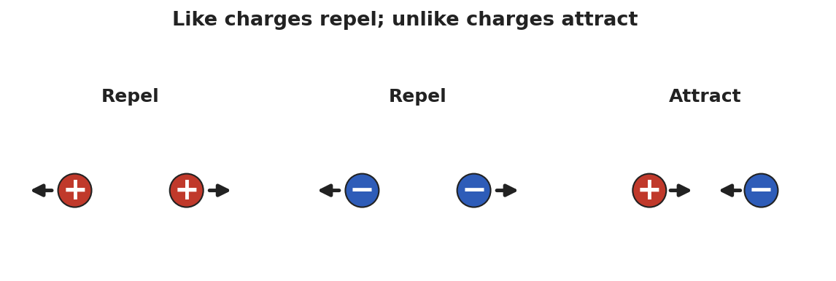
Three side-by-side diagrams of paired charges: two positive charges repel (arrows point apart), two negative charges repel, and a positive next to a negative attract (arrows point together).
Teacher facilitation language:
“When did the two objects pull together, and when did they push apart? What’s different about those two cases?” “If both balloons were rubbed the same way, do they carry the same kind of charge or opposite kinds?”

Teacher facilitation during Explore
- What to look for — students noticing that two of the same (two rubbed balloons) repel, while charged + neutral attracts.
- What to resist — don’t supply “positive/negative” yet; let “same pushes, different pulls” emerge from the balloons.
- What to redirect — students who say “the balloon makes its own charge” should be asked where it could come from (the hair lost what the balloon gained).

Phase 3 · Explain (32 – 37 min)

32–35 min · Turn-and-Talk #2 + class consensus
“Across the stations, what was always true about objects that pushed apart versus objects that pulled together?”
Target consensus:
“Matter carries one of two kinds of charge. The same kind repels; opposite kinds attract. Rubbing moves tiny charged particles (electrons) from one object to the other — it doesn’t create them. Whatever one object loses, the other gains.”

35–37 min · Vocabulary introduction (≤ 3 terms)
Sample teacher language:
“We call the two kinds positive charge and negative charge. The thing being moved is electric charge itself — it comes in whole packages (multiples of the elementary charge e = 1.6 × 10⁻¹⁹ C), and it is conserved: never made or destroyed, only transferred. A neutral object simply has equal positive and negative charge.”
The clinging balloon below is the model students return to in Phase 4.
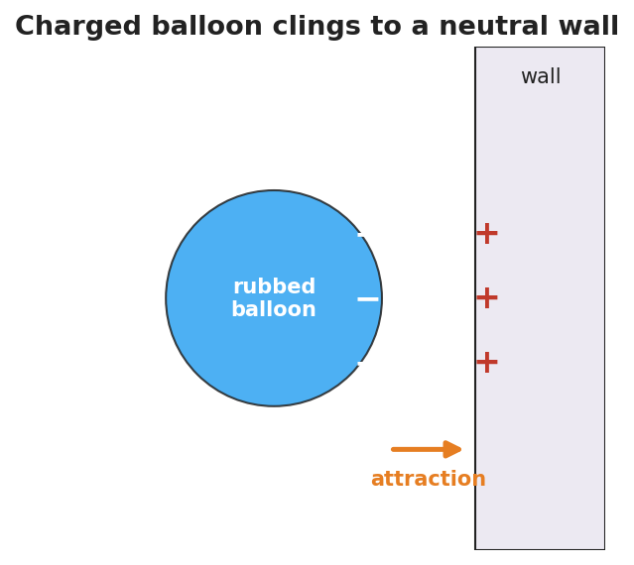
A negatively charged balloon held against a neutral wall; minus signs cover the balloon’s near face and plus signs appear on the wall surface closest to it, with an arrow showing the attraction between them.

Discussion prompts to deploy here
- “Your hair stands up toward the balloon you just used on it. What sign is your hair now, and why?”
  - Sample student response: “The balloon took electrons, so my hair lost negatives and is positive — opposite to the balloon, so it’s attracted.”
- “If you charge a balloon −5 units, what happened to the hair?”
  - Sample student response: “The hair became +5 units; the total charge didn’t change.”

Phase 4 · Elaborate (37 – 40 min)

37–39 min · Revise the model
“Return to your balloon drawing. Re-label what moved using the words electric charge and negative/positive. Write one sentence explaining the stick using conservation of charge.”

39–40 min · Return to the phenomenon
“Why do you get a shock at a metal doorknob after walking across carpet? Answer in one sentence using charge.”
Target: “Walking rubbed extra electrons onto me; touching the metal lets that built-up charge jump across as a spark, returning me to neutral.”

Phase 5 · Evaluate (40 – 42 min)

40–42 min · Exit Ticket + Closing Reflection
“Two small spheres hang side by side. (a) When both are rubbed with the same cloth, they swing apart. What does that tell you about their charges? (b) A third sphere is brought near and the first sphere swings toward it. What sign is the third sphere? (c) A balloon gains a charge of −8 units after being rubbed on a wool sock. What is the charge on the sock, and why?”
Expected: (a) they carry the same sign (like charges repel); (b) opposite to the first — attraction means unlike charges; (c) +8 units, because charge is conserved (the electrons the balloon gained came from the sock). See Answer_Key.docx.
Closing Reflection (SEL, 30 seconds):
“What is one everyday ‘shock or cling’ moment you now understand differently? Who helped you make sense of it?”

Common Misconceptions
- Misconception: “Rubbing creates charge out of nothing.” → Correction: Rubbing transfers charge; electrons move from one object to the other. Charge is conserved.
- Misconception: “There is only one kind of electricity that things have more or less of.” → Correction: There are two distinct kinds, positive and negative; neutral means equal amounts of each.
- Misconception: “A charged object and a neutral object can’t interact.” → Correction: A charged object attracts a neutral one (it polarizes it) — developed fully in Lesson 03.

Access & Differentiation
- ELL/ENL supports: Sentence frame: “The two objects ___ (attracted/repelled) because they have ___ (the same / opposite) charge.” Word-choice box: {positive, negative, charge, attract, repel, conserved, neutral}. Pair repel with hands pushing apart and attract with hands pulling together.
- IEP/SPED supports: Provide the attract/repel diagram pre-printed; students label each pair “attract” or “repel” rather than drawing arrows from scratch. Offer the balloon-on-hair demo as a hands-on alternative to written explanation.
- Extensions: Have students rank a triboelectric list (hair, glass, rubber, plastic) and predict which way electrons move when two are rubbed together, justifying with conservation.

Strategy Spotlight
RESTORATIVE CIRCLE (unit opener). Today’s opening uses a circle to launch the Electrostatics unit. Use a talking piece, one-sentence responses, and equity of voice (everyone speaks or passes). The prompt — a shock, spark, or cling you’ve felt — is chosen so you can call back to it in Phase 3 (“that surprising zap has a name: a transfer of charge”). Keep the circle to ~2–3 minutes; the goal is community plus shared lived experience to explain, not a long discussion.

NYSSLS Observation Checklist Crosswalk
# | Checklist item | Where it appears in this lesson
1 | Local/relatable phenomenon | Phase 1 — balloon on hair/wall; doorknob shock in Phase 4
2 | Turn and Talk (2–3×) | Phase 1 (TT#1 — what changed), Phase 3 (TT#2 — push vs. pull)
3 | Students develop questions/models/procedures | Phase 1 (initial model), Phase 2 (balloon + electroscope investigation), Phase 4 (revise model)
4 | CCC defined and used | Lesson Overview · Cause and Effect, restated in Phase 2
5 | ENL — ≤ 3 vocab, second half | Phase 3 — vocabulary at 35–37 min (electric charge / positive / negative)
6 | Revisit phenomenon with evidence | Phase 4 — doorknob + balloon re-labeling
7 | ENL/SPED supports | Access & Differentiation block
8 | Assessment check | Phase 5 — Exit Ticket (two-sphere sign reasoning + conservation)

Companion Materials
- Student_Worksheet.docx — the 5E student investigation (hand out at start of Phase 2)
- Student_Notes.docx — guided note-guide for vocabulary and the worked example
- Answer_Key.docx — answers to “Make It Make Sense” prompts and the Exit Ticket

Key Vocabulary (max 3)
- electric charge — a basic property of matter that causes electric forces; it comes in two kinds (positive and negative) and in whole multiples of the elementary charge e = 1.6 × 10⁻¹⁹ C
- positive charge — the kind of charge carried by protons; two positives repel
- negative charge — the kind of charge carried by electrons; a positive and a negative attract

Electric Charge — Student Worksheet
Unit: Electrostatics — Lesson 01 Name: _______________________ Date: __________ Period: ____

Phenomenon
Your teacher rubs a balloon on their hair and it sticks to the wall — no glue. Held near your head, the balloon makes your hair rise toward it. Small bits of paper jump up to meet it.
Driving question: What invisible change does rubbing make, and why does it cause objects to pull or push on each other?

Notice & Wonder
I notice… | I wonder…
Turn & Talk #1: The balloon and the wall were both ordinary before. What changed, and why would they now pull on each other?

Initial Model
Draw the rubbed balloon next to the wall. Show what you think moved (and which direction) when the balloon was rubbed. Then predict: will the balloon stick to a second rubbed balloon, or push it away?

My prediction: _______________________________

Investigation
The diagram shows the rule you are testing: same kinds of charge repel; opposite kinds attract.

Three diagrams of charge pairs: two + charges repel, two − charges repel, and a + with a − attract.
Complete each station. Record what you observe and what it tells you.
Station | What I did | What happened | What it tells me
1. Two rubbed balloons on strings
2. Charged balloon + paper bits
3. Javalab electroscope
Key question: When did the two objects pull together, and when did they push apart? What was different about those cases?

Make It Make Sense
- Two balloons are each rubbed on the same wool sweater, then brought close. Do they attract or repel? How do you know?
- A balloon is rubbed and gains a negative charge. Where did that charge come from, and what sign is the object it was rubbed on?
- A neutral scrap of paper is pulled toward a charged balloon. Was the paper given a charge, or is something else going on?

Vocabulary in Action
Use each term in a sentence about today’s phenomenon.
- electric charge: _______________________________________________
- positive charge: _______________________________________________
- negative charge: _______________________________________________

Revise Your Model
Return to your Initial Model. Re-label what moved using electric charge and positive/negative. Rewrite your explanation of why the balloon sticks, using the idea that charge is conserved (only moved, never made).

Exit Ticket
Two small spheres hang side by side.
- When both are rubbed with the same cloth, they swing apart. What does that tell you about their charges?
- A third sphere is brought near, and the first sphere swings toward it. What sign is the third sphere?
- A balloon gains a charge of −8 units after being rubbed on a wool sock. What is the charge on the sock, and why?

Electric Charge — Student Notes
Unit: Electrostatics — Lesson 01 Name: _______________________ Date: __________ Period: ____

Learning Targets
By the end of today’s 42 minutes I can:
- State that there are two kinds of charge and that like charges repel while unlike charges attract.
- Explain a static phenomenon as a transfer of electrons (charge is conserved).
- Predict whether two charged objects attract or repel from their signs.

Key Vocabulary
- electric charge — _______________________________________________
- positive charge — _______________________________________________
- negative charge — _______________________________________________

Guided Notes
Big idea: All matter is made of atoms that contain __________ charge (protons) and __________ charge (electrons).
- There are exactly __________ kinds of charge: positive and negative.
- Like charges __________ (push apart). Unlike charges __________ (pull together).
- A neutral object has __________ amounts of positive and negative charge.
- Charge is quantized: it comes in whole multiples of the elementary charge e = __________ × 10⁻¹⁹ C.
- Charge is conserved: it is never created or destroyed, only __________ from one object to another.
Rubbing a balloon on hair:
- Electrons move from the __________ onto the __________.
- The balloon becomes __________ (gained electrons); the hair becomes __________ (lost electrons).

A negatively charged balloon clinging to a neutral wall; the wall surface nearest the balloon shows + signs.
The same kind repels; the opposite kind attracts — that single rule explains every demo today:

Three charge pairs: + with + repel, − with − repel, + with − attract.

Worked Example
Problem. A glass rod is rubbed with silk. The rod ends up with a charge of +6 units. What charge does the silk carry, and why?
Solution. 1. Rubbing only __________ charge — it does not create it (conservation of charge). 2. The rod became +6, so it __________ 6 units of negative charge (electrons). 3. Those electrons went __________ the silk, so the silk carries a charge of __________ units. 4. Total charge before = total charge after = __________.

Summary
Finish the sentence (Because / But / So):
Two balloons rubbed the same way push each other apart because __________________________________________, but a balloon and a neutral wall pull together __________________________________________, so __________________________________________.

Electric Charge — Answer Key

Cover
Unit: Electrostatics — Lesson 01: Electric Charge East Meadow Schools × Valley Stream Central HSD Strategy chip: RESTORATIVE CIRCLE

Make-It-Make-Sense Answers
- They repel. Rubbing both balloons on the same material gives them the same kind of charge, and like charges repel. · Rubric: “repel” AND “same charge” → full credit. · NYSSLS: HS-PS3-5
- The charge (electrons) came from the wool sweater/hair it was rubbed on; that object is left with the opposite (positive) charge. Charge was transferred, not created. · Rubric: names the source object AND opposite sign. · NYSSLS: HS-PS3-5
- The paper was not given a charge. The neutral paper’s own charges shift slightly (polarization), so its near side is attracted to the balloon. It remains overall neutral. · Rubric: says paper stays neutral AND mentions its charges shifting/polarizing. · NYSSLS: HS-PS3-5

Exit Ticket Answer
- The two spheres carry the same sign of charge — like charges repel, so they swing apart.
- The third sphere is oppositely charged to the first (attraction means unlike charges).
- The sock carries +8 units. Charge is conserved: the 8 units of negative charge (electrons) the balloon gained came from the sock, leaving it positive by the same amount.
Tolerance/rubric: (a) “same sign / like charges” + repel; (b) “opposite sign”; (c) “+8” AND a conservation justification. 1 point each. NYSSLS: HS-PS3-5.

Closing Reflection (rubric)
Closing reflection is formative, not graded. Award full credit for any honest response. Look for: - A genuine everyday example reinterpreted as a charge transfer in answer 1 - Naming a peer or self-acknowledgment in answer 2

Conductors, Insulators, and Charging by Conduction — Teacher Guide

Cover
Unit: Electrostatics — Lesson 02: Conductors, Insulators, and Charging by Conduction East Meadow Schools × Valley Stream Central High School District Strategy chips: ACTIVE LEARNING

Curated Resources (from East Meadow Scope & Sequence)

NYSSLS Standards
This lesson continues building toward HS-PS3-5: “Develop and use a model of two objects interacting through electric or magnetic fields to illustrate the forces between objects and the changes in energy of the objects due to the interaction. (Cause and Effect).” Students model why a charged object shares its charge on contact — because in a conductor, charge is free to move — which is the mechanism behind the interactions they will quantify in later lessons.

Phenomenon
- Van de Graaff generator makes hair stand on end (Physics demo): https://www.youtube.com/watch?v=2gYUmTGYbeI
- Touching a charged rod to a metal-leaf electroscope makes the leaves spread (PhET / classroom demo): https://www.youtube.com/watch?v=Yb56oCEMBuc

Javalab / Labs
- Electroscope (charge by touching): https://javalab.org/en/electroscope_en/
- Conductor and insulator (where does charge go?): https://javalab.org/en/conductor_and_insulator_en/

Assessments
- PhET “Balloons and Static Electricity” — sweater (insulator) vs. the conducting wall: https://phet.colorado.edu/en/simulations/balloons-and-static-electricity. The Exit Ticket below is the formative check for this lesson.

Lesson Overview
Duration | 42 minutes (1 period)
NYSSLS link | HS-PS3-5 (mechanism — free vs. fixed charge in interacting objects)
CCC focus | Cause and Effect — whether charge spreads or stays put is caused by the material’s structure (free electrons or not).
Strategy chips | ACTIVE LEARNING
Materials | Electroscope (or Javalab); charged rod (PVC/acetate) + cloth; assorted samples (metal spoon, copper wire, wooden ruler, glass, rubber, plastic); aluminum foil; whiteboards/markers.
Safety | If a Van de Graaff is used, follow its discharge procedure; keep it away from students with cardiac devices.
Prior knowledge | Lesson 01 — two kinds of charge; like repel, unlike attract; charge is conserved and carried by electrons.
Lesson objectives — students can:
- Distinguish a conductor (charge moves freely) from an insulator (charge stays put) and classify common materials.
- Describe charging by conduction: direct contact with a charged object transfers charge, leaving both objects with the same sign.
- Predict the sign of an object after it is charged by conduction.

Phase 1 · Engage (0 – 12 min)

0–2 min · Opening Connection (SEL)
Quick whip-around (one phrase each): “Name something that lets things pass through it easily, and something that blocks them.” (water vs. a wall; a hallway vs. a locked door.) This primes the conductor/insulator contrast without naming it.

2–8 min · Phenomenon hook — the electroscope jumps
Teacher actions. Show the metal electroscope. Touch a charged rod directly to its metal knob. The thin leaves spring apart and stay apart after the rod is gone. Then touch the knob with your finger — the leaves collapse. (If available, run the Van de Graaff: a volunteer’s hair stands on end because the charge spreads over every strand.)
Sample teacher language:
“I touched the metal once and the leaves are still spread. Why did the charge stay — and why does my finger make it vanish?”
Anticipated student responses:
- “The charge went into the metal and got stuck.” — partly right; it moved in, but ask why it doesn’t move out on its own.
- “Your finger is grounding it.” — excellent; hold the word “ground” (we name it next lesson).
- “The leaves repel because they have the same charge.” — yes! Connect to Lesson 01’s “like charges repel.”

8–12 min · Notice & Wonder + Turn-and-Talk #1
Capture two columns. Then:
“Turn to your partner: the rod touched only the top knob, but the bottom leaves moved. How did the charge get all the way down?”
Target idea: charge can travel through the metal. Leave open if unspoken.

Bridge to Phase 2
Each student writes a one-sentence initial model: “The leaves spread because ______.”

Phase 2 · Explore (12 – 32 min)

12–16 min · Initial Model (silent / individual)
“Draw the electroscope. Show where the charge is right after the rod touches the knob, and which way it moves. Predict whether a wooden ruler touched to the knob would do the same thing.”

16–32 min · Active-Learning investigation — sort and test
Hand each group a tray of samples (metal spoon, copper wire, wooden ruler, glass, rubber band, plastic, aluminum foil). Active-learning protocol:
- Predict + sort — groups sort samples into “lets charge move” vs. “blocks charge” before testing, on a whiteboard.
- Test — touch a charged rod, then the sample, to the electroscope knob. Does the charge reach the leaves?
- Gallery walk — groups circulate, compare sorts, and revise. Mismatches become the discussion.
Use the diagram below as the model students are building.
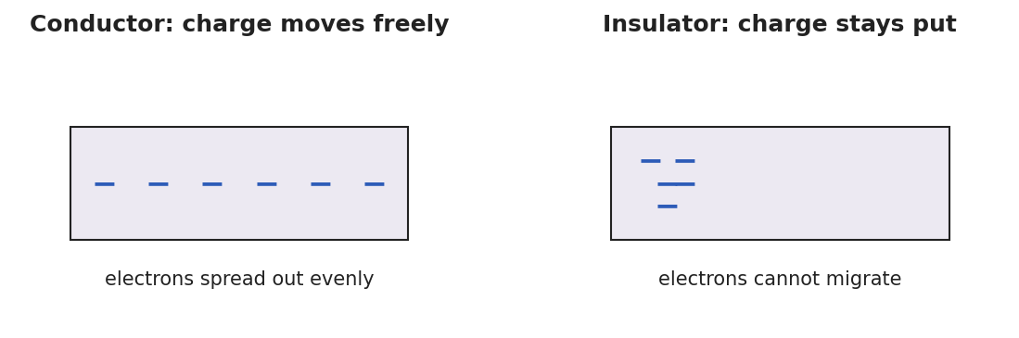
Two panels: in a conductor, minus signs spread evenly across the block (electrons move freely); in an insulator, minus signs stay clustered where they were placed (electrons cannot migrate).
Teacher facilitation language:
“Which samples let the leaves move, and what do those samples have in common?” “When you touched the charged rod straight to the knob, did the rod lose some charge? How could you tell?”

Teacher facilitation during Explore
- What to look for — groups grouping metals together as “charge moves” and naming the metal/non-metal pattern.
- What to resist — don’t pre-classify the samples; let the gallery-walk disagreements drive the consensus.
- What to redirect — students who think the rod must keep all its charge should compare the rod before and after several touches.

Phase 3 · Explain (32 – 37 min)

32–35 min · Turn-and-Talk #2 + class consensus
“What kind of material let the charge travel to the leaves, and what happened to the rod’s charge when it touched a conductor?”
Target consensus:
“In some materials — metals — electrons are free to move, so charge spreads through them; these are conductors. In others — rubber, glass, plastic — charge stays where you put it; these are insulators. When a charged object touches a conductor, some charge moves onto it, and both end up with the same sign.”

35–37 min · Vocabulary introduction (≤ 3 terms)
Sample teacher language:
“A conductor lets charge move freely (metals). An insulator holds charge in place (rubber, glass). Transferring charge by direct touch is charging by conduction — and because charge just spreads from one to the other, both objects end up with the same sign.”
The three-step diagram below is the model students revisit in Phase 4.
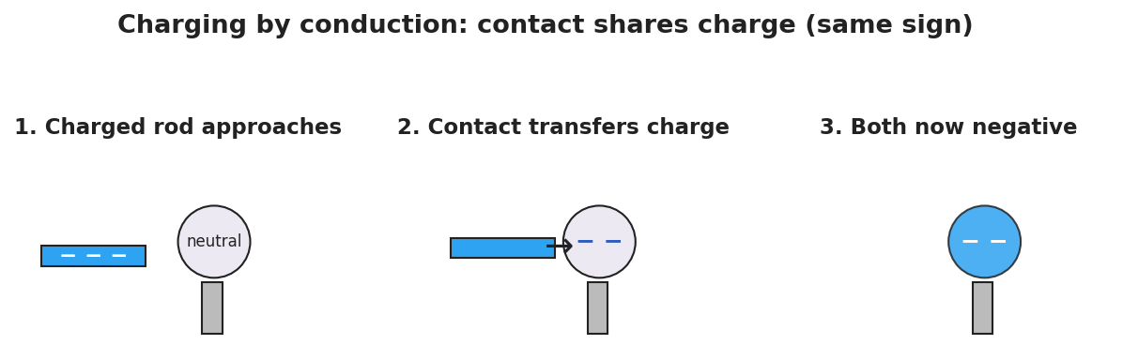
A three-step sequence: a negatively charged rod approaches a neutral metal sphere, then touches it and transfers electrons, and finally the rod is removed leaving the sphere negatively charged — the same sign as the rod.

Discussion prompts to deploy here
- “You charge a metal sphere by touching it with a negative rod. What sign is the sphere now?”
  - Sample student response: “Negative — conduction shares the rod’s charge, so the sphere gets the same sign.”
- “Why won’t a charged rubber rod share its charge if you touch it to a wooden block?”
  - Sample student response: “Both are insulators; the charge can’t move, so it stays on the rubber.”

Phase 4 · Elaborate (37 – 40 min)

37–39 min · Revise the model
“Return to your electroscope drawing. Re-label it: is the metal a conductor or insulator? Use conduction to explain in one sentence why the leaves stayed spread after the rod left.”

39–40 min · Return to the phenomenon
“On the Van de Graaff, why does every hair stand up, not just the ones you touch? Answer in one sentence.”
Target: “The dome is a conductor, so the charge spreads to every strand; all the hairs get the same sign and repel each other.”

Phase 5 · Evaluate (40 – 42 min)

40–42 min · Exit Ticket + Closing Reflection
“(a) Classify each as a conductor or insulator: copper wire, rubber band, aluminum foil, glass rod. (b) A negatively charged rod is touched directly to a neutral metal sphere. What sign is the sphere afterward? Name the charging method. (c) Explain in one sentence why a charged comb shares its charge with a metal doorknob you touch it to, but not with a dry plastic cup.”
Expected: (a) copper = conductor, rubber = insulator, aluminum = conductor, glass = insulator; (b) negative, by conduction (same sign as the rod); (c) the doorknob is a conductor so charge moves onto it, while the plastic cup is an insulator that won’t let charge flow. See Answer_Key.docx.
Closing Reflection (SEL, 30 seconds):
“What did a groupmate notice during the sort that changed your sorting? Name one thing you’d test differently next time.”

Common Misconceptions
- Misconception: “Conduction reverses the charge — the touched object becomes opposite.” → Correction: Conduction shares charge, so both objects end up the same sign. (Opposite sign comes from induction, Lesson 03.)
- Misconception: “Insulators can’t be charged at all.” → Correction: Insulators can hold charge (a rubbed balloon!) — they just won’t let it move or spread.
- Misconception: “Charge flows through anything if you push hard enough.” → Correction: In an insulator the electrons are bound; ordinary contact does not free them to move.

Access & Differentiation
- ELL/ENL supports: Sentence frame: *“A ___ (conductor/insulator) lets charge ___ (move/stay), so when it touches a charged object the charge ___.”* Word-choice box: {conductor, insulator, move freely, stay put, same sign, conduction}. Provide a two-column T-chart pre-labeled “moves / stays.”
- IEP/SPED supports: Pre-sort half the samples as worked examples; students place only the remaining ones. Offer the Javalab electroscope as a low-prep alternative to handling a physical rod.
- Extensions: Have students explain why airplanes and fuel trucks are bonded with a wire before refueling, using conductor + conduction + charge buildup.

Strategy Spotlight
ACTIVE LEARNING. Today’s Explore is a predict–sort–test–revise cycle on vertical whiteboards. Students commit to a sort before testing (productive struggle), then a gallery walk turns disagreements into the lesson’s discussion. Keep groups to 3, rotate the marker, and resist confirming answers during the walk — the mismatches between groups are the teaching tool. Your role is to ask “what do your ‘moves’ samples have in common?” rather than to classify for them.

NYSSLS Observation Checklist Crosswalk
# | Checklist item | Where it appears in this lesson
1 | Local/relatable phenomenon | Phase 1 — electroscope/Van de Graaff; doorknob + comb in Phase 5
2 | Turn and Talk (2–3×) | Phase 1 (TT#1 — how charge reached the leaves), Phase 3 (TT#2 — what let charge travel)
3 | Students develop questions/models/procedures | Phase 1 (initial model), Phase 2 (predict-sort-test), Phase 4 (revise model)
4 | CCC defined and used | Lesson Overview · Cause and Effect, restated in Phase 2
5 | ENL — ≤ 3 vocab, second half | Phase 3 — vocabulary at 35–37 min (conductor / insulator / charging by conduction)
6 | Revisit phenomenon with evidence | Phase 4 — Van de Graaff hair + electroscope re-labeling
7 | ENL/SPED supports | Access & Differentiation block
8 | Assessment check | Phase 5 — Exit Ticket (classify + conduction sign)

Companion Materials
- Student_Worksheet.docx — the 5E student investigation (hand out at start of Phase 2)
- Student_Notes.docx — guided note-guide for vocabulary and the worked example
- Answer_Key.docx — answers to “Make It Make Sense” prompts and the Exit Ticket

Key Vocabulary (max 3)
- conductor — a material (such as a metal) in which charge moves freely because some electrons are not bound to single atoms
- insulator — a material (such as rubber, glass, or plastic) in which charge stays put because electrons are bound and cannot migrate
- charging by conduction — transferring charge by direct contact with a charged object; both objects end up with the same sign

Conductors, Insulators, and Charging by Conduction — Student Worksheet
Unit: Electrostatics — Lesson 02 Name: _______________________ Date: __________ Period: ____

Phenomenon
Your teacher touches a charged rod to the metal knob of an electroscope. The thin metal leaves at the bottom spring apart — and stay apart even after the rod is taken away. A touch of a finger makes them collapse.
Driving question: What decides whether charge spreads through an object or stays stuck in one spot?

Notice & Wonder
I notice… | I wonder…
Turn & Talk #1: The rod touched only the top knob, but the bottom leaves moved. How did the charge get all the way down?

Initial Model
Draw the electroscope. Show where the charge is right after the rod touches the knob, and which way it moves. Predict: would a wooden ruler touched to the knob do the same thing?

My prediction: _______________________________

Investigation
In a conductor, charge spreads out freely; in an insulator, it stays where you put it.

Two panels: a conductor with charge spread evenly across it, and an insulator with charge clustered in one spot.
Predict first, then test. Sort each sample before touching it to the electroscope.
Sample | My prediction (moves / stays) | What happened | Conductor or insulator?
Copper wire
Wooden ruler
Aluminum foil
Rubber band
Glass rod
Key question: What do all your “charge moves” samples have in common?

Make It Make Sense
- A negatively charged rod is touched to a neutral metal sphere. What sign is the sphere afterward, and what is this charging method called?
- Why does touching a charged metal object with your bare hand make its charge disappear?
- A charged balloon (an insulator) is pressed against a wooden block. Will the block become charged all over? Why or why not?

Vocabulary in Action
Use each term in a sentence about today’s phenomenon.
- conductor: _______________________________________________
- insulator: _______________________________________________
- charging by conduction: _______________________________________________

Revise Your Model
Return to your Initial Model. Re-label the electroscope: is the metal a conductor or insulator? Using conduction, write one sentence explaining why the leaves stayed spread after the rod was removed.

Exit Ticket
- Classify each as a conductor or insulator: copper wire, rubber band, aluminum foil, glass rod.
- A negatively charged rod is touched directly to a neutral metal sphere. What sign is the sphere afterward? Name the charging method.
- Explain in one sentence why a charged comb shares its charge with a metal doorknob, but not with a dry plastic cup.

Conductors, Insulators, and Charging by Conduction — Student Notes
Unit: Electrostatics — Lesson 02 Name: _______________________ Date: __________ Period: ____

Learning Targets
By the end of today’s 42 minutes I can:
- Tell a conductor from an insulator and classify common materials.
- Explain charging by conduction and why both objects end with the same sign.
- Predict the sign of an object charged by conduction.

Key Vocabulary
- conductor — _______________________________________________
- insulator — _______________________________________________
- charging by conduction — _______________________________________________

Guided Notes
Big idea: Whether charge spreads depends on the __________ of the material.
- In a conductor (mostly __________), some electrons are free to move, so charge spreads __________.
- In an insulator (rubber, glass, plastic), electrons are __________, so charge stays __________.
- Charging by conduction = transferring charge by direct __________ with a charged object.
- After conduction, both objects have the __________ sign (the charge simply spreads from one to the other).
Electroscope:
- The metal is a __________, so charge from the rod travels down to the __________.
- The two leaves get the __________ sign, so they __________ (push apart).

Three-step charging by conduction: a − rod approaches a neutral metal sphere, touches it, then leaves the sphere negative.
Conductor vs. insulator at the particle level:

A conductor with charge spread evenly; an insulator with charge stuck in one place.

Worked Example
Problem. A rod carrying a charge of −10 units is touched to an identical neutral metal sphere. The charge shares equally between the two metals. What charge ends up on the sphere, and what sign is it?
Solution. 1. The rod is a conductor and the sphere is a conductor, so charge can __________ between them. 2. Total charge = −10 units, shared __________ between two identical metals → −5 units each. 3. The sphere ends up with __________ units — the __________ sign as the rod (conduction shares charge, it does not reverse it).

Summary
Finish the sentence (Because / But / So):
A charged rod shares its charge with a metal sphere on contact because __________________________________________, but it will not share with a rubber block __________________________________________, so __________________________________________.

Conductors, Insulators, and Charging by Conduction — Answer Key

Cover
Unit: Electrostatics — Lesson 02: Conductors, Insulators, and Charging by Conduction East Meadow Schools × Valley Stream Central HSD Strategy chip: ACTIVE LEARNING

Make-It-Make-Sense Answers
- The sphere becomes negative — the same sign as the rod. This is charging by conduction: direct contact lets some of the rod’s charge spread onto the sphere. · Rubric: “negative” AND “conduction.” · NYSSLS: HS-PS3-5
- Your body and the ground form a conductor to the Earth, so the excess charge spreads off the object into the ground through you, leaving it neutral. · Rubric: charge leaves through you to ground/Earth. · NYSSLS: HS-PS3-5
- No. The wooden block is an insulator, so even at the contact point the charge cannot spread through it; only the touched spot might hold a little charge. · Rubric: identifies wood as an insulator AND says charge can’t spread. · NYSSLS: HS-PS3-5

Exit Ticket Answer
- Copper wire = conductor; rubber band = insulator; aluminum foil = conductor; glass rod = insulator.
- The sphere is negative, charged by conduction (it ends with the same sign as the rod).
- The doorknob is a conductor, so charge moves freely onto it; the plastic cup is an insulator, so charge cannot flow into it.
Tolerance/rubric: (a) all four correct = 1 pt (½ for 2–3 correct); (b) “negative” + “conduction”; (c) contrasts conductor vs. insulator. 1 point each. NYSSLS: HS-PS3-5.

Closing Reflection (rubric)
Closing reflection is formative, not graded. Award full credit for any honest response. Look for: - A specific moment in the gallery walk that shifted the student’s sort in answer 1 - A concrete “test differently” idea in answer 2 (e.g., trying a longer wire, a wet vs. dry sample)

Charging by Induction and Polarization — Teacher Guide

Cover
Unit: Electrostatics — Lesson 03: Charging by Induction and Polarization East Meadow Schools × Valley Stream Central High School District Strategy chips: BTC

Curated Resources (from East Meadow Scope & Sequence)

NYSSLS Standards
This lesson develops HS-PS3-5: “Develop and use a model of two objects interacting through electric or magnetic fields to illustrate the forces between objects and the changes in energy of the objects due to the interaction. (Cause and Effect).” Induction and polarization are the clearest cases of objects interacting at a distance — the charged rod rearranges charge in a neutral object it never touches, which is exactly the field-mediated interaction the next lessons model.

Phenomenon
- A charged rod attracts a thin stream of water / tiny paper bits without touching (Veritasium/standard demo): https://www.youtube.com/watch?v=N2lWX_zk1Q4
- Glass rod rubbed with silk picks up small neutral scraps (Khan Academy, “Triboelectric effect and charge”): https://www.khanacademy.org/science/physics/electric-charge-electric-force-and-voltage

Javalab / Labs
- Electrostatic induction (charge a sphere without contact): https://javalab.org/en/electrostatic_induction_en/
- Electroscope (induction vs. conduction): https://javalab.org/en/electroscope_en/

Assessments
- PhET “Balloons and Static Electricity” — drag the balloon near the neutral wall and watch the wall’s charges shift (polarization): https://phet.colorado.edu/en/simulations/balloons-and-static-electricity. The Exit Ticket below is the formative check.

Lesson Overview
Duration | 42 minutes (1 period)
NYSSLS link | HS-PS3-5 (interaction at a distance — rearranging charge without contact)
CCC focus | Cause and Effect — a charged object causes charge in a neutral object to rearrange, with no contact.
Strategy chips | BTC (Building Thinking Classrooms)
Materials | Charged rods (PVC + acetate) + cloth; metal sphere on an insulating stand (or two touching cans); thin water stream from a tap; paper bits; vertical non-permanent surfaces (whiteboards) + markers; a grounding wire/finger.
Safety | Standard classroom safety. Keep water away from any electrical outlets.
Prior knowledge | Lessons 01–02 — two charges; like repel/unlike attract; conductors let charge move; conduction gives the same sign.
Lesson objectives — students can:
- Explain polarization: a neutral object’s charges shift when a charged object is brought near, so its near side is attracted.
- Describe charging by induction: bring a charge near, ground the far side, remove the ground, then remove the charge — leaving the opposite sign, with no contact.
- Contrast induction (opposite sign, no contact) with conduction (same sign, contact).

Phase 1 · Engage (0 – 10 min)

0–2 min · Opening Connection (SEL)
One-phrase whip-around: “Name a time someone influenced you from a distance — without ever touching or talking to you.” (A role model, a crowd’s mood.) This primes “acting at a distance,” the heart of today’s lesson.

2–7 min · Phenomenon hook — attraction without contact
Teacher actions. Rub a rod and hold it near (not touching) a thin stream of water — the stream bends toward the rod. Then hold it over neutral paper bits — they leap up to it, even though the rod and paper started neutral-to-charged with no contact at all.
Sample teacher language:
“The paper has no charge, the rod never touched it — so how is a neutral scrap of paper being pulled toward something it isn’t even touching?”
Anticipated student responses:
- “The rod pulls the paper like a magnet.” — useful analogy; we’ll sharpen why.
- “The paper must be a little bit charged.” — probe: it was neutral a second ago; what changed?
- “The charges inside the paper moved.” — excellent; this is polarization — hold for Phase 3.

7–10 min · Notice & Wonder + Turn-and-Talk #1
“Turn to your partner: the paper is neutral, yet it’s attracted. What could the charged rod be doing to the inside of the paper?”
Target idea: the rod pushes/pulls the paper’s own charges around. Leave open if unspoken.

Bridge to Phase 2
Each student writes a one-sentence initial model: “The neutral paper is attracted because ______.”

Phase 2 · Explore (10 – 30 min)

BTC launch (random groups, vertical whiteboards)
Form visibly random groups of 3. Each group works at a vertical non-permanent surface. Pose the thin-slice task without front-loading vocabulary:
Thin-slice task: “You have a NEUTRAL metal sphere on an insulating stand and a NEGATIVE rod you may NOT touch to the sphere. Find a sequence of moves — bring the rod near, touch the sphere with a finger (ground), step away — that leaves the sphere with a LASTING positive charge. Draw each step and where the charges are.”
BTC facilitation moves:
“Don’t tell me the answer — show me on the board where the electrons are at each step.” “Your sphere is neutral the whole time the rod is near. So how can it end up positive? What had to leave?”
Mid-task, project the Javalab electrostatic-induction sim so groups can test their proposed sequence. Then reveal the canonical sequence as the model to check against:
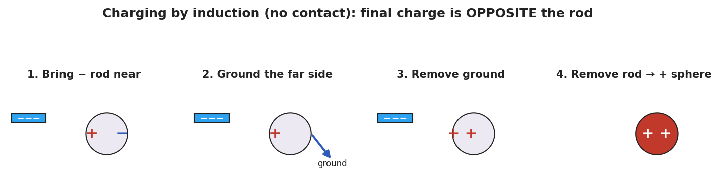
A four-panel sequence of charging a neutral metal sphere by induction with a negative rod: (1) the rod nearby polarizes the sphere with + on the near side and − on the far side; (2) grounding the far side lets electrons flee to the ground; (3) the ground is removed, leaving the sphere net positive; (4) the rod is removed and the positive charge spreads over the sphere.

Teacher facilitation during Explore
- What to look for — groups realizing the ground must be removed before the rod, or the trick fails.
- What to resist — don’t name “induction” until the consolidation; let the sequence emerge on the boards.
- What to redirect — groups who let the rod touch the sphere have done conduction (same sign) — ask them to compare the final sign with the no-touch version.

Phase 3 · Explain (30 – 36 min)

30–34 min · BTC consolidation + class consensus
Tour two or three boards in a deliberate sequence (least-to-most complete). Build the consensus:
“When a charge comes near a neutral object, the object’s own charges shift — near side opposite to the rod, far side same as the rod. That’s polarization, and it explains the attracted paper. If we then connect the far side to the ground, the rod-repelled charge escapes; cut the ground, then remove the rod, and the object is left with the opposite sign — that’s charging by induction, with no contact at all.”

34–36 min · Vocabulary introduction (≤ 3 terms)
Sample teacher language:
“Polarization is the shift of charge within a neutral object. Induction uses that shift, plus a grounding step, to leave an object charged opposite to the rod — without ever touching it.”
Polarization explains the attracted paper:
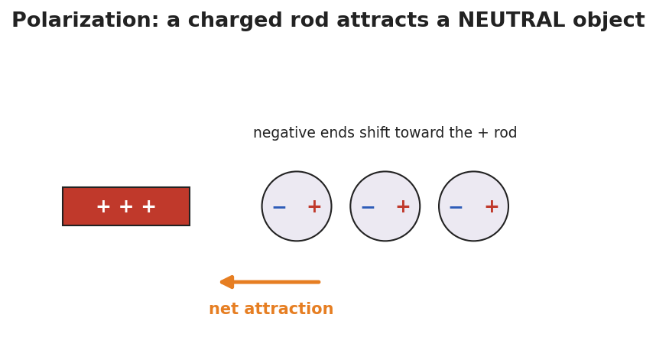
A positive rod near three neutral atoms; in each atom the negative end has shifted toward the rod and the positive end away, so the near side is negative and the whole object is pulled toward the rod.

Discussion prompts to deploy here
- “In induction, why must we remove the ground before the rod?”
  - Sample student response: “If the rod leaves first, the charges just flow back and the object goes neutral again.”
- “A negative rod charges a sphere by induction. What sign is the sphere — and how is that different from conduction?”
  - Sample student response: “Positive — opposite to the rod. Conduction would have made it negative, the same sign, but it needs contact.”

Phase 4 · Elaborate (36 – 40 min)

36–39 min · Revise the model
“Return to your paper-bits drawing. Re-label it using polarization: which side of the paper is attracted, and why? Then write one sentence stating the final sign if you instead charged a metal sphere by induction with a positive rod.”

39–40 min · Return to the phenomenon
“Why does the water stream bend toward either a positive or a negative rod? Answer in one sentence using polarization.”
Target: “Water molecules are polar and rotate so their attracted end faces the rod — so it bends toward a rod of either sign.”

Phase 5 · Evaluate (40 – 42 min)

40–42 min · Exit Ticket + Closing Reflection
“A POSITIVE rod is brought near (not touching) a neutral metal sphere on an insulating stand. (a) Sketch where the + and − charges sit on the sphere while the rod is near. What is this called? (b) You now ground the sphere, remove the ground, then remove the rod. What sign is the sphere’s net charge? Name the method. (c) In one sentence, state the key difference between charging by induction and charging by conduction.”
Expected: (a) negatives gather on the near side, positives on the far side — polarization; (b) the sphere ends up negative (opposite the positive rod), by induction; (c) induction leaves the opposite sign with no contact, while conduction leaves the same sign through direct contact. See Answer_Key.docx.
Closing Reflection (SEL, 30 seconds):
“Which groupmate’s board move helped you see the grounding step? Name one idea you changed your mind about.”

Common Misconceptions
- Misconception: “Induction and conduction give the same result.” → Correction: Induction → opposite sign, no contact; conduction → same sign, with contact.
- Misconception: “A polarized object has gained a net charge.” → Correction: Polarization only shifts existing charge; the object stays overall neutral.
- Misconception: “Order doesn’t matter — remove the rod or the ground first.” → Correction: The ground must be removed before the rod, or the separated charge flows back and the object returns to neutral.

Access & Differentiation
- ELL/ENL supports: Sentence frame: “When the rod comes near, the ___ charges move to the ___ side, so the object becomes ___ (polarized / charged by induction).” Word-choice box: {polarization, induction, grounding, near side, far side, opposite, no contact}. Provide a numbered four-step strip to put in order.
- IEP/SPED supports: Give the four induction panels on cards out of order; students sequence them rather than draw from scratch. Pair the BTC board work with a partner scribe.
- Extensions: Have students design an induction sequence that leaves two spheres oppositely charged at once (the classic two-sphere split), and explain it with grounding.

Strategy Spotlight
BTC (Building Thinking Classrooms). Today uses three BTC pillars: visibly random groups of 3, vertical non-permanent surfaces, and a thin-slice task with the answer withheld. The task (“leave the sphere positive using a negative rod you may not touch”) is deliberately just past what conduction can do, forcing the grounding insight. Consolidate by touring boards least-to-most complete. Keep yourself from naming “induction” until the consolidation — the sequence should be discovered on the boards first.

NYSSLS Observation Checklist Crosswalk
# | Checklist item | Where it appears in this lesson
1 | Local/relatable phenomenon | Phase 1 — bending water/paper bits; water stream in Phase 4
2 | Turn and Talk (2–3×) | Phase 1 (TT#1 — what the rod does inside the paper), Phase 3 (consolidation discussion)
3 | Students develop questions/models/procedures | Phase 1 (initial model), Phase 2 (BTC thin-slice procedure), Phase 4 (revise model)
4 | CCC defined and used | Lesson Overview · Cause and Effect, restated in Phase 2
5 | ENL — ≤ 3 vocab, second half | Phase 3 — vocabulary at 34–36 min (polarization / induction / grounding)
6 | Revisit phenomenon with evidence | Phase 4 — water stream + paper re-labeling
7 | ENL/SPED supports | Access & Differentiation block
8 | Assessment check | Phase 5 — Exit Ticket (induction sequence + induction-vs-conduction contrast)

Companion Materials
- Student_Worksheet.docx — the 5E student investigation (hand out at start of Phase 2)
- Student_Notes.docx — guided note-guide for vocabulary and the worked example
- Answer_Key.docx — answers to “Make It Make Sense” prompts and the Exit Ticket

Key Vocabulary (max 3)
- polarization — the shift of charge within a neutral object when a charged object is brought near; the near side becomes oppositely charged, so the object is attracted (it stays overall neutral)
- induction — charging an object without contact by bringing a charge near, grounding, then removing the ground and the charge; the object is left with the opposite sign
- grounding — connecting an object to the Earth (or a large conductor) so charge can flow off to or from it

Charging by Induction and Polarization — Student Worksheet
Unit: Electrostatics — Lesson 03 Name: _______________________ Date: __________ Period: ____

Phenomenon
Your teacher holds a charged rod near a thin stream of water — the stream bends toward it. The rod never touches the water, and the water started out neutral. Held over tiny scraps of neutral paper, the rod makes them jump up to meet it.
Driving question: How can a charged object pull on a neutral object it never even touches?

Notice & Wonder
I notice… | I wonder…
Turn & Talk #1: The paper is neutral, yet it’s attracted. What could the charged rod be doing to the inside of the paper?

Initial Model
Draw a scrap of neutral paper with a charged rod held above it. Show what you think happens to the charges inside the paper. Predict whether the paper is pulled up, pushed down, or unaffected.

My prediction: _______________________________

Investigation
BTC thin-slice task (vertical whiteboard, groups of 3):
You have a neutral metal sphere on an insulating stand and a negative rod you may not touch to the sphere. Find a sequence of moves — bring the rod near, touch the sphere with a finger (ground), step away — that leaves the sphere with a lasting positive charge. Draw each step and show where the charges are.
Check your sequence against this model:

Four panels of charging a metal sphere by induction with a negative rod: polarize, ground the far side, remove the ground, then remove the rod, leaving the sphere positive.
Step | What I do | Where the charges are
1
2
3
4
Key question: Why must you remove the ground before you remove the rod?

Make It Make Sense
- A charged rod attracts a neutral piece of paper. Explain what happens to the paper’s charges (use the word polarization).
- A negative rod is used to charge a metal sphere by induction. What sign does the sphere end up with, and why?
- A student lets the rod touch the sphere instead. Now what charging method is it, and what sign does the sphere get?

Vocabulary in Action
Use each term in a sentence about today’s phenomenon.
- polarization: _______________________________________________
- induction: _______________________________________________
- grounding: _______________________________________________

Revise Your Model
Return to your Initial Model. Re-label it using polarization: which side of the paper is attracted, and why? Then write one sentence stating the final sign if you charged a metal sphere by induction with a positive rod.

Exit Ticket
A positive rod is brought near (not touching) a neutral metal sphere on an insulating stand.
- Sketch where the + and − charges sit on the sphere while the rod is near. What is this called?
- You ground the sphere, remove the ground, then remove the rod. What sign is the sphere’s net charge? Name the method.
- In one sentence, state the key difference between charging by induction and charging by conduction.

Charging by Induction and Polarization — Student Notes
Unit: Electrostatics — Lesson 03 Name: _______________________ Date: __________ Period: ____

Learning Targets
By the end of today’s 42 minutes I can:
- Explain polarization and why a charged object attracts a neutral one.
- Describe the four steps of charging by induction.
- Contrast induction (opposite sign, no contact) with conduction (same sign, contact).

Key Vocabulary
- polarization — _______________________________________________
- induction — _______________________________________________
- grounding — _______________________________________________

Guided Notes
Polarization (in a neutral object):
- A charged object brought near makes the neutral object’s charges __________.
- The near side becomes __________ (opposite to the rod); the far side becomes __________.
- The object is overall still __________, but its near side is attracted.
Charging by induction (with a negative rod, no contact):
- Bring the negative rod __________ the neutral metal sphere → it polarizes.
- __________ the far side; electrons (repelled by the rod) flee to the __________.
- Remove the __________ first, while the rod is still near.
- Remove the __________; the sphere is left with the __________ sign (positive).

Four panels of induction: polarize, ground, remove ground, remove rod → positive sphere.
Why a neutral object is attracted (polarization):

A + rod near neutral atoms whose negative ends have shifted toward the rod, so the object is pulled toward it.
Induction vs. conduction:
 | Contact? | Final sign vs. rod
Conduction | __________ | __________
Induction | __________ | __________

Worked Example
Problem. A metal sphere is charged by induction using a rod that is +8 units. After the procedure, what sign is the sphere’s net charge, and why?
Solution. 1. The + rod is brought near; it __________ the sphere (− on the near side, + on the far side). 2. Grounding lets the rod-repelled charge (the __________ charges) escape to the ground. 3. Remove the ground, then the rod → the sphere keeps the charge __________ to the rod. 4. The rod was +, so the sphere ends up __________ — opposite, with no contact.

Summary
Finish the sentence (Because / But / So):
A charged rod can attract a neutral object because __________________________________________, but to leave the object permanently charged without touching it __________________________________________, so __________________________________________.

Charging by Induction and Polarization — Answer Key

Cover
Unit: Electrostatics — Lesson 03: Charging by Induction and Polarization East Meadow Schools × Valley Stream Central HSD Strategy chip: BTC

Make-It-Make-Sense Answers
- The rod’s charge makes the paper’s own charges shift (polarize): the near side becomes oppositely charged to the rod and the far side the same. Because the near (opposite) side is closer, the net force is attraction, even though the paper stays neutral. · Rubric: names polarization AND explains near-side attraction. · NYSSLS: HS-PS3-5
- The sphere ends up positive — the opposite sign of the negative rod. The rod repels electrons to the grounded far side; once they drain to ground and the ground/rod are removed (in that order), the sphere is left with a deficit of electrons. · Rubric: “positive/opposite” + grounding mechanism. · NYSSLS: HS-PS3-5
- Letting the rod touch the sphere makes it charging by conduction, and the sphere ends up negative — the same sign as the rod. · Rubric: “conduction” AND “negative/same sign.” · NYSSLS: HS-PS3-5

Exit Ticket Answer
- The sphere’s electrons are repelled away from the positive rod is wrong — the rod is positive, so it attracts electrons: negatives gather on the near side, positives on the far side. This is polarization.
- The sphere ends up negative (opposite the positive rod), charged by induction.
- Induction leaves the opposite sign with no contact; conduction leaves the same sign through direct contact.
Tolerance/rubric: (a) correct charge placement (− near the + rod) + “polarization”; (b) “negative” + “induction”; (c) names opposite-vs-same AND contact-vs-no-contact. 1 point each. NYSSLS: HS-PS3-5.

Closing Reflection (rubric)
Closing reflection is formative, not graded. Award full credit for any honest response. Look for: - A specific board move (especially the grounding step) named in answer 1 - A genuine “changed my mind” statement in answer 2 (e.g., realizing order of removal matters)

Coulomb’s Law — Teacher Guide

Cover
Unit: Electrostatics — Lesson 04: Coulomb’s Law East Meadow Schools × Valley Stream Central High School District Strategy chips: HOCHMAN

Curated Resources (from East Meadow Scope & Sequence)

NYSSLS Standards
This is the quantitative core of the unit and the unit’s anchor to HS-PS2-4: “Use mathematical representations of Newton’s Law of Gravitation and Coulomb’s Law to describe and predict the gravitational and electrostatic forces between objects. (Patterns).” Students see the same inverse-square pattern they met in Universal Gravitation (Forces, Lesson 06) reappear for charge — a deliberate Patterns crosscutting-concept callback.

Phenomenon
- PhET “Coulomb’s Law” — drag two charged spheres, read the force in real time: https://phet.colorado.edu/en/simulations/coulombs-law
- Two charged pith balls / foil-covered balls swing apart on threads (classroom demo): https://www.youtube.com/watch?v=G+coulombs+law+pith+ball

Javalab / Labs
- PhET “Coulomb’s Law” macro scale (primary lab): https://phet.colorado.edu/en/simulations/coulombs-law
- Coulomb force between two charges (Javalab): https://javalab.org/en/coulombs_law_en/

Assessments
- Reference Table relationship: Fₑ = k·q₁·q₂ / r², with k = 8.99 × 10⁹ N·m²/C² and e = 1.6 × 10⁻¹⁹ C. The numeric Exit Ticket below is the formative check.

Lesson Overview
Duration | 42 minutes (1 period)
NYSSLS link | HS-PS2-4 (mathematical representation of Coulomb’s Law; the inverse-square Pattern)
CCC focus | Patterns — the electrostatic force follows the same inverse-square pattern as gravity.
Strategy chips | HOCHMAN (literacy)
Materials | Devices for the PhET sim; calculators; Reference Table; sentence-expansion strips (Because/But/So); whiteboards/markers.
Safety | Standard classroom safety; simulation-based, no hazards.
Prior knowledge | Lessons 01–03 (like repel/unlike attract); the inverse-square law from Universal Gravitation (Fg = G·m₁·m₂ / r²).
Lesson objectives — students can:
- State Coulomb’s law in words and symbols: Fₑ = k·q₁·q₂ / r², and identify each quantity and its unit.
- Predict how the force changes when charge or distance changes (especially the inverse-square fall-off with r).
- Calculate the electrostatic force between two charges using the Reference Table value of k.

Phase 1 · Engage (0 – 10 min)

0–2 min · Opening Connection (SEL)
One-phrase whip-around: “Name something that gets dramatically weaker the farther away you get from it.” (A campfire’s warmth, a speaker’s volume.) This primes the inverse-square fall-off.

2–7 min · Phenomenon hook — PhET two charges
Teacher actions. Open PhET “Coulomb’s Law.” Project two charges with the force readout visible. Double one charge — force doubles. Halve the distance — force quadruples. Let students call out predictions before each move.
Sample teacher language:
“I’m going to move these two charges to half their distance apart. The force won’t just double — watch the number. Predict first: by how much?”
Anticipated student responses:
- “It doubles when you halve the distance.” — capture; the surprise that it quadruples is the hook.
- “More charge means more force.” — yes, build on it: how exactly?
- “It looks like gravity from last unit.” — gold; this is the Patterns callback to HS-PS2-4.

7–10 min · Notice & Wonder + Turn-and-Talk #1
“Turn to your partner: halving the distance made the force four times bigger, not two. What relationship between force and distance would do that?”
Target idea: force depends on distance squared. Leave open if unspoken.

Bridge to Phase 2
Each student writes a one-sentence initial model: “The force gets bigger when ______ and smaller when ______.”

Phase 2 · Explore (10 – 28 min)

10–14 min · Initial Model (silent / individual)
“Sketch two charges a distance r apart. Predict, in words, what happens to the force if you (a) triple one charge, (b) double the distance. Then test each on PhET.”

14–28 min · Investigation — find the pattern on PhET
Structured data collection (devices in pairs):
- Charge sweep — fix r; set q₁ = 1, 2, 3, 4 µC; record force. Pattern: force is proportional to charge.
- Distance sweep — fix charges; set r = 1, 2, 3, 4 units; record force. Pattern: force ÷ 4, ÷ 9, ÷ 16 → inverse-square.
Plot the distance data; it matches the curve below.
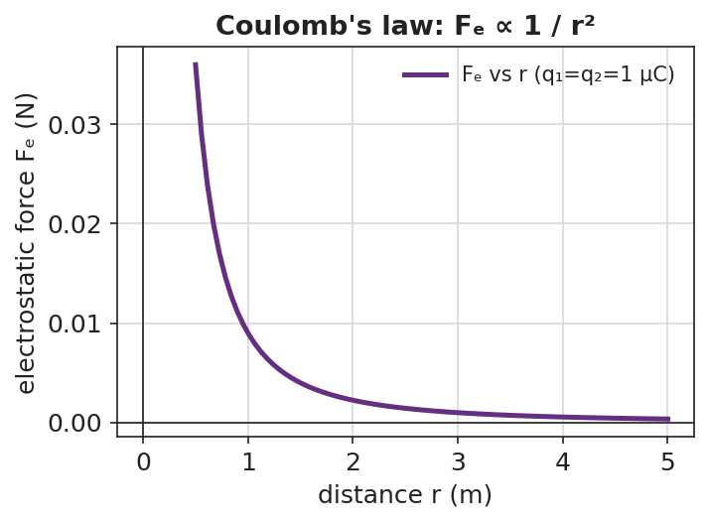
A line graph of electrostatic force versus separation distance: the curve starts high at small r and falls off steeply, flattening as r grows — the inverse-square shape of Coulomb’s law.
Teacher facilitation language:
“When you doubled r, the force didn’t halve — what fraction did it become? And at triple r?” “Where have you seen a force that dies off as 1/r² before this unit?”

Teacher facilitation during Explore
- What to look for — pairs noticing force ÷ 4 at double distance, ÷ 9 at triple → “it’s r squared.”
- What to resist — don’t write the formula yet; let the ÷4, ÷9 data force the squared relationship.
- What to redirect — pairs who confuse “double charge” (×2) with “double distance” (÷4) should re-run one variable at a time.

Phase 3 · Explain (28 – 36 min)

28–31 min · Turn-and-Talk #2 + class consensus
“In one sentence: how does the electrostatic force depend on the two charges and on the distance between them?”
Target consensus:
“The force grows in proportion to each charge and falls off as the square of the distance — exactly like gravity, but for charge.”

31–33 min · Vocabulary introduction (≤ 3 terms)
Sample teacher language:
“This relationship is Coulomb’s law. The push or pull between charges is the electrostatic force, Fₑ. Because it dies off as 1/r², we call it an inverse-square law — the same Pattern as gravity. In symbols: Fₑ = k·q₁·q₂ / r², with k = 8.99 × 10⁹ N·m²/C².”
The two-charge force pair below shows the forces are equal and opposite (Newton’s third law for charge):
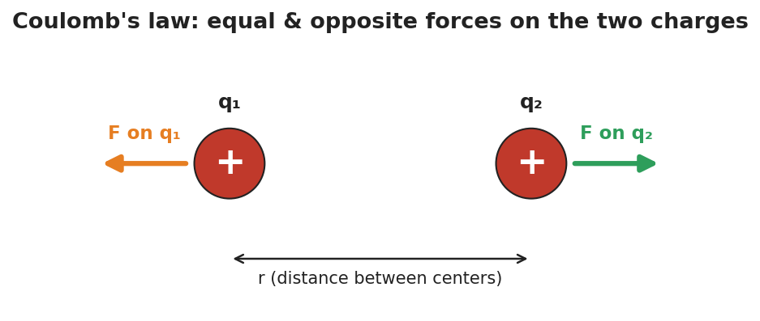
Two like charges with equal-length repulsive force arrows pointing away from each other, separated by a distance r — the electrostatic force on each charge is equal in size and opposite in direction.

33–36 min · HOCHMAN sentence work
Run a Because/But/So expansion of the key relationship on sentence strips:
Stem: “The electrostatic force gets stronger…” - because … (more charge → more force) - but … (it weakens fast as the charges move apart) - so … (doubling the distance cuts the force to one-quarter)
Then an appositive drill: “Coulomb’s law, the rule that the force falls off as 1/r², predicts the force between any two charges.”

Discussion prompts to deploy here
- “If you triple both charges, what happens to the force?”
  - Sample student response: “It goes up nine times — three times for each charge, 3 × 3.”
- “Why is the unit of k written N·m²/C²?”
  - Sample student response: “So that q·q/r² (C²/m²) times k gives newtons — the units cancel to a force.”

Phase 4 · Elaborate (36 – 40 min)

36–39 min · Revise the model (with numbers)
“Two charges of +2.0 × 10⁻⁶ C each sit 0.30 m apart. Use Fₑ = k·q₁·q₂ / r² to find the force. Then state what happens to that force if the distance is doubled.”
Work it with the class (full solution in Student_Notes.docx): Fₑ = (8.99 × 10⁹)(2.0 × 10⁻⁶)(2.0 × 10⁻⁶) / (0.30)² ≈ 0.40 N, repulsive. Doubling r → one-quarter the force ≈ 0.10 N.

39–40 min · Return to the phenomenon
“On PhET, why did halving the distance quadruple the force? Answer in one Because/But/So sentence.”
Target: “Halving r made r² one-quarter as big, but r² is in the denominator, so the force became four times larger.”

Phase 5 · Evaluate (40 – 42 min)

40–42 min · Exit Ticket (numeric) + Closing Reflection
“Use Fₑ = k·q₁·q₂ / r², k = 8.99 × 10⁹ N·m²/C². (a) Two charges, q₁ = +3.0 × 10⁻⁶ C and q₂ = +3.0 × 10⁻⁶ C, are 0.20 m apart. Calculate the electrostatic force. Is it attractive or repulsive? (b) Without recalculating from scratch, state what happens to the force if the distance is tripled. (c) Coulomb’s law shares its 1/r² shape with which force from the Forces unit?”
Expected: (a) Fₑ = (8.99 × 10⁹)(3.0 × 10⁻⁶)(3.0 × 10⁻⁶)/(0.20)² ≈ 2.0 N, repulsive (both positive); (b) tripling r divides the force by 9 → ≈ 0.22 N; (c) gravitation (Fg = G·m₁·m₂/r²). See Answer_Key.docx.
Closing Reflection (SEL, 30 seconds):
“Which sentence stem (because / but / so) made the math click for you today, and why?”

Common Misconceptions
- Misconception: “Doubling the distance halves the force.” → Correction: Distance is squared, so doubling r divides the force by four.
- Misconception: “The bigger charge feels a bigger force than the smaller one.” → Correction: The two charges feel equal and opposite forces (Newton’s third law), regardless of their relative sizes.
- Misconception: “k and the masses/charges have the same role as in gravity.” → Correction: The form is identical (inverse-square), but k (8.99 × 10⁹) is enormous compared with G — the electric force is vastly stronger than gravity for the same separation.

Access & Differentiation
- ELL/ENL supports: Provide the Because/But/So strips pre-printed with the stem. Word-choice box: {Coulomb’s law, electrostatic force, inverse-square, charge, distance, quadruple, quarter}. Pair “inverse-square” with a hand gesture (force shrinking fast as hands separate).
- IEP/SPED supports: Provide a plug-in template for the calculation with the formula and k pre-filled; students substitute only the numbers. Offer a scaffolded “÷4, ÷9, ÷16” table for the distance pattern.
- Extensions: Have students compute the ratio of the electric force to the gravitational force between two protons and explain (with k vs. G) why electricity dominates at the atomic scale.

Strategy Spotlight
HOCHMAN (literacy). Today’s vocabulary and the key relationship are consolidated through sentence-level Hochman moves: a Because/But/So expansion of “the electrostatic force gets stronger…,” and an appositive drill naming Coulomb’s law inside the sentence. These force students to encode the inverse-square idea in precise prose, not just a formula. Keep the strips short (one clause each) and read several aloud — fluency with the sentence is the goal, not length.

NYSSLS Observation Checklist Crosswalk
# | Checklist item | Where it appears in this lesson
1 | Local/relatable phenomenon | Phase 1 — PhET two charges; campfire warmth analogy
2 | Turn and Talk (2–3×) | Phase 1 (TT#1 — why force quadruples), Phase 3 (TT#2 — force vs. charge and distance)
3 | Students develop questions/models/procedures | Phase 1 (initial model), Phase 2 (PhET data sweeps), Phase 4 (numeric revision)
4 | CCC defined and used | Lesson Overview · Patterns (inverse-square callback), restated in Phase 3
5 | ENL — ≤ 3 vocab, second half | Phase 3 — vocabulary at 31–33 min (Coulomb’s law / electrostatic force / inverse-square law)
6 | Revisit phenomenon with evidence | Phase 4 — PhET “why quadruple” Because/But/So
7 | ENL/SPED supports | Access & Differentiation block
8 | Assessment check | Phase 5 — numeric Exit Ticket (calculate Fₑ; predict ×⅑ at triple r)

Companion Materials
- Student_Worksheet.docx — the 5E student investigation (hand out at start of Phase 2)
- Student_Notes.docx — guided note-guide with the full worked calculation
- Answer_Key.docx — worked answers to “Make It Make Sense” prompts and the numeric Exit Ticket

Key Vocabulary (max 3)
- Coulomb’s law — the rule that the electrostatic force between two charges is Fₑ = k·q₁·q₂ / r², with k = 8.99 × 10⁹ N·m²/C²
- electrostatic force — the attractive or repulsive force (Fₑ) between charged objects
- inverse-square law — a relationship in which a quantity falls off as 1 / r²; shared by Coulomb’s law and Newton’s law of gravitation

Coulomb’s Law — Student Worksheet
Unit: Electrostatics — Lesson 04 Name: _______________________ Date: __________ Period: ____
Reference: Fₑ = k·q₁·q₂ / r² · k = 8.99 × 10⁹ N·m²/C² · e = 1.6 × 10⁻¹⁹ C

Phenomenon
Your teacher drags two charged spheres in the PhET “Coulomb’s Law” simulation. Doubling one charge doubles the force — no surprise. But halving the distance quadruples the force, and the readout looks just like the gravity behavior from the Forces unit.
Driving question: How exactly does the force between two charges depend on the charges and on the distance between them?

Notice & Wonder
I notice… | I wonder…
Turn & Talk #1: Halving the distance made the force four times bigger, not two. What relationship between force and distance would do that?

Initial Model
Sketch two charges a distance r apart. Predict, in words, what happens to the force if you (a) triple one charge, (b) double the distance.
- Triple one charge: __________________________
- Double the distance: ________________________

Investigation
Test each prediction on PhET, one variable at a time.
Charge sweep (keep r fixed):
q₁ (µC) | 1 | 2 | 3 | 4
Force (record)
Distance sweep (keep charges fixed):
r (units) | 1 | 2 | 3 | 4
Force (record)
The distance data should trace this inverse-square curve:

A force-versus-distance curve that drops steeply at small distances and flattens at larger distances — the 1/r² shape.
Key question: When you doubled r, the force became what fraction? At triple r?

Make It Make Sense
- The two charges in PhET have very different sizes. Which one feels the bigger force? Explain. (See the force-pair diagram below.)

Two like charges with equal, opposite repulsive force arrows, separated by distance r.
- If you triple both charges, what happens to the force? Show your reasoning.
- Coulomb’s law has the same 1/r² shape as which force from the Forces unit? What does that tell you about how nature works?

Vocabulary in Action
Use each term in a sentence about today’s phenomenon.
- Coulomb’s law: _______________________________________________
- electrostatic force: _______________________________________________
- inverse-square law: _______________________________________________

Revise Your Model
Two charges of +2.0 × 10⁻⁶ C each sit 0.30 m apart. Use Fₑ = k·q₁·q₂ / r² to find the force. Then state what happens to it if the distance is doubled.
Fₑ = ____________________ → Fₑ ≈ __________ N If r is doubled, Fₑ becomes __________________

Exit Ticket
Use Fₑ = k·q₁·q₂ / r², with k = 8.99 × 10⁹ N·m²/C².
- Two charges, q₁ = +3.0 × 10⁻⁶ C and q₂ = +3.0 × 10⁻⁶ C, are 0.20 m apart. Calculate the electrostatic force. Is it attractive or repulsive?
- Without recalculating from scratch, state what happens to the force if the distance is tripled.
- Coulomb’s law shares its 1/r² shape with which force from the Forces unit?

Coulomb’s Law — Student Notes
Unit: Electrostatics — Lesson 04 Name: _______________________ Date: __________ Period: ____
Reference: Fₑ = k·q₁·q₂ / r² · k = 8.99 × 10⁹ N·m²/C² · e = 1.6 × 10⁻¹⁹ C

Learning Targets
By the end of today’s 42 minutes I can:
- State Coulomb’s law in words and symbols and name each quantity’s unit.
- Predict how the force changes when charge or distance changes.
- Calculate the electrostatic force between two charges.

Key Vocabulary
- Coulomb’s law — _______________________________________________
- electrostatic force — _______________________________________________
- inverse-square law — _______________________________________________

Guided Notes
Coulomb’s law: Fₑ = k · q₁ · q₂ / r²
- Fₑ = the __________ force, in newtons (N)
- q₁, q₂ = the two __________, in coulombs (C)
- r = the __________ between the charges, in meters (m)
- k = __________ × 10⁹ N·m²/C² (Coulomb constant)
Patterns:
- Force is __________ to each charge → double a charge, the force __________.
- Force depends on distance __________ (squared) → double r, force becomes __________; triple r, force becomes __________.
- This 1/r² shape is an inverse-square law — the same pattern as __________ (gravitation).

A force-versus-distance curve falling off as 1/r².
The two charges always feel equal and opposite forces (Newton’s third law):

Two charges with equal-length, opposite repulsive force arrows.

Worked Example
Problem. Two charges of +2.0 × 10⁻⁶ C each sit 0.30 m apart. Find the electrostatic force, and state whether it is attractive or repulsive.
Solution. 1. Write the formula: Fₑ = k · q₁ · q₂ / r². 2. Substitute: Fₑ = (8.99 × 10⁹)(2.0 × 10⁻⁶)(2.0 × 10⁻⁶) / (0.30)². 3. Numerator: (8.99 × 10⁹)(4.0 × 10⁻¹²) = __________ ≈ 3.6 × 10⁻² N·m². 4. Divide by r² = (0.30)² = 0.090 m²: Fₑ ≈ __________ ≈ 0.40 N. 5. Both charges are positive, so the force is __________ (repulsive).
Check the pattern: if r doubles to 0.60 m, r² ×4, so Fₑ → 0.40 / 4 = __________ N.

Summary
Finish the sentence (Because / But / So):
The electrostatic force between two charges gets stronger because __________________________________________, but it weakens fast as the charges move apart __________________________________________, so __________________________________________.

Coulomb’s Law — Answer Key

Cover
Unit: Electrostatics — Lesson 04: Coulomb’s Law East Meadow Schools × Valley Stream Central HSD Strategy chip: HOCHMAN Reference: Fₑ = k·q₁·q₂ / r² · k = 8.99 × 10⁹ N·m²/C² · e = 1.6 × 10⁻¹⁹ C

Make-It-Make-Sense Answers
- They feel the same-size force — equal in magnitude and opposite in direction (Newton’s third law). The smaller charge does not feel a smaller force; Fₑ uses the product q₁·q₂, which is the same for both. · Rubric: “equal/same force” + Newton’s third law or “same product.” · NYSSLS: HS-PS2-4
- The force goes up nine times (×9). Each charge tripled multiplies the force by 3, and 3 × 3 = 9. · Rubric: “×9” with the 3 × 3 reasoning. · NYSSLS: HS-PS2-4
- Gravitation (Fg = G·m₁·m₂ / r²). The shared inverse-square shape shows nature reuses the same mathematical Pattern for very different forces. · Rubric: names gravitation AND the Patterns idea. · NYSSLS: HS-PS2-4

Exit Ticket Answer
- Fₑ = (8.99 × 10⁹)(3.0 × 10⁻⁶)(3.0 × 10⁻⁶) / (0.20)² = (8.99 × 10⁹)(9.0 × 10⁻¹²) / 0.040 = (8.09 × 10⁻²) / 0.040 ≈ 2.0 N. Repulsive (both charges positive).
- Tripling the distance multiplies r² by 9, so the force is divided by 9: 2.0 / 9 ≈ 0.22 N.
- Newton’s law of universal gravitation, Fg = G·m₁·m₂ / r² (the inverse-square Pattern, HS-PS2-4).
Tolerance/rubric: (a) accept 2.0 N ± 0.1 (≈ 2.02 N) AND “repulsive”; (b) “÷9” or ≈ 0.22 N; (c) gravitation. 1 point each (part a worth 2: setup + answer). NYSSLS: HS-PS2-4.
Worked detail for (a): q₁·q₂ = (3.0 × 10⁻⁶)² = 9.0 × 10⁻¹² C². Times k: 8.99 × 10⁹ × 9.0 × 10⁻¹² = 8.09 × 10⁻² N·m². Divide by r² = 0.040 m²: 8.09 × 10⁻² / 0.040 = 2.02 N.

Closing Reflection (rubric)
Closing reflection is formative, not graded. Award full credit for any honest response. Look for: - The student naming a specific stem (because / but / so) and tying it to a real understanding (e.g., “but” captured why the force dies off with distance)

Electric Fields — Teacher Guide

Cover
Unit: Electrostatics — Lesson 05: Electric Fields East Meadow Schools × Valley Stream Central High School District Strategy chips: ACTIVE LEARNING

Curated Resources (from East Meadow Scope & Sequence)

NYSSLS Standards
This lesson is the heart of the unit’s modeling standard, HS-PS3-5: “Develop and use a model of two objects interacting through electric or magnetic fields to illustrate the forces between objects and the changes in energy of the objects due to the interaction. (Cause and Effect).” Students develop the field model — the idea that a charge fills the space around it with a force-per-charge that causes a force on any other charge placed there.

Phenomenon
- A plasma ball; bringing a hand or a fluorescent tube near it lights up at a distance (standard demo): https://www.youtube.com/watch?v=plasma+ball+fluorescent
- A fluorescent bulb glows when held near a Van de Graaff or charged source (Veritasium/PhysicsGirl): https://www.youtube.com/watch?v=electric+field+bulb

Javalab / Labs
- Electric field line (place a charge, see the field): https://javalab.org/en/electric_field_line_en/
- Electric field of point charges (Javalab): https://javalab.org/en/electric_field_en/

Assessments
- Reference Table relationship: E = Fₑ / q (units N/C). The Exit Ticket below is the formative check.

Lesson Overview
Duration | 42 minutes (1 period)
NYSSLS link | HS-PS3-5 (the field model of charge interaction)
CCC focus | Cause and Effect — a charge creates a field everywhere, and that field causes a force on any charge placed in it.
Strategy chips | ACTIVE LEARNING
Materials | Plasma ball (or Javalab); small “test charge” tokens for the floor-map activity; tape; calculators; Reference Table; whiteboards/markers.
Safety | If a plasma ball is used, follow its operating limits; no prolonged contact.
Prior knowledge | Lesson 04 — Coulomb’s law (Fₑ = k·q₁·q₂ / r²); the inverse-square fall-off.
Lesson objectives — students can:
- Define the electric field as force per unit charge, E = Fₑ / q, with units N/C.
- Explain the test-charge idea: a tiny positive charge maps the field’s direction (away from +, toward −).
- Calculate field strength from a force and a charge, and the force on a charge from a field.

Phase 1 · Engage (0 – 10 min)

0–2 min · Opening Connection (SEL)
One-phrase whip-around: “Name something you can’t see but you know is there because of what it does to other things.” (Wind moving leaves, gravity, a smell.) This primes “a field you detect by its effect.”

2–7 min · Phenomenon hook — the plasma ball lights a bulb
Teacher actions. Run a plasma ball. Bring a fluorescent tube near it (not touching) — it glows. Move it farther — it dims. The ball is doing something to the space around it.
Sample teacher language:
“The bulb isn’t plugged in and it isn’t touching the ball — yet it lights up, and it dims as I pull it away. What is filling the space between them?”
Anticipated student responses:
- “Electricity is jumping to it.” — close; ask what the electricity travels through.
- “There’s an invisible energy field around the ball.” — excellent; we’ll name it the electric field.
- “It’s like the balloon attracting paper, but stronger.” — yes, connect to the at-a-distance interactions from Lessons 03–04.

7–10 min · Notice & Wonder + Turn-and-Talk #1
“Turn to your partner: the effect on the bulb got weaker as it moved away. What does that tell you about whatever surrounds the ball?”
Target idea: the influence fills space and weakens with distance. Leave open if unspoken.

Bridge to Phase 2
Each student writes a one-sentence initial model: “The bulb lights because the space around the ball ______.”

Phase 2 · Explore (10 – 28 min)

10–14 min · Initial Model (silent / individual)
“Draw the plasma ball. Around it, draw arrows showing how you think it pushes or pulls on a small positive test charge placed at several spots. Where would the push be strongest?”

14–28 min · Active-Learning investigation — map the field with your bodies
Tape a large “+” source charge on the floor. Hand out “test charge” cards (each a small +). Active-learning protocol:
- Place and feel — students stand at assigned spots holding a + test card; each predicts the direction of the force on it and points an arrow (away from the source).
- Map the strength — students close to the source crouch (strong field); those far stand tall (weak field) → a human inverse-square map.
- Flip the source — swap to a “−” source; every arrow reverses (now pointing toward the source). Quick re-vote.
Compare the human map to the field diagram below.
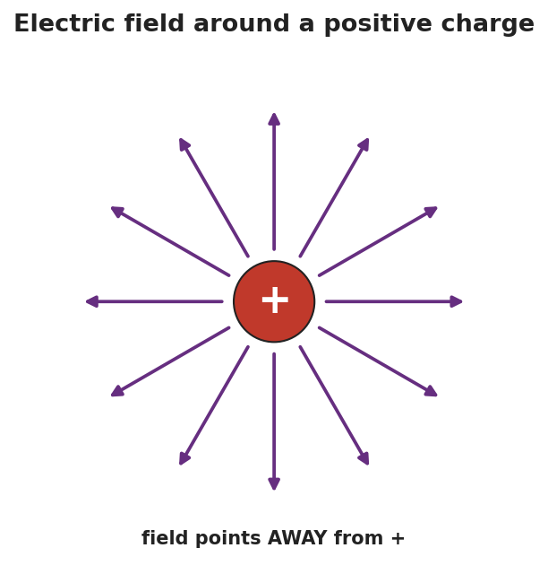
Radial arrows pointing outward from a single positive charge in all directions, representing the electric field around a positive charge — the field points away from a positive source.
Teacher facilitation language:
“Point your test-charge arrow. Which way does the force push a positive test charge near a positive source?” “Who’s feeling the strongest field — and what does that tell us about field strength vs. distance?”

Teacher facilitation during Explore
- What to look for — students pointing arrows away from a + source and toward a − source, and crowding-strength near the source.
- What to resist — don’t give E = Fₑ/q yet; let the human map establish direction and strength first.
- What to redirect — students who point the arrow toward a + source should recall: a + test charge is repelled by +, so it points away.

Phase 3 · Explain (28 – 36 min)

28–31 min · Turn-and-Talk #2 + class consensus
“In one sentence: what is in the space around a charge, and how do we know which way it points?”
Target consensus:
“Every charge surrounds itself with an electric field — a force-per-charge at every point. We probe it with a tiny positive test charge: the field points the way that test charge is pushed (away from +, toward −), and it’s strongest near the source.”

31–33 min · Vocabulary introduction (≤ 3 terms)
Sample teacher language:
“That force-per-charge is the electric field, E = Fₑ / q, measured in newtons per coulomb (N/C). The tiny imaginary charge we use to find its direction is the test charge. The size of E at a point is the field strength — bigger near the source, falling off as 1/r².”
The E-vs-r graph shows the strength falling off:
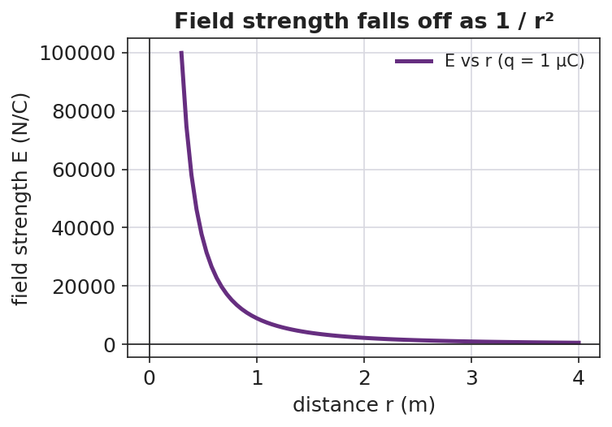
A graph of electric field strength E versus distance r from a point charge, falling off steeply as 1/r².

Discussion prompts to deploy here
- “If a 2 N force acts on a +0.5 C charge placed at a point, what is E there?”
  - Sample student response: “E = Fₑ/q = 2 / 0.5 = 4 N/C.”
- “Why do we use a positive test charge to define the field’s direction?”
  - Sample student response: “It’s the agreed convention — the field points the way a positive charge would be pushed.”

Phase 4 · Elaborate (36 – 40 min)

36–39 min · Revise the model (with numbers)
“A field of 500 N/C exists at a point. (a) What force would it exert on a charge of +2.0 × 10⁻⁶ C placed there? (b) Which way, if the field points east?”
Work it with the class: Fₑ = E·q = (500)(2.0 × 10⁻⁶) = 1.0 × 10⁻³ N, directed east (a positive charge follows the field).

39–40 min · Return to the phenomenon
“Why does the fluorescent tube glow brighter the closer it is to the plasma ball? Answer in one sentence using field strength.”
Target: “The electric field is stronger closer to the ball, so it pushes the gas’s charges harder and the tube glows brighter.”

Phase 5 · Evaluate (40 – 42 min)

40–42 min · Exit Ticket + Closing Reflection
“Use E = Fₑ / q. (a) A charge of +4.0 × 10⁻⁶ C feels a force of 0.012 N at a point. Calculate the electric field strength there, with units. (b) Draw the field around a single negative charge — which way do the arrows point? (c) In one sentence, explain what a ‘test charge’ is and why it must be small.”
Expected: (a) E = Fₑ/q = 0.012 / (4.0 × 10⁻⁶) = 3.0 × 10³ N/C; (b) arrows point inward, toward the negative charge; (c) a tiny positive charge used to probe a field’s direction and strength — small so it doesn’t disturb the field it’s measuring. See Answer_Key.docx.
Closing Reflection (SEL, 30 seconds):
“What part of the human field-map helped you ‘see’ the invisible field? Whose arrow helped you fix yours?”

Common Misconceptions
- Misconception: “The field only exists where there’s another charge to feel it.” → Correction: The field fills the space around a charge whether or not a second charge is present; the second charge just reveals it.
- Misconception: “The field points whichever way the source charge would move.” → Correction: By convention E points the way a positive test charge is pushed (away from +, toward −).
- Misconception: “Field strength and force are the same thing.” → Correction: E is force per coulomb (N/C); the force on a particular charge is Fₑ = E·q.

Access & Differentiation
- ELL/ENL supports: Sentence frame: “The electric field points ___ a positive charge and ___ a negative charge, and it is ___ (stronger/weaker) close to the source.” Word-choice box: {electric field, test charge, field strength, away from, toward, N/C}. Provide pre-drawn radial arrows to label.
- IEP/SPED supports: Give an E = Fₑ/q plug-in template with units printed; students substitute numbers only. Offer the human field-map as the hands-on alternative to drawing.
- Extensions: Have students combine Coulomb’s law and E = Fₑ/q to show E = k·q / r² for a point charge, and use it to find the field 0.10 m from a +1 µC charge.

Strategy Spotlight
ACTIVE LEARNING. Today’s Explore turns the class into a living field map: each student is a positive test charge that points the force direction and crouches/stands to show strength. Flipping the source from + to − forces an immediate, embodied re-vote. Keep the activity kinetic and quick (3–4 source positions), then connect the human map directly to the radial-arrow diagram. Your role is to ask “which way are you pushed?” rather than to draw the field for them.

NYSSLS Observation Checklist Crosswalk
# | Checklist item | Where it appears in this lesson
1 | Local/relatable phenomenon | Phase 1 — plasma ball lighting a bulb; brightness vs. distance in Phase 4
2 | Turn and Talk (2–3×) | Phase 1 (TT#1 — what fills the space), Phase 3 (TT#2 — field direction and strength)
3 | Students develop questions/models/procedures | Phase 1 (initial model), Phase 2 (human field-map), Phase 4 (numeric revision)
4 | CCC defined and used | Lesson Overview · Cause and Effect, restated in Phase 2
5 | ENL — ≤ 3 vocab, second half | Phase 3 — vocabulary at 31–33 min (electric field / test charge / field strength)
6 | Revisit phenomenon with evidence | Phase 4 — bulb brightness + field-strength explanation
7 | ENL/SPED supports | Access & Differentiation block
8 | Assessment check | Phase 5 — Exit Ticket (calculate E; field direction around −)

Companion Materials
- Student_Worksheet.docx — the 5E student investigation (hand out at start of Phase 2)
- Student_Notes.docx — guided note-guide with the worked field calculation
- Answer_Key.docx — worked answers to “Make It Make Sense” prompts and the Exit Ticket

Key Vocabulary (max 3)
- electric field — the force per unit charge at a point in space around a charge: E = Fₑ / q, measured in newtons per coulomb (N/C)
- test charge — a tiny positive charge used to probe a field’s direction and strength without disturbing it
- field strength — the magnitude of the electric field at a point; larger near the source and falling off as 1/r²

Electric Fields — Student Worksheet
Unit: Electrostatics — Lesson 05 Name: _______________________ Date: __________ Period: ____
Reference: E = Fₑ / q (units: N/C) · k = 8.99 × 10⁹ N·m²/C²

Phenomenon
Your teacher holds a fluorescent tube near a plasma ball — it glows, even though it isn’t plugged in or touching the ball. Move it away and it dims. Something is filling the space around the ball.
Driving question: What is in the space around a charge, and how can we describe its direction and strength?

Notice & Wonder
I notice… | I wonder…
Turn & Talk #1: The effect on the bulb got weaker as it moved away. What does that tell you about whatever surrounds the ball?

Initial Model
Draw the plasma ball. Around it, draw arrows showing how it would push or pull on a small positive test charge placed at several spots. Mark where the push would be strongest.

Strongest at: _________________________________

Investigation
Human field map. Stand at your assigned spot holding a + test-charge card near the floor “+” source.
My spot | Direction my + card is pushed | Near or far from source? | Strong or weak field?
Round 1 (+ source)
Round 2 (− source)
Compare your map to the field around a single positive charge:

Arrows radiating outward in all directions from a single positive charge.
Key question: Which way does the field point near a positive source? Near a negative source?

Make It Make Sense
- A 2.0 N force acts on a +0.5 C charge placed at a point. What is the electric field strength there? Show E = Fₑ/q.
- The field strength drops as you move away from the source (see the graph). What shape is that fall-off, and where have you seen it before?

A graph of field strength E versus distance r, falling off as 1/r².
- Why do we use a positive test charge (and a small one) to define the field’s direction?

Vocabulary in Action
Use each term in a sentence about today’s phenomenon.
- electric field: _______________________________________________
- test charge: _______________________________________________
- field strength: _______________________________________________

Revise Your Model
A field of 500 N/C exists at a point, pointing east. (a) What force would it exert on a +2.0 × 10⁻⁶ C charge placed there? (b) Which direction?
Fₑ = E·q = ____________________ ≈ __________ N Direction: ____________________

Exit Ticket
Use E = Fₑ / q.
- A charge of +4.0 × 10⁻⁶ C feels a force of 0.012 N at a point. Calculate the electric field strength there, with units.
- Draw the field around a single negative charge. Which way do the arrows point?
- In one sentence, explain what a “test charge” is and why it must be small.

Electric Fields — Student Notes
Unit: Electrostatics — Lesson 05 Name: _______________________ Date: __________ Period: ____
Reference: E = Fₑ / q (units: N/C) · k = 8.99 × 10⁹ N·m²/C²

Learning Targets
By the end of today’s 42 minutes I can:
- Define the electric field as force per unit charge (E = Fₑ / q).
- Explain the test-charge idea and which way the field points.
- Calculate field strength from a force and a charge.

Key Vocabulary
- electric field — _______________________________________________
- test charge — _______________________________________________
- field strength — _______________________________________________

Guided Notes
Big idea: A charge fills the space around it with an electric field — a __________ per unit charge at every point.
- Formula: E = __________ / __________, with units __________ (newtons per coulomb).
- We find its direction with a tiny positive test charge: the field points the way that charge is __________.
- Near a positive charge, the field points __________ (away).
- Near a negative charge, the field points __________ (toward).
- Field strength is __________ near the source and falls off as __________ (inverse-square).

Radial arrows pointing away from a positive charge.

A graph of field strength E versus distance, falling off as 1/r².
Two ways to use E = Fₑ / q:
- Find the field: E = Fₑ / q.
- Find the force on a charge in a field: Fₑ = __________ · __________.

Worked Example
Problem. A field of 500 N/C points east at a point. What force does it exert on a charge of +2.0 × 10⁻⁶ C placed there, and in which direction?
Solution. 1. Rearrange E = Fₑ / q to solve for force: Fₑ = __________ · __________. 2. Substitute: Fₑ = (500 N/C)(2.0 × 10⁻⁶ C) = __________ N. 3. Result: Fₑ ≈ 1.0 × 10⁻³ N. 4. The charge is __________, so it is pushed in the __________ direction the field points → east.

Summary
Finish the sentence (Because / But / So):
A charge fills the space around it with an electric field because __________________________________________, but you only feel a force when another charge sits in that field __________________________________________, so __________________________________________.

Electric Fields — Answer Key

Cover
Unit: Electrostatics — Lesson 05: Electric Fields East Meadow Schools × Valley Stream Central HSD Strategy chip: ACTIVE LEARNING Reference: E = Fₑ / q (N/C) · k = 8.99 × 10⁹ N·m²/C²

Make-It-Make-Sense Answers
- E = Fₑ / q = 2.0 N / 0.5 C = 4 N/C. · Rubric: correct formula AND 4 N/C with units. · NYSSLS: HS-PS3-5
- It falls off as an inverse-square (1/r²) — the same shape as Coulomb’s law (Lesson 04) and gravitation. · Rubric: “inverse-square / 1/r²” AND a prior connection. · NYSSLS: HS-PS3-5
- A positive test charge is the agreed convention for field direction (the field points the way a + charge is pushed). It must be small so it does not disturb (move or distort) the field it is measuring. · Rubric: convention/direction AND “small so it doesn’t disturb the field.” · NYSSLS: HS-PS3-5

Exit Ticket Answer
- E = Fₑ / q = 0.012 N / (4.0 × 10⁻⁶ C) = 3.0 × 10³ N/C (3000 N/C).
- The arrows point inward — toward the negative charge (a + test charge is attracted to it).
- A test charge is a tiny positive charge used to probe a field’s direction and strength; it must be small so it does not disturb the field it is measuring.
Tolerance/rubric: (a) 3.0 × 10³ N/C with units (accept 3000 N/C); (b) “toward / inward”; (c) “small positive” + “doesn’t disturb the field.” 1 point each (part a worth 2: setup + answer). NYSSLS: HS-PS3-5.

Closing Reflection (rubric)
Closing reflection is formative, not graded. Award full credit for any honest response. Look for: - A specific feature of the human field-map (direction arrows or the crouch-for-strong idea) named in answer 1 - A peer acknowledgment in answer 2

Electric Field Lines — Teacher Guide

Cover
Unit: Electrostatics — Lesson 06: Electric Field Lines East Meadow Schools × Valley Stream Central High School District Strategy chips: HOCHMAN

Curated Resources (from East Meadow Scope & Sequence)

NYSSLS Standards
This lesson completes the field model of HS-PS3-5: “Develop and use a model of two objects interacting through electric or magnetic fields to illustrate the forces between objects and the changes in energy of the objects due to the interaction. (Cause and Effect).” Field lines are the visual representation students use to illustrate the forces between charges — for a single charge, a dipole, and parallel plates.

Phenomenon
- Semolina grains (or grass seed) in oil line up along the field of charged electrodes (classic field-mapping demo): https://www.youtube.com/watch?v=field+lines+semolina+oil
- Iron-filings analogy for visualizing an invisible field (Veritasium): https://www.youtube.com/watch?v=field+lines+visualization

Javalab / Labs
- Electric field line (single charge, dipole, plates): https://javalab.org/en/electric_field_line_en/
- Electric field of point charges (Javalab): https://javalab.org/en/electric_field_en/

Assessments
- Reference Table relationship: E = Fₑ / q (line density ↔ field strength). The Exit Ticket below is the formative check.

Lesson Overview
Duration | 42 minutes (1 period)
NYSSLS link | HS-PS3-5 (using a model — field lines — to illustrate the forces between charges)
CCC focus | Cause and Effect — line direction shows the force direction; line density shows the field strength.
Strategy chips | HOCHMAN (literacy)
Materials | Javalab field-line sim; (optional) semolina-in-oil dish with electrodes; rulers; sentence-expansion strips (appositive / Because-But-So); whiteboards/markers.
Safety | If running the semolina/oil dish with electrodes, keep the high-voltage supply away from students and observe its limits.
Prior knowledge | Lesson 05 — the electric field (E = Fₑ/q); field points away from + and toward −; strength falls off with distance.
Lesson objectives — students can:
- State and apply the rules for drawing field lines: start on +, end on −, never cross, line density shows strength.
- Draw the field-line pattern for a single charge, a dipole, and parallel plates (a uniform field).
- Read field strength from line spacing (closer lines = stronger field).

Phase 1 · Engage (0 – 10 min)

0–2 min · Opening Connection (SEL)
One-phrase whip-around: “Name a map or diagram you read where the lines tell you something — a subway map, a weather chart, a contour line.” This primes the idea that lines on a page carry meaning.

2–7 min · Phenomenon hook — semolina reveals the field
Teacher actions. Show the semolina-in-oil dish (or the video): switch on the electrodes and the grains snap into curved chains running between them — the invisible field made visible. Or run the Javalab sim and drop test points that trace lines.
Sample teacher language:
“Each grain just lined itself up along something it can’t see. Those chains are a picture of the field. What rules do they seem to follow — where do the chains start, end, and how do they bunch up?”
Anticipated student responses:
- “They go from one electrode to the other.” — capture: lines connect + to −.
- “They’re closer together near the points.” — gold: density shows strength.
- “They never seem to cross.” — excellent; this is one of the core rules.

7–10 min · Notice & Wonder + Turn-and-Talk #1
“Turn to your partner: from the semolina chains, write two ‘rules’ the field lines seem to obey.”
Target ideas: lines run from one charge to the other; they bunch up where the field is strong; they don’t cross. Leave open if unspoken.

Bridge to Phase 2
Each student writes a one-sentence initial model: “The chains run from ______ to ______, and they are closest together where ______.”

Phase 2 · Explore (10 – 28 min)

10–14 min · Initial Model (silent / individual)
“Draw a single + charge and sketch how you think the field lines leave it. Then draw a + and a − near each other and sketch the lines between them.”

14–28 min · Investigation — discover the rules (Javalab)
Pairs use the Javalab field-line sim to build three patterns and record what they notice:
- Single + charge — lines leave straight out in all directions; density falls with distance.
- Dipole (+ and −) — lines curve from the + to the −, never crossing.
- Parallel plates (+ and −) — lines run straight, evenly spaced → a uniform field.
Use the reference diagrams below to confirm each pattern.
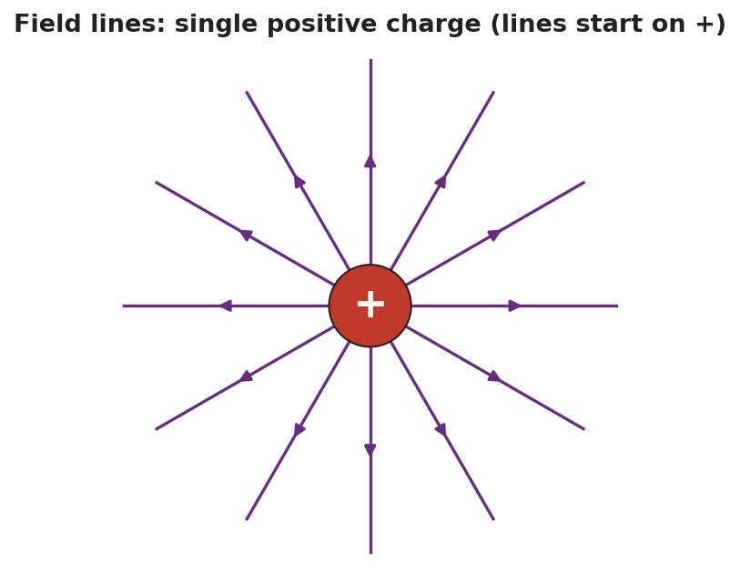
Field lines for a single positive charge: straight lines radiating outward in all directions, each with an arrow pointing away from the charge.
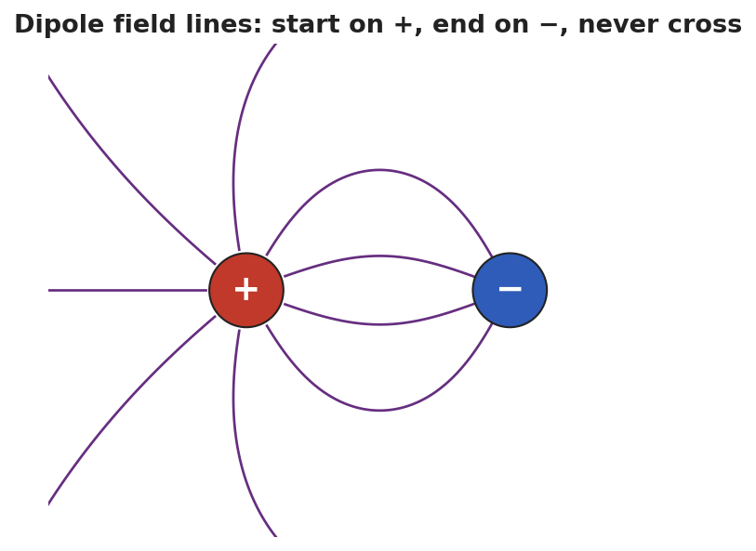
Dipole field lines: curved lines that start on the positive charge and end on the negative charge, none of them crossing.
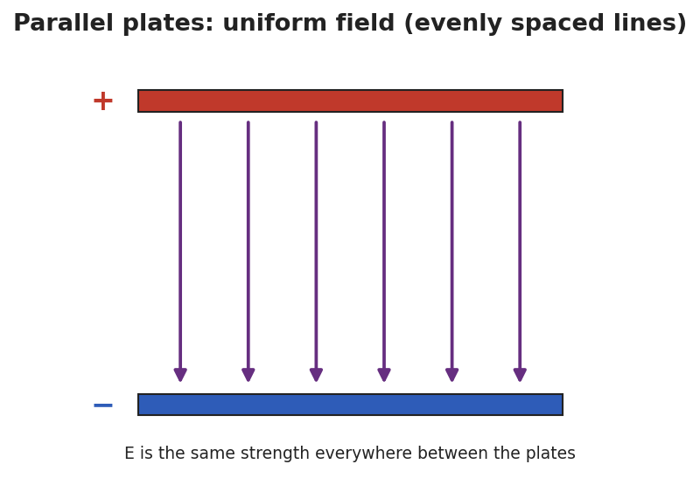
Parallel-plate field: a positive top plate and a negative bottom plate with straight, evenly spaced field lines running from + to −, representing a uniform field of constant strength.
Teacher facilitation language:
“Where do every one of your lines begin, and where do they end?” “Between the plates, are the lines bunching up anywhere, or evenly spaced? What does even spacing tell you about the field’s strength?”

Teacher facilitation during Explore
- What to look for — pairs articulating start-on-+, end-on-−, never-cross, and density-shows-strength from the sim.
- What to resist — don’t list the rules first; let the three patterns reveal them.
- What to redirect — pairs who draw crossing lines should be asked: “if two lines crossed, the field would point two ways at once — can it?”

Phase 3 · Explain (28 – 36 min)

28–31 min · Turn-and-Talk #2 + class consensus
“State the four rules for drawing electric field lines, in your own words.”
Target consensus (the four rules):
“1) Lines start on positive charges and end on negative ones. 2) They point the way a positive test charge would move. 3) They never cross. 4) Where lines are closer together, the field is stronger.”

31–33 min · Vocabulary introduction (≤ 3 terms)
Sample teacher language:
“These are field lines. A + and a − charge close together form a dipole, with lines curving from + to −. Between parallel plates the lines are straight and evenly spaced — a uniform field, the same strength everywhere.”

33–36 min · HOCHMAN sentence work
Run an appositive drill naming the dipole inside a sentence:
“A dipole, a pair of equal and opposite charges set close together, produces field lines that curve from the + to the −.”
Then a Because/But/So expansion of the density rule:
Stem: “Field lines that are close together…” - because … (a strong field is drawn with crowded lines) - but … (far from a charge the lines spread out) - so … (you can read the field’s strength straight off the spacing)

Discussion prompts to deploy here
- “Why can’t two field lines ever cross?”
  - Sample student response: “A crossing point would have the field pointing two directions at once, which is impossible.”
- “How is the field between parallel plates different from the field around a single charge?”
  - Sample student response: “The plates give a uniform field — straight, evenly spaced lines; a single charge’s field spreads out and weakens with distance.”

Phase 4 · Elaborate (36 – 40 min)

36–39 min · Revise the model
“Return to your dipole sketch. Re-draw it to obey all four rules: lines start on +, end on −, don’t cross, and crowd where the field is strong. Label where the field is strongest.”

39–40 min · Return to the phenomenon
“Why did the semolina grains line up exactly along the field lines? Answer in one sentence.”
Target: “Each grain became polarized and lined up end-to-end along the field’s direction, tracing the lines we’d draw.”

Phase 5 · Evaluate (40 – 42 min)

40–42 min · Exit Ticket + Closing Reflection
“(a) State two rules for drawing electric field lines. (b) Two diagrams show field lines: in Diagram A the lines are close together; in Diagram B they are spread far apart. Where is the field stronger, and how do you know? (c) Sketch the field lines for a single negative charge — which way do the arrows point, and where do they end?”
Expected: (a) any two of: start on +, end on −; never cross; point the way a + test charge moves; density shows strength; (b) Diagram A — closely spaced lines mean a stronger field; (c) straight lines pointing inward toward the negative charge (lines end on negative charges). See Answer_Key.docx.
Closing Reflection (SEL, 30 seconds):
“Which Hochman sentence (the appositive or a Because/But/So) best captured a rule for you today?”

Common Misconceptions
- Misconception: “Field lines can cross.” → Correction: They never cross — a crossing would mean the field points two ways at one point.
- Misconception: “Field lines are real, physical wires.” → Correction: They are a model — a way to picture the field’s direction and strength; the field itself is continuous.
- Misconception: “Evenly spaced or not, spacing doesn’t matter.” → Correction: Line density encodes strength: crowded = strong, spread out = weak; uniform spacing means a uniform field.

Access & Differentiation
- ELL/ENL supports: Sentence frame: “Field lines start on the ___ charge and end on the ___ charge; where they are ___ (close/far), the field is ___ (strong/weak).” Word-choice box: {field line, dipole, uniform field, start, end, never cross, density}. Provide pre-printed +, −, and plate templates to draw onto.
- IEP/SPED supports: Give partially drawn patterns (single charge, dipole, plates) with a few lines complete; students add the rest following the rules. Offer the Javalab sim as the primary tool over freehand drawing.
- Extensions: Have students draw the field for two like charges (both +) and explain the “no-man’s-land” point between them where the field is zero (no lines).

Strategy Spotlight
HOCHMAN (literacy). The four field-line rules are consolidated as sentences, not a bullet list: an appositive that defines a dipole inside a working sentence, and a Because/But/So expansion of the density rule. This pushes students to encode each rule in precise prose, supporting transfer to constructed-response items. Keep each strip to one clause and read several aloud; the goal is sentence fluency with the rule, not length.

NYSSLS Observation Checklist Crosswalk
# | Checklist item | Where it appears in this lesson
1 | Local/relatable phenomenon | Phase 1 — semolina-in-oil field reveal; grains lining up in Phase 4
2 | Turn and Talk (2–3×) | Phase 1 (TT#1 — two rules from the chains), Phase 3 (TT#2 — state the four rules)
3 | Students develop questions/models/procedures | Phase 1 (initial model), Phase 2 (Javalab pattern-building), Phase 4 (revise dipole)
4 | CCC defined and used | Lesson Overview · Cause and Effect (direction + density), restated in Phase 2
5 | ENL — ≤ 3 vocab, second half | Phase 3 — vocabulary at 31–33 min (field line / dipole / uniform field)
6 | Revisit phenomenon with evidence | Phase 4 — semolina explanation + dipole re-draw
7 | ENL/SPED supports | Access & Differentiation block
8 | Assessment check | Phase 5 — Exit Ticket (rules; density→strength; single-negative sketch)

Companion Materials
- Student_Worksheet.docx — the 5E student investigation (hand out at start of Phase 2)
- Student_Notes.docx — guided note-guide for the rules and the worked example
- Answer_Key.docx — answers to “Make It Make Sense” prompts and the Exit Ticket

Key Vocabulary (max 3)
- field line — a line drawn to represent an electric field: it starts on a positive charge, ends on a negative charge, never crosses another, and shows the field’s strength by how closely spaced it is
- dipole — a pair of equal and opposite charges set close together; its field lines curve from the + charge to the − charge
- uniform field — a field of constant strength and direction, shown by straight, evenly spaced field lines (as between parallel plates)

Electric Field Lines — Student Worksheet
Unit: Electrostatics — Lesson 06 Name: _______________________ Date: __________ Period: ____

Phenomenon
Your teacher switches on two electrodes in a dish of semolina grains in oil. The grains snap into curved chains running between the electrodes — an invisible field suddenly made visible.
Driving question: What rules do field lines follow, and how do they show us the direction and strength of an electric field?

Notice & Wonder
I notice… | I wonder…
Turn & Talk #1: From the semolina chains, write two rules the field lines seem to obey.
Rule 1: __________________________________________ Rule 2: __________________________________________

Initial Model
Draw a single + charge and sketch how you think the field lines leave it. Then draw a + and a − near each other and sketch the lines between them.

Investigation
Use the Javalab field-line sim to build three patterns. Record what you notice.
Setup | Where lines start / end | Spacing (even? bunched?) | Field strongest where?
1. Single + charge
2. Dipole (+ and −)
3. Parallel plates
Confirm each against these diagrams:

Field lines radiating outward from a single positive charge.

Dipole field lines curving from + to −, never crossing.

Parallel plates with straight, evenly spaced field lines — a uniform field.
Key question: Why can’t two field lines ever cross?

Make It Make Sense
- List the four rules for drawing electric field lines.
- Two diagrams show field lines: in Diagram A the lines are close together; in Diagram B they are far apart. Where is the field stronger, and how do you know?
- How is the field between parallel plates different from the field around a single charge?

Vocabulary in Action
Use each term in a sentence about today’s phenomenon.
- field line: _______________________________________________
- dipole: _______________________________________________
- uniform field: _______________________________________________

Revise Your Model
Return to your dipole sketch. Re-draw it to obey all four rules: lines start on +, end on −, never cross, and crowd where the field is strong. Label where the field is strongest.

Exit Ticket
- State two rules for drawing electric field lines.
- Two diagrams show field lines: in Diagram A the lines are close together; in Diagram B they are spread far apart. Where is the field stronger, and how do you know?
- Sketch the field lines for a single negative charge. Which way do the arrows point, and where do they end?

Electric Field Lines — Student Notes
Unit: Electrostatics — Lesson 06 Name: _______________________ Date: __________ Period: ____

Learning Targets
By the end of today’s 42 minutes I can:
- State and apply the four rules for drawing field lines.
- Draw the field for a single charge, a dipole, and parallel plates.
- Read field strength from line spacing.

Key Vocabulary
- field line — _______________________________________________
- dipole — _______________________________________________
- uniform field — _______________________________________________

Guided Notes
The four rules for field lines:
- Lines start on __________ charges and end on __________ charges.
- They point the way a __________ test charge would move.
- Field lines never __________.
- Where lines are __________ together, the field is __________ (density shows strength).
Three key patterns:
- Single charge: lines go straight __________ (for +) and weaken with distance.

Field lines radiating from a single positive charge.
- Dipole (+ and −): lines curve from the __________ to the __________, never crossing.

Dipole field lines from + to −.
- Parallel plates: straight, __________ spaced lines → a __________ field (same strength everywhere).

Parallel plates with a uniform field.

Worked Example
Problem. Two field-line diagrams are drawn to the same scale. In Diagram A the lines are spaced 2 mm apart; in Diagram B they are spaced 8 mm apart. In which diagram is the electric field stronger, and how do you know?
Solution. 1. Rule 4: line __________ shows field strength. 2. Closer lines mean a __________ field; lines farther apart mean a __________ field. 3. Diagram A has lines only __________ mm apart (closer), so Diagram A has the stronger field.

Summary
Finish the sentence (Because / But / So):
Field lines that are close together show a strong field because __________________________________________, but far from a charge the lines spread out __________________________________________, so __________________________________________.

Electric Field Lines — Answer Key

Cover
Unit: Electrostatics — Lesson 06: Electric Field Lines East Meadow Schools × Valley Stream Central HSD Strategy chip: HOCHMAN

Make-It-Make-Sense Answers
- The four rules: (1) lines start on + charges and end on − charges; (2) they point the way a positive test charge would move; (3) lines never cross; (4) closer lines mean a stronger field (density shows strength). · Rubric: all four = full credit (¾ for three). · NYSSLS: HS-PS3-5
- Diagram A (the closely spaced lines) has the stronger field, because line density represents field strength — crowded lines = strong field. · Rubric: “A” AND density-shows-strength reasoning. · NYSSLS: HS-PS3-5
- Parallel plates give a uniform field — straight, evenly spaced lines, the same strength everywhere. A single charge’s field spreads out and weakens with distance (lines diverge and the field falls off as 1/r²). · Rubric: “uniform vs. spreading/weakening.” · NYSSLS: HS-PS3-5

Exit Ticket Answer
- Any two of: lines start on + and end on −; lines never cross; lines point the way a + test charge moves; closer lines mean a stronger field.
- Diagram A (close-together lines) has the stronger field. Line density encodes field strength, so more crowded lines = stronger field.
- Straight lines pointing inward, toward the negative charge — field lines end on negative charges (and point the way a + test charge would be pulled).
Tolerance/rubric: (a) any two valid rules = 1 pt; (b) “A” + density reasoning; (c) “toward / inward” AND “lines end on −.” 1 point each. NYSSLS: HS-PS3-5.

Closing Reflection (rubric)
Closing reflection is formative, not graded. Award full credit for any honest response. Look for: - The student naming the appositive or a specific Because/But/So sentence and tying it to one of the four rules

