Physics — Unit 07: Current Electricity (Review)
Table of Contents

Unit 7 · Current Electricity

Current Electricity — Unit Plan

Cover
Unit: Current Electricity East Meadow Schools × Valley Stream Central High School District 5 lessons · ~5 instructional periods (42 min each) Format: DOCX (Teacher Guide · Student Worksheet · Student Notes · Answer Key per lesson)

Unit Scope (from East Meadow Scope & Sequence)
This unit develops the physics of moving charge: what current and voltage are, how Ohm’s Law (V = I·R) relates them through resistance, how resistance arises in a wire, how resistors combine in series and parallel circuits, and how current and magnetism interact through electromagnetic induction. It builds on the energy ideas of HS-PS3 and the charge ideas from Electrostatics, and it closes with the field/energy connection that anchors generators and motors.
# | Lesson | Core idea
01 | Electric Current and Ohm’s Law | Current = charge ÷ time; voltage drives current; V = I·R; slope of V–I is R
02 | Resistance in a Wire | R rises with length and resistivity, falls with cross-sectional area; temperature matters
03 | Series Circuits | One path; same current everywhere; R_total = R₁ + R₂ + …; voltage drops add
04 | Parallel Circuits | Multiple paths; same voltage per branch; currents add; 1/R_total = Σ 1/R
05 | Electromagnetism (The Induction Junction) | Current makes a magnetic field; a changing field induces current; generators & motors

Pacing Calendar
Day | Lesson | Phenomenon anchor | Strategy
1 | 01 Electric Current and Ohm’s Law | Energy stick that lights when hands complete the loop | Hochman
2 | 02 Resistance in a Wire | Thin/long vs. thick/short wire changes bulb brightness | BTC
3 | 03 Series Circuits | Old holiday lights — one missing bulb kills the string | Active Learning
4 | 04 Parallel Circuits | Home outlets — unplug one lamp, others stay lit | Active Learning
5 | 05 Electromagnetism (Induction) | Coil + magnet lighting an LED; electromagnet + paperclips | Active Learning (NYS Investigation)
Double-period days (every other day) let the investigation phases of Lessons 03–05 run long with the PhET/Javalab labs and the hands-on induction station.

Strategy Rotation
- HOCHMAN (literacy): Lesson 01 — Because/But/So expansion on the V–I–R relationship (the “but” clause carries the resistance idea).
- BTC (Building Thinking Classrooms): Lesson 02 — visibly random groups at vertical non-permanent surfaces on a resistance thin-slice (length vs. area).
- ACTIVE LEARNING: Lessons 03, 04, 05 — predict-measure-reconcile at PhET stations (series/parallel) and a hands-on NYS induction investigation.
SEL (Opening Connection + Closing Reflection), ELL/SPED supports, and a Curated Resources block appear in every lesson.

NYSSLS Coverage Matrix
PE | Description | Lessons
HS-PS3-6 | Analyze data to support the claim that Ohm’s Law describes the mathematical relationship among the potential difference, current, and resistance of an electric circuit. | 01 (core), 02 (origin of R), 03 (series), 04 (parallel)
HS-PS3-5 | Develop and use a model of two objects interacting through electric or magnetic fields to illustrate the forces and the changes in energy due to the interaction. | 05 (core — induction, generators/motors)
HS-PS3-3 | Design a device that converts energy from one form to another (thread). | 05 (generator/motor energy conversion — connection)

Vocabulary Scope
Three terms maximum per lesson, introduced in the second half (NYSSLS observation item 5).
Lesson | Terms
01 | current · voltage · resistance
02 | resistance · resistivity · cross-sectional area
03 | series circuit · equivalent resistance · current
04 | parallel circuit · branch · equivalent resistance
05 | magnetic field · electromagnet · electromagnetic induction

Electric Current and Ohm’s Law — Teacher Guide

Cover
Unit: Current Electricity — Lesson 01: Electric Current and Ohm’s Law East Meadow Schools × Valley Stream Central High School District Strategy chips: HOCHMAN

Curated Resources (from East Meadow Scope & Sequence)

NYSSLS Standards
This lesson is the anchor for HS-PS3-6: “Analyze data to support the claim that Ohm’s Law describes the mathematical relationship among the potential difference, current, and resistance of an electric circuit.” Students collect (or read) V–I data, see the straight-line pattern, and name the slope as resistance. It builds on the energy ideas of HS-PS3 (energy transfer in a system) and sets up the series/parallel analysis in Lessons 03–04.

Phenomenon
- Energy-stick / human-circuit toy that lights and buzzes only when two people complete the loop by holding hands: https://www.youtube.com/results?search_query=energy+stick+human+circuit
- Why a dimmer knob changes brightness — changing resistance changes current (Khan Academy, “Ohm’s law”): https://www.khanacademy.org/science/physics/circuits-topic/circuits-resistance/a/ee-voltage-and-current

Javalab / Labs
- PhET Circuit Construction Kit: DC — build a battery + resistor loop, read the ammeter and voltmeter: https://phet.colorado.edu/en/simulations/circuit-construction-kit-dc
- Javalab — Electric current (charge flowing through a conductor): https://javalab.org/en/electric_current_en/

Assessments
- PhET CCK-DC guided data table (V vs I) — formative during Explore.
- Exit ticket below (numeric Ohm’s-law problem) is the formative check; full key in Answer_Key.docx.

Lesson Overview
Duration | 42 minutes (1 period)
NYSSLS link | HS-PS3-6 (core — V, I, R relationship)
CCC focus | Patterns — V plotted against I forms a straight line whose slope is the resistance.
Strategy chips | HOCHMAN (Because/But/So on the V–I relationship)
Materials | Energy stick (or a simple battery–bulb kit); devices/Chromebooks for PhET CCK-DC; whiteboards/markers; calculators.
Safety | Low-voltage kits only (≤ 6 V). No wall outlets. Do not short a battery directly across its terminals — always include a bulb or resistor.
Prior knowledge | Charge (positive/negative), conservation of charge, and energy as the capacity to do work.
Lesson objectives — students can:
- Define current as charge per unit time (amperes) and voltage as the push that drives charge around a circuit.
- Use Ohm’s Law, V = I·R, to solve for any one of V, I, or R given the other two.
- Interpret a V-vs-I graph: a straight line through the origin whose slope equals the resistance.

Phase 1 · Engage (0 – 10 min)

0–2 min · Opening Connection (SEL)
Quick whip-around (one sentence each, pass allowed): “Name one thing in your home that needs to be ‘plugged in’ or charged to work.” Capture two or three answers; you’ll return to the idea that all of these move electric charge.

2–7 min · Phenomenon hook — the energy stick
Teacher actions. Hold the energy stick by one metal end. Nothing happens. Grab the other end with your free hand — it lights and buzzes. Break contact — it stops. Then form a chain of students holding hands; the stick lights only when the loop is closed.
Sample teacher language:
“Watch — when the loop is open, nothing. The moment we close the loop with our hands, charge can flow all the way around and the light comes on. What’s our skin doing in this circuit?”
Anticipated student responses:
- “We’re the wire.” — capture this; skin is a (poor) conductor completing the path.
- “Electricity needs a complete circle.” — exactly; name it closed loop / complete circuit.
- “More people should make it brighter/dimmer.” — flag it; we’ll connect more people = more resistance later.

7–10 min · Notice & Wonder + Turn-and-Talk #1
Two columns on the board. Then:
“Turn to your partner: what has to be true for the charge to flow? Use the word path in your answer.”
Target insight: charge needs a complete, closed path and a push (the battery) to keep it moving.

Bridge to Phase 2
Each student writes a one-sentence initial model: “The stick lights up because ______.”

Phase 2 · Explore (10 – 30 min)

10–14 min · Initial Model (silent / individual)
Prompt on the board:
“Draw the energy-stick loop with two people holding hands. Mark where the push comes from and draw arrows showing which way the charge moves around the loop. Predict: what would make the light brighter?”

14–30 min · Investigation — PhET Circuit Construction Kit DC
Students build a single battery + resistor loop, add an ammeter (current, A) in the loop and a voltmeter (voltage, V) across the resistor.
- Same resistor, change the battery voltage. Record V and I for 9 V, 18 V, 27 V across a fixed resistor. Plot V (y) vs I (x).
- Same battery, change the resistor. Watch the current drop as resistance rises.
Teacher facilitation language:
“When you double the battery voltage, what happens to the current? Is it exactly double?” “Your V-vs-I points — are they making a line? What does the steepness of that line tell you?” “Which resistor let the most current through for the same push?”
Use the V-vs-I graph below to make the linear pattern (slope = R) visible once a group has three data points.
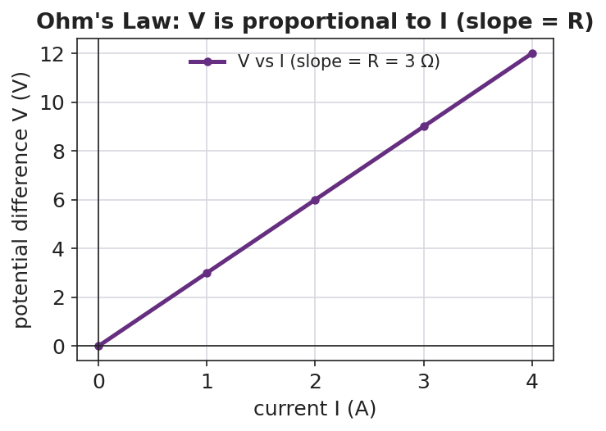
Graph of potential difference V on the vertical axis versus current I on the horizontal axis: the points fall on a straight line through the origin, and the slope of the line equals the resistance R.
The single-loop schematic students are building:
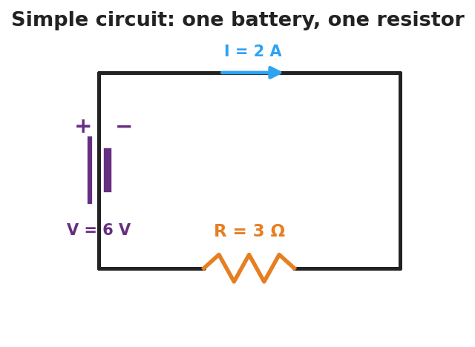
Schematic of a simple circuit: a battery labeled V equals 6 volts on the left side drives a current I equals 2 amperes clockwise through a single resistor labeled R equals 3 ohms on the bottom wire.

Teacher facilitation during Explore
- What to look for — groups noticing that V ÷ I gives the same number every time for one resistor (that number is R).
- What to resist — don’t hand them “V = IR” yet; let the straight line emerge from the data.
- What to redirect — students who say “more voltage means more resistance” should re-check: more voltage means more current; resistance is the slope, set by the resistor.

Phase 3 · Explain (30 – 36 min)

30–33 min · Turn-and-Talk #2 + class consensus
“Across your data, how did current respond when you increased the voltage but kept the same resistor?”
Target consensus:
“Current grows in proportion to voltage. For one resistor, V divided by I is always the same number — that constant is the resistance.”

33–36 min · Vocabulary introduction (≤ 3 terms)
Sample teacher language:
“The flow of charge is current — charge per second, measured in amperes. The push that drives it is the voltage (potential difference), in volts. What slows the flow is the resistance, in ohms. Put them together and you get Ohm’s Law: V = I·R — voltage equals current times resistance. On your graph, the slope is R.”
Reference relationships to post: V = I·R; power P = V·I = I²·R.

Discussion prompts to deploy here
- “A 12 V battery drives 3 A through a resistor. What is the resistance?”
  - Sample response: “R = V/I = 12/3 = 4 Ω.”
- “If you keep the resistor the same but double the voltage, what happens to the current?”
  - Sample response: “It doubles, because I = V/R and R didn’t change.”

Phase 4 · Elaborate (36 – 40 min)

36–38 min · Hochman Because/But/So
Students complete a Because/But/So sentence on the core relationship:
“Current increases when voltage increases because ____, but ____, so ____.”
Target: …because voltage is the push that drives charge, but the resistance limits how much charge gets through, so the current is set by both together (I = V/R).

38–40 min · Return to the phenomenon
“On the energy stick, why does adding more people in the hand-chain make it harder to light? Answer in one sentence using resistance and current.”
Target: “Each person adds resistance, so for the same small voltage the current drops below what the stick needs to light.”

Phase 5 · Evaluate (40 – 42 min)

40–42 min · Exit Ticket + Closing Reflection
“A resistor has 6 V across it and carries 2 A of current. (a) What is its resistance? Show V = I·R. (b) The voltage is raised to 12 V with the same resistor. What is the new current? (c) In one sentence, what does the slope of a V-vs-I graph represent?”
Expected: (a) R = V/I = 6/2 = 3 Ω; (b) I = V/R = 12/3 = 4 A; (c) the slope equals the resistance. See Answer_Key.docx.
Closing Reflection (SEL, 30 seconds):
“What is one thing about electricity you understand now that you didn’t this morning?”

Common Misconceptions
- Misconception: “Current gets used up as it goes around the loop.” → Correction: Charge is conserved; the same current flows all the way around a single loop. Energy is transferred, not the charge itself.
- Misconception: “Voltage flows through the wire.” → Correction: Current (charge) flows; voltage is the difference in electric potential between two points — the push, not the stuff that moves.
- Misconception: “More resistance means more current.” → Correction: For a fixed voltage, more resistance means less current (I = V/R).

Access & Differentiation
- ELL/ENL supports: Sentence frame: “Current is the ___ of charge; voltage is the ___ that drives it; resistance ___ the flow.” Word box: {flow, push, opposes, amperes, volts, ohms}. Pair current with a hand-sweeping gesture (flow) and resistance with a hand-blocking gesture.
- IEP/SPED supports: Provide the V-vs-I axes pre-drawn and a partly filled data table; students plot two given points and read the slope. Offer a triangle “V over I·R” cover-up card for solving Ohm’s Law.
- Extensions: Have students compute the power delivered to the resistor in the exit ticket (P = V·I) and explain why a higher-resistance wire of the same length runs hotter for the same voltage (P = V²/R reasoning).

Strategy Spotlight
HOCHMAN (sentence-level literacy). The Elaborate phase uses a Because/But/So expansion on a single physics relationship (voltage up → current up, limited by resistance). Insist on one complete sentence with all three conjunctions; the “but” clause is where the resistance idea must appear, which is exactly the conceptual hinge of Ohm’s Law. Read two or three aloud and revise one together so students hear how the “but” sharpens the claim.

NYSSLS Observation Checklist Crosswalk
# | Checklist item | Where it appears in this lesson
1 | Local/relatable phenomenon | Phase 1 — energy-stick human circuit; dimmer callback
2 | Turn and Talk (2–3×) | Phase 1 (TT#1 — what makes charge flow), Phase 3 (TT#2 — current vs. voltage)
3 | Students develop questions/models/procedures | Phase 1 (initial model), Phase 2 (PhET data + graph), Phase 4 (revise)
4 | CCC defined and used | Lesson Overview · Patterns (linear V–I), used in Phase 2 graph
5 | ENL — ≤ 3 vocab, second half | Phase 3 — current / voltage / resistance at 33–36 min
6 | Revisit phenomenon with evidence | Phase 4 — why more people dims the stick
7 | ENL/SPED supports | Access & Differentiation block
8 | Assessment check | Phase 5 — numeric Ohm’s-law exit ticket

Companion Materials
- Student_Worksheet.docx — the 5E student investigation (hand out at start of Phase 2)
- Student_Notes.docx — guided note-guide for vocabulary and the worked example
- Answer_Key.docx — answers to “Make It Make Sense” prompts and the Exit Ticket

Key Vocabulary (max 3)
- current — the rate of flow of electric charge through a conductor, equal to charge ÷ time, measured in amperes (A)
- voltage — the potential difference (electrical “push”) between two points that drives current around a circuit, measured in volts (V)
- resistance — the opposition a material offers to the flow of charge; the slope of a V-vs-I graph, measured in ohms (Ω)

Electric Current and Ohm’s Law — Student Worksheet
Unit: Current Electricity — Lesson 01 Name: _______________________ Date: __________ Period: ____

Phenomenon
Your teacher holds an “energy stick.” Nothing happens — until two people grab the metal ends and complete the loop with their hands. Then it lights up and buzzes. Break the loop, and it goes dark again.
Driving question: What has to be true for electric charge to flow, and what controls how much flows?

Notice & Wonder
I notice… | I wonder…
Turn & Talk #1: What has to be true for the charge to flow? Use the word path in your answer.

Initial Model
Draw the energy-stick loop with two people holding hands. Mark where the push comes from and draw arrows for which way the charge moves. Then predict: what would make the light brighter?

My prediction: _______________________________

Investigation
In PhET Circuit Construction Kit: DC, build one battery connected to one resistor. Add an ammeter (reads current I in amperes) in the loop and a voltmeter (reads voltage V in volts) across the resistor.

Schematic of a simple circuit: a battery on the left drives current I around a single loop through one resistor R on the bottom wire.
Part A — Same resistor, change the voltage. Set the resistor to a fixed value. Record current at three battery voltages.
Battery voltage V (V) | Current I (A) | V ÷ I (Ω)
9
18
27
Plot your three points with I on the x-axis and V on the y-axis. Draw the best-fit line.

Graph of voltage V versus current I showing a straight line through the origin whose slope equals the resistance R.
Part B — Same voltage, change the resistor. Keep the battery fixed and increase the resistance. What happens to the current?

Key question: What number do you get every time you compute V ÷ I for the same resistor? What is that number called?

Make It Make Sense
- A resistor has 12 V across it and 3 A flowing through it. Use V = I·R to find its resistance.
- A 4 Ω resistor is connected to a 24 V battery. How much current flows?
- The slope of your V-vs-I line was 3. What physical quantity does that slope represent, and what are its units?

Vocabulary in Action
Use each term in a sentence about today’s phenomenon.
- current: _______________________________________________
- voltage: _______________________________________________
- resistance: _______________________________________________

Revise Your Model
Return to your Initial Model. Add the energy-stick hand-chain. Explain, using resistance and current, why adding more people makes the stick harder to light.

Exit Ticket
A resistor has 6 V across it and carries 2 A of current.
- What is its resistance? Show V = I·R.
- The voltage is raised to 12 V with the same resistor. What is the new current?
- In one sentence, what does the slope of a V-vs-I graph represent?

Electric Current and Ohm’s Law — Student Notes
Unit: Current Electricity — Lesson 01 Name: _______________________ Date: __________ Period: ____

Learning Targets
By the end of today’s 42 minutes I can:
- Define current (charge ÷ time) and voltage (the push that drives charge).
- Use V = I·R to solve for V, I, or R.
- Read a V-vs-I graph and explain that its slope is the resistance.

Key Vocabulary
- current — _______________________________________________
- voltage — _______________________________________________
- resistance — _______________________________________________

Guided Notes
What flows, and what pushes it.
- Current (I) is the flow of electric __________ through a wire. It equals charge ÷ __________, and is measured in __________ (A).
- Voltage (V), also called potential difference, is the __________ that drives the charge around the loop. It is measured in __________ (V).
- Resistance (R) is how much a material __________ the flow. It is measured in __________ (Ω).
- Charge needs a __________ (closed) loop to flow — break the loop and the current __________.
Ohm’s Law.
V = I · R (voltage = current × resistance)
Rearranged: I = V ÷ __________ and R = V ÷ __________.
Reading the V-vs-I graph. When you plot V (up) against I (across) for one resistor, the points form a straight __________ through the origin. The __________ of that line equals the __________.

Graph of voltage versus current: a straight line through the origin whose slope equals the resistance R.
Power (extension). The electrical power delivered is P = V·I = I²·R, measured in watts (W).

Worked Example
Problem. A resistor has 9 V across it and a current of 3 A flowing through it. (a) Find its resistance. (b) If the voltage is raised to 18 V, find the new current.
Solution. 1. Write Ohm’s Law: V = I·R, so R = V ÷ I = 9 V ÷ 3 A = __________ Ω. 2. Same resistor, new voltage: I = V ÷ R = 18 V ÷ __________ Ω = __________ A. 3. Doubling the voltage __________ the current, because R stayed the same.

Summary
Finish the sentence (Because / But / So):
Current increases when the voltage increases because __________________________________________, but __________________________________________, so __________________________________________.

Electric Current and Ohm’s Law — Answer Key

Cover
Unit: Current Electricity — Lesson 01: Electric Current and Ohm’s Law East Meadow Schools × Valley Stream Central HSD Strategy chip: HOCHMAN

Make-It-Make-Sense Answers
- R = V ÷ I = 12 V ÷ 3 A = 4 Ω. · Rubric: correct rearrangement of V = I·R AND correct value with unit. · NYSSLS: HS-PS3-6
- I = V ÷ R = 24 V ÷ 4 Ω = 6 A. · Rubric: solves I = V/R; unit amperes. · NYSSLS: HS-PS3-6
- The slope represents the resistance, in ohms (Ω) — a slope of 3 means R = 3 Ω. · Rubric: names resistance AND gives ohms. · NYSSLS: HS-PS3-6

Exit Ticket Answer
- R = V ÷ I = 6 V ÷ 2 A = 3 Ω. (Must show V = I·R rearranged.)
- Same resistor (3 Ω), new voltage 12 V: I = V ÷ R = 12 ÷ 3 = 4 A.
- The slope of a V-vs-I graph represents the resistance of the circuit element.
Tolerance/rubric: (a) 3 Ω with work; (b) 4 A; (c) “slope = resistance.” 1 point each. Accept correct units stated as Ω and A. NYSSLS: HS-PS3-6.

Closing Reflection (rubric)
Formative, not graded. Award full credit for any honest one-sentence response that names a specific idea now understood (e.g., “current is the flow, voltage is the push,” “the slope is resistance,” “the loop must be closed”).

Resistance in a Wire — Teacher Guide

Cover
Unit: Current Electricity — Lesson 02: Resistance in a Wire East Meadow Schools × Valley Stream Central High School District Strategy chips: BTC

Curated Resources (from East Meadow Scope & Sequence)

NYSSLS Standards
This lesson supports HS-PS3-6: “Analyze data to support the claim that Ohm’s Law describes the mathematical relationship among the potential difference, current, and resistance of an electric circuit.” Here students analyze how the resistance term in Ohm’s Law is itself determined — by the wire’s length, cross-sectional area, material (resistivity), and temperature. It deepens Lesson 01’s V = I·R by explaining where R comes from.

Phenomenon
- A circuit built with a thin/long wire glows dim; the same circuit with a thick/short wire glows bright (extension-cord and filament demos): https://www.youtube.com/results?search_query=wire+thickness+resistance+demonstration
- Why long, thin extension cords drop voltage and run warm (Khan Academy, “Resistivity and conductivity”): https://www.khanacademy.org/science/physics/circuits-topic/circuits-resistance/a/resistivity-and-conductivity

Javalab / Labs
- PhET — Resistance in a Wire: drag sliders for resistivity ρ, length L, and area A, and watch R change: https://phet.colorado.edu/en/simulations/resistance-in-a-wire
- PhET Circuit Construction Kit: DC — substitute wires of different length to see current change: https://phet.colorado.edu/en/simulations/circuit-construction-kit-dc

Assessments
- PhET Resistance-in-a-Wire data table (R vs L, R vs A) — formative during Explore.
- Exit ticket below; full key in Answer_Key.docx.

Lesson Overview
Duration | 42 minutes (1 period)
NYSSLS link | HS-PS3-6 (supports — origin of the R term)
CCC focus | Patterns / Scale — R rises in proportion to length and falls in proportion to cross-sectional area.
Strategy chips | BTC (Building Thinking Classrooms — random groups, vertical surfaces)
Materials | Devices for PhET Resistance in a Wire; whiteboards / vertical non-permanent surfaces; markers; (optional) nichrome vs. copper wire samples, thick vs. thin.
Safety | If running a real filament demo, use a low-voltage supply; wire can get hot — do not touch a powered nichrome coil.
Prior knowledge | Lesson 01 — current, voltage, resistance, and Ohm’s Law V = I·R.
Lesson objectives — students can:
- Predict how the resistance of a wire changes when its length or cross-sectional area changes.
- Explain the role of the material’s resistivity and of temperature in setting a wire’s resistance.
- Analyze R-vs-L and R-vs-A data to state the proportional relationships (R ∝ L, R ∝ 1/A).

Phase 1 · Engage (0 – 10 min)

0–2 min · Opening Connection (SEL)
One-sentence whip-around: “Describe a time you used a really long extension cord — did anything seem off about the device on the end?” Surface “it was dimmer / charged slower”; you’ll explain why by the end.

2–7 min · Phenomenon hook — thin vs. thick, long vs. short
Teacher actions. Show (live or on video) the same battery + bulb circuit wired first with a long, thin wire, then a short, thick wire. The bulb is noticeably brighter with the short, thick wire.
Sample teacher language:
“Same battery, same bulb — the only thing I changed was the wire connecting them. Why would the wire itself change how bright the bulb is?”
Anticipated student responses:
- “The thin wire blocks the electricity.” — capture “blocks”; we’ll sharpen to more resistance.
- “Longer means it has farther to travel.” — useful intuition; longer wire = more resistance.
- “Different metal?” — flag it; material (resistivity) matters too.

7–10 min · Notice & Wonder + Turn-and-Talk #1
“Turn to your partner: list every property of the wire that you think could change the brightness. Use the word resistance.”
Target list: length, thickness (area), material, maybe temperature.

Bridge to Phase 2
Each student writes a one-sentence initial model: “A thin, long wire dims the bulb because ______.”

Phase 2 · Explore (10 – 30 min)

10–14 min · Initial Model (BTC — random groups to vertical surfaces)
Form visibly random groups of three and send them to vertical non-permanent surfaces. Prompt:
“At your board, predict: if you make a wire twice as long, what happens to R? If you make it twice as thick (double the area), what happens to R? Write a prediction before you touch the sim.”

14–30 min · Investigation — PhET Resistance in a Wire
Groups drag the sliders one variable at a time and record R.
- Vary length L (hold ρ and A fixed). Record R at L = 1, 2, 3, 4, 5.
- Vary area A (hold ρ and L fixed). Record R as A doubles, triples, quadruples.
- Change material/resistivity ρ qualitatively — does a higher ρ raise or lower R?
Teacher facilitation language (circulating at the boards):
“When you doubled the length, exactly how did R change? Is that a straight-line pattern?” “When you doubled the area, did R double — or do something else?” “Convince your group: is area in the top or the bottom of the resistance relationship?”
Use the R-vs-length graph and the R-vs-area bar chart to consolidate the two patterns:
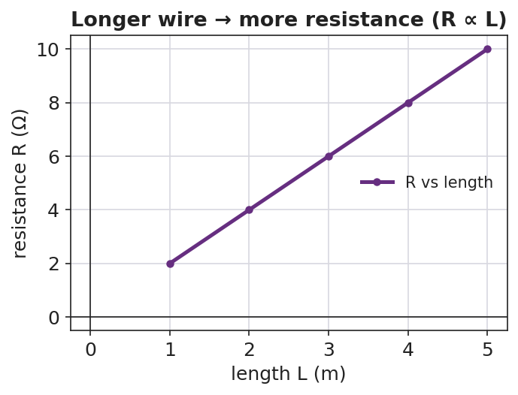
Line graph of resistance R versus wire length L: the points rise on a straight line, showing resistance is proportional to length.
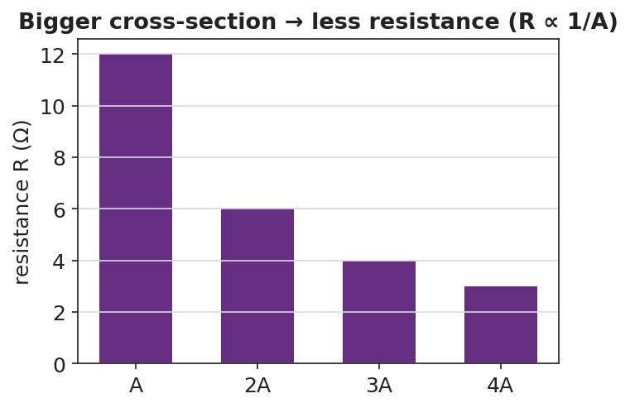
Bar chart of resistance versus cross-sectional area for areas A, 2A, 3A, and 4A: the bars fall as area increases, showing resistance is inversely proportional to area.
The wire model students are reasoning about — length L, cross-sectional area A, material resistivity ρ:
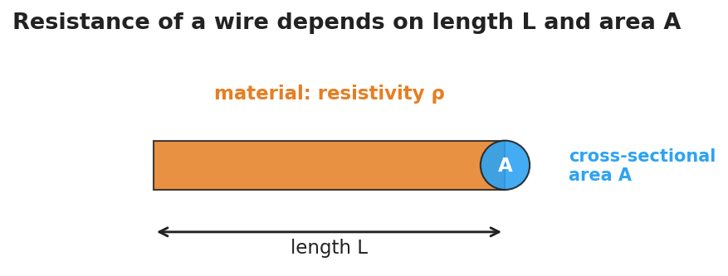
Diagram of a wire showing its length L along the long dimension, a circular end cap labeled cross-sectional area A, and a label for the material’s resistivity rho.

Teacher facilitation during Explore
- What to look for — groups stating “R doubles when L doubles” (direct) and “R halves when A doubles” (inverse).
- What to resist — handing them ρ·L/A; let the sim’s sliders reveal direct vs. inverse first.
- What to redirect — groups who change two sliders at once: insist on one variable at a time (control of variables).

Phase 3 · Explain (30 – 36 min)

30–33 min · Group consensus + Turn-and-Talk #2
“At your board, write one sentence each for length and for area: ’When ___ increases, R ___ because ___.’”
Target consensus:
“Resistance goes up with length and down with cross-sectional area. A wider wire gives charge more room to flow; a longer wire makes it fight resistance over a greater distance.”

33–36 min · Vocabulary introduction (≤ 3 terms)
Sample teacher language:
“We already met resistance. The property of the material itself is its resistivity — symbol ρ. Copper has low ρ (good conductor); nichrome has high ρ. And the wire’s thickness is its cross-sectional area, A. Put it together: R grows with length and resistivity, and shrinks with area. (Heating the wire also raises R for most metals.)”
Reference relationship to post: resistance ties back to Ohm’s Law V = I·R — change R, and the current changes.

Discussion prompts to deploy here
- “You have two copper wires, same thickness, but one is twice as long. Which has more resistance, and by how much?”
  - Sample response: “The long one — twice the resistance, because R is proportional to length.”
- “Why are thick wires used for high-current appliances?”
  - Sample response: “More cross-sectional area means less resistance, so less heat and voltage loss.”

Phase 4 · Elaborate (36 – 40 min)

36–38 min · Apply to the extension cord
“Explain why a long, thin extension cord makes a power tool run weaker than a short, thick one. Use length, area, and resistance in your answer.”
Target: the long, thin cord has high resistance, so more voltage is lost in the cord and less reaches the tool.

38–40 min · Return to the phenomenon
“Back to our two wires and the bulb: in one sentence, why did the short, thick wire make the bulb brighter?”
Target: “The short, thick wire has lower resistance, so more current reaches the bulb (I = V/R).”

Phase 5 · Evaluate (40 – 42 min)

40–42 min · Exit Ticket + Closing Reflection
“Two wires are made of the same material. (a) Wire B is twice as long as Wire A (same thickness). How does B’s resistance compare to A’s? (b) Wire C is twice as thick as Wire A (same length, so double the cross-sectional area). How does C’s resistance compare to A’s? (c) Name one property of the material itself that affects resistance.”
Expected: (a) twice the resistance; (b) half the resistance; (c) resistivity (ρ) — also accept temperature. See Answer_Key.docx.
Closing Reflection (SEL, 30 seconds):
“Whose explanation at the boards today helped you see the area pattern? Name them.”

Common Misconceptions
- Misconception: “A thicker wire has more resistance because there’s more metal.” → Correction: More cross-sectional area gives charge more parallel room to flow, so resistance decreases (R ∝ 1/A).
- Misconception: “Resistance only depends on the material.” → Correction: It depends on material (ρ) and geometry (length and area) and temperature.
- Misconception: “Longer wires carry more current because they’re bigger.” → Correction: Longer wires have more resistance, so for the same voltage they carry less current.

Access & Differentiation
- ELL/ENL supports: Sentence frames at the board: *“When length increases, resistance ___.”* / *“When area increases, resistance ___.”* Word box: {increases, decreases, longer, wider, resistivity, material}. Pair resistivity with sample wires labeled “easy flow” (copper) and “hard flow” (nichrome).
- IEP/SPED supports: Pre-filled data tables for the sim; students circle “up” or “down” rather than recording raw numbers. Provide the R-vs-L and R-vs-A figures with the patterns pre-drawn for annotation.
- Extensions: Introduce the full relationship R = ρ·L / A and have students compute R for a copper wire (ρ ≈ 1.7 × 10⁻⁸ Ω·m) of a given length and area; predict the effect of heating the wire.

Strategy Spotlight
BTC (Building Thinking Classrooms). Use visibly random groups of three and vertical non-permanent surfaces (whiteboards or windows). Give the thin-slice task verbally, not on a handout, and keep students standing. Circulate with the facilitation questions above rather than answers; when one group lands the “R halves when A doubles” insight, route other groups to go read that board. The vertical surfaces make every group’s thinking public, which is the point.

NYSSLS Observation Checklist Crosswalk
# | Checklist item | Where it appears in this lesson
1 | Local/relatable phenomenon | Phase 1 — thin/thick wire bulb; extension cord
2 | Turn and Talk (2–3×) | Phase 1 (TT#1 — wire properties), Phase 3 (TT#2 — length/area sentences)
3 | Students develop questions/models/procedures | Phase 1 (initial model), Phase 2 (sim, control of variables), Phase 4 (revise)
4 | CCC defined and used | Lesson Overview · Patterns/Scale, used in Phase 2 graphs
5 | ENL — ≤ 3 vocab, second half | Phase 3 — resistance / resistivity / cross-sectional area at 33–36 min
6 | Revisit phenomenon with evidence | Phase 4 — why the short, thick wire is brighter
7 | ENL/SPED supports | Access & Differentiation block
8 | Assessment check | Phase 5 — R-vs-length/area exit ticket

Companion Materials
- Student_Worksheet.docx — the 5E student investigation (hand out at start of Phase 2)
- Student_Notes.docx — guided note-guide for vocabulary and the worked example
- Answer_Key.docx — answers to “Make It Make Sense” prompts and the Exit Ticket

Key Vocabulary (max 3)
- resistance — the opposition a wire offers to the flow of charge, set by its length, area, material, and temperature, measured in ohms (Ω)
- resistivity — a property of the material itself (symbol ρ) describing how strongly it opposes current; copper is low, nichrome is high
- cross-sectional area — the area of the wire’s circular end face (A); a larger area gives charge more room to flow, lowering resistance

Resistance in a Wire — Student Worksheet
Unit: Current Electricity — Lesson 02 Name: _______________________ Date: __________ Period: ____

Phenomenon
The same battery and the same bulb are connected first with a long, thin wire — the bulb glows dim. Then they’re connected with a short, thick wire — the bulb glows bright. The only thing that changed was the wire.
Driving question: What properties of a wire decide how much it resists the flow of charge?

Notice & Wonder
I notice… | I wonder…
Turn & Talk #1: List every property of the wire that could change the brightness. Use the word resistance.

Initial Model
At your group’s board, predict before you touch the simulation:
- If you make a wire twice as long (same thickness), what happens to its resistance R?
- If you make a wire twice as thick (double the cross-sectional area, same length), what happens to R?
Length prediction: __________________________ Area prediction: ____________________________

Investigation
Open PhET Resistance in a Wire. Change one slider at a time.

Diagram of a wire labeled with its length L, its circular end cap as cross-sectional area A, and the material’s resistivity rho.
Part A — Vary length L (keep ρ and A fixed):
Length L (m) | Resistance R (Ω)
1
2
3
4
5

Line graph of resistance versus length showing a rising straight line: resistance is proportional to length.
Part B — Vary area A (keep ρ and L fixed). As area gets bigger, what happens to R?


Bar chart of resistance versus cross-sectional area showing the bars get shorter as area increases.
Part C — Material. Increase the resistivity ρ slider. Does R go up or down?

Key question: Complete each pattern. R is proportional to __________ and inversely proportional to __________.

Make It Make Sense
- A wire is made twice as long with the same thickness. By what factor does its resistance change?
- A wire is made twice as thick (double the area) with the same length. By what factor does its resistance change?
- Copper has a low resistivity and nichrome has a high resistivity. Which makes a better connecting wire, and why?

Vocabulary in Action
Use each term in a sentence about today’s phenomenon.
- resistance: _______________________________________________
- resistivity: _______________________________________________
- cross-sectional area: _______________________________________________

Revise Your Model
Return to your Initial Model. Rewrite your explanation for why the long, thin wire dimmed the bulb, using length, cross-sectional area, and resistance.

Exit Ticket
Two wires are made of the same material.
- Wire B is twice as long as Wire A (same thickness). How does B’s resistance compare to A’s?
- Wire C is twice as thick as Wire A (same length, double the cross-sectional area). How does C’s resistance compare to A’s?
- Name one property of the material itself that affects resistance.

Resistance in a Wire — Student Notes
Unit: Current Electricity — Lesson 02 Name: _______________________ Date: __________ Period: ____

Learning Targets
By the end of today’s 42 minutes I can:
- Predict how a wire’s resistance changes with its length and its cross-sectional area.
- Explain how the material’s resistivity and temperature affect resistance.
- Analyze R-vs-L and R-vs-A data to state the proportional relationships.

Key Vocabulary
- resistance — _______________________________________________
- resistivity — _______________________________________________
- cross-sectional area — _______________________________________________

Guided Notes
What sets a wire’s resistance? Four things:
- Length L — a longer wire has __________ resistance. R is __________ to length (R ∝ L).
- Cross-sectional area A — a thicker wire has __________ resistance. R is __________ to area (R ∝ 1/A).
- Material (resistivity ρ) — a higher-ρ material like nichrome has __________ resistance than a low-ρ material like __________.
- Temperature — for most metals, heating the wire __________ its resistance.
The two key patterns:

Line graph of resistance versus length: a rising straight line showing R is proportional to length.
When length doubles, resistance __________.

Bar chart of resistance versus cross-sectional area: bars shrink as area grows, showing R is inversely proportional to area.
When area doubles, resistance __________.
Connection to Ohm’s Law. Resistance is the R in V = I·R. If a wire’s resistance is high, then for the same voltage the current is __________.

Worked Example
Problem. Wire A and Wire B are the same copper, same thickness, but Wire B is three times as long as Wire A. Wire A has resistance 2 Ω. (a) Find Wire B’s resistance. (b) If both are connected to the same 12 V battery, which carries more current?
Solution. 1. Resistance is proportional to length, so tripling the length __________ the resistance: R_B = 3 × 2 Ω = __________ Ω. 2. Using I = V ÷ R: Wire A carries 12 ÷ 2 = __________ A; Wire B carries 12 ÷ 6 = __________ A. 3. Wire A carries more current because it has the __________ resistance.

Summary
Finish the sentence (Because / But / So):
A long, thin wire dims the bulb because __________________________________________, but __________________________________________, so __________________________________________.

Resistance in a Wire — Answer Key

Cover
Unit: Current Electricity — Lesson 02: Resistance in a Wire East Meadow Schools × Valley Stream Central HSD Strategy chip: BTC

Make-It-Make-Sense Answers
- Resistance is proportional to length, so doubling the length doubles the resistance (× 2). · Rubric: states direct proportion AND factor of 2. · NYSSLS: HS-PS3-6
- Resistance is inversely proportional to area, so doubling the area halves the resistance (× ½). · Rubric: states inverse proportion AND factor of ½. · NYSSLS: HS-PS3-6
- Copper makes the better connecting wire because it has lower resistivity, so it resists current less and wastes less energy as heat. · Rubric: names copper AND links to lower resistivity. · NYSSLS: HS-PS3-6

Exit Ticket Answer
- Wire B has twice (2×) the resistance of Wire A, because resistance is proportional to length.
- Wire C has half (½) the resistance of Wire A, because resistance is inversely proportional to cross-sectional area.
- The resistivity (ρ) of the material. (Also accept temperature as a property affecting resistance.)
Tolerance/rubric: (a) 2× / “doubles”; (b) ½ / “halves”; (c) resistivity (or temperature). 1 point each. NYSSLS: HS-PS3-6.

Closing Reflection (rubric)
Formative, not graded. Award full credit for naming a specific peer and/or the idea their board helped reveal (the inverse-area pattern is the common “aha”).

Series Circuits — Teacher Guide

Cover
Unit: Current Electricity — Lesson 03: Series Circuits East Meadow Schools × Valley Stream Central High School District Strategy chips: ACTIVE LEARNING

Curated Resources (from East Meadow Scope & Sequence)

NYSSLS Standards
This lesson supports HS-PS3-6: “Analyze data to support the claim that Ohm’s Law describes the mathematical relationship among the potential difference, current, and resistance of an electric circuit.” Students apply V = I·R to a single-path circuit, discover that resistances add (R_total = R₁ + R₂ + …) and that the same current flows everywhere while voltage drops add up to the source. It extends Lessons 01–02 to multi-resistor circuits.

Phenomenon
- Old-style holiday light string where removing or burning out one bulb kills the whole string: https://www.youtube.com/results?search_query=why+do+old+christmas+lights+all+go+out
- Series-circuit walkthrough (Khan Academy, “Series resistors”): https://www.khanacademy.org/science/physics/circuits-topic/circuits-resistance/a/ee-series-resistors

Javalab / Labs
- PhET Circuit Construction Kit: DC — build a one-loop series circuit with three resistors; measure current at several points and voltage across each resistor: https://phet.colorado.edu/en/simulations/circuit-construction-kit-dc

Assessments
- PhET CCK-DC series data table (I at three points; V across each resistor) — formative during Explore.
- Exit ticket below; full key in Answer_Key.docx.

Lesson Overview
Duration | 42 minutes (1 period)
NYSSLS link | HS-PS3-6 (core — Ohm’s Law in a series path)
CCC focus | Systems and System Models — a series circuit is one path; what happens at one element constrains the whole system.
Strategy chips | ACTIVE LEARNING (build-measure-predict at PhET stations)
Materials | Devices for PhET CCK-DC; whiteboards; calculators; (optional) an old holiday light string and a fresh one for the hook.
Safety | Low-voltage / simulated circuits only. If using a real light string, keep it unplugged during inspection.
Prior knowledge | Lessons 01–02 — Ohm’s Law V = I·R; resistance and its origins.
Lesson objectives — students can:
- Identify a series circuit as a single path and explain why the same current flows everywhere in it.
- Compute the equivalent resistance of resistors in series (R_total = R₁ + R₂ + …) and use it to find the current.
- Explain why the voltage drops across series resistors add up to the source voltage.

Phase 1 · Engage (0 – 10 min)

0–2 min · Opening Connection (SEL)
One-sentence whip-around: “Describe a time when one small thing breaking shut down something much bigger (a group project, a relay race, a recipe).” Hold the metaphor; a series circuit fails exactly this way.

2–7 min · Phenomenon hook — the holiday lights
Teacher actions. Show the old light string. Remove (or “burn out”) one bulb — the whole string goes dark. Contrast with a modern string where the rest stay lit.
Sample teacher language:
“I pulled out one bulb and the entire string died. There are fifty bulbs — why would one missing bulb take down all of them?”
Anticipated student responses:
- “It broke the circle.” — yes; one path, one break stops everything.
- “They’re all connected in a line.” — capture “line”; that’s series.
- “The electricity can’t get around the gap.” — exactly; no alternate path.

7–10 min · Notice & Wonder + Turn-and-Talk #1
“Turn to your partner: in a single-loop circuit, if you removed one resistor, what happens to the current everywhere else? Use the word path.”
Target: with only one path, breaking it stops the current everywhere.

Bridge to Phase 2
Each student writes a one-sentence initial model: “One missing bulb kills the whole string because ______.”

Phase 2 · Explore (10 – 30 min)

10–14 min · Initial Model (silent / individual)
Prompt on the board:
“Sketch three bulbs wired in a single loop with a battery. Draw one arrow showing the current. Predict: is the current the same at every bulb, or does it shrink as it passes each one?”
This surfaces the “current gets used up” misconception before measurement.

14–30 min · Investigation — PhET CCK-DC series circuit
Students build a battery (20 V) with three resistors (2 Ω, 3 Ω, 5 Ω) in one loop.
- Measure current at three points (before R₁, between R₂ and R₃, after R₃). Is it the same?
- Measure voltage across each resistor; add the three drops.
- Remove one resistor (open the loop) — what happens to the current?
Teacher facilitation language:
“Is the ammeter reading the same at all three spots? What does that tell you about current in a series loop?” “Add up the three voltage drops — how does the total compare to the battery’s 20 V?” “You found R_total. How does it compare to R₁ + R₂ + R₃?”
Use the schematic and the voltage-drop bar chart to consolidate:
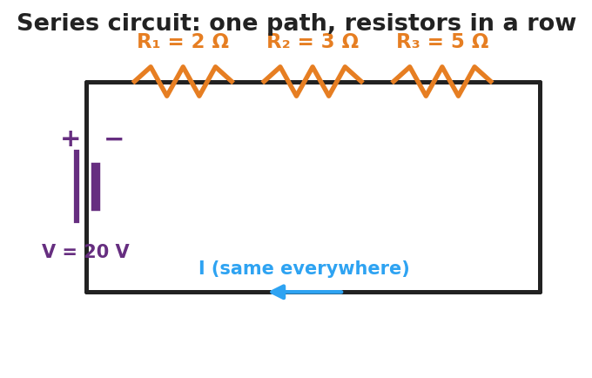
Schematic of a series circuit: a 20-volt battery on the left side drives a single current through three resistors in a row along the top wire labeled R-one 2 ohms, R-two 3 ohms, and R-three 5 ohms; the current is the same everywhere.
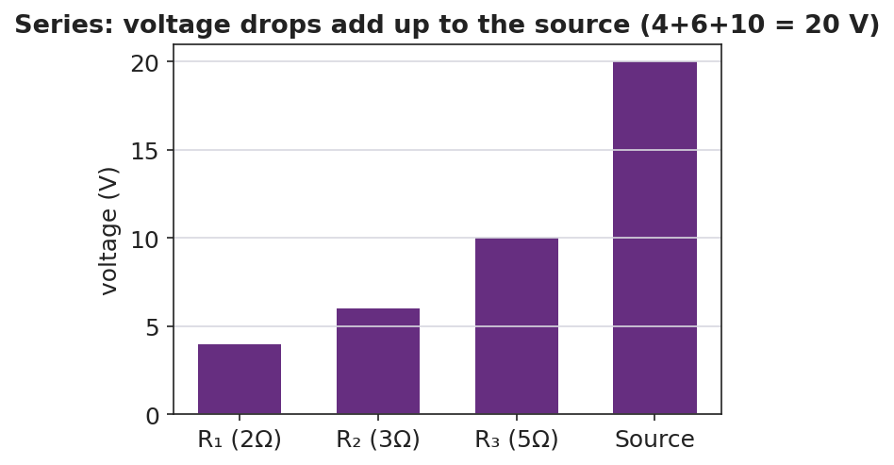
Bar chart of voltage drops in a series circuit: 4 volts across R-one, 6 volts across R-two, 10 volts across R-three, summing to the 20-volt source.

Teacher facilitation during Explore
- What to look for — groups stating “the ammeter reads the same everywhere” and “the three drops add to the battery voltage.”
- What to resist — handing them R_total = ΣR; let them sum the resistors and check against I = V/R_total.
- What to redirect — students who think current is consumed: have them re-read all three ammeters aloud (identical).

Phase 3 · Explain (30 – 36 min)

30–33 min · Turn-and-Talk #2 + class consensus
“Across your measurements, what three rules describe a series circuit?”
Target consensus:
“(1) The current is the same everywhere. (2) The total resistance is the sum of the resistors. (3) The voltage drops add up to the source voltage.”

33–36 min · Vocabulary introduction (≤ 3 terms)
Sample teacher language:
“A circuit with a single path is a series circuit. Because there’s one path, the current is the same at every point. The single resistor that could replace all of them is the equivalent resistance: R_total = R₁ + R₂ + R₃. Then the loop current is just I = V ÷ R_total.”
Reference relationships to post: V = I·R; series R_total = R₁ + R₂ + …; power P = V·I = I²·R.

Discussion prompts to deploy here
- “Three 2 Ω resistors are in series with a 12 V battery. What’s R_total and the current?”
  - Sample response: “R_total = 6 Ω; I = 12/6 = 2 A everywhere.”
- “Why do the voltage drops have to add up to the source?”
  - Sample response: “All the energy the battery gives each charge is spent crossing the resistors, so the drops total the battery voltage.”

Phase 4 · Elaborate (36 – 40 min)

36–38 min · Apply — add a resistor
“You add a fourth resistor in series. Predict what happens to R_total and to the current. Explain in one sentence.”
Target: R_total increases, so the current decreases (same battery, more total resistance).

38–40 min · Return to the phenomenon
“Explain, in one sentence using series and path, why one missing bulb kills the whole old light string.”
Target: “The bulbs are in series — one path — so a missing bulb breaks the only path and stops the current everywhere.”

Phase 5 · Evaluate (40 – 42 min)

40–42 min · Exit Ticket + Closing Reflection
“A 24 V battery is connected in series to a 4 Ω and an 8 Ω resistor. (a) Find the equivalent (total) resistance. (b) Find the current in the circuit. (c) Find the voltage drop across the 8 Ω resistor and check that the two drops add to 24 V.”
Expected: (a) R_total = 12 Ω; (b) I = 24/12 = 2 A; (c) V₈ = I·R = 2 × 8 = 16 V; V₄ = 8 V; 16 + 8 = 24 V. See Answer_Key.docx.
Closing Reflection (SEL, 30 seconds):
“What’s one prediction you made today that the measurements proved wrong — and what changed your mind?”

Common Misconceptions
- Misconception: “Current is used up as it passes each resistor.” → Correction: Current is the same at every point in a series loop; it is the voltage (energy per charge) that drops across each resistor.
- Misconception: “Adding resistors in series increases the current.” → Correction: Adding series resistors raises R_total, so the current decreases for the same battery.
- Misconception: “Each resistor gets the full battery voltage.” → Correction: The battery voltage is shared — the drops across the resistors add up to the source.

Access & Differentiation
- ELL/ENL supports: Sentence frames: “In a series circuit, the current is ___ everywhere.” / “The total resistance is the ___ of the resistors.” Word box: {same, sum, single path, voltage drops, add}. Color-code the single current path on the schematic.
- IEP/SPED supports: Provide a pre-built PhET file and a fill-in table (I at each point, V across each resistor). Give a partly worked R_total = R₁ + R₂ + R₃ template.
- Extensions: Have students show algebraically that the voltage drops must add to the source (V = I·R₁ + I·R₂ + I·R₃ = I·R_total) and compute the power dissipated in each resistor (P = I²·R), noting which runs hottest.

Strategy Spotlight
ACTIVE LEARNING. Students build, measure, and predict at PhET stations rather than receive the three series rules. Structure each station with a predict → measure → reconcile loop: predict the ammeter reading, take it, then explain any mismatch. The removal-of-a-resistor test is the active hinge — it forces the “one path” idea into the open. Close by having groups post their three-rule consensus and compare.

NYSSLS Observation Checklist Crosswalk
# | Checklist item | Where it appears in this lesson
1 | Local/relatable phenomenon | Phase 1 — old holiday light string
2 | Turn and Talk (2–3×) | Phase 1 (TT#1 — removing a resistor), Phase 3 (TT#2 — three series rules)
3 | Students develop questions/models/procedures | Phase 1 (initial model), Phase 2 (build/measure/predict), Phase 4 (revise)
4 | CCC defined and used | Lesson Overview · Systems and System Models, used in Phase 2
5 | ENL — ≤ 3 vocab, second half | Phase 3 — series circuit / equivalent resistance / current at 33–36 min
6 | Revisit phenomenon with evidence | Phase 4 — why one missing bulb kills the string
7 | ENL/SPED supports | Access & Differentiation block
8 | Assessment check | Phase 5 — series Ohm’s-law exit ticket

Companion Materials
- Student_Worksheet.docx — the 5E student investigation (hand out at start of Phase 2)
- Student_Notes.docx — guided note-guide for vocabulary and the worked example
- Answer_Key.docx — answers to “Make It Make Sense” prompts and the Exit Ticket

Key Vocabulary (max 3)
- series circuit — a circuit with a single path for charge, so the current is the same at every point
- equivalent resistance — the single resistance that could replace a group of resistors; in series, R_total = R₁ + R₂ + …
- current — the rate of flow of charge (amperes); in a series circuit it is identical everywhere in the loop

Series Circuits — Student Worksheet
Unit: Current Electricity — Lesson 03 Name: _______________________ Date: __________ Period: ____

Phenomenon
An old string of holiday lights has fifty bulbs. You remove just one bulb — and the entire string goes dark. On a newer string, removing one bulb leaves the rest glowing.
Driving question: Why can a single missing bulb shut down an entire string of lights?

Notice & Wonder
I notice… | I wonder…
Turn & Talk #1: In a single-loop circuit, if you removed one resistor, what happens to the current everywhere else? Use the word path.

Initial Model
Sketch three bulbs wired in a single loop with a battery. Draw one arrow for the current. Predict: is the current the same at every bulb, or does it shrink as it passes each one?

My prediction: _______________________________

Investigation
Open PhET Circuit Construction Kit: DC. Build a 20 V battery with three resistors in one loop: R₁ = 2 Ω, R₂ = 3 Ω, R₃ = 5 Ω.

Schematic of a series circuit: a 20-volt battery drives one current through three resistors in a row, R-one 2 ohms, R-two 3 ohms, R-three 5 ohms; the current is the same everywhere.
Part A — Current. Measure the current at three points.
Point | Current I (A)
Before R₁
Between R₂ and R₃
After R₃
What do you notice about the three readings?

Part B — Voltage drops. Measure the voltage across each resistor and add them.
Resistor | Voltage drop (V)
R₁ (2 Ω)
R₂ (3 Ω)
R₃ (5 Ω)
Sum

Bar chart of series voltage drops: 4 V, 6 V, and 10 V across the three resistors, summing to the 20 V source.
Part C — Break it. Remove one resistor (open the loop). What happens to the current everywhere?

Key question: How does R₁ + R₂ + R₃ compare to the total resistance you’d compute from I = V ÷ R_total?

Make It Make Sense
- Three resistors (1 Ω, 2 Ω, 3 Ω) are in series with a 12 V battery. Find the equivalent resistance and the current.
- In a series circuit the current is 2 A everywhere. The resistors are 3 Ω and 5 Ω. Find the voltage drop across each.
- You add a fourth resistor in series. Does the current go up or down? Why?

Vocabulary in Action
Use each term in a sentence about today’s phenomenon.
- series circuit: _______________________________________________
- equivalent resistance: _______________________________________________
- current: _______________________________________________

Revise Your Model
Return to your Initial Model. Was the current actually the same at every bulb? Rewrite your explanation for why one missing bulb kills the whole old string, using series and path.

Exit Ticket
A 24 V battery is connected in series to a 4 Ω resistor and an 8 Ω resistor.
- Find the equivalent (total) resistance.
- Find the current in the circuit.
- Find the voltage drop across the 8 Ω resistor, and check that the two drops add to 24 V.

Series Circuits — Student Notes
Unit: Current Electricity — Lesson 03 Name: _______________________ Date: __________ Period: ____

Learning Targets
By the end of today’s 42 minutes I can:
- Identify a series circuit and explain why the current is the same everywhere in it.
- Compute the equivalent resistance in series (R_total = R₁ + R₂ + …) and find the current.
- Explain why the voltage drops add up to the source voltage.

Key Vocabulary
- series circuit — _______________________________________________
- equivalent resistance — _______________________________________________
- current — _______________________________________________

Guided Notes
A series circuit has a single __________ for charge. Because there is only one path:
- The current is the __________ at every point in the loop.
- The total (equivalent) resistance is the __________ of the resistors: > R_total = R₁ + R₂ + R₃ + …
- The voltage drops across the resistors __________ up to the source voltage.
- One break anywhere stops the current __________.

Schematic of a series circuit: one battery drives a single current through three resistors in a row; the current is the same everywhere.
Finding the current. Once you have R_total, use Ohm’s Law: > I = V ÷ R_total (this same I flows through every resistor)
Voltage drops add to the source:

Bar chart of voltage drops in a series circuit summing to the source voltage.
Reference: V = I·R · series R_total = R₁ + R₂ + … · power P = V·I = I²·R

Worked Example
Problem. A 20 V battery is in series with R₁ = 2 Ω, R₂ = 3 Ω, and R₃ = 5 Ω. (a) Find R_total. (b) Find the current. (c) Find the voltage drop across R₃.
Solution. 1. R_total = R₁ + R₂ + R₃ = 2 + 3 + 5 = __________ Ω. 2. I = V ÷ R_total = 20 ÷ 10 = __________ A (this current flows through every resistor). 3. Voltage across R₃: V₃ = I·R₃ = 2 × 5 = __________ V. (Check: drops are 4 V + 6 V + 10 V = __________ V = the source.)

Summary
Finish the sentence (Because / But / So):
In a series circuit the current is the same everywhere because __________________________________________, but __________________________________________, so __________________________________________.

Series Circuits — Answer Key

Cover
Unit: Current Electricity — Lesson 03: Series Circuits East Meadow Schools × Valley Stream Central HSD Strategy chip: ACTIVE LEARNING

Make-It-Make-Sense Answers
- R_total = 1 + 2 + 3 = 6 Ω; I = V ÷ R_total = 12 ÷ 6 = 2 A (everywhere). · Rubric: correct sum AND I = V/R_total. · NYSSLS: HS-PS3-6
- V across 3 Ω = I·R = 2 × 3 = 6 V; V across 5 Ω = 2 × 5 = 10 V. · Rubric: uses the common 2 A current with V = I·R for each. · NYSSLS: HS-PS3-6
- The current goes down, because adding a series resistor raises R_total and I = V ÷ R_total. · Rubric: “down” AND links to larger R_total. · NYSSLS: HS-PS3-6

Exit Ticket Answer
- R_total = 4 Ω + 8 Ω = 12 Ω.
- I = V ÷ R_total = 24 ÷ 12 = 2 A.
- Across the 8 Ω: V₈ = I·R = 2 × 8 = 16 V. Across the 4 Ω: V₄ = 2 × 4 = 8 V. Check: 16 + 8 = 24 V = the source. ✓
Tolerance/rubric: (a) 12 Ω; (b) 2 A; (c) 16 V with a correct sum-check to 24 V. 1 point each. NYSSLS: HS-PS3-6.

Closing Reflection (rubric)
Formative, not graded. Award full credit for naming a real prediction that was disproved (most common: “current gets used up / shrinks at each bulb”) and what changed their mind (identical ammeter readings).

Parallel Circuits — Teacher Guide

Cover
Unit: Current Electricity — Lesson 04: Parallel Circuits East Meadow Schools × Valley Stream Central High School District Strategy chips: ACTIVE LEARNING

Curated Resources (from East Meadow Scope & Sequence)

NYSSLS Standards
This lesson supports HS-PS3-6: “Analyze data to support the claim that Ohm’s Law describes the mathematical relationship among the potential difference, current, and resistance of an electric circuit.” Students apply V = I·R to a multi-path circuit, discover that each branch sees the full source voltage, that branch currents add to the total, and that the equivalent resistance follows 1/R_total = Σ(1/R). It completes the series/parallel pair begun in Lesson 03.

Phenomenon
- Home outlets — unplug one lamp and the others stay lit (house wiring is parallel): https://www.youtube.com/results?search_query=why+are+house+circuits+wired+in+parallel
- Parallel-resistor walkthrough (Khan Academy, “Parallel resistors”): https://www.khanacademy.org/science/physics/circuits-topic/circuits-resistance/a/ee-parallel-resistors

Javalab / Labs
- PhET Circuit Construction Kit: DC — build a battery with two or three resistor branches; measure the voltage across each branch and the current in each branch and in the main wire: https://phet.colorado.edu/en/simulations/circuit-construction-kit-dc

Assessments
- PhET CCK-DC parallel data table (branch voltages; branch and total currents) — formative during Explore.
- Exit ticket below; full key in Answer_Key.docx.

Lesson Overview
Duration | 42 minutes (1 period)
NYSSLS link | HS-PS3-6 (core — Ohm’s Law across parallel branches)
CCC focus | Systems and System Models — multiple independent paths; a system can keep functioning when one branch fails.
Strategy chips | ACTIVE LEARNING (build-measure-predict at PhET stations)
Materials | Devices for PhET CCK-DC; whiteboards; calculators; (optional) a power strip with several plugged-in lamps for the hook.
Safety | Low-voltage / simulated circuits only. Never demonstrate house wiring with real mains.
Prior knowledge | Lessons 01–03 — Ohm’s Law V = I·R; series rules (single path, current same, R adds).
Lesson objectives — students can:
- Identify a parallel circuit and explain why each branch has the same voltage across it.
- Explain why branch currents add to the total current, and why one branch can fail while others keep working.
- Compute the equivalent resistance of parallel resistors using 1/R_total = 1/R₁ + 1/R₂ + … and find branch currents.

Phase 1 · Engage (0 – 10 min)

0–2 min · Opening Connection (SEL)
One-sentence whip-around: “Name a system in your life with a ‘backup path’ — where if one option fails, you still have another way through.” Hold the idea of independent paths.

2–7 min · Phenomenon hook — home outlets
Teacher actions. Plug three lamps into a power strip; all are lit. Unplug one — the other two stay bright. Contrast with yesterday’s series string, where one removal killed everything.
Sample teacher language:
“Yesterday one missing bulb killed the whole string. Today I unplug one lamp and the others don’t even flicker. What’s different about how these are wired?”
Anticipated student responses:
- “They each have their own wire.” — yes; separate branches / paths.
- “The electricity has another way to go.” — capture; multiple paths.
- “Each one is connected straight to the outlet.” — each branch sees the full voltage.

7–10 min · Notice & Wonder + Turn-and-Talk #1
“Turn to your partner: if each lamp has its own path to the source, what must be true about the voltage each lamp gets? Use the word branch.”
Target: each branch gets the full source voltage.

Bridge to Phase 2
Each student writes a one-sentence initial model: “Unplugging one lamp leaves the others lit because ______.”

Phase 2 · Explore (10 – 30 min)

10–14 min · Initial Model (silent / individual)
Prompt on the board:
“Sketch three lamps each wired directly across the same battery (three branches). Predict: does each lamp get the full battery voltage or a share of it? Does the same current flow through all three?”

14–30 min · Investigation — PhET CCK-DC parallel circuit
Students build a 12 V battery with three parallel resistor branches (6 Ω, 3 Ω, 2 Ω).
- Measure the voltage across each branch. Are they equal?
- Measure the current in each branch and in the main wire. How do the branch currents relate to the total?
- Open one branch — what happens to the other branches?
Teacher facilitation language:
“Is the voltmeter reading the same across all three branches? What does that tell you?” “Add the three branch currents — how do they compare to the current in the main wire?” “When you open one branch, do the others change? Why does that match the lamp demo?”
Use the schematic and the branch-current bar chart to consolidate:
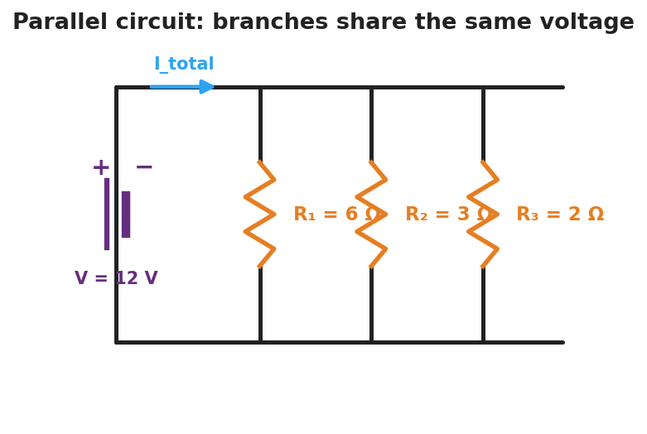
Schematic of a parallel circuit: a 12-volt battery on the left connects to a top rail and a bottom rail, with three vertical resistor branches between them labeled R-one 6 ohms, R-two 3 ohms, and R-three 2 ohms; the total current splits among the branches.
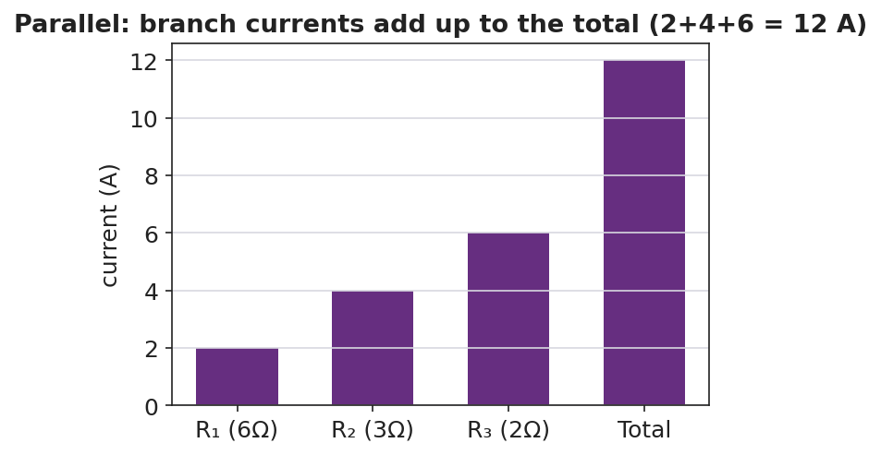
Bar chart of branch currents in a parallel circuit: 2 amps, 4 amps, and 6 amps in the three branches, summing to a 12-amp total.

Teacher facilitation during Explore
- What to look for — groups stating “the voltage is the same across every branch” and “the branch currents add to the main current.”
- What to resist — handing them 1/R_total = Σ1/R; let them compute each branch current with I = V/R first, then add.
- What to redirect — students surprised that R_total is less than the smallest resistor: more paths means less total opposition.

Phase 3 · Explain (30 – 36 min)

30–33 min · Turn-and-Talk #2 + class consensus
“Across your measurements, what three rules describe a parallel circuit?”
Target consensus:
“(1) The voltage is the same across every branch. (2) The branch currents add up to the total. (3) The equivalent resistance is less than any single branch.”

33–36 min · Vocabulary introduction (≤ 3 terms)
Sample teacher language:
“A circuit with more than one path is a parallel circuit. Each separate path is a branch, and every branch has the full source voltage across it. The single resistor that could replace them all is the equivalent resistance — but in parallel you combine reciprocals: 1/R_total = 1/R₁ + 1/R₂ + 1/R₃. Because you’re adding paths, R_total comes out smaller than any one branch.”
Reference relationships to post: V = I·R; parallel 1/R_total = 1/R₁ + 1/R₂ + …; power P = V·I = I²·R.

Discussion prompts to deploy here
- “Two 4 Ω resistors are in parallel across 8 V. Find each branch current and the total.”
  - Sample response: “Each branch: I = 8/4 = 2 A; total = 4 A; R_total = 2 Ω.”
- “Why is R_total smaller than the smallest branch resistor?”
  - Sample response: “Every added branch gives charge another path, so overall it’s easier for current to flow.”

Phase 4 · Elaborate (36 – 40 min)

36–38 min · Apply — add a branch
“You add a fourth lamp in parallel. Predict what happens to the total current drawn from the battery and to the equivalent resistance. Explain in one sentence.”
Target: equivalent resistance drops further, so the total current the battery delivers increases.

38–40 min · Return to the phenomenon
“Explain, in one sentence using parallel and branch, why unplugging one lamp leaves the others lit.”
Target: “The lamps are in parallel — each on its own branch — so opening one branch leaves the other branches (and their full voltage) untouched.”

Phase 5 · Evaluate (40 – 42 min)

40–42 min · Exit Ticket + Closing Reflection
“A 12 V battery is connected to two parallel resistors: 4 Ω and 6 Ω. (a) What is the voltage across each resistor? (b) Find the current in each branch. (c) Find the total current and the equivalent resistance (1/R_total = 1/4 + 1/6).”
Expected: (a) 12 V across each; (b) I₄ = 3 A, I₆ = 2 A; (c) total = 5 A, R_total = 12/5 = 2.4 Ω. See Answer_Key.docx.
Closing Reflection (SEL, 30 seconds):
“What surprised you most about parallel circuits compared with yesterday’s series circuits?”

Common Misconceptions
- Misconception: “The voltage splits among the parallel branches.” → Correction: Each branch gets the full source voltage; it’s the current that splits among the branches.
- Misconception: “Adding a parallel branch raises the total resistance.” → Correction: Adding branches lowers the equivalent resistance (more paths for current), so the battery delivers more total current.
- Misconception: “Opening one branch changes the others.” → Correction: Branches are independent; opening one leaves the others’ voltage and current unchanged.

Access & Differentiation
- ELL/ENL supports: Sentence frames: *“In a parallel circuit, the voltage across each branch is ___.”* / “The branch currents ___ to the total.” Word box: {same, add, branch, multiple paths, full voltage}. Color-code each branch a different color on the schematic.
- IEP/SPED supports: Provide a pre-built PhET file and a fill-in table (branch voltages, branch currents). Give a step-by-step reciprocal template for 1/R_total with the fractions pre-set.
- Extensions: Have students show that for two parallel resistors R_total = (R₁·R₂)/(R₁+R₂), and explain why home circuits use parallel wiring (each device gets full voltage and operates independently) while computing the power each branch draws (P = V²/R).

Strategy Spotlight
ACTIVE LEARNING. As in Lesson 03, students build-measure-predict at PhET stations. The active hinge here is opening one branch and watching the others stay lit — the experiential counterpart to yesterday’s series break. Run a predict → measure → reconcile loop on branch voltage (predict equal, confirm) and on total current (predict the sum, confirm). Have groups post their three-rule consensus side-by-side with the series rules from Lesson 03 to make the contrast explicit.

NYSSLS Observation Checklist Crosswalk
# | Checklist item | Where it appears in this lesson
1 | Local/relatable phenomenon | Phase 1 — home outlets / power strip
2 | Turn and Talk (2–3×) | Phase 1 (TT#1 — branch voltage), Phase 3 (TT#2 — three parallel rules)
3 | Students develop questions/models/procedures | Phase 1 (initial model), Phase 2 (build/measure/predict), Phase 4 (revise)
4 | CCC defined and used | Lesson Overview · Systems and System Models, used in Phase 2
5 | ENL — ≤ 3 vocab, second half | Phase 3 — parallel circuit / branch / equivalent resistance at 33–36 min
6 | Revisit phenomenon with evidence | Phase 4 — why other lamps stay lit
7 | ENL/SPED supports | Access & Differentiation block
8 | Assessment check | Phase 5 — parallel Ohm’s-law exit ticket

Companion Materials
- Student_Worksheet.docx — the 5E student investigation (hand out at start of Phase 2)
- Student_Notes.docx — guided note-guide for vocabulary and the worked example
- Answer_Key.docx — answers to “Make It Make Sense” prompts and the Exit Ticket

Key Vocabulary (max 3)
- parallel circuit — a circuit with more than one path for charge, so every branch has the same full source voltage across it
- branch — one of the separate parallel paths between the same two points; its current is set by its own resistance (I = V/R)
- equivalent resistance — the single resistance that could replace the branches; in parallel, 1/R_total = 1/R₁ + 1/R₂ + … (smaller than any branch)

Parallel Circuits — Student Worksheet
Unit: Current Electricity — Lesson 04 Name: _______________________ Date: __________ Period: ____

Phenomenon
Three lamps are plugged into a power strip — all lit. You unplug one, and the other two stay bright. Yesterday, removing one bulb from a series string killed the whole string. Something is wired differently here.
Driving question: How can one lamp turn off while the others stay on?

Notice & Wonder
I notice… | I wonder…
Turn & Talk #1: If each lamp has its own path to the source, what must be true about the voltage each lamp gets? Use the word branch.

Initial Model
Sketch three lamps each wired directly across the same battery (three branches). Predict: does each lamp get the full battery voltage or a share of it? Does the same current go through all three?

My prediction: _______________________________

Investigation
Open PhET Circuit Construction Kit: DC. Build a 12 V battery with three parallel resistor branches: R₁ = 6 Ω, R₂ = 3 Ω, R₃ = 2 Ω.

Schematic of a parallel circuit: a 12-volt battery connects to a top and bottom rail, with three vertical resistor branches between them, R-one 6 ohms, R-two 3 ohms, R-three 2 ohms; the total current splits among the branches.
Part A — Branch voltages. Measure the voltage across each branch.
Branch | Voltage (V)
R₁ (6 Ω)
R₂ (3 Ω)
R₃ (2 Ω)
What do you notice?

Part B — Currents. Measure the current in each branch and in the main wire.
Branch | Current (A)
R₁ (6 Ω)
R₂ (3 Ω)
R₃ (2 Ω)
Sum
Main wire

Bar chart of branch currents in a parallel circuit: 2 A, 4 A, and 6 A summing to a 12 A total.
Part C — Open a branch. Disconnect one branch. What happens to the other branches?

Key question: How do the branch currents compare to the current in the main wire? Is R_total bigger or smaller than the smallest branch resistor?

Make It Make Sense
- Two 4 Ω resistors are in parallel across an 8 V battery. Find the current in each branch and the total current.
- For those two 4 Ω resistors, find the equivalent resistance using 1/R_total = 1/4 + 1/4.
- You add a fourth lamp in parallel. Does the total current from the battery go up or down? Why?

Vocabulary in Action
Use each term in a sentence about today’s phenomenon.
- parallel circuit: _______________________________________________
- branch: _______________________________________________
- equivalent resistance: _______________________________________________

Revise Your Model
Return to your Initial Model. Did each lamp get the full voltage? Rewrite your explanation for why unplugging one lamp leaves the others lit, using parallel and branch.

Exit Ticket
A 12 V battery is connected to two parallel resistors: 4 Ω and 6 Ω.
- What is the voltage across each resistor?
- Find the current in each branch.
- Find the total current and the equivalent resistance (use 1/R_total = 1/4 + 1/6).

Parallel Circuits — Student Notes
Unit: Current Electricity — Lesson 04 Name: _______________________ Date: __________ Period: ____

Learning Targets
By the end of today’s 42 minutes I can:
- Identify a parallel circuit and explain why each branch has the same voltage.
- Explain why branch currents add to the total and why one branch can fail while others stay on.
- Compute the equivalent resistance in parallel (1/R_total = 1/R₁ + 1/R₂ + …) and find branch currents.

Key Vocabulary
- parallel circuit — _______________________________________________
- branch — _______________________________________________
- equivalent resistance — _______________________________________________

Guided Notes
A parallel circuit has more than one __________ for charge. Because each branch connects to the same two points:
- The voltage across every branch is the __________ (the full source voltage).
- The branch currents __________ up to the total current in the main wire.
- The equivalent resistance combines as reciprocals: > 1 / R_total = 1/R₁ + 1/R₂ + 1/R₃ + …
- R_total comes out __________ than any single branch (more paths = easier flow).
- Opening one branch leaves the other branches __________.

Schematic of a parallel circuit: a battery connected to three resistor branches that each see the full source voltage.
Finding branch currents. Each branch follows Ohm’s Law with the full voltage: > I_branch = V ÷ R_branch then add them for the total.
Branch currents add to the total:

Bar chart of branch currents adding up to the total current in a parallel circuit.
Reference: V = I·R · parallel 1/R_total = 1/R₁ + 1/R₂ + … · power P = V·I = I²·R

Worked Example
Problem. A 12 V battery has three parallel branches: R₁ = 6 Ω, R₂ = 3 Ω, R₃ = 2 Ω. (a) Voltage across each branch? (b) Current in each branch? (c) Total current and equivalent resistance.
Solution. 1. Each branch has the full __________ V across it. 2. Branch currents (I = V/R): I₁ = 12/6 = __________ A; I₂ = 12/3 = __________ A; I₃ = 12/2 = __________ A. 3. Total current = 2 + 4 + 6 = __________ A. Equivalent resistance: R_total = V ÷ I_total = 12 ÷ 12 = __________ Ω — note it’s smaller than the 2 Ω branch.

Summary
Finish the sentence (Because / But / So):
Unplugging one lamp leaves the others lit because __________________________________________, but __________________________________________, so __________________________________________.

Parallel Circuits — Answer Key

Cover
Unit: Current Electricity — Lesson 04: Parallel Circuits East Meadow Schools × Valley Stream Central HSD Strategy chip: ACTIVE LEARNING

Make-It-Make-Sense Answers
- Each branch has the full 8 V, so each branch current = 8 ÷ 4 = 2 A; total = 2 + 2 = 4 A. · Rubric: full voltage on each branch AND correct branch/total currents. · NYSSLS: HS-PS3-6
- 1/R_total = 1/4 + 1/4 = 2/4 = 1/2, so R_total = 2 Ω (smaller than either branch). · Rubric: correct reciprocal sum AND inverts to 2 Ω. · NYSSLS: HS-PS3-6
- The total current goes up, because adding a parallel branch lowers the equivalent resistance, so the battery delivers more total current. · Rubric: “up” AND links to lower R_total. · NYSSLS: HS-PS3-6

Exit Ticket Answer
- Each resistor has the full 12 V across it (parallel branches share the source voltage).
- I₄ = V ÷ R = 12 ÷ 4 = 3 A; I₆ = 12 ÷ 6 = 2 A.
- Total current = 3 + 2 = 5 A. Equivalent resistance: 1/R_total = 1/4 + 1/6 = 3/12 + 2/12 = 5/12, so R_total = 12/5 = 2.4 Ω (check: 12 V ÷ 5 A = 2.4 Ω ✓).
Tolerance/rubric: (a) 12 V each; (b) 3 A and 2 A; (c) 5 A total and 2.4 Ω. 1 point each. Accept R_total ≈ 2.4 Ω. NYSSLS: HS-PS3-6.

Closing Reflection (rubric)
Formative, not graded. Award full credit for any honest surprise that contrasts parallel with series (common: “the voltage is the same on every branch, not split” or “the total resistance got smaller, not bigger”).

Electromagnetism: The Induction Junction — Teacher Guide

Cover
Unit: Current Electricity — Lesson 05: Electromagnetism (The Induction Junction) East Meadow Schools × Valley Stream Central High School District Strategy chips: ACTIVE LEARNING

Curated Resources (from East Meadow Scope & Sequence)

NYSSLS Standards
This lesson is a NYS Required Investigation on electromagnetism. It supports HS-PS3-5: “Develop and use a model of two objects interacting through electric or magnetic fields to illustrate the forces between objects and the changes in energy of the objects due to the interaction.” Students model how a current creates a magnetic field, and how a changing magnetic field transfers energy into a circuit as an induced current — connecting the current-electricity unit to fields and energy. (It builds on, but does not directly assess, the Ohm’s-Law standard HS-PS3-6 from Lessons 01–04.)

Phenomenon
- A coil of wire + a magnet lighting an LED only while the magnet moves through the coil (shake-flashlight / hand-crank generator): https://www.youtube.com/results?search_query=magnet+coil+led+induction+demonstration
- A battery-powered coil (electromagnet) picking up paperclips, then dropping them when the current is cut: https://www.youtube.com/results?search_query=electromagnet+paperclips+demonstration

Javalab / Labs
- Javalab — Electromagnetic induction (move a magnet through a coil, watch the induced current): https://javalab.org/en/electromagnetic_induction_en/
- PhET — Faraday’s Electromagnetic Lab / Generator (magnet, coil, light bulb): https://phet.colorado.edu/en/simulations/faradays-law

Assessments
- Javalab/PhET induction observation table (when does the LED light? when is it brightest?) — formative during Explore.
- Exit ticket below; full key in Answer_Key.docx.

Lesson Overview
Duration | 42 minutes (1 period) · NYS Required Investigation
NYSSLS link | HS-PS3-5 (core — electric/magnetic field interaction and energy transfer)
CCC focus | Energy and Matter — energy is transferred between a moving magnet and a circuit through the magnetic field.
Strategy chips | ACTIVE LEARNING (predict-test-explain with a real coil/magnet)
Materials | Coil of magnetized wire, strong magnet, LED or galvanometer (or shake-flashlight); battery + iron nail + insulated wire for the electromagnet; paperclips; devices for Javalab/PhET.
Safety | Low-voltage only. The electromagnet wire can warm up — limit how long the battery stays connected. Keep strong magnets away from devices and pacemakers.
Prior knowledge | Lessons 01–04 — current, voltage, complete circuits; the idea that current is moving charge.
Lesson objectives — students can:
- Explain that a moving charge / electric current produces a magnetic field (an electromagnet).
- Describe electromagnetic induction: a changing magnetic field through a coil induces a current.
- Use a field model to explain how generators and motors transfer energy between motion and electric current.

Phase 1 · Engage (0 – 10 min)

0–2 min · Opening Connection (SEL)
One-sentence whip-around: “Name something you charge or power by moving it — a shake flashlight, a hand-crank radio, a bike light.” Hold the idea that motion can make electricity.

2–7 min · Phenomenon hook — coil, magnet, and LED
Teacher actions. Hold a magnet still inside the coil — the LED stays dark. Move the magnet in and out — the LED flashes. Then connect the iron-nail coil to a battery and pick up paperclips; disconnect, and they drop.
Sample teacher language:
“Holding the magnet still — nothing. But the moment I move it through the coil, the LED lights. And over here, the coil only grabs paperclips while the battery is connected. What links moving magnets and electric current?”
Anticipated student responses:
- “You have to keep moving it.” — capture; it’s the change that matters.
- “The coil becomes a magnet when the battery’s on.” — yes; current makes a magnetic field.
- “Faster shaking makes it brighter.” — flag; faster change → more induced current.

7–10 min · Notice & Wonder + Turn-and-Talk #1
“Turn to your partner: what do the LED demo and the paperclip demo have in common? Use the word magnetic field.”
Target: current ↔ magnetic field — current makes a field; a changing field makes current.

Bridge to Phase 2
Each student writes a one-sentence initial model: “The LED only lights while the magnet moves because ______.”

Phase 2 · Explore (10 – 30 min)

10–14 min · Initial Model (silent / individual)
Prompt on the board:
“Draw the coil with the magnet inside it and the LED in the loop. Mark when the LED is ON. Predict: does it matter how fast you move the magnet? Does it matter if you stop?”

14–30 min · Investigation — coil/magnet + Javalab/PhET (NYS Investigation)
Hands-on station plus the simulation.
- Electromagnet. Connect the nail-coil to the battery; count paperclips lifted. Add more coil turns or a second battery — does it lift more?
- Induction. Move the magnet through the coil slowly, then quickly. When is the LED brightest? What happens when the magnet sits still?
- Reverse it. Pull the magnet out — does the current reverse (LED on opposite lead / galvanometer needle flips)?
Teacher facilitation language:
“When the magnet sits still inside the coil, is the field changing? Is there any current?” “Faster motion — what happens to the brightness? What does that tell you about ‘rate of change’?” “More coil turns or more current — does the electromagnet get stronger?”
Use the two diagrams to consolidate the current→field and field-change→current ideas:
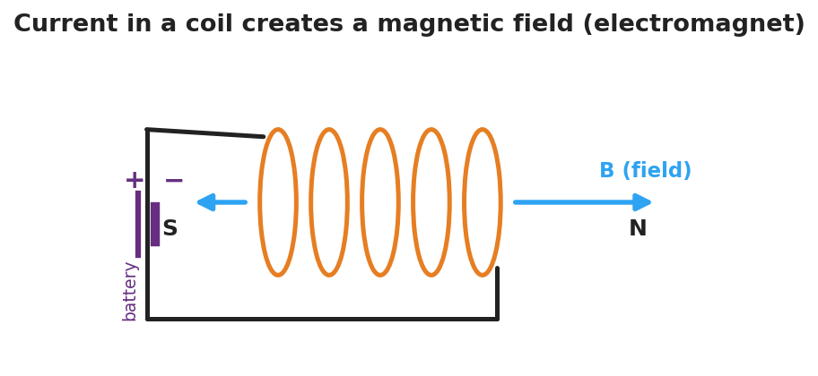
Diagram of current flowing through a wire coil: the loops of the coil create a magnetic field B running along the coil’s axis, with a north pole at one end and a south pole at the other, like a bar magnet.
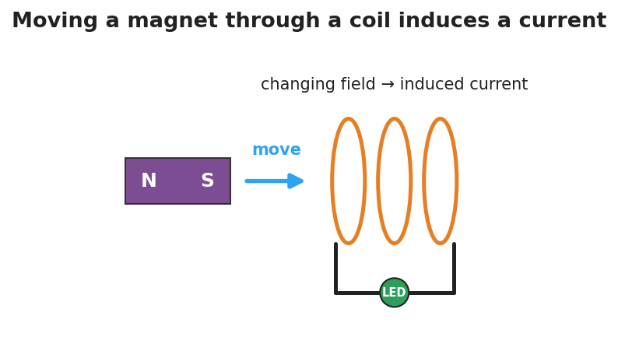
Diagram of electromagnetic induction: a bar magnet with north and south poles moves toward a wire coil connected to an LED; the changing magnetic field through the coil induces a current that lights the LED.

Teacher facilitation during Explore
- What to look for — groups stating “current only while the magnet moves” and “faster motion → brighter LED.”
- What to resist — supplying “Faraday’s law” equations; keep it at the model level (changing field → induced current).
- What to redirect — students who expect a steady LED from a still magnet: point them back to “is the field changing?”

Phase 3 · Explain (30 – 36 min)

30–33 min · Turn-and-Talk #2 + class consensus
“Across both demos, what is the two-way relationship between current and magnetic fields?”
Target consensus:
“An electric current creates a magnetic field (that’s an electromagnet). And a changing magnetic field through a coil creates — induces — a current. Faster change means more induced current.”

33–36 min · Vocabulary introduction (≤ 3 terms)
Sample teacher language:
“The region around a magnet or a current where magnetic forces act is the magnetic field. A coil carrying current that acts like a magnet is an electromagnet. And when a changing magnetic field through a coil drives a current, that’s electromagnetic induction — the principle behind every generator. A generator turns motion into current; a motor runs it backward, turning current into motion.”
Connection to energy (HS-PS3-5): the moving magnet transfers energy through the field into the circuit as electrical energy.

Discussion prompts to deploy here
- “Why doesn’t a magnet just resting inside a coil light the LED?”
  - Sample response: “The field isn’t changing, so no current is induced.”
- “How does a bike’s hand-crank/dynamo light work?”
  - Sample response: “Spinning moves a magnet near a coil, the changing field induces a current that lights the lamp.”

Phase 4 · Elaborate (36 – 40 min)

36–38 min · Apply — generators and motors
“A wind turbine spins a magnet inside a coil. Explain, using electromagnetic induction, how the wind ends up powering a light bulb.”
Target: the spinning magnet keeps changing the field through the coil, which induces a current that carries energy to the bulb — motion energy → electrical energy.

38–40 min · Return to the phenomenon
“In one sentence using electromagnetic induction, explain why the shake-flashlight only makes light while you shake it.”
Target: “Shaking keeps moving the magnet through the coil, so the changing field induces a current — stop shaking and the field stops changing, so the current (and light) stops.”

Phase 5 · Evaluate (40 – 42 min)

40–42 min · Exit Ticket + Closing Reflection
“(a) A current flows through a coil of wire. What does it create around the coil? (b) A magnet is held perfectly still inside a coil connected to an LED. Is there an induced current? Why or why not? (c) Name one device that uses electromagnetic induction to generate electricity, and explain in one sentence where the energy comes from.”
Expected: (a) a magnetic field (it becomes an electromagnet); (b) no — the field isn’t changing, and only a changing field induces current; (c) a generator/dynamo/turbine — the energy comes from the motion that keeps the field changing. See Answer_Key.docx.
Closing Reflection (SEL, 30 seconds):
“Where in your own life do you now realize electromagnetic induction is quietly working?”

Common Misconceptions
- Misconception: “A magnet sitting in a coil produces a current.” → Correction: Only a changing magnetic field induces a current; a stationary magnet’s steady field induces nothing.
- Misconception: “An electromagnet is permanently magnetic.” → Correction: It’s magnetic only while current flows; cut the current and the field collapses.
- Misconception: “Generators create energy.” → Correction: Generators convert energy — the motion that spins the magnet supplies the energy that becomes electrical energy.

Access & Differentiation
- ELL/ENL supports: Sentence frames: “A current makes a ___ field.” / *“A changing field induces a ___.”* Word box: {magnetic, current, moving, changing, induction, electromagnet}. Pair induction with the in-and-out magnet gesture.
- IEP/SPED supports: Provide the coil/magnet diagrams pre-labeled; students circle “ON” vs. “OFF” for each scenario (magnet still / moving / stopped). Offer the Javalab sim as a low-stakes alternative to the hands-on station.
- Extensions: Have students explain why a faster spin or more coil turns increases the induced voltage (Faraday’s law qualitatively) and sketch how a motor reverses a generator (current in → motion out), tying back to energy transfer (HS-PS3-5).

Strategy Spotlight
ACTIVE LEARNING (NYS Required Investigation). Students physically move the magnet and watch the LED rather than being told the rule. Build a predict → test → explain loop: predict whether the LED lights for (magnet still / slow / fast / pulled out), test each, then reconcile. The “still magnet = dark LED” result is the conceptual hinge — it isolates change as the cause. Capture each group’s observation table; the class consensus on “current ↔ changing field” should come from their data, not the slide.

NYSSLS Observation Checklist Crosswalk
# | Checklist item | Where it appears in this lesson
1 | Local/relatable phenomenon | Phase 1 — shake flashlight; coil/magnet LED; electromagnet + paperclips
2 | Turn and Talk (2–3×) | Phase 1 (TT#1 — what the demos share), Phase 3 (TT#2 — current↔field)
3 | Students develop questions/models/procedures | Phase 1 (initial model), Phase 2 (NYS investigation), Phase 4 (revise)
4 | CCC defined and used | Lesson Overview · Energy and Matter, used in Phase 2/4
5 | ENL — ≤ 3 vocab, second half | Phase 3 — magnetic field / electromagnet / electromagnetic induction at 33–36 min
6 | Revisit phenomenon with evidence | Phase 4 — why the shake-flashlight needs shaking
7 | ENL/SPED supports | Access & Differentiation block
8 | Assessment check | Phase 5 — induction exit ticket

Companion Materials
- Student_Worksheet.docx — the 5E student investigation (hand out at start of Phase 2)
- Student_Notes.docx — guided note-guide for vocabulary and the worked example
- Answer_Key.docx — answers to “Make It Make Sense” prompts and the Exit Ticket

Key Vocabulary (max 3)
- magnetic field — the region around a magnet or a current-carrying wire where magnetic forces act, represented by field lines from north to south
- electromagnet — a coil of wire that becomes magnetic only while an electric current flows through it; more turns or more current makes it stronger
- electromagnetic induction — the production of a current in a coil by a changing magnetic field; the basis of generators (motion → electricity)

Electromagnetism: The Induction Junction — Student Worksheet
Unit: Current Electricity — Lesson 05 Name: _______________________ Date: __________ Period: ____

Phenomenon
A magnet held still inside a coil of wire does nothing. But move the magnet in and out, and an LED in the circuit flashes. Across the room, a coil wrapped around a nail picks up paperclips — but only while a battery is connected.
Driving question: What is the two-way connection between electric current and magnetism?

Notice & Wonder
I notice… | I wonder…
Turn & Talk #1: What do the LED demo and the paperclip demo have in common? Use the words magnetic field.

Initial Model
Draw the coil with the magnet inside it and the LED in the loop. Mark when the LED is ON. Predict: does it matter how fast you move the magnet? What happens if you stop?

My prediction: _______________________________

Investigation
Hands-on station + Javalab/PhET simulation.

Diagram of current in a coil creating a magnetic field along its axis, with a north and a south pole like a bar magnet.
Part A — Electromagnet. Connect the nail-coil to the battery and count paperclips lifted. Then add more coil turns or a second battery.
Setup | Paperclips lifted
Battery + coil
More turns / more current
What makes the electromagnet stronger?

Part B — Induction. Move the magnet through the coil at different speeds and record the LED.

Diagram of electromagnetic induction: a moving bar magnet’s changing field through a coil induces a current that lights an LED.
Magnet action | LED (off / dim / bright)
Held still inside coil
Moved slowly
Moved quickly
Pulled back out
Part C — Reverse. When you pull the magnet out instead of pushing it in, what happens to the current direction (which LED lead lights / which way the needle moves)?

Key question: Under what condition does the coil have an induced current? What makes that current bigger?

Make It Make Sense
- A current flows through a coil of wire. What forms around the coil, and what is the coil now acting like?
- A magnet is held perfectly still inside a coil connected to an LED. Is there an induced current? Explain.
- A hand-crank flashlight has no battery. Explain where the light’s energy comes from, using electromagnetic induction.

Vocabulary in Action
Use each term in a sentence about today’s phenomenon.
- magnetic field: _______________________________________________
- electromagnet: _______________________________________________
- electromagnetic induction: _______________________________________________

Revise Your Model
Return to your Initial Model. Did the speed of the magnet matter? Rewrite your explanation for why the LED only lights while the magnet moves, using electromagnetic induction.

Exit Ticket
- A current flows through a coil of wire. What does it create around the coil?
- A magnet is held perfectly still inside a coil connected to an LED. Is there an induced current? Why or why not?
- Name one device that uses electromagnetic induction to generate electricity, and explain in one sentence where the energy comes from.

Electromagnetism: The Induction Junction — Student Notes
Unit: Current Electricity — Lesson 05 Name: _______________________ Date: __________ Period: ____

Learning Targets
By the end of today’s 42 minutes I can:
- Explain that an electric current creates a magnetic field (an electromagnet).
- Describe electromagnetic induction: a changing magnetic field induces a current.
- Use a field model to explain how generators transfer energy between motion and current.

Key Vocabulary
- magnetic field — _______________________________________________
- electromagnet — _______________________________________________
- electromagnetic induction — _______________________________________________

Guided Notes
The two-way relationship (the “induction junction”):
- Current → field. A current in a coil of wire creates a __________ field. The coil acts like a bar magnet — this is an __________. More coil turns or more current makes it __________.

Diagram of current in a coil creating a magnetic field with north and south poles.
- Changing field → current. A changing magnetic field through a coil __________ a current. This is electromagnetic induction.
  - A magnet held __________ inside a coil induces __________ current (the field isn’t changing).
  - Moving the magnet __________ induces a larger current (faster change → more current).

Diagram of induction: a moving magnet’s changing field through a coil induces a current that lights an LED.
Generators and motors (energy connection — HS-PS3-5).
- A generator spins a magnet near a coil; the changing field induces a current. It converts __________ energy into __________ energy.
- A motor runs the idea backward: current in → __________ out.

Worked Example
Problem. A student moves a magnet into a coil connected to an LED. (a) Why does the LED light only while the magnet moves? (b) She moves it twice as fast — what happens to the LED, and why? (c) Where does the LED’s energy come from?
Solution. 1. The LED lights only while moving because only a __________ magnetic field induces a current. 2. Moving twice as fast makes the field change __________, so the induced current is __________ and the LED is brighter. 3. The energy comes from the __________ she does moving the magnet — motion energy becomes electrical energy.

Summary
Finish the sentence (Because / But / So):
The LED lights only while the magnet moves through the coil because __________________________________________, but __________________________________________, so __________________________________________.

Electromagnetism: The Induction Junction — Answer Key

Cover
Unit: Current Electricity — Lesson 05: Electromagnetism (The Induction Junction) East Meadow Schools × Valley Stream Central HSD Strategy chip: ACTIVE LEARNING · NYS Required Investigation

Make-It-Make-Sense Answers
- A magnetic field forms around the coil; the coil is now acting like a magnet — an electromagnet. · Rubric: names magnetic field AND electromagnet. · NYSSLS: HS-PS3-5
- No induced current. A current is induced only by a changing magnetic field; a still magnet’s field is steady (not changing), so nothing is induced. · Rubric: “no” AND explains via unchanging field. · NYSSLS: HS-PS3-5
- The energy comes from the motion (the muscular work of cranking): cranking spins a magnet near a coil, the changing field induces a current by electromagnetic induction, and that current lights the bulb. · Rubric: energy from motion AND links via induction. · NYSSLS: HS-PS3-5

Exit Ticket Answer
- It creates a magnetic field around the coil — the coil becomes an electromagnet.
- No — the magnetic field is not changing, and only a changing magnetic field induces a current.
- A generator (or dynamo / wind turbine / hand-crank flashlight). The energy comes from the motion that keeps the magnetic field changing through the coil — mechanical energy is converted to electrical energy.
Tolerance/rubric: (a) magnetic field / electromagnet; (b) “no” with the unchanging-field reason; (c) any induction generator named AND energy traced to motion. 1 point each. NYSSLS: HS-PS3-5.

Closing Reflection (rubric)
Formative, not graded. Award full credit for naming any real place induction operates (phone chargers, generators, hand-crank/shake devices, microphones, card readers) — the goal is transfer of the model, not a single right answer.

