Physics — Unit 08: Waves (Review)
Table of Contents

Unit 8 · Waves & Sound

Waves — Unit Plan

Cover
Unit: Waves & Sound East Meadow Schools × Valley Stream Central High School District 10 lessons · ~10 instructional periods (42 min each) Format: DOCX (Teacher Guide · Student Worksheet · Student Notes · Answer Key per lesson)

Unit Scope (from East Meadow Scope & Sequence)
This unit develops the physics of waves — mechanical and electromagnetic — from anatomy and the wave equation through interference, the Doppler effect, the EM spectrum, geometric optics, and the analog-to-digital encoding of information. It builds on Energy (a wave transports energy) and connects outward to astronomy (redshift → expanding universe) and to information technology (digital transmission and storage).
# | Lesson | Core idea
01 | Wave Anatomy and Characteristics | Amplitude, wavelength, frequency, period; a wave transfers energy, not matter
02 | Transverse and Longitudinal Waves | Oscillation perpendicular (light) vs. parallel (sound) to travel
03 | Wave Speed, Frequency, and Wavelength | v = f·λ; at fixed speed, f and λ trade off inversely; T = 1/f
04 | Standing Waves and Resonance | Interference of reflections → nodes/antinodes; resonance at natural frequencies
05 | Interference (Constructive and Destructive) | Superposition; in phase adds, out of phase cancels
06 | The Doppler Effect | Relative motion shifts observed frequency; light → red/blueshift
07 | The Electromagnetic Spectrum | EM waves are transverse, all travel at c; radio → gamma by increasing f
08 | Refraction and Snell’s Law | Light bends when speed changes; n₁ sin θ₁ = n₂ sin θ₂; total internal reflection
09 | Optics (Lenses and Mirrors) | Ray diagrams; 1/f = 1/dₒ + 1/dᵢ; real vs. virtual images
10 | Digital Technologies and Information | Analog vs. digital; sampling/bits; digital is robust to noise
Reference-table equations used in this unit: v = f·λ · T = 1/f · n₁ sin θ₁ = n₂ sin θ₂ · 1/f = 1/dₒ + 1/dᵢ

Pacing Calendar
Day | Lesson | Phenomenon anchor | Strategy
1 | 01 Wave Anatomy | Stadium wave; slinky; guitar string | Restorative Circle (unit opener)
2 | 02 Transverse / Longitudinal | Slinky shaken side-to-side vs. push-pull | Active Learning
3 | 03 Wave Speed (v = f·λ) | Guitar strings of different thickness/length | Hochman
4 | 04 Standing Waves / Resonance | Standing wave on a string; shattering glass; fire table | Active Learning
5 | 05 Interference | Two speakers → loud/quiet spots; noise-canceling headphones | BTC
6 | 06 Doppler Effect | Ambulance siren; race car; galaxy redshift | Hochman
7 | 07 EM Spectrum | Radios, X-rays, microwaves — one room, whole spectrum | Active Learning
8 | 08 Refraction / Snell’s Law | Laser bending into water; broken pencil; disappearing Pyrex | Hochman
9 | 09 Optics (Lenses & Mirrors) | Glasses; magnifying glass; curved mirror | Active Learning
10 | 10 Digital Technologies | Vinyl vs. streaming; pixelated vs. smooth image | BTC
Double-period days (every other day) allow the lab phases of Lessons 03, 08, and 09 to run long with PhET/oPhysics measurement and ray-tracing work.

Strategy Rotation
- HOCHMAN (literacy): Lessons 03, 06, 08 — Because/But/So expansion on the key causal relationships (v = f·λ trade-off; Doppler shift; refraction from a speed change).
- ACTIVE LEARNING: Lessons 02, 04, 07, 09 — slinky/human-wave building, harmonic hunting, EM-spectrum card sort, and hands-on ray-tracing.
- BTC (Building Thinking Classrooms): Lessons 05, 10 — random groups + vertical non-permanent surfaces on interference thin-slices and the analog/digital evaluation.
- RESTORATIVE CIRCLE: Lesson 01 — unit-opening circle (“a sound or signal that travels to you”).
SEL (Opening Connection + Closing Reflection), ELL/SPED supports, and a Curated Resources block appear in every lesson.

NYSSLS Coverage Matrix
PE | Description | Lessons
HS-PS4-1 | Mathematical representations of frequency, wavelength, and speed of waves in various media (Cause and Effect) | 01, 02, 03 (core), 04, 05, 06, 07
HS-PS4-6 (NYS) | Mathematical models relating image/object size & location and focal lengths of lenses and mirrors | 08 (Snell’s law foundation), 09 (core)
HS-PS4-2 | Evaluate the advantages of digital transmission and storage of information (Stability and Change) | 10
HS-ESS1-2 | Big Bang from astronomical evidence of light spectra (connection) | 06 (Doppler redshift → expanding universe)

Vocabulary Scope
Three terms maximum per lesson, introduced in the second half (NYSSLS observation item 5).
Lesson | Terms
01 | amplitude · wavelength · frequency
02 | transverse wave · longitudinal wave · medium
03 | wave speed · period · hertz
04 | standing wave · node · resonance
05 | superposition · constructive interference · destructive interference
06 | Doppler effect · frequency shift · redshift
07 | electromagnetic wave · spectrum · speed of light
08 | refraction · index of refraction · Snell’s law
09 | focal length · converging lens · image
10 | analog signal · digital signal · bit

Wave Anatomy and Characteristics — Teacher Guide

Cover
Unit: Waves — Lesson 01: Wave Anatomy and Characteristics East Meadow Schools × Valley Stream Central High School District Strategy chips: RESTORATIVE CIRCLE

Curated Resources (from East Meadow Scope & Sequence)

NYSSLS Standards
HS-PS4-1. “Use mathematical representations to support a claim regarding relationships among the frequency, wavelength, and speed of waves traveling in various media. (Cause and Effect)”
This opening lesson builds the vocabulary and mental picture students need before they can reason mathematically with v = f·λ in Lessons 02–03. Establishing crest, trough, amplitude, wavelength, frequency, and period is the prerequisite for every wave claim that follows.

Phenomenon
- A stadium “wave” travels around the bowl, but each fan stays in their seat — only their arms go up and down: https://www.youtube.com/watch?v=njBJW9pStLA
- A slinky pulse and a plucked guitar string as live, in-room versions of the same idea.

Javalab / Labs
- PhET Wave on a String — drive a string at the left end and watch a wave travel: https://phet.colorado.edu/en/simulations/wave-on-a-string

Assessments
- PhET Wave on a String “Oscillate + Slow Motion” check: students set amplitude and frequency and measure wavelength. Exit ticket below serves as the formative check.

Lesson Overview
Duration | 42 minutes (1 period)
NYSSLS link | HS-PS4-1 (vocabulary + model foundation)
CCC focus | Cause and Effect — driving the source faster (higher frequency) causes the wave’s shape to change, but the medium itself does not travel.
Strategy chips | RESTORATIVE CIRCLE (unit opener)
Materials | Long spring/slinky; a length of rope; a guitar or ukulele (optional); rulers; whiteboards/markers; device for PhET.
Safety | Give the slinky room; do not stretch past ~3 m or release under tension.
Prior knowledge | Energy transfer (Energy unit); the idea of a repeating, periodic motion.
Lesson objectives — students can:
- Label the parts of a wave: crest, trough, amplitude, and wavelength.
- Distinguish frequency (cycles per second) from period (seconds per cycle) and state that they are reciprocals (T = 1/f).
- Explain, with evidence, that a wave transfers energy without transferring matter.

Phase 1 · Engage (0 – 12 min)

0–3 min · Opening Connection (SEL) — Restorative Circle (unit opener)
This is the first lesson of the Waves unit, so open with a brief restorative circle. Pass a talking piece. Prompt: “Name a sound or signal that travels to you every day — a voice, a song, a notification — and where it comes from.” One sentence each, no cross-talk. This seeds the central idea: something travels to you, but the air, the wire, or the screen did not come with it.

3–8 min · Phenomenon hook — the stadium wave
Teacher actions. Play the stadium-wave clip with the sound off for ~30 seconds. Then run a slinky pulse across the front bench so students see the in-room version.
Sample teacher language:
“Watch one single fan, not the whole stadium. Did that person travel around the stadium? Then what did go all the way around?”
Anticipated student responses:
- “The wave moved but the people stayed.” — exactly the target; capture the word stayed.
- “Energy went around.” — affirm and hold; we will sharpen this.
- “The people passed it on.” — good, reframe as “each one moved up and down in place.”

8–12 min · Notice & Wonder + Turn-and-Talk #1
Capture two columns on the board. Then:
“Turn to your partner: what actually traveled around the stadium, and what stayed put? Use the word energy in your answer.”
Take 2–3 responses. Desirable insight: the disturbance (energy) traveled; the matter (people, slinky coils) only moved in place and returned.

Bridge to Phase 2
Every student leaves Phase 1 with a one-sentence initial model: “In the stadium wave, ______ traveled but ______ stayed put.”

Phase 2 · Explore (12 – 32 min)

12–17 min · Initial Model (silent / individual)
Prompt on the board:
“Draw the slinky at one instant as a wave passes. Mark a high point and a low point. Draw an arrow showing which way the wave moves, and an arrow showing which way a single coil moves. Are they the same direction?”
This surfaces the matter-vs-energy distinction before any vocabulary.

17–32 min · Investigation — PhET Wave on a String + slinky stations
Students work in pairs at PhET (with a slinky available to handle):
- Amplitude — set the oscillator higher/lower. What part of the wave changes? (Tie a ribbon to one slinky coil — does the ribbon travel down the slinky, or bob in place?)
- Frequency — speed up and slow down the oscillator. Count cycles in 10 seconds. What happens to the spacing of the crests?
- Energy, not matter — pause the sim and tag one point on the string. Step it forward. Does the tagged point move along the string, or up and down?
Use the labeled-wave figure to anchor the vocabulary you will name in Phase 3:
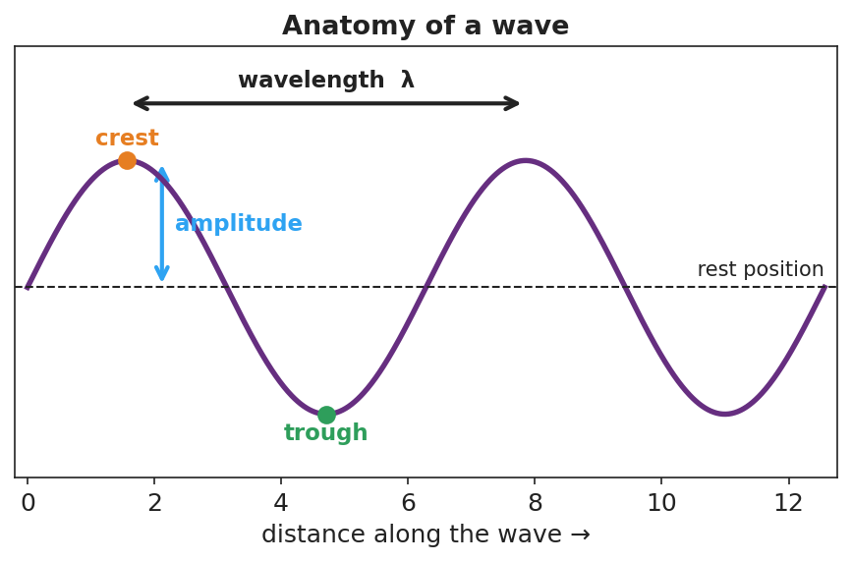
A sine wave with the crest, trough, rest position, amplitude (rest-to-crest), and wavelength (crest-to-crest) all labeled.

Teacher facilitation during Explore
- What to look for — pairs noticing that the ribbon/tagged point bobs in place while crests march along; that more cycles per second means crests are closer together.
- What to resist — don’t define “frequency” or “wavelength” yet; let the counting and the ribbon do the teaching.
- What to redirect — students who say “the string moves to the right” should be asked, “does that piece of string end up on the right, or does it come back?”

Phase 3 · Explain (32 – 37 min)

32–35 min · Turn-and-Talk #2 + class consensus
“Across both the slinky and PhET, what moved along the medium and what only moved in place?”
Target consensus:
“A wave is a disturbance that carries energy from place to place. The matter it travels through only vibrates in place — it does not travel with the wave.”

35–37 min · Vocabulary introduction (≤ 3 terms)
Sample teacher language:
“The height of the wave from rest to a crest is the amplitude — bigger amplitude means more energy. The distance from one crest to the next is the wavelength. And how many full cycles pass a point each second is the frequency, measured in hertz. The time for one cycle is its period, and period and frequency are reciprocals: T = 1/f.”
Show the frequency/period figure here:
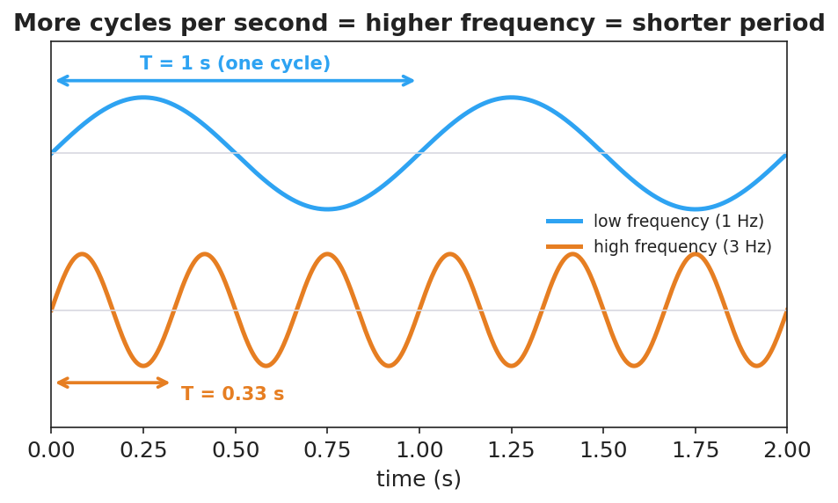
Two waves over the same two seconds: a 1 Hz wave with period T = 1 s, and a 3 Hz wave with period T = 0.33 s, showing more cycles per second means a shorter period.

Discussion prompts to deploy here
- “A wave’s amplitude doubles. Does it travel faster?”
  - Sample student response: “No — amplitude is about energy/height, not speed. Speed depends on the medium.”
- “If a wave’s frequency is 4 Hz, what is its period?”
  - Sample student response: “T = 1/f = 1/4 = 0.25 s per cycle.”

Phase 4 · Elaborate (37 – 40 min)

37–39 min · Revise the model
“Return to your slinky drawing. Label the crest, trough, amplitude, and one wavelength. Re-write your one-sentence explanation using the words energy, amplitude, and wavelength.”

39–40 min · Return to the phenomenon
“Back to the stadium: what is the ‘amplitude’ of the stadium wave, and what stayed in place? Answer in one sentence.”
Target: “The amplitude is how high fans raise their arms; the fans (the matter) stayed in their seats while the wave (energy) traveled around.”

Phase 5 · Evaluate (40 – 42 min)

40–42 min · Exit Ticket + Closing Reflection
“A buoy bobs up and down 12 times in 6 seconds as ocean waves pass. (a) What is the frequency of the waves? (b) What is the period? (c) Does the water itself travel toward the shore with the wave? Explain in one sentence.”
Expected: (a) f = 12/6 = 2 Hz; (b) T = 1/f = 0.5 s; (c) no — the water (matter) bobs in place; the wave carries energy toward shore. See Answer_Key.docx.
Closing Reflection (SEL, 30 seconds):
“What is one everyday ‘wave’ you now see differently? Who in your group helped you picture it?”

Common Misconceptions
- Misconception: “A wave carries the medium along with it (the water moves to shore).” → Correction: The medium vibrates in place; only energy is transported.
- Misconception: “Bigger waves (higher amplitude) move faster.” → Correction: Amplitude is energy/height; wave speed is set by the medium, not the amplitude.
- Misconception: “Frequency and period are the same thing.” → Correction: They are reciprocals — frequency is cycles per second, period is seconds per cycle (T = 1/f).

Access & Differentiation
- ELL/ENL supports: Sentence frame: “A wave carries ______ but not ______; the ______ moves up and down in place.” Word-choice box: {energy, matter, amplitude, wavelength, frequency, crest, trough}. Pair amplitude with a hand gesture (high vs. low).
- IEP/SPED supports: Provide a pre-printed blank sine curve; students drag/label cut-out tags (crest, trough, amplitude, wavelength) rather than drawing from scratch. Offer the slinky as a hands-on alternative to the simulation.
- Extensions: Have students measure a real wavelength in PhET by reading the ruler tool, then predict how the wavelength changes when they double the frequency at the same speed (preview of Lesson 03).

Strategy Spotlight
RESTORATIVE CIRCLE (unit opener). Today’s circle launches the Waves unit. Use a talking piece, one-sentence responses, and equity of voice (everyone speaks or passes). The prompt — a sound or signal that travels to you and where it comes from — is chosen so you can call it back in Phase 3 (“the song reached your ears, but the singer’s air did not travel to you — energy did”). Keep the circle to ~2–3 minutes; the goal is community plus a shared anchor.

NYSSLS Observation Checklist Crosswalk
# | Checklist item | Where it appears in this lesson
1 | Local/relatable phenomenon | Phase 1 — stadium wave; slinky; ocean buoy in Phase 5
2 | Turn and Talk (2–3×) | Phase 1 (TT#1 — what traveled), Phase 3 (TT#2 — along vs. in place)
3 | Students develop questions/models/procedures | Phase 1 (initial model), Phase 2 (PhET + slinky stations), Phase 4 (revise model)
4 | CCC defined and used | Lesson Overview · Cause and Effect, restated in Phase 2
5 | ENL — ≤ 3 vocab, second half | Phase 3 — vocabulary at 35–37 min (amplitude / wavelength / frequency)
6 | Revisit phenomenon with evidence | Phase 4 — stadium-wave amplitude re-label
7 | ENL/SPED supports | Access & Differentiation block
8 | Assessment check | Phase 5 — Exit Ticket (ocean buoy)

Companion Materials
- Student_Worksheet.docx — the 5E student investigation (hand out at start of Phase 2)
- Student_Notes.docx — guided note-guide for vocabulary and the worked example
- Answer_Key.docx — answers to “Make It Make Sense” prompts and the Exit Ticket

Key Vocabulary (max 3)
- amplitude — the maximum distance a wave rises from its rest position; larger amplitude means more energy
- wavelength — the distance between two matching points on a wave, such as crest to crest (symbol λ)
- frequency — the number of complete wave cycles that pass a point each second, measured in hertz (Hz)

Wave Anatomy and Characteristics — Student Worksheet
Unit: Waves — Lesson 01 Name: _______________________ Date: __________ Period: ____

Phenomenon
A “wave” travels all the way around a packed stadium — but every single fan stays in their own seat, just raising and lowering their arms. On the front bench, a slinky pulse races from one end to the other, yet each coil only jiggles in place.
Driving question: When a wave travels, what actually moves — and what stays put?

Notice & Wonder
I notice… | I wonder…
Turn & Talk #1: What actually traveled around the stadium, and what stayed put? Use the word energy in your answer.

Initial Model
Draw the slinky at one instant as a wave passes. Mark a high point and a low point. Draw one arrow for the direction the wave moves, and a second arrow for the direction a single coil moves.

Are the two arrows the same direction? _______________________

Investigation
Open PhET Wave on a String and keep a slinky handy. Tie a ribbon to one slinky coil.
Station | What I changed | What happened to the wave | What happened to the ribbon / tagged point
1. Amplitude (oscillator height)
2. Frequency (oscillator speed)
3. Energy, not matter (tag one point)
Use this labeled wave to name the parts you measured:

A sine wave with crest, trough, rest position, amplitude, and wavelength labeled.
Key question: Did the ribbon (a piece of matter) travel down the slinky, or move in place? What does that tell you about what a wave transports?

Make It Make Sense
- On the wave diagram above, which measurement tells you how much energy the wave carries? Explain.
- A wave’s frequency is 5 Hz. What is its period? Show the formula you used.
- Two ocean waves have the same speed, but Wave A has a larger amplitude than Wave B. Which carries more energy? Does it travel faster? Explain.

Vocabulary in Action
Use each term in a sentence about today’s phenomenon.
- amplitude: _______________________________________________
- wavelength: _______________________________________________
- frequency: _______________________________________________

Revise Your Model
Return to your Initial Model. Label the crest, trough, amplitude, and one wavelength. Rewrite your explanation using the words energy, amplitude, and wavelength.

Exit Ticket
A buoy bobs up and down 12 times in 6 seconds as ocean waves pass.
- What is the frequency of the waves?
- What is the period?
- Does the water itself travel toward the shore with the wave? Explain in one sentence.

Wave Anatomy and Characteristics — Student Notes
Unit: Waves — Lesson 01 Name: _______________________ Date: __________ Period: ____

Learning Targets
By the end of today’s 42 minutes I can:
- Label the parts of a wave: crest, trough, amplitude, and wavelength.
- Tell the difference between frequency (cycles per second) and period, and use T = 1/f.
- Explain that a wave transfers energy, not matter.

Key Vocabulary
- amplitude — _______________________________________________
- wavelength — _______________________________________________
- frequency — _______________________________________________

Guided Notes
Big idea: A wave is a __________ that carries __________ from one place to another. The matter it passes through only __________ in place — it does not travel with the wave.
Label the wave below:

A sine wave with crest, trough, rest position, amplitude, and wavelength labeled.
- Crest — the __________ point of the wave.
- Trough — the __________ point of the wave.
- Amplitude — distance from rest to a crest; more amplitude → more __________.
- Wavelength (λ) — distance from one crest to the __________ crest.
Frequency and period.
- Frequency (f) = number of cycles per __________, measured in __________ (Hz).
- Period (T) = time for __________ complete cycle, in seconds.
- They are reciprocals: T = 1 / __________ and f = 1 / __________.

Two waves over the same two seconds: a 1 Hz wave (T = 1 s) and a 3 Hz wave (T = 0.33 s).
More cycles per second → __________ frequency → __________ period.

Worked Example
Problem. A wave passes a dock and a seagull bobs up and down 20 times in 4 seconds. Find the frequency and the period.
Solution. 1. Frequency: f = cycles ÷ time = 20 ÷ 4 = __________ Hz. 2. Period: T = 1 / f = 1 / __________ = __________ s per cycle. 3. Check: 5 cycles each second × 4 seconds = __________ cycles. ✓

Summary
Finish the sentence (Because / But / So):
A wave travels across a slinky because __________________________________________, but __________________________________________, so __________________________________________.

Wave Anatomy and Characteristics — Answer Key

Cover
Unit: Waves — Lesson 01: Wave Anatomy and Characteristics East Meadow Schools × Valley Stream Central HSD Strategy chip: RESTORATIVE CIRCLE

Make-It-Make-Sense Answers
- Amplitude tells you the energy. The larger the amplitude (height from rest to crest), the more energy the wave carries. Wavelength and frequency describe the wave’s shape and timing, not its energy. · Rubric: names amplitude AND links it to energy → full credit. · NYSSLS: HS-PS4-1
- Period T = 1/f = 1/5 = 0.2 s per cycle. · Rubric: correct reciprocal formula AND correct value with units. · NYSSLS: HS-PS4-1
- Wave A carries more energy because it has the larger amplitude. It does not travel faster — wave speed is set by the medium, not the amplitude, and both waves are in the same water. · Rubric: larger amplitude → more energy AND speed unchanged. · NYSSLS: HS-PS4-1

Exit Ticket Answer
- f = 12 cycles ÷ 6 s = 2 Hz.
- T = 1/f = 1/2 = 0.5 s per cycle.
- No. The water bobs up and down in place (the matter stays put); the wave carries energy toward shore, not the water itself.
Tolerance/rubric: (a) 2 Hz with work; (b) 0.5 s; (c) must state water stays in place AND energy travels. 1 point each. NYSSLS: HS-PS4-1.

Closing Reflection (rubric)
Closing reflection is formative, not graded. Award full credit for any honest response. Look for: - An everyday “wave” the student now interprets as energy travel without matter travel - Naming a peer or a self-acknowledgment in the second answer

Transverse and Longitudinal Waves — Teacher Guide

Cover
Unit: Waves — Lesson 02: Transverse and Longitudinal Waves East Meadow Schools × Valley Stream Central High School District Strategy chips: ACTIVE LEARNING

Curated Resources (from East Meadow Scope & Sequence)

NYSSLS Standards
HS-PS4-1. “Use mathematical representations to support a claim regarding relationships among the frequency, wavelength, and speed of waves traveling in various media. (Cause and Effect)”
Sorting waves into transverse and longitudinal types lets students see that the same relationships (amplitude, wavelength, frequency, v = f·λ) apply to both light (transverse) and sound (longitudinal). The wave type is a property of the medium and the disturbance — a Cause-and-Effect link the unit returns to in the EM spectrum (Lesson 07) and refraction (Lesson 08).

Phenomenon
- A long slinky shaken side-to-side makes a wave you can see wiggling across the room; the same slinky pushed and pulled along its length makes a compression pulse race down it: https://www.youtube.com/watch?v=Rbuhdo0AZDU

Javalab / Labs
- Javalab Transverse and Longitudinal Waves — animated side-by-side particle motion: https://javalab.org/en/transverse_longitudinal_wave_en/

Assessments
- Javalab “tag a particle” check: students predict whether the tagged dot moves across the screen or oscillates in place, for each wave type. Exit ticket below serves as the formative check.

Lesson Overview
Duration | 42 minutes (1 period)
NYSSLS link | HS-PS4-1 (wave types; both obey v = f·λ)
CCC focus | Cause and Effect — how you disturb the medium (across vs. along) causes the two different wave types.
Strategy chips | ACTIVE LEARNING
Materials | Long slinky (one per group of 4); tape ribbons; Javalab on devices; whiteboards.
Safety | Keep slinky ends held; never release a stretched slinky.
Prior knowledge | Lesson 01 — crest, trough, amplitude, wavelength; energy travels, matter does not.
Lesson objectives — students can:
- Describe how the medium oscillates relative to the direction the wave travels.
- Classify a wave as transverse (oscillation perpendicular to travel) or longitudinal (oscillation parallel to travel) and give an example of each.
- Identify compressions and rarefactions in a longitudinal wave such as sound.

Phase 1 · Engage (0 – 12 min)

0–3 min · Opening Connection (SEL)
Quick check-in: “Show me with your hand: are you feeling more like a side-to-side day or a steady-straight-ahead day?” One gesture each. This primes the two motions you’ll formalize as transverse vs. longitudinal.

3–8 min · Phenomenon hook — one slinky, two waves
Teacher actions. Stretch a slinky across the front. First shake one end side to side — students see a transverse wiggle. Then push and pull the same end along its length — students see a compression pulse sprint down it. Same slinky, same energy idea, two very different looks.
Sample teacher language:
“Same slinky, same person, same energy — but two completely different-looking waves. What did I change about how I moved my hand?”
Anticipated student responses:
- “You shook it sideways the first time, in-and-out the second.” — exactly; capture the two hand motions.
- “The second one looks like it’s squishing.” — affirm; we’ll name compressions.
- “They both still went down the slinky.” — yes — energy travels both times.

8–12 min · Notice & Wonder + Turn-and-Talk #1
Capture two columns. Then:
“Turn to your partner: in each case, which way did a single coil move compared to the way the wave traveled?”
Target insight: in the first wave the coil moved across the travel direction; in the second it moved along it.

Bridge to Phase 2
Every student leaves with a one-sentence initial model: “The two waves were different because the coils moved ______ vs. ______ the direction the wave traveled.”

Phase 2 · Explore (12 – 32 min)

12–17 min · Initial Model (silent / individual)
Prompt:
“Draw both slinky waves. For each, draw one arrow for the wave’s travel direction and one arrow for how a single coil moves. Circle the case where the two arrows are perpendicular.”

17–32 min · Investigation — ACTIVE LEARNING: be the wave
Groups of 4. Each group has a slinky and a device with the Javalab sim.
- Build a transverse wave. Tape a ribbon to one coil. Shake side to side. Track the ribbon: does it travel along the slinky or move across, in place?
- Build a longitudinal wave. Push/pull along the length. Find where coils bunch (compression) and spread (rarefaction). Track the ribbon again.
- Human wave (kinesthetic). Line up shoulder-to-shoulder. For transverse, each person steps left/right as the “wave” passes; for longitudinal, each leans forward/back (toward/away from neighbors). Which one looks like sound?
- Javalab check. Tag a particle in each animation. Confirm your slinky observations.
Use this figure to compare what each group is building:
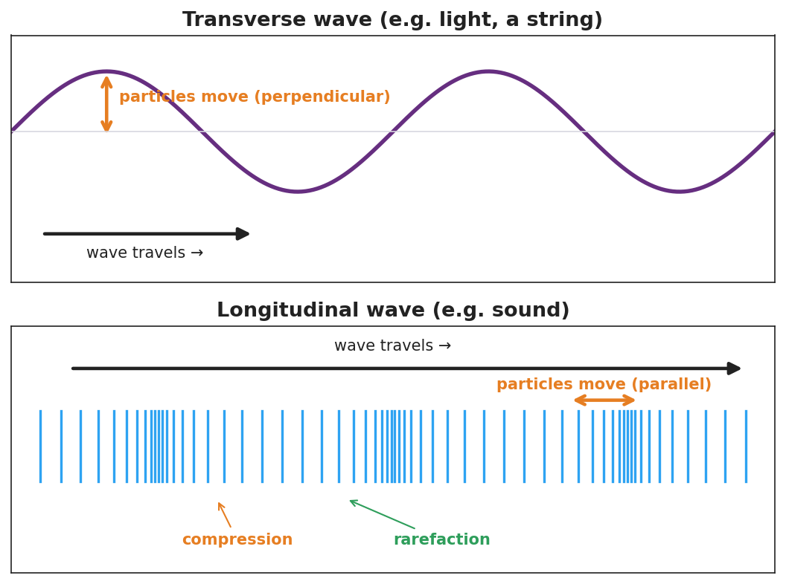
Top: a transverse wave (sine) with travel arrow horizontal and particle motion perpendicular. Bottom: a longitudinal wave shown as vertical lines that bunch into compressions and spread into rarefactions, with particle motion parallel to travel.
This second figure isolates the single-particle motion students should track at each station — up/down (perpendicular) for transverse, back/forth (parallel) for longitudinal:
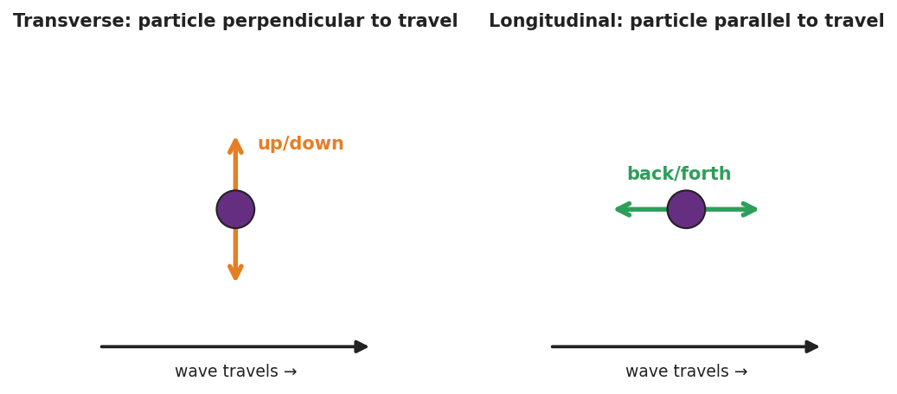
Two panels: a single particle in a transverse wave moving up and down (perpendicular to travel), and a single particle in a longitudinal wave moving back and forth (parallel to travel), each beside the rightward wave-travel arrow.

Teacher facilitation during Explore
- What to look for — groups stating the relationship between oscillation and travel, not just “sideways” vs. “in-out.”
- What to resist — don’t supply the words transverse/longitudinal yet; let “perpendicular” and “parallel” emerge from the ribbon tracking.
- What to redirect — students who say the longitudinal coil “travels down the slinky” should re-tag the ribbon and watch it return.

Phase 3 · Explain (32 – 37 min)

32–35 min · Turn-and-Talk #2 + class consensus
“What is the rule that separates the two wave types?”
Target consensus:
“If the medium oscillates across (perpendicular to) the direction of travel, it’s one type. If it oscillates along (parallel to) the direction of travel, it’s the other.”

35–37 min · Vocabulary introduction (≤ 3 terms)
Sample teacher language:
“When the particles move perpendicular to the wave’s travel — like the sideways slinky and like light — we call it a transverse wave. When they move parallel to the travel — like the push-pull slinky and like sound — it’s a longitudinal wave, with compressions (bunched) and rarefactions (spread out). The stuff the wave travels through is the medium.”

Discussion prompts to deploy here
- “Sound needs air, water, or a solid to travel. Which wave type is sound, and why does it need a medium?”
  - Sample student response: “Longitudinal — the particles have to push on the next ones, so it needs matter to push.”
- “A wave on a guitar string — transverse or longitudinal?”
  - Sample student response: “Transverse — the string moves up and down while the wave travels along its length.”

Phase 4 · Elaborate (37 – 40 min)

37–39 min · Revise the model
“Return to your two slinky drawings. Label one transverse and one longitudinal. On the longitudinal one, mark a compression and a rarefaction. Re-write your one-sentence rule using both vocabulary words.”

39–40 min · Return to the phenomenon
“If a friend asks why the side-to-side slinky and the push-pull slinky look so different, what’s your one-sentence answer using transverse and longitudinal?”
Target: “They’re different wave types — the side-to-side one is transverse (medium moves perpendicular to travel) and the push-pull one is longitudinal (medium moves parallel to travel).”

Phase 5 · Evaluate (40 – 42 min)

40–42 min · Exit Ticket + Closing Reflection
“A sound wave travels through air toward your ear. (a) Is sound a transverse or longitudinal wave? (b) Describe how the air molecules move compared to the direction the sound travels. (c) Name the bunched-up regions and the spread-out regions of a sound wave.”
Expected: (a) longitudinal; (b) molecules move back-and-forth parallel to the travel direction; (c) compressions (bunched) and rarefactions (spread out). See Answer_Key.docx.
Closing Reflection (SEL, 30 seconds):
“Which hands-on station made the idea click for you, and who in your group made it work?”

Common Misconceptions
- Misconception: “In a longitudinal wave the particles travel all the way down with the wave.” → Correction: They oscillate back and forth in place; only the compression pattern (energy) travels.
- Misconception: “All waves are S-shaped like the ones in pictures.” → Correction: That picture fits transverse waves; longitudinal waves are compressions and rarefactions, often drawn as a sine of density but physically a push-pull.
- Misconception: “Sound can travel through empty space like light.” → Correction: Sound is longitudinal and needs a medium to push through; space is a near-vacuum, so sound cannot travel there.

Access & Differentiation
- ELL/ENL supports: Sentence frame: “In a ______ wave the medium moves ______ to the direction the wave travels.” Word-choice box: {transverse, longitudinal, perpendicular, parallel, compression, rarefaction, medium}. Pair perpendicular and parallel with crossed-arm and aligned-arm gestures.
- IEP/SPED supports: Provide a two-column sort with pre-printed examples (light, sound, guitar string, slinky push-pull); students place each under “transverse” or “longitudinal.” Use the human-wave station as a movement-based alternative to writing.
- Extensions: Earthquake waves — research P-waves (longitudinal) vs. S-waves (transverse) and explain why S-waves cannot pass through Earth’s liquid outer core.

Strategy Spotlight
ACTIVE LEARNING. Students physically build both wave types with a slinky and with their own bodies (the human-wave station) before any term is named. The kinesthetic memory (“I stepped sideways” vs. “I leaned forward and back”) becomes the anchor for transverse vs. longitudinal. Facilitate by circulating with one question — “Which way did your body move compared to the wave?” — and resist naming the terms until Phase 3.

NYSSLS Observation Checklist Crosswalk
# | Checklist item | Where it appears in this lesson
1 | Local/relatable phenomenon | Phase 1 — one slinky, two waves; sound in Phase 5
2 | Turn and Talk (2–3×) | Phase 1 (TT#1 — coil vs. travel direction), Phase 3 (TT#2 — the rule)
3 | Students develop questions/models/procedures | Phase 1 (initial model), Phase 2 (slinky + human-wave + Javalab), Phase 4 (revise)
4 | CCC defined and used | Lesson Overview · Cause and Effect, restated in Phase 2
5 | ENL — ≤ 3 vocab, second half | Phase 3 — vocabulary at 35–37 min (transverse / longitudinal / medium)
6 | Revisit phenomenon with evidence | Phase 4 — label and explain the two slinky waves
7 | ENL/SPED supports | Access & Differentiation block
8 | Assessment check | Phase 5 — Exit Ticket (sound in air)

Companion Materials
- Student_Worksheet.docx — the 5E student investigation (hand out at start of Phase 2)
- Student_Notes.docx — guided note-guide for vocabulary and the worked example
- Answer_Key.docx — answers to “Make It Make Sense” prompts and the Exit Ticket

Key Vocabulary (max 3)
- transverse wave — a wave in which the medium oscillates perpendicular to the direction the wave travels (e.g., light, a wave on a string)
- longitudinal wave — a wave in which the medium oscillates parallel to the direction the wave travels, forming compressions and rarefactions (e.g., sound)
- medium — the matter (solid, liquid, or gas) through which a mechanical wave travels

Transverse and Longitudinal Waves — Student Worksheet
Unit: Waves — Lesson 02 Name: _______________________ Date: __________ Period: ____

Phenomenon
Your teacher takes one slinky and makes two completely different-looking waves with it. First they shake the end side to side — a wiggle travels across the room. Then they push and pull the same end along its length — a squeeze races down the coils. Same slinky, same energy. Two different waves.
Driving question: What did the teacher change about how they moved their hand to make two different wave types?

Notice & Wonder
I notice… | I wonder…
Turn & Talk #1: In each case, which way did a single coil move compared to the way the wave traveled?

Initial Model
Draw both slinky waves. For each, draw one arrow for the wave’s travel direction and one arrow for how a single coil moves. Circle the case where the two arrows are perpendicular.

Investigation
Work in a group of 4 with a slinky and the Javalab simulation. Tape a ribbon to one coil.
Station | What I did | Did the ribbon travel or move in place? | Coil motion vs. wave travel
1. Side-to-side slinky
2. Push-pull slinky
3. Human wave (step / lean)
4. Javalab tag-a-particle
Compare your two waves to this diagram:

Top: transverse wave with perpendicular particle motion. Bottom: longitudinal wave with compressions, rarefactions, and parallel particle motion.
Key question: Which station moved your body across the wave’s travel, and which moved it along the travel? Which one is like sound?

Make It Make Sense
- Light is a transverse wave. Describe how the wave “oscillates” compared to the direction the light travels.
- Sound is a longitudinal wave. Why does it need a medium (air, water, or a solid) to travel?
- A wave on a guitar string — transverse or longitudinal? Justify your answer with the direction the string moves.

Vocabulary in Action
Use each term in a sentence about today’s phenomenon.
- transverse wave: _______________________________________________
- longitudinal wave: _______________________________________________
- medium: _______________________________________________

Revise Your Model
Return to your two slinky drawings. Label one transverse and one longitudinal. On the longitudinal one, mark a compression and a rarefaction. Rewrite your rule using both vocabulary words.

Exit Ticket
A sound wave travels through air toward your ear.
- Is sound a transverse or longitudinal wave?
- Describe how the air molecules move compared to the direction the sound travels.
- Name the bunched-up regions and the spread-out regions of a sound wave.

Transverse and Longitudinal Waves — Student Notes
Unit: Waves — Lesson 02 Name: _______________________ Date: __________ Period: ____

Learning Targets
By the end of today’s 42 minutes I can:
- Describe how the medium oscillates compared to the direction a wave travels.
- Classify a wave as transverse or longitudinal and give an example of each.
- Identify compressions and rarefactions in a longitudinal wave.

Key Vocabulary
- transverse wave — _______________________________________________
- longitudinal wave — _______________________________________________
- medium — _______________________________________________

Guided Notes
There are two ways the matter in a wave can move compared to the way the wave travels:

Top: transverse wave (particles move perpendicular). Bottom: longitudinal wave with compressions and rarefactions (particles move parallel).
Transverse wave.
- The medium moves __________ (perpendicular) to the direction of travel.
- Examples: light, a wave on a __________.
- Has crests and __________.
Longitudinal wave.
- The medium moves __________ (parallel) to the direction of travel.
- Example: __________ (it needs a medium to push through).
- Bunched-up regions = __________; spread-out regions = __________.
The medium is the __________ the wave travels through. A wave does not travel with the medium — the medium just __________ in place.

Worked Example
Problem. Decide whether each wave is transverse or longitudinal, and explain how you know.
Wave | Type | How the medium moves
Light from the sun | __________ | __________ to travel
Sound from a speaker | __________ | __________ to travel
Ripple on a pond surface | __________ | __________ to travel
Reasoning. I look at the direction the medium oscillates compared with the direction the wave travels. If __________, it’s transverse; if __________, it’s longitudinal.

Summary
Finish the sentence (Because / But / So):
Sound and light are both waves that carry energy because __________________________________________, but __________________________________________, so __________________________________________.

Transverse and Longitudinal Waves — Answer Key

Cover
Unit: Waves — Lesson 02: Transverse and Longitudinal Waves East Meadow Schools × Valley Stream Central HSD Strategy chip: ACTIVE LEARNING

Make-It-Make-Sense Answers
- In light (transverse), the wave oscillates perpendicular to the direction the light travels — the electric and magnetic fields wiggle across the line of travel while the energy moves forward. · Rubric: states perpendicular relationship. · NYSSLS: HS-PS4-1
- Sound is longitudinal: the particles push on the next particles to pass the compression along, so there must be matter (a medium) to do the pushing. In a vacuum there are no particles to push, so sound cannot travel. · Rubric: links particle-pushing to needing a medium. · NYSSLS: HS-PS4-1
- Transverse. The string moves up and down (side to side) while the wave travels along the length of the string — the motion is perpendicular to the travel direction. · Rubric: transverse AND perpendicular justification. · NYSSLS: HS-PS4-1

Exit Ticket Answer
- Longitudinal.
- The air molecules move back and forth parallel to the direction the sound travels (not across it).
- Bunched-up regions are compressions; spread-out regions are rarefactions.
Tolerance/rubric: (a) longitudinal; (b) parallel/back-and-forth along travel; (c) both terms correct. 1 point each. NYSSLS: HS-PS4-1.

Closing Reflection (rubric)
Formative, not graded. Award full credit for any honest response. Look for: - Naming a specific station (slinky, human wave, Javalab) that made the idea click - An acknowledgment of a group member’s contribution

Wave Speed, Frequency, and Wavelength — Teacher Guide

Cover
Unit: Waves — Lesson 03: Wave Speed, Frequency, and Wavelength East Meadow Schools × Valley Stream Central High School District Strategy chips: HOCHMAN

Curated Resources (from East Meadow Scope & Sequence)

NYSSLS Standards
HS-PS4-1. “Use mathematical representations to support a claim regarding relationships among the frequency, wavelength, and speed of waves traveling in various media. (Cause and Effect)”
This is the lesson where students do the mathematical representation: v = f·λ. They use it to support the claim that in a given medium the speed is fixed, so frequency and wavelength must trade off (an inverse relationship). This is the quantitative heart of HS-PS4-1.

Phenomenon
- Guitar strings of different thickness and length sound different notes even when plucked the same way: https://www.youtube.com/watch?v=DLOmHViGqYY

Javalab / Labs
- PhET Wave on a String (oscillate mode) — fix the speed, change the driver frequency, measure the wavelength with the ruler tool: https://phet.colorado.edu/en/simulations/wave-on-a-string

Assessments
- PhET measurement task: students complete an f-vs-λ data table at fixed tension (fixed speed) and confirm f·λ is constant. Numeric exit ticket below serves as the formative check.

Lesson Overview
Duration | 42 minutes (1 period)
NYSSLS link | HS-PS4-1 (core — the v = f·λ relationship)
CCC focus | Cause and Effect — at a fixed wave speed, increasing frequency causes wavelength to decrease (inverse trade-off).
Strategy chips | HOCHMAN
Materials | Guitar/ukulele or rubber bands stretched over a box; rulers; calculators; whiteboards; device for PhET.
Safety | None beyond normal classroom care.
Prior knowledge | Lessons 01–02 — wavelength, frequency, period (T = 1/f); wave types.
Lesson objectives — students can:
- Use the equation v = f·λ to solve for speed, frequency, or wavelength.
- Explain that in a given medium the wave speed is constant, so f and λ are inversely related.
- Convert between period and frequency using T = 1/f.

Phase 1 · Engage (0 – 12 min)

0–3 min · Opening Connection (SEL)
Quick check-in: “Name a song stuck in your head — and whether it’s a high-pitched or low-pitched part.” One sentence each. This previews high vs. low frequency.

3–8 min · Phenomenon hook — different strings, different notes
Teacher actions. Pluck a thick, low string and a thin, high string on a guitar. Then play the same string open vs. fretted (shorter). Same instrument, different pitches.
Sample teacher language:
“I plucked these the same way, but they sound completely different. The wave speed on each string is set by the string itself. So if the speed is fixed, what must be different about the waves making these two notes?”
Anticipated student responses:
- “The thick one is lower.” — affirm; lower pitch = lower frequency.
- “The short string is higher.” — yes; shorter → higher frequency.
- “Different wavelengths?” — capture; this is the target.

8–12 min · Notice & Wonder + Turn-and-Talk #1
Capture columns. Then:
“Turn to your partner: if two notes travel at the same speed on a string but have different frequencies, what has to be different about their wavelengths?”
Target: higher frequency must mean shorter wavelength, so the speed comes out the same.

Bridge to Phase 2
Initial model sentence: “At a fixed wave speed, a higher-frequency wave must have a ______ wavelength.”

Phase 2 · Explore (12 – 32 min)

12–17 min · Initial Model (silent / individual)
Prompt:
“Predict: if you keep the wave speed the same but double the frequency, what happens to the wavelength? Write your prediction and a reason.”

17–32 min · Investigation — PhET measurement (fixed speed)
Pairs at PhET in oscillate mode, tension fixed (so speed is fixed):
- Set frequency to a low value. Use the ruler to measure one wavelength. Record f and λ.
- Increase frequency in steps. Measure λ each time. Build a data table of (f, λ).
- Compute f·λ for each row. What do you notice about the product?
- Plot λ vs. f on a quick whiteboard graph.
Use these figures to anchor the pattern and the equation:
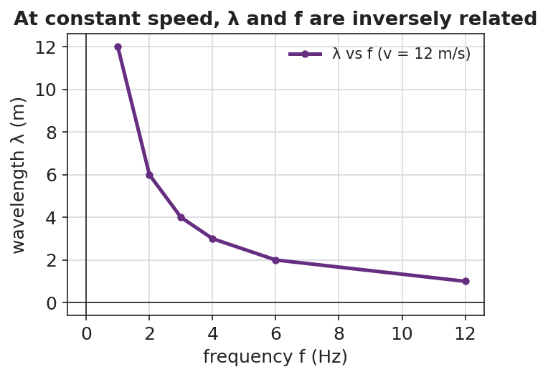
A line graph of wavelength versus frequency at a constant wave speed of 12 m/s, showing an inverse (curved-down) relationship.
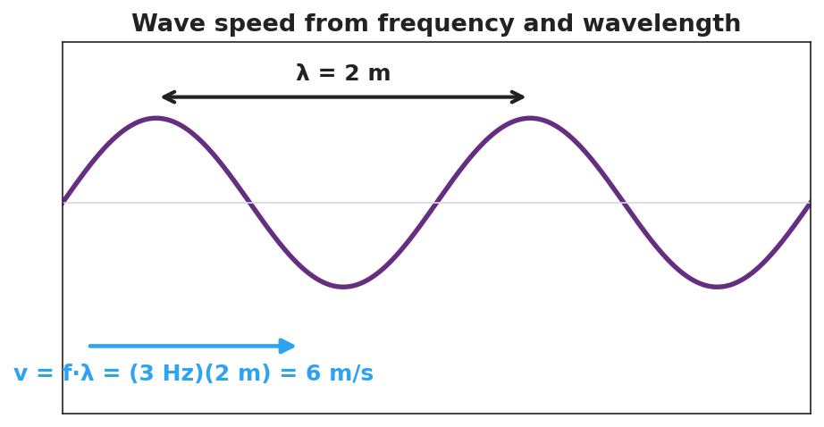
A wave with wavelength λ = 2 m labeled, showing the worked relationship v = f·λ = (3 Hz)(2 m) = 6 m/s.

Teacher facilitation during Explore
- What to look for — pairs noticing f·λ stays (nearly) constant; the λ-vs-f graph curving downward (inverse, not straight-line).
- What to resist — don’t write v = f·λ on the board yet; let the constant product surface from the data.
- What to redirect — students who expect a straight line should be asked, “if f goes up and the product stays the same, what must λ do?”

Phase 3 · Explain (32 – 37 min)

32–35 min · Turn-and-Talk #2 + class consensus
“Why did f·λ come out the same in every row?”
Target consensus:
“Because f·λ equals the wave’s speed, and the speed didn’t change — it’s set by the medium. So when f goes up, λ must go down to keep the product (the speed) the same.”

35–37 min · Vocabulary introduction (≤ 3 terms) + the HOCHMAN sentence
Sample teacher language:
“That constant product is the wave speed: v = f·λ. Frequency is measured in hertz (cycles per second), and the time for one cycle is the period, T = 1/f.”
HOCHMAN Because/But/So expansion (do this aloud, then students write):
“In a given medium the wave speed is constant because the medium sets how fast a disturbance travels, but the source can change the frequency, so the wavelength must change in the opposite direction to keep v = f·λ true.”

Discussion prompts to deploy here
- “A wave travels at 340 m/s with a frequency of 170 Hz. What is its wavelength?”
  - Sample student response: “λ = v/f = 340/170 = 2 m.”
- “If you double the frequency at the same speed, what happens to the wavelength?”
  - Sample student response: “It halves — they’re inversely related.”

Phase 4 · Elaborate (37 – 40 min)

37–39 min · Revise the model
“Return to your prediction. Was it right? Re-write it as a Because/But/So sentence using v = f·λ and the words wave speed, frequency, and wavelength.”

39–40 min · Return to the phenomenon
“Back to the guitar: the thin string and thick string can carry the same note’s speed — so why do they sound different? Answer in one sentence using frequency and wavelength.”
Target: “Each string’s wave speed is fixed, so a different frequency (pitch) means a different wavelength — that’s why thinner/shorter strings sound higher.”

Phase 5 · Evaluate (40 – 42 min)

40–42 min · Exit Ticket + Closing Reflection
“A sound wave in air travels at 340 m/s. (a) A note has a frequency of 256 Hz. Find its wavelength. Show v = f·λ rearranged. (b) A higher note has a frequency of 512 Hz at the same speed. Without a calculator, is its wavelength longer or shorter, and by what factor? (c) What is the period of the 256 Hz note?”
Expected: (a) λ = v/f = 340/256 ≈ 1.33 m; (b) shorter — half the wavelength, since frequency doubled at the same speed; (c) T = 1/f = 1/256 ≈ 0.0039 s. See Answer_Key.docx.
Closing Reflection (SEL, 30 seconds):
“What is one thing about the v = f·λ relationship that finally clicked today?”

Common Misconceptions
- Misconception: “Increasing the frequency makes the wave travel faster.” → Correction: Speed is set by the medium; raising f shortens λ instead — the product v = f·λ stays the same.
- Misconception: “Wavelength and frequency are directly proportional.” → Correction: At constant speed they are inversely proportional (f up → λ down).
- Misconception: “Period and frequency are the same number.” → Correction: They are reciprocals; a 256 Hz note has a tiny period of about 0.0039 s.

Access & Differentiation
- ELL/ENL supports: Provide the formula triangle (v on top; f and λ on the bottom) and a sentence frame: “When frequency goes ______, wavelength goes ______, because the speed stays ______.” Word-choice box: {up, down, constant, inversely}.
- IEP/SPED supports: Give a partially completed v = f·λ table; students fill only the missing cell using the formula triangle. Provide calculators and a worked first row.
- Extensions: Different media — a sound wave moving from air (340 m/s) into water (~1500 m/s) keeps the same frequency (set by the source). What happens to its wavelength? (It gets longer.) Preview of refraction (Lesson 08).

Strategy Spotlight
HOCHMAN. The key relationship is built as a single complex sentence using Because / But / So. Model it aloud first, then have students write their own. The conjunctions force the causal logic: the speed is fixed because the medium sets it, but the source changes the frequency, so the wavelength must change in the opposite direction. This sentence-level expansion is the literacy core of the lesson; collect a few and read them back to refine precision (e.g., replacing “changes” with “decreases”).

NYSSLS Observation Checklist Crosswalk
# | Checklist item | Where it appears in this lesson
1 | Local/relatable phenomenon | Phase 1 — guitar strings; sound wave in Phase 5
2 | Turn and Talk (2–3×) | Phase 1 (TT#1 — same speed, different f), Phase 3 (TT#2 — why f·λ is constant)
3 | Students develop questions/models/procedures | Phase 1 (prediction), Phase 2 (PhET data table + graph), Phase 4 (revise)
4 | CCC defined and used | Lesson Overview · Cause and Effect, restated in Phase 2
5 | ENL — ≤ 3 vocab, second half | Phase 3 — vocabulary at 35–37 min (wave speed / period / hertz)
6 | Revisit phenomenon with evidence | Phase 4 — guitar explanation using v = f·λ
7 | ENL/SPED supports | Access & Differentiation block
8 | Assessment check | Phase 5 — numeric Exit Ticket (sound in air)

Companion Materials
- Student_Worksheet.docx — the 5E student investigation (hand out at start of Phase 2)
- Student_Notes.docx — guided note-guide for vocabulary and the worked example
- Answer_Key.docx — answers to “Make It Make Sense” prompts and the Exit Ticket

Key Vocabulary (max 3)
- wave speed — how fast a wave’s energy travels through a medium; v = f·λ, set by the medium (not by amplitude or frequency)
- period — the time for one complete wave cycle, in seconds; the reciprocal of frequency, T = 1/f
- hertz — the unit of frequency, equal to one cycle per second (Hz)

Wave Speed, Frequency, and Wavelength — Student Worksheet
Unit: Waves — Lesson 03 Name: _______________________ Date: __________ Period: ____

Phenomenon
Your teacher plucks a thick low string and a thin high string the same way — they sound like completely different notes. The wave speed on each string is fixed by the string itself, yet the pitches are not the same.
Driving question: If two notes travel at the same speed, what must be different about their waves?

Notice & Wonder
I notice… | I wonder…
Turn & Talk #1: If two waves on a string travel at the same speed but have different frequencies, what has to be different about their wavelengths?

Initial Model
Predict: if you keep the wave speed the same but double the frequency, what happens to the wavelength? Write your prediction and a reason.

My reason: _______________________________________________

Investigation
Open PhET Wave on a String in oscillate mode with the tension fixed (so the speed stays constant). Use the ruler to measure one wavelength at each frequency.
Frequency f (Hz) | Wavelength λ (m) | Product f × λ
These figures show the pattern you are testing:

Wavelength versus frequency at constant speed — an inverse relationship.

A wave labeled with λ = 2 m and the worked relationship v = f·λ = (3 Hz)(2 m) = 6 m/s.
Key question: What do you notice about the column f × λ? What does that product represent?

Make It Make Sense
- A wave travels at 340 m/s with a frequency of 170 Hz. Find its wavelength. Show v = f·λ rearranged.
- At a fixed wave speed, you triple the frequency. What happens to the wavelength, and by what factor?
- Write a Because/But/So sentence explaining why frequency and wavelength are inversely related at a constant wave speed.

Vocabulary in Action
Use each term in a sentence about today’s investigation.
- wave speed: _______________________________________________
- period: _______________________________________________
- hertz: _______________________________________________

Revise Your Model
Return to your prediction. Was it right? Rewrite it as a Because / But / So sentence using v = f·λ and the words wave speed, frequency, and wavelength.
Because __________________________________________, but __________________________________________, so __________________________________________.

Exit Ticket
A sound wave in air travels at 340 m/s.
- A note has a frequency of 256 Hz. Find its wavelength. Show v = f·λ rearranged.
- A higher note has a frequency of 512 Hz at the same speed. Without a calculator, is its wavelength longer or shorter, and by what factor?
- What is the period of the 256 Hz note?

Wave Speed, Frequency, and Wavelength — Student Notes
Unit: Waves — Lesson 03 Name: _______________________ Date: __________ Period: ____

Learning Targets
By the end of today’s 42 minutes I can:
- Use v = f·λ to solve for speed, frequency, or wavelength.
- Explain why, in a given medium, frequency and wavelength are inversely related.
- Convert between period and frequency with T = 1/f.

Key Vocabulary
- wave speed — _______________________________________________
- period — _______________________________________________
- hertz — _______________________________________________

Guided Notes
The wave equation: v = f · λ
- v = wave __________ (m/s)
- f = __________ (Hz)
- λ = __________ (m)
Big idea. In a given medium the wave speed is __________ (set by the medium). So if the source raises the frequency, the wavelength must go __________ to keep the product the same.

Wavelength versus frequency at constant speed — an inverse relationship.
- Higher frequency → __________ wavelength (inverse).
- The product f·λ always equals the __________.
Period and frequency are reciprocals:
- T = 1 / __________ and f = 1 / __________.

A wave labeled with λ = 2 m and v = f·λ = (3 Hz)(2 m) = 6 m/s.

Worked Example
Problem. A wave travels at 6 m/s. Its frequency is 3 Hz. (a) Find the wavelength. (b) Find the period.
Solution. 1. Rearrange v = f·λ for wavelength: λ = v / f = 6 / 3 = __________ m. 2. Period: T = 1 / f = 1 / 3 = __________ s (about 0.33 s). 3. Check with v = f·λ: (3 Hz)(2 m) = __________ m/s. ✓

Summary
Finish the sentence (Because / But / So):
In one medium the wave speed stays the same because __________________________________________, but __________________________________________, so __________________________________________.

Wave Speed, Frequency, and Wavelength — Answer Key

Cover
Unit: Waves — Lesson 03: Wave Speed, Frequency, and Wavelength East Meadow Schools × Valley Stream Central HSD Strategy chip: HOCHMAN

Make-It-Make-Sense Answers
- Rearrange v = f·λ → λ = v/f = 340 / 170 = 2 m. · Rubric: correct rearrangement AND value with units. · NYSSLS: HS-PS4-1
- Tripling the frequency at fixed speed makes the wavelength one-third as long (inverse relationship). · Rubric: states 1/3 AND inverse reasoning. · NYSSLS: HS-PS4-1
- Example: “The wave speed stays constant because the medium sets how fast a disturbance moves, but the source can raise the frequency, so the wavelength must shrink to keep v = f·λ true.” · Rubric: correct Because/But/So with inverse logic. · NYSSLS: HS-PS4-1

Exit Ticket Answer
- λ = v/f = 340 / 256 ≈ 1.33 m.
- Shorter — half the wavelength (≈ 0.66 m), because doubling the frequency at the same speed halves the wavelength.
- T = 1/f = 1/256 ≈ 0.0039 s (about 3.9 ms).
Tolerance/rubric: (a) 1.3–1.33 m with v = f·λ shown; (b) “half / shorter by factor 2”; (c) ≈ 0.0039 s. 1 point each. NYSSLS: HS-PS4-1.

Closing Reflection (rubric)
Formative, not graded. Award full credit for any honest response. Look for: - A specific statement of what clicked about v = f·λ (often the inverse trade-off) - Genuine reflection rather than a restated definition

Standing Waves and Resonance — Teacher Guide

Cover
Unit: Waves — Lesson 04: Standing Waves and Resonance East Meadow Schools × Valley Stream Central High School District Strategy chips: ACTIVE LEARNING

Curated Resources (from East Meadow Scope & Sequence)

NYSSLS Standards
HS-PS4-1. “Use mathematical representations to support a claim regarding relationships among the frequency, wavelength, and speed of waves traveling in various media. (Cause and Effect)”
Standing waves are a direct consequence of v = f·λ on a bounded medium: only certain wavelengths (and therefore certain frequencies) “fit” between the fixed ends, producing the harmonic series. Resonance is the Cause-and-Effect link — driving a system at one of its natural frequencies causes a large-amplitude response.

Phenomenon
- A standing wave on a vibrating string (Melde’s experiment) and a “musical fire table” (a Rubens’ tube) showing standing sound waves: https://www.youtube.com/watch?v=PHRO_d0M5wo
- An opera singer shattering a wine glass by matching its resonant frequency: https://www.youtube.com/watch?v=BE827gwnnk4

Javalab / Labs
- Javalab Standing Wave — drive a fixed-end string and watch nodes and antinodes form at the natural frequencies: https://javalab.org/en/standing_wave_en/

Assessments
- Javalab “find the harmonics” task: students sweep the driving frequency to locate the first three standing-wave patterns and count nodes/antinodes. Exit ticket below serves as the formative check.

Lesson Overview
Duration | 42 minutes (1 period)
NYSSLS link | HS-PS4-1 (which wavelengths “fit”; resonance)
CCC focus | Cause and Effect — driving a bounded medium at a natural frequency causes a large, stable standing-wave pattern.
Strategy chips | ACTIVE LEARNING
Materials | Long elastic cords or strings (one per group); a function generator/string vibrator OR a hand-shaken rope; tuning forks; a wine glass + dampened finger (demo); devices for Javalab.
Safety | Eye protection if doing a real glass-shatter demo; otherwise show the video.
Prior knowledge | Lessons 01–03 — wavelength, frequency, v = f·λ; reflection of a wave at a fixed end.
Lesson objectives — students can:
- Explain that a standing wave forms when a wave interferes with its own reflection, creating fixed nodes and antinodes.
- Identify nodes (no motion) and antinodes (maximum motion) and count them for the first few harmonics.
- Explain resonance: a large response occurs when a system is driven at one of its natural frequencies.

Phase 1 · Engage (0 – 12 min)

0–3 min · Opening Connection (SEL)
Quick check-in: “Name something that ‘clicks’ for you when the timing is just right — a song, a sport, a routine.” One sentence each. This previews resonance: the right timing produces a big effect.

3–8 min · Phenomenon hook — the glass and the string
Teacher actions. Play the wine-glass shatter clip, then shake a rope at increasing speed until a clean standing-wave loop snaps into place. Most frequencies make a messy rope; one special frequency makes a clean, big, standing pattern.
Sample teacher language:
“Most of the time the rope just looks chaotic. But at one special speed of my hand, it locks into this beautiful, big, still-looking pattern. What’s special about that frequency?”
Anticipated student responses:
- “It looks like it’s standing still.” — capture standing; the loops stay in place.
- “You hit the right rhythm.” — affirm; that’s resonance in everyday words.
- “The wave bounced back and added to itself.” — excellent; this is the mechanism.

8–12 min · Notice & Wonder + Turn-and-Talk #1
Capture columns. Then:
“Turn to your partner: where on the rope is there no motion at all, and where is the motion biggest?”
Target: there are points that never move (future nodes) and points that swing the most (future antinodes).

Bridge to Phase 2
Initial model sentence: “A clean, big rope pattern formed because the wave and its ______ added together at just the right ______.”

Phase 2 · Explore (12 – 32 min)

12–17 min · Initial Model (silent / individual)
Prompt:
“Sketch the rope at the special frequency. Mark with an X every point that does not move, and with a star every point that moves the most. Predict what happens to the number of loops if you shake faster.”

17–32 min · Investigation — ACTIVE LEARNING: hunt the harmonics
Groups of 3–4, each with a string/cord (one end fixed or held, the other shaken or driven) and Javalab open:
- Find the fundamental. Shake slowly and increase frequency until one clean loop appears. Mark the still points and the big-swing point.
- Climb the series. Keep increasing frequency. Catch the 2-loop pattern, then the 3-loop pattern. Record how many nodes and antinodes each has.
- Off-resonance test. Set a frequency between two harmonics. What does the rope do? (Messy, small.)
- Javalab confirm. Reproduce the first three harmonics in the sim; count nodes/antinodes.
Use this figure to compare each group’s harmonics:
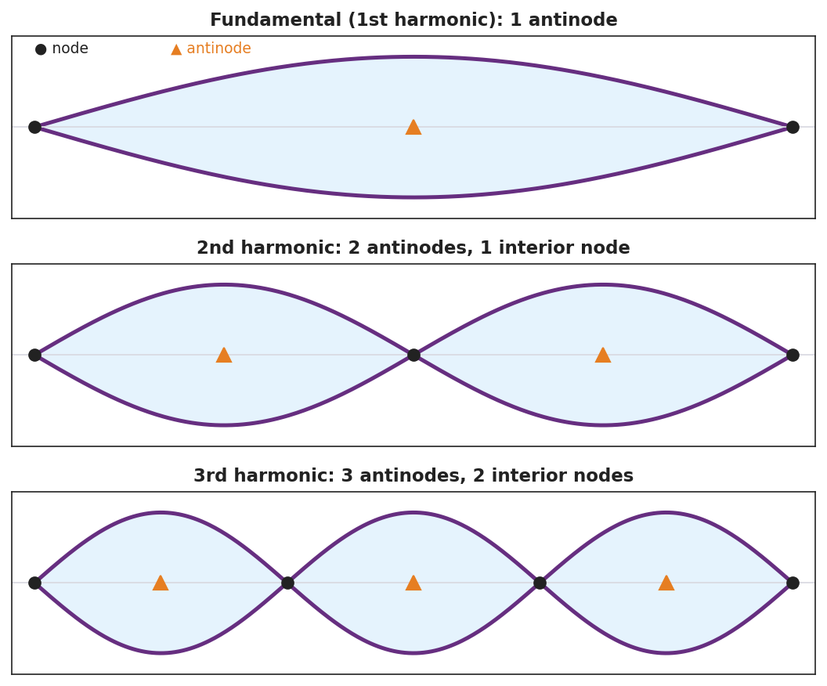
Three fixed-end standing-wave patterns: the fundamental (1 antinode), the 2nd harmonic (2 antinodes, 1 interior node), and the 3rd harmonic (3 antinodes, 2 interior nodes), with nodes and antinodes marked.
The resonance curve below explains why only the off-resonance test (step 3) gives a small, messy response — amplitude spikes sharply only at the natural frequency:
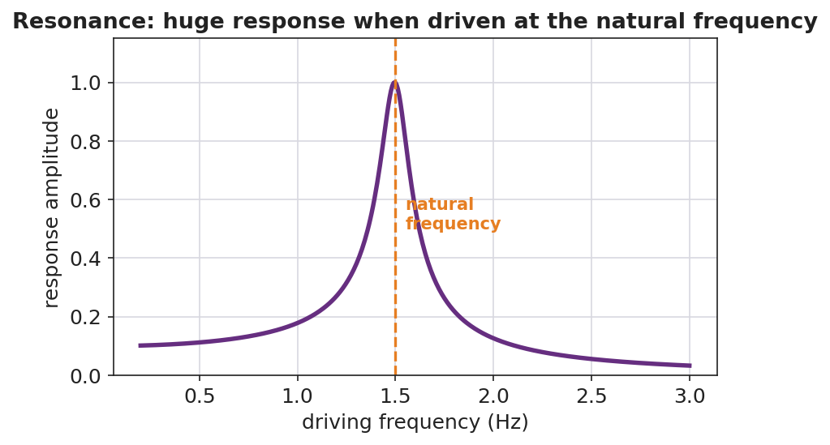
A resonance response curve: response amplitude is small at most driving frequencies but spikes sharply at the natural frequency.

Teacher facilitation during Explore
- What to look for — groups connecting “only certain hand-speeds work” to “only certain wavelengths fit between the ends.”
- What to resist — don’t name node/antinode/resonance yet; let “still point” and “big-swing point” and “the right speed” emerge.
- What to redirect — students who think the pattern travels should be asked, “do the loops move along the rope, or stay in place?”

Phase 3 · Explain (32 – 37 min)

32–35 min · Turn-and-Talk #2 + class consensus
“Why does only the right frequency make a clean, standing pattern?”
Target consensus:
“The wave reflects off the fixed end and travels back. At certain frequencies the returning wave lines up with the new wave so they always add the same way, creating a pattern that stays in place with fixed still points and big-swing points.”

35–37 min · Vocabulary introduction (≤ 3 terms)
Sample teacher language:
“A pattern that stays in place from a wave interfering with its own reflection is a standing wave. The points that never move are nodes; the points of maximum motion are antinodes. And when you drive a system at one of its natural frequencies and get this big response, that’s resonance — exactly how the opera singer shattered the glass.”

Discussion prompts to deploy here
- “How many nodes does the 3rd harmonic have between the two ends?”
  - Sample student response: “Two interior nodes (plus the two fixed ends).”
- “Why did the glass shatter only at one pitch?”
  - Sample student response: “That pitch matched the glass’s natural frequency — resonance built the vibration up until it broke.”

Phase 4 · Elaborate (37 – 40 min)

37–39 min · Revise the model
“Return to your rope sketch. Re-label the X’s as nodes and the stars as antinodes. Add a one-sentence definition of resonance using the word natural frequency.”

39–40 min · Return to the phenomenon
“Explain to a peer, in one sentence, why pushing a swing at just the right rhythm makes it go higher — and connect it to the rope and the glass.”
Target: “Pushing at the swing’s natural frequency is resonance, the same reason the rope locks into a standing wave and the glass shatters — driving at the natural frequency builds a large response.”

Phase 5 · Evaluate (40 – 42 min)

40–42 min · Exit Ticket + Closing Reflection
“A standing wave on a string shows 2 full loops between the fixed ends. (a) How many nodes are there in total (including the ends)? How many antinodes? (b) Define resonance in one sentence. (c) A bridge can sway dangerously if wind or marching feet hit a certain frequency. Which idea from today explains this?”
Expected: (a) 3 nodes (two ends + one middle), 2 antinodes; (b) resonance = large-amplitude response when a system is driven at its natural frequency; (c) resonance. See Answer_Key.docx.
Closing Reflection (SEL, 30 seconds):
“When did your group hit ‘resonance’ today — a moment where everything clicked? What made it work?”

Common Misconceptions
- Misconception: “A standing wave is not really moving.” → Correction: It is two waves moving in opposite directions; the pattern of nodes/antinodes stays fixed while the medium still oscillates.
- Misconception: “Any frequency makes a standing wave.” → Correction: Only the natural frequencies (where reflections line up) produce standing waves; other frequencies give a messy, small response.
- Misconception: “Resonance is just ‘loud.’” → Correction: Resonance is a large-amplitude response that occurs specifically when the driving frequency matches a natural frequency.

Access & Differentiation
- ELL/ENL supports: Sentence frame: “A node is a point that ______; an antinode is a point that ______. Resonance happens when the driving frequency ______ a natural frequency.” Word-choice box: {never moves, moves the most, matches, standing wave}. Pair node with a closed fist (no motion) and antinode with a wide wave of the hand.
- IEP/SPED supports: Provide the harmonics figure with blanks; students label N (node) and A (antinode) rather than drawing. Offer the hand-shaken rope as a tactile alternative to the function generator.
- Extensions: For a fixed-fixed string of length L, the fundamental wavelength is 2L. Have students predict the wavelengths of the 2nd and 3rd harmonics (L and 2L/3) and use v = f·λ to relate the harmonic frequencies.

Strategy Spotlight
ACTIVE LEARNING. Students physically sweep the driving frequency and “catch” each harmonic, marking the still points and big-swing points with their own hands before the words node, antinode, and resonance are introduced. The act of hunting — most frequencies fail, a few succeed — builds an intuition for natural frequencies that a lecture cannot. Facilitate with one prompt: “What’s special about the frequencies that work?”

NYSSLS Observation Checklist Crosswalk
# | Checklist item | Where it appears in this lesson
1 | Local/relatable phenomenon | Phase 1 — shattering glass, shaken rope; bridge/swing in Phase 4–5
2 | Turn and Talk (2–3×) | Phase 1 (TT#1 — still vs. big-swing points), Phase 3 (TT#2 — why only the right frequency)
3 | Students develop questions/models/procedures | Phase 1 (initial model), Phase 2 (harmonic hunt + Javalab), Phase 4 (revise)
4 | CCC defined and used | Lesson Overview · Cause and Effect, restated in Phase 2
5 | ENL — ≤ 3 vocab, second half | Phase 3 — vocabulary at 35–37 min (standing wave / node / resonance)
6 | Revisit phenomenon with evidence | Phase 4 — swing/glass/rope connection
7 | ENL/SPED supports | Access & Differentiation block
8 | Assessment check | Phase 5 — Exit Ticket (2-loop standing wave; bridge)

Companion Materials
- Student_Worksheet.docx — the 5E student investigation (hand out at start of Phase 2)
- Student_Notes.docx — guided note-guide for vocabulary and the worked example
- Answer_Key.docx — answers to “Make It Make Sense” prompts and the Exit Ticket

Key Vocabulary (max 3)
- standing wave — a fixed pattern of nodes and antinodes formed when a wave interferes with its own reflection in a bounded medium
- node — a point in a standing wave that stays at rest (no motion) because the two waves always cancel there
- resonance — the large-amplitude response that occurs when a system is driven at one of its natural frequencies

Standing Waves and Resonance — Student Worksheet
Unit: Waves — Lesson 04 Name: _______________________ Date: __________ Period: ____

Phenomenon
An opera singer holds one steady note and a wine glass shatters. On a shaken rope, most hand-speeds make a messy mess — but at one special speed the rope locks into a clean, big pattern that seems to stand still.
Driving question: What is special about the one frequency that makes a clean, standing pattern?

Notice & Wonder
I notice… | I wonder…
Turn & Talk #1: On the rope at the special frequency, where is there no motion at all, and where is the motion biggest?

Initial Model
Sketch the rope at the special frequency. Mark with an X every point that does not move, and a star at every point that moves the most. Predict: what happens to the number of loops if you shake faster?

My prediction: _______________________________________________

Investigation
Work in a group of 3–4 with a string and the Javalab Standing Wave sim.
Step | Frequency / speed | Number of loops | Nodes (still points) | Antinodes (big-swing)
1. Fundamental
2. Next harmonic
3. Third harmonic
4. Off-resonance (between) |  | (messy?)
Compare your patterns to this diagram:

Three standing-wave harmonics with nodes and antinodes marked: fundamental, 2nd, and 3rd.
Key question: What did the rope do at a frequency between two harmonics? What does that tell you about which frequencies “work”?

Make It Make Sense
- How does a standing wave form? Use the words reflection and interfere.
- The 3rd harmonic on a fixed-end string has how many nodes (including the ends) and how many antinodes?
- Why did the wine glass shatter at only one specific pitch? Use the word natural frequency.

Vocabulary in Action
Use each term in a sentence about today’s phenomenon.
- standing wave: _______________________________________________
- node: _______________________________________________
- resonance: _______________________________________________

Revise Your Model
Return to your rope sketch. Re-label the X’s as nodes and the stars as antinodes. Add a one-sentence definition of resonance using the words natural frequency.

Exit Ticket
A standing wave on a string shows 2 full loops between the fixed ends.
- How many nodes are there in total (including the ends)? How many antinodes?
- Define resonance in one sentence.
- A bridge can sway dangerously if wind or marching feet hit a certain frequency. Which idea from today explains this?

Standing Waves and Resonance — Student Notes
Unit: Waves — Lesson 04 Name: _______________________ Date: __________ Period: ____

Learning Targets
By the end of today’s 42 minutes I can:
- Explain how a standing wave forms from a wave and its reflection.
- Identify nodes and antinodes and count them for the first harmonics.
- Explain resonance in terms of natural frequency.

Key Vocabulary
- standing wave — _______________________________________________
- node — _______________________________________________
- resonance — _______________________________________________

Guided Notes
How a standing wave forms. A wave hits a fixed end and __________ back. The returning wave __________ (interferes) with the new wave. At certain frequencies they always add the same way, making a pattern that stays in __________.

Three standing-wave harmonics with nodes and antinodes labeled.
- Node — a point that __________ moves (the waves cancel there).
- Antinode — a point that moves the __________.
- Fundamental (1st harmonic) — __________ antinode.
- 2nd harmonic — __________ antinodes, 1 interior node.
- 3rd harmonic — 3 antinodes, __________ interior nodes.
Resonance. Driving a system at one of its __________ frequencies produces a __________ (large) response. Examples: a swing pushed in rhythm, a shattering glass, a vibrating string.

Worked Example
Problem. A standing wave on a string shows 3 full loops between the fixed ends.
Solution. 1. Each loop is one antinode → there are __________ antinodes. 2. Nodes appear between loops plus at both fixed ends → __________ nodes total. 3. This is the __________ harmonic.

Summary
Finish the sentence (Because / But / So):
A shaken rope usually looks messy because __________________________________________, but __________________________________________, so __________________________________________.

Standing Waves and Resonance — Answer Key

Cover
Unit: Waves — Lesson 04: Standing Waves and Resonance East Meadow Schools × Valley Stream Central HSD Strategy chip: ACTIVE LEARNING

Make-It-Make-Sense Answers
- A wave travels to a fixed end and reflects back. The reflected wave interferes with the incoming wave; at the natural frequencies they always add the same way, producing a fixed pattern of nodes and antinodes. · Rubric: uses reflection AND interference. · NYSSLS: HS-PS4-1
- The 3rd harmonic has 4 nodes (two fixed ends + two interior) and 3 antinodes. · Rubric: both counts correct. · NYSSLS: HS-PS4-1
- The glass has a natural frequency. When the singer’s pitch matched it, resonance built the glass’s vibration to a large amplitude until it shattered. · Rubric: names natural frequency AND resonance. · NYSSLS: HS-PS4-1

Exit Ticket Answer
- 2 full loops → 3 nodes total (both ends + one in the middle) and 2 antinodes (one per loop).
- Resonance is the large-amplitude response that happens when a system is driven at one of its natural frequencies.
- Resonance — the wind or marching feet drive the bridge at its natural frequency, building a dangerously large sway.
Tolerance/rubric: (a) 3 nodes AND 2 antinodes; (b) must include “natural frequency”; (c) resonance. 1 point each. NYSSLS: HS-PS4-1.

Closing Reflection (rubric)
Formative, not graded. Award full credit for any honest response. Look for: - A genuine “click” moment connected to the group’s harmonic hunt - Acknowledgment of what made the collaboration work

Interference: Constructive and Destructive — Teacher Guide

Cover
Unit: Waves — Lesson 05: Interference (Constructive and Destructive) East Meadow Schools × Valley Stream Central High School District Strategy chips: BTC

Curated Resources (from East Meadow Scope & Sequence)

NYSSLS Standards
HS-PS4-1. “Use mathematical representations to support a claim regarding relationships among the frequency, wavelength, and speed of waves traveling in various media. (Cause and Effect)”
Interference is the principle of superposition in action and is the mechanism behind the standing waves of Lesson 04. Two waves of the same frequency and wavelength add point-by-point; whether they reinforce or cancel depends on their phase — a Cause-and-Effect relationship between path difference and loudness/brightness.

Phenomenon
- Two speakers playing the same steady tone create “loud spots” and “quiet spots” as you walk across a room: https://www.youtube.com/watch?v=ImoQqDyHd1Y
- Noise-canceling headphones: a microphone hears the noise and the speaker plays the opposite wave to cancel it.

Javalab / Labs
- Javalab Wave Superposition / Interference — drag two waves together and watch them add: https://javalab.org/en/wave_synthesis_en/

Assessments
- Javalab superposition task: students align two waves in phase (predict the sum) and then shift one by half a wavelength (predict cancellation). Exit ticket below serves as the formative check.

Lesson Overview
Duration | 42 minutes (1 period)
NYSSLS link | HS-PS4-1 (superposition; mechanism of standing waves)
CCC focus | Cause and Effect — the phase relationship between two waves causes either reinforcement (constructive) or cancellation (destructive).
Strategy chips | BTC (Building Thinking Classrooms)
Materials | Vertical non-permanent surfaces (whiteboards/windows); markers; two small speakers + tone generator app; ripple-tank video or Javalab on devices.
Safety | Keep tone-generator volume moderate.
Prior knowledge | Lessons 01–04 — amplitude, wavelength, frequency; standing waves come from interfering reflections.
Lesson objectives — students can:
- State the principle of superposition: overlapping waves add point-by-point.
- Distinguish constructive interference (in phase → amplitudes add) from destructive interference (out of phase → amplitudes cancel).
- Explain a real “loud/quiet spot” or noise-canceling situation using interference.

Phase 1 · Engage (0 – 12 min)

0–3 min · Opening Connection (SEL)
Quick check-in: “Name a time two things combined to make something bigger — or two things canceled each other out.” One sentence each. This previews constructive vs. destructive.

3–8 min · Phenomenon hook — walk the room of two speakers
Teacher actions. Play the same steady tone from two speakers a few meters apart. Walk slowly across the front; students hear the volume rise and fall. Show the noise-canceling clip as the second case.
Sample teacher language:
“Same tone, two speakers, and yet some spots are loud and some are nearly silent — and I didn’t touch the volume. How can adding a second speaker make a spot quieter?”
Anticipated student responses:
- “The sounds cancel somewhere.” — exactly; capture cancel.
- “They add up in the loud spots.” — yes; reinforcement.
- “The waves are out of step.” — excellent; this is phase.

8–12 min · Notice & Wonder + Turn-and-Talk #1
Capture columns. Then:
“Turn to your partner: what would have to be true about the two waves arriving at a quiet spot for them to cancel?”
Target: they arrive out of step — a crest of one lands on a trough of the other.

Bridge to Phase 2
Initial model sentence: “A quiet spot happens because the two waves arrive ______, so they ______ each other.”

Phase 2 · Explore (12 – 32 min)

12–17 min · Initial Model (silent / individual)
Prompt:
“Draw two waves arriving at the same point. Draw one version that would make a LOUD spot and one that would make a QUIET spot. What’s different about how the crests line up?”

17–32 min · Investigation — BTC: random groups, vertical surfaces
Form visibly random groups of 3; send each to a vertical non-permanent surface with one marker per group. Pose the thin-slice tasks one at a time, escalating:
- Two identical waves, crest-on-crest. Draw the sum. (Bigger.)
- Two identical waves, crest-on-trough. Draw the sum. (Flat — zero.)
- Shift one wave by half a wavelength. What’s the sum now? Relate it to task 2.
- Stretch: In the two-speaker room, why does the quiet spot become loud if you cover one speaker? (Removing one wave removes the cancellation.)
Have students confirm at Javalab, then check predictions against this figure pair:
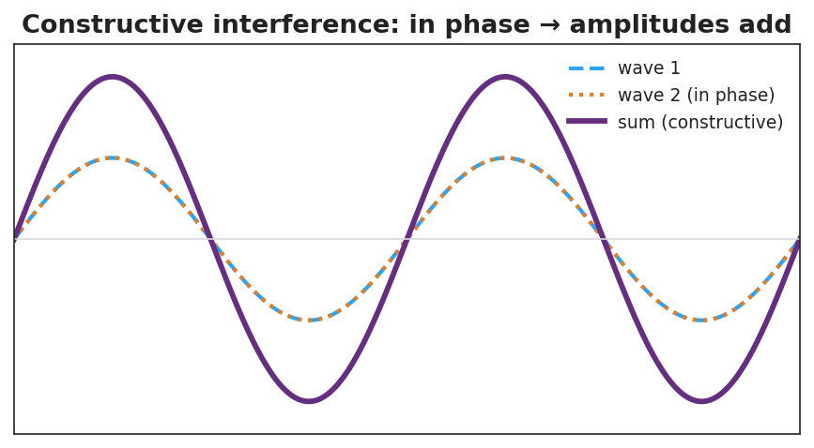
Two in-phase waves adding to a larger wave — constructive interference.
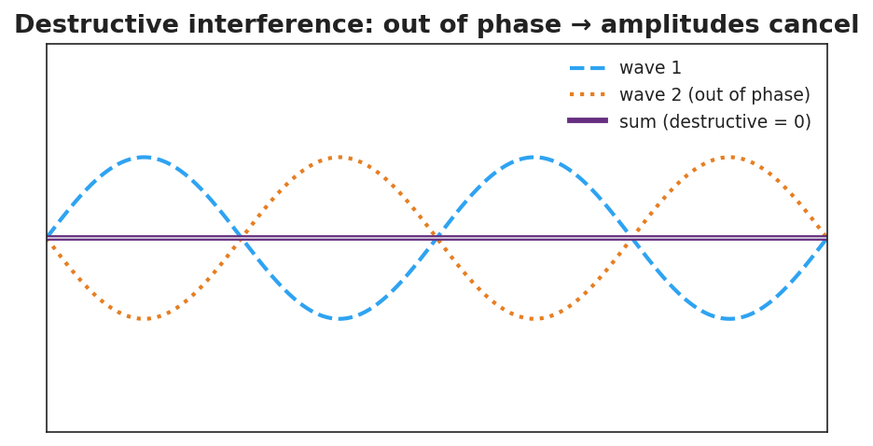
Two out-of-phase waves canceling to a flat line — destructive interference.

Teacher facilitation during Explore
- What to look for — groups adding waves point-by-point (sampling several x-values), not just eyeballing.
- What to resist — don’t supply “superposition,” “constructive,” or “destructive” yet; circulate and ask, “what did you do to combine them?”
- What to redirect — groups who say “they just disappear” should be asked, “where did the energy go — is it gone everywhere, or moved to the loud spots?”

Phase 3 · Explain (32 – 37 min)

32–35 min · Turn-and-Talk #2 + class consensus
“What is the rule for combining two overlapping waves, and what decides whether you get a loud or quiet result?”
Target consensus:
“You add the two waves point-by-point. If they’re in step (in phase), the crests add and you get a bigger wave. If they’re out of step (a crest on a trough), they cancel.”

35–37 min · Vocabulary introduction (≤ 3 terms)
Sample teacher language:
“Adding overlapping waves point-by-point is superposition. When they’re in phase and reinforce, that’s constructive interference. When they’re out of phase and cancel, that’s destructive interference — exactly how noise-canceling headphones silence a hum.”

Discussion prompts to deploy here
- “Two waves of amplitude 3 cm meet exactly in phase. What is the amplitude of the result?”
  - Sample student response: “6 cm — they add.”
- “The same two waves meet exactly out of phase. What is the result?”
  - Sample student response: “Zero — they cancel.”

Phase 4 · Elaborate (37 – 40 min)

37–39 min · Revise the model
“Return to your loud-spot and quiet-spot drawings. Label one constructive and one destructive. Add a sentence using the word superposition.”

39–40 min · Return to the phenomenon
“Explain in one sentence how noise-canceling headphones make a hum disappear, using destructive interference.”
Target: “The headphones play a wave that is exactly out of phase with the hum, so by superposition the two cancel — destructive interference — and you hear silence.”

Phase 5 · Evaluate (40 – 42 min)

40–42 min · Exit Ticket + Closing Reflection
“Two speakers play the same tone. At one point in the room a listener hears almost nothing. (a) Is this constructive or destructive interference? (b) Describe how the two waves are arriving at that point (in phase or out of phase?). (c) Two waves of amplitude 4 cm meet exactly in phase. What is the resulting amplitude?”
Expected: (a) destructive; (b) out of phase — crest meets trough; (c) 8 cm. See Answer_Key.docx.
Closing Reflection (SEL, 30 seconds):
“In your random group today, when did your thinking ‘add up’ (constructive) — and was there a moment it ‘canceled’ and you had to rethink?”

Common Misconceptions
- Misconception: “When two waves cancel, the energy is destroyed.” → Correction: Energy is conserved — it is redistributed to the constructive (loud/bright) regions; cancellation is local.
- Misconception: “Two waves always make a bigger wave.” → Correction: Only if in phase; out of phase they cancel.
- Misconception: “Interference only happens with sound.” → Correction: All waves interfere — light, water, and radio waves too.

Access & Differentiation
- ELL/ENL supports: Sentence frame: “When two waves are ______ they add (constructive); when they are ______ they cancel (destructive).” Word-choice box: {in phase, out of phase, superposition, amplitude}. Pair constructive with hands coming together and destructive with hands canceling.
- IEP/SPED supports: Provide graph paper with two pre-drawn waves aligned; students add the y-values at marked x-points to build the sum. Offer a “crest + trough = flat” manipulative (two transparency sine curves to overlay).
- Extensions: Path difference — explain why a fixed point is loud or quiet in terms of the difference in distance to the two speakers (a whole number of wavelengths → constructive; a half-wavelength offset → destructive).

Strategy Spotlight
BTC (Building Thinking Classrooms). Use visibly random groups of 3 and vertical non-permanent surfaces (whiteboards/windows), one marker per group. Pose the interference tasks as escalating thin slices — start with crest-on-crest, then crest-on-trough, then a half-wavelength shift — giving each task only after the previous is solved. The vertical surface keeps thinking public and erasable; the single marker forces collaboration. Defer all vocabulary to Phase 3.

NYSSLS Observation Checklist Crosswalk
# | Checklist item | Where it appears in this lesson
1 | Local/relatable phenomenon | Phase 1 — two-speaker loud/quiet spots; noise-canceling headphones
2 | Turn and Talk (2–3×) | Phase 1 (TT#1 — cancellation condition), Phase 3 (TT#2 — the combining rule)
3 | Students develop questions/models/procedures | Phase 1 (initial model), Phase 2 (BTC vertical-surface tasks + Javalab), Phase 4 (revise)
4 | CCC defined and used | Lesson Overview · Cause and Effect, restated in Phase 2
5 | ENL — ≤ 3 vocab, second half | Phase 3 — vocabulary at 35–37 min (superposition / constructive / destructive)
6 | Revisit phenomenon with evidence | Phase 4 — noise-canceling explanation
7 | ENL/SPED supports | Access & Differentiation block
8 | Assessment check | Phase 5 — Exit Ticket (quiet spot; amplitude sum)

Companion Materials
- Student_Worksheet.docx — the 5E student investigation (hand out at start of Phase 2)
- Student_Notes.docx — guided note-guide for vocabulary and the worked example
- Answer_Key.docx — answers to “Make It Make Sense” prompts and the Exit Ticket

Key Vocabulary (max 3)
- superposition — the principle that when waves overlap, the total displacement is the point-by-point sum of the individual waves
- constructive interference — when waves meet in phase so their amplitudes add, producing a larger wave (louder/brighter)
- destructive interference — when waves meet out of phase so their amplitudes cancel, producing a smaller wave or silence

Interference: Constructive and Destructive — Student Worksheet
Unit: Waves — Lesson 05 Name: _______________________ Date: __________ Period: ____

Phenomenon
Two speakers play the exact same steady tone. As you walk across the room, the volume rises and falls — some spots are loud, some are nearly silent — and nobody touched the volume knob. Noise-canceling headphones do something even stranger: they add sound to create silence.
Driving question: How can adding a second wave make a spot quieter?

Notice & Wonder
I notice… | I wonder…
Turn & Talk #1: What would have to be true about two waves arriving at a quiet spot for them to cancel?

Initial Model
Draw two waves arriving at the same point. Draw one version that makes a LOUD spot and one that makes a QUIET spot. What is different about how the crests line up?

Investigation
Work in your random group of 3 at a vertical surface (one marker). Solve each task, then confirm in Javalab.
Task | Sketch the sum | What I found
1. Crest-on-crest
2. Crest-on-trough
3. Shift one wave by ½ wavelength
4. Why does covering one speaker make a quiet spot loud?
Compare your sketches to these:

Two in-phase waves adding to a larger wave — constructive interference.

Two out-of-phase waves canceling to a flat line — destructive interference.
Key question: When two waves cancel at a quiet spot, where did the energy go? Is it gone everywhere?

Make It Make Sense
- State the principle of superposition in your own words.
- Two waves of amplitude 3 cm meet exactly in phase. What is the resulting amplitude? What if they meet exactly out of phase?
- Explain how noise-canceling headphones make a hum disappear. Use the term destructive interference.

Vocabulary in Action
Use each term in a sentence about today’s phenomenon.
- superposition: _______________________________________________
- constructive interference: _______________________________________________
- destructive interference: _______________________________________________

Revise Your Model
Return to your loud-spot and quiet-spot drawings. Label one constructive and one destructive. Add a sentence using the word superposition.

Exit Ticket
Two speakers play the same tone. At one point in the room a listener hears almost nothing.
- Is this constructive or destructive interference?
- Describe how the two waves are arriving at that point (in phase or out of phase?).
- Two waves of amplitude 4 cm meet exactly in phase. What is the resulting amplitude?

Interference: Constructive and Destructive — Student Notes
Unit: Waves — Lesson 05 Name: _______________________ Date: __________ Period: ____

Learning Targets
By the end of today’s 42 minutes I can:
- State the principle of superposition.
- Distinguish constructive interference from destructive interference.
- Explain a real loud/quiet spot or noise-canceling situation.

Key Vocabulary
- superposition — _______________________________________________
- constructive interference — _______________________________________________
- destructive interference — _______________________________________________

Guided Notes
Superposition. When two waves overlap, the total displacement at each point is the __________ of the two waves at that point. You add them __________-by-__________.

Two in-phase waves adding to a larger wave.
Constructive interference.
- The waves are __________ phase (crest lines up with crest).
- The amplitudes __________.
- Result: a __________ wave (louder / brighter).

Two out-of-phase waves canceling to a flat line.
Destructive interference.
- The waves are __________ phase (crest lines up with trough).
- The amplitudes __________.
- Result: a __________ wave, or silence.
Energy is not destroyed. At a cancellation point the energy is __________ to the constructive (loud) regions — total energy is conserved.

Worked Example
Problem. Two waves, each with amplitude 5 cm, overlap. Find the resulting amplitude (a) exactly in phase, (b) exactly out of phase.
Solution. 1. In phase: amplitudes add → 5 + 5 = __________ cm (constructive). 2. Out of phase: amplitudes cancel → 5 − 5 = __________ cm (destructive). 3. So the same two waves can make a big wave or __________, depending on phase.

Summary
Finish the sentence (Because / But / So):
Two speakers playing the same tone can make a spot silent because __________________________________________, but __________________________________________, so __________________________________________.

Interference: Constructive and Destructive — Answer Key

Cover
Unit: Waves — Lesson 05: Interference (Constructive and Destructive) East Meadow Schools × Valley Stream Central HSD Strategy chip: BTC

Make-It-Make-Sense Answers
- Superposition: when two waves overlap, the total displacement at each point equals the point-by-point sum of the two waves. · Rubric: conveys point-by-point addition. · NYSSLS: HS-PS4-1
- In phase → amplitudes add → 6 cm (constructive). Out of phase → amplitudes cancel → 0 cm (destructive). · Rubric: both values correct with phase reasoning. · NYSSLS: HS-PS4-1
- The headphone plays a wave that is exactly out of phase with the hum. By superposition the two cancel (destructive interference), so the listener hears silence. · Rubric: out-of-phase AND cancellation. · NYSSLS: HS-PS4-1

Exit Ticket Answer
- Destructive interference.
- The two waves arrive out of phase — a crest of one meets a trough of the other, so they cancel.
- In phase → amplitudes add → 8 cm.
Tolerance/rubric: (a) destructive; (b) out of phase / crest-on-trough; (c) 8 cm. 1 point each. NYSSLS: HS-PS4-1.

Closing Reflection (rubric)
Formative, not graded. Award full credit for any honest response. Look for: - A specific moment thinking “added up” or had to be revised within the random group - Evidence of reflection on the collaborative process at the vertical surface

The Doppler Effect — Teacher Guide

Cover
Unit: Waves — Lesson 06: The Doppler Effect East Meadow Schools × Valley Stream Central High School District Strategy chips: HOCHMAN

Curated Resources (from East Meadow Scope & Sequence)

NYSSLS Standards
HS-PS4-1. “Use mathematical representations to support a claim regarding relationships among the frequency, wavelength, and speed of waves traveling in various media. (Cause and Effect)”
The Doppler effect is a Cause-and-Effect consequence of v = f·λ: relative motion between source and observer compresses or stretches the wavelength, so the observed frequency shifts. Connection to HS-ESS1-2 (“Construct an explanation of the Big Bang theory based on astronomical evidence of light spectra…”): the same physics gives redshift, the evidence that distant galaxies are receding and the universe is expanding.

Phenomenon
- An ambulance siren drops in pitch the instant it passes you; a race car “neeee-yowwm”: https://www.youtube.com/watch?v=imoxDcn2Sgo
- Astronomers’ redshift: light from receding galaxies is shifted toward longer (redder) wavelengths.

Javalab / Labs
- Javalab Doppler Effect — drag a moving source and watch the wavefronts bunch ahead and stretch behind: https://javalab.org/en/doppler_effect_en/

Assessments
- Javalab observer task: students place observers ahead of and behind a moving source and report which hears a higher frequency. Exit ticket below serves as the formative check.

Lesson Overview
Duration | 42 minutes (1 period)
NYSSLS link | HS-PS4-1 (core); connects to HS-ESS1-2 (redshift / expanding universe)
CCC focus | Cause and Effect — relative motion of source/observer causes a shift in the observed frequency and wavelength.
Strategy chips | HOCHMAN
Materials | A buzzer or phone playing a steady tone on a string to whirl safely (or video); devices for Javalab; whiteboards.
Safety | If whirling a buzzer, clear a wide circle and use a secure string.
Prior knowledge | Lessons 01–03 — frequency, wavelength, v = f·λ; wavefront idea.
Lesson objectives — students can:
- Explain that the Doppler effect is an apparent frequency shift caused by relative motion of source and observer.
- Predict that an approaching source sounds higher-pitched and a receding source sounds lower-pitched.
- Connect the light version (blueshift/redshift) to evidence for an expanding universe.

Phase 1 · Engage (0 – 12 min)

0–3 min · Opening Connection (SEL)
Quick check-in: “Name a sound that tells you something is coming or going — a siren, footsteps, a train.” One sentence each. This primes the source-in-motion idea.

3–8 min · Phenomenon hook — the passing siren
Teacher actions. Play the ambulance clip. Ask students to listen for the exact moment the pitch changes. Whirl a buzzer on a string (or show the video) so they hear it live: higher as it swings toward them, lower as it swings away.
Sample teacher language:
“The driver of that ambulance hears one steady pitch the whole time. But you, standing on the curb, hear it drop the instant it passes. The siren didn’t change — so what did?”
Anticipated student responses:
- “It gets lower after it passes.” — exactly; capture approaching-vs-receding.
- “The sound stretches out.” — excellent; this is the wavelength idea.
- “It’s moving toward you then away.” — yes; relative motion.

8–12 min · Notice & Wonder + Turn-and-Talk #1
Capture columns. Then:
“Turn to your partner: if the siren makes the same pitch the whole time, why do you hear it change?”
Target: because the source is moving, the waves reaching you are bunched (approaching) or stretched (receding).

Bridge to Phase 2
Initial model sentence: “The pitch you hear changes because the moving source ______ the waves in front and ______ the waves behind.”

Phase 2 · Explore (12 – 32 min)

12–17 min · Initial Model (silent / individual)
Prompt:
“Draw a source sitting still, making circular wavefronts. Then draw the same source moving to the right. Show what happens to the spacing of the wavefronts ahead of it and behind it.”

17–32 min · Investigation — Javalab Doppler + wavefront sketching
Pairs at Javalab:
- Stationary source. Watch the evenly spaced circular wavefronts. Note the wavelength everywhere is the same.
- Moving source. Set the source moving. Compare the wavelength ahead of it vs. behind it.
- Place observers. One observer ahead, one behind. Which hears more wavefronts per second (higher frequency)?
- Light version. Read the sim’s note (or teacher’s) that light does the same: toward you = blueshift, away = redshift.
Use this figure to anchor the bunching/stretching pattern:
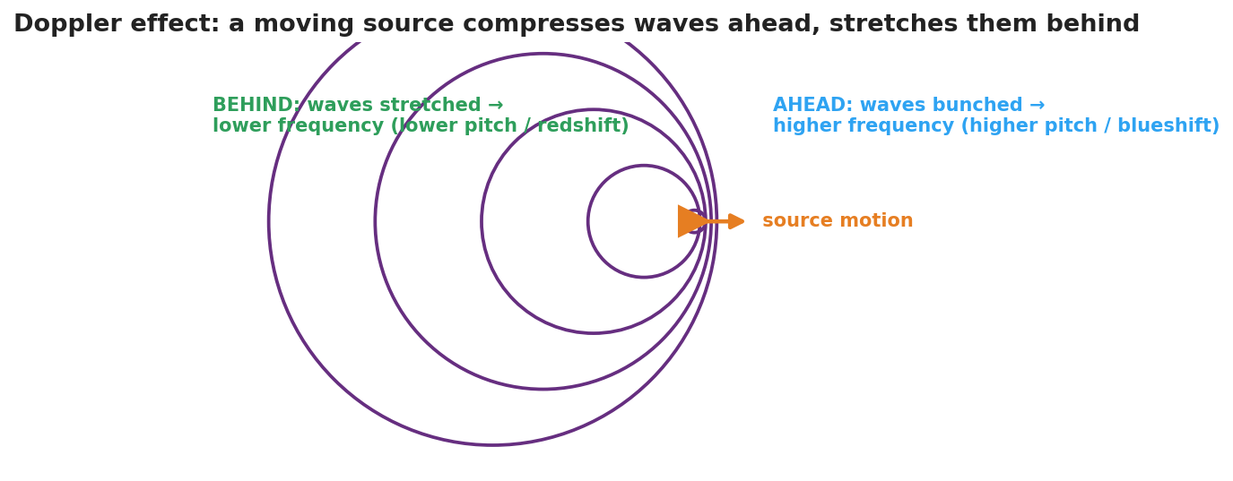
Concentric wavefronts from a source moving to the right: the circles bunch together ahead (higher frequency, blueshift) and spread out behind (lower frequency, redshift).
The bar chart below quantifies the same idea for a 700 Hz source: an observer ahead hears a higher frequency, an observer behind hears a lower one:
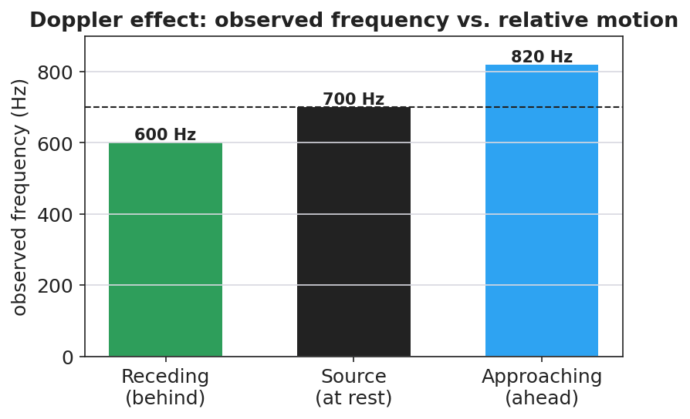
A bar chart of observed frequency for a 700 Hz source: about 600 Hz when receding (behind), 700 Hz at rest, and about 820 Hz when approaching (ahead).

Teacher facilitation during Explore
- What to look for — pairs stating that the wavelength changes ahead/behind, and connecting shorter wavelength to higher frequency (via v = f·λ).
- What to resist — don’t name “Doppler effect,” “frequency shift,” or “redshift” yet; let “bunched/stretched” and “higher/lower” emerge.
- What to redirect — students who think the source’s own pitch changes should re-watch the moving observer vs. the source’s frame.

Phase 3 · Explain (32 – 37 min)

32–35 min · Turn-and-Talk #2 + class consensus
“Why does an approaching source sound higher and a receding source sound lower?”
Target consensus:
“When the source moves toward you, each new wavefront is emitted a little closer, so the wavelength is shorter and the frequency you receive is higher. When it moves away, the wavelengths stretch and the frequency is lower.”

35–37 min · Vocabulary introduction (≤ 3 terms) + the HOCHMAN sentence
Sample teacher language:
“This apparent change in observed frequency due to relative motion is the Doppler effect. The change itself is a frequency shift. For light, a source moving away stretches the wavelength toward the red end — a redshift — which is exactly how astronomers know distant galaxies are racing away from us.”
HOCHMAN Because/But/So expansion (model aloud, then students write):
“A passing siren drops in pitch because the moving source compresses the wavelengths ahead and stretches them behind, but the source itself never changes its frequency, so only the observed frequency shifts as the source approaches and then recedes.”

Discussion prompts to deploy here
- “A star’s light is redshifted. Is it moving toward us or away from us?”
  - Sample student response: “Away — the wavelengths are stretched (longer/redder), so it’s receding.”
- “Does the Doppler effect change the speed of the wave in the medium?”
  - Sample student response: “No — the speed is set by the medium; only the observed wavelength and frequency change.”

Phase 4 · Elaborate (37 – 40 min)

37–39 min · Revise the model
“Return to your moving-source drawing. Label the bunched side ‘higher frequency (blueshift)’ and the stretched side ‘lower frequency (redshift).’ Write your Because/But/So sentence.”

39–40 min · Return to the phenomenon
“In one sentence, tell a friend why the ambulance sounds higher coming and lower going, using Doppler effect and frequency shift.”
Target: “The Doppler effect: as the ambulance approaches, the waves bunch up so I hear a higher frequency; as it recedes, they stretch out so I hear a lower frequency — a frequency shift caused by its motion.”

Phase 5 · Evaluate (40 – 42 min)

40–42 min · Exit Ticket + Closing Reflection
“A race car drives past a spectator. (a) Does the engine sound higher or lower as it approaches? Explain using wavelength. (b) After it passes, what happens to the pitch and why? (c) Astronomers see the light from a distant galaxy redshifted. What does this tell us about the galaxy’s motion, and what does that suggest about the universe?”
Expected: (a) higher — wavelengths bunch/shorten on approach; (b) lower — wavelengths stretch as it recedes; (c) the galaxy is moving away from us, evidence that the universe is expanding (HS-ESS1-2). See Answer_Key.docx.
Closing Reflection (SEL, 30 seconds):
“What’s one place you’ll now notice the Doppler effect in daily life?”

Common Misconceptions
- Misconception: “The source changes its pitch as it moves.” → Correction: The source’s frequency is constant; only the observed frequency shifts because of relative motion.
- Misconception: “The Doppler effect changes the wave’s speed.” → Correction: Speed is fixed by the medium; the wavelength and observed frequency change, not v.
- Misconception: “Redshift means the object is literally red.” → Correction: Redshift means the wavelengths are shifted toward the red (longer) end; the object is receding.

Access & Differentiation
- ELL/ENL supports: Sentence frame: “When a source moves ______ you, the waves bunch up and the frequency is ______; when it moves ______ you, the waves stretch and the frequency is ______.” Word-choice box: {toward, away, higher, lower, redshift, blueshift}. Pair approach (hand toward face) and recede (hand away) gestures.
- IEP/SPED supports: Provide the moving-source figure with the two sides blank; students label “higher/bunched” and “lower/stretched.” Offer the whirling-buzzer demo as the auditory anchor.
- Extensions: Police radar guns use the Doppler shift of reflected radio waves to measure car speed. Sketch how a larger speed produces a larger frequency shift.

Strategy Spotlight
HOCHMAN. The Doppler explanation is built as one complex sentence with Because / But / So, forcing students to hold the causal chain: the moving source compresses/stretches wavelengths, but the source frequency is unchanged, so only the observed frequency shifts. Model it, have students write their own, then read several aloud and tighten the language (e.g., distinguishing “observed frequency” from “the source’s frequency”). The appositive “a frequency shift” can be folded in for advanced writers.

NYSSLS Observation Checklist Crosswalk
# | Checklist item | Where it appears in this lesson
1 | Local/relatable phenomenon | Phase 1 — passing siren; race car in Phase 5; redshift connection
2 | Turn and Talk (2–3×) | Phase 1 (TT#1 — why you hear a change), Phase 3 (TT#2 — approach vs. recede)
3 | Students develop questions/models/procedures | Phase 1 (initial model), Phase 2 (Javalab + wavefront sketch), Phase 4 (revise)
4 | CCC defined and used | Lesson Overview · Cause and Effect, restated in Phase 2
5 | ENL — ≤ 3 vocab, second half | Phase 3 — vocabulary at 35–37 min (Doppler effect / frequency shift / redshift)
6 | Revisit phenomenon with evidence | Phase 4 — labeled moving-source model + Because/But/So
7 | ENL/SPED supports | Access & Differentiation block
8 | Assessment check | Phase 5 — Exit Ticket (race car; galaxy redshift)

Companion Materials
- Student_Worksheet.docx — the 5E student investigation (hand out at start of Phase 2)
- Student_Notes.docx — guided note-guide for vocabulary and the worked example
- Answer_Key.docx — answers to “Make It Make Sense” prompts and the Exit Ticket

Key Vocabulary (max 3)
- Doppler effect — the apparent change in a wave’s observed frequency caused by relative motion between the source and the observer
- frequency shift — the difference between the frequency emitted by the source and the frequency received by the observer
- redshift — a shift of light toward longer (redder) wavelengths, observed when a source moves away; evidence that distant galaxies are receding (an expanding universe)

The Doppler Effect — Student Worksheet
Unit: Waves — Lesson 06 Name: _______________________ Date: __________ Period: ____

Phenomenon
An ambulance races past you. The driver hears one steady siren the whole time — but you, on the curb, hear the pitch drop the instant it passes. Out in space, astronomers see the light from distant galaxies “shifted” toward red.
Driving question: If the siren makes the same pitch the whole time, why do you hear it change?

Notice & Wonder
I notice… | I wonder…
Turn & Talk #1: If the siren’s pitch is constant, why does the listener on the curb hear it change?

Initial Model
Draw a source sitting still, making circular wavefronts. Then draw the same source moving to the right. Show what happens to the spacing of the wavefronts ahead of it and behind it.

Investigation
Open Javalab Doppler Effect.
Step | What I observed
1. Stationary source — wavefront spacing
2. Moving source — spacing ahead vs. behind
3. Observer ahead vs. behind — who hears higher f?
4. Light version — toward = ______ , away = ______
Compare to this diagram:

Wavefronts from a source moving right: bunched ahead (higher frequency / blueshift), stretched behind (lower frequency / redshift).
Key question: When the source moves toward an observer, what happens to the wavelength they receive — and therefore to the frequency they hear?

Make It Make Sense
- Why does an approaching source sound higher in pitch? Use the word wavelength.
- A star’s light is redshifted. Is it moving toward us or away from us? How do you know?
- Does the Doppler effect change the speed of the wave in the medium? Explain.

Vocabulary in Action
Use each term in a sentence about today’s phenomenon.
- Doppler effect: _______________________________________________
- frequency shift: _______________________________________________
- redshift: _______________________________________________

Revise Your Model
Return to your moving-source drawing. Label the bunched side “higher frequency (blueshift)” and the stretched side “lower frequency (redshift).” Then write a Because / But / So sentence.
Because __________________________________________, but __________________________________________, so __________________________________________.

Exit Ticket
A race car drives past a spectator.
- Does the engine sound higher or lower as it approaches? Explain using wavelength.
- After it passes, what happens to the pitch and why?
- Astronomers see the light from a distant galaxy redshifted. What does this tell us about the galaxy’s motion, and what does that suggest about the universe?

The Doppler Effect — Student Notes
Unit: Waves — Lesson 06 Name: _______________________ Date: __________ Period: ____

Learning Targets
By the end of today’s 42 minutes I can:
- Explain the Doppler effect as an apparent shift caused by relative motion.
- Predict that an approaching source sounds higher and a receding source sounds lower.
- Connect light’s redshift to evidence for an expanding universe.

Key Vocabulary
- Doppler effect — _______________________________________________
- frequency shift — _______________________________________________
- redshift — _______________________________________________

Guided Notes
The big idea. The source makes a __________ frequency. But if the source (or observer) is __________, the observed frequency changes.

Wavefronts from a source moving right: bunched ahead, stretched behind.
Approaching source.
- Wavefronts ahead are __________ (bunched).
- Shorter wavelength → __________ frequency → higher pitch.
- For light: shifted toward blue (__________).
Receding source.
- Wavefronts behind are __________ (spread out).
- Longer wavelength → __________ frequency → lower pitch.
- For light: shifted toward red (__________).
Important: the wave speed does not change — only the observed __________ and __________ change.
Connection to astronomy (HS-ESS1-2). Distant galaxies show __________, so they are moving __________ from us — evidence the universe is __________.

Worked Example
Problem. You stand on a corner. A fire truck with a constant 700 Hz siren drives toward you, then away.
Solution. 1. As it approaches, the wavelengths bunch up, so you hear a frequency __________ than 700 Hz. 2. As it recedes, the wavelengths stretch, so you hear a frequency __________ than 700 Hz. 3. The driver always hears __________ Hz, because there is no relative motion between the driver and the siren.

Summary
Finish the sentence (Because / But / So):
A passing siren drops in pitch because __________________________________________, but __________________________________________, so __________________________________________.

The Doppler Effect — Answer Key

Cover
Unit: Waves — Lesson 06: The Doppler Effect East Meadow Schools × Valley Stream Central HSD Strategy chip: HOCHMAN

Make-It-Make-Sense Answers
- As the source approaches, each new wavefront is emitted a little closer to you, so the wavelength is shorter. By v = f·λ at constant speed, a shorter wavelength means a higher frequency → higher pitch. · Rubric: shorter wavelength → higher frequency. · NYSSLS: HS-PS4-1
- The star is moving away from us. Redshift means the wavelengths are stretched (longer/redder), which happens when the source recedes. · Rubric: away + redshift reasoning. · NYSSLS: HS-PS4-1 / HS-ESS1-2
- No. The wave speed is set by the medium and stays the same. Only the observed wavelength and frequency change. · Rubric: speed unchanged + reason. · NYSSLS: HS-PS4-1

Exit Ticket Answer
- Higher. Approaching, the wavefronts bunch up so the wavelength shortens; shorter wavelength → higher frequency → higher pitch.
- Lower. Receding, the wavefronts stretch so the wavelength lengthens → lower frequency → lower pitch.
- The galaxy is moving away from us. Because nearly all distant galaxies are redshifted, this is evidence that the universe is expanding (Big Bang / HS-ESS1-2).
Tolerance/rubric: (a) higher + wavelength shortening; (b) lower + wavelength stretching; (c) receding AND expanding universe. 1 point each. NYSSLS: HS-PS4-1, HS-ESS1-2.

Closing Reflection (rubric)
Formative, not graded. Award full credit for any honest response. Look for: - A specific everyday place the student will notice the Doppler effect - Genuine reflection rather than a restated definition

The Electromagnetic Spectrum — Teacher Guide

Cover
Unit: Waves — Lesson 07: The Electromagnetic Spectrum East Meadow Schools × Valley Stream Central High School District Strategy chips: ACTIVE LEARNING

Curated Resources (from East Meadow Scope & Sequence)

NYSSLS Standards
HS-PS4-1. “Use mathematical representations to support a claim regarding relationships among the frequency, wavelength, and speed of waves traveling in various media. (Cause and Effect)”
The EM spectrum is the ultimate test of v = f·λ: every band — radio to gamma — travels at the same speed c in vacuum, so the bands differ only by frequency and wavelength (which trade off inversely). Naming the order radio → micro → IR → visible → UV → X → gamma is a Cause-and-Effect application of v = f·λ at fixed v = c.

Phenomenon
- A single classroom “uses” the whole spectrum: the radio plays music (radio waves), the microwave heats lunch (microwaves), the remote works (infrared), you see the board (visible), sunscreen blocks sunburn (ultraviolet), the nurse takes an X-ray, and radiation therapy uses gamma rays: https://www.youtube.com/watch?v=cfXzwh3KadE

Javalab / Labs
- Javalab Electromagnetic Wave — a 3D transverse EM wave (electric and magnetic fields perpendicular): https://javalab.org/en/electromagnetic_wave_en/

Assessments
- Card-sort + Javalab check: students order the seven bands by increasing frequency and confirm all share c. Exit ticket below serves as the formative check.

Lesson Overview
Duration | 42 minutes (1 period)
NYSSLS link | HS-PS4-1 (all EM waves obey v = f·λ at v = c)
CCC focus | Cause and Effect — because v = c is fixed for all EM waves, a higher frequency causes a proportionally shorter wavelength.
Strategy chips | ACTIVE LEARNING
Materials | Seven band cards per group (radio, micro, IR, visible, UV, X-ray, gamma) with one example each; devices for Javalab; whiteboards.
Safety | None.
Prior knowledge | Lessons 01–03 — frequency, wavelength, v = f·λ; Lesson 02 — transverse waves.
Lesson objectives — students can:
- State that EM waves are transverse and travel at c = 3.0 × 10⁸ m/s in a vacuum.
- Order the spectrum from radio to gamma by increasing frequency / decreasing wavelength.
- Explain that all EM waves share the same speed, so frequency and wavelength trade off.

Phase 1 · Engage (0 – 12 min)

0–3 min · Opening Connection (SEL)
Quick check-in: “Name a device you used this morning that sent or received an invisible signal.” One sentence each. This primes the “invisible waves everywhere” idea.

3–8 min · Phenomenon hook — one room, the whole spectrum
Teacher actions. Point around the room: the speaker (radio), the microwave (microwaves), the TV remote (IR), your eyes (visible), the sunscreen poster (UV), the X-ray on the screen, the cancer-treatment clip (gamma). Same family of waves, wildly different uses.
Sample teacher language:
“Every one of these — the radio, the remote, your own eyes, an X-ray — is the same kind of wave. They all travel at the same speed. So what makes a radio wave different from an X-ray?”
Anticipated student responses:
- “They have different energies.” — affirm; energy tracks frequency.
- “Different wavelengths.” — yes; this is the key sorting variable.
- “Some you can see, some you can’t.” — true; visible is a tiny slice.

8–12 min · Notice & Wonder + Turn-and-Talk #1
Capture columns. Then:
“Turn to your partner: if all these waves travel at the same speed, what must be different between a radio wave and a gamma ray?”
Target: frequency and wavelength differ (inversely), since speed is the same.

Bridge to Phase 2
Initial model sentence: “Radio waves and X-rays are the same kind of wave but differ in ______ and ______.”

Phase 2 · Explore (12 – 32 min)

12–17 min · Initial Model (silent / individual)
Prompt:
“Make your best guess at the order of the spectrum from longest wavelength to shortest. Where does visible light fall? Where would the highest-energy waves go?”

17–32 min · Investigation — ACTIVE LEARNING: build the spectrum
Groups of 3–4 get seven shuffled band cards (each with an example and, on the back, a wavelength).
- Order by use/intuition first. Lay the cards left-to-right however your group thinks they go.
- Check with wavelengths. Flip the cards. Re-order by decreasing wavelength. Does visible light land between IR and UV?
- Apply v = f·λ. Since v = c for all, rank by frequency. Which band has the highest frequency? The shortest wavelength?
- Javalab. View the 3D EM wave; confirm it’s transverse and note that all bands share c.
Use this figure as the answer key the groups check against:
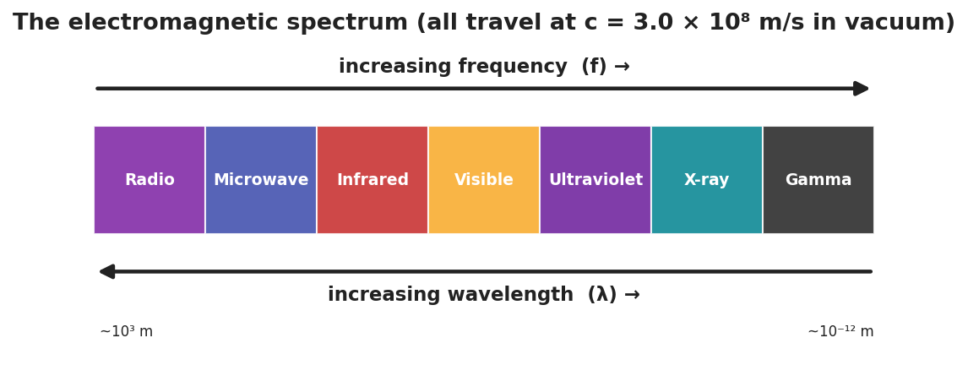
A horizontal band chart of the electromagnetic spectrum, radio to gamma, with arrows showing increasing frequency one way and increasing wavelength the other; all bands travel at c = 3.0 × 10⁸ m/s.
This paired bar chart makes the key claim explicit — every band shares the same speed c, even though their wavelengths span 15 orders of magnitude:
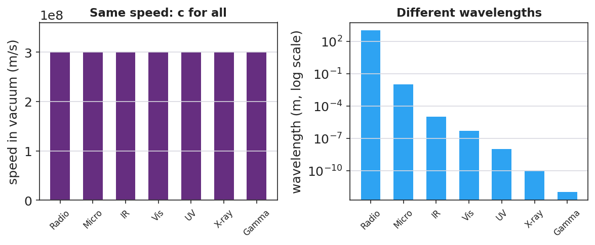
Two bar charts: on the left, all seven EM bands have the identical speed c = 3.0 × 10⁸ m/s; on the right, their wavelengths differ enormously on a logarithmic scale, from kilometers (radio) to picometers (gamma).

Teacher facilitation during Explore
- What to look for — groups using v = c (fixed) to argue that higher frequency must mean shorter wavelength.
- What to resist — don’t give the order; let the card-flip and v = f·λ reasoning produce it.
- What to redirect — groups who think “different waves go different speeds” should revisit the v = c claim at Javalab.

Phase 3 · Explain (32 – 37 min)

32–35 min · Turn-and-Talk #2 + class consensus
“What stays the same across the whole spectrum, and what changes from band to band?”
Target consensus:
“All EM waves are transverse and travel at the same speed, c, in a vacuum. What changes is the frequency and wavelength — and they trade off inversely (radio = low f / long λ; gamma = high f / short λ).”

35–37 min · Vocabulary introduction (≤ 3 terms)
Sample teacher language:
“These are all electromagnetic waves — waves of electric and magnetic fields that need no medium. The full ordered family is the spectrum. And the speed they all share in a vacuum is the speed of light, c = 3.0 × 10⁸ m/s.”

Discussion prompts to deploy here
- “Which has the longer wavelength: a radio wave or an X-ray?”
  - Sample student response: “Radio — it has the lowest frequency, so by v = f·λ the longest wavelength.”
- “Do microwaves travel faster than visible light in a vacuum?”
  - Sample student response: “No — all EM waves travel at c in a vacuum.”

Phase 4 · Elaborate (37 – 40 min)

37–39 min · Revise the model
“Return to your guessed order. Correct it using the spectrum chart. Add an arrow for ‘increasing frequency’ and one for ‘increasing wavelength,’ pointing opposite ways.”

39–40 min · Return to the phenomenon
“In one sentence, explain to a peer why a radio wave and an X-ray are the ‘same kind’ of wave, using electromagnetic wave and speed of light.”
Target: “Both are electromagnetic waves that travel at the speed of light; they only differ in frequency and wavelength, with X-rays having far higher frequency and shorter wavelength than radio waves.”

Phase 5 · Evaluate (40 – 42 min)

40–42 min · Exit Ticket + Closing Reflection
“Use the EM spectrum. (a) List these in order of increasing frequency: visible light, radio, X-ray, infrared. (b) A microwave and a gamma ray both travel through a vacuum. Which is faster? Explain. (c) Ultraviolet light has a higher frequency than visible light. Compare their wavelengths.”
Expected: (a) radio < infrared < visible < X-ray; (b) neither — both travel at c in vacuum; (c) UV has a shorter wavelength than visible (higher f → shorter λ). See Answer_Key.docx.
Closing Reflection (SEL, 30 seconds):
“Which part of the spectrum will you ‘see’ differently now — and who in your group sorted it best?”

Common Misconceptions
- Misconception: “Higher-frequency EM waves travel faster.” → Correction: All EM waves travel at c in a vacuum; higher frequency means shorter wavelength, not higher speed.
- Misconception: “EM waves need a medium like sound does.” → Correction: EM waves are not mechanical; they travel through a vacuum (that’s why sunlight reaches Earth).
- Misconception: “Visible light is a big part of the spectrum.” → Correction: Visible light is a tiny band between infrared and ultraviolet.

Access & Differentiation
- ELL/ENL supports: Sentence frame: “All EM waves travel at ______, so a higher frequency means a ______ wavelength.” Word-choice box: {c / speed of light, shorter, longer, transverse}. Provide a bilingual band-name glossary (radio, micro, IR, visible, UV, X-ray, gamma).
- IEP/SPED supports: Provide the seven band cards pre-printed with both the name and a familiar example image; students sequence rather than recall. Color-code the cards to match the spectrum figure.
- Extensions: Use c = f·λ to compute the wavelength of a 100 MHz FM radio station (λ = c/f = 3.0×10⁸ / 1.0×10⁸ = 3 m) and compare to an X-ray (~10⁻¹⁰ m).

Strategy Spotlight
ACTIVE LEARNING. Groups physically build the spectrum from shuffled cards, first by intuition and then by flipping to reveal wavelengths and reasoning with v = c. The manipulation — argue, flip, re-order, justify — makes the inverse f/λ relationship concrete before it is named. Facilitate with one prompt: “All the same speed — so what has to be true about frequency and wavelength as you move down the line?”

NYSSLS Observation Checklist Crosswalk
# | Checklist item | Where it appears in this lesson
1 | Local/relatable phenomenon | Phase 1 — one room uses the whole spectrum
2 | Turn and Talk (2–3×) | Phase 1 (TT#1 — what differs at same speed), Phase 3 (TT#2 — same vs. changing)
3 | Students develop questions/models/procedures | Phase 1 (guessed order), Phase 2 (card sort + Javalab), Phase 4 (revise)
4 | CCC defined and used | Lesson Overview · Cause and Effect, restated in Phase 2
5 | ENL — ≤ 3 vocab, second half | Phase 3 — vocabulary at 35–37 min (electromagnetic wave / spectrum / speed of light)
6 | Revisit phenomenon with evidence | Phase 4 — radio-vs-X-ray explanation
7 | ENL/SPED supports | Access & Differentiation block
8 | Assessment check | Phase 5 — Exit Ticket (order by frequency; same speed)

Companion Materials
- Student_Worksheet.docx — the 5E student investigation (hand out at start of Phase 2)
- Student_Notes.docx — guided note-guide for vocabulary and the worked example
- Answer_Key.docx — answers to “Make It Make Sense” prompts and the Exit Ticket

Key Vocabulary (max 3)
- electromagnetic wave — a transverse wave of oscillating electric and magnetic fields that requires no medium and travels at the speed of light in a vacuum
- spectrum — the full ordered range of electromagnetic waves, from radio (low frequency) through gamma rays (high frequency)
- speed of light — the speed of all electromagnetic waves in a vacuum, c = 3.0 × 10⁸ m/s

The Electromagnetic Spectrum — Student Worksheet
Unit: Waves — Lesson 07 Name: _______________________ Date: __________ Period: ____

Phenomenon
Look around the room. The speaker plays music (radio waves), the microwave heats lunch (microwaves), the remote changes the channel (infrared), your eyes read the board (visible light), sunscreen blocks sunburn (ultraviolet), and a nurse can take an X-ray. Every one of these is the same kind of wave, all traveling at the same speed.
Driving question: If all these waves travel at the same speed, what makes a radio wave different from an X-ray?

Notice & Wonder
I notice… | I wonder…
Turn & Talk #1: If all these waves travel at the same speed, what must be different between a radio wave and a gamma ray?

Initial Model
Make your best guess at the order of the spectrum from longest wavelength to shortest. Where does visible light fall? Where would the highest-energy waves go?

Investigation
Work in a group with the seven band cards. Order, flip to check, then reason with v = c.
Step | Result
1. Our first guess (left → right)
2. Re-order by decreasing wavelength
3. Highest-frequency band? Shortest wavelength?
4. Javalab — is the EM wave transverse? Same speed for all?
Check your order against this chart:

The electromagnetic spectrum, radio to gamma, with increasing frequency one way and increasing wavelength the other; all travel at c.
Key question: Since v = c is the same for every band, what must be true about frequency and wavelength as you move from radio toward gamma?

Make It Make Sense
- Which has the longer wavelength: a radio wave or an X-ray? Use v = f·λ to justify your answer.
- Do microwaves travel faster than visible light in a vacuum? Explain.
- An FM radio station broadcasts at 100 MHz (1.0 × 10⁸ Hz). Use λ = c/f to find its wavelength. (c = 3.0 × 10⁸ m/s)

Vocabulary in Action
Use each term in a sentence about today’s phenomenon.
- electromagnetic wave: _______________________________________________
- spectrum: _______________________________________________
- speed of light: _______________________________________________

Revise Your Model
Return to your guessed order. Correct it using the chart. Add an arrow for “increasing frequency” and one for “increasing wavelength,” pointing opposite ways.

Exit Ticket
Use the EM spectrum.
- List these in order of increasing frequency: visible light, radio, X-ray, infrared.
- A microwave and a gamma ray both travel through a vacuum. Which is faster? Explain.
- Ultraviolet light has a higher frequency than visible light. Compare their wavelengths.

The Electromagnetic Spectrum — Student Notes
Unit: Waves — Lesson 07 Name: _______________________ Date: __________ Period: ____

Learning Targets
By the end of today’s 42 minutes I can:
- State that electromagnetic waves are transverse and travel at the speed of light in a vacuum.
- Order the spectrum from radio to gamma by increasing frequency.
- Explain that all EM waves share c, so frequency and wavelength trade off.

Key Vocabulary
- electromagnetic wave — _______________________________________________
- spectrum — _______________________________________________
- speed of light — _______________________________________________

Guided Notes
What EM waves have in common.
- They are __________ waves (electric and magnetic fields oscillate perpendicular to travel).
- They need __________ medium — they travel through a vacuum.
- They all travel at the __________ of light, c = 3.0 × 10⁸ m/s, in a vacuum.

The electromagnetic spectrum from radio to gamma, with frequency and wavelength axes.
The order (low frequency → high frequency):
Radio → Microwave → __________ → Visible → __________ → X-ray → __________
- As frequency __________, wavelength __________ (because v = c is fixed: v = f·λ).
- Visible light is a __________ (small) band between infrared and ultraviolet.

Worked Example
Problem. An FM station broadcasts at 100 MHz (1.0 × 10⁸ Hz). Find its wavelength. (c = 3.0 × 10⁸ m/s)
Solution. 1. Use v = f·λ with v = c: λ = c / f. 2. λ = (3.0 × 10⁸) / (1.0 × 10⁸) = __________ m. 3. Compare: an X-ray’s wavelength is about 10⁻¹⁰ m — far __________ than a radio wave’s. ✓

Summary
Finish the sentence (Because / But / So):
A radio wave and an X-ray are the same kind of wave because __________________________________________, but __________________________________________, so __________________________________________.

The Electromagnetic Spectrum — Answer Key

Cover
Unit: Waves — Lesson 07: The Electromagnetic Spectrum East Meadow Schools × Valley Stream Central HSD Strategy chip: ACTIVE LEARNING

Make-It-Make-Sense Answers
- A radio wave has the longer wavelength. Radio has the lowest frequency; since v = f·λ with v = c fixed, the lowest frequency gives the longest wavelength. · Rubric: radio + v = f·λ reasoning. · NYSSLS: HS-PS4-1
- No. In a vacuum all EM waves travel at c = 3.0 × 10⁸ m/s, so microwaves and visible light have the same speed. · Rubric: same speed + states c. · NYSSLS: HS-PS4-1
- λ = c/f = (3.0 × 10⁸) / (1.0 × 10⁸) = 3.0 m. · Rubric: correct formula AND 3 m. · NYSSLS: HS-PS4-1

Exit Ticket Answer
- Increasing frequency: radio < infrared < visible < X-ray.
- Neither — they are equally fast. Both travel at c = 3.0 × 10⁸ m/s in a vacuum.
- UV has a shorter wavelength than visible light, because higher frequency means shorter wavelength (v = c fixed).
Tolerance/rubric: (a) correct order; (b) equal speed = c; (c) UV shorter wavelength with reasoning. 1 point each. NYSSLS: HS-PS4-1.

Closing Reflection (rubric)
Formative, not graded. Award full credit for any honest response. Look for: - A specific band the student now understands differently - Acknowledgment of a peer’s contribution to the card sort

Refraction and Snell’s Law — Teacher Guide

Cover
Unit: Waves — Lesson 08: Refraction and Snell’s Law East Meadow Schools × Valley Stream Central High School District Strategy chips: HOCHMAN

Curated Resources (from East Meadow Scope & Sequence)

NYSSLS Standards
HS-PS4-6 (NYS). “Use mathematical models to determine relationships among the size and location of images, size and location of objects, and focal lengths of lenses and mirrors.”
Refraction is the bending of light that makes lenses and mirrors form images at all, so this lesson is the conceptual and mathematical entry to HS-PS4-6 (developed fully in Lesson 09). Students apply the mathematical model Snell’s law, n₁ sin θ₁ = n₂ sin θ₂, to relate the index of refraction and the bending angle — a direct Cause-and-Effect link between a change in speed and a change in direction.

Phenomenon
- A laser beam bends as it crosses from air into water; a pencil looks “broken” at the surface of a glass; a Pyrex stirrer “disappears” when placed in cooking oil of matching index: https://www.youtube.com/watch?v=y55tzg_jW9I

Javalab / Labs
- PhET Bending Light — fire a ray at a boundary, vary the angle and the media, and read both angles: https://phet.colorado.edu/en/simulations/bending-light

Assessments
- PhET Snell’s-law lab: students collect (θ₁, θ₂) pairs for air→water and confirm n₁ sin θ₁ = n₂ sin θ₂. Numeric exit ticket below serves as the formative check.

Lesson Overview
Duration | 42 minutes (1 period)
NYSSLS link | HS-PS4-6 (NYS) — mathematical model for light at a boundary
CCC focus | Cause and Effect — a change in light’s speed when it enters a new medium causes it to bend (refract).
Strategy chips | HOCHMAN
Materials | Laser pointer + clear tank of water (or video); a pencil in a glass of water; protractors; calculators with sin/sin⁻¹; PhET on devices.
Safety | Never aim a laser at eyes; keep beams below eye level and pointed into the tank.
Prior knowledge | Lessons 01–03 — v = f·λ; Lesson 07 — light is an EM wave that travels at c in vacuum (slower in matter).
Lesson objectives — students can:
- Explain that light bends when it changes media because its speed changes.
- Use the index of refraction n and Snell’s law (n₁ sin θ₁ = n₂ sin θ₂) to solve for an unknown angle or index.
- Describe total internal reflection and when it occurs.

Phase 1 · Engage (0 – 12 min)

0–3 min · Opening Connection (SEL)
Quick check-in: “Name a time something looked different from how it really was.” One sentence each. This primes the “your eyes are fooled by bending light” idea.

3–8 min · Phenomenon hook — the broken pencil and the bending laser
Teacher actions. Put a pencil in a glass of water — it looks broken at the surface. Fire a laser into a tank of water (or play the clip) so students see the beam kink at the boundary.
Sample teacher language:
“The pencil isn’t broken and the laser isn’t crooked. Yet the beam clearly bends the instant it hits the water. What changes for the light right at that surface?”
Anticipated student responses:
- “The water bends it.” — affirm; we’ll explain why.
- “Light slows down in water.” — excellent; this is the cause.
- “It’s like a lens.” — good; foreshadows Lesson 09.

8–12 min · Notice & Wonder + Turn-and-Talk #1
Capture columns. Then:
“Turn to your partner: the laser only bends at the boundary, not inside the water. What does that tell you about what causes the bend?”
Target: something changes exactly at the boundary — the light’s speed — and that causes the direction change.

Bridge to Phase 2
Initial model sentence: “Light bends at the boundary because its ______ changes when it enters a new ______.”

Phase 2 · Explore (12 – 32 min)

12–17 min · Initial Model (silent / individual)
Prompt:
“Draw a ray hitting the water at an angle. Draw the normal (perpendicular to the surface). Predict: does the ray bend toward the normal or away from it when it slows down?”

17–32 min · Investigation — PhET Bending Light (Snell’s law lab)
Pairs at PhET:
- See the bend. Fire air→water at 45°. Note that the refracted ray bends toward the normal (water is slower).
- Collect data. Record (θ₁, θ₂) for several incident angles. Compute sin θ₁ and sin θ₂.
- Find the pattern. Compute the ratio sin θ₁ / sin θ₂. Compare to n₂/n₁ (≈ 1.33 for air→water).
- Total internal reflection. Now go water→air and increase the angle. Find the angle past which the ray cannot leave — it reflects entirely.
Use this ray diagram to fix the geometry and the equation:
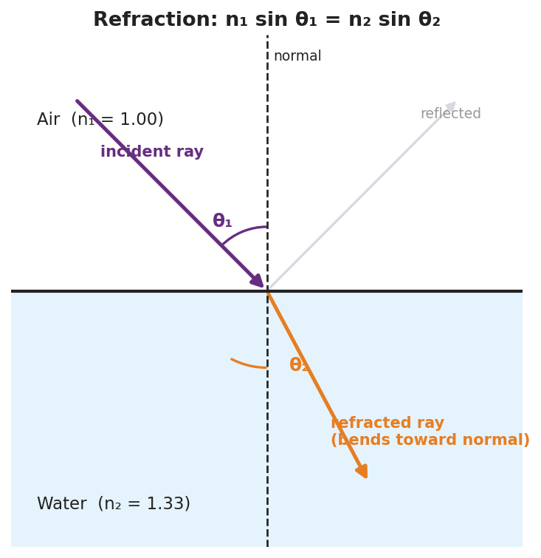
A refraction ray diagram at an air–water boundary: the normal, the incident ray at angle θ₁ in air (n₁ = 1.00), the refracted ray bending toward the normal at θ₂ in water (n₂ = 1.33), and a faint reflected ray; labeled with Snell’s law n₁ sin θ₁ = n₂ sin θ₂.
This chart of indices explains how much light bends in each material — the higher the index, the slower the light and the stronger the bend:
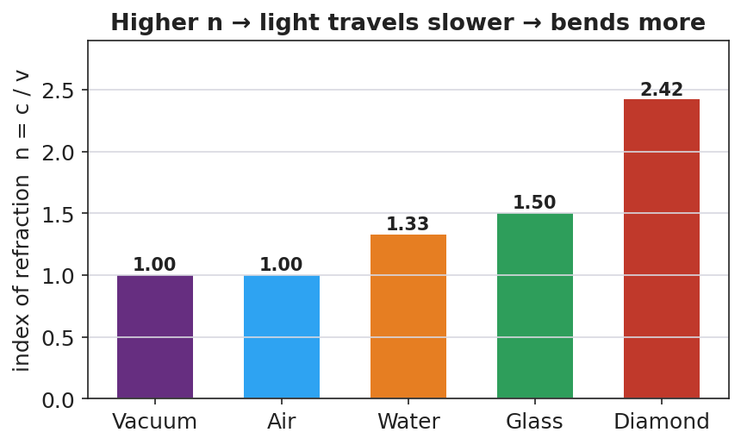
A bar chart of the index of refraction for vacuum (1.00), air (1.00), water (1.33), glass (1.50), and diamond (2.42), noting n = c/v: higher n means slower light and more bending.

Teacher facilitation during Explore
- What to look for — pairs discovering that sin θ₁ / sin θ₂ is constant (= n₂/n₁) — the data form of Snell’s law.
- What to resist — don’t write Snell’s law first; let the constant ratio emerge from their (θ₁, θ₂) data.
- What to redirect — students who measure angles from the surface instead of the normal should re-read where the protractor’s zero goes.

Phase 3 · Explain (32 – 37 min)

32–35 min · Turn-and-Talk #2 + class consensus
“Why does light bend toward the normal entering water, and what stays constant in your data?”
Target consensus:
“Light slows in water, so it bends toward the normal. The ratio sin θ₁ / sin θ₂ stays constant — it equals the ratio of the indices, which is the math behind the bending.”

35–37 min · Vocabulary introduction (≤ 3 terms) + the HOCHMAN sentence
Sample teacher language:
“The bending of light when it changes media is refraction. How much a material slows light is its index of refraction, n = c/v (n = 1 in vacuum, 1.33 in water, ~1.5 in glass). The rule relating angles and indices is Snell’s law: n₁ sin θ₁ = n₂ sin θ₂.”
HOCHMAN Because/But/So expansion (model aloud, then students write):
“Light bends toward the normal when it enters water because the water slows it down, but its frequency stays the same, so its wavelength shortens and the wavefronts pivot, changing the ray’s direction.”

Discussion prompts to deploy here
- “Light goes from air (n = 1.00) into glass (n = 1.50) at θ₁ = 30°. Find θ₂.”
  - Sample student response: “sin θ₂ = (1.00·sin30°)/1.50 = 0.333 → θ₂ ≈ 19.5°.”
- “When does total internal reflection happen?”
  - Sample student response: “Going from a slower (higher-n) medium to a faster one, past the critical angle — the light can’t escape, so it all reflects.”

Phase 4 · Elaborate (37 – 40 min)

37–39 min · Revise the model
“Return to your prediction. Label the incident angle θ₁, the refracted angle θ₂, and the normal. Write your Because/But/So sentence and confirm: into a slower medium, the ray bends toward the normal.”

39–40 min · Return to the phenomenon
“Explain in one sentence why the pencil looks broken, using refraction and index of refraction.”
Target: “Light from the underwater part of the pencil refracts (bends) as it leaves the higher-index water into the lower-index air, so your eye traces it back to the wrong spot and the pencil looks broken.”

Phase 5 · Evaluate (40 – 42 min)

40–42 min · Exit Ticket + Closing Reflection
“Light travels from air (n = 1.00) into water (n = 1.33). (a) The incident angle is 40°. Use Snell’s law to find the angle of refraction. Show your work. (b) Does the ray bend toward or away from the normal? Why? (c) The Pyrex stirrer ‘disappears’ in oil of the same index. Explain why, in one sentence.”
Expected: (a) sin θ₂ = (1.00·sin40°)/1.33 = 0.483 → θ₂ ≈ 28.9°; (b) toward the normal (entering a slower, higher-n medium); (c) equal indices mean no speed change, so no refraction or reflection at the boundary — the light passes straight through, making the glass invisible. See Answer_Key.docx.
Closing Reflection (SEL, 30 seconds):
“What’s one illusion in your daily life you can now explain with refraction?”

Common Misconceptions
- Misconception: “Light bends because the water ‘pushes’ it.” → Correction: Light bends because its speed changes at the boundary; the frequency stays the same and the wavelength changes.
- Misconception: “Angles are measured from the surface.” → Correction: Incident and refracted angles are measured from the normal (perpendicular to the surface).
- Misconception: “Light always bends the same way.” → Correction: Entering a slower medium it bends toward the normal; entering a faster medium it bends away (and can totally internally reflect).

Access & Differentiation
- ELL/ENL supports: Sentence frame: “When light enters a ______ medium, it slows down and bends ______ the normal.” Word-choice box: {slower, faster, toward, away, normal}. Provide a worked Snell’s-law example with each calculator key labeled (sin, ×, ÷, sin⁻¹).
- IEP/SPED supports: Provide the ray diagram pre-drawn with the normal; students measure θ₁ and θ₂ with a protractor rather than constructing rays. Give a Snell’s-law “plug-in” template with the unknown isolated.
- Extensions: Fiber optics — explain how total internal reflection keeps a light pulse trapped inside a glass fiber, enabling internet data transmission (links to Lesson 10).

Strategy Spotlight
HOCHMAN. The causal mechanism is captured in one Because / But / So sentence: light slows in water (because), its frequency is unchanged (but), so its wavelength shortens and the ray pivots toward the normal (so). This sentence does the heavy lifting of separating cause (speed change) from the constant (frequency) and the result (direction change). Model it, have students write, then refine — many will first say “the water bends it”; push them to name the speed change as the cause.

NYSSLS Observation Checklist Crosswalk
# | Checklist item | Where it appears in this lesson
1 | Local/relatable phenomenon | Phase 1 — broken pencil, bending laser; disappearing Pyrex in Phase 5
2 | Turn and Talk (2–3×) | Phase 1 (TT#1 — bend only at boundary), Phase 3 (TT#2 — why toward normal)
3 | Students develop questions/models/procedures | Phase 1 (prediction), Phase 2 (PhET Snell’s-law data), Phase 4 (revise)
4 | CCC defined and used | Lesson Overview · Cause and Effect, restated in Phase 2
5 | ENL — ≤ 3 vocab, second half | Phase 3 — vocabulary at 35–37 min (refraction / index of refraction / Snell’s law)
6 | Revisit phenomenon with evidence | Phase 4 — broken-pencil explanation
7 | ENL/SPED supports | Access & Differentiation block
8 | Assessment check | Phase 5 — numeric Exit Ticket (air→water; Pyrex)

Companion Materials
- Student_Worksheet.docx — the 5E student investigation (hand out at start of Phase 2)
- Student_Notes.docx — guided note-guide for vocabulary and the worked example
- Answer_Key.docx — answers to “Make It Make Sense” prompts and the Exit Ticket

Key Vocabulary (max 3)
- refraction — the bending of light (or any wave) as it passes from one medium into another because its speed changes
- index of refraction — a number n = c/v that tells how much a medium slows light (n = 1 in vacuum, 1.33 in water, ≈ 1.5 in glass)
- Snell’s law — the mathematical model relating the angles and indices at a boundary: n₁ sin θ₁ = n₂ sin θ₂

Refraction and Snell’s Law — Student Worksheet
Unit: Waves — Lesson 08 Name: _______________________ Date: __________ Period: ____

Phenomenon
A pencil standing in a glass of water looks broken at the surface. A laser beam fired into a tank of water kinks the instant it hits the water. And a Pyrex stirrer placed in oil of just the right kind seems to vanish completely.
Driving question: What changes for the light right at the surface that makes it bend?

Notice & Wonder
I notice… | I wonder…
Turn & Talk #1: The laser bends only at the boundary, not inside the water. What does that tell you about what causes the bend?

Initial Model
Draw a ray hitting the water at an angle. Draw the normal (perpendicular to the surface). Predict: when the light slows down, does the ray bend toward the normal or away from it?

My prediction: _______________________________________________

Investigation
Open PhET Bending Light. Fire rays from air into water and measure angles from the normal.
Incident angle θ₁ | Refracted angle θ₂ | sin θ₁ | sin θ₂ | sin θ₁ ÷ sin θ₂
Use this ray diagram to set up your geometry:

Refraction at an air–water boundary: normal, incident ray θ₁ in air (n₁ = 1.00), refracted ray θ₂ in water (n₂ = 1.33), labeled with n₁ sin θ₁ = n₂ sin θ₂.
Key question: What is the value of sin θ₁ ÷ sin θ₂? How does it compare to n₂ ÷ n₁ for air→water (≈ 1.33)?

Make It Make Sense
- Light goes from air (n = 1.00) into glass (n = 1.50) at θ₁ = 30°. Use Snell’s law to find θ₂. Show your work.
- Why does light bend toward the normal when it enters a slower (higher-n) medium? Write a Because/But/So sentence.
- Total internal reflection: under what conditions can light not escape a medium, reflecting entirely instead?

Vocabulary in Action
Use each term in a sentence about today’s phenomenon.
- refraction: _______________________________________________
- index of refraction: _______________________________________________
- Snell’s law: _______________________________________________

Revise Your Model
Return to your prediction. Label the incident angle θ₁, the refracted angle θ₂, and the normal. Confirm: into a slower medium, the ray bends toward the normal. Write your Because/But/So sentence.
Because __________________________________________, but __________________________________________, so __________________________________________.

Exit Ticket
Light travels from air (n = 1.00) into water (n = 1.33).
- The incident angle is 40°. Use Snell’s law to find the angle of refraction. Show your work.
- Does the ray bend toward or away from the normal? Why?
- The Pyrex stirrer “disappears” in oil of the same index. Explain why, in one sentence.

Refraction and Snell’s Law — Student Notes
Unit: Waves — Lesson 08 Name: _______________________ Date: __________ Period: ____

Learning Targets
By the end of today’s 42 minutes I can:
- Explain that light bends (refraction) when its speed changes between media.
- Use the index of refraction and Snell’s law to find an unknown angle or index.
- Describe total internal reflection.

Key Vocabulary
- refraction — _______________________________________________
- index of refraction — _______________________________________________
- Snell’s law — _______________________________________________

Guided Notes
Why light bends. When light crosses into a new medium, its __________ changes. Its frequency stays the __________, so its wavelength changes — and the ray pivots, bending at the boundary.
- Into a slower (higher-n) medium → bends __________ the normal.
- Into a faster (lower-n) medium → bends __________ from the normal.
Index of refraction: n = c / v.
- Vacuum: n = __________
- Water: n ≈ __________
- Glass: n ≈ __________

Refraction at an air–water boundary with the normal, θ₁, θ₂, and n₁ sin θ₁ = n₂ sin θ₂.
Snell’s law (reference table):
n₁ sin θ₁ = n₂ sin θ₂
Angles are always measured from the __________ (not the surface).
Total internal reflection. Going from a slower to a __________ medium, past a critical angle the light cannot escape and __________ entirely. (This is how fiber-optic cables carry data.)

Worked Example
Problem. Light goes from air (n₁ = 1.00) into glass (n₂ = 1.50) at θ₁ = 30°. Find θ₂.
Solution. 1. Snell’s law: n₁ sin θ₁ = n₂ sin θ₂. 2. sin θ₂ = (n₁ sin θ₁) / n₂ = (1.00 × sin 30°) / 1.50 = (1.00 × 0.500) / 1.50 = __________. 3. θ₂ = sin⁻¹(0.333) ≈ __________°. 4. Check: θ₂ < θ₁, so the ray bent __________ the normal (entered a slower medium). ✓

Summary
Finish the sentence (Because / But / So):
A pencil looks broken in a glass of water because __________________________________________, but __________________________________________, so __________________________________________.

Refraction and Snell’s Law — Answer Key

Cover
Unit: Waves — Lesson 08: Refraction and Snell’s Law East Meadow Schools × Valley Stream Central HSD Strategy chip: HOCHMAN

Make-It-Make-Sense Answers
- Snell’s law: n₁ sin θ₁ = n₂ sin θ₂ → sin θ₂ = (1.00 × sin 30°) / 1.50 = (1.00 × 0.500) / 1.50 = 0.333 → θ₂ ≈ 19.5°. · Rubric: correct setup AND ≈ 19–20°. · NYSSLS: HS-PS4-6
- Example: “Light bends toward the normal entering water because the water slows it down, but its frequency stays the same, so its wavelength shortens and the ray pivots toward the normal.” · Rubric: Because/But/So with speed change as cause. · NYSSLS: HS-PS4-6
- Total internal reflection happens when light travels from a slower (higher-n) medium toward a faster (lower-n) one at an angle greater than the critical angle — the ray cannot refract out, so it reflects entirely. · Rubric: high-n → low-n AND past critical angle. · NYSSLS: HS-PS4-6

Exit Ticket Answer
- sin θ₂ = (n₁ sin θ₁)/n₂ = (1.00 × sin 40°)/1.33 = (1.00 × 0.643)/1.33 = 0.483 → θ₂ ≈ 28.9° (about 29°).
- Toward the normal, because the light enters a slower, higher-index medium (water), so the refracted angle is smaller than the incident angle.
- The oil and Pyrex have the same index of refraction, so light does not change speed at the boundary — no refraction and no reflection — and the glass becomes invisible.
Tolerance/rubric: (a) 28°–29° with Snell’s law shown; (b) toward the normal + slower-medium reason; (c) equal indices → no bend. 1 point each. NYSSLS: HS-PS4-6.

Closing Reflection (rubric)
Formative, not graded. Award full credit for any honest response. Look for: - A specific everyday illusion the student can now explain with refraction - Genuine reflection rather than a restated definition

Optics: Lenses and Mirrors — Teacher Guide

Cover
Unit: Waves — Lesson 09: Optics (Lenses and Mirrors) East Meadow Schools × Valley Stream Central High School District Strategy chips: ACTIVE LEARNING

Curated Resources (from East Meadow Scope & Sequence)

NYSSLS Standards
HS-PS4-6 (NYS). “Use mathematical models to determine relationships among the size and location of images, size and location of objects, and focal lengths of lenses and mirrors.”
This is the core HS-PS4-6 lesson. Building on refraction (Lesson 08), students use ray diagrams and the thin-lens / mirror equation 1/f = 1/dₒ + 1/dᵢ to relate object distance, image distance, and focal length, and to predict whether an image is real or virtual.

Phenomenon
- Corrective glasses and contact lenses fix blurry vision; a magnifying glass enlarges print and can focus sunlight; a curved makeup/shaving mirror magnifies your face: https://www.youtube.com/watch?v=Q3FrL_T0r2c

Javalab / Labs
- oPhysics Converging Lens and Concave/Convex Mirror — drag the object and read the image position, size, and type: https://www.ophysics.com/l1.html

Assessments
- oPhysics ray-tracing task: students place an object at several distances and record image distance, magnification, and real/virtual, confirming 1/f = 1/dₒ + 1/dᵢ. Quantitative exit ticket below serves as the formative check.

Lesson Overview
Duration | 42 minutes (1 period)
NYSSLS link | HS-PS4-6 (NYS) — the thin-lens / mirror equation
CCC focus | Cause and Effect — the object’s distance relative to the focal length causes a real or virtual image of a predictable size and location.
Strategy chips | ACTIVE LEARNING
Materials | Converging lenses (magnifiers); concave mirrors (or spoons); a candle/LED + screen; rulers; calculators; devices for oPhysics.
Safety | Do not focus sunlight onto skin or flammable material with a lens.
Prior knowledge | Lesson 08 — refraction, index of refraction, Snell’s law (lenses bend light by refraction; mirrors by reflection).
Lesson objectives — students can:
- Distinguish converging from diverging lenses and concave from convex mirrors, and identify the focal point.
- Draw principal rays to locate an image and classify it as real or virtual.
- Use 1/f = 1/dₒ + 1/dᵢ to solve for focal length, object distance, or image distance.

Phase 1 · Engage (0 – 12 min)

0–3 min · Opening Connection (SEL)
Quick check-in: “Name something you use to see better — glasses, a phone zoom, a screen.” One sentence each. This primes “lenses shape what we see.”

3–8 min · Phenomenon hook — the magnifying glass surprise
Teacher actions. Hand out (or demo) a magnifying glass. Have students hold it close to text (enlarged, upright) and then far from text/a window (small, upside-down image). Same lens, two completely different images.
Sample teacher language:
“Close up, the magnifier makes the print bigger and right-side-up. Move it far away, and look — the image flips upside down and shrinks. Same lens. What changed?”
Anticipated student responses:
- “How far away it is.” — exactly; object distance is the variable.
- “It flipped.” — capture; foreshadows real vs. virtual.
- “It focuses the window on the wall.” — great; that’s a real image.

8–12 min · Notice & Wonder + Turn-and-Talk #1
Capture columns. Then:
“Turn to your partner: what decides whether the image is big-and-upright or small-and-upside-down?”
Target: the object’s distance compared with the lens’s focal length.

Bridge to Phase 2
Initial model sentence: “The magnifier gives a different image depending on the ______ between the object and the lens.”

Phase 2 · Explore (12 – 32 min)

12–17 min · Initial Model (silent / individual)
Prompt:
“Draw a lens with a candle on the left. Sketch where you think the image forms when the candle is FAR from the lens, then when it’s VERY CLOSE. Label which one is upside-down.”

17–32 min · Investigation — ACTIVE LEARNING: ray-trace and measure
Groups of 3–4 with a converging lens, a screen, a light source, and oPhysics open:
- Real image. Place the object well beyond the focal point. Move the screen until the image is sharp. Measure dₒ and dᵢ; note size and orientation (inverted).
- Virtual image. Bring the object inside the focal length. The screen shows nothing — look through the lens (magnified, upright, virtual).
- Concave mirror. Repeat with a concave mirror (or the bowl of a spoon): far object → small inverted real image; close object → magnified upright image.
- oPhysics. Drag the object, record (dₒ, dᵢ) pairs, and check 1/f = 1/dₒ + 1/dᵢ.
Use these ray diagrams to standardize the three principal rays:
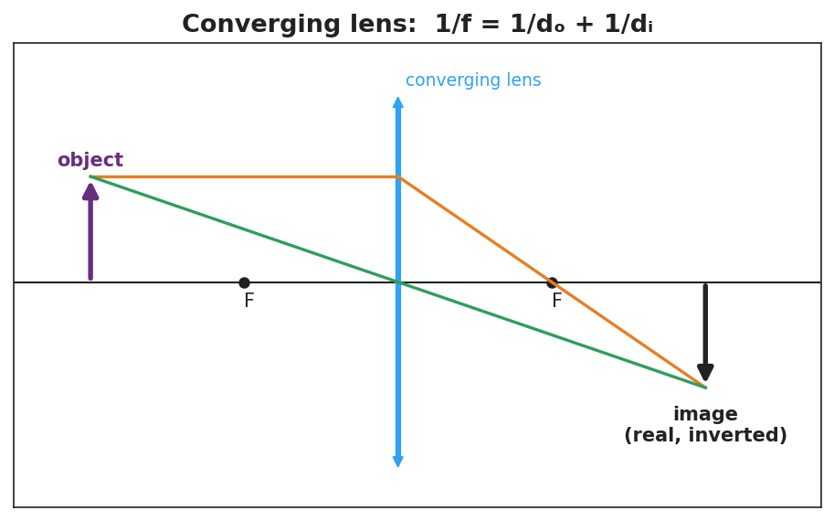
A converging-lens ray diagram: an object beyond F, the parallel ray refracting through the far focus, the central ray going straight, meeting at a real, inverted image; labeled 1/f = 1/dₒ + 1/dᵢ.
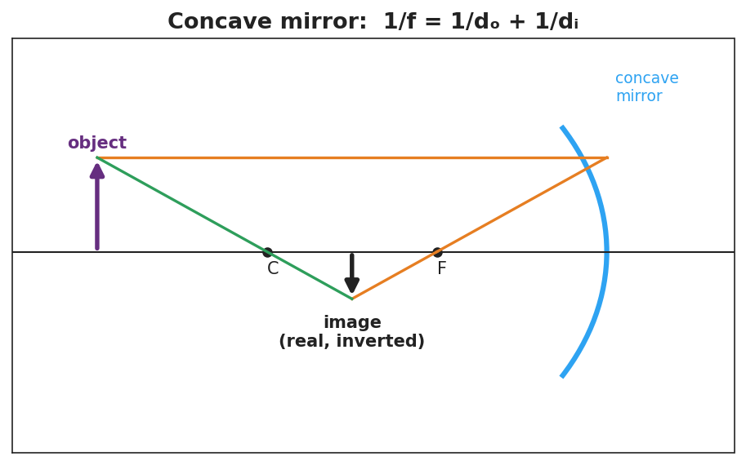
A concave-mirror ray diagram: an object beyond C, the parallel ray reflecting through F, the ray through C reflecting back on itself, meeting at a real, inverted image; labeled 1/f = 1/dₒ + 1/dᵢ.

Teacher facilitation during Explore
- What to look for — groups connecting “object inside f → no image on the screen” to “virtual image” (cannot be projected).
- What to resist — don’t give the equation first; let the (dₒ, dᵢ) data reveal the 1/f relationship.
- What to redirect — students who expect a screen image from a close object should be asked, “can you catch this image on paper, or only see it through the lens?”

Phase 3 · Explain (32 – 37 min)

32–35 min · Turn-and-Talk #2 + class consensus
“What decides whether you get a real (projectable) or virtual (look-through) image?”
Target consensus:
“If the object is beyond the focal point, a converging lens or concave mirror forms a real, inverted image you can project. If the object is inside the focal length, the image is virtual, upright, and magnified — you can only see it by looking through.”

35–37 min · Vocabulary introduction (≤ 3 terms)
Sample teacher language:
“The distance from the lens or mirror to its focus is the focal length, f. A lens that brings parallel rays together is a converging lens (and a concave mirror converges too). What forms where the rays meet — or appear to meet — is the image, related by 1/f = 1/dₒ + 1/dᵢ.”

Discussion prompts to deploy here
- “An object is 30 cm from a converging lens with f = 10 cm. Where is the image?”
  - Sample student response: “1/dᵢ = 1/f − 1/dₒ = 1/10 − 1/30 = 1/15 → dᵢ = 15 cm (real, inverted).”
- “Why can’t you project the magnified image from a magnifying glass onto a wall?”
  - Sample student response: “It’s a virtual image — the rays don’t actually meet, so there’s nothing to catch on a screen.”

Phase 4 · Elaborate (37 – 40 min)

37–39 min · Revise the model
“Return to your candle sketch. Re-draw both cases with the three principal rays. Label one image real, inverted and one virtual, upright. Note where the focal point F is.”

39–40 min · Return to the phenomenon
“Explain in one sentence why the magnifier’s image flips when you move it far from the page, using focal length and image.”
Target: “When the page is closer than the focal length the image is virtual and upright (magnified), but when the page is beyond the focal length the rays cross and form a real, inverted image — so it flips.”

Phase 5 · Evaluate (40 – 42 min)

40–42 min · Exit Ticket + Closing Reflection
“A converging lens has a focal length of 12 cm. An object is placed 36 cm from the lens. (a) Use 1/f = 1/dₒ + 1/dᵢ to find the image distance. Show your work. (b) Is the image real or virtual? Upright or inverted? (c) If the object is moved to 6 cm (inside the focal length), can the image be projected on a screen? Why or why not?”
Expected: (a) 1/dᵢ = 1/12 − 1/36 = 1/18 → dᵢ = 18 cm; (b) real and inverted (object beyond f); (c) no — inside f the image is virtual and cannot be projected. See Answer_Key.docx.
Closing Reflection (SEL, 30 seconds):
“What’s one device with a lens or mirror you now understand better, and who helped you trace the rays?”

Common Misconceptions
- Misconception: “A bigger lens always magnifies more.” → Correction: Magnification depends on the focal length and object distance, not the lens diameter.
- Misconception: “All images can be projected on a screen.” → Correction: Only real images (rays actually meet) project; virtual images (rays only appear to meet) cannot.
- Misconception: “Converging and concave mean opposite things.” → Correction: A converging lens and a concave mirror both bring parallel rays to a focus; they converge light.

Access & Differentiation
- ELL/ENL supports: Sentence frame: “When the object is ______ the focal length, the image is ______ (real/virtual) and ______ (upright/inverted).” Word-choice box: {beyond, inside, real, virtual, upright, inverted}. Provide a labeled ray-diagram template.
- IEP/SPED supports: Provide pre-drawn principal axes with F marked; students draw only the two easiest rays (parallel and central). Give a 1/f = 1/dₒ + 1/dᵢ template with the unknown isolated and a worked example beside it.
- Extensions: Diverging lenses and convex mirrors always form reduced, upright, virtual images. Explain why a convex (passenger-side) car mirror is labeled “objects are closer than they appear.”

Strategy Spotlight
ACTIVE LEARNING. Students physically place objects, hunt for the sharp image on a screen, and discover that a close object yields no screen image (a virtual image) before any term is introduced. Tracing the three principal rays by hand on the diagram cements the geometry. Facilitate with one prompt during the hunt: “Can you catch this image on paper, or only see it through the lens?” — separating real from virtual by experience.

NYSSLS Observation Checklist Crosswalk
# | Checklist item | Where it appears in this lesson
1 | Local/relatable phenomenon | Phase 1 — magnifying glass; glasses, spoons; car mirror in extensions
2 | Turn and Talk (2–3×) | Phase 1 (TT#1 — what decides image type), Phase 3 (TT#2 — real vs. virtual)
3 | Students develop questions/models/procedures | Phase 1 (initial sketch), Phase 2 (ray-trace + oPhysics data), Phase 4 (revise)
4 | CCC defined and used | Lesson Overview · Cause and Effect, restated in Phase 2
5 | ENL — ≤ 3 vocab, second half | Phase 3 — vocabulary at 35–37 min (focal length / converging lens / image)
6 | Revisit phenomenon with evidence | Phase 4 — magnifier flip explanation
7 | ENL/SPED supports | Access & Differentiation block
8 | Assessment check | Phase 5 — quantitative Exit Ticket (lens, f = 12 cm)

Companion Materials
- Student_Worksheet.docx — the 5E student investigation (hand out at start of Phase 2)
- Student_Notes.docx — guided note-guide for vocabulary and the worked example
- Answer_Key.docx — answers to “Make It Make Sense” prompts and the Exit Ticket

Key Vocabulary (max 3)
- focal length — the distance (f) from a lens or mirror to its focal point, where parallel rays converge
- converging lens — a lens (thicker in the middle) that brings parallel rays together at the focal point; a concave mirror does the same by reflection
- image — the reproduction of an object formed by a lens or mirror; real if rays actually meet (projectable), virtual if they only appear to meet

Optics: Lenses and Mirrors — Student Worksheet
Unit: Waves — Lesson 09 Name: _______________________ Date: __________ Period: ____

Phenomenon
Hold a magnifying glass close to this page — the print looks bigger and right-side-up. Now hold it far from a window — the image flips upside down and shrinks. Same lens, two totally different images. Eyeglasses, magnifiers, and curved mirrors all do this kind of thing.
Driving question: What decides whether a lens makes an image big-and-upright or small-and-upside-down?

Notice & Wonder
I notice… | I wonder…
Turn & Talk #1: What decides whether the image is big-and-upright or small-and-upside-down?

Initial Model
Draw a lens with a candle on the left. Sketch where the image forms when the candle is far from the lens, then when it is very close. Label which image is upside-down.

Investigation
Work in a group with a converging lens, a screen, a light source, and oPhysics.
Trial | Object distance dₒ | Image distance dᵢ | Real or virtual? | Upright or inverted?
1. Object far (beyond F)
2. Object inside F
3. Concave mirror, object far
Use these ray diagrams to trace your three principal rays:

Converging-lens ray diagram: object beyond F → real, inverted image; 1/f = 1/dₒ + 1/dᵢ.

Concave-mirror ray diagram: object beyond C → real, inverted image; 1/f = 1/dₒ + 1/dᵢ.
Key question: When the object was inside the focal length, could you catch the image on the screen? What does that tell you about the image?

Make It Make Sense
- An object is 30 cm from a converging lens with f = 10 cm. Use 1/f = 1/dₒ + 1/dᵢ to find the image distance.
- Why can’t you project a magnifying glass’s enlarged image onto a wall?
- A converging lens and a concave mirror are both called “converging.” What do they have in common?

Vocabulary in Action
Use each term in a sentence about today’s phenomenon.
- focal length: _______________________________________________
- converging lens: _______________________________________________
- image: _______________________________________________

Revise Your Model
Return to your candle sketch. Re-draw both cases with the three principal rays. Label one image real, inverted and one virtual, upright, and mark the focal point F.

Exit Ticket
A converging lens has a focal length of 12 cm. An object is placed 36 cm from the lens.
- Use 1/f = 1/dₒ + 1/dᵢ to find the image distance. Show your work.
- Is the image real or virtual? Upright or inverted?
- If the object is moved to 6 cm (inside the focal length), can the image be projected on a screen? Why or why not?

Optics: Lenses and Mirrors — Student Notes
Unit: Waves — Lesson 09 Name: _______________________ Date: __________ Period: ____

Learning Targets
By the end of today’s 42 minutes I can:
- Identify a converging lens / concave mirror and its focal point.
- Draw principal rays to locate an image and label it real or virtual.
- Use 1/f = 1/dₒ + 1/dᵢ to solve for f, dₒ, or dᵢ.

Key Vocabulary
- focal length — _______________________________________________
- converging lens — _______________________________________________
- image — _______________________________________________

Guided Notes
Focal point and focal length. Parallel rays hitting a converging lens (or concave mirror) meet at the __________ point. The distance to it is the __________ length, f.

Converging-lens ray diagram: object beyond F → real, inverted image.
Three principal rays (converging lens):
- A ray parallel to the axis refracts through the far __________.
- A ray through the __________ of the lens goes straight.
- Where the rays cross is the __________.

Concave-mirror ray diagram: object beyond C → real, inverted image.
Real vs. virtual images.
- Object beyond the focal length → image is __________ and inverted; can be __________ on a screen.
- Object inside the focal length → image is __________ and upright; can only be __________ through the lens (magnifier).
The thin-lens / mirror equation (reference table):
1/f = 1/dₒ + 1/dᵢ

Worked Example
Problem. A converging lens has f = 10 cm. An object sits dₒ = 30 cm away. Find the image distance.
Solution. 1. 1/dᵢ = 1/f − 1/dₒ = 1/10 − 1/30. 2. Common denominator: 3/30 − 1/30 = __________ /30 = 1/15. 3. dᵢ = __________ cm. 4. Since dₒ > f, the image is __________ and inverted. ✓

Summary
Finish the sentence (Because / But / So):
A magnifying glass can make an image either upright or upside-down because __________________________________________, but __________________________________________, so __________________________________________.

Optics: Lenses and Mirrors — Answer Key

Cover
Unit: Waves — Lesson 09: Optics (Lenses and Mirrors) East Meadow Schools × Valley Stream Central HSD Strategy chip: ACTIVE LEARNING

Make-It-Make-Sense Answers
- 1/dᵢ = 1/f − 1/dₒ = 1/10 − 1/30 = 3/30 − 1/30 = 2/30 = 1/15 → dᵢ = 15 cm (real, inverted, since dₒ > f). · Rubric: correct equation AND 15 cm. · NYSSLS: HS-PS4-6
- The magnifier’s enlarged image is virtual — the refracted rays only appear to come from it and never actually meet, so there is nothing to catch on a screen. · Rubric: identifies virtual + rays don’t meet. · NYSSLS: HS-PS4-6
- Both converge light: a converging lens brings parallel rays to a focus by refraction, and a concave mirror brings them to a focus by reflection. Both form real, inverted images when the object is beyond f. · Rubric: both bring parallel rays to a focus. · NYSSLS: HS-PS4-6

Exit Ticket Answer
- 1/dᵢ = 1/f − 1/dₒ = 1/12 − 1/36 = 3/36 − 1/36 = 2/36 = 1/18 → dᵢ = 18 cm.
- Real and inverted — the object (36 cm) is beyond the focal length (12 cm).
- No. Inside the focal length the image is virtual (upright, magnified); virtual images cannot be projected on a screen because the rays do not actually meet.
Tolerance/rubric: (a) 18 cm with the equation shown; (b) real AND inverted; (c) no + virtual reasoning. 1 point each. NYSSLS: HS-PS4-6.

Closing Reflection (rubric)
Formative, not graded. Award full credit for any honest response. Look for: - A specific lens/mirror device the student now understands - Acknowledgment of a peer who helped trace the rays

Digital Technologies and Information — Teacher Guide

Cover
Unit: Waves — Lesson 10: Digital Technologies and Information East Meadow Schools × Valley Stream Central High School District Strategy chips: BTC

Curated Resources (from East Meadow Scope & Sequence)

NYSSLS Standards
HS-PS4-2. “Evaluate questions about the advantages of using a digital transmission and storage of information. (Stability and Change)”
This closing lesson asks students to evaluate why modern technology encodes information digitally. Waves (the whole unit) are how signals travel; here students compare an analog wave to its digital (sampled, bit-encoded) version and weigh the advantages — robustness to noise, exact copying, and easy storage. The Crosscutting Concept is Stability and Change: digital encoding keeps information stable as it is transmitted and copied.

Phenomenon
- A scratchy vinyl record (analog) vs. a crisp streamed song (digital); a blurry, pixelated photo “cleaning up” as more data loads; a tenth-generation photocopy vs. a re-printed PDF: https://www.youtube.com/watch?v=Hh-qWaMG6Sw

Javalab / Labs
- Javalab Analog vs Digital Signal — toggle between a smooth wave and its sampled, quantized version and add “noise”: https://javalab.org/en/analog_digital_signal_en/

Assessments
- Telephone-game data activity + Javalab noise test: students pass an analog vs. a digital “message” down a line and measure which survives copying. Exit ticket below serves as the formative check.

Lesson Overview
Duration | 42 minutes (1 period)
NYSSLS link | HS-PS4-2 (advantages of digital transmission/storage)
CCC focus | Stability and Change — digital encoding keeps information stable against noise and repeated copying.
Strategy chips | BTC (Building Thinking Classrooms)
Materials | Vertical non-permanent surfaces + markers; graph paper; an old photocopy + a fresh PDF print (demo); devices for Javalab.
Safety | None.
Prior knowledge | Lessons 01–07 — waves carry information as signals; amplitude/frequency encode a message.
Lesson objectives — students can:
- Distinguish an analog signal (continuous) from a digital signal (discrete samples encoded as bits).
- Explain how sampling and bits represent a wave, and that more bits / faster sampling means higher fidelity.
- Evaluate, with reasoning, why digital transmission and storage are more robust to noise and easier to copy than analog.

Phase 1 · Engage (0 – 12 min)

0–3 min · Opening Connection (SEL)
Quick check-in: “Name a message that got ‘garbled’ on the way to you — a bad photocopy, a frozen video call, a misheard rumor.” One sentence each. This primes the noise/fidelity idea.

3–8 min · Phenomenon hook — vinyl crackle vs. clean stream
Teacher actions. Play a few seconds of a scratchy vinyl/old tape recording, then the same song streamed. Show a tenth-generation photocopy next to a freshly printed PDF. Old analog copies degrade; digital copies don’t.
Sample teacher language:
“Copy a copy of a copy on this photocopier and it turns to mush. But I can copy this PDF a million times and the millionth is identical to the first. Why does one survive copying and the other doesn’t?”
Anticipated student responses:
- “The digital one is just numbers.” — excellent; capture this.
- “The analog one picks up noise.” — yes; noise accumulates.
- “Computers can fix errors.” — good; digital is correctable.

8–12 min · Notice & Wonder + Turn-and-Talk #1
Capture columns. Then:
“Turn to your partner: what is it about storing something as numbers (digital) that lets it survive copying perfectly?”
Target: a digital signal only has to decide between a few exact values, so small noise can be cleaned back to the nearest value.

Bridge to Phase 2
Initial model sentence: “A digital copy survives because the signal is stored as ______ instead of a continuous ______.”

Phase 2 · Explore (12 – 32 min)

12–17 min · Initial Model (silent / individual)
Prompt:
“Draw a smooth wave (analog). Now show how you would store it using only a few measured points (samples). What information do you lose? What do you gain?”

17–32 min · Investigation — BTC: random groups, vertical surfaces
Form visibly random groups of 3 at vertical non-permanent surfaces, one marker each. Escalating thin-slice tasks:
- Sample it. Given a printed analog wave, mark sample points at regular intervals and round each to the nearest grid line (quantize). Draw the resulting stair-step.
- More vs. fewer samples. Redraw with twice as many samples. Which stair-step matches the original better?
- Add noise. Add a small random wobble to both an analog wave and a digital stair-step. After “cleaning” (rounding to nearest level), which one recovers the original exactly?
- Evaluate (the HS-PS4-2 question). List two advantages of digital over analog for transmitting and storing a song. Is there any disadvantage?
Confirm at Javalab, then compare to these figures:
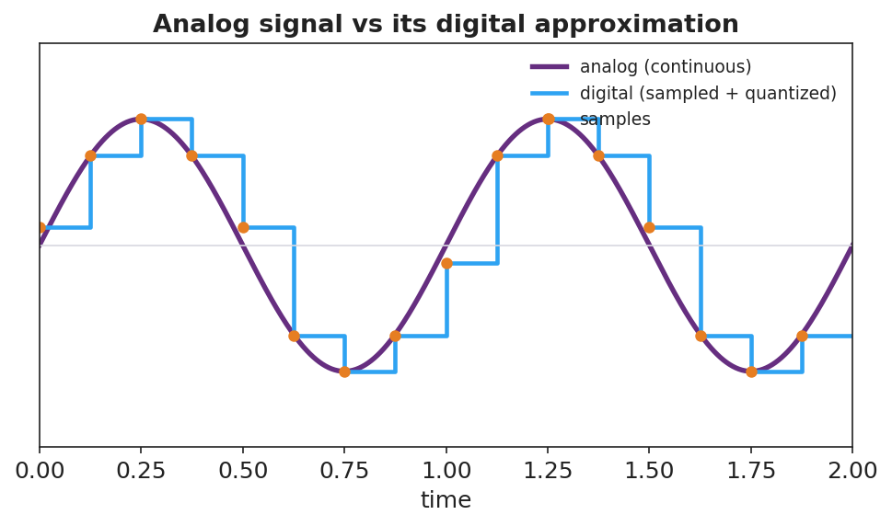
A smooth analog sine wave overlaid with its digital version: sample points and a stair-step (sampled and quantized) approximation.
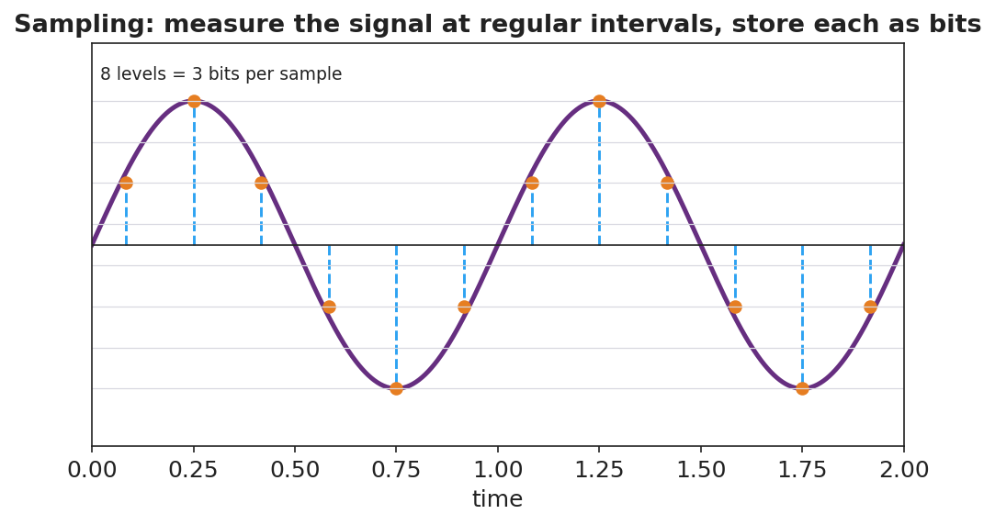
A sampling diagram: a continuous wave measured at regular time intervals, each sample stored at a discrete level (8 levels = 3 bits).

Teacher facilitation during Explore
- What to look for — groups reasoning that small noise on a digital signal rounds back to the correct level, while noise on analog is indistinguishable from the real signal.
- What to resist — don’t define analog/digital/bit first; let “smooth vs. stair-step” and “numbers vs. continuous” emerge.
- What to redirect — groups who claim digital is “always better/perfect” should be pushed to find the cost (lost detail between samples; needs enough bits/sampling rate).

Phase 3 · Explain (32 – 37 min)

32–35 min · Turn-and-Talk #2 + class consensus
“Why does digital information survive transmission and copying better than analog?”
Target consensus:
“An analog signal is continuous, so any noise becomes part of the signal and builds up with each copy. A digital signal is a set of exact numbers (bits); small noise can be cleaned back to the nearest value, so copies stay identical.”

35–37 min · Vocabulary introduction (≤ 3 terms)
Sample teacher language:
“A continuous, smoothly varying signal is analog. A signal stored as discrete sampled values is digital. The smallest unit of digital information — a single 0 or 1 — is a bit; more bits per sample means more levels and higher fidelity.”

Discussion prompts to deploy here
- “Why does a digital photo copied 100 times look identical, but a photocopied photo degrades?”
  - Sample student response: “The digital photo is exact numbers that get reproduced perfectly; the photocopy adds a little noise each time.”
- “What’s a disadvantage of digital?”
  - Sample student response: “You lose the detail between samples unless you sample fast enough and use enough bits.”

Phase 4 · Elaborate (37 – 40 min)

37–39 min · Revise the model
“Return to your sampled wave. Label the smooth curve analog and the stair-step digital. Add a one-sentence evaluation: why is digital better for sending a song across the world?”

39–40 min · Return to the phenomenon
“Explain in one sentence why the streamed song stays crisp but the vinyl gets scratchier, using analog, digital, and noise.”
Target: “Vinyl is analog, so every scratch adds noise to the continuous groove; a streamed song is digital — stored as bits — so noise can be removed by rounding to the nearest value and every copy stays identical.”

Phase 5 · Evaluate (40 – 42 min)

40–42 min · Exit Ticket + Closing Reflection
“A friend says, ‘Records sound warmer, so analog must be better in every way.’ (a) Define analog and digital signals. (b) Give two advantages of digital for transmitting and storing music. (c) Evaluate the friend’s claim: name one thing analog might do well and one clear advantage of digital they’re overlooking.”
Expected: (a) analog = continuous signal, digital = discrete sampled values stored as bits; (b) robust to noise / identical copies / easy to store and compress; (c) analog can capture continuous nuance, but digital resists noise and copies perfectly — the friend overlooks robustness/fidelity in transmission. See Answer_Key.docx.
Closing Reflection (SEL, 30 seconds):
“After this whole Waves unit, what’s one wave idea you’ll carry with you — and how did this class help you ‘tune in’?”

Common Misconceptions
- Misconception: “Digital signals are perfect with no information loss.” → Correction: Sampling and quantization discard detail between samples; fidelity depends on sampling rate and bit depth.
- Misconception: “Analog is old and useless.” → Correction: Analog captures continuous variation; the lesson is about trade-offs, especially digital’s robustness to noise.
- Misconception: “A bit is the same as a byte / a sample.” → Correction: A bit is a single 0/1; multiple bits encode one sample’s level (e.g., 3 bits = 8 levels).

Access & Differentiation
- ELL/ENL supports: Sentence frame: “An analog signal is ______; a digital signal is ______. Digital survives noise because ______.” Word-choice box: {continuous, discrete/sampled, rounded to the nearest value, bits}. Provide the analog-vs-digital figure with both labeled.
- IEP/SPED supports: Provide graph paper with an analog wave already drawn and grid levels marked; students place sample dots and round to the nearest line. Offer the photocopy-degradation demo as a concrete anchor for “noise builds up.”
- Extensions: Estimate the bits needed for CD audio (16 bits/sample × 44,100 samples/s × 2 channels) and discuss why higher sampling rates and bit depths improve fidelity but increase file size.

Strategy Spotlight
BTC (Building Thinking Classrooms). Use visibly random groups of 3 at vertical non-permanent surfaces, one marker per group. The escalating thin slices — sample, refine, add noise, then evaluate — culminate in the HS-PS4-2 evaluation question, which is genuinely open and benefits from public, erasable thinking. Defer vocabulary to Phase 3 and circulate with one prompt: “After adding noise, which signal can you clean back to the original — and why?”

NYSSLS Observation Checklist Crosswalk
# | Checklist item | Where it appears in this lesson
1 | Local/relatable phenomenon | Phase 1 — vinyl vs. stream; photocopy vs. PDF
2 | Turn and Talk (2–3×) | Phase 1 (TT#1 — why numbers survive copying), Phase 3 (TT#2 — why digital is robust)
3 | Students develop questions/models/procedures | Phase 1 (initial model), Phase 2 (BTC sampling + noise tasks + Javalab), Phase 4 (revise)
4 | CCC defined and used | Lesson Overview · Stability and Change, restated in Phase 2
5 | ENL — ≤ 3 vocab, second half | Phase 3 — vocabulary at 35–37 min (analog signal / digital signal / bit)
6 | Revisit phenomenon with evidence | Phase 4 — vinyl-vs-stream explanation
7 | ENL/SPED supports | Access & Differentiation block
8 | Assessment check | Phase 5 — Exit Ticket (evaluate the “analog is better” claim)

Companion Materials
- Student_Worksheet.docx — the 5E student investigation (hand out at start of Phase 2)
- Student_Notes.docx — guided note-guide for vocabulary and the worked example
- Answer_Key.docx — answers to “Make It Make Sense” prompts and the Exit Ticket

Key Vocabulary (max 3)
- analog signal — a continuous, smoothly varying signal that can take any value (e.g., a vinyl groove, a sound wave in air)
- digital signal — a signal represented by discrete sampled values encoded as bits, taking only specific levels
- bit — the smallest unit of digital information, a single 0 or 1; more bits per sample give more levels and higher fidelity

Digital Technologies and Information — Student Worksheet
Unit: Waves — Lesson 10 Name: _______________________ Date: __________ Period: ____

Phenomenon
A vinyl record gets scratchier every time it’s played, and a copy of a copy of a photocopy turns to mush. But you can stream the same song a million times, or copy a PDF endlessly, and the last copy is identical to the first.
Driving question: Why does a digital copy survive perfectly while an analog copy degrades?

Notice & Wonder
I notice… | I wonder…
Turn & Talk #1: What is it about storing something as numbers (digital) that lets it survive copying perfectly?

Initial Model
Draw a smooth wave (analog). Now show how you would store it using only a few measured points (samples). What information do you lose? What do you gain?

Investigation
Work in your random group of 3 at a vertical surface. Use graph paper and Javalab.
Task | What we did | What we found
1. Sample + round an analog wave
2. Twice as many samples
3. Add noise to both, then “clean”
4. List 2 advantages of digital
Compare your stair-step to these:

Analog sine wave overlaid with its sampled, quantized digital version.

A sampling diagram: a wave measured at regular intervals, each sample stored at a discrete level (8 levels = 3 bits).
Key question: After you added noise, which signal could you clean back to the original exactly — analog or digital? Why?

Make It Make Sense
- Define analog and digital signals in your own words.
- Why does a digital photo copied 100 times look identical, but a photocopied photo degrades?
- Name one disadvantage of digital — what gets lost when you sample a smooth wave?

Vocabulary in Action
Use each term in a sentence about today’s phenomenon.
- analog signal: _______________________________________________
- digital signal: _______________________________________________
- bit: _______________________________________________

Revise Your Model
Return to your sampled wave. Label the smooth curve analog and the stair-step digital. Add a one-sentence evaluation: why is digital better for sending a song across the world?

Exit Ticket
A friend says, “Records sound warmer, so analog must be better in every way.”
- Define analog and digital signals.
- Give two advantages of digital for transmitting and storing music.
- Evaluate the friend’s claim: name one thing analog might do well and one clear advantage of digital they’re overlooking.

Digital Technologies and Information — Student Notes
Unit: Waves — Lesson 10 Name: _______________________ Date: __________ Period: ____

Learning Targets
By the end of today’s 42 minutes I can:
- Distinguish an analog signal from a digital signal.
- Explain how sampling and bits represent a wave.
- Evaluate why digital transmission and storage resist noise and copy perfectly.

Key Vocabulary
- analog signal — _______________________________________________
- digital signal — _______________________________________________
- bit — _______________________________________________

Guided Notes
Analog vs. digital.

Analog sine wave overlaid with its sampled, quantized digital version.
- Analog — a __________ signal that can take any value (vinyl groove, sound in air).
- Digital — a signal stored as __________ (sampled) values, each rounded to a level and written as __________.
Sampling. To digitize a wave you measure it at regular __________ and store each measurement.

Sampling: a wave measured at regular intervals, 8 levels = 3 bits.
- More samples per second + more bits per sample → __________ fidelity.
- A bit is a single __________ or __________; 3 bits give 2³ = __________ levels.
Why digital wins (HS-PS4-2, Stability and Change).
- Noise on a digital signal can be __________ back to the nearest level → copies stay identical.
- Noise on an analog signal becomes part of the signal and __________ up with each copy.
- Digital is also easy to __________, compress, and error-check.
Trade-off: digital loses the detail __________ the samples unless you sample fast enough.

Worked Example
Problem. A sound is sampled with 3 bits per sample. (a) How many levels is that? (b) Why does adding a 4th bit improve the recording?
Solution. 1. 3 bits → 2³ = __________ levels. 2. A 4th bit → 2⁴ = __________ levels, so each sample is rounded to a __________ value → higher fidelity. 3. More bits trade larger __________ for better quality. ✓

Summary
Finish the sentence (Because / But / So):
A streamed song stays crisp but a vinyl record gets scratchier because __________________________________________, but __________________________________________, so __________________________________________.

Digital Technologies and Information — Answer Key

Cover
Unit: Waves — Lesson 10: Digital Technologies and Information East Meadow Schools × Valley Stream Central HSD Strategy chip: BTC

Make-It-Make-Sense Answers
- Analog = a continuous signal that can take any value (smooth wave). Digital = a signal stored as discrete sampled values encoded as bits (a stair-step of specific levels). · Rubric: continuous vs. discrete/sampled. · NYSSLS: HS-PS4-2
- A digital photo is stored as exact numbers (bits) that are reproduced perfectly each copy; a photocopy is analog and adds a little noise every time, which accumulates and degrades the image. · Rubric: exact numbers reproduce vs. noise accumulates. · NYSSLS: HS-PS4-2
- Sampling discards the detail between the sample points (and rounds each sample to the nearest level); if you don’t sample fast enough or use enough bits, the digital version misses fine variation. · Rubric: names lost detail between samples / quantization. · NYSSLS: HS-PS4-2

Exit Ticket Answer
- Analog = continuous signal (any value); digital = discrete sampled values stored as bits.
- Any two: resistant to noise (can be cleaned back to exact levels); perfect, identical copies; easy to store, compress, and error-check; easy to transmit over long distances without degrading.
- Analog can capture continuous nuance/detail (the “warmth”), but the friend overlooks that digital is far more robust to noise and copies perfectly — a major advantage for transmitting and storing music.
Tolerance/rubric: (a) both defined; (b) two valid advantages; (c) one fair point for analog AND one clear digital advantage (robustness/fidelity). 1 point each. NYSSLS: HS-PS4-2.

Closing Reflection (rubric)
Formative, not graded. Award full credit for any honest response. Look for: - One wave idea from the whole unit the student will carry forward - A genuine reflection on how the class helped them learn

