Physics — Unit 09: Modern Physics (Review)
Table of Contents

Unit 9 · Modern Physics

Modern Physics — Unit Plan

Cover
Unit: Modern Physics East Meadow Schools × Valley Stream Central High School District 5 lessons · ~5 instructional periods (42 min each) Format: DOCX (Teacher Guide · Student Worksheet · Student Notes · Answer Key per lesson)

Unit Scope (from East Meadow Scope & Sequence)
This closing unit reframes everything students have learned about waves, energy, and matter at the scale of the atom and the nucleus. Light, which earlier behaved as a wave, now also behaves as a stream of energy packets called photons. Matter, which earlier was modeled as solid particles, is now organized into a small set of fundamental particles. The unit develops and uses models (a core SEP) as the through-line: each lesson revises a model when new evidence demands it. It builds on Waves (frequency and wavelength) and Energy, and it connects outward to chemistry (nuclear change) and astronomy (starlight and the Big Bang).
# | Lesson | Core idea
01 | The Photoelectric Effect | Light is quantized: photons of energy E = h·f eject electrons only above a threshold frequency
02 | Models of the Atom | The atomic model evolved (Dalton → Thomson → Rutherford → Bohr → quantum) as evidence accumulated
03 | Energy-Level Diagrams and Spectra | Electrons occupy discrete energy levels; photon jumps produce line spectra that fingerprint elements
04 | The Standard Model | Matter is built from quarks and leptons; forces are carried by bosons
05 | Fusion, Fission, and Radioactive Decay | Nuclear changes release enormous energy (E = mc², scale only); they power stars and form elements

Pacing Calendar
Day | Lesson | Phenomenon anchor | Strategy
1 | 01 Photoelectric Effect | Different-color lasers on a photo surface — only some eject electrons | Hochman
2 | 02 Models of the Atom | Rutherford gold-foil scattering | Active Learning
3 | 03 Energy Levels & Spectra | Gas-discharge tubes show colored line spectra, not a rainbow | BTC
4 | 04 The Standard Model | Cassiopeia Project Standard Model video — what is everything made of? | Hochman
5 | 05 Fusion / Fission / Decay | The Sun, nuclear power, and carbon dating | Active Learning
Double-period days (every other day) let the Explore phases of Lessons 01 and 03 run long with the PhET and ophysics simulations as full labs.

Strategy Rotation
- HOCHMAN (literacy): Lessons 01, 04 — Because/But/So expansion and appositives on the key relationships (E = h·f and threshold frequency; quarks/leptons/bosons as an organizing model).
- ACTIVE LEARNING: Lessons 02, 05 — gold-foil claim-evidence card sort and model-revision gallery; the fission/fusion/decay station rotation.
- BTC (Building Thinking Classrooms): Lesson 03 — random groups + vertical non-permanent surfaces on an energy-level/spectrum thin-slice.
SEL (Opening Connection + Closing Reflection), ELL/SPED supports, and a Curated Resources block appear in every lesson.

NYSSLS Coverage Matrix
PE | Description | Lessons
HS-PS4-4 | Evaluate the validity and reliability of claims about the effects of different frequencies of electromagnetic radiation absorbed by matter (Cause and Effect) | 01 (core)
HS-PS1-8 | Develop models to illustrate changes in the nucleus and the energy released during fission, fusion, and radioactive decay (Energy and Matter) — scale of energy only | 05 (core)
HS-ESS1-2 | Construct an explanation of the Big Bang based on light spectra, galaxy motion, and composition — connection to wavelength/frequency of light and star formation | 03 (spectra), 05 (star formation, thread)
The Science and Engineering Practice Developing and Using Models anchors Lessons 02 and 04, which are conceptual model-building lessons rather than single-PE lessons.

Vocabulary Scope
Three terms maximum per lesson, introduced in the second half (NYSSLS observation item 5).
Lesson | Terms
01 | photon · photoelectric effect · threshold frequency
02 | nucleus · electron · atomic model
03 | energy level · photon emission · line spectrum
04 | quark · lepton · fundamental particle
05 | fission · fusion · radioactive decay

The Photoelectric Effect — Teacher Guide

Cover
Unit: Modern Physics — Lesson 01: The Photoelectric Effect East Meadow Schools × Valley Stream Central High School District Strategy chips: HOCHMAN

Curated Resources (from East Meadow Scope & Sequence)

NYSSLS Standards
This lesson is the core treatment of HS-PS4-4: “Evaluate the validity and reliability of claims in published materials of the effects that different frequencies of electromagnetic radiation have when absorbed by matter. (Cause and Effect).” The photoelectric effect is the cleanest case in the curriculum where the frequency of light — not its brightness — is the cause that determines an effect (whether electrons are ejected). It also closes the Waves unit’s wave model of light by introducing the complementary particle (photon) model.

Phenomenon
- Different-color lasers (red, green, violet) shining on a glow/photo surface — only some colors eject electrons, no matter how bright: https://www.youtube.com/watch?v=kcSYV8bMQzg
- Why a UV lamp fogs photographic paper but a much brighter red lamp does not (cause-and-effect framing).

Javalab / Labs
- PhET Photoelectric Effect simulation: https://phet.colorado.edu/en/simulations/photoelectric

Assessments
- Exit ticket below (threshold-frequency reasoning) is the formative check. The PhET simulation includes built-in data tables students can screenshot as evidence.

Lesson Overview
Duration | 42 minutes (1 period)
NYSSLS link | HS-PS4-4 (core)
CCC focus | Cause and Effect — the frequency of light, not its intensity, causes (or fails to cause) electron ejection.
Strategy chips | HOCHMAN (Because/But/So + appositive on threshold frequency)
Materials | Projector for the laser/PhET demo; student devices or a shared screen for PhET; whiteboards/markers; reference table (E = h·f, h = 6.63×10⁻³⁴ J·s).
Safety | If using real lasers, never aim at eyes; the simulation is the safe default.
Prior knowledge | Waves — frequency and wavelength (violet light is higher frequency than red); energy as a measurable quantity.
Lesson objectives — students can:
- Describe light as a stream of energy packets (photons) whose energy is set by frequency, E = h·f.
- Explain why electrons are ejected only above a threshold frequency, regardless of intensity.
- Use E = h·f to calculate a photon’s energy and compare it to a threshold.

Phase 1 · Engage (0 – 10 min)

0–2 min · Opening Connection (SEL)
Quick whip-around (one sentence each, pass allowed): “Name something where doing it harder doesn’t help — only doing it a different way does.” (e.g., a key that’s the wrong shape — pushing harder won’t open the lock.) Park these; you’ll call back to “wrong shape vs. harder push” when intensity fails but frequency succeeds.

2–7 min · Phenomenon hook — colored lasers on a photo surface
Teacher actions. Project the laser clip (or PhET). Shine a bright red beam on the surface: no electrons leave. Switch to a dim violet beam: electrons fly off immediately.
Sample teacher language:
“I just made the red light much brighter and nothing happened. Then I used a dim purple light and electrons jumped off right away. Brightness lost to color. Why would the color of the light decide this, when more brightness couldn’t?”
Anticipated student responses:
- “Purple light is stronger.” — reframe: “Stronger how? It’s actually dimmer. What’s different about purple?”
- “Maybe purple has more energy per beam.” — capture energy; we’ll sharpen “per beam” to “per packet.”
- “It’s the frequency — purple is higher frequency.” — gold; hold it for Phase 3.

7–10 min · Notice & Wonder + Turn-and-Talk #1
Two columns on the board. Then:
“Turn to your partner: what does brightness change, and what does color change? Predict which one controls whether electrons leave.”
Target seed: brightness = how many; color (frequency) = how much energy each carries.

Bridge to Phase 2
Every student leaves with a one-sentence initial model: “Electrons are ejected when ______.”

Phase 2 · Explore (10 – 30 min)

10–14 min · Initial Model (silent / individual)
Prompt on the board:
“Draw the light hitting the metal. Show what you think ‘brighter’ does and what ‘higher frequency’ does. Predict: which change will start ejecting electrons?”

14–30 min · Investigation — PhET Photoelectric Effect
Students (pairs) run the PhET sim and fill the data table on the worksheet:
- Hold frequency low (red), raise intensity to max. Do electrons eject? (No.)
- Hold intensity low, raise frequency until electrons just begin to leave. Record that frequency — the threshold.
- Above threshold: raise frequency higher. What happens to the speed/energy of ejected electrons? (Increases.)
- Above threshold: raise intensity. What happens to the number of electrons? (Increases, but their energy does not.)
Teacher facilitation language:
“At max brightness with red light — anything? Now creep the frequency up. Watch for the exact moment electrons appear.” “Once they’re flying, what does turning up brightness change — their number or their speed?” “What does turning up frequency change instead?”
Use the diagram below to make “one photon, one electron” visible while students model the ejection event:
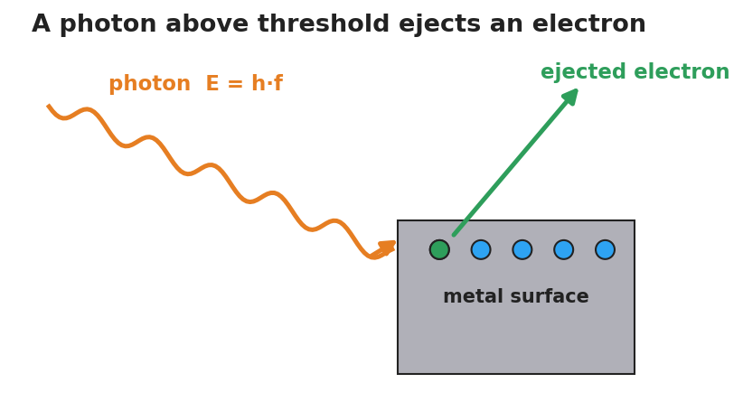
A single photon of energy E equals h times f strikes a metal surface and ejects one electron, which flies away.

Teacher facilitation during Explore
- What to look for — students noticing the sharp on/off at a particular frequency, not a gradual fade.
- What to resist — don’t name “photon” or “quantized” yet; let the threshold surprise them.
- What to redirect — “more brightness = more energy” should be tested: more brightness below threshold still ejects nothing.

Phase 3 · Explain (30 – 36 min)

30–33 min · Turn-and-Talk #2 + class consensus
“Brightness changed the number of electrons but never started them. Frequency had an on/off line. What does that tell you about how light delivers its energy?”
Target consensus:
“Light arrives in separate packets. Each packet’s energy depends on frequency. One packet hits one electron — if that single packet doesn’t carry enough energy, no amount of extra packets (brightness) helps.”

33–36 min · Vocabulary introduction (≤ 3 terms)
Sample teacher language:
“Each energy packet of light is a photon — a particle of light. Its energy is E = h·f, so higher frequency means a more energetic photon. The ejecting of electrons by light is the photoelectric effect. The lowest frequency that can eject any electron is the threshold frequency — below it, brightness is useless; above it, brightness only adds more electrons.”

Discussion prompts to deploy here
- “Why can’t a brighter red beam ever eject an electron that violet ejects easily?”
  - Sample student response: “Brighter red just sends more low-energy photons; each one is still too weak. Violet photons each clear the threshold.”
- “If h is tiny, why does frequency matter so much?”
  - Sample student response: “E = h·f — h is fixed, so the only way to raise each photon’s energy is to raise f.”

Phase 4 · Elaborate (36 – 39 min)

36–38 min · Hochman Because/But/So + revise the model
Students complete the sentence stem (modeled, then independent):
“A bright red light cannot eject electrons because ______, but a dim violet light can because ______, so the deciding factor is ______ , not ______.”
Coach the appositive: “A photon, a single packet of light energy, carries E = h·f.”

38–39 min · Return to the phenomenon
“Restate the laser demo in one sentence using photon and threshold frequency.”
Target: “Violet photons cleared the threshold frequency and ejected electrons; red photons — even many of them — each fell below it.”

Phase 5 · Evaluate (39 – 42 min)

39–42 min · Exit Ticket + Closing Reflection
“A metal has a threshold frequency of 5.0×10¹⁴ Hz. (a) Find the energy of one photon of light at 6.0×10¹⁴ Hz. (Use E = h·f, h = 6.63×10⁻³⁴ J·s.) (b) Will that light eject electrons? Explain. (c) Doubling the brightness of light at 4.0×10¹⁴ Hz does what? Why?”
Expected: (a) E = (6.63×10⁻³⁴)(6.0×10¹⁴) ≈ 4.0×10⁻¹⁹ J; (b) yes — 6.0×10¹⁴ Hz is above threshold; (c) nothing is ejected — below threshold, more photons still each lack the energy. See Answer_Key.docx.
Closing Reflection (SEL, 30 seconds):
“What is one idea about light that changed for you today?”

Common Misconceptions
- Misconception: “Brighter light always carries more energy to each electron.” → Correction: Brighter light = more photons, not more energetic ones. Each photon’s energy is set by frequency (E = h·f).
- Misconception: “Light is only a wave.” → Correction: Light also behaves as particles (photons); the photoelectric effect is the evidence the wave model alone cannot explain.
- Misconception: “Any light, given enough time/intensity, eventually ejects electrons.” → Correction: Below the threshold frequency, no intensity and no waiting will eject an electron — it’s an on/off threshold.

Access & Differentiation
- ELL/ENL supports: Sentence frame: “Light below the ___ frequency ejects ___ electrons, but light above it ejects electrons whose energy ___ as frequency rises.” Word box: {threshold, no, increases, photon, intensity}. Pair photon with a gesture (one fist = one packet).
- IEP/SPED supports: Provide the PhET data table pre-labeled; students circle “ejects / does not eject” rather than writing. Offer a partially worked E = h·f calculation with the substitution already set up.
- Extensions: Have students compute the threshold energy in joules from the threshold frequency and explain why two metals with different thresholds respond to different colors.

Strategy Spotlight
HOCHMAN (literacy). Today’s literacy move is the Because/But/So expansion in Phase 4, which forces students to coordinate cause (frequency) against a distractor (intensity) in a single complex sentence. Model one aloud, then release. The appositive drill — “A photon, a single packet of light energy, carries E = h·f” — gives students a compact way to define the new term mid-sentence, a transferable academic-writing structure.

NYSSLS Observation Checklist Crosswalk
# | Checklist item | Where it appears in this lesson
1 | Local/relatable phenomenon | Phase 1 — colored lasers; UV vs. red lamp
2 | Turn and Talk (2–3×) | Phase 1 (TT#1 — brightness vs. color), Phase 3 (TT#2 — how light delivers energy)
3 | Students develop questions/models/procedures | Phase 1 (initial model), Phase 2 (PhET investigation), Phase 4 (revise model)
4 | CCC defined and used | Lesson Overview · Cause and Effect (frequency → ejection), restated in Phase 3
5 | ENL — ≤ 3 vocab, second half | Phase 3 — vocabulary at 33–36 min (photon / photoelectric effect / threshold frequency)
6 | Revisit phenomenon with evidence | Phase 4 — restate the laser demo using new terms
7 | ENL/SPED supports | Access & Differentiation block
8 | Assessment check | Phase 5 — Exit Ticket (E = h·f + threshold)

Companion Materials
- Student_Worksheet.docx — the 5E student investigation with the PhET data table (hand out at start of Phase 2)
- Student_Notes.docx — guided note-guide for vocabulary and the E = h·f worked example
- Answer_Key.docx — answers to “Make It Make Sense” prompts and the Exit Ticket

Key Vocabulary (max 3)
- photon — a single packet (particle) of light energy; its energy is E = h·f, where h = 6.63×10⁻³⁴ J·s
- photoelectric effect — the ejection of electrons from a surface when light of high enough frequency strikes it
- threshold frequency — the lowest frequency of light that can eject electrons from a given surface; below it, no electrons leave regardless of intensity

The Photoelectric Effect — Student Worksheet
Unit: Modern Physics — Lesson 01 Name: _______________________ Date: __________ Period: ____

Phenomenon
A very bright red laser shines on a metal surface — and nothing happens. Then a dim violet light hits the same surface and electrons fly off instantly. Turning the red light brighter still does nothing.
Driving question: What decides whether light can knock electrons off a surface — how bright it is, or its color (frequency)?

Notice & Wonder
I notice… | I wonder…
Turn & Talk #1: What does changing the brightness of light do? What does changing the color do? Which one do you predict controls electron ejection?

Initial Model
Draw the light hitting the metal. Show what you think “brighter” does and what “higher frequency (more violet)” does. Then predict which change will start ejecting electrons.

My prediction: _______________________________

Investigation
Use the PhET Photoelectric Effect simulation. The diagram shows one photon striking the metal and ejecting one electron — use it as your model of a single ejection event.

A single photon of energy E equals h times f strikes a metal surface and ejects one electron.
Test | What I changed | Electrons ejected? (Y/N) | What changed about them (number / energy)
1. Red light, brightness to MAX
2. Raise frequency slowly |  |  | (record the frequency where ejection starts)
3. Above threshold, raise frequency more
4. Above threshold, raise brightness
Key question: Below the ejecting frequency, does turning up the brightness ever start ejecting electrons?

Make It Make Sense
- A bright red beam ejects no electrons, but a dim violet beam does. What does this tell you about how light delivers its energy?
- Above the threshold, turning up the brightness adds more electrons but does not speed them up. Turning up the frequency speeds them up. Explain why, using the idea of a photon.
- A photon’s energy is E = h·f. If you wanted to give each photon more energy, what would you change?

Vocabulary in Action
Use each term in a sentence about today’s phenomenon.
- photon: _______________________________________________
- photoelectric effect: _______________________________________________
- threshold frequency: _______________________________________________

Revise Your Model
Return to your Initial Model. Using photon and threshold frequency, rewrite your explanation of why brightness failed but color succeeded.

Exit Ticket
A metal has a threshold frequency of 5.0×10¹⁴ Hz. (Reference table: E = h·f, h = 6.63×10⁻³⁴ J·s.)
- Find the energy of one photon of light at 6.0×10¹⁴ Hz.
- Will that light eject electrons from this metal? Explain.
- Light at 4.0×10¹⁴ Hz is made twice as bright. What happens to the ejected electrons? Why?

The Photoelectric Effect — Student Notes
Unit: Modern Physics — Lesson 01 Name: _______________________ Date: __________ Period: ____

Learning Targets
By the end of today’s 42 minutes I can:
- Describe light as a stream of energy packets (photons) whose energy depends on frequency.
- Explain why electrons are ejected only above a threshold frequency, no matter the brightness.
- Use E = h·f to calculate a photon’s energy.

Key Vocabulary
- photon — _______________________________________________
- photoelectric effect — _______________________________________________
- threshold frequency — _______________________________________________

Guided Notes
Big idea: Light is not only a wave — it also arrives in __________ packets called photons.
- The energy of one photon: E = h·f, where h = __________ J·s (Planck’s constant) and f is the __________.
- Higher frequency → __________ energy per photon. (Violet photons carry more energy than red photons.)
- Brightness = how __________ photons arrive each second (the number), not how much energy each one has.
The photoelectric effect (one photon, one electron):
- One photon hits one __________. If that single photon’s energy is high enough, the electron is __________.
- The lowest frequency that can eject any electron is the threshold frequency.
  - Below threshold: __________ electrons leave, no matter how bright.
  - Above threshold: raising brightness adds __________ electrons; raising frequency adds __________ to each electron.

A single photon of energy E equals h times f strikes a metal surface and ejects one electron.
The graph below shows it: no electron energy below the threshold frequency f₀, then a straight line rising with frequency.
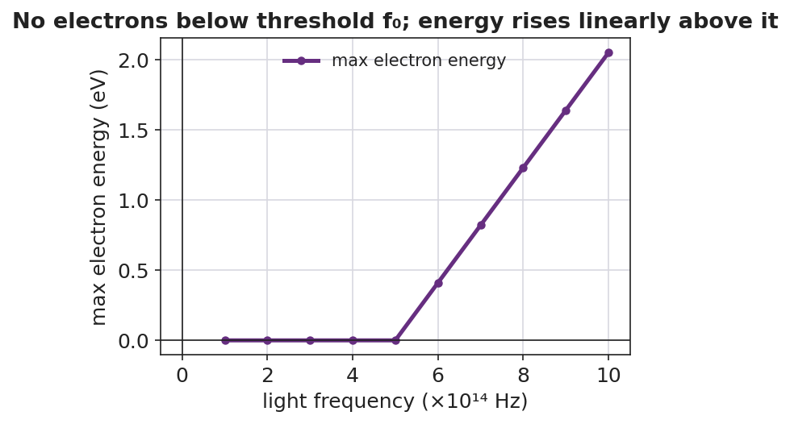
Graph of maximum ejected-electron energy versus light frequency: zero below the threshold frequency, then rising linearly above it.

Worked Example
Problem. Find the energy of one photon of green light with frequency 5.5×10¹⁴ Hz. (h = 6.63×10⁻³⁴ J·s.)
Solution. 1. Write the formula: E = h·f. 2. Substitute: E = (6.63×10⁻³⁴ J·s)(5.5×10¹⁴ Hz). 3. Multiply: E = __________ J ≈ 3.6×10⁻¹⁹ J. 4. A violet photon (higher f) would have __________ energy; a red photon (lower f) would have __________ energy.

Summary
Finish the sentence (Because / But / So):
A very bright red light cannot eject electrons because __________________________________________, but a dim violet light can because __________________________________________, so __________________________________________.

The Photoelectric Effect — Answer Key

Cover
Unit: Modern Physics — Lesson 01: The Photoelectric Effect East Meadow Schools × Valley Stream Central HSD Strategy chip: HOCHMAN

Make-It-Make-Sense Answers
- Light delivers its energy in separate packets (photons), not as one continuous flow. A single red photon is too weak to free an electron, and many weak photons (a bright red beam) still can’t — each electron is hit by one photon at a time. A violet photon carries enough energy in one packet. · Rubric: names packets/photons AND states “one photon hits one electron” → full credit. · NYSSLS: HS-PS4-4
- Brightness adds more photons, so more electrons are freed, but each electron still gets the energy of just one photon — so their speed/energy doesn’t change. Raising the frequency raises each photon’s energy (E = h·f), so each freed electron leaves with more energy. · Rubric: links brightness → number and frequency → energy-per-electron. · NYSSLS: HS-PS4-4
- Raise the frequency (use higher-frequency / more-violet light). Since E = h·f and h is fixed, frequency is the only factor that changes a photon’s energy. · Rubric: identifies frequency via E = h·f. · NYSSLS: HS-PS4-4

Exit Ticket Answer
- E = h·f = (6.63×10⁻³⁴ J·s)(6.0×10¹⁴ Hz) = 3.98×10⁻¹⁹ J ≈ 4.0×10⁻¹⁹ J.
- Yes. 6.0×10¹⁴ Hz is above the threshold frequency (5.0×10¹⁴ Hz), so each photon carries enough energy to eject an electron.
- Nothing is ejected. 4.0×10¹⁴ Hz is below the threshold; doubling the brightness only doubles the number of too-weak photons — each still lacks the energy to free an electron.
Tolerance/rubric: (a) E ≈ 4.0×10⁻¹⁹ J (accept 3.9–4.0×10⁻¹⁹ J), must show E = h·f; (b) “yes” + “above threshold”; (c) “no electrons” + “below threshold / brightness only adds photons.” 1 point each. NYSSLS: HS-PS4-4.

Closing Reflection (rubric)
Closing reflection is formative, not graded. Award full credit for any honest response. Look for: - A genuine shift-in-thinking statement (e.g., “I used to think brighter always meant more energy”). - A correct association between frequency/color and photon energy.

Models of the Atom — Teacher Guide

Cover
Unit: Modern Physics — Lesson 02: Models of the Atom East Meadow Schools × Valley Stream Central High School District Strategy chips: ACTIVE LEARNING

Curated Resources (from East Meadow Scope & Sequence)

NYSSLS Standards
This is a model-building lesson anchored to the Science and Engineering Practice Developing and Using Models. Students see that a scientific model is revised when new evidence appears — the central habit of mind behind every Modern Physics standard. It builds the atomic structure that the spectra lesson (HS-ESS1-2 connection) and the nuclear-change lesson (HS-PS1-8) depend on.

Phenomenon
- Rutherford’s gold-foil scattering: most alpha particles pass straight through a thin gold foil, but a tiny fraction bounce sharply backward: https://www.youtube.com/watch?v=XBqHkraf8iE
- Rutherford’s own line: “as if you fired a 15-inch shell at a piece of tissue paper and it came back and hit you.”

Javalab / Labs
- Rutherford scattering (interactive): https://javalab.org/en/rutherford_scattering_en/

Assessments
- Exit ticket below (match a model to the evidence that overturned it). The gold-foil claim-evidence card sort in Phase 2 is the formative check.

Lesson Overview
Duration | 42 minutes (1 period)
NYSSLS link | SEP: Developing and Using Models (supports HS-PS1-8 and HS-ESS1-2 later in the unit)
CCC focus | Patterns / Stability and Change — a model holds until new evidence forces a change.
Strategy chips | ACTIVE LEARNING (claim–evidence card sort + model-revision gallery)
Materials | Pre-cut model/evidence card sets (one per group); chart paper or whiteboards; markers; the model-progression handout.
Safety | None — simulation and paper-based.
Prior knowledge | Atoms contain protons, neutrons, electrons (from earlier science); charge basics (+/−).
Lesson objectives — students can:
- Sequence the atomic models (Dalton → Thomson → Rutherford → Bohr → quantum) and state what each got right.
- Explain how the gold-foil experiment provided evidence for a small, dense nucleus.
- Argue, using evidence, why a scientific model changes over time.

Phase 1 · Engage (0 – 10 min)

0–2 min · Opening Connection (SEL)
Whip-around (one sentence, pass allowed): “Tell me about a time you changed your mind because you got new information.” Park responses — you’ll connect them to “scientists change models with new evidence.”

2–7 min · Phenomenon hook — the gold-foil surprise
Teacher actions. Play the gold-foil clip (or run the Javalab sim). Set up the expectation first: scientists thought the atom was a soft “pudding” of positive charge. Show alphas firing at the foil; most pass through, a rare few rebound.
Sample teacher language:
“They expected every bullet to sail straight through soft pudding. Instead, one in thousands bounced straight back. Rutherford said it was like firing a cannon shell at tissue paper and having it come back at you. What inside the atom could do that?”
Anticipated student responses:
- “There’s something hard in the middle.” — gold; capture small + hard + central.
- “The whole atom is solid.” — counter with: “Then why do most pass straight through?”
- “It’s charged and pushed them back.” — capture; the dense center is positive.

7–10 min · Notice & Wonder + Turn-and-Talk #1
“Turn and talk: if MOST pass through but a FEW bounce hard, what must the inside of the atom look like — solid, empty, or something in between?”
Target seed: mostly empty space with a tiny, dense, charged center.

Bridge to Phase 2
Each student writes a one-sentence initial model: “The atom’s inside must be ______ because ______.”

Phase 2 · Explore (10 – 30 min)

10–14 min · Initial Model (silent / individual)
Prompt:
“Draw what you think the inside of a gold atom looks like, based on the scattering result. Mark where the ‘hard’ part is and how much is empty.”

14–30 min · Investigation — model/evidence card sort (ACTIVE LEARNING)
Groups of 3–4 receive shuffled cards: five model cards (Dalton solid sphere, Thomson plum pudding, Rutherford nucleus, Bohr orbits, quantum cloud) and matching evidence cards (e.g., “elements combine in fixed ratios,” “rays bend toward + plate → negative particles exist,” “alpha particles bounce back,” “atoms emit only specific colors of light,” “electrons behave as probability clouds”). Groups:
- Order the models oldest → newest.
- Match each model to the evidence that supported it and the evidence that broke it.
- Build a chart-paper timeline; star the gold-foil card as the turning point for the nucleus.
Teacher facilitation language:
“Which evidence card could Dalton’s solid sphere NOT explain?” “What did Thomson get right that Dalton missed — and what did the gold foil reveal that Thomson missed?” “Bohr’s orbits explain which observation that Rutherford’s couldn’t? (Hold that — it’s Lesson 03.)”
Use the progression figure to anchor the gallery:
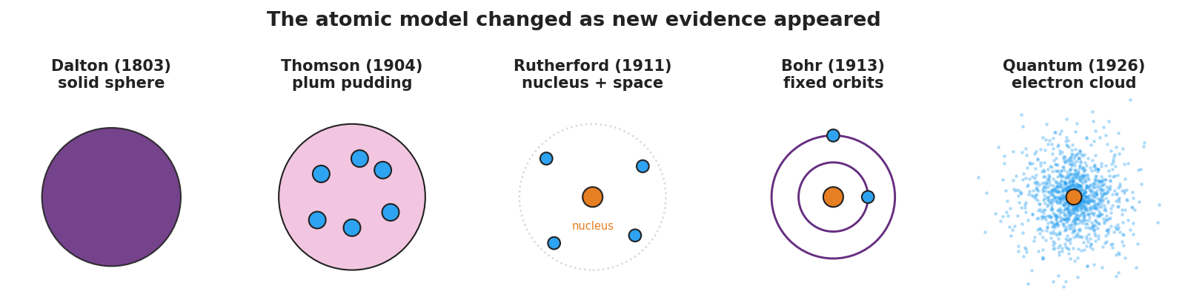
Five-panel progression of atomic models: Dalton solid sphere, Thomson plum pudding, Rutherford nucleus with empty space, Bohr fixed orbits, and the quantum electron cloud.
And the scattering diagram for the turning-point card:
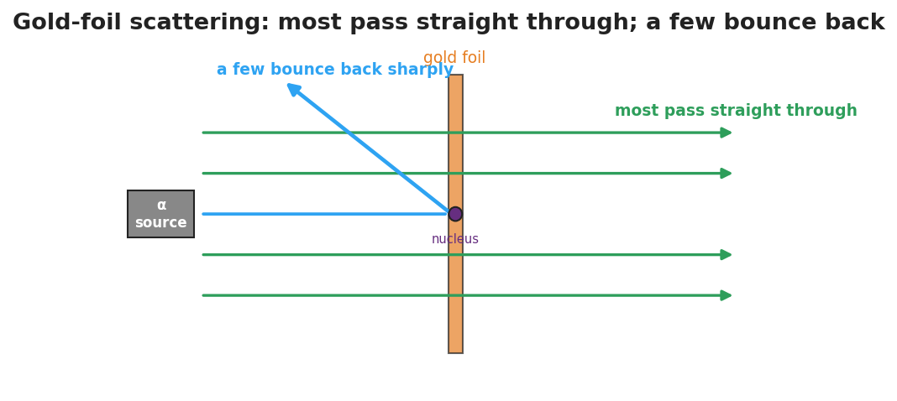
Gold-foil scattering: most alpha particles pass straight through the foil while a few deflect sharply off the tiny dense nucleus.

Teacher facilitation during Explore
- What to look for — groups tying each change to a specific new observation, not just memorizing an order.
- What to resist — don’t pre-label which evidence breaks which model; let the sort do the reasoning.
- What to redirect — “the newest model is the only right one” → every model was the best fit for its evidence.

Phase 3 · Explain (30 – 36 min)

30–33 min · Gallery walk + class consensus
Groups post timelines; one quick gallery walk. Then build consensus:
“Across all five, what always triggered a new model? New, surprising evidence that the old model couldn’t explain.”

33–36 min · Vocabulary introduction (≤ 3 terms)
Sample teacher language:
“The tiny, dense, positively charged center the gold foil revealed is the nucleus. The light, negatively charged particles around it are electrons. A picture scientists use to represent the atom’s structure is an atomic model — and that model has changed every time new evidence arrived.”

Discussion prompts to deploy here
- “Why didn’t Thomson’s plum-pudding model survive the gold-foil result?”
  - Sample student response: “Soft, spread-out positive charge couldn’t bounce an alpha straight back; only a tiny dense nucleus could.”
- “Is the quantum model ‘the truth’ or just the current best model?”
  - Sample student response: “The current best model — it fits today’s evidence, and it could be revised again.”

Phase 4 · Elaborate (36 – 39 min)

36–38 min · Revise the model
“Return to your Initial Model. Redraw the gold atom using the words nucleus and electron, showing the right proportions (tiny dense center, lots of empty space).”

38–39 min · Return to the phenomenon
“In one sentence, explain the gold-foil result using nucleus.”
Target: “Most alphas pass through the empty space, but the few that hit the tiny dense nucleus are pushed sharply back.”

Phase 5 · Evaluate (39 – 42 min)

39–42 min · Exit Ticket + Closing Reflection
“(a) Which atomic model first included a tiny, dense nucleus, and what experiment supported it? (b) Name one thing the Thomson (plum-pudding) model got right. (c) Why do scientists change a model like the atom over time?”
Expected: (a) Rutherford’s model; the gold-foil scattering experiment; (b) atoms contain negative electrons (and a positive part); (c) new evidence appears that the old model cannot explain. See Answer_Key.docx.
Closing Reflection (SEL, 30 seconds):
“Whose idea in your group helped you make sense of the timeline today?”

Common Misconceptions
- Misconception: “The newest model proves the old ones were wrong/stupid.” → Correction: Each model was the best explanation for the evidence available; models improve, they don’t shame their predecessors.
- Misconception: “The atom is mostly solid matter.” → Correction: An atom is overwhelmingly empty space; the nucleus is tiny but holds nearly all the mass.
- Misconception: “Electrons orbit the nucleus on neat circular tracks.” → Correction: That’s the Bohr picture; the current quantum model describes electrons as probability clouds, not fixed paths.

Access & Differentiation
- ELL/ENL supports: Sentence frame: *“The ___ model changed to the ___ model because of evidence from ___.”* Word box: {Thomson, Rutherford, gold foil, nucleus, electron}. Provide the model cards with both a picture and a one-word label.
- IEP/SPED supports: Pre-sort the card set into the correct order for some groups; their task becomes matching evidence to a given sequence. Provide a fill-in timeline rather than blank chart paper.
- Extensions: Have students research and add a sixth card — a modern refinement (e.g., isotopes, the discovery of the neutron) — and justify where it fits and what evidence supports it.

Strategy Spotlight
ACTIVE LEARNING. The card sort makes students do the historical reasoning rather than receive a timeline. Cognitive load stays on the model–evidence relationship. Keep groups to 3–4, rotate a “challenger” role whose job is to ask “what evidence breaks this model?”, and end with a brief gallery walk so every group sees an alternative arrangement before consensus. This positions the gold-foil result as the turning point students argue toward, not one you announce.

NYSSLS Observation Checklist Crosswalk
# | Checklist item | Where it appears in this lesson
1 | Local/relatable phenomenon | Phase 1 — gold-foil “cannon shell off tissue paper”
2 | Turn and Talk (2–3×) | Phase 1 (TT#1 — what’s inside the atom), Phase 3 (gallery-walk consensus discussion)
3 | Students develop questions/models/procedures | Phase 1 (initial model), Phase 2 (card sort + timeline), Phase 4 (revise model)
4 | CCC defined and used | Lesson Overview · Patterns / Stability and Change, restated in Phase 3
5 | ENL — ≤ 3 vocab, second half | Phase 3 — vocabulary at 33–36 min (nucleus / electron / atomic model)
6 | Revisit phenomenon with evidence | Phase 4 — re-explain gold foil using nucleus
7 | ENL/SPED supports | Access & Differentiation block
8 | Assessment check | Phase 5 — Exit Ticket (model ↔ evidence)

Companion Materials
- Student_Worksheet.docx — the 5E student investigation with the card-sort timeline (hand out at start of Phase 2)
- Student_Notes.docx — guided note-guide for the model progression and vocabulary
- Answer_Key.docx — answers to “Make It Make Sense” prompts and the Exit Ticket

Key Vocabulary (max 3)
- nucleus — the tiny, dense, positively charged center of an atom; it holds nearly all the atom’s mass
- electron — a light, negatively charged particle found in the space around the nucleus
- atomic model — a scientific picture or representation of the atom’s structure, revised as new evidence appears

Models of the Atom — Student Worksheet
Unit: Modern Physics — Lesson 02 Name: _______________________ Date: __________ Period: ____

Phenomenon
Scientists fired tiny positive “bullets” (alpha particles) at an ultra-thin sheet of gold. They expected all of them to sail straight through. Almost all did — but a tiny fraction bounced straight back, as if they had hit something small and hard.
Driving question: What does the gold-foil result tell us about what is inside an atom — and why did the atomic model keep changing?

Notice & Wonder
I notice… | I wonder…
Turn & Talk #1: If most bullets pass straight through but a few bounce hard, what must the inside of the atom look like — solid, empty, or something in between?

Initial Model
Draw what you think the inside of a gold atom looks like, based on the scattering result. Mark where the “hard” part is and how much of the atom is empty.

My idea: _______________________________

Investigation
Your group has model cards and evidence cards. The figures below show the model progression and the gold-foil setup.

Five-panel progression of atomic models: Dalton solid sphere, Thomson plum pudding, Rutherford nucleus, Bohr orbits, and the quantum electron cloud.

Gold-foil scattering: most alpha particles pass straight through while a few bounce sharply off the tiny dense nucleus.
- Order the model cards from oldest to newest.
- Match each model to the evidence that supported it and the evidence that broke it.
Model | What it got right | The evidence that broke it
Dalton (solid sphere)
Thomson (plum pudding)
Rutherford (nucleus)
Bohr (orbits)
Quantum (electron cloud) |  | (current best model)
Key question: What did it take, every single time, to make scientists change the atomic model?

Make It Make Sense
- Why couldn’t Thomson’s plum-pudding model explain the alpha particles that bounced straight back?
- The atom is mostly empty space, yet it has nearly all its mass in one tiny spot. Where is that mass, and what is that spot called?
- Is the quantum (electron-cloud) model “the final truth,” or could it change? Explain.

Vocabulary in Action
Use each term in a sentence about today’s phenomenon.
- nucleus: _______________________________________________
- electron: _______________________________________________
- atomic model: _______________________________________________

Revise Your Model
Return to your Initial Model. Redraw the gold atom using the words nucleus and electron, with the correct proportions (tiny dense center, lots of empty space).

Exit Ticket
- Which atomic model first included a tiny, dense nucleus, and which experiment supported it?
- Name one thing the Thomson (plum-pudding) model got right.
- Why do scientists change a model like the atom over time?

Models of the Atom — Student Notes
Unit: Modern Physics — Lesson 02 Name: _______________________ Date: __________ Period: ____

Learning Targets
By the end of today’s 42 minutes I can:
- Put the atomic models in order and state what each one got right.
- Explain how the gold-foil experiment gave evidence for a nucleus.
- Explain why a scientific model changes over time.

Key Vocabulary
- nucleus — _______________________________________________
- electron — _______________________________________________
- atomic model — _______________________________________________

Guided Notes
Big idea: An atomic model is a picture of the atom that scientists __________ whenever new evidence appears.
The progression (oldest → newest):

Five-panel progression of atomic models: Dalton solid sphere, Thomson plum pudding, Rutherford nucleus, Bohr orbits, and the quantum electron cloud.
- Dalton — the atom is a tiny, solid __________ (no inside parts).
- Thomson — discovered the __________ (negative); pictured them stuck in a positive “pudding.”
- Rutherford — the gold-foil experiment showed the atom is mostly __________ space with a tiny, dense, positive __________.
- Bohr — electrons travel in fixed __________ around the nucleus (sets up Lesson 03).
- Quantum — electrons are best described as a __________ cloud (probability), not fixed paths.
The gold-foil evidence:

Gold-foil scattering: most alpha particles pass straight through while a few bounce sharply off the tiny dense nucleus.
- Most alpha particles passed __________ through → the atom is mostly empty.
- A few bounced sharply __________ → there is a tiny, dense, positive __________.

Worked Example
Problem. A classmate says, “The newest model proves all the old models were wrong, so they were useless.” How would you correct this using the idea of evidence?
Solution. 1. Each model was the __________ explanation for the evidence available at that time. 2. A model changes when new __________ appears that the old model cannot explain. 3. So the old models were not useless — each one __________ the next. (Thomson’s electron survived into every later model.)

Summary
Finish the sentence (Because / But / So):
Scientists believed the atom was a soft “plum pudding” because __________________________________________, but the gold-foil experiment showed __________________________________________, so __________________________________________.

Models of the Atom — Answer Key

Cover
Unit: Modern Physics — Lesson 02: Models of the Atom East Meadow Schools × Valley Stream Central HSD Strategy chip: ACTIVE LEARNING

Make-It-Make-Sense Answers
- The plum-pudding model spread the positive charge thinly across the whole atom. A soft, spread-out positive charge could only nudge an alpha particle slightly — it could never bounce one straight back. A sharp rebound requires a tiny, dense, concentrated positive region, which the model didn’t have. · Rubric: contrasts spread-out charge (Thomson) with concentrated charge (nucleus). · NYSSLS: SEP — Developing and Using Models
- The mass is concentrated in the nucleus, the tiny, dense, positively charged center; the rest of the atom is mostly empty space holding the light electrons. · Rubric: names the nucleus AND “tiny/dense/center.” · NYSSLS: SEP — Developing and Using Models
- It could change. The quantum model is the current best fit to today’s evidence, but if scientists found a new observation it could not explain, the model would be revised again — that is how all atomic models developed. · Rubric: “current best model” + “could change with new evidence.” · NYSSLS: SEP — Developing and Using Models

Exit Ticket Answer
- Rutherford’s model first included a tiny, dense nucleus; it was supported by the gold-foil scattering experiment (most alphas pass through, a few bounce back).
- Thomson’s model correctly included negative electrons inside the atom (and a positive part to balance them).
- Because new evidence appears that the old model cannot explain; scientists revise the model so it fits all the observations.
Tolerance/rubric: (a) “Rutherford” + “gold foil”; (b) any correct feature (electrons present / atom has + and − parts); (c) “new evidence the old model can’t explain.” 1 point each. NYSSLS: SEP — Developing and Using Models.

Closing Reflection (rubric)
Closing reflection is formative, not graded. Award full credit for any honest response. Look for: - Naming a specific peer or group idea that helped (collaboration). - An accurate sense that models improve with evidence rather than being simply “right” or “wrong.”

Energy-Level Diagrams and Spectra — Teacher Guide

Cover
Unit: Modern Physics — Lesson 03: Energy-Level Diagrams and Spectra East Meadow Schools × Valley Stream Central High School District Strategy chips: BTC

Curated Resources (from East Meadow Scope & Sequence)

NYSSLS Standards
This lesson develops the model that supports the HS-ESS1-2 connection: “Construct an explanation of the big bang theory based on astronomical evidence of light spectra, motion of distant galaxies, and composition of matter (Energy and Matter)” — specifically the connection to wavelength and frequency of light and the formation of stars. Because each element emits a unique set of wavelengths, astronomers read the line spectra in starlight to identify what distant stars are made of. The lesson also extends Lesson 01 (photons, E = h·f) and Lesson 02 (the Bohr model).

Phenomenon
- Gas-discharge tubes: hydrogen, helium, and neon tubes each glow a different color and, through a diffraction grating, show only a few sharp colored lines — not a full rainbow: https://www.youtube.com/watch?v=byp3KFwMjW8

Javalab / Labs
- ophysics hydrogen spectrum / energy levels: https://ophysics.com/modern2.html
- “H Spectrum” lab: measure hydrogen’s visible emission lines through a grating and match them to energy-level jumps.

Assessments
- Exit ticket below (why a line spectrum, and how it fingerprints an element). The energy-level / spectrum matching at the boards in Phase 2 is the formative check.

Lesson Overview
Duration | 42 minutes (1 period)
NYSSLS link | HS-ESS1-2 connection (light spectra → composition of stars; star formation)
CCC focus | Energy and Matter / Patterns — discrete energy levels produce a repeatable pattern of emitted wavelengths.
Strategy chips | BTC (random groups + vertical non-permanent surfaces, thin-slice problems)
Materials | Vertical whiteboards/windows + markers; diffraction gratings + discharge tubes if available (or the ophysics sim); the energy-level handout; reference table (E = h·f).
Safety | Discharge tubes use high voltage — teacher-operated only; the simulation is the safe default.
Prior knowledge | Photons and E = h·f (Lesson 01); the Bohr model with electrons in fixed levels (Lesson 02); visible-light color ↔ wavelength/frequency.
Lesson objectives — students can:
- Explain that electrons occupy discrete energy levels and that a photon is emitted or absorbed when an electron jumps between them.
- Relate the size of an energy jump to the frequency/wavelength (color) of the emitted photon.
- Explain why each element produces a unique line spectrum and how astronomers use it to identify stars.

Phase 1 · Engage (0 – 10 min)

0–2 min · Opening Connection (SEL)
Whip-around (one sentence, pass allowed): “Name something you can recognize instantly from just a tiny clue — a ringtone, a logo, a friend’s footsteps.” Park these; you’ll call back to “elements have a fingerprint” in Phase 3.

2–7 min · Phenomenon hook — discharge tubes vs. a rainbow
Teacher actions. Show a hydrogen tube (or sim) through a grating: only a few sharp colored lines. Then show white light through the same grating: a full continuous rainbow. Switch to helium: a different set of lines.
Sample teacher language:
“Sunlight through this grating gives a smooth rainbow — every color. But this glowing hydrogen gives only four sharp lines, always the same four. Helium gives a totally different set. Why would a glowing gas pick only certain colors?”
Anticipated student responses:
- “The gas only makes some colors.” — capture only certain colors.
- “Each gas has its own pattern.” — gold; we’ll name this a fingerprint.
- “It’s about the electrons.” — capture; connect to Bohr’s levels from Lesson 02.

7–10 min · Notice & Wonder + Turn-and-Talk #1
“Turn and talk: a rainbow has every color, but hydrogen shows only a few. Using last lesson’s idea of electron levels, why would only certain colors come out?”
Target seed: electrons can only sit on certain “steps,” so only certain jumps — and only certain photon energies/colors — are possible.

Bridge to Phase 2
Each student writes a one-sentence initial model: “A glowing gas emits only certain colors because ______.”

Phase 2 · Explore (10 – 30 min)

10–13 min · Initial Model (silent / individual)
Prompt:
“Draw a few horizontal lines as electron ‘energy steps.’ Show an electron and use an arrow to show what you think it does to release light.”

13–30 min · Investigation — BTC at the boards
Form visibly random groups of 3 (cards). Each group works a vertical surface through a thin-sliced problem set (reveal one at a time):
- Here is an energy-level diagram. An electron drops from n = 3 to n = 1. Draw the arrow. Does it absorb or emit a photon?
- Which drop releases a higher-energy (bluer) photon: n = 4 → n = 2, or n = 3 → n = 2? Why?
- Match three given drops to three colored lines on a spectrum strip (biggest drop ↔ highest-frequency line).
- Two unknown gases show different line patterns. Could they be the same element? Explain.
Teacher facilitation language:
“Bigger jump down — bigger energy gap — what does that do to the photon’s frequency? Its color?” “If the steps are fixed, how many different photon energies are even possible?” “Defend it to the group at the next board — do they agree which line is the biggest drop?”
Anchor with the energy-level diagram and the spectrum strip:
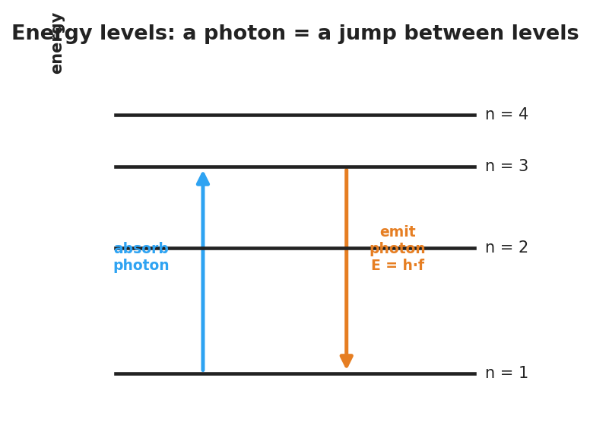
Energy-level diagram: an electron absorbs a photon to jump up and emits a photon E = h·f when it drops down between discrete levels.
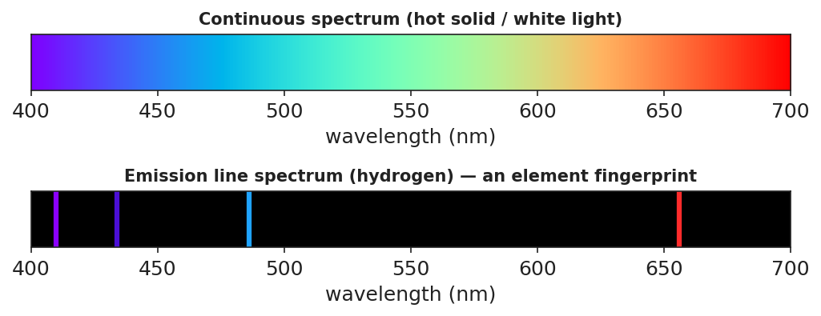
Top: a continuous rainbow spectrum from white light. Bottom: hydrogen’s emission line spectrum — a few bright colored lines on black, an element fingerprint.

Teacher facilitation during Explore
- What to look for — groups connecting bigger energy gap → higher frequency → bluer line.
- What to resist — don’t hand out the term “line spectrum” yet; let the pattern emerge.
- What to redirect — “the gas just glows that color” → it glows specific colors because only specific jumps exist.

Phase 3 · Explain (30 – 36 min)

30–33 min · Consensus
“Why only a few lines, and why always the same few for a given gas?”
Target consensus:
“Electrons can only occupy fixed energy levels, so only certain jumps are possible. Each jump emits a photon whose energy — and color — equals the gap. The set of gaps is unique to each element, so each element shows the same fixed set of lines.”

33–36 min · Vocabulary introduction (≤ 3 terms)
Sample teacher language:
“Each allowed electron ‘step’ is an energy level. When an electron drops to a lower level, it releases a photon — that’s photon emission, and E = h·f for that photon equals the energy gap. The full set of sharp colored lines a glowing element produces is its line spectrum — its fingerprint.”

Discussion prompts to deploy here
- “How can astronomers know a distant star contains hydrogen without ever visiting it?”
  - Sample student response: “The starlight shows hydrogen’s exact line pattern — its fingerprint — so we know hydrogen is there.”
- “Why is a star’s light evidence used in the Big Bang explanation?”
  - Sample student response: “Spectra tell us what stars are made of and (with shifts) how they move — evidence for how matter and the universe formed.”

Phase 4 · Elaborate (36 – 39 min)

36–38 min · Revise the model
“Return to your energy-step drawing. Add labels: which arrow direction emits a photon, and which color comes from the biggest drop? Connect one line in the spectrum strip to one jump in your diagram.”

38–39 min · Return to the phenomenon
“In one sentence, explain why hydrogen shows only a few lines, using energy level and line spectrum.”
Target: “Hydrogen’s electrons can only jump between fixed energy levels, so only a few photon energies are possible — producing hydrogen’s unique line spectrum.”

Phase 5 · Evaluate (39 – 42 min)

39–42 min · Exit Ticket + Closing Reflection
“(a) White light makes a continuous rainbow, but glowing hydrogen makes only a few sharp lines. Explain why, using energy levels. (b) An electron drops from n = 4 → n = 1 (a big drop) and from n = 2 → n = 1 (a small drop). Which emitted photon has the higher frequency? Why? (c) How can astronomers tell what a distant star is made of?”
Expected: (a) electrons occupy only discrete levels, so only certain jumps/photon energies (colors) are possible; (b) the n = 4 → n = 1 drop — larger energy gap → higher-frequency photon (E = h·f); (c) by matching the star’s line spectrum to known element fingerprints. See Answer_Key.docx.
Closing Reflection (SEL, 30 seconds):
“What clicked for you at the boards today, and who helped it click?”

Common Misconceptions
- Misconception: “Atoms can emit any color of light.” → Correction: Only colors matching the gaps between fixed energy levels are emitted, so each element gives a few specific lines.
- Misconception: “Bigger energy jump = redder light.” → Correction: Bigger energy gap = higher-energy photon = higher frequency = bluer light (E = h·f).
- Misconception: “Line spectra and continuous rainbows are the same thing.” → Correction: A hot solid/white light gives a continuous spectrum; a glowing low-density gas gives discrete lines.

Access & Differentiation
- ELL/ENL supports: Sentence frame: *“When an electron drops to a ___ energy level, it ___ a photon; a bigger drop makes a ___-frequency color.”* Word box: {lower, emits, higher, energy level, line spectrum}. Pair jump with a stair-step hand gesture.
- IEP/SPED supports: Provide a pre-drawn energy-level diagram with the arrows already drawn; students label “emit/absorb” and “bigger/smaller gap.” Offer color chips to physically match to spectrum lines.
- Extensions: Give students hydrogen’s four visible wavelengths and have them order the jumps by energy, then research why these are called the Balmer series.

Strategy Spotlight
BTC (Building Thinking Classrooms). Use visibly random groups of three and vertical non-permanent surfaces so thinking is public and mobile. Deliver the problems as a thin-sliced sequence — each problem a small step harder than the last — and circulate without giving answers, redirecting groups to defend their reasoning to the next board. The vertical surfaces let you see, in one glance, which groups have connected “bigger gap → bluer line,” so you know exactly when to pull the class to consensus.

NYSSLS Observation Checklist Crosswalk
# | Checklist item | Where it appears in this lesson
1 | Local/relatable phenomenon | Phase 1 — discharge tubes vs. rainbow; starlight fingerprints
2 | Turn and Talk (2–3×) | Phase 1 (TT#1 — why only some colors), Phase 3 (consensus discussion)
3 | Students develop questions/models/procedures | Phase 1 (initial model), Phase 2 (board work), Phase 4 (revise model)
4 | CCC defined and used | Lesson Overview · Energy and Matter / Patterns, restated in Phase 3
5 | ENL — ≤ 3 vocab, second half | Phase 3 — vocabulary at 33–36 min (energy level / photon emission / line spectrum)
6 | Revisit phenomenon with evidence | Phase 4 — re-explain hydrogen lines; starlight in Phase 3
7 | ENL/SPED supports | Access & Differentiation block
8 | Assessment check | Phase 5 — Exit Ticket (line spectra + starlight)

Companion Materials
- Student_Worksheet.docx — the 5E student investigation with the board-work problems (hand out at start of Phase 2)
- Student_Notes.docx — guided note-guide for energy-level jumps and the worked example
- Answer_Key.docx — answers to “Make It Make Sense” prompts and the Exit Ticket

Key Vocabulary (max 3)
- energy level — one of the fixed, allowed energies an electron can have in an atom (its allowed “steps”)
- photon emission — the release of a photon when an electron drops to a lower energy level; the photon’s energy equals the gap (E = h·f)
- line spectrum — the unique set of sharp colored lines a glowing element emits; it acts as the element’s fingerprint

Energy-Level Diagrams and Spectra — Student Worksheet
Unit: Modern Physics — Lesson 03 Name: _______________________ Date: __________ Period: ____

Phenomenon
Sunlight through a diffraction grating spreads into a smooth, continuous rainbow — every color. But a glowing tube of hydrogen gas through the same grating shows only a few sharp colored lines — always the same ones. Helium glows with a completely different set of lines.
Driving question: Why does a glowing gas emit only certain colors, and how can that fingerprint tell us what a distant star is made of?

Notice & Wonder
I notice… | I wonder…
Turn & Talk #1: A rainbow has every color, but hydrogen shows only a few. Using the idea of electron energy levels, why would only certain colors come out?

Initial Model
Draw a few horizontal lines as electron “energy steps.” Show an electron and use an arrow to show what you think it does to release light.

My idea: _______________________________

Investigation
Work the problems at your board. Use these figures.

Energy-level diagram: an electron absorbs a photon to jump up and emits a photon E = h·f when it drops down between discrete levels.

Top: a continuous rainbow from white light. Bottom: hydrogen’s emission line spectrum — a few bright lines on black.
- An electron drops from n = 3 to n = 1. Draw the arrow. Does it emit or absorb a photon? _______________
- Which drop releases a higher-energy (bluer) photon: n = 4 → n = 2, or n = 3 → n = 2? Why?
- Match each drop to a colored line (biggest drop ↔ highest-frequency line):
Electron drop | Size of energy gap | Line color (predict)
n = 4 → n = 1
n = 3 → n = 2
n = 2 → n = 1
- Two unknown gases show different line patterns. Could they be the same element? Explain.
Key question: If electrons can only sit on certain energy levels, how many different photon colors can a single element emit?

Make It Make Sense
- White light makes a continuous rainbow, but glowing hydrogen makes only a few sharp lines. Explain why, using energy levels.
- A big electron drop and a small electron drop both emit photons. Which photon has the higher frequency (bluer color)? Why?
- How can astronomers know what a distant star is made of without going there?

Vocabulary in Action
Use each term in a sentence about today’s phenomenon.
- energy level: _______________________________________________
- photon emission: _______________________________________________
- line spectrum: _______________________________________________

Revise Your Model
Return to your energy-step drawing. Label which arrow direction emits a photon and which color comes from the biggest drop. Connect one line in the spectrum strip to one jump in your diagram.

Exit Ticket
- White light makes a continuous rainbow, but glowing hydrogen makes only a few sharp lines. Explain why, using energy levels.
- An electron drops from n = 4 → n = 1 (a big drop) and from n = 2 → n = 1 (a small drop). Which emitted photon has the higher frequency? Why?
- How can astronomers tell what a distant star is made of?

Energy-Level Diagrams and Spectra — Student Notes
Unit: Modern Physics — Lesson 03 Name: _______________________ Date: __________ Period: ____

Learning Targets
By the end of today’s 42 minutes I can:
- Explain that electrons occupy fixed energy levels and emit a photon when they drop.
- Relate the size of an electron’s jump to the frequency (color) of the emitted photon.
- Explain why each element makes a unique line spectrum and how that identifies stars.

Key Vocabulary
- energy level — _______________________________________________
- photon emission — _______________________________________________
- line spectrum — _______________________________________________

Guided Notes
Big idea: Electrons in an atom can only have certain fixed energies, called energy levels — like steps on a ladder, not a ramp.

Energy-level diagram: an electron absorbs a photon to jump up and emits a photon E = h·f when it drops down between discrete levels.
- To jump up a level, an electron must absorb a photon.
- To drop down a level, an electron __________ a photon — this is photon emission.
- The photon’s energy equals the size of the __________: E = h·f.
- A bigger drop → bigger energy gap → __________ frequency → bluer color.
- A smaller drop → smaller gap → __________ frequency → redder color.
Why a line spectrum:

Top: a continuous rainbow from white light. Bottom: hydrogen’s line spectrum — a few bright lines on black.
- Because levels are fixed, only certain jumps — and only certain photon colors — are __________.
- Each element has its own set of gaps, so each makes its own unique line spectrum (a __________).
- Astronomers match a star’s line spectrum to known elements to learn what the star is __________ of. (This is part of the evidence behind the Big Bang explanation.)

Worked Example
Problem. In an atom, electron drops A (n = 5 → n = 1) and B (n = 2 → n = 1) both emit photons. Which photon has the higher frequency?
Solution. 1. Compare the energy gaps: drop A is the __________ jump, so the bigger gap. 2. A bigger gap means a __________-energy photon. 3. Since E = h·f, a higher-energy photon has a __________ frequency (bluer). 4. So **drop ___** emits the higher-frequency photon.

Summary
Finish the sentence (Because / But / So):
White light makes a smooth, continuous rainbow, because __________________________________________, but glowing hydrogen makes only a few sharp lines because __________________________________________, so __________________________________________.

Energy-Level Diagrams and Spectra — Answer Key

Cover
Unit: Modern Physics — Lesson 03: Energy-Level Diagrams and Spectra East Meadow Schools × Valley Stream Central HSD Strategy chip: BTC

Make-It-Make-Sense Answers
- Electrons can only occupy fixed energy levels, so only certain jumps are possible. Each jump emits a photon whose energy equals the gap between levels, so only certain photon energies — only certain colors — come out. White light, by contrast, contains all energies/colors, giving a continuous rainbow. · Rubric: “fixed/discrete levels → only certain jumps → only certain colors.” · NYSSLS: HS-ESS1-2 (connection)
- The big drop emits the higher-frequency (bluer) photon. A bigger energy gap means a higher-energy photon, and since E = h·f, higher energy means higher frequency. · Rubric: big gap → high energy → high frequency, references E = h·f. · NYSSLS: HS-ESS1-2 (connection)
- Astronomers spread the starlight into a spectrum and match its line spectrum (its fingerprint) to the known line patterns of elements measured on Earth. Matching lines reveal which elements the star contains. · Rubric: “match the star’s line spectrum to known element fingerprints.” · NYSSLS: HS-ESS1-2 (connection)

Exit Ticket Answer
- Electrons occupy only discrete energy levels, so only certain jumps — and therefore only certain photon energies/colors — are possible; that gives a few sharp lines instead of a full rainbow. White light contains all colors, so it spreads continuously.
- The n = 4 → n = 1 drop emits the higher-frequency photon. It is the larger energy gap, so the photon carries more energy, and E = h·f means more energy → higher frequency.
- By matching the line spectrum in the star’s light to the known fingerprint spectra of elements measured on Earth.
Tolerance/rubric: (a) discrete levels → limited colors; (b) “n = 4 → n = 1” + “bigger gap → higher frequency (E = h·f)”; (c) “match line spectrum to known element fingerprints.” 1 point each. NYSSLS: HS-ESS1-2 (connection).

Closing Reflection (rubric)
Closing reflection is formative, not graded. Award full credit for any honest response. Look for: - A specific “aha” moment from the board work (e.g., “bigger jump = bluer light”). - Acknowledgment of a groupmate’s contribution (collaboration at the vertical surfaces).

The Standard Model — Teacher Guide

Cover
Unit: Modern Physics — Lesson 04: The Standard Model East Meadow Schools × Valley Stream Central High School District Strategy chips: HOCHMAN

Curated Resources (from East Meadow Scope & Sequence)

NYSSLS Standards
This is a conceptual model-building lesson anchored to the SEP Developing and Using Models. The Standard Model is the modern answer to “what is everything made of?” — it organizes all known matter particles (quarks and leptons) and force carriers (bosons) into a single chart, exactly as the periodic table organizes elements. It extends the atomic-structure work of Lesson 02 (electrons and nuclei) down to the next level and sets up the nuclear changes of Lesson 05 (protons and neutrons are made of quarks).

Phenomenon
- Cassiopeia Project: “The Standard Model” — a clear visual tour of quarks, leptons, and the forces between them: https://www.youtube.com/watch?v=Unl1jXFnzgo
- The driving puzzle: if atoms are made of protons, neutrons, and electrons — what are those made of?

Javalab / Labs
- Particle Adventure (interactive Standard Model explorer): https://www.particleadventure.org/

Assessments
- Exit ticket below (classify particles; build a proton from quarks). The “build-a-particle” sort in Phase 2 is the formative check.

Lesson Overview
Duration | 42 minutes (1 period)
NYSSLS link | SEP: Developing and Using Models (organizing matter; supports HS-PS1-8 in Lesson 05)
CCC focus | Systems and System Models / Patterns — a small set of fundamental particles, organized like a periodic table, builds everything.
Strategy chips | HOCHMAN (Because/But/So + appositive on quark / lepton)
Materials | Projector for the Cassiopeia clip; particle cards (quarks u/d, electron, neutrino, photon, gluon); the Standard-Model chart handout; whiteboards.
Safety | None — video and paper-based.
Prior knowledge | Atoms = protons + neutrons + electrons (Lessons 02–03); the periodic table as an organizing tool.
Lesson objectives — students can:
- State that all matter is built from two families of fundamental particles: quarks and leptons.
- Explain that protons and neutrons are made of quarks (a proton = up-up-down) and that forces are carried by bosons.
- Use the Standard-Model chart as a model that organizes particles, the way the periodic table organizes elements.

Phase 1 · Engage (0 – 10 min)

0–2 min · Opening Connection (SEL)
Whip-around (one sentence, pass allowed): “What is the smallest ‘building block’ you can think of that bigger things are made from?” (Lego bricks, pixels, letters in words.) Park these; you’ll call back to “a few blocks build everything” in Phase 3.

2–7 min · Phenomenon hook — “what is everything made of?”
Teacher actions. Play the Cassiopeia Standard Model clip (first few minutes). Pose the chain: a chair → atoms → protons, neutrons, electrons → and then?
Sample teacher language:
“We zoomed in: the chair is atoms, the atom is a nucleus plus electrons, the nucleus is protons and neutrons. So I’ll keep zooming — what is a proton made of? Is there a bottom to this, or does it go forever?”
Anticipated student responses:
- “Smaller protons.” / “It goes forever.” — reframe: scientists found it does bottom out.
- “Quarks!” (if seen before) — capture; we’ll organize them.
- “Electrons are already smallest.” — affirm partly: electrons are fundamental; protons are not.

7–10 min · Notice & Wonder + Turn-and-Talk #1
“Turn and talk: scientists found a small set of particles that everything is built from. Why might it help to organize them into a chart, like the periodic table?”
Target seed: a chart reveals patterns and families, and shows what’s fundamental vs. built-from-parts.

Bridge to Phase 2
Each student writes a one-sentence initial model: “I think a proton is made of ______.”

Phase 2 · Explore (10 – 30 min)

10–13 min · Initial Model (silent / individual)
Prompt:
“Draw a proton. If it has smaller parts inside, draw them and label what you’d call them.”

13–30 min · Investigation — build-a-particle sort
Groups get particle cards and the Standard-Model chart. Tasks:
- Sort the cards into matter particles (quarks + leptons) and force carriers (bosons).
- Within matter, separate quarks (up, down, …) from leptons (electron, neutrino).
- Build a proton and a neutron from quark cards. (Proton = up + up + down; neutron = up + down + down.) Check the charges add up (+⅔ +⅔ −⅓ = +1 for the proton; +⅔ −⅓ −⅓ = 0 for the neutron).
- Where does the familiar electron sit? (It’s a lepton — already fundamental, not made of quarks.)
Teacher facilitation language:
“Add the quark charges in your proton — do they land on +1?” “Which of your cards is already fundamental — has nothing smaller inside?” “What’s the boson’s job? It’s not matter — it carries a force between matter particles.”
Anchor with the chart and the proton diagram:
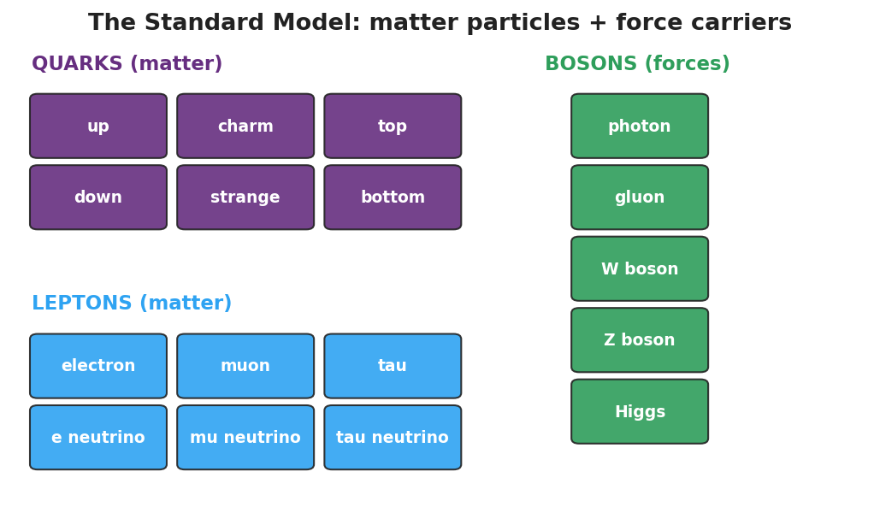
Standard-Model chart: a grid of quarks and leptons (matter particles) plus bosons (force carriers).
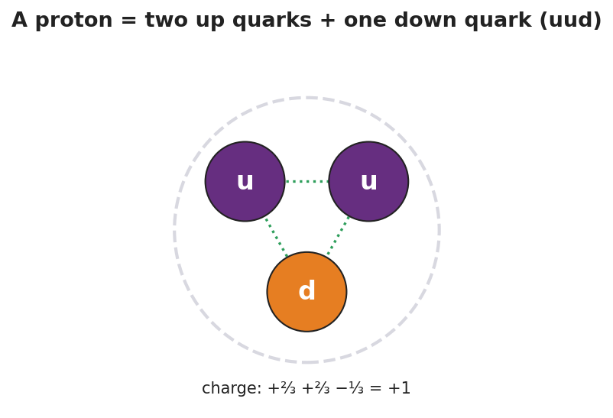
A proton drawn as two up quarks and one down quark (uud); the charges +2/3, +2/3, and −1/3 add to +1.

Teacher facilitation during Explore
- What to look for — groups checking that quark charges sum to the right particle charge.
- What to resist — don’t over-detail the second/third generations or color charge; keep it to the organizing idea.
- What to redirect — “electrons are made of quarks” → no, electrons are leptons, already fundamental.

Phase 3 · Explain (30 – 36 min)

30–33 min · Consensus
“What is the smallest level we found, and how is it organized?”
Target consensus:
“Everything is built from a small set of fundamental particles: quarks make up protons and neutrons, and leptons include the electron. Forces between them are carried by bosons. The Standard-Model chart organizes them the way the periodic table organizes elements.”

33–36 min · Vocabulary introduction (≤ 3 terms)
Sample teacher language:
“A quark is a fundamental matter particle; protons and neutrons are each made of three quarks. A lepton is the other family of matter particles — the electron is a lepton. Both quarks and leptons are fundamental particles: as far as we know, they have no smaller parts inside.”

Discussion prompts to deploy here
- “How is the Standard Model like the periodic table?”
  - Sample student response: “Both organize the basic pieces into families that show patterns; the table organizes elements, the Standard Model organizes the particles inside them.”
- “Why isn’t a proton on the chart of fundamental particles?”
  - Sample student response: “A proton is made of quarks, so it’s not fundamental — only its quarks are.”

Phase 4 · Elaborate (36 – 39 min)

36–38 min · Hochman Because/But/So + revise the model
Students complete the stem (modeled, then independent):
“A proton is not a fundamental particle because ______, but an electron is because ______, so the truly fundamental matter particles are the ______ and the ______.”
Coach the appositive: “A quark, a fundamental building block of protons and neutrons, carries a fractional charge.”

38–39 min · Return to the phenomenon
“Restate the ‘what is everything made of?’ chain in one sentence using quark and fundamental particle.”
Target: “Everything is built from fundamental particles — quarks (which make protons and neutrons) and leptons (like the electron).”

Phase 5 · Evaluate (39 – 42 min)

39–42 min · Exit Ticket + Closing Reflection
“(a) Name the two families of fundamental matter particles. (b) A proton is made of two up quarks and one down quark. Is a proton a fundamental particle? Explain. (c) The electron belongs to which family — quarks or leptons?”
Expected: (a) quarks and leptons; (b) no — it is made of smaller particles (quarks), so it is not fundamental; (c) leptons. See Answer_Key.docx.
Closing Reflection (SEL, 30 seconds):
“What’s one question about the universe you now want to ask?”

Common Misconceptions
- Misconception: “Protons and neutrons are the smallest particles.” → Correction: They are made of quarks; quarks (and leptons like the electron) are the fundamental particles.
- Misconception: “Electrons are made of quarks too.” → Correction: Electrons are leptons — already fundamental, with no quarks inside.
- Misconception: “Bosons are matter.” → Correction: Bosons are force carriers (like the photon), not matter particles.

Access & Differentiation
- ELL/ENL supports: Sentence frame: “A ___ is a fundamental particle, but a ___ is made of smaller parts, so the ___ is fundamental and the ___ is not.” Word box: {quark, proton, electron, lepton, fundamental}. Pair fundamental with “can’t break it smaller” and a closed-fist gesture.
- IEP/SPED supports: Provide pre-grouped card sets (matter vs. force already separated); students only build the proton/neutron. Give a partially completed chart to fill the last few tiles.
- Extensions: Have students build a neutron (udd), verify its zero charge, and explain why a free neutron’s beta decay (Lesson 05) changes a down quark into an up quark.

Strategy Spotlight
HOCHMAN (literacy). The Because/But/So in Phase 4 forces students to coordinate a contrast — fundamental (electron/quark) vs. composite (proton) — in one complex sentence, the heart of the lesson’s conceptual distinction. Model one, then release. The appositive drill — “A quark, a fundamental building block of protons and neutrons, carries a fractional charge” — gives students a compact academic structure for defining a new term in place, transferable to any content area.

NYSSLS Observation Checklist Crosswalk
# | Checklist item | Where it appears in this lesson
1 | Local/relatable phenomenon | Phase 1 — “what is everything made of?” zoom-in from a chair to quarks
2 | Turn and Talk (2–3×) | Phase 1 (TT#1 — why organize into a chart), Phase 3 (consensus discussion)
3 | Students develop questions/models/procedures | Phase 1 (initial model), Phase 2 (build-a-particle sort), Phase 4 (revise model)
4 | CCC defined and used | Lesson Overview · Systems and System Models / Patterns, restated in Phase 3
5 | ENL — ≤ 3 vocab, second half | Phase 3 — vocabulary at 33–36 min (quark / lepton / fundamental particle)
6 | Revisit phenomenon with evidence | Phase 4 — restate the “what is everything made of?” chain
7 | ENL/SPED supports | Access & Differentiation block
8 | Assessment check | Phase 5 — Exit Ticket (classify particles; proton from quarks)

Companion Materials
- Student_Worksheet.docx — the 5E student investigation with the build-a-particle sort (hand out at start of Phase 2)
- Student_Notes.docx — guided note-guide for the particle families and the worked example
- Answer_Key.docx — answers to “Make It Make Sense” prompts and the Exit Ticket

Key Vocabulary (max 3)
- quark — a fundamental matter particle; protons and neutrons are each built from three quarks (a proton is up-up-down)
- lepton — the other family of fundamental matter particles; the electron is a lepton
- fundamental particle — a particle with no smaller parts inside, as far as we know (quarks and leptons are fundamental; protons are not)

The Standard Model — Student Worksheet
Unit: Modern Physics — Lesson 04 Name: _______________________ Date: __________ Period: ____

Phenomenon
Zoom in on a chair: it’s made of atoms. An atom is a nucleus plus electrons. The nucleus is protons and neutrons. So what is a proton made of? Scientists kept zooming — and found that the zoom finally stops at a small set of particles that everything else is built from.
Driving question: What are the smallest building blocks of matter, and how do scientists organize them?

Notice & Wonder
I notice… | I wonder…
Turn & Talk #1: Scientists found a small set of particles that everything is built from. Why might it help to organize them into a chart, like the periodic table?

Initial Model
Draw a proton. If you think it has smaller parts inside, draw them and label what you would call them.

My idea: _______________________________

Investigation
Use the particle cards and the figures below.

Standard-Model chart: a grid of quarks and leptons (matter particles) plus bosons (force carriers).

A proton drawn as two up quarks and one down quark (uud); charges +2/3, +2/3, −1/3 add to +1.
- Sort the cards into matter particles and force carriers (bosons).
- Within matter, separate the quarks from the leptons.
Card | Matter or force carrier? | If matter: quark or lepton?
up
down
electron
neutrino
photon
- Build a proton from quark cards and check the charge adds up.
Particle | Quarks | Charges added | Total charge
Proton | up + up + down | (+⅔) + (+⅔) + (−⅓)
Neutron | up + down + down | (+⅔) + (−⅓) + (−⅓)
Key question: Which of your cards is already fundamental — has nothing smaller inside?

Make It Make Sense
- A proton is made of two up quarks and one down quark. Is a proton a fundamental particle? Explain.
- How is the Standard-Model chart similar to the periodic table?
- The electron is not made of quarks. Which family does it belong to, and what does that tell you about it?

Vocabulary in Action
Use each term in a sentence about today’s phenomenon.
- quark: _______________________________________________
- lepton: _______________________________________________
- fundamental particle: _______________________________________________

Revise Your Model
Return to your Initial Model of a proton. Redraw it using quark cards (up, up, down) and check that the charges add to +1. Label which particles are fundamental.

Exit Ticket
- Name the two families of fundamental matter particles.
- A proton is made of two up quarks and one down quark. Is a proton a fundamental particle? Explain.
- The electron belongs to which family — quarks or leptons?

The Standard Model — Student Notes
Unit: Modern Physics — Lesson 04 Name: _______________________ Date: __________ Period: ____

Learning Targets
By the end of today’s 42 minutes I can:
- Name the two families of fundamental particles that build all matter.
- Explain that protons and neutrons are made of quarks, and forces are carried by bosons.
- Use the Standard-Model chart as a model that organizes particles.

Key Vocabulary
- quark — _______________________________________________
- lepton — _______________________________________________
- fundamental particle — _______________________________________________

Guided Notes
Big idea: All matter is built from a small set of fundamental particles — particles with no smaller parts inside.

Standard-Model chart: a grid of quarks and leptons (matter particles) plus bosons (force carriers).
- Matter particles come in two families: quarks and __________.
- Quarks join together to build protons and __________.
- Leptons include the familiar __________ (which is already fundamental).
- Forces between matter particles are carried by bosons (for example, the __________ carries the electromagnetic force).
Building a proton (and a neutron):

A proton drawn as two up quarks and one down quark (uud); charges +2/3, +2/3, −1/3 add to +1.
- Proton = up + up + down → charge (+⅔) + (+⅔) + (−⅓) = __________.
- Neutron = up + down + down → charge (+⅔) + (−⅓) + (−⅓) = __________.
- So a proton is not fundamental — it is made of __________.
The Standard Model organizes particles the way the __________ table organizes elements.

Worked Example
Problem. Is an electron a fundamental particle? Is a proton? Explain how you know.
Solution. 1. An electron is a __________ — it has no smaller parts inside, so it is fundamental. 2. A proton is made of three __________ (up, up, down), so it has smaller parts inside. 3. Therefore the proton is not __________; only its quarks are.

Summary
Finish the sentence (Because / But / So):
A proton is not a fundamental particle because __________________________________________, but an electron is fundamental because __________________________________________, so __________________________________________.

The Standard Model — Answer Key

Cover
Unit: Modern Physics — Lesson 04: The Standard Model East Meadow Schools × Valley Stream Central HSD Strategy chip: HOCHMAN

Make-It-Make-Sense Answers
- No, a proton is not fundamental. It is made of smaller particles — two up quarks and one down quark — so it has parts inside. Only particles with no smaller parts (like quarks and the electron) are fundamental. · Rubric: “made of quarks → has smaller parts → not fundamental.” · NYSSLS: SEP — Developing and Using Models
- Both are organizing models: the periodic table sorts the elements into families that reveal patterns, and the Standard Model sorts the fundamental particles (quarks, leptons, bosons) into families that reveal patterns. The Standard Model is one level “smaller” — it organizes the particles the elements are built from. · Rubric: “both organize basic pieces into families/patterns.” · NYSSLS: SEP — Developing and Using Models
- The electron is a lepton. Leptons are fundamental, so the electron has no smaller parts inside — it is a basic building block, unlike the proton. · Rubric: “lepton” + “fundamental / no smaller parts.” · NYSSLS: SEP — Developing and Using Models

Exit Ticket Answer
- The two families of fundamental matter particles are quarks and leptons.
- No — a proton is made of smaller particles (two up quarks and one down quark), so it has parts inside and is not fundamental. (Its quarks are fundamental.)
- The electron is a lepton.
Tolerance/rubric: (a) “quarks and leptons”; (b) “no” + “made of quarks / has smaller parts”; (c) “lepton.” 1 point each. NYSSLS: SEP — Developing and Using Models.

Closing Reflection (rubric)
Closing reflection is formative, not graded. Award full credit for any honest response. Look for: - A genuine new question about matter or the universe (curiosity). - Evidence the student distinguishes “fundamental” from “made of smaller parts.”

Fusion, Fission, and Radioactive Decay — Teacher Guide

Cover
Unit: Modern Physics — Lesson 05: Fusion, Fission, and Radioactive Decay East Meadow Schools × Valley Stream Central High School District Strategy chips: ACTIVE LEARNING

Curated Resources (from East Meadow Scope & Sequence)

NYSSLS Standards
This lesson is the core treatment of the chemistry-shared HS-PS1-8: “Develop models to illustrate the changes in the composition of the nucleus of the atom and the energy released during the processes of fission, fusion, and radioactive decay. (Energy and Matter) (only teach scale of energy release).” Per the standard, we teach the scale of nuclear energy (E = mc² as a why-it’s-enormous idea, not a calculation). It connects to HS-ESS1-2 through star formation: fusion in stars is what lights them and forges new elements.

Phenomenon
- The Sun (fusion), a nuclear power plant (fission), and carbon-14 dating of ancient artifacts (radioactive decay) — three places nuclear change shows up: https://www.youtube.com/watch?v=KWAsz59F8gA
- The puzzle: the Sun has burned for billions of years. No chemical fire could last that long — so what powers it?

Javalab / Labs
- Nuclear fission / chain reaction (interactive): https://javalab.org/en/nuclear_fission_en/

Assessments
- Exit ticket below (classify a nuclear change; explain the scale of energy). The fission/fusion/decay station sort in Phase 2 is the formative check.

Lesson Overview
Duration | 42 minutes (1 period)
NYSSLS link | HS-PS1-8 (core; scale of energy only) · HS-ESS1-2 (star formation connection)
CCC focus | Energy and Matter — nuclear changes rearrange the nucleus and release enormous energy.
Strategy chips | ACTIVE LEARNING (three-station rotation: fission, fusion, decay)
Materials | Three station setups (model pieces or printed scenarios); the fission/fusion and decay diagrams; whiteboards; reference note: E = mc² (scale only).
Safety | None — models and simulation; no radioactive sources.
Prior knowledge | The nucleus holds protons and neutrons (Lessons 02, 04); quarks make up nucleons (Lesson 04); energy is conserved/transferred.
Lesson objectives — students can:
- Distinguish fission (a heavy nucleus splits), fusion (light nuclei combine), and radioactive decay (a nucleus emits α, β, or γ).
- Explain that nuclear changes release enormous energy compared with chemical reactions, on the scale described by E = mc² (no calculation).
- Connect fusion to star formation and decay to applications like carbon dating.

Phase 1 · Engage (0 – 10 min)

0–2 min · Opening Connection (SEL)
Whip-around (one sentence, pass allowed): “Name something that has lasted way longer than you’d expect.” Park these; you’ll call back to “the Sun has burned for billions of years” in Phase 1’s hook.

2–7 min · Phenomenon hook — what powers the Sun?
Teacher actions. Show the Sun / power-plant / carbon-dating clip. Pose the puzzle: a campfire burns out in hours; the Sun has shone for ~5 billion years. Chemical burning cannot explain that.
Sample teacher language:
“A bonfire dies overnight. The Sun has been blazing for five billion years and is barely halfway done. No chemical fire could last like that. Where is all that energy coming from — and why is it so much more than burning?”
Anticipated student responses:
- “It’s huge, so it lasts.” — capture huge, but push: size alone isn’t the source.
- “It’s nuclear.” — gold; we’ll split nuclear change into three types.
- “Stuff turns into energy.” — capture; this is the E = mc² scale idea (later).

7–10 min · Notice & Wonder + Turn-and-Talk #1
“Turn and talk: the same word — nuclear — covers the Sun, power plants, and carbon dating. Predict how the nucleus might change differently in each.”
Target seed: some nuclei split, some combine, some emit a particle.

Bridge to Phase 2
Each student writes a one-sentence initial model: “Nuclear energy is so large because ______.”

Phase 2 · Explore (10 – 30 min)

10–13 min · Initial Model (silent / individual)
Prompt:
“Draw a nucleus (protons + neutrons). Show one way you think it could change to release energy.”

13–30 min · Investigation — three-station rotation (ACTIVE LEARNING)
Groups rotate through three stations (~5 min each); each has a scenario card + model pieces:
- Fission station. A neutron strikes a heavy uranium nucleus; it splits into two lighter nuclei + more neutrons + energy. Model it; note the chain-reaction possibility.
- Fusion station. Two light hydrogen nuclei are forced together into a heavier nucleus + energy. Model it; label this as what powers the Sun and stars.
- Decay station. An unstable nucleus emits alpha (a helium nucleus), beta (an electron, as a neutron becomes a proton), or gamma (a high-energy photon). Sort three scenario cards by decay type; note carbon-14 dating as a use of decay.
Teacher facilitation language:
“At fission — what hits the nucleus to start it, and what comes out that could start the next one?” “At fusion — are nuclei joining or splitting? Which one happens in the Sun?” “At decay — which type changes the element (alpha/beta), and which just sheds energy (gamma)?”
Anchor with the diagrams:
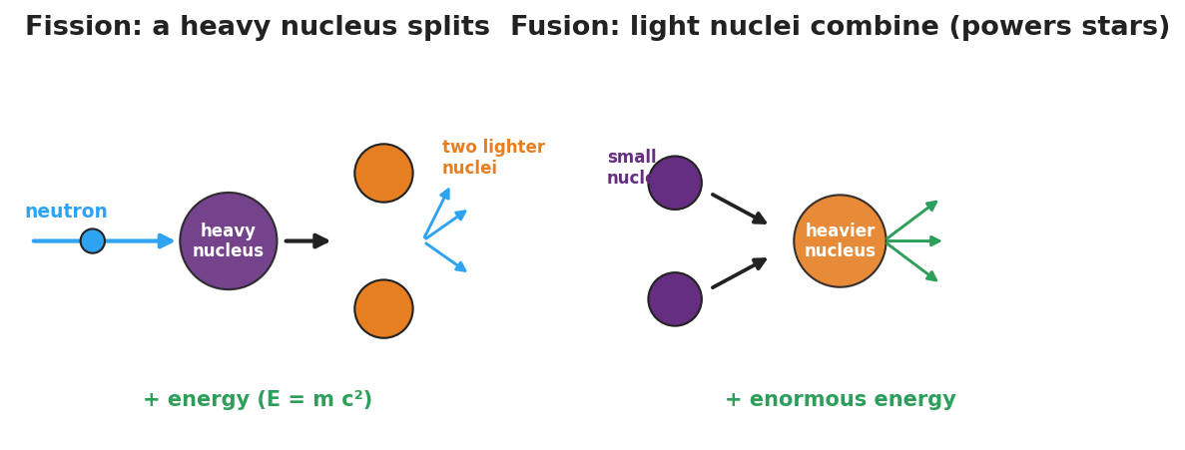
Side-by-side diagram: fission, where a neutron splits a heavy nucleus into two lighter nuclei plus more neutrons and energy; and fusion, where light nuclei combine into a heavier nucleus plus enormous energy.
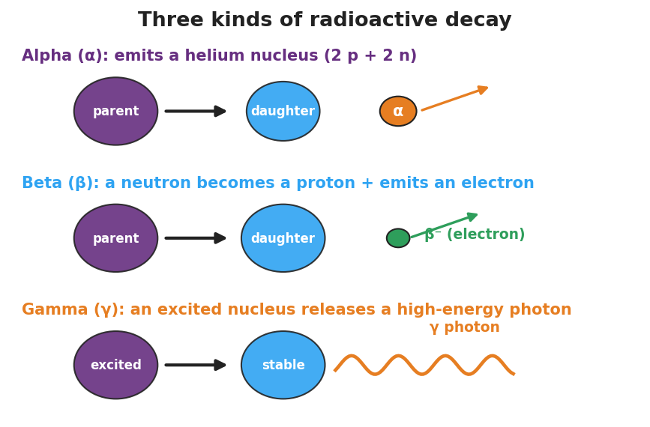
Diagram of alpha, beta, and gamma decay: alpha emits a helium nucleus, beta emits an electron as a neutron becomes a proton, and gamma releases a high-energy photon.

Teacher facilitation during Explore
- What to look for — groups correctly sorting “split vs. combine vs. emit” and tying fusion to stars.
- What to resist — do not do E = mc² calculations; keep energy at the scale/comparison level per the standard.
- What to redirect — “fission and fusion are the same” → fission splits heavy nuclei; fusion combines light ones.

Phase 3 · Explain (30 – 36 min)

30–33 min · Consensus
“Three nuclear changes, one common result — what is it, and why is it so much bigger than burning?”
Target consensus:
“Fission splits a heavy nucleus, fusion combines light nuclei, and radioactive decay emits a particle (α/β/γ). All rearrange the nucleus and release energy — and because a small amount of mass is converted to energy (E = mc², where c is huge), the energy released is enormous compared with chemical reactions.”

33–36 min · Vocabulary introduction (≤ 3 terms)
Sample teacher language:
“Fission is the splitting of a heavy nucleus into lighter ones — that’s how nuclear power plants work. Fusion is the combining of light nuclei into a heavier one — that’s what powers the Sun and forms elements in stars. Radioactive decay is when an unstable nucleus emits radiation (alpha, beta, or gamma) on its own. All three release energy on the scale of E = mc².”

Discussion prompts to deploy here
- “Why does fusion connect to how stars and elements form?”
  - Sample student response: “Stars fuse light nuclei into heavier ones, which lights the star and builds the elements that later make planets and us.”
- “Why is nuclear energy so much larger than chemical energy?”
  - Sample student response: “A tiny bit of mass becomes energy, and E = mc² with a huge c means even tiny mass gives huge energy.”

Phase 4 · Elaborate (36 – 39 min)

36–38 min · Revise the model
“Return to your Initial Model. Redraw it as one of the three changes — fission, fusion, or decay — and label where the enormous energy comes from (mass → energy, E = mc², scale only).”

38–39 min · Return to the phenomenon
“In one sentence, explain what powers the Sun, using fusion.”
Target: “The Sun is powered by fusion — light hydrogen nuclei combine into heavier nuclei, releasing enormous energy (E = mc² scale) and forming new elements.”

Phase 5 · Evaluate (39 – 42 min)

39–42 min · Exit Ticket + Closing Reflection
“(a) A heavy uranium nucleus is struck by a neutron and splits into two lighter nuclei. Is this fission, fusion, or decay? (b) The Sun combines hydrogen nuclei into helium. Which process is this, and what does it have to do with star formation? (c) Why is the energy from a nuclear change so much larger than the energy from burning fuel? (Use E = mc² as a scale idea — no calculation.)”
Expected: (a) fission; (b) fusion — fusion powers and lights stars and forms heavier elements; (c) a small amount of mass is converted to energy, and because c is enormous, E = mc² gives a huge energy from tiny mass — far more than chemical bonds release. See Answer_Key.docx.
Closing Reflection (SEL, 30 seconds):
“What’s one place in your life that nuclear physics quietly shows up?”

Common Misconceptions
- Misconception: “Fission and fusion are basically the same.” → Correction: Fission splits a heavy nucleus; fusion combines light nuclei. Opposite directions.
- Misconception: “The Sun is a giant chemical fire.” → Correction: The Sun runs on nuclear fusion; no chemical fire could last billions of years.
- Misconception: “Nuclear energy comes from nowhere.” → Correction: A tiny amount of mass is converted to energy (E = mc²); because c is enormous, even a little mass yields enormous energy.

Access & Differentiation
- ELL/ENL supports: Sentence frame: *“In , a heavy nucleus splits; in , light nuclei combine; in ___, a nucleus emits radiation.”* Word box: {fission, fusion, radioactive decay, neutron, energy}. Pair fusion with hands coming together, fission with hands splitting apart.
- IEP/SPED supports: Provide pre-sorted station cards (already labeled fission/fusion/decay) so the task is matching the energy/result rather than identifying the type. Offer the alpha/beta/gamma diagram as a fill-in match.
- Extensions: Have students explain, using beta decay, how a neutron (udd) becomes a proton (uud) — connecting to the quark changes from Lesson 04 — and why this changes the element.

Strategy Spotlight
ACTIVE LEARNING. The three-station rotation lets students model each nuclear change with their hands before any definitions, so “split vs. combine vs. emit” is physical, not memorized. Keep stations to ~5 minutes with a clear rotation signal, assign a recorder at each, and reserve E = mc² strictly for the scale-of-energy discussion in Phase 3 (per HS-PS1-8, no calculation). End with a whole-class consensus so the three stations resolve into one big idea.

NYSSLS Observation Checklist Crosswalk
# | Checklist item | Where it appears in this lesson
1 | Local/relatable phenomenon | Phase 1 — the Sun, nuclear power, carbon dating
2 | Turn and Talk (2–3×) | Phase 1 (TT#1 — how the nucleus changes differently), Phase 3 (consensus discussion)
3 | Students develop questions/models/procedures | Phase 1 (initial model), Phase 2 (station modeling), Phase 4 (revise model)
4 | CCC defined and used | Lesson Overview · Energy and Matter, restated in Phase 3
5 | ENL — ≤ 3 vocab, second half | Phase 3 — vocabulary at 33–36 min (fission / fusion / radioactive decay)
6 | Revisit phenomenon with evidence | Phase 4 — explain the Sun using fusion
7 | ENL/SPED supports | Access & Differentiation block
8 | Assessment check | Phase 5 — Exit Ticket (classify change; scale of energy)

Companion Materials
- Student_Worksheet.docx — the 5E student investigation with the three-station sort (hand out at start of Phase 2)
- Student_Notes.docx — guided note-guide for the three nuclear changes and the worked example
- Answer_Key.docx — answers to “Make It Make Sense” prompts and the Exit Ticket

Key Vocabulary (max 3)
- fission — the splitting of a heavy nucleus into lighter nuclei, releasing energy (used in nuclear power plants)
- fusion — the combining of light nuclei into a heavier nucleus, releasing enormous energy (powers the Sun and forms elements in stars)
- radioactive decay — the spontaneous emission of radiation (alpha, beta, or gamma) from an unstable nucleus

Fusion, Fission, and Radioactive Decay — Student Worksheet
Unit: Modern Physics — Lesson 05 Name: _______________________ Date: __________ Period: ____

Phenomenon
A campfire burns out overnight. The Sun has blazed for about five billion years — and is barely halfway done. No chemical fire could last that long. The same word, nuclear, shows up in the Sun, in power plants, and in carbon-14 dating of ancient bones.
Driving question: Where does nuclear energy come from, why is it so enormous, and how does the nucleus change in each case?

Notice & Wonder
I notice… | I wonder…
Turn & Talk #1: The same word — nuclear — covers the Sun, power plants, and carbon dating. Predict how the nucleus might change differently in each.

Initial Model
Draw a nucleus (protons + neutrons). Show one way you think it could change to release energy.

My idea: _______________________________

Investigation
Rotate through the three stations. Use the figures below.

Side-by-side diagram: fission, where a neutron splits a heavy nucleus into two lighter nuclei plus more neutrons and energy; and fusion, where light nuclei combine into a heavier nucleus plus enormous energy.

Diagram of alpha, beta, and gamma decay: alpha emits a helium nucleus, beta emits an electron as a neutron becomes a proton, and gamma releases a high-energy photon.
Station | What happens to the nucleus? | Splits, combines, or emits? | Where do you see it in the real world?
1. Fission
2. Fusion
3. Radioactive decay (α / β / γ)
Key question: What do all three nuclear changes have in common?

Make It Make Sense
- A heavy uranium nucleus is hit by a neutron and breaks into two lighter nuclei. Is this fission, fusion, or decay? How do you know?
- The Sun combines hydrogen nuclei into helium. Which process is this, and what does it have to do with how stars and elements form?
- Why is the energy released by a nuclear change so much larger than the energy from burning fuel? (Use E = mc² as a scale idea — no calculation.)

Vocabulary in Action
Use each term in a sentence about today’s phenomenon.
- fission: _______________________________________________
- fusion: _______________________________________________
- radioactive decay: _______________________________________________

Revise Your Model
Return to your Initial Model. Redraw it as one of the three changes — fission, fusion, or decay — and label where the enormous energy comes from (mass → energy, E = mc², scale only).

Exit Ticket
- A heavy uranium nucleus is struck by a neutron and splits into two lighter nuclei. Is this fission, fusion, or decay?
- The Sun combines hydrogen nuclei into helium. Which process is this, and what does it have to do with star formation?
- Why is the energy from a nuclear change so much larger than the energy from burning fuel? (Use E = mc² as a scale idea — no calculation.)

Fusion, Fission, and Radioactive Decay — Student Notes
Unit: Modern Physics — Lesson 05 Name: _______________________ Date: __________ Period: ____

Learning Targets
By the end of today’s 42 minutes I can:
- Tell apart fission, fusion, and radioactive decay by how the nucleus changes.
- Explain why nuclear changes release enormous energy (E = mc², scale only).
- Connect fusion to star formation and decay to uses like carbon dating.

Key Vocabulary
- fission — _______________________________________________
- fusion — _______________________________________________
- radioactive decay — _______________________________________________

Guided Notes
Big idea: In a nuclear change, the nucleus itself changes, and a tiny amount of mass becomes a huge amount of energy.

Side-by-side diagram: fission (a neutron splits a heavy nucleus into two lighter nuclei plus neutrons and energy) and fusion (light nuclei combine into a heavier nucleus plus enormous energy).
- Fission — a heavy nucleus __________ into lighter nuclei (+ extra neutrons + energy). Used in nuclear __________ plants.
- Fusion — light nuclei __________ into a heavier nucleus (+ enormous energy). Powers the __________ and forms elements in stars.
Radioactive decay — an unstable nucleus emits radiation on its own:

Diagram of alpha, beta, and gamma decay.
- Alpha (α) — emits a __________ nucleus (2 protons + 2 neutrons).
- Beta (β) — a neutron becomes a proton and emits an __________.
- Gamma (γ) — emits a high-energy __________ (no change in protons/neutrons).
Why so much energy? A small amount of __________ is converted to energy. Because E = mc² and c (the speed of light) is __________, even a tiny mass gives an enormous energy — far more than burning fuel. (Scale idea only — no calculation.)

Worked Example
Problem. A campfire lasts one night, but the Sun has shone for billions of years. Why can the Sun outlast any chemical fire?
Solution. 1. A campfire is a __________ reaction (rearranging atoms/bonds) — relatively little energy. 2. The Sun runs on nuclear __________ — combining hydrogen nuclei into heavier ones. 3. A tiny amount of mass turns into energy, and E = mc² (huge c) makes that energy __________ — so the Sun’s fuel lasts far longer.

Summary
Finish the sentence (Because / But / So):
A campfire burns out in one night because __________________________________________, but the Sun has shone for billions of years because __________________________________________, so __________________________________________.

Fusion, Fission, and Radioactive Decay — Answer Key

Cover
Unit: Modern Physics — Lesson 05: Fusion, Fission, and Radioactive Decay East Meadow Schools × Valley Stream Central HSD Strategy chip: ACTIVE LEARNING

Make-It-Make-Sense Answers
- This is fission — a heavy nucleus is split into lighter nuclei (here, started by an incoming neutron, which also releases more neutrons + energy). · Rubric: “fission” + “heavy nucleus splits.” · NYSSLS: HS-PS1-8
- This is fusion — light hydrogen nuclei combine into a heavier helium nucleus. Fusion is what powers stars (lights them and lets them last billions of years) and forms heavier elements, which later build planets and living things — the connection to star formation. · Rubric: “fusion” + “powers stars / forms elements.” · NYSSLS: HS-PS1-8, HS-ESS1-2 (connection)
- In a nuclear change, a tiny amount of mass is converted into energy. By E = mc², and because c (the speed of light) is enormous, even a tiny mass yields a huge amount of energy — far more than the energy stored in chemical bonds (burning). (Scale comparison only; no calculation expected.) · Rubric: “small mass → energy via E = mc², huge because c is large.” · NYSSLS: HS-PS1-8

Exit Ticket Answer
- Fission — a heavy nucleus splits into two lighter nuclei.
- Fusion — light nuclei combine into a heavier one. Fusion powers and lights stars and forges heavier elements, so it is central to how stars form and how the matter around us was made.
- A small amount of mass is converted to energy; because E = mc² and c is enormous, even a tiny mass releases a huge amount of energy — far more than a chemical reaction like burning. (Scale idea only, no calculation.)
Tolerance/rubric: (a) “fission”; (b) “fusion” + star/element formation connection; (c) “mass → energy, E = mc², huge because c is large.” 1 point each. NYSSLS: HS-PS1-8; (b) also HS-ESS1-2 (connection).

Closing Reflection (rubric)
Closing reflection is formative, not graded. Award full credit for any honest response. Look for: - A real-world place nuclear physics appears (Sun, power, medical imaging, smoke detectors, carbon dating). - Evidence the student connects nuclear change to the scale of energy released.

