The 2025 Chemistry Reference Tables — Student Notes
Unit: Safety and Measurement — Lesson 08 Name: _______________________ Date: __________ Period: ____

Learning Targets
By the end of today’s 42 minutes I can:
- Navigate the 2025 NYS Chemistry Reference Tables to find a specific value, identify its table or section, and record its correct units.
- State the definition of STP and give both the temperature (in K and °C) and the pressure (in kPa) as defined in the reference tables.
- Look up the density of water and use it in a one-step mass calculation.
- Connect every Unit-1 concept to the reference-table section that supports it, using the matter map as a synthesis tool.

Key Vocabulary
- reference table — _______________________________________________ _______________________________________________
- STP (standard temperature and pressure) — _______________________________________________ _______________________________________________
- density — _______________________________________________ _______________________________________________

Guided Notes
The big idea — Patterns (CCC): The reference tables don’t just list numbers — they encode __________ of chemical data. Periodic trends, physical constants, solubility rules, and SI prefixes are each organized into a named __________ because the data within each section follows a recurring pattern. Recognizing those patterns makes the lookup __________ rather than a treasure hunt.
Why the reference tables matter for the Regents: On the Regents exam, you receive the reference tables at the start. The exam is designed __________ you use them — some questions omit a value (like the density of water or STP conditions) and expect you to __________ it up. Memorizing individual constants is less reliable than knowing __________ in the tables to find them.
The Regents-Verb Decoder:
Regents verb | What it means | What you produce
Identify
Describe
Calculate / Determine
Explain the relationship
Compare
Key STP values (look up in the reference tables and fill in):
Standard temperature: _______________ K (also = _______________ °C)
Standard pressure: _______________ kPa
Table / section where found: _______________________________________________
Density of water (look up in the reference tables):
Density of water at 4 °C: _______________ g/mL (also written as _______________ g/cm³)
Table / section where found: _______________________________________________
The lookup formula for density calculations:
mass = density × volume → m = __________ × __________
Units: g = (g/mL) × (mL) ← unit cancellation confirms the answer is in __________
Hochman appositive definitions (fill in the blanks):
A reference table — _________________________ — organizes recurring patterns of chemical information into _________________________ for rapid, accurate lookup.
STP — _________________________ — is defined in the reference tables as _________________________ and _________________________.

Worked Example
Scenario: A student on the Regents exam needs the mass of 250 mL of water at 4 °C. The problem does not give the density — it expects the student to look it up.
Step 1 — Look up the density of water:
Density of water at 4 °C (from the reference tables): _______________ g/mL
Table used: _______________________________________________
Step 2 — Set up the calculation:
mass = density × volume
mass = _______________ g/mL × _______________ mL
Step 3 — Cancel units and solve:
mass = _______________ g
Unit cancellation: (g/mL) × (mL) = g ✓
Step 4 — Check for reasonableness:
250 mL of water has a mass of 250 g. Does that seem right? (1 mL of water weighs about 1 g, so 250 mL should weigh about 250 g.) ___
Step 5 — Appositive sentence about this problem:
The density of water — _______________ — was found in the _________________________ table of the reference tables and used to calculate a mass of _____________ g for _______________ mL of water.
Step 6 — Because / But / So
A student who memorizes the density of water as “about 1” instead of looking it up because _______________________________________________, but _______________________________________________, so _______________________________________________.
Check your reasoning: “because” should describe why approximate memory might work; “but” should name the risk of approximation; “so” should connect to exam accuracy.

Summary
Unit-1 reference-table connections:
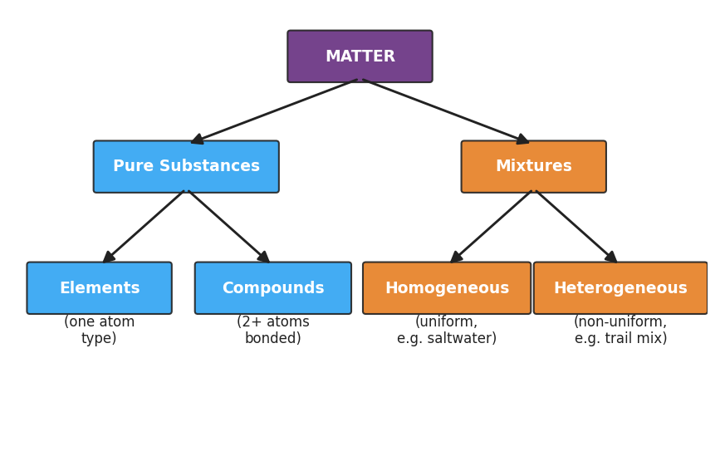
Flowchart titled ‘Unit 1 Concept Map — Classification of Matter’ showing that Matter branches into Pure Substances (which include Elements and Compounds) and Mixtures (which include Homogeneous mixtures and Heterogeneous mixtures); labels note that pure substances have fixed composition and properties while mixtures have variable composition.
Use the concept map above to complete the table:
Unit-1 concept | Reference-table section | Key value or data type
SI units and prefixes (L02)
Density (L05) |  | density of water = _______________
Gram formula mass (L06) |  | atomic masses from _____________
Percent composition (L07) |  | atomic masses from _____________
STP conditions (L08) |  | T = _____ K; P = _____ kPa
Complete the Because / But / So sentence:
The reference tables turn chemistry’s data into a navigable resource because __________________________________________, but __________________________________________, so __________________________________________.
The key lookup check (copy into your Reference Tables booklet as a reminder):
Before every reference-table lookup, ask: 1. What type of data am I looking for? (constant? element property? unit conversion?) 2. Which section holds that type of data? 3. Did I write the value and the units?

