The 2025 Chemistry Reference Tables — Student Worksheet
Unit: Safety and Measurement — Lesson 08 Name: _______________________ Date: __________ Period: ____

Phenomenon
Every chemistry student in New York receives the exact same 2025 NYS Chemistry Reference Tables booklet on Regents day. Two students of equal ability sit down — one finds a needed value in under fifteen seconds; the other never opens the booklet and guesses. The booklet is identical. The skill of using it is not.
Driving question: How does one shared document support every chemistry concept on the exam?

Notice & Wonder
I notice… | I wonder…
Turn & Talk #1: Flip through the reference tables for 90 seconds without instruction. Where do you predict you would find the density of water? Where would you find the atomic masses of elements? Write one prediction for each:
Density of water: I predict it is in the _______________ section because _______________.
Atomic masses: I predict they are in the _______________ section because _______________.

Initial Model
Before any instruction, try to find the following three values using only the reference tables booklet. Write the value (with units) AND the name of the section where you found it.
Lookup task | Value I found (with units) | Section / table name
Density of water at 4 °C
Atomic symbol for gold
Meaning of the prefix kilo- (what multiplier does it represent?)
After the class debrief: did your predictions from Notice & Wonder match where you actually found these values? What surprised you?

Investigation

Part 1 — ABCs: Open exploration
Your teacher has given you a 2025 Reference Tables booklet. Without any guidance, find the answers to the three lookups in the Initial Model (above) and record them. Then rank the following four sections in the order you predict you will use them most often this year (1 = most often):
Section | My predicted rank
Periodic Table
Physical Constants for Water
Selected Prefixes / SI Units
Solubility Guidelines
After the scavenger hunt is complete, return and check your ranking. Was your prediction accurate?
After checking: _______________________________________________

Part 2 — Scavenger-Hunt Stations
Work with your partner. For each station, record (a) the exact value with correct units, (b) the name of the table or section where you found it, and (c) any answer to the calculation if required. Write clearly — your table name is as important as the number.
Station 1 — Density of water
What is the density of water at 4 °C?
Value: _______________ Units: _______________ Table / section: _______________________________________________
Station 2 — Element data
For the element calcium (Ca): what is its atomic symbol and its atomic mass?
Atomic symbol: ___ Atomic mass: _______________ g/mol Table / section: _______________________________________________
Station 3 — SI prefixes
What multiplier does the prefix milli- represent? What multiplier does kilo- represent?
milli- = _______________ (or 10^) kilo- = ____________ (or 10^___)
Table / section: _______________________________________________
Station 4 — STP conditions
What are the standard temperature and pressure conditions defined in the reference tables?
Temperature at STP: _______________ K (also written as _______________ °C)
Pressure at STP: _______________ kPa
Table / section: _______________________________________________
Station 5 — One-step calculation using a looked-up value
A student needs to find the mass of 350 mL of water at 4 °C. Use the density you looked up in Station 1.
Density of water (from Station 1): _______________ g/mL
Setup: mass = density × volume = _______________ × _______________ =
Mass = _______________ g
Show the unit cancellation: (g/mL) × (mL) = _______________
Does your answer make sense? In one sentence, explain: _______________________________________________

Make It Make Sense
Answer each question below. These lookups are different from the Exit Ticket — work carefully and record both the value and the table name for each.
1. Which section of the reference tables holds the atomic symbol and atomic mass of each element?
Section name: _______________________________________________
Use that section: What is the atomic mass of iron (Fe)? _______________ g/mol
2. Which section gives the value of standard pressure (the pressure condition at STP)?
Section name: _______________________________________________
Value of standard pressure: _______________ kPa
3. Use the density of water (from the reference tables) to solve the following:
A student has a sample of water with a volume of 500 mL at 4 °C. What is the mass of this sample?
Density of water (write the looked-up value with units): _______________
Setup: mass = _______________________________________________
Mass = _______________ g
4. A classmate says, “STP means room temperature.” In one sentence, explain why this is incorrect and what STP actually means according to the reference tables.

Vocabulary in Action
Use each term in a sentence about today’s investigation. Do not copy the definition — describe something you actually did or observed.
- reference table: _______________________________________________ _______________________________________________
- STP: _______________________________________________ _______________________________________________
- density: _______________________________________________ _______________________________________________

Revise Your Model
Return to the matter map your teacher projected at the start of class:
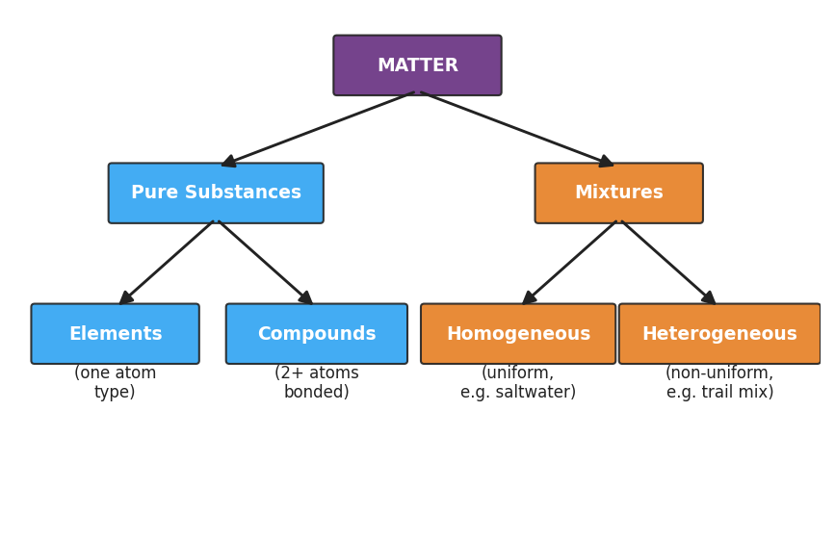
Flowchart titled ‘Unit 1 Concept Map — Classification of Matter’ showing that Matter branches into Pure Substances (which include Elements and Compounds) and Mixtures (which include Homogeneous mixtures and Heterogeneous mixtures); labels note that pure substances have fixed composition and properties while mixtures have variable composition.
For each Unit-1 lesson listed below, identify one section of the reference tables that supports it:
Unit-1 lesson | Reference-table section that supports it
L02 — Measurement and SI Units
L04 — Dimensional Analysis
L05 — Density
L06 — Gram Formula Mass
L07 — Percent Composition
Then write a Because / But / So sentence connecting the reference tables to the unit:
Every chemistry concept in Unit 1 shows up somewhere in the reference tables because __________________________________________, but __________________________________________, so __________________________________________.

Exit Ticket
(a) Which table or section in the 2025 Reference Tables gives you the density of water?

(b) What are the STP conditions? Give both temperature (in K and °C) and pressure (in kPa).
Temperature: _______________ K (_______________°C) Pressure: _______________ kPa
(c) In one sentence, why is practicing with the reference tables before the exam worth class time?

