Dimensional Analysis — Student Notes
Unit: Safety and Measurement — Lesson 04 Name: _______________________ Date: __________ Period: ____

Learning Targets
By the end of today’s 42 minutes I can:
- Set up a factor-label track so that unwanted units cancel diagonally, leaving only the target unit.
- Convert between metric units (km, m, cm, mm; L, mL; kg, g, mg) using conversion factors written as ratios.
- Convert between moles and atoms using Avogadro’s number from the Reference Table.
- Explain, using Scale, Proportion, and Quantity, why a conversion factor equals 1 and why dimensional analysis never changes the physical quantity — only the unit used to express it.

Key Vocabulary
- conversion factor — _______________________________________________ _______________________________________________
- dimensional analysis — _______________________________________________ _______________________________________________
- metric prefix — _______________________________________________ _______________________________________________

Guided Notes
The big idea — Scale, Proportion, and Quantity: A conversion factor is a __________ — a ratio equal to exactly __________ — that lets you cross between different scales. Multiplying by a conversion factor never changes the __________ quantity, only the __________ used to express it.
The factor-label track — how it works:
Each “car” in the track holds a quantity (number + unit). When a unit appears once in a __________ and once in a __________, the two cancel diagonally — they cross each other out. The unit that has not been canceled is the __________ unit.
Setting up a conversion factor:
A conversion factor can be written two ways:
Option A (going mol → atoms) | Option B (going atoms → mol)
6.02 × 10²³ atoms / 1 mol | 1 mol / 6.02 × 10²³ atoms
Choose the orientation that puts the unit you want to __________ in the denominator.
Avogadro’s number (from the 2025 Reference Table):
1 mol = 6.02 × 10²³ particles (atoms, molecules, or ions)
The figure — a mol → atoms track:
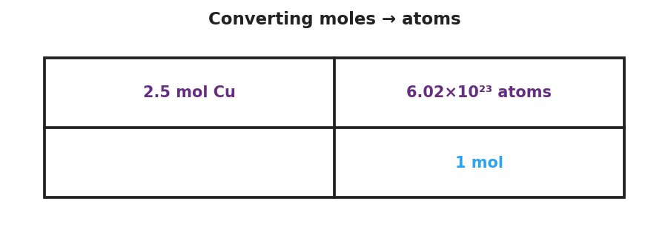
A factor-label railroad-track grid showing the conversion 2.5 mol Cu × (6.02 × 10²³ atoms / 1 mol); the numerator of the first box contains 2.5 mol Cu, the numerator of the second box contains 6.02 × 10²³ atoms, the denominator of the second box contains 1 mol; diagonal slashes show that “mol” in the numerator of the first box cancels with “mol” in the denominator of the second box, leaving atoms as the surviving unit; the result 1.505 × 10²⁴ atoms appears after the equals sign.
From the figure above, fill in the blanks:
- Starting quantity: ___________ mol Cu
- Conversion factor: ___________ atoms / ___________ mol
- Unit that cancels: ___________
- Surviving unit: ___________
- Numerical answer: ___________ ___________
Metric prefix conversion factors:
Prefix | Meaning | Conversion factor (going → base unit)
kilo- (k) | 10³ = 1000 | 1 km / 1000 m (or 1000 m / 1 km)
centi- (c) | 10⁻² = 1/100 | 1 cm / 0.01 m (or equivalently: 100 cm / 1 m)
milli- (m) | 10⁻³ = 1/1000 | 1 mL / 0.001 L (or equivalently: 1000 mL / 1 L)
For a metric conversion, the conversion factor you choose is the one that puts the __________ you want to cancel in the denominator.

Worked Example
Scenario: A student needs to convert 4.0 mol of copper atoms to individual atoms.
Step 1 — Identify starting quantity and target unit:
- Starting quantity: ___________ mol Cu
- Target unit: ___________
Step 2 — Write the conversion factor (choose the orientation that cancels mol):
Conversion factor: ___________ atoms / ___________ mol
Explain why this orientation: _______________________________________________
Step 3 — Set up the factor-label track:
Starting quantity | × | Conversion factor | = | Answer
4.0 mol Cu |  | _________________
Units that cancel: ___________
Surviving unit: ___________
Step 4 — Calculate:
4.0 × 6.02 × 10²³ = ___________ (write in scientific notation)
Step 5 — Because / But / So
The conversion factor (6.02 × 10²³ atoms / 1 mol) is placed with mol in the denominator because _______________________________________________, but _______________________________________________, so _______________________________________________.
Check your reasoning: “because” should say why mol needs to be on the bottom; “but” should explain that you can choose either orientation; “so” should state what survives.

Summary
Complete the sentence (Because / But / So):
Dimensional analysis works because __________________________________________, but __________________________________________, so __________________________________________.
Reminder: Write units at every step of every conversion track. If the surviving unit is not the target unit, your conversion factor is oriented backwards — flip it and recalculate.
Key number to know (from the Reference Table): Avogadro’s number: 6.02 × 10²³ particles/mol

