Measurement & SI Units — Student Notes
Unit: Safety and Measurement — Lesson 02 Name: _______________________ Date: __________ Period: ____

Learning Targets
By the end of today’s 42 minutes I can:
- Identify the SI unit and the instrument used to measure mass, volume, length, and temperature.
- Read a graduated cylinder by finding the bottom of the meniscus.
- Distinguish between precision and accuracy using repeated-measurement data.
- Record a measurement correctly: number, unit, and appropriate precision.

Key Vocabulary
- SI unit — _______________________________________________ _______________________________________________
- precision — _______________________________________________ _______________________________________________
- accuracy — _______________________________________________ _______________________________________________

Guided Notes
The big idea — Scale, Proportion, and Quantity: A measurement has two parts: the __________ (how many) and the __________ (what kind). Without both parts, the measurement is meaningless. 36.5 is a number. 36.5 mL is a measurement.
The Mars Climate Orbiter (1999): Engineers reported thruster force in __________ instead of __________. The numbers were correct, but the units were wrong. The spacecraft missed its orbit and burned up. One unit error cost $125 million.
SI units — the international agreement:
Quantity | SI Unit | Symbol | Instrument
Mass | kilogram | kg | balance
Volume | liter / milliliter | L / mL | graduated cylinder
Length | meter / centimeter | m / cm | ruler
Temperature | kelvin (scientific) | K | thermometer
Note: In chemistry, temperature is often recorded in °C in the lab and converted to K for calculations. Conversion: K = °C + __________.
Reading a graduated cylinder — the meniscus rule:
Water in a glass cylinder forms a curved surface called a meniscus. The center of the surface curves __________ (concave). Always read the __________ of the curve, not the edges where the liquid touches the glass.
Reading at the edges gives a value that is too __________ (high / low).
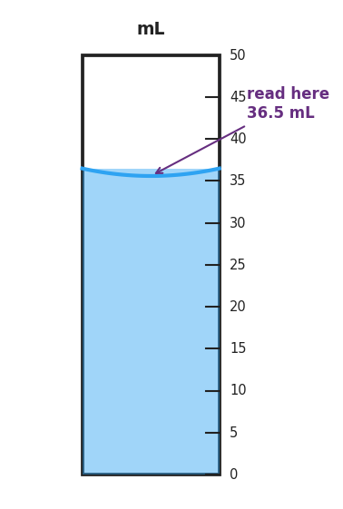
A 50 mL graduated cylinder filled to 36.5 mL, showing a concave meniscus; annotation reads “read here 36.5 mL” at the bottom of the curved surface.
The correct reading in the figure above: _____________ mL
Precision vs. accuracy — the dartboard model:
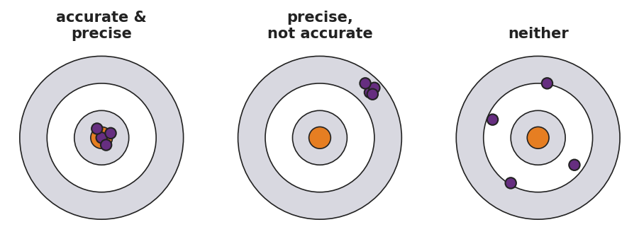
Three dartboard targets side by side: left labeled ‘accurate and precise’ with darts clustered tightly on the bullseye; center labeled ‘precise, not accurate’ with darts clustered tightly but off-center; right labeled ‘neither’ with darts scattered across the board.
- Precision = how close repeated measurements are to __________ (each other / the true value)
- Accuracy = how close a measurement is to __________ (each other / the true value)
- You can have precision WITHOUT accuracy. Example: _______________________________________________
- The Mars orbiter data was (circle one): precise but not accurate / accurate but not precise / neither Because: _______________________________________________

Worked Example
Scenario: A student measures the mass of a metal sample four times on an electronic balance: 12.3 g, 12.3 g, 12.4 g, 12.3 g. The accepted mass of the sample is 15.8 g.
Step 1 — Is the data precise?
The four readings are: 12.3, 12.3, 12.4, 12.3 g. They cluster __________ (tightly / loosely) around __________ g. Conclusion: the data is __________ (precise / not precise).
Step 2 — Is the data accurate?
The average measured value is approximately __________ g. The true value is 15.8 g. The readings are __________ from the true value. Conclusion: the data is __________ (accurate / not accurate).
Step 3 — What might explain this result?
The balance reads the same wrong value repeatedly. This is called a __________ error — the instrument is __________ (calibrated correctly / miscalibrated).
Step 4 — Because / But / So
The balance gives a precise but inaccurate reading because _______________________________________________, but _______________________________________________, so _______________________________________________.
Check your reasoning: “because” should name what is wrong with the instrument; “but” should name why the readings are still precise; “so” should name the action to take (recalibrate, repeat, or check against a known standard).

Summary
Complete the sentence (Because / But / So):
Scientists worldwide use SI units because __________________________________________, but __________________________________________, so __________________________________________.
Reference Table reminder: The 2025 NYS Chemistry Reference Table lists SI units, metric prefixes, and unit conversion factors. Keep it at your station for every lab this year.

