Algebra and Trigonometry for Physics — Student Notes
Unit: Math in Science — Lesson 01 Name: _______________________ Date: __________ Period: ____

Learning Targets
By the end of today’s 42 minutes I can:
- Isolate a chosen variable in a physics formula (rearrange v = d / t into d = v t and t = d / v).
- Label the opposite, adjacent, and hypotenuse sides of a right triangle for a given angle.
- Use sine, cosine, or tangent (SOH-CAH-TOA) to find a missing side of a right triangle.

Key Vocabulary
- isolate (a variable) — _______________________________________________
- sine — _______________________________________________
- right triangle — _______________________________________________

Guided Notes
Golden rule of rearranging: whatever I do to one side of an equation, I do to the __________ side. I undo an operation with its __________ (multiply undoes divide; subtract undoes add).
Starting from v = d / t:
- To isolate d: d is being __________ by t, so __________ both sides by t → d = __________.
- To isolate t: get t out of the bottom, then __________ → t = __________.
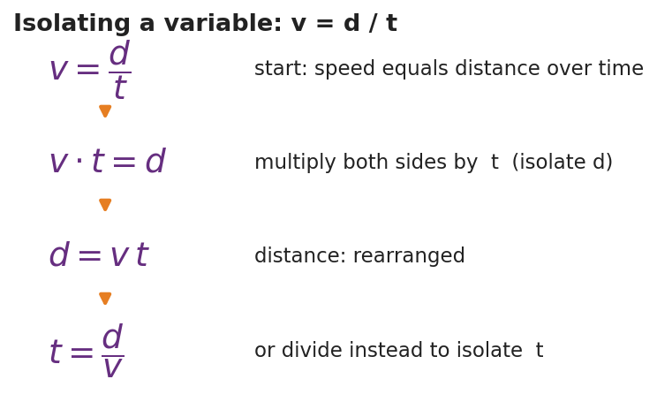
Isolating a variable in v = d / t
Right-triangle trig — SOH-CAH-TOA. For an angle θ:
- Sin θ = __________ / hypotenuse
- Cos θ = adjacent / __________
- Tan θ = opposite / __________
The opposite side is across from θ; the adjacent side touches θ; the hypotenuse is the longest side, across from the __________ angle.
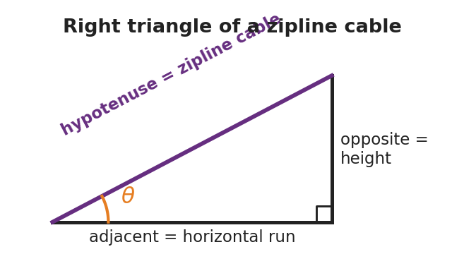
Right triangle of a zipline cable

Worked Example
Problem. A zipline cable is 26 m long (the hypotenuse) and leaves the top at 18° below horizontal. Find the tower height (the rise).
Solution. 1. The height is the side __________ the 18° angle, and I was given the __________. 2. Opposite over hypotenuse means I use __________: sin 18° = height / 26. 3. Solve: height = 26 × sin 18° = 26 × 0.309 ≈ __________ m. 4. (Run = 26 × cos 18° ≈ 24.7 m — the adjacent side.)

Summary
Finish the sentence (Because / But / So):
I can find a height I cannot reach because __________________________________________, but __________________________________________, so __________________________________________.

