Algebra and Trigonometry for Physics — Student Worksheet
Unit: Math in Science — Lesson 01 Name: _______________________ Date: __________ Period: ____

Phenomenon
A zipline cable runs from a tall tower down to a low platform. The installer measured only two things: the cable is 26 m long and it leaves the top at 18° below horizontal. The town inspector needs two numbers nobody measured — how high is the top tower, and how far across the ground does the rider travel.
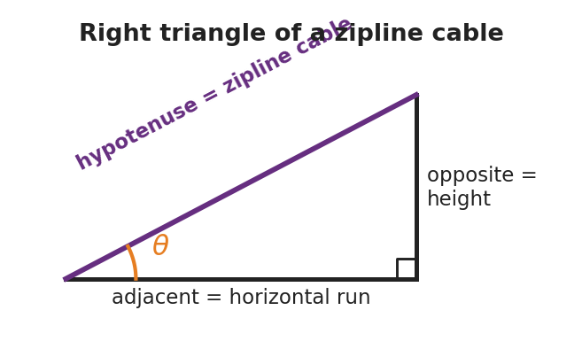
Right triangle of a zipline cable
Driving question: How can we find a height and a distance we can’t reach, using only a length and an angle?

Notice & Wonder
I notice… | I wonder…
Turn & Talk #1: What did the installer give us, and what is missing? Which shape could this cable make with the ground and the tower?

Initial Model
Sketch the zipline as a triangle. Label the 26 m cable and the 18° angle. Mark which side is the height of the tower and which side is the ground run. Write a one-sentence guess for how you might find the height.

My guess: ______________________________________

Investigation
Part A — Rearranging an equation. Start from the speed formula v = d / t.
I want to solve for… | What is happening to that variable now | What I do to both sides | Rearranged formula
d
t
Part B — Right-triangle trig. Using the triangle (hypotenuse = 26 m, angle = 18°):
I want | Which side is it (opp / adj / hyp)? | Which ratio (SOH-CAH-TOA)? | Value
height (rise)
ground run
Key question: Why does the height use the hypotenuse, and which trig function uses opposite ÷ hypotenuse?

Make It Make Sense
- Rearrange a = (v − u) / t to solve for v (the final speed).
- A ramp’s slanted top is 5.0 m long (the hypotenuse) and tilts 10° above the ground. Which side is the rise — opposite or adjacent to the 10° angle?
- Using question 2, find the rise (height) of the ramp.

Vocabulary in Action
Use each term in a sentence about today’s phenomenon.
- isolate (a variable): _______________________________________________
- sine: _______________________________________________
- right triangle: _______________________________________________

Revise Your Model
Return to your Initial Model sketch. Fill in the actual height and ground run of the zipline, with units. Then rewrite your one-sentence method using the word sine.
Height = __________ Ground run = __________ My method: _____________________________________

Exit Ticket
A wheelchair ramp is 5.0 m long (the slanted hypotenuse) and rises at 10° above the ground.
- Rearrange v = d / t to solve for t.
- Which side of the ramp triangle is the rise — opposite or adjacent to the 10° angle?
- Find the rise (height) of the ramp. Show the ratio you used.

