Graphing and Interpreting Data — Student Notes
Unit: Math in Science — Lesson 02 Name: _______________________ Date: __________ Period: ____

Learning Targets
By the end of today’s 42 minutes I can:
- Identify the independent and dependent variable and put each on the correct axis.
- Draw a line of best fit and explain why it beats connect-the-dots.
- Calculate a slope (rise / run) with units and say what it means.

Key Vocabulary
- independent variable — _______________________________________________
- dependent variable — _______________________________________________
- slope — _______________________________________________

Guided Notes
Which axis? The variable I choose (the __________ variable) goes on the __________-axis. The variable that responds and I measure (the __________ variable) goes on the __________-axis.
Line of best fit: a single straight line drawn close to as many points as possible, with about equal points __________ and below it. It is NOT __________-to-__________, because that would treat measurement error as real.
Slope: slope = rise / run = Δy / Δ__________ . Always include __________ (e.g., cm per gram). When a line is straight through the origin, the slope is the __________ constant.
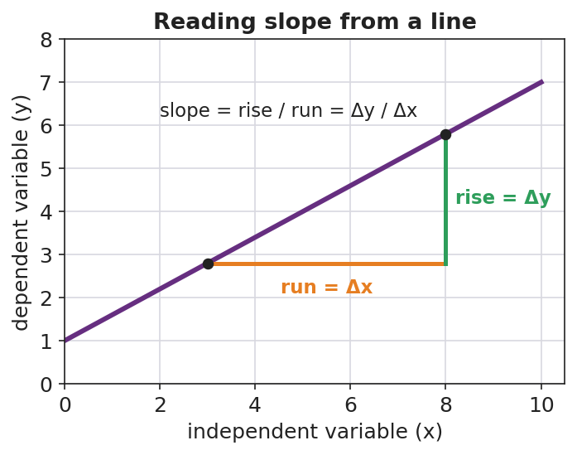
Reading slope from a line

Worked Example
Problem. Lid data gives a straight line through the origin. Between two points, the circumference rises 31.4 cm while the diameter runs 10.0 cm. Find the slope and interpret it.
Solution. 1. slope = rise / run = 31.4 cm / __________ cm. 2. slope = __________ (no length unit left — cm / cm cancels). 3. The line passes through the __________, so this slope is the proportionality constant: C = __________ × d. 4. That constant ≈ 3.14, which is __________. So C = πd.
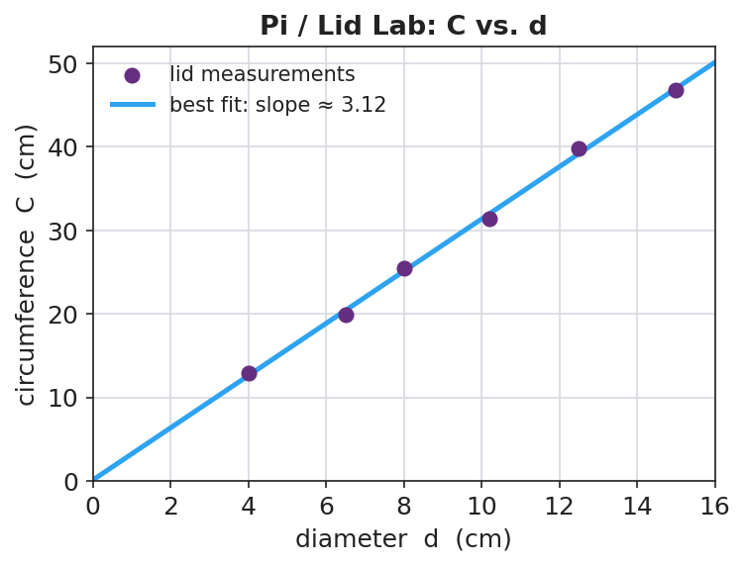
Pi / Lid Lab: circumference vs. diameter

Summary
Finish the sentence (Because / But / So):
A straight-line graph through the origin shows a proportional relationship because __________________________________________, but __________________________________________, so __________________________________________.

