Graphing and Interpreting Data — Student Worksheet
Unit: Math in Science — Lesson 02 Name: _______________________ Date: __________ Period: ____

Phenomenon
Your teacher claims that for any round lid, the distance around it and the distance across it are locked together by the same multiplier — big lid or small lid, same number. Today you will catch that multiplier on a graph.
Driving question: What single number connects the circumference of a circle to its diameter, and how does a graph reveal it?

Notice & Wonder
I notice… | I wonder…
Turn & Talk #1: As the lids get bigger across, what happens to the distance around them? What shape do you predict the graph will be?

Initial Model
Sketch the graph you expect before measuring. Label the axes. Predict in one sentence what the line will look like and whether it passes through the origin (0, 0).
My prediction: _________________________________

Investigation
Set the variables: Which quantity do you choose (independent, x-axis)? __________ Which responds (dependent, y-axis)? __________
Measure 5–6 lids. Use string to find the circumference, then straighten it against a ruler.
Lid | Diameter, d (cm) | Circumference, C (cm)
1
2
3
4
5
6
Plot all points. Draw one straight line of best fit (not dot-to-dot). Build a slope triangle on it.
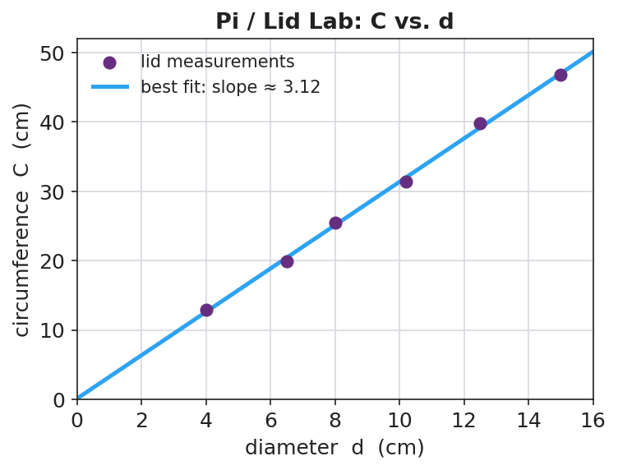
Pi / Lid Lab: circumference vs. diameter
Slope: rise = __________ run = __________ slope = rise / run = __________
Key question: Why did your slope come out near 3.14 even though your lids were all different sizes?

Make It Make Sense
- A graph plots distance (y) versus time (x) for a walker. Which variable is independent and which is dependent?
- A best-fit line rises 6 units over a run of 3 units. What is its slope?
- Two lines are drawn on the same axes. Line A is steeper than Line B. What does the steeper slope mean about how fast y changes?

Vocabulary in Action
Use each term in a sentence about today’s lid investigation.
- independent variable: _______________________________________________
- dependent variable: _______________________________________________
- slope: _______________________________________________

Revise Your Model
Compare the graph you predicted to the graph you measured. Was it a straight line? Did it pass through the origin? Rewrite the locked-together rule as an equation using your slope.
Measured rule: C = __________ × d

Exit Ticket
A class plots a stretched spring’s length (cm) versus the mass hung on it (g). The line is straight and starts at 12 cm when 0 g is hung.
- Which is the independent variable and which is the dependent variable?
- The line rises 8 cm over a run of 200 g. What is the slope, including units?
- Explain in plain words what that slope tells you about the spring.

