Graphing and Interpreting Data — Teacher Guide

Cover
Unit: Math in Science — Lesson 02: Graphing and Interpreting Data East Meadow Schools × Valley Stream Central High School District Strategy chips: ACTIVE LEARNING

Curated Resources (from East Meadow Scope & Sequence)

NYSSLS Standards
This is a foundational math-skills lesson with no single NYSSLS performance expectation of its own. It develops the science and engineering practice “Using Mathematics and Computational Thinking” (and “Analyzing and Interpreting Data”), which every quantitative HS-PS standard depends on — a slope is how students will later read acceleration off a velocity graph (HS-PS2) or a spring constant off a force graph (HS-PS3). The crosscutting concept in focus is Patterns: a straight line through data reveals a proportional relationship, and its slope is the constant that names that pattern.

Phenomenon
- “Pi / Lid Lab” — students measure the circumference and diameter of many round lids; plotted together, the points fall on a line whose slope is π.
- Slow Reveal Graphs — reveal a graph piece by piece to build interpretation skills: https://slowrevealgraphs.com/

Javalab / Labs
- Graphing Pi / Lid Lab (this lesson’s investigation): collect circumference vs. diameter for 5–6 round objects; plot and find the slope.
- Slow Reveal Graphs routine as the Engage warm-up: https://slowrevealgraphs.com/
- Desmos or graph paper for the line of best fit.

Assessments
- Slow Reveal Graphs includes discussion checks. The Exit Ticket below (read a slope and name the relationship) is the formative check for this lesson.

Lesson Overview
Duration | 42 minutes (1 period)
NYSSLS link | Practices: Using Mathematics & Computational Thinking; Analyzing & Interpreting Data (supports all HS-PS)
CCC focus | Patterns — a straight-line graph reveals a proportional relationship; the slope names it
Strategy chips | ACTIVE LEARNING (hands-on lid measurement + Slow Reveal discourse)
Materials | 5–6 round lids/cans per group; string or flexible tape measures; rulers; graph paper or Desmos; whiteboards
Safety | No hazards. Remind students not to roll cans off the desks.
Prior knowledge | Plotting an (x, y) point; the idea of “per” (miles per hour). No formal slope formula assumed.
Lesson objectives — students can:
- Identify the independent variable and dependent variable in an investigation and place each on the correct axis.
- Draw a line of best fit through scattered data and explain why it is not connect-the-dots.
- Calculate the slope (rise / run) of the best-fit line and interpret it as the constant of a proportional relationship.

Phase 1 · Engage (0 – 8 min)

0–3 min · Opening Connection (SEL)
Quick check-in. Prompt: “Name a time a picture (a chart, a map, a meme) explained something faster than words could.” This frames a graph as a fast-reading tool, not a chore.

3–8 min · Phenomenon hook — Slow Reveal + the lid question
Teacher actions. Run one Slow Reveal Graphs slide (reveal axes first, then points, then the line). Then hold up two round lids of very different sizes.
Sample teacher language:
“Here’s a wild claim: if I measure the distance around any of these lids and the distance across it, those two numbers are locked together by the same multiplier — every lid, big or small. Same multiplier. We’re going to catch that multiplier on a graph.”
Anticipated student responses:
- “Bigger lid, bigger everything.” — affirm; that’s a pattern, and we’ll make it exact.
- “The multiplier is pi!” — great early guess; have them prove it from data, not memory.
- “How do you measure around a circle?” — wrap string, then straighten it — a measurement procedure they design.

Bridge to Phase 2
Every student leaves Phase 1 with a prediction in one sentence: “As the diameter goes up, the circumference will , and the graph will look like .”

Phase 2 · Explore (8 – 26 min)

8–12 min · Set the variables (whole class)
Together, decide what we change and what we measure. We choose which lids to grab (diameter), and the circumference responds. Name the roles now so the graph is set up correctly.
Teacher facilitation language:
“Which number are we choosing, and which one just comes along for the ride? The one we choose goes on the bottom axis.”

12–26 min · Investigation — the Pi / Lid Lab (groups of 3–4)
Each group measures diameter (ruler) and circumference (string then ruler) for 5–6 lids, records a data table, and plots all points on one graph. Then they draw a single straight line of best fit — close to as many points as possible, NOT dot-to-dot — and compute its slope from a slope triangle.
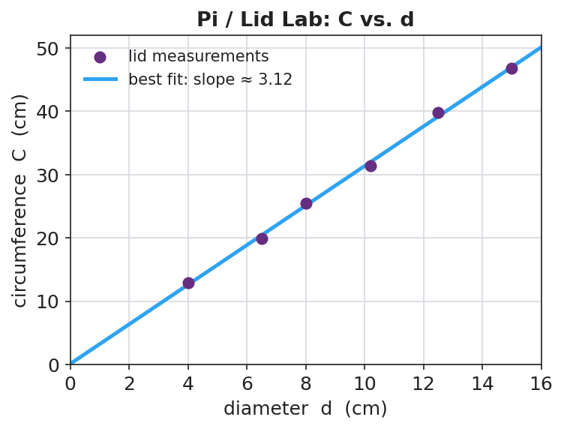
Pi / Lid Lab: circumference vs. diameter
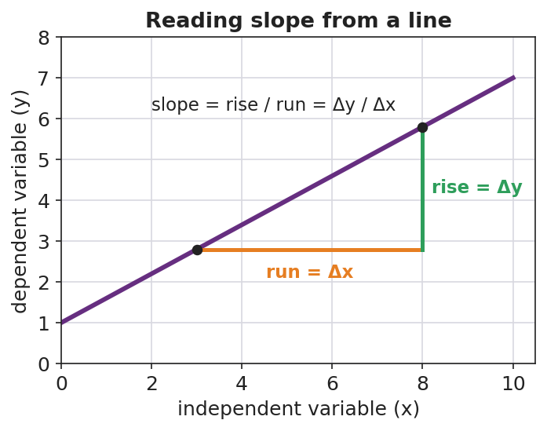
Reading slope from a line
Teacher facilitation during Explore:
- What to look for — best-fit lines that pass through the cloud, with roughly equal points above and below, and that pass near the origin.
- What to resist — handing out the slope formula before they’ve drawn the triangle; let the rise/run come from their own line.
- What to redirect — groups connecting dots zig-zag style (“that’s not a measured law, that’s tracing your errors”); groups forcing the line through the first point only.

Phase 3 · Explain (26 – 34 min)

26–30 min · Turn-and-Talk + class consensus
Post several groups’ slopes on the board (they will cluster near 3.1–3.2).
“Compare your slope to your neighbors’. Why did everyone — with different lids — land near the same number?”
Target consensus:
“The graph is a straight line through the origin, so circumference is proportional to diameter. The slope is the constant multiplier, and it’s about 3.14 — that’s π.”

30–34 min · Vocabulary introduction (≤ 3 terms)
Sample teacher language:
“Three words make every future graph readable. The independent variable is the one we choose — it goes on the x-axis (here, diameter). The dependent variable responds — it goes on the y-axis (circumference). And the slope is rise over run: how much y changes for each step in x. When the line is straight through the origin, that slope is the proportionality constant — for us, π.”

Discussion prompts to deploy here
- “If you’d plotted circumference on the x-axis instead, what would the slope have been?”
  - Sample student response: “About 1/π ≈ 0.32, because the axes are swapped — slope is y-over-x.”
- “Why is a best-fit line more trustworthy than connecting the dots?”
  - Sample student response: “It averages out our measurement errors instead of treating each wobble as real.”

Phase 4 · Elaborate (34 – 39 min)

34–37 min · Active Learning — predict from the line
“Without measuring, use your best-fit line to predict the circumference of a lid 20 cm across. Mark it on the graph and read it off. Then check: 20 × your slope. Do they match?”
This makes the line a tool, not a decoration — interpolation/extrapolation.

37–39 min · Return to the phenomenon
“State the locked-together rule in one sentence with the word slope.”
Target: “Circumference = slope × diameter, and the slope is π ≈ 3.14, so C = πd — the same multiplier for every lid.”

Phase 5 · Evaluate (39 – 42 min)

39–42 min · Exit Ticket + Closing Reflection
“A class plots a stretched spring’s length (cm) versus the mass hung on it (g). The line is straight and rises from 12 cm at 0 g. (a) Which is the independent variable and which is the dependent variable? (b) The line rises 8 cm over a run of 200 g. What is the slope, with units? (c) What does that slope tell you in plain words?”
Expected: (a) mass = independent (x), length = dependent (y); (b) slope = 8 cm / 200 g = 0.04 cm/g; (c) the spring stretches 0.04 cm for every extra gram. See Answer_Key.docx.
Closing Reflection (SEL, 30 seconds):
“Whose idea in your group changed how you drew or read the line today? Name them.”

Common Misconceptions
- Misconception: “Connect the dots to show the relationship.” → Correction: A best-fit line averages out measurement error; connect-the-dots treats every wobble as a real effect.
- Misconception: “The independent variable goes wherever there’s room.” → Correction: Independent (what you choose) goes on the x-axis; dependent (what responds) on the y-axis — always.
- Misconception: “Slope is just ‘how steep,’ no units.” → Correction: Slope is rise/run with units (e.g., cm per gram) and it carries the physical meaning of the relationship.
- Misconception: “A steeper line means a bigger y-value.” → Correction: Steepness is the rate of change, not the size of any single value.

Access & Differentiation
- ELL/ENL supports: Sentence frame: *“When the ___ goes up by , the goes up by ___.”* Color-code the axes (x = “I choose,” y = “it responds”). Provide a labeled slope-triangle card. Pre-teach “per” as “for each.”
- IEP/SPED supports: Provide a pre-labeled grid with axis titles and a scale already chosen, so students plot only. Offer a partially drawn best-fit line and have them compute the slope from a marked triangle. Reduce to 4 lids if measuring is slow.
- Extensions: Ask students to find the y-intercept of the spring graph and explain its physical meaning (the unstretched length), then write the full equation y = mx + b for their data.

Strategy Spotlight
ACTIVE LEARNING. Today’s chip pairs a hands-on measurement lab with a Slow Reveal discourse routine. Students generate the data that produces π rather than being told the value — the proportional pattern emerges from their own messy points, which is exactly why the best-fit line conversation lands. Keep groups small (3–4) so everyone measures, and require every group to post a slope so the class can see the pattern converge. The Slow Reveal warm-up trains the interpretation move (axes → points → line) you want them to use on their own graph.

NYSSLS Observation Checklist Crosswalk
# | Checklist item | Where it appears in this lesson
1 | Local/relatable phenomenon | Phase 1 — round lids; Phase 5 — stretched spring
2 | Turn and Talk (2–3×) | Phase 3 (why same slope?), Phase 4 (predict from the line)
3 | Students develop questions/models/procedures | Phase 2 — design the measuring method, plot, draw best fit
4 | CCC defined and used | Lesson Overview · Patterns, applied in Phase 3 consensus
5 | ENL — ≤ 3 vocab, second half | Phase 3 — vocabulary at 30–34 min (independent / dependent / slope)
6 | Revisit phenomenon with evidence | Phase 4 — state C = πd from the measured slope
7 | ENL/SPED supports | Access & Differentiation block
8 | Assessment check | Phase 5 — Exit Ticket (spring slope + interpretation)

Companion Materials
- Student_Worksheet.docx — the 5E student investigation with the lid data table (hand out at start of Phase 2)
- Student_Notes.docx — guided note-guide for variables, best fit, and the slope worked example
- Answer_Key.docx — answers to “Make It Make Sense” prompts and the Exit Ticket

Key Vocabulary (max 3)
- independent variable — the quantity you choose or change; it goes on the x-axis (here, the lid’s diameter)
- dependent variable — the quantity that responds and is measured; it goes on the y-axis (here, the circumference)
- slope — the rise divided by the run of a line (Δy / Δx); for a line through the origin it is the proportionality constant

