Scientific Notation and Fermi Estimates — Student Notes
Unit: Math in Science — Lesson 03 Name: _______________________ Date: __________ Period: ____

Learning Targets
By the end of today’s 42 minutes I can:
- Write large and small numbers in scientific notation and convert them back.
- Use the exponent to compare the sizes of two numbers.
- Make an order-of-magnitude (Fermi) estimate and express it as a power of ten.

Key Vocabulary
- scientific notation — _______________________________________________
- order of magnitude — _______________________________________________
- exponent — _______________________________________________

Guided Notes
The form: scientific notation is (a number from 1 to 10) × 10^(exponent). The leading number must be at least 1 and less than __________.
Moving the decimal:
- Big numbers → exponent is __________ (positive). 47,000 = 4.7 × 10^___ (decimal moved __________ places left).
- Small numbers → exponent is __________ (negative). 0.006 = 6 × 10^___ (decimal moved __________ places right).
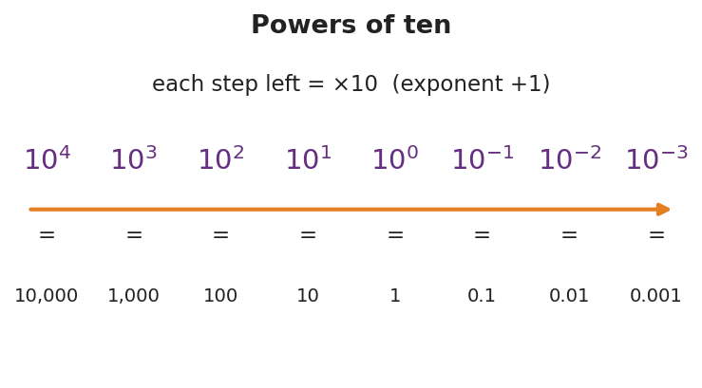
Powers of ten
Comparing sizes: the number with the larger __________ is bigger. Each step in the exponent is a factor of __________. So 10⁶ is __________ times bigger than 10³.
Order of magnitude = the power of ten a quantity is nearest. It answers “what level of size?” not “exactly how many?”

Worked Example
Problem (Fermi). About how many basketballs fill a gym? Use only round numbers.
Solution. 1. Gym ≈ 30 m × 20 m × 10 m = __________ m³ = 6 × 10³ m³. 2. One basketball ≈ a 0.24 m sphere ≈ 0.01 m³ = 1 × 10⁻² m³. 3. Number ≈ gym ÷ ball = (6 × 10³) ÷ (1 × 10⁻²). Divide leading numbers, __________ the exponents: 6 × 10^(3 − (−2)) = 6 × 10^. 4. Answer ≈ 6 × 10⁵ → order of magnitude _______. (Hundreds of thousands — a defensible estimate.)
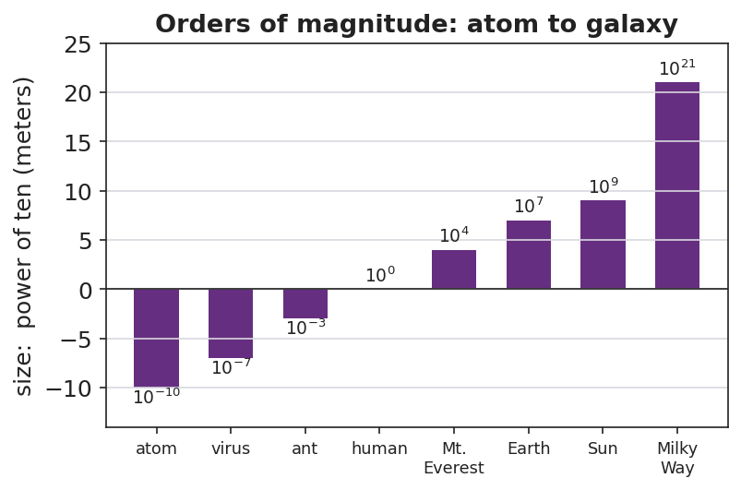
Orders of magnitude: atom to galaxy

Summary
Finish the sentence (Because / But / So):
I can estimate a number too big to count because __________________________________________, but __________________________________________, so __________________________________________.

