Scientific Notation and Fermi Estimates — Student Worksheet
Unit: Math in Science — Lesson 03 Name: _______________________ Date: __________ Period: ____

Phenomenon
In “Scale of the Universe” you zoom from an atom (about 10⁻¹⁰ m) all the way out to a galaxy (about 10²¹ m) — dozens of powers of ten. Then your teacher asks a number nobody could ever count: how many basketballs would fill this gym?
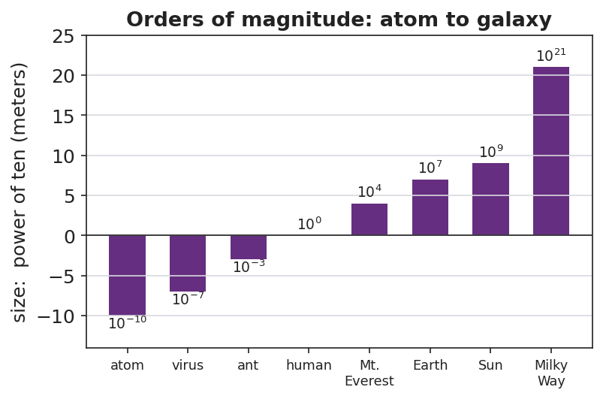
Orders of magnitude: atom to galaxy
Driving question: How do scientists write — and estimate — numbers far too big or too small to count?

Notice & Wonder
I notice… | I wonder…
Turn & Talk #1: What number do you guess for the basketballs in the gym? Is it closer to a thousand, a million, or a billion?

Initial Model
Write your gym guess as a normal number AND circle the power of ten you think it lives near (10³, 10⁴, 10⁵, 10⁶). You will test this guess by the end of class.
My guess: __________ Power of ten: __________

Investigation
Part A — Scientific notation warm-up. Fill in the blanks.
Standard form | Scientific notation
3,000
47,000
0.006
 | 5.2 × 10⁴
 | 8 × 10⁻³
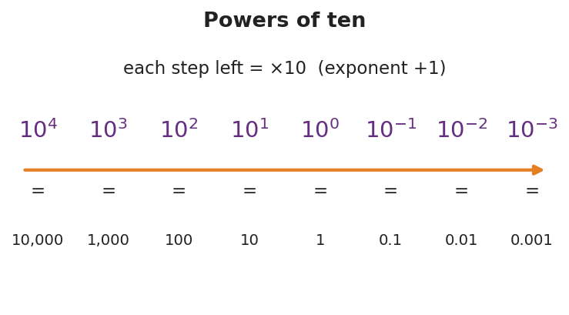
Powers of ten
Part B — Fermi: basketballs in the gym. Use only round numbers.
- Gym volume ≈ length × width × height = __________ × __________ × __________ ≈ __________ m³
- One basketball ≈ a sphere about 0.24 m across ≈ __________ m³ (round to ~0.01 m³)
- Number of basketballs ≈ gym volume ÷ ball volume ≈ __________
- Rounded to one power of ten, in scientific notation: __________
Key question: Why is the power of ten a more honest answer here than an exact count?

Make It Make Sense
- Write 920,000 and 0.00045 in scientific notation.
- Which is larger: 7 × 10⁴ or 3 × 10⁵? Explain how you can tell quickly.
- A bacterium is about 10⁻⁶ m long and a person is about 10⁰ m (1 m) tall. How many orders of magnitude separate them?

Vocabulary in Action
Use each term in a sentence about today’s phenomenon.
- scientific notation: _______________________________________________
- order of magnitude: _______________________________________________
- exponent: _______________________________________________

Revise Your Model
Compare your gym answer to your Initial Model guess. Was your power of ten too high, too low, or right? Write the final answer in scientific notation and name its order of magnitude.
Final: __________ basketballs ≈ __________ (order of magnitude 10^___)

Exit Ticket
- Write 84,000 and 0.00072 in scientific notation.
- Which is larger: 4 × 10⁷ or 9 × 10⁶? How do you know?
- Fermi estimate: about how many grains of rice would fill a coffee mug? Give your answer as a single power of ten and one sentence of reasoning.

