Scientific Notation and Fermi Estimates — Teacher Guide

Cover
Unit: Math in Science — Lesson 03: Scientific Notation and Fermi Estimates East Meadow Schools × Valley Stream Central High School District Strategy chips: BTC

Curated Resources (from East Meadow Scope & Sequence)

NYSSLS Standards
This is a foundational math-skills lesson with no single NYSSLS performance expectation of its own. It develops the science and engineering practice “Using Mathematics and Computational Thinking,” which underpins every HS-PS standard — students will write charge in coulombs (HS-PS3), wavelengths in meters (HS-PS4), and astronomical distances (HS-ESS1) in scientific notation, and they will sanity-check answers by order of magnitude. The crosscutting concept in focus is Scale, Proportion, and Quantity: scientific notation is the language for comparing sizes that span dozens of powers of ten, from an atom to a galaxy.

Phenomenon
- “Scale of the Universe” interactive — zoom from quarks to the observable universe: https://htwins.net/scale2/
- Fermi question: “How many basketballs would fill the gym?” — a quantity nobody could ever count directly, estimated to the nearest power of ten.

Javalab / Labs
- Fermi estimation station (this lesson’s investigation): groups estimate “how many basketballs fill the gym” using only reasonable round numbers.
- “Scale of the Universe” as the Engage zoom: https://htwins.net/scale2/
- Powers of Ten classic film (Eames) as an optional extension: https://www.youtube.com/watch?v=0fKBhvDjuy0

Assessments
- The Exit Ticket below (convert to scientific notation + a one-step Fermi estimate) is the formative check for this lesson.

Lesson Overview
Duration | 42 minutes (1 period)
NYSSLS link | Practice: Using Mathematics and Computational Thinking (supports all HS-PS)
CCC focus | Scale, Proportion, and Quantity — comparing sizes across many powers of ten
Strategy chips | BTC (random groups + vertical non-permanent surfaces on a thin-sliced task)
Materials | Whiteboards / windows / vertical surfaces + markers; visibly random grouping cards; a basketball + the room dimensions; calculators
Safety | No hazards.
Prior knowledge | Place value; multiplying by 10; exponents as repeated multiplication.
Lesson objectives — students can:
- Write a large or small number in scientific notation (a number from 1–10 times a power of ten) and convert back to standard form.
- Use the exponent to count how many places the decimal moves and to compare two numbers’ sizes.
- Make an order-of-magnitude (Fermi) estimate of a quantity that cannot be counted directly, and express it as a power of ten.

Phase 1 · Engage (0 – 8 min)

0–3 min · Opening Connection (SEL)
Quick check-in. Prompt: “Name something so big or so small you can’t really picture it (a national debt, a virus, the number of stars).” This legitimizes the discomfort of huge/tiny numbers — the exact problem scientific notation solves.

3–8 min · Phenomenon hook — Scale of the Universe + the gym question
Teacher actions. Project “Scale of the Universe” and zoom from an atom out to a galaxy. Then point around the room: “How many basketballs would fill this gym?”
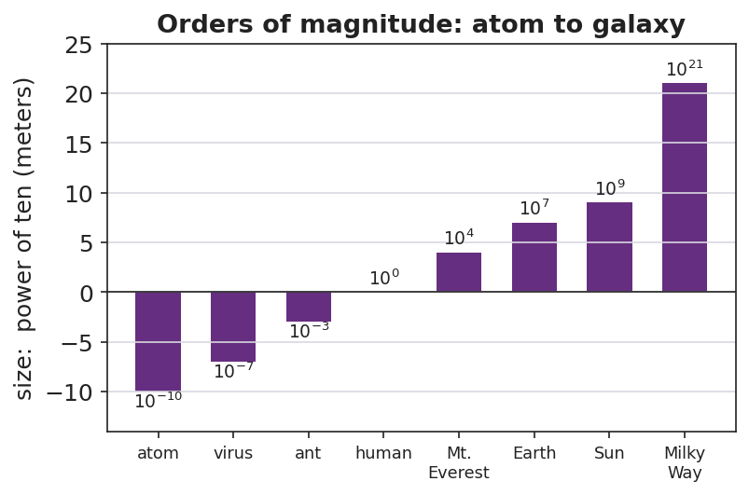
Orders of magnitude: atom to galaxy
Sample teacher language:
“Watch the exponent in the corner as I zoom — it jumps from negative ten to positive twenty. Nobody could write all those zeros and stay sane. Now: how many basketballs fill this gym? You will never count them — but by the end of class you’ll name the right power of ten, and you’ll defend it.”
Anticipated student responses:
- “A million? A billion?” — capture the guesses; we’ll see whose power of ten survives.
- “That’s impossible to know.” — reframe: “We don’t need exact; we need the right order of magnitude — the right power of ten.”
- “Just measure the gym and divide.” — yes — name that as the Fermi strategy.

Bridge to Phase 2
Every student leaves Phase 1 able to state the goal in one sentence: “Find the power of ten for the number of basketballs, not the exact count.”

Phase 2 · Explore (8 – 26 min)

8–14 min · Skill — scientific notation (BTC thin-slice at the boards)
Visibly random groups, markers, vertical surfaces. Feed a thin-sliced sequence (each step a small notch harder), one at a time:
- Write 3,000 as ___ × 10^? → 3 × 10³
- Write 47,000. Write 0.006. Write 250,000.
- Convert back: 5.2 × 10⁴ = ? ; 8 × 10⁻³ = ?
- Which is bigger: 9 × 10⁵ or 2 × 10⁶? (compare exponents first)
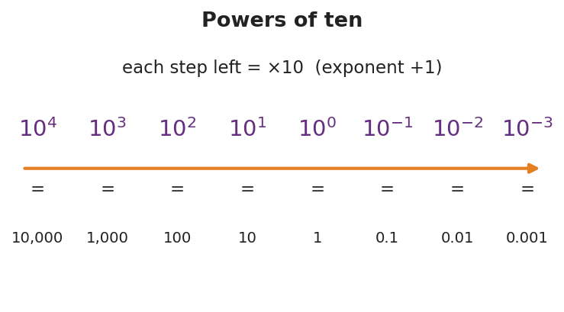
Powers of ten
Teacher facilitation language (BTC):
“I’m not answering ‘is this right?’ — convince your group at the board. When you’ve got it, signal and I’ll feed the next slice.”

14–26 min · Investigation — the Fermi gym estimate
Same boards. Groups estimate how many basketballs fill the gym using only round numbers: gym ≈ L × W × H; basketball ≈ a 0.24 m sphere (round its volume to ~10⁻² m³). Divide, then round the answer to a single power of ten and write it in scientific notation.
Teacher facilitation during Explore:
- What to look for — groups rounding aggressively (24 cm → 0.25 m → volume ~0.01 m³) instead of chasing decimals.
- What to resist — demanding the “real” answer; the win is a defensible power of ten.
- What to redirect — groups adding/subtracting exponents wrong; have them write each factor in scientific notation first, then combine.

Phase 3 · Explain (26 – 34 min)

26–30 min · Turn-and-Talk + class consensus
Post each group’s power of ten (they’ll cluster around 10⁴–10⁵).
“Compare your exponent to the next group’s. You don’t have to match exactly — but you should be within about one power of ten. Why is that ‘close enough’ in physics?”
Target consensus:
“Exact counts are impossible, but the order of magnitude — the power of ten — tells us if an answer is reasonable. Tens of thousands of basketballs, not hundreds and not billions.”

30–34 min · Vocabulary introduction (≤ 3 terms)
Sample teacher language:
“Three words run the rest of physics. Scientific notation writes any number as a value from 1 to 10 times a power of ten. The exponent is that power — it counts how many places the decimal moved, and it’s how we compare sizes fast. And the order of magnitude is just the power of ten itself — the level a quantity lives on, like 10⁴ for our basketballs.”

Discussion prompts to deploy here
- “9 × 10⁵ vs. 2 × 10⁶ — which is bigger and how do you know at a glance?”
  - Sample student response: “2 × 10⁶, because its exponent is bigger — one whole order of magnitude up.”
- “Why write 0.000006 as 6 × 10⁻⁶ instead of leaving it?”
  - Sample student response: “Fewer zeros to miscount, and the −6 instantly tells me how small it is.”

Phase 4 · Elaborate (34 – 39 min)

34–37 min · A second Fermi slice
“Estimate how many heartbeats you’ve had in your whole life. Round everything; give the answer as one power of ten in scientific notation.”
Target reasoning: ~70 beats/min × ~5×10⁵ min/yr × ~15 yr ≈ 5×10⁸ → order of magnitude 10⁸–10⁹.

37–39 min · Return to the phenomenon
“State the gym answer in scientific notation and name its order of magnitude in one sentence.”
Target: “About 3 × 10⁴ basketballs — order of magnitude 10⁴ — tens of thousands, because the gym’s volume is roughly ten thousand times a basketball’s.”

Phase 5 · Evaluate (39 – 42 min)

39–42 min · Exit Ticket + Closing Reflection
“(a) Write 84,000 and 0.00072 in scientific notation. (b) Which is larger: 4 × 10⁷ or 9 × 10⁶? How do you know? (c) Fermi: about how many grains of rice fill a coffee mug? Give your answer as a single power of ten and one sentence of reasoning.”
Expected: (a) 8.4 × 10⁴ and 7.2 × 10⁻⁴; (b) 4 × 10⁷ (bigger exponent); (c) ~10⁴ grains (mug ≈ 300 mL, a grain ≈ 0.02 mL → ~15,000 ≈ 10⁴), reasoning accepted if within one order. See Answer_Key.docx.
Closing Reflection (SEL, 30 seconds):
“Fermi estimates feel uncomfortable because there’s no single ‘right’ answer. Name one way being okay with ‘close enough’ could help you outside physics class.”

Common Misconceptions
- Misconception: “Scientific notation can start with any number, like 30 × 10².” → Correction: The leading number must be from 1 up to (not including) 10; 30 × 10² = 3 × 10³.
- Misconception: “A negative exponent means the number is negative.” → Correction: A negative exponent means small (between 0 and 1), not negative; 6 × 10⁻³ = 0.006, still positive.
- Misconception: “10⁶ is twice 10³ because 6 is twice 3.” → Correction: Each step up is ×10; 10⁶ is a thousand times 10³ (three orders of magnitude bigger).
- Misconception: “A Fermi estimate is wrong if it isn’t exact.” → Correction: The goal is the right order of magnitude; being within one power of ten is a success.

Access & Differentiation
- ELL/ENL supports: Sentence frame: “The number ___ equals ___ × 10 to the , so its order of magnitude is .” Provide the powers-of-ten chart as a reference. Pair “order of magnitude” with the zoom gesture from the Scale of the Universe demo.
- IEP/SPED supports: Provide a decimal-place counting strip (arrows showing the decimal hop) for conversions. Give the Fermi task with the round numbers pre-listed so students only divide and round the exponent. Allow calculator for the arithmetic.
- Extensions: Have students multiply two numbers in scientific notation (e.g., (3 × 10⁴)(2 × 10⁵)) by multiplying the leading numbers and adding the exponents, then estimate the mass of all the air in the room.

Strategy Spotlight
BTC (Building Thinking Classrooms). Today uses the three core BTC moves: visibly random groups, vertical non-permanent surfaces (whiteboards/windows), and a thin-sliced task fed one slice at a time. The thin-slicing matters most here — scientific notation fails quietly when students skip a difficulty notch, so each prompt rises just one step (whole thousands → arbitrary numbers → small numbers → comparisons). Refuse to be the answer key (“convince your group”); release the next slice only when a group signals understanding. The Fermi estimate is the rich task the slicing builds toward — open enough that no two boards look identical, bounded enough that all land within an order of magnitude.

NYSSLS Observation Checklist Crosswalk
# | Checklist item | Where it appears in this lesson
1 | Local/relatable phenomenon | Phase 1 — basketballs in the gym; Phase 4 — lifetime heartbeats
2 | Turn and Talk (2–3×) | Phase 3 (compare exponents), Phase 4 (heartbeat estimate share)
3 | Students develop questions/models/procedures | Phase 2 — design the Fermi division and round to a power of ten
4 | CCC defined and used | Lesson Overview · Scale, Proportion, and Quantity, applied in Phase 3
5 | ENL — ≤ 3 vocab, second half | Phase 3 — vocabulary at 30–34 min (scientific notation / order of magnitude / exponent)
6 | Revisit phenomenon with evidence | Phase 4 — state the gym answer in scientific notation
7 | ENL/SPED supports | Access & Differentiation block
8 | Assessment check | Phase 5 — Exit Ticket (conversion + comparison + Fermi)

Companion Materials
- Student_Worksheet.docx — the 5E student investigation with the Fermi gym task (hand out at start of Phase 2)
- Student_Notes.docx — guided note-guide for notation rules and the Fermi worked example
- Answer_Key.docx — answers to “Make It Make Sense” prompts and the Exit Ticket

Key Vocabulary (max 3)
- scientific notation — a way to write any number as a value from 1 to 10 multiplied by a power of ten (e.g., 8.4 × 10⁴)
- order of magnitude — the power of ten a quantity is closest to; the “level” of its size (e.g., 10⁴ basketballs)
- exponent — the power that ten is raised to; it counts how many places the decimal moves and lets you compare sizes

