Units, Prefixes, and Dimensional Analysis — Student Notes
Unit: Math in Science — Lesson 04 Name: _______________________ Date: __________ Period: ____

Learning Targets
By the end of today’s 42 minutes I can:
- Name the SI units for length, mass, and time and what each measures.
- Convert with a metric prefix (k, c, m, μ, M) by moving the decimal.
- Use dimensional analysis (factor-label) to convert a compound unit and check that units cancel.

Key Vocabulary
- SI unit — _______________________________________________
- metric prefix — _______________________________________________
- dimensional analysis — _______________________________________________

Guided Notes
SI base units: length → __________ (m); mass → __________ (kg); time → __________ (s).
Prefix ladder (each rung is a power of ten):
- kilo (k) = 10^___ ; centi (c) = 10^___ ; milli (m) = 10^___ ; micro (μ) = 10^___ ; mega (M) = 10^___ .
- A bigger unit needs __________ of them: 1500 m = __________ km.
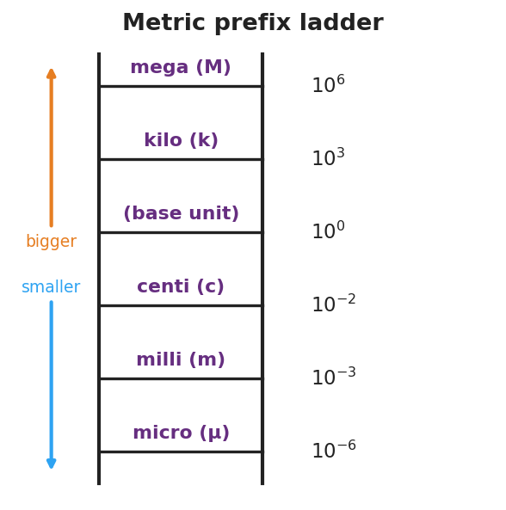
Metric prefix ladder
Factor-label rule: multiply by a ratio that equals __________ (because the top and bottom are the same amount). Write the unwanted unit on the __________ so it __________ . The units of your answer prove it is right.
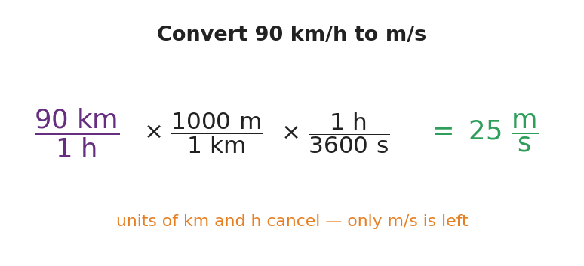
Convert 90 km/h to m/s with factor-label

Worked Example
Problem. Convert 90 km/h to m/s.
Solution. 1. Start with 90 km/h. I need to change km → m and h → s. 2. Multiply by (1000 m / 1 km) so __________ cancels, leaving meters on top. 3. Multiply by (1 h / 3600 s) so __________ cancels, leaving seconds on the bottom. 4. 90 × 1000 ÷ 3600 = __________ m/s. The leftover units are exactly __________, so it’s correct.

Summary
Finish the sentence (Because / But / So):
I can change a quantity’s units without changing the amount because __________________________________________, but __________________________________________, so __________________________________________.

