Units, Prefixes, and Dimensional Analysis — Student Worksheet
Unit: Math in Science — Lesson 04 Name: _______________________ Date: __________ Period: ____

Phenomenon
A recipe reads “250 g flour, 0.2 L milk, bake at 180 °C” — but your kitchen has measuring cups and an oven in °F. A road sign says “100 km/h” — but your speedometer reads mph. Same physical amounts, different units. Today you become the translator.
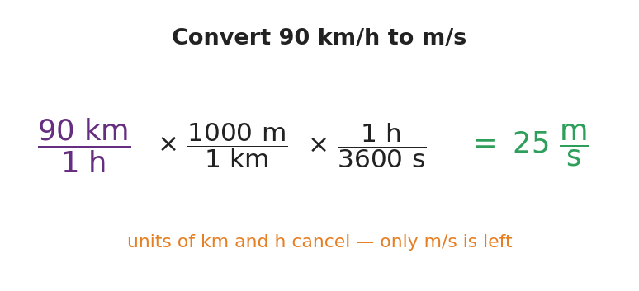
Convert 90 km/h to m/s with factor-label
Driving question: How do we change a quantity’s units without changing the actual amount — and how do the units themselves prove we did it right?

Notice & Wonder
I notice… | I wonder…
Turn & Talk #1: Which numbers in the recipe/sign are in units your kitchen or car can’t read? What would you need to “translate” them?

Initial Model
Pick one quantity from the recipe or the road sign. Write what you’d have to do to express it in the US system. Do you think the number will get bigger or smaller? Why?

Investigation
Part A — The prefix ladder. Fill in the power of ten and convert.
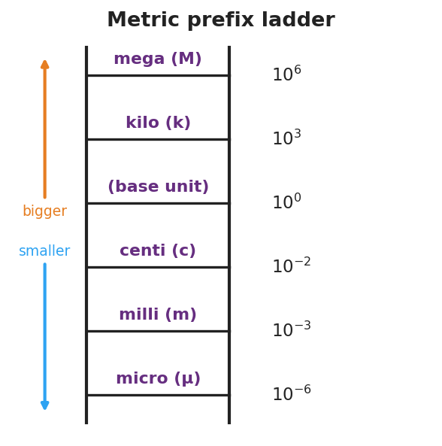
Metric prefix ladder
Prefix | Power of ten | Example conversion
kilo (k) |  | 3 km = __________ m
centi (c) |  | 250 cm = __________ m
milli (m) |  | 45 mm = __________ m
micro (μ) |  | 1 m = __________ μm
Part B — Factor-label conversion. Convert 90 km/h to m/s. Write each factor as a ratio equal to 1 and cancel units.
90 km/h × ( ______ m / 1 km ) × ( 1 h / ______ s ) = __________ m/s
Key question: Which units cancel, and how does that tell you the answer is in the right units?

Make It Make Sense
- Convert 5,000 m to kilometers. Did the number get bigger or smaller, and why?
- Convert 3.2 m to centimeters.
- A student converts 72 km/h and gets an answer in km·m/h. What went wrong, and how should they fix it?

Vocabulary in Action
Use each term in a sentence about today’s phenomenon.
- SI unit: _______________________________________________
- metric prefix: _______________________________________________
- dimensional analysis: _______________________________________________

Revise Your Model
Return to the quantity you chose in your Initial Model. Convert it now, showing your factor-label or prefix step. Was your “bigger or smaller” prediction right?
Converted value: __________ Prediction correct? __________

Exit Ticket
- Convert 2.5 km to meters.
- Convert 45 mm to meters (use the prefix).
- Convert 72 km/h to m/s using the factor-label method. Circle the units that cancel.

