Units, Prefixes, and Dimensional Analysis — Teacher Guide

Cover
Unit: Math in Science — Lesson 04: Units, Prefixes, and Dimensional Analysis East Meadow Schools × Valley Stream Central High School District Strategy chips: HOCHMAN

Curated Resources (from East Meadow Scope & Sequence)

NYSSLS Standards
This is a foundational math-skills lesson with no single NYSSLS performance expectation of its own. It develops the science and engineering practice “Using Mathematics and Computational Thinking,” required everywhere in HS-PS — students must report acceleration in m/s², energy in joules, and current in amperes, and they must catch a wrong answer by noticing the units don’t work out. The crosscutting concept in focus is Scale, Proportion, and Quantity: metric prefixes rescale a base unit by powers of ten, and dimensional analysis keeps a quantity’s meaning intact while its units change.

Phenomenon
- A recipe / road sign with mixed units that must be reconciled — e.g., a European recipe in grams and milliliters, or a speed-limit sign in km/h that a US driver reads as mph.
- NIST “SI Units” primer for the base units and prefixes: https://www.nist.gov/pml/owm/metric-si/si-units

Javalab / Labs
- Unit-conversion station (this lesson’s investigation): convert a mixed-unit recipe or trip so every quantity shares one system.
- Optional: measure a hallway in meters, then convert to cm, mm, and km to feel the prefix ladder.

Assessments
- The Exit Ticket below (a prefix conversion + a factor-label conversion with a unit check) is the formative check for this lesson.

Lesson Overview
Duration | 42 minutes (1 period)
NYSSLS link | Practice: Using Mathematics and Computational Thinking (supports all HS-PS)
CCC focus | Scale, Proportion, and Quantity — prefixes rescale by powers of ten; units carry meaning
Strategy chips | HOCHMAN (appositive + Because/But/So on the role of units)
Materials | A mixed-unit recipe or road sign (projected/printed); metric prefix reference; calculators; whiteboards
Safety | No hazards.
Prior knowledge | Powers of ten (Lesson 03); multiplying fractions; the idea of canceling.
Lesson objectives — students can:
- Name the SI units for length, mass, and time (meter, kilogram, second) and the quantities they measure.
- Convert between units using a metric prefix (k, c, m, μ, M) by moving the decimal the right number of places.
- Use dimensional analysis (the factor-label method) to convert a compound unit (e.g., km/h → m/s) and check that the units cancel correctly.

Phase 1 · Engage (0 – 8 min)

0–3 min · Opening Connection (SEL)
Quick check-in. Prompt: “Tell us about a time a misunderstanding about ‘how much’ or ‘how big’ caused a problem (a recipe, a road trip, a measurement).” This sets up that units, not just numbers, carry meaning.

3–8 min · Phenomenon hook — the mixed-unit recipe / road sign
Teacher actions. Project a recipe that lists “250 g flour, 0.2 L milk, 15 mL oil, bake at 180 °C” next to US measuring cups and an oven in °F — or a “100 km/h” sign next to a US speedometer in mph.
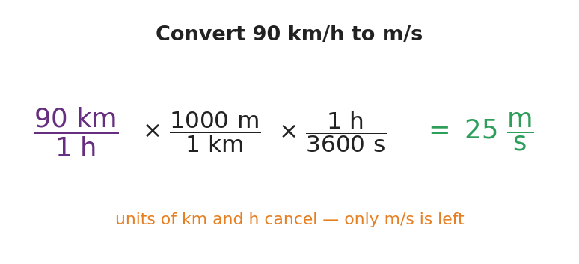
Convert 90 km/h to m/s with factor-label
Sample teacher language:
“This recipe and your kitchen don’t speak the same language. The recipe says 250 grams; your scoop says cups. The sign says 100 kilometers per hour; your speedometer says miles. Same physical amount — different units. Today we become the translators, and we’ll do it so carefully the units themselves tell us when we’re right.”
Anticipated student responses:
- “Just look it up / use Siri.” — affirm the instinct, then: “Siri doesn’t show its work, and on the Regents you do — let’s see the machinery.”
- “Grams and cups aren’t the same thing.” — exactly; one’s mass, one’s volume — units track what kind of quantity.
- “Kilo means a thousand, right?” — yes, capture it; that’s the prefix ladder.

Bridge to Phase 2
Every student leaves Phase 1 able to state the goal: “Rewrite every quantity in one consistent system without changing the actual amount.”

Phase 2 · Explore (8 – 26 min)

8–14 min · Skill A — SI base units and the prefix ladder
Establish the three core SI units: meter (length), kilogram (mass), second (time). Then build the prefix ladder — each rung is a power of ten.
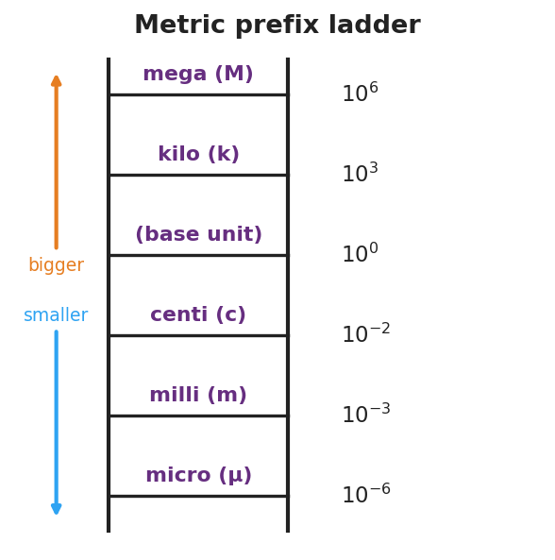
Metric prefix ladder
Teacher facilitation language:
“Going up a prefix means a bigger unit, so it takes fewer of them — 1500 m is only 1.5 km. Each rung is the decimal hopping by powers of ten. How many places, and which way?”
Anticipated student responses:
- “1 km = 100 m?” — common slip; kilo is 10³ = 1000, not 100.
- “Micro is the tiny one.” — yes, μ = 10⁻⁶; pair it with a gesture.

14–26 min · Skill B — dimensional analysis (factor-label)
Model converting 90 km/h → m/s by multiplying by “1” written as a ratio (1000 m / 1 km)(1 h / 3600 s) so the unwanted units cancel. Then groups convert the recipe / road-trip quantities.

Convert 90 km/h to m/s with factor-label
Teacher facilitation during Explore:
- What to look for — students writing the conversion factor so the old unit lands on the bottom and cancels.
- What to resist — letting them “just multiply by 1000” from memory; insist on writing the labeled ratio so the units do the checking.
- What to redirect — answers where km didn’t cancel (unit ends up km·m/h); have them flip the offending factor.

Phase 3 · Explain (26 – 34 min)

26–30 min · Turn-and-Talk + class consensus
“When you multiply by (1000 m / 1 km), why are you allowed to — and how do you know which way to write it? Use the word cancel.”
Target consensus:
“1000 m equals 1 km, so that ratio equals 1 — multiplying by 1 doesn’t change the amount, only the units. We write it with km on the bottom so the km we started with cancels, leaving meters.”

30–34 min · Vocabulary introduction (≤ 3 terms)
Sample teacher language:
“Three words make every conversion safe. An SI unit is the agreed scientific unit for a quantity — meter, kilogram, second. A metric prefix — like kilo or milli — rescales that unit by a power of ten. And dimensional analysis is the factor-label method: you multiply by ratios that equal 1 so the unwanted units cancel and the units of your answer prove it’s right.”

Discussion prompts to deploy here
- “How is multiplying by (1 h / 3600 s) different from just dividing by 3600?”
  - Sample student response: “It’s the same arithmetic, but the labeled ratio shows the hours cancel, so I can’t lose track of the units.”
- “If my answer for a speed comes out in km·m/h, what went wrong?”
  - Sample student response: “A factor was upside down — km didn’t cancel. Flip it so the unwanted unit is on the bottom.”

Phase 4 · Elaborate (34 – 39 min)

34–37 min · HOCHMAN appositive + Because/But/So
Have students define a unit with an appositive, then expand with the conjunctions.
“Write one sentence with an appositive: ’A newton, , is the SI unit of force.’ Then expand: Units must match before you add or compare because , but , so .”
Target appositive: “A newton, the push that gives 1 kg an acceleration of 1 m/s², is the SI unit of force.” Target B/B/S: “…because numbers without matching units are meaningless, but a prefix or factor-label step can rescale them, so I convert first, then compute.”

37–39 min · Return to the phenomenon
“Pick one recipe or road-sign quantity. State it in the US system in one sentence, and name how you knew your conversion was right.”
Target: e.g., “100 km/h ≈ 62 mph, and I knew it was right because the km and h units canceled, leaving mi/h.”

Phase 5 · Evaluate (39 – 42 min)

39–42 min · Exit Ticket + Closing Reflection
“(a) Convert 2.5 km to meters. (b) Convert 45 mm to meters (use the prefix). (c) Convert 72 km/h to m/s using the factor-label method, and circle the units that cancel.”
Expected: (a) 2,500 m; (b) 0.045 m; (c) 72 × (1000 m / 1 km) × (1 h / 3600 s) = 20 m/s, with km and h canceling. See Answer_Key.docx.
Closing Reflection (SEL, 30 seconds):
“Where else in your life would ‘check that the units make sense’ have saved you a mistake? Name one.”

Common Misconceptions
- Misconception: “kilo means 100.” → Correction: kilo = 10³ = 1000; centi = 10⁻², milli = 10⁻³.
- Misconception: “To convert km/h to m/s, just multiply by 1000.” → Correction: You must convert both the km (→ m) and the h (→ s); 90 km/h = 25 m/s, not 90,000 m/s.
- Misconception: “Units are just labels you tack on at the end.” → Correction: Units carry the meaning and the math; if they don’t cancel correctly, the number is wrong.
- Misconception: “Bigger prefix → bigger number of units.” → Correction: A bigger unit needs fewer of them — 1500 m is only 1.5 km.

Access & Differentiation
- ELL/ENL supports: Sentence frame: “To go from ___ to , I multiply by so the ___ cancels.” Provide the prefix ladder as a wall reference. Pre-teach “cancel” with a visual (crossing out matching units top and bottom).
- IEP/SPED supports: Provide a fill-in factor-label scaffold with the unit slots pre-drawn (just numbers to place). Offer a prefix-conversion arrow strip (places + direction). Limit Exit Ticket to parts (a) and (b) if needed.
- Extensions: Have students convert a compound unit they’ll meet later — e.g., g/cm³ to kg/m³ — and predict before computing whether the number gets bigger or smaller, justifying with the prefixes.

Strategy Spotlight
HOCHMAN (sentence-level literacy). Today’s chip is the appositive plus the Because/But/So expansion in Phase 4. Defining a unit with an appositive (“A newton, the push that…, is the SI unit of force”) forces students to pack a precise definition into a single clause — the exact skill the Regents constructed-response rewards. The Because/But/So then makes them articulate why units must match and what to do about it, turning a procedure into reasoning. Keep responses to one sentence each and collect the most precise appositives aloud.

NYSSLS Observation Checklist Crosswalk
# | Checklist item | Where it appears in this lesson
1 | Local/relatable phenomenon | Phase 1 — mixed-unit recipe / road sign; Phase 4 — km/h ↔ mph
2 | Turn and Talk (2–3×) | Phase 3 (why multiply by a ratio?), Phase 4 (appositive + B/B/S share)
3 | Students develop questions/models/procedures | Phase 2 — build the factor-label chain so units cancel
4 | CCC defined and used | Lesson Overview · Scale, Proportion, and Quantity, applied in Phase 2
5 | ENL — ≤ 3 vocab, second half | Phase 3 — vocabulary at 30–34 min (SI unit / metric prefix / dimensional analysis)
6 | Revisit phenomenon with evidence | Phase 4 — convert a recipe/road-sign quantity and justify
7 | ENL/SPED supports | Access & Differentiation block
8 | Assessment check | Phase 5 — Exit Ticket (prefix + factor-label conversions)

Companion Materials
- Student_Worksheet.docx — the 5E student investigation with the recipe/road-trip conversion (hand out at start of Phase 2)
- Student_Notes.docx — guided note-guide for prefixes and the factor-label worked example
- Answer_Key.docx — answers to “Make It Make Sense” prompts and the Exit Ticket

Key Vocabulary (max 3)
- SI unit — the agreed international scientific unit for a quantity: meter (length), kilogram (mass), second (time)
- metric prefix — a word/symbol (k, c, m, μ, M) that rescales a base unit by a power of ten (kilo = 10³, milli = 10⁻³)
- dimensional analysis — the factor-label method: multiplying by ratios equal to 1 so unwanted units cancel, leaving the desired units

