Momentum — Teacher Guide

Cover
Unit: Momentum & Impulse — Lesson 01: Momentum East Meadow Schools × Valley Stream Central High School District Strategy chips: RESTORATIVE CIRCLE

Curated Resources (from East Meadow Scope & Sequence)

NYSSLS Standards
This unit opener for Momentum & Impulse launches the strand assessed by HS-PS2-2:
HS-PS2-2. “Use mathematical representations to support the claim that the total momentum of a system of objects is conserved when there is no net force on the system.” (Crosscutting Concept: Systems and System Models)
Lesson 01 builds the quantity that the rest of the unit conserves: momentum, p = m·v. Before students can argue that a system’s momentum is conserved (L03–L04), they must first be fluent that a single object’s momentum scales with both its mass and its velocity, and that momentum is a vector (it has direction). The Regents Reference Table relationship introduced today is p = m·v, with momentum measured in kg·m/s.

Phenomenon
- Newton’s cradle in slow motion — one ball in, one ball out: https://youtu.be/2UHS883_P60
- A loaded dump truck vs. a bicycle, both rolling at the same speed — which is harder to stop? (district anchor video / teacher demo with carts of different mass)

Javalab / Labs
- PhET Collision Lab — set two masses and speeds, read off momentum: https://phet.colorado.edu/en/simulations/collision-lab
- Javalab momentum simulation: https://javalab.org/en/momentum_en/

Assessments
- Exit Ticket below (computing and comparing momentum, identifying it as a vector) is the formative check. PhET “momentum” readout serves as a live self-check during Explore.

Lesson Overview
Duration | 42 minutes (1 period)
NYSSLS link | HS-PS2-2 (introduces the conserved quantity, momentum)
CCC focus | Systems and System Models — momentum is the quantity we will track through a system; today we build it for one object.
Strategy chips | RESTORATIVE CIRCLE (unit opener)
Materials | Newton’s cradle (or video); two dynamics carts of clearly different mass; a basketball and a tennis ball; whiteboards/markers; devices for PhET Collision Lab.
Safety | Roll carts on a clear, level surface; keep the cradle away from desk edges.
Prior knowledge | Kinematics — velocity as a vector (size + direction); Forces — mass and inertia.
Lesson objectives — students can:
- Calculate the momentum of an object using p = m·v and state its unit, kg·m/s.
- Explain that momentum is a vector — it points in the direction of the velocity.
- Predict and justify which of two objects has more momentum when mass or velocity differs.

Phase 1 · Engage (0 – 12 min)

0–3 min · Opening Connection (SEL) — Restorative Circle (unit opener)
This is the first lesson of a new unit, so open with a brief restorative circle. Pass a talking piece; one sentence each, no cross-talk. Prompt:
“Tell us about one moment when something was really hard to stop once it got going — it could be a feeling, a habit, a game, anything.”
This builds community and seeds the intuition that “hard to stop” depends on how big and how fast — the two ingredients of momentum you’ll name in Phase 3.

3–8 min · Phenomenon hook — Newton’s cradle + truck vs. bike
Teacher actions. Lift one ball of the Newton’s cradle; release; one ball swings out the far side. Then pose the truck-vs-bike comparison: “A dump truck and a bike are both rolling at 20 miles per hour toward you. You can only step out of the way of one. Which do you let pass — and why?”
Sample teacher language:
“Same speed for both. So what makes the truck the scarier one to be hit by? Hold that thought — we’re going to put a number on it today.”
Anticipated student responses:
- “The truck, because it’s way heavier.” — capture mass.
- “It would hurt more / it’s harder to stop.” — capture hard to stop; this is the everyday name for momentum.
- “But a bike going super fast could still hurt.” — excellent; this previews that speed matters too.

8–12 min · Notice & Wonder + Turn-and-Talk #1
Capture two columns on the board. Then:
“Turn to your partner: what two things seem to decide how hard something is to stop? Use the words mass and speed.”
Take 2–3 responses. Desired insight: both how much stuff is moving (mass) and how fast it moves (speed) matter. Leave it open if nobody combines them yet.

Bridge to Phase 2
Every student leaves Phase 1 with a one-sentence initial model: “Something is hard to stop when ______ and ______.”

Phase 2 · Explore (12 – 32 min)

12–17 min · Initial Model (silent / individual)
Prompt on the board:
“Rank these from easiest to hardest to stop: a tennis ball thrown gently, a tennis ball thrown hard, a bowling ball rolled gently, a bowling ball rolled hard. Write one sentence explaining the rule you used to rank them.”
This surfaces students’ intuition that mass and speed combine before any formula.

17–32 min · Investigation — PhET Collision Lab
Students open PhET Collision Lab (or watch a guided projection). Task card:
- Set Ball 1 to mass 1 kg, velocity 2 m/s. Read the momentum. Record it.
- Double the mass (2 kg, still 2 m/s). What happens to momentum?
- Go back to 1 kg, then double the velocity (1 kg, 4 m/s). What happens to momentum?
- Send Ball 1 to the left instead of the right. What changes about the momentum value? (Sign!)
Teacher facilitation language:
“When you doubled the mass, by what factor did momentum change? When you doubled the speed?” “What does the negative sign on the momentum tell you — is the ball slower, or is it going a different way?” “Write the rule the simulation is following before I tell you the formula.”

Teacher facilitation during Explore
- What to look for — students noticing momentum doubles when either mass or velocity doubles (proportional to both).
- What to resist — don’t give “p = mv” until Phase 3; let the readout teach the proportionality.
- What to redirect — students who ignore the sign should be asked, “Could two balls have the same speed but different momentum? What’s different?” (direction).

Phase 3 · Explain (32 – 37 min)

32–35 min · Turn-and-Talk #2 + class consensus
“Across all your trials, write the relationship between momentum, mass, and velocity as a word equation.”
Target consensus:
“Momentum equals mass times velocity. It grows if you add mass or add speed, and it points whichever way the object is moving.”

35–37 min · Vocabulary introduction (≤ 3 terms)
Sample teacher language:
“That ‘hard-to-stop’ quantity is momentum, symbol p. It equals mass times velocity: p = m·v, measured in kilogram-meters per second, kg·m/s. Because velocity is a vector, momentum is a vector too — it points the same direction the object moves.”
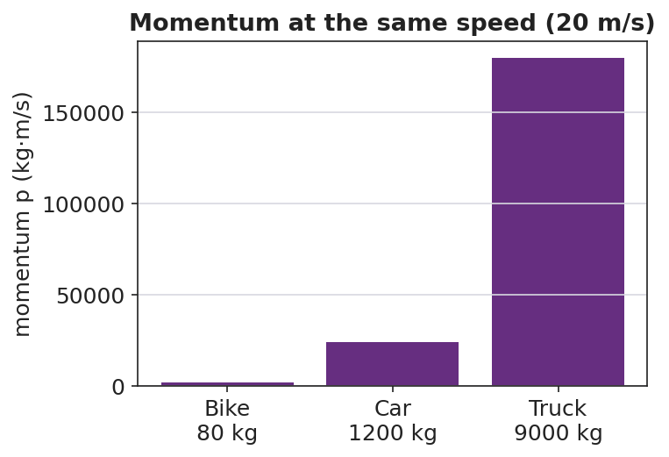
Momentum at the same speed for three vehicles
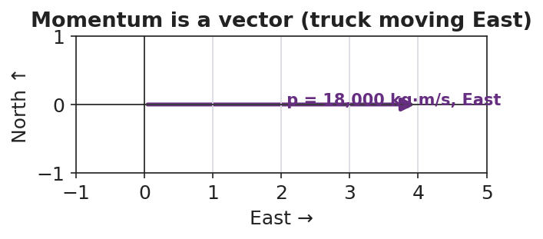
Momentum is a vector pointing the way the object moves

Discussion prompts to deploy here
- “A 1,200 kg car moves East at 20 m/s. Find its momentum and its direction.”
  - Sample student response: “p = 1,200 × 20 = 24,000 kg·m/s, East.”
- “Two objects have the same speed but different momentum. What must be different?”
  - Sample student response: “Their masses — more mass means more momentum at the same speed.”

Phase 4 · Elaborate (37 – 40 min)

37–39 min · Revise the model
“Return to your tennis-ball / bowling-ball ranking. Re-rank them by computing p = m·v for each (use tennis ball = 0.06 kg, bowling ball = 6 kg; gentle = 2 m/s, hard = 8 m/s). Does the math match your gut ranking?”

39–40 min · Return to the phenomenon
“Back to the truck and the bike at the same speed — in one sentence, use p = m·v to say why the truck is the dangerous one.”
Target: “At the same velocity, the truck’s far greater mass gives it far more momentum (p = m·v), so it is much harder to stop.”

Phase 5 · Evaluate (40 – 42 min)

40–42 min · Exit Ticket + Closing Reflection
“A 0.145 kg baseball is pitched West at 40 m/s. (a) Calculate its momentum, with units and direction. (b) A 0.045 kg golf ball is hit at 70 m/s. Show which ball has more momentum. (c) Is momentum a vector or a scalar? Give one reason.”
Expected: (a) p = 0.145 × 40 = 5.8 kg·m/s, West; (b) golf ball = 0.045 × 70 = 3.15 kg·m/s, so the baseball has more; (c) vector, because it has a direction (the same direction as the velocity). See Answer_Key.docx.
Closing Reflection (SEL, 30 seconds):
“What is one idea today that you understand better because of something a classmate said?”

Common Misconceptions
- Misconception: “Heavier always means more momentum.” → Correction: Only if speeds are equal; a light, fast object can out-momentum a heavy, slow one (p = m·v).
- Misconception: “Momentum is the same as speed.” → Correction: Speed ignores mass; momentum = mass × velocity and carries direction.
- Misconception: “Momentum has no direction.” → Correction: Momentum is a vector; it points the way the object moves, so opposite directions get opposite signs.

Access & Differentiation
- ELL/ENL supports: Sentence frame: *“The ___ has more momentum because its ___ (mass / velocity) is larger, so p = m·v is ___.”* Word-choice box: {mass, velocity, momentum, kg·m/s, direction, vector}. Pair momentum with a gesture (two hands pushing forward, “hard to stop”).
- IEP/SPED supports: Provide a pre-built p = m·v table with mass and velocity columns filled in; students compute only the product. Offer the cart demo as a hands-on alternative to the simulation.
- Extensions: Ask students to find a velocity at which a 0.045 kg golf ball would have the same momentum as a 0.145 kg baseball thrown at 40 m/s, and explain the trade-off between mass and speed.

Strategy Spotlight
RESTORATIVE CIRCLE (unit opener). Today’s opening uses a circle to launch the Momentum & Impulse unit. Use a talking piece, one-sentence responses, and equity of voice (everyone speaks or passes). The prompt — something hard to stop once it got going — is chosen so you can call it back in Phase 3 (“that ‘hard to stop’ feeling has a name and a formula: momentum, p = m·v”). Keep the circle to ~2–3 minutes; the goal is community plus a shared metaphor, not a long discussion.

NYSSLS Observation Checklist Crosswalk
# | Checklist item | Where it appears in this lesson
1 | Local/relatable phenomenon | Phase 1 — Newton’s cradle; truck vs. bike
2 | Turn and Talk (2–3×) | Phase 1 (TT#1 — what makes something hard to stop), Phase 3 (TT#2 — write the relationship)
3 | Students develop questions/models/procedures | Phase 1 (initial model), Phase 2 (PhET investigation), Phase 4 (revise model)
4 | CCC defined and used | Lesson Overview · Systems and System Models, restated in Phase 2
5 | ENL — ≤ 3 vocab, second half | Phase 3 — vocabulary at 35–37 min (momentum / mass / velocity)
6 | Revisit phenomenon with evidence | Phase 4 — re-rank with p = m·v; truck-vs-bike answer
7 | ENL/SPED supports | Access & Differentiation block
8 | Assessment check | Phase 5 — Exit Ticket (baseball / golf ball momentum)

Companion Materials
- Student_Worksheet.docx — the 5E student investigation (hand out at start of Phase 2)
- Student_Notes.docx — guided note-guide for vocabulary and the worked example
- Answer_Key.docx — answers to “Make It Make Sense” prompts and the Exit Ticket

Key Vocabulary (max 3)
- momentum — a measure of how hard an object is to stop; p = m·v, a vector measured in kg·m/s
- mass — the amount of matter in an object (kg); one of the two factors that set momentum
- velocity — how fast and in what direction an object moves (m/s); momentum points the same way

