Impulse and the Impulse–Momentum Theorem — Teacher Guide

Cover
Unit: Momentum & Impulse — Lesson 02: Impulse and the Impulse–Momentum Theorem East Meadow Schools × Valley Stream Central High School District Strategy chips: HOCHMAN

Curated Resources (from East Meadow Scope & Sequence)

NYSSLS Standards
This lesson is the engineering hinge of the unit, assessed by HS-PS2-3:
HS-PS2-3. “Apply scientific and engineering ideas to design, evaluate, and refine a device that minimizes the force on a macroscopic object during a collision.” (Crosscutting Concept: Cause and Effect)
The impulse–momentum theorem, J = F·Δt = Δp, is the physics that makes that design possible: for a fixed change in momentum, extending the contact time lowers the force. Airbags, crumple zones, and bending your knees on landing all trade time for force. The lesson also reinforces HS-PS2-2 by treating momentum change as the target quantity. Reference-Table relationships: p = m·v and J = F·Δt = Δp.

Phenomenon
- Egg drop onto a pillow vs. a plate — same drop, very different outcome: https://youtu.be/BLRfWtN3SQE
- Slow-motion airbag deployment / crash test: https://youtu.be/yQHDosNQGZk
- Catching a fast ball by pulling your hands back (teacher demo).

Javalab / Labs
- PhET Collision Lab (read force/time intuition by varying elasticity): https://phet.colorado.edu/en/simulations/collision-lab
- Javalab “impulse and momentum”: https://javalab.org/en/impulse_en/

Assessments
- Exit Ticket below (apply J = Δp; explain airbag in terms of Δt and force) is the formative check, scored with the Answer Key rubric.

Lesson Overview
Duration | 42 minutes (1 period)
NYSSLS link | HS-PS2-3 (design to minimize force) · HS-PS2-2 (momentum change)
CCC focus | Cause and Effect — extending contact time causes a smaller force for the same change in momentum.
Strategy chips | HOCHMAN (sentence-level literacy: Because/But/So + appositive on J = F·Δt = Δp)
Materials | Raw eggs, pillow + hard tray (over a tarp); a ball to catch; whiteboards; devices for PhET.
Safety | Egg drop over a covered/washable surface; wear closed-toe shoes; goggles optional.
Prior knowledge | Lesson 01 — momentum p = m·v; Forces — net force changes motion.
Lesson objectives — students can:
- Define impulse and use J = F·Δt = Δp to relate force, time, and change in momentum.
- Explain why extending the contact time reduces the force for a fixed change in momentum.
- Write a Hochman Because/But/So sentence connecting Δt and force in a safety device.

Phase 1 · Engage (0 – 12 min)

0–3 min · Opening Connection (SEL, 30 seconds)
Quick check-in (no circle today): “Thumbs up/middle/down — how ready do you feel after Lesson 01’s momentum formula?” Name that today we use that momentum to explain how airbags save lives.

3–8 min · Phenomenon hook — the egg drop
Teacher actions. Drop one egg onto a hard tray (it breaks) and an identical egg from the same height onto a pillow (it survives). Both eggs hit the surface with the same momentum and end at rest — the same change in momentum.
Sample teacher language:
“Same egg, same height, same speed at the bottom — so the change in momentum is identical. One survives. What was different about the stop?”
Anticipated student responses:
- “The pillow is soft.” — push for why soft helps: “what does soft do to the time of the stop?”
- “The pillow slows it down more gently / over more time.” — capture time; this is the key variable.
- “The hard tray stops it instantly.” — capture short time → big force.

8–12 min · Notice & Wonder + Turn-and-Talk #1
Two columns on the board. Then:
“Turn to your partner: both eggs had the same change in momentum, so what made the force on the egg so different? Use the word time.”
Target insight: the pillow stretches out the stopping time, so the force is smaller.

Bridge to Phase 2
Initial model sentence: “The pillow saves the egg because the stop took ______ time, so the force was ______.”

Phase 2 · Explore (12 – 32 min)

12–17 min · Initial Model (silent / individual)
Prompt on the board:
“Sketch two force-vs-time graphs for the same egg stopping: one on the tray, one on the pillow. Make them have the same total ‘push’ (area) but different shapes. Predict which has the taller spike.”
This surfaces the area-equals-impulse idea before it is named.

17–32 min · Investigation — catching a ball + PhET
Stations / whole-class:
- Catch a thrown ball two ways — once with stiff arms (hands stay still), once by pulling your hands back as you catch. Which sting less? Why?
- PhET Collision Lab — set one ball to hit a wall; compare a fast (elastic) bounce vs. a soft (inelastic) stop; relate the “harder hit” to a shorter interaction time.
- Read the graph — given the force-vs-time graphs below, students shade and compare the area (impulse) under each.
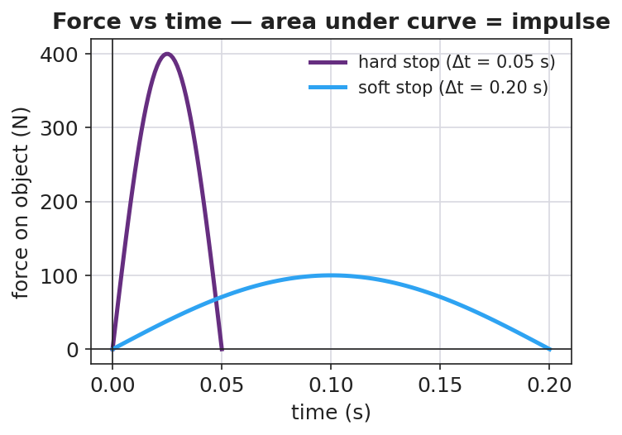
Force vs time for a hard stop and a soft stop (equal area = equal impulse)
Teacher facilitation language:
“When you pulled your hands back, did you change the ball’s momentum by a different amount — or just spread the stop over more time?” “Point to the area under each curve. If the areas are equal, what does that say about the impulse?” “Which graph has the dangerous spike — the tall narrow one or the low wide one?”

Teacher facilitation during Explore
- What to look for — students saying the area (impulse) is the same but the peak force differs.
- What to resist — don’t write J = F·Δt yet; let the graphs and the catch do the teaching.
- What to redirect — students who think the pillow “changes the momentum less” should compare end states: both eggs end at rest, so Δp is identical; only the time differs.

Phase 3 · Explain (32 – 37 min)

32–35 min · Turn-and-Talk #2 + class consensus
“Write a word equation linking force, the time it acts, and the change in momentum.”
Target consensus:
“Force times the time it acts equals the change in momentum. So for a fixed change in momentum, more time means less force.”

35–37 min · Vocabulary introduction (≤ 3 terms)
Sample teacher language:
“That product — force times the time interval it acts — is called impulse, symbol J. The impulse–momentum theorem says J = F·Δt = Δp: impulse equals the change in momentum. Rearranged, F = Δp / Δt — so stretching Δt shrinks the force for the same Δp. That is exactly what an airbag does.”
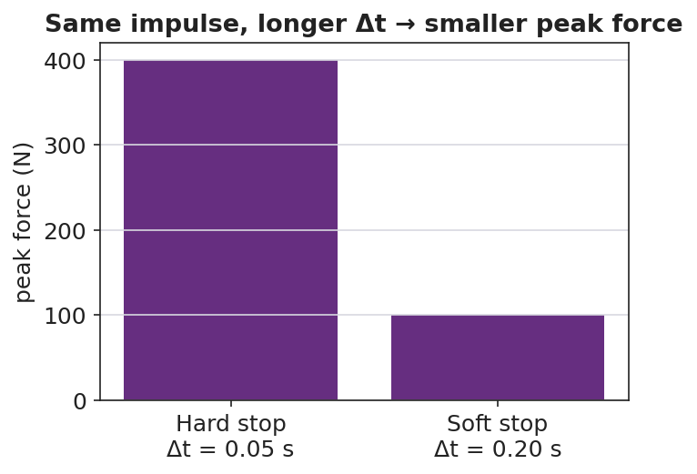
Same impulse, longer contact time gives a smaller peak force

Discussion prompts to deploy here
- “Why do crumple zones make a car safer even though the car is more damaged?”
  - Sample student response: “The crumple stretches out the collision time, so the force on the passengers is smaller (F = Δp/Δt).”
- “A boxer ‘rolls with the punch.’ How does that reduce the force?”
  - Sample student response: “Moving with the glove extends the contact time, so the same impulse delivers less force.”

Phase 4 · Elaborate (37 – 40 min)

37–39 min · Hochman Because/But/So + appositive
Today’s literacy move. On the board:
Sentence expansion. Finish all three for the airbag: “An airbag protects a driver because ______; but ______; so ______.” Appositive. Rewrite this into one sentence with an appositive naming impulse: “Impulse, ______, equals the change in momentum, so a longer contact time means a smaller force.”
Model one aloud, then have students draft. This is the Hochman thin-slice: precise sentences about J = F·Δt = Δp.

39–40 min · Return to the phenomenon
“In one Because/But/So sentence, explain why the egg on the pillow survives.”
Target: “Both eggs have the same change in momentum because they hit at the same speed and stop, but the pillow stretches the stopping time, so the force on the egg is small enough not to break it.”

Phase 5 · Evaluate (40 – 42 min)

40–42 min · Exit Ticket + Closing Reflection
“A 0.5 kg ball moving at 8 m/s is brought to rest. (a) Find the impulse needed to stop it (give units and direction). (b) If a glove stops it in 0.4 s, what average force does the glove apply? If a bare hand stops it in 0.05 s, what force? (c) Use J = F·Δt to explain, in one sentence, why the glove hurts less.”
Expected: (a) J = Δp = m·Δv = 0.5 × (0 − 8) = −4 kg·m/s, i.e. 4 N·s opposite the motion; (b) glove F = 4/0.4 = 10 N; bare hand F = 4/0.05 = 80 N; (c) same impulse over a longer time gives a smaller force. See Answer_Key.docx.
Closing Reflection (SEL, 30 seconds):
“Name one everyday object that secretly uses the impulse–momentum theorem to keep someone safe.”

Common Misconceptions
- Misconception: “A pillow reduces the change in momentum.” → Correction: Δp is the same (the egg still stops); the pillow reduces the force by extending the time.
- Misconception: “Impulse and force are the same thing.” → Correction: Impulse = force × time (J = F·Δt); a small force over a long time can equal a big force over a short time.
- Misconception: “More time means more force.” → Correction: For a fixed impulse, more time means less force (F = Δp/Δt).

Access & Differentiation
- ELL/ENL supports: Provide the Because/But/So frame pre-printed with the airbag context; word-choice box: {impulse, force, time interval, change in momentum, smaller, longer}. Pair impulse with the gesture of catching softly (hands drawing back).
- IEP/SPED supports: Give the force-vs-time graphs pre-shaded so students compare areas rather than draw them; provide the J = F·Δt formula triangle as a rearrangement scaffold.
- Extensions: Have students sketch and justify a force-vs-time graph for a phone dropped onto a rubber case vs. bare floor, predicting which has the larger peak force and why (HS-PS2-3 design link).

Strategy Spotlight
HOCHMAN (sentence-level literacy). Today’s literacy work lives in Phase 4: a Because/But/So sentence expansion and an appositive that names impulse precisely. The Hochman method keeps the writing at the sentence level — students are not writing paragraphs, they are building one accurate, complex sentence about J = F·Δt = Δp. Model one sentence aloud, require the appositive to define the term, and circulate to check that every Because/But/So clause is physically correct (Δp constant, Δt up, F down).

NYSSLS Observation Checklist Crosswalk
# | Checklist item | Where it appears in this lesson
1 | Local/relatable phenomenon | Phase 1 — egg drop; airbag; catching a ball
2 | Turn and Talk (2–3×) | Phase 1 (TT#1 — why the force differs), Phase 3 (TT#2 — word equation)
3 | Students develop questions/models/procedures | Phase 1 (initial model graphs), Phase 2 (catch + PhET), Phase 4 (revise)
4 | CCC defined and used | Lesson Overview · Cause and Effect, restated in Phase 3 (F = Δp/Δt)
5 | ENL — ≤ 3 vocab, second half | Phase 3 — vocabulary at 35–37 min (impulse / force / time interval)
6 | Revisit phenomenon with evidence | Phase 4 — Because/But/So egg-on-pillow sentence
7 | ENL/SPED supports | Access & Differentiation block
8 | Assessment check | Phase 5 — Exit Ticket (glove vs. bare hand force)

Companion Materials
- Student_Worksheet.docx — the 5E student investigation (hand out at start of Phase 2)
- Student_Notes.docx — guided note-guide for vocabulary and the worked example
- Answer_Key.docx — answers to “Make It Make Sense” prompts and the Exit Ticket

Key Vocabulary (max 3)
- impulse — the product of force and the time it acts, J = F·Δt; equals the change in momentum (Δp); unit N·s = kg·m/s
- force — a push or pull (N); for a fixed impulse, a smaller force results from a longer contact time
- time interval — Δt, how long a force acts (s); extending it reduces the force for the same impulse

