Work — Student Worksheet
Unit: Work, Energy & Power — Lesson 01 Name: _______________________ Date: __________ Period: ____

Phenomenon
Your teacher lifts a loaded backpack straight up onto a high shelf. Then your teacher carries the same backpack across the room at a steady height. Both make the arms tired — but a physicist says work was done in only one of them.
Driving question: What does it take to do work on an object, and why can a tiring task do zero work?

Notice & Wonder
I notice… | I wonder…
Turn & Talk #1: In which case did the applied force point the same direction the bag actually moved? Use the words force and direction.

Initial Model
Draw the backpack in each case. Draw one arrow for the force you apply and one arrow for the bag’s displacement (the way it actually moves).
Lifting (up onto shelf) | Carrying (across the room)
My prediction — which case does more work on the bag, and is one of them zero? _______________________________________________

Investigation
Use the scale (force, in newtons) and meter stick. Record your measurements.
Station | Force F (N) | Distance moved along the force d (m) | Work W = F·d (J)
1. Lift it straight up
2. Carry it sideways (force is up, motion is sideways)
3. Lift again — double the height
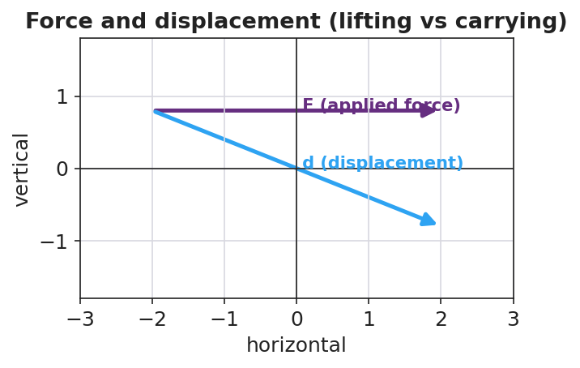
Force and displacement diagram
Key question: When you carried the bag, how much of your (upward) force pointed along the (sideways) motion? What does that make the work on the bag?

Make It Make Sense
- You push a 200 N crate 3.0 m across the floor in the direction of the push. How much work do you do on the crate? Show W = F·d.
- A waiter holds a tray perfectly still for 30 seconds. How much work does he do on the tray? Explain using the word displacement.
- Why does carrying a box across a level room at steady height do zero work on the box, even though your arms get tired?

Vocabulary in Action
Use each term in a sentence about today’s phenomenon.
- work: _______________________________________________
- joule: _______________________________________________
- displacement: _______________________________________________

Revise Your Model
Return to your two drawings. Re-label each arrow pair: is the force along the motion or perpendicular to it? Rewrite your explanation as one Because / But / So sentence using work and displacement.
Because _______________________________________________, but _______________________________________________, so _______________________________________________.

Exit Ticket
A custodian pushes a 250 N mop bucket 8.0 m across a level floor at steady speed.
- How much work does she do on the bucket? Show W = F·d.
- She then holds the bucket still for 10 seconds. How much work does she do during those 10 seconds? Explain.
- A student carries a 40 N lunch tray across the cafeteria at constant height. How much work is done on the tray, and why?

