Power — Student Worksheet
Unit: Work, Energy & Power — Lesson 02 Name: _______________________ Date: __________ Period: ____

Phenomenon
Two students climb the same staircase. One climbs fast, one climbs slowly. Both reach the top, so both did about the same work against gravity — but everyone agrees something is different.
Driving question: If two people do the same work, what makes one of them “more powerful,” and how do we measure it?

Notice & Wonder
I notice… | I wonder…
Turn & Talk #1: If both climbers did the same work, what made the fast climber different? Use the word time.

Initial Model
Write, in words, a formula for “how fast work is done.” What would you divide by what?
How-fast-work-is-done = ____________ ÷ ____________
My prediction — who has more of it, a heavier climber or a faster climber? Why? _______________________________________________

Investigation — Stair-Climb Personal-Power Lab
Roles: climber, timer, recorder, calculator. Walk, hold the rail, one at a time. Record two trials for the same climber.
Trial | Weight F (N) | Vertical height d (m) | Work W = F·d (J) | Time t (s) | Power P = W/t (W)
1 (normal pace)
2 (faster)
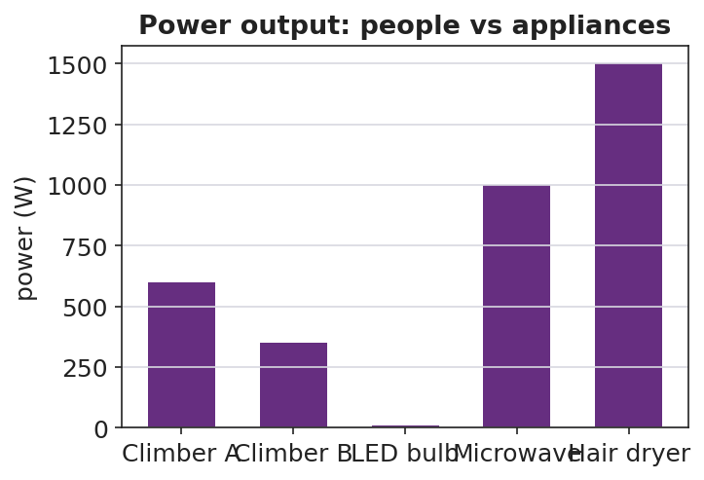
Power output: people vs appliances
Key question: Your two trials did the same work. Why was your power different? What changed?

Make It Make Sense
- Two motors raise the same load the same height. Motor A takes 2.0 s; motor B takes 8.0 s. Which motor is more powerful, and by what factor? Explain.
- A 60 W light bulb runs for 10 seconds. How much energy does it use? (Hint: rearrange P = W/t.)
- Your friend says, “The faster climber did more work.” Correct your friend using the words work, time, and power.

Vocabulary in Action
Use each term in a sentence about today’s phenomenon.
- power: _______________________________________________
- watt: _______________________________________________
- energy: _______________________________________________

Revise Your Model
Plot work vs. time for a fast climber and a slow climber. What does the slope of each line represent? Rewrite your explanation of “more powerful” in one sentence using power and time.
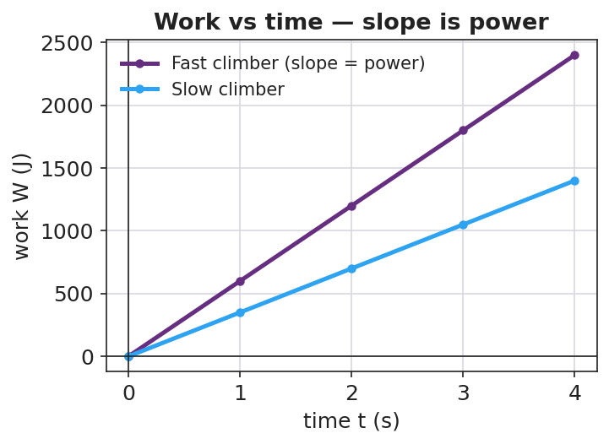
Work vs time — slope is power
The slope of a work-vs-time graph represents ____________. The fast climber is more powerful because _______________________________________________

Exit Ticket
An elevator does 48,000 J of work lifting a load.
- If it takes 8.0 s, what is its power output? Show P = W/t.
- A second elevator does the same 48,000 J in 16 s. How does its power compare to the first?
- A 700 N student runs up a 4.0 m staircase in 5.0 s. What is the student’s power output?

