Power — Teacher Guide

Cover
Unit: Work, Energy & Power — Lesson 02: Power East Meadow Schools × Valley Stream Central High School District Strategy chips: ACTIVE LEARNING

Curated Resources (from East Meadow Scope & Sequence)

NYSSLS Standards
Power is the rate of energy transfer — how fast work is done. It deepens HS-PS3-1: “Create a computational model to calculate the change in energy of one component in a system when the change in energy of the other component(s) and energy flows in and out of the system are known.” (CCC: Systems and System Models.) Once students can compute work (Lesson 01), power lets them quantify how quickly energy flows in or out of a system — the time dimension of every energy model.

Phenomenon
- Two students climbing the same staircase, one fast and one slow — same work, different power. https://www.youtube.com/watch?v=8jBJBwwTBc8 (Physics of stair-climbing power)
- The Physics Classroom — “Power”: https://www.physicsclassroom.com/class/energy/Lesson-1/Power

Javalab / Labs
- Stair-Climb Personal-Power Lab (this lesson) — students time a stair climb and compute their own power output. Javalab energy index for support sims: https://javalab.org/en/category/energy_en/

Assessments
- The Physics Classroom power problem set (link above). The Exit Ticket below is the formative check; the stair-climb data feed the “Make It Make Sense” items (HS-PS3-1).

Lesson Overview
Duration | 42 minutes (1 period)
NYSSLS link | HS-PS3-1 (rate of energy flow in/out of a system)
CCC focus | Systems and System Models — power is how fast energy enters or leaves a system.
Strategy chips | ACTIVE LEARNING (stair-climb lab, station data, predict-and-test)
Materials | A safe staircase or a step/box; stopwatches or phones; bathroom scale (to get weight in N); meter stick (step height); whiteboards.
Safety | One climber at a time; hand on rail; walk, do not run; spotter at base. No climbing for students who opt out — they time and record.
Prior knowledge | Work (W = F·d) and the joule from Lesson 01; weight = mass × g.
Lesson objectives — students can:
- Define power as the rate of doing work and state its unit, the watt.
- Calculate power with P = W/t (and recognize P = Fv for constant-speed motion).
- Explain why doing the same work in less time means more power, using stair-climb data.

Phase 1 · Engage (0 – 10 min)

0–3 min · Opening Connection (SEL)
Pair-share, one sentence: “Name something you do fast and something you do slow — and does doing it faster make it harder?” Surface a few (running vs. walking up stairs, sprinting to class). Plant the idea that speed of effort matters, not just total effort.

3–7 min · Phenomenon hook — two climbers, same stairs
Teacher actions. Two volunteers (or a video) climb the same staircase: one quickly, one slowly. Both reach the top.
Sample teacher language:
“Same stairs, same height, roughly the same body weight — so they did about the same work against gravity. But something is clearly different. What is it, and can we measure it?”
Anticipated student responses:
- “The fast one worked harder!” — reframe: did they do more work, or the same work faster?
- “The fast one is more powerful.” — capture the word powerful; we will define it precisely.
- “Time is the difference.” — exactly the variable we’ll add to work.

7–10 min · Notice & Wonder + Turn-and-Talk #1
Two columns. Then:
“Turn to your partner: if both climbers did the same work, what made the fast climber different? Use the word time.”
Desirable insight: same work ÷ less time = a bigger something. Leave the name for Phase 3.

Bridge to Phase 2
Each student leaves with an initial model sentence: “The faster climber was more ______ because ______.”

Phase 2 · Explore (10 – 28 min)

10–14 min · Initial Model (silent / individual)
Prompt:
“Write a formula in words for ‘how fast work is done.’ What would you divide by what? Predict whether a heavier climber or a faster climber has more of it.”

14–28 min · Investigation — Stair-Climb Personal-Power Lab
Active-learning rotation. Each student (who opts in) climbs a measured set of stairs; partners time and record. Compute personal power.
- Measure weight. Read weight on the scale; convert to newtons (N) — or use mass × g with g ≈ 9.81 m/s².
- Measure height. Height of the staircase (vertical rise only), in meters.
- Compute work. W = F·d = (weight in N) × (vertical height).
- Time the climb. t in seconds.
- Compute power. P = W/t, in watts.
- Compare fast vs. slow trials for the same climber.
Project as data arrive:
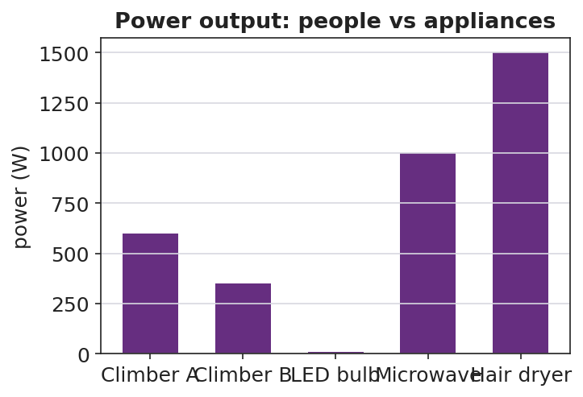
Power output of people vs household appliances
Teacher facilitation language:
“You climbed the same stairs twice. Same work? Then why is your power different?” “Whose power is bigger — and is it because of weight, height, or time? Isolate the variable.”
Anticipated student responses:
- “My second climb was faster, so my power went up even though the work was the same.” — exactly; P = W/t.
- “A heavier person doing the same climb in the same time has more power.” — yes; more work in the same time.

Teacher facilitation during Explore
- What to look for — students dividing work by time and getting watts; recognizing same-work/different-time.
- What to resist — don’t define “watt” until students need a name for W/t.
- What to redirect — “faster always means more work” → no, faster means same work in less time, so more power.

Phase 3 · Explain (28 – 35 min)

28–31 min · Turn-and-Talk #2 + class consensus
“From the lab: what single number tells us how fast work is done, and how did you compute it?”
Target consensus:
“Power is work divided by time, P = W/t. The same work done in less time is more power. For something moving at steady speed, power is also force times speed, P = Fv.”

31–35 min · Vocabulary introduction (≤ 3 terms)
From the reference table: P = W/t = Fv. The unit of power is the watt (W) — one watt is one joule per second (1 W = 1 J/s).
Sample teacher language:
“Power, the rate at which work is done, is measured in watts — joules per second. Energy is what gets transferred; power is how fast it’s transferred. Your stair climb was a few hundred watts; a hair dryer is over a thousand.”

Discussion prompts to deploy here
- “Two motors raise the same load the same height. Motor A takes 2 s, motor B takes 8 s. Which is more powerful, and by how much?”
  - Sample response: “A — same work, one-fourth the time, so four times the power.”
- “A 60 W bulb runs for 10 s. How much energy did it use?”
  - Sample response: “W = P·t = 60 × 10 = 600 J.”

Phase 4 · Elaborate (35 – 40 min)

35–38 min · Revise the model + read the graph
“Plot work vs. time for the fast climber and the slow climber. What does the slope of each line represent?”
Project:
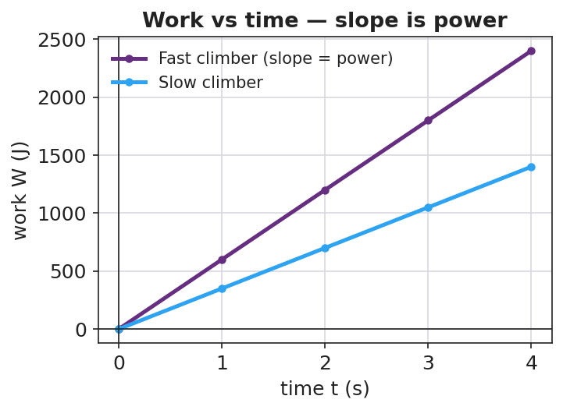
Work vs time: the slope of each line is the power
Target: the slope of a work-vs-time graph is the power; a steeper line = more power. Tie back to P = W/t.

38–40 min · Return to the phenomenon
“In one sentence, explain why the fast stair-climber is ‘more powerful’ than the slow one even though they did the same work. Use the words power and time.”

Phase 5 · Evaluate (40 – 42 min)

40–42 min · Exit Ticket + Closing Reflection
“An elevator does 48,000 J of work lifting a load. (a) If it takes 8.0 s, what is its power output? Show P = W/t. (b) A second elevator does the same 48,000 J in 16 s. How does its power compare? (c) A 700 N student runs up a 4.0 m staircase in 5.0 s. What is the student’s power output?”
Expected: (a) 6000 W; (b) half the power (3000 W) — same work, twice the time; (c) W = 700 × 4.0 = 2800 J, P = 2800/5.0 = 560 W. See Answer_Key.docx.
Closing Reflection (SEL, 30 seconds):
“What is one thing you can now measure about yourself that you couldn’t this morning — and who helped you figure it out?”

Common Misconceptions
- Misconception: “More power means more work.” → Correction: Power is the rate of work; the same work done faster is more power even though total work is unchanged.
- Misconception: “Power and energy are the same thing.” → Correction: Energy (joules) is the quantity transferred; power (watts) is how fast it transfers — joules per second.
- Misconception: “A watt is a unit of energy.” → Correction: A watt is a unit of power (1 W = 1 J/s); a watt-second is a joule of energy.

Access & Differentiation
- ELL/ENL supports: Sentence frame: *“The ___ climber has more power because they did the same work in ___ time, so P = W/t is ___.”* Word box: {power, watt, energy, rate, per second}. Build a “per second” gesture (tapping a beat).
- IEP/SPED supports: Provide a pre-built data table with labeled columns (weight, height, time) and the P = W/t formula with one row worked. Offer the timer/recorder role to students who opt out of climbing — full participation, no physical demand.
- Extensions: Convert personal power to horsepower (1 hp ≈ 746 W) and compare to a car engine; explore why sprinting up stairs cannot be sustained (peak vs. average power).

Strategy Spotlight
ACTIVE LEARNING. The whole lesson is built on student-generated data: each learner measures their own weight, height, and time, then computes their own power. The comparison that matters — same work, different time — emerges from their two trials, not from the teacher. Assign clear roles (climber, timer, recorder, calculator) so every student is doing physics, and rotate so opt-out students still own the math. The graph in Phase 4 turns their messy data into the clean “slope = power” idea.

NYSSLS Observation Checklist Crosswalk
# | Checklist item | Where it appears in this lesson
1 | Local/relatable phenomenon | Phase 1 — two students climbing the same stairs
2 | Turn and Talk (2–3×) | Phase 1 (TT#1 — what makes the fast climber different), Phase 3 (TT#2 — defining P = W/t)
3 | Students develop questions/models/procedures | Phase 1 (initial model), Phase 2 (stair-climb lab), Phase 4 (revise model)
4 | CCC defined and used | Lesson Overview · Systems and System Models, applied in Phase 2
5 | ENL — ≤ 3 vocab, second half | Phase 3 — vocabulary at 31–35 min (power / watt / energy)
6 | Revisit phenomenon with evidence | Phase 4 — work-vs-time slope; restate the two-climber result
7 | ENL/SPED supports | Access & Differentiation block
8 | Assessment check | Phase 5 — Exit Ticket (elevators + stair runner)

Companion Materials
- Student_Worksheet.docx — the 5E student investigation + stair-climb lab table (hand out at start of Phase 2)
- Student_Notes.docx — guided note-guide for vocabulary and the worked example
- Answer_Key.docx — answers to “Make It Make Sense” prompts and the Exit Ticket

Key Vocabulary (max 3)
- power — the rate at which work is done (energy transferred per unit time); P = W/t = Fv
- watt — the SI unit of power; one watt equals one joule per second (1 W = 1 J/s)
- energy — the capacity to do work, measured in joules; power tells how fast energy is transferred

