Kinetic Energy — Student Worksheet
Unit: Work, Energy & Power — Lesson 03 Name: _______________________ Date: __________ Period: ____

Phenomenon
A car at 20 mph and the same car at 40 mph: the speed only doubled, but the distance needed to stop roughly quadruples. The energy of motion is not growing the way you’d expect.
Driving question: How does the energy of a moving object depend on its speed — and why does a small speed increase make it so much harder to stop?

Notice & Wonder
I notice… | I wonder…
Turn & Talk #1: If the speed only doubled, why might the energy of motion grow by more than double? Make a guess about the math.

Initial Model
Write your prediction before any calculating.
When the car’s speed doubles, I predict its energy of motion becomes ____________ times bigger, because _______________________________________________

Investigation — Thin-Sliced Task (at the board)
Use KE = ½mv² with m = 1000 kg for every slice. Work at your group’s board.
Slice | Speed v (m/s) | KE = ½mv² (J) | Factor vs. Slice 1
1 | 10 |  | 1
2 | 20 (double)
3 | 30 (triple)
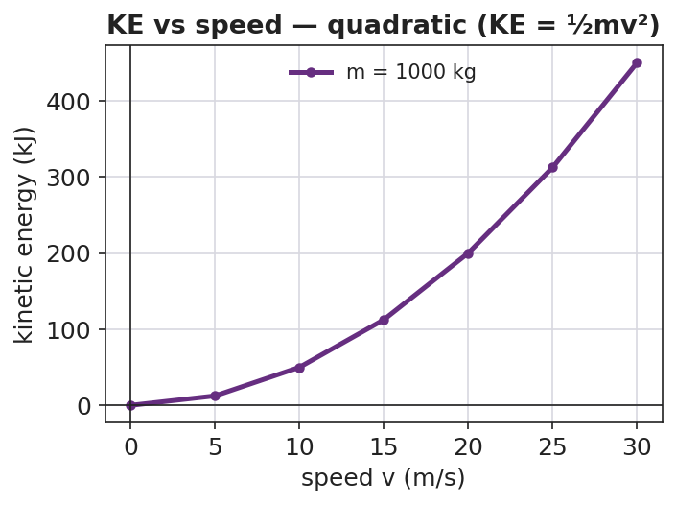
KE vs speed — quadratic curve
Generalize: If the speed becomes n times bigger, the kinetic energy becomes ____________ times bigger. Why?

Make It Make Sense
- A 2.0 kg ball moves at 3.0 m/s. Calculate its kinetic energy. Show KE = ½mv².
- Two identical cars move down the road. Car A goes 15 m/s; car B goes 30 m/s. How many times more kinetic energy does car B have? Explain using v².
- Your friend says “double the speed, double the energy.” Use the formula to correct your friend.

Vocabulary in Action
Use each term in a sentence about today’s phenomenon.
- kinetic energy: _______________________________________________
- mass: _______________________________________________
- speed: _______________________________________________

Revise Your Model
Make a bar chart of KE at 1×, 2×, and 3× speed for the same car. Label each bar with its factor.
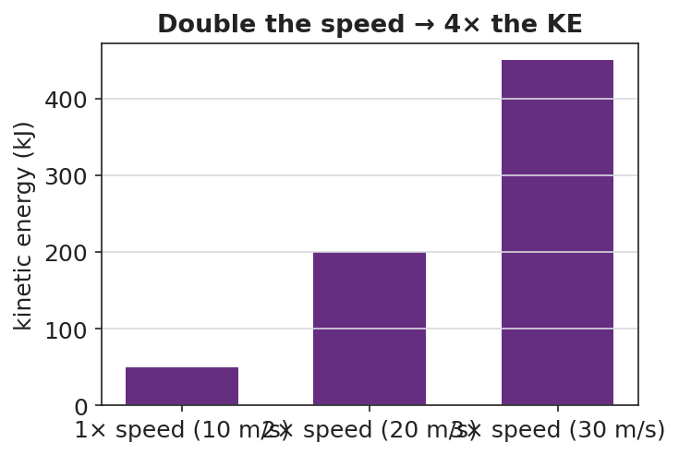
KE at 1×, 2×, 3× speed
The bars are in the ratio ____ : ____ : ____ . Revise your prediction: when speed doubles, KE becomes ____________ times bigger because _______________________________________________

Exit Ticket
A 1500 kg car travels at 10 m/s.
- Calculate its kinetic energy. Show KE = ½mv².
- The car speeds up to 20 m/s. What is its new kinetic energy, and by what factor did it change?
- In one sentence, explain why doubling the speed makes the car so much harder to stop.

