Kinetic Energy — Teacher Guide

Cover
Unit: Work, Energy & Power — Lesson 03: Kinetic Energy East Meadow Schools × Valley Stream Central High School District Strategy chips: BTC

Curated Resources (from East Meadow Scope & Sequence)

NYSSLS Standards
Kinetic energy names the energy of motion — the macroscopic “energy of motion of particles” half of HS-PS3-2: “Develop and use models to illustrate that energy at the macroscopic scale can be accounted for as a combination of energy associated with the motions of particles (objects) and energy associated with the relative positions of particles (objects).” (CCC: Energy and Matter.) It also supplies a quantity for HS-PS3-1 energy models: the moving component’s energy is ½mv².

Phenomenon
- Car stopping distance vs. speed — doubling speed roughly quadruples the stopping distance. https://www.youtube.com/watch?v=PIA1AfQfM4U (Stopping distance and speed)
- The Physics Classroom — “Kinetic Energy”: https://www.physicsclassroom.com/class/energy/Lesson-1/Kinetic-Energy

Javalab / Labs
- Javalab energy index (kinetic/potential sims for VNPS support): https://javalab.org/en/category/energy_en/

Assessments
- The Physics Classroom kinetic-energy problem set (link above). The Exit Ticket below is the formative check; the “Make It Make Sense” items map to HS-PS3-2.

Lesson Overview
Duration | 42 minutes (1 period)
NYSSLS link | HS-PS3-2 (energy of motion); supports HS-PS3-1
CCC focus | Energy and Matter — kinetic energy is the energy a moving object carries because of its motion.
Strategy chips | BTC (random groups, vertical non-permanent surfaces, a thin-sliced KE = ½mv² task)
Materials | Vertical whiteboards / wall surfaces + markers; calculators; visibly random grouping cards; the stopping-distance video.
Safety | Standard classroom movement protocols for VNPS rotation.
Prior knowledge | Work (W = F·d), the joule; speed/velocity from Kinematics.
Lesson objectives — students can:
- Define kinetic energy as the energy of motion and compute it with KE = ½mv².
- Explain why kinetic energy depends on the square of speed: doubling the speed multiplies KE by four.
- Use the v² relationship to reason about why fast cars need far more stopping distance.

Phase 1 · Engage (0 – 10 min)

0–3 min · Opening Connection (SEL)
Pair-share, one sentence: “Describe a time you (or a car) needed way more room to stop than you expected.” Surface a couple. Plant the puzzle that speed changes stopping distance more than people think.

3–7 min · Phenomenon hook — stopping distance vs. speed
Teacher actions. Play the stopping-distance clip (or show a stopping-distance table). At 20 mph vs. 40 mph, the stopping distance roughly quadruples, not doubles.
Sample teacher language:
“Speed only doubled — 20 to 40. So why does it take four times the distance to stop? The energy of motion isn’t growing the way you’d guess.”
Anticipated student responses:
- “Double the speed, double the distance.” — capture this prediction; the data will contradict it.
- “It’s heavier when it’s faster?” — no, mass is unchanged; the change is in speed.
- “Faster means way more energy somehow.” — yes; we’ll find the v² rule.

7–10 min · Notice & Wonder + Turn-and-Talk #1
Two columns. Then:
“Turn to your partner: if speed only doubled, why might the energy grow by more than double? Make a guess about the math.”

Bridge to Phase 2
Each student leaves with an initial model: “When the car’s speed doubles, its energy of motion ______ because ______.”

Phase 2 · Explore (10 – 28 min)

10–13 min · BTC setup — visibly random groups + VNPS
Form visibly random groups of 3 with cards. Each group claims a vertical non-permanent surface (whiteboard/wall). No sitting; thinking happens standing at the board.

13–28 min · Thin-sliced task — building KE = ½mv²
Reveal the task one slice at a time; let early groups race ahead. Give m = 1000 kg throughout so the v² pattern is unmasked.
- Compute KE at v = 10 m/s using KE = ½mv².
- Now v = 20 m/s (double). Compare to slice 1 — by what factor did KE grow?
- Now v = 30 m/s (triple). Factor?
- Generalize: “If speed becomes n times bigger, KE becomes ____ times bigger. Why?”
- Extension slice: two cars, same speed, one twice the mass — compare KE.
Project the building pattern when most groups reach slice 3:
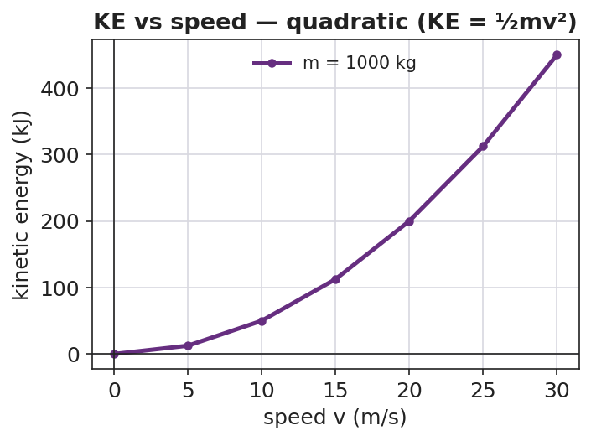
Kinetic energy vs speed is a quadratic curve
Teacher facilitation language (BTC — answer questions with questions):
“You doubled v and KE went up by four — where did the 4 come from in ½mv²?” “Will tripling the speed triple the energy? Test it on the board before you tell me.”
Anticipated student responses:
- “Doubling v gave 4× because we square the velocity!” — the target insight.
- “Tripling gives 9× — it’s n².” — generalization reached.

Teacher facilitation during Explore
- What to look for — groups connecting the v² in the formula to the 4×, 9× growth.
- What to resist — don’t confirm answers; bounce questions back; let groups check each other’s boards.
- What to redirect — groups computing 2× growth → “show me 20² vs 10² — is that doubling?”

Phase 3 · Explain (28 – 35 min)

28–31 min · Turn-and-Talk #2 + class consensus
“Tour two other boards. What is the rule connecting speed to kinetic energy?”
Target consensus:
“Kinetic energy is ½mv². Because the speed is squared, doubling the speed gives four times the KE, and tripling gives nine times. Mass matters too, but only to the first power.”

31–35 min · Vocabulary introduction (≤ 3 terms)
From the reference table: KE = ½mv², in joules. Name the terms.
Sample teacher language:
“Kinetic energy is the energy of motion. It grows with mass to the first power, but with speed squared — that v² is why a small jump in speed is a big jump in energy, and a big jump in stopping distance.”

Discussion prompts to deploy here
- “A 2.0 kg ball moves at 3.0 m/s. What is its KE?”
  - Sample response: “KE = ½(2.0)(3.0²) = ½(2.0)(9.0) = 9.0 J.”
- “Why is a highway speed limit so important for safety, in energy terms?”
  - Sample response: “A small speed increase squares into a large KE increase, so far more energy must be removed to stop — much longer stopping distance.”

Phase 4 · Elaborate (35 – 40 min)

35–38 min · Revise the model + the bar chart
“Return to your initial model. Using KE = ½mv², make a bar chart of KE at 1×, 2×, and 3× speed for the same car. Label each bar with the factor (1, 4, 9).”
Project:
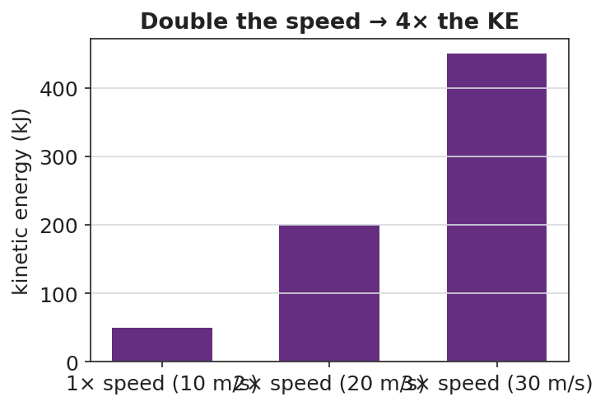
Kinetic energy at 1×, 2×, 3× speed — bars in ratio 1:4:9
Target: the bars are in the ratio 1 : 4 : 9, matching n².

38–40 min · Return to the phenomenon
“In one sentence, explain why a car at 40 mph needs about four times the stopping distance of a car at 20 mph. Use KE = ½mv².”

Phase 5 · Evaluate (40 – 42 min)

40–42 min · Exit Ticket + Closing Reflection
“A 1500 kg car travels at 10 m/s. (a) Calculate its kinetic energy. Show KE = ½mv². (b) The car speeds up to 20 m/s. What is its new KE, and by what factor did it change? (c) In one sentence, explain why doubling speed makes the car so much harder to stop.”
Expected: (a) 75,000 J; (b) 300,000 J — 4×; (c) KE depends on v², so doubling v quadruples KE, requiring 4× the work/distance to stop. See Answer_Key.docx.
Closing Reflection (SEL, 30 seconds):
“What is one idea your group cracked today that you couldn’t alone — and who pushed the thinking forward?”

Common Misconceptions
- Misconception: “Double the speed, double the kinetic energy.” → Correction: KE depends on v², so doubling speed quadruples KE.
- Misconception: “Mass affects KE the same way speed does.” → Correction: Mass is to the first power, speed is squared — speed has a far stronger effect.
- Misconception: “A stopped object has some kinetic energy.” → Correction: If v = 0, KE = ½m(0)² = 0; kinetic energy requires motion.

Access & Differentiation
- ELL/ENL supports: Sentence frame: *“When the speed becomes ___ times bigger, the kinetic energy becomes ___ times bigger because the speed is ___.”* Word box: {kinetic energy, mass, speed, squared, four times}. Provide a labeled ½mv² formula card.
- IEP/SPED supports: Pre-fill the m and v values in a table so the cognitive load is on the squaring and the pattern, not setup. Allow calculator use for v². Provide the bar chart pre-drawn for labeling.
- Extensions: Derive KE = ½mv² from work: a net force does work W = F·d on a mass, and with kinematics this equals ½mv². Explore why kinetic energy is always positive.

Strategy Spotlight
BTC (Building Thinking Classrooms). This lesson uses the three core BTC moves: visibly random groups (cards, no friend-clusters), vertical non-permanent surfaces (everyone standing and writing at boards), and a thin-sliced task (KE at 1×, 2×, 3× speed) that lets every group find an entry point and lets fast groups push to the n² generalization. Answer questions with questions; let groups verify against neighboring boards rather than against you. The v² pattern is discovered, not told.

NYSSLS Observation Checklist Crosswalk
# | Checklist item | Where it appears in this lesson
1 | Local/relatable phenomenon | Phase 1 — car stopping distance vs. speed
2 | Turn and Talk (2–3×) | Phase 1 (TT#1 — why energy grows more than double), Phase 3 (TT#2 — board tour consensus)
3 | Students develop questions/models/procedures | Phase 1 (initial model), Phase 2 (VNPS thin-sliced task), Phase 4 (revise model)
4 | CCC defined and used | Lesson Overview · Energy and Matter, applied in Phase 2
5 | ENL — ≤ 3 vocab, second half | Phase 3 — vocabulary at 31–35 min (kinetic energy / mass / speed)
6 | Revisit phenomenon with evidence | Phase 4 — 1:4:9 bar chart; restate stopping distance
7 | ENL/SPED supports | Access & Differentiation block
8 | Assessment check | Phase 5 — Exit Ticket (1500 kg car)

Companion Materials
- Student_Worksheet.docx — the 5E student investigation + thin-sliced task (hand out at start of Phase 2)
- Student_Notes.docx — guided note-guide for vocabulary and the worked example
- Answer_Key.docx — answers to “Make It Make Sense” prompts and the Exit Ticket

Key Vocabulary (max 3)
- kinetic energy — the energy an object has because of its motion; KE = ½mv², in joules
- mass — the amount of matter in an object (kg); kinetic energy is proportional to mass (first power)
- speed — how fast an object moves (m/s); kinetic energy is proportional to speed squared (v²)

