Gravitational Potential Energy — Student Worksheet
Unit: Work, Energy & Power — Lesson 04 Name: _______________________ Date: __________ Period: ____

Phenomenon
A roller-coaster car is slowly hauled up the lift hill. Nothing exciting happens on the way up — but every meter of height stores energy the coaster will spend on the way down. A water tower does the same thing with water.
Driving question: What is being stored as the car climbs, and what does the amount of stored energy depend on?

Notice & Wonder
I notice… | I wonder…
Turn & Talk #1: What two things about the coaster car decide how much energy is stored at the top? Use the word height.

Initial Model
Draw the coaster car on the lift hill at three heights.
My prediction — when the height doubles, the stored energy becomes ____________ times bigger, because _______________________________________________

Investigation — Javalab: Potential energy due to gravity
Open https://javalab.org/en/potential_energy_en/. Record what changes the stored energy.
Test | What I changed | PE before | PE after | Effect
1. Double the height
2. Double the mass
3. Move the reference line (zero)
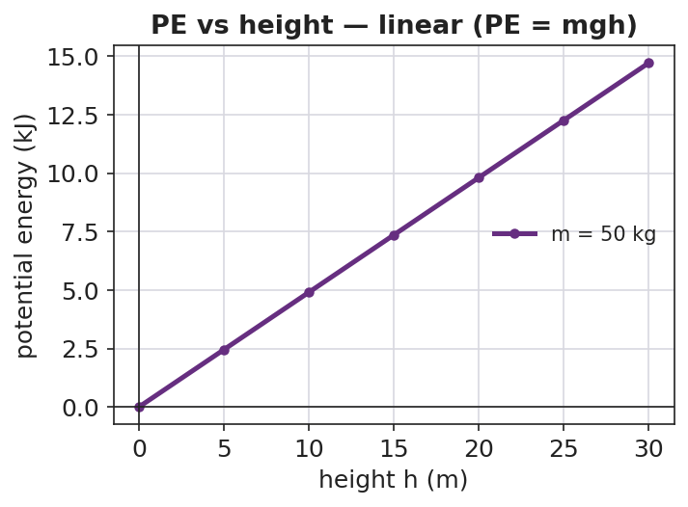
Gravitational PE vs height
Key question: In test 3 the object did not move, yet the PE number changed. Why?

Make It Make Sense
- A 2.0 kg book sits on a 1.0 m table. What is its gravitational PE relative to the floor? Use PE = mgh with g ≈ 9.81 m/s².
- Two coaster cars sit at the same height. Car A is 400 kg; car B is 800 kg. Which has more PE, and by what factor? Explain.
- Why must we always state the reference height (the “zero”) when we report a potential energy?

Vocabulary in Action
Use each term in a sentence about today’s phenomenon.
- potential energy: _______________________________________________
- height: _______________________________________________
- gravitational field: _______________________________________________

Revise Your Model
Using PE = mgh, make a bar chart of PE at several lift-hill heights for one car. What pattern do the bar heights follow?
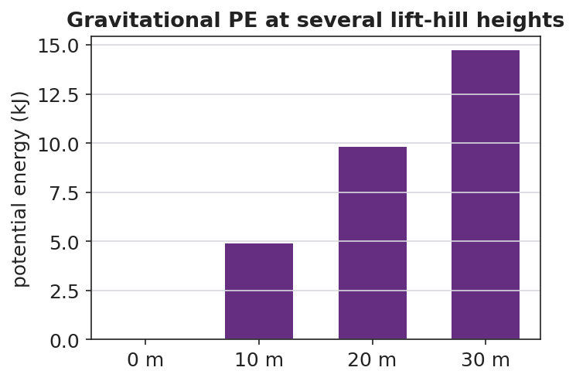
Gravitational PE at several heights
The bar heights follow this pattern: ____________ . Revise your prediction: when height doubles, PE becomes ____________ times bigger because _______________________________________________

Exit Ticket
A 500 kg roller-coaster car is hauled to the top of a 30 m lift hill. (Use g ≈ 9.81 m/s².)
- Calculate its gravitational potential energy relative to the ground. Show PE = mgh.
- If the lift hill were only 15 m, what would its PE be, and how does it compare to part (a)?
- Explain why your answer to (a) would change if we measured height from a platform halfway up instead of from the ground.

