Gravitational Potential Energy — Teacher Guide

Cover
Unit: Work, Energy & Power — Lesson 04: Gravitational Potential Energy East Meadow Schools × Valley Stream Central High School District Strategy chips: HOCHMAN

Curated Resources (from East Meadow Scope & Sequence)

NYSSLS Standards
Gravitational potential energy names the “energy associated with relative position” half of HS-PS3-2: “Develop and use models to illustrate that energy at the macroscopic scale can be accounted for as a combination of energy associated with the motions of particles (objects) and energy associated with the relative positions of particles (objects).” (CCC: Energy and Matter.) Together with Lesson 03 (KE = motion), PE = mgh completes the two-component macroscopic energy account and feeds the HS-PS3-1 energy model.

Phenomenon
- A roller-coaster lift hill / a water tower: stored energy that depends on height above the ground. https://www.youtube.com/watch?v=Anv2Rr-A3MI (Roller coaster energy)
- The Physics Classroom — “Potential Energy”: https://www.physicsclassroom.com/class/energy/Lesson-1/Potential-Energy

Javalab / Labs
- Javalab — Potential energy due to gravity (this lesson’s interactive): https://javalab.org/en/potential_energy_en/

Assessments
- The Physics Classroom potential-energy problem set (link above). The Exit Ticket below is the formative check; the “Make It Make Sense” items map to HS-PS3-2.

Lesson Overview
Duration | 42 minutes (1 period)
NYSSLS link | HS-PS3-2 (energy of relative position); supports HS-PS3-1
CCC focus | Energy and Matter — stored energy depends on an object’s position (height) relative to a reference.
Strategy chips | HOCHMAN (appositive + Because/But/So on PE = mgh and the reference height)
Materials | Computers/tablets for the Javalab sim; masses at different heights (book on desk vs. shelf); meter stick; whiteboards.
Safety | Keep raised masses secured; do not let objects fall on people or devices.
Prior knowledge | Work (W = F·d), the joule; weight = mass × g; g ≈ 9.81 m/s².
Lesson objectives — students can:
- Define gravitational potential energy as stored energy that depends on height and compute it with PE = mgh.
- Explain why PE is measured relative to a chosen reference height (ground, floor, table).
- Predict how PE changes when height or mass changes, and connect lift-hill height to a coaster’s stored energy.

Phase 1 · Engage (0 – 10 min)

0–3 min · Opening Connection (SEL)
Pair-share, one sentence: “Name the highest place you’ve ever climbed or stood — and how it felt to look down.” Surface a couple. Plant the intuition that height feels like stored “ready-to-fall” energy.

3–7 min · Phenomenon hook — the lift hill / water tower
Teacher actions. Show the slow climb up a roller-coaster lift hill (or a water tower). Pause at the top before the drop.
Sample teacher language:
“Nothing exciting happens on the way up — the chain just hauls the car higher. But every meter of height is storing something the coaster will spend on the way down. What is being stored, and what does it depend on?”
Anticipated student responses:
- “It’s storing speed for later.” — close; it stores energy that will become speed.
- “The higher it goes, the bigger the drop.” — capture height as the key variable.
- “A heavier car stores more.” — yes; mass matters too.

7–10 min · Notice & Wonder + Turn-and-Talk #1
Two columns. Then:
“Turn to your partner: what two things about the coaster car decide how much energy is stored at the top? Use the word height.”

Bridge to Phase 2
Each student leaves with an initial model: “Stored energy at the top depends on ______ because ______.”

Phase 2 · Explore (10 – 28 min)

10–14 min · Initial Model (silent / individual)
Prompt:
“Draw the coaster on the lift hill at three heights. Predict how the stored energy changes as the height doubles. Does it double? More? Less?”

14–28 min · Investigation — Javalab “Potential energy due to gravity”
Students use the Javalab sim (https://javalab.org/en/potential_energy_en/) and a desk/shelf comparison.
- Set a mass at height h; read/record PE. Double h; record again. What happened to PE?
- Keep h fixed; double the mass. What happened to PE?
- Move the reference line (floor → tabletop): does the same object now have a different PE? Why?
- Tabulate PE vs. h for a fixed mass.
Project as data come in:
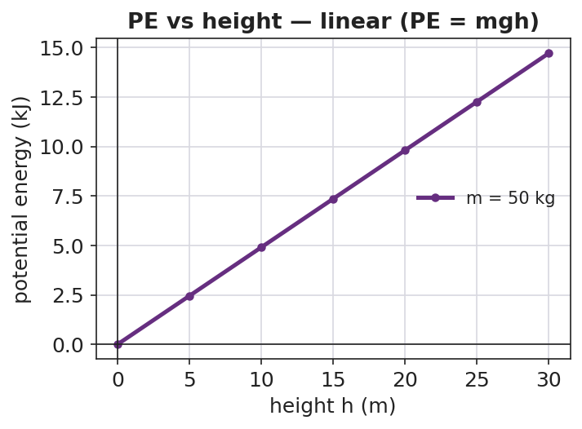
Gravitational PE vs height is a straight line through the origin
Teacher facilitation language:
“You doubled the height — what did the stored energy do? Now predict tripling before you test.” “When you moved the reference line, the object didn’t move — so why did the PE number change?”
Anticipated student responses:
- “Doubling the height doubled the PE — it’s a straight line.” — yes; PE ∝ h.
- “PE changed when we moved the zero line — so ‘height’ is measured from somewhere.” — land the reference-height idea.

Teacher facilitation during Explore
- What to look for — students seeing PE ∝ h (linear) and recognizing that PE is relative to a chosen zero.
- What to resist — don’t pre-state PE = mgh; let the sim build the proportionality.
- What to redirect — “PE is just height” → no, it’s mass × g × height; height alone isn’t energy.

Phase 3 · Explain (28 – 35 min)

28–31 min · Turn-and-Talk #2 + class consensus
“From the sim: what three things set the stored energy, and why does the reference height matter?”
Target consensus:
“Gravitational potential energy is mass × g × height: PE = mgh. It grows in a straight line with height. The height must be measured from a chosen reference — change the reference and the number changes, because PE is about relative position.”

31–35 min · Vocabulary introduction (≤ 3 terms) + HOCHMAN
From the reference table: PE = mgh, with g ≈ 9.81 m/s², in joules.
Sample teacher language (Hochman appositive + Because/But/So):
“Appositive: Gravitational potential energy, the energy stored because of an object’s height above a reference point, equals mgh. Because/But/So: We can call the floor ‘zero height’ because PE is measured relative to a reference, but if we chose the tabletop as zero the same book would have less PE, so PE depends on the reference we pick.”

Discussion prompts to deploy here
- “A 2.0 kg book sits on a 1.0 m table. What is its PE relative to the floor? (g ≈ 9.81)”
  - Sample response: “PE = mgh = 2.0 × 9.81 × 1.0 ≈ 19.6 J.”
- “Why does a water tower need to be tall?”
  - Sample response: “Height gives the water gravitational PE, which provides pressure to push water through the pipes.”

Phase 4 · Elaborate (35 – 40 min)

35–38 min · Revise the model + the bar chart
“Return to your three-height drawing. Using PE = mgh, make a bar chart of PE at several lift-hill heights for one car. What pattern do the bar heights follow?”
Project:
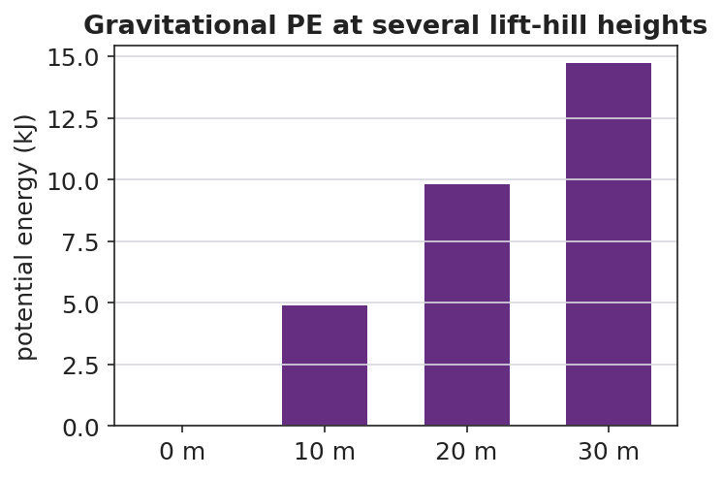
Gravitational PE at several lift-hill heights — bars grow in proportion to height
Target: bar heights are proportional to the lift-hill height — double the height, double the stored energy (a linear pattern).

38–40 min · Return to the phenomenon
“In one Because/But/So sentence, explain why the tallest lift hill stores the most energy — and why we always state PE relative to the ground.”

Phase 5 · Evaluate (40 – 42 min)

40–42 min · Exit Ticket + Closing Reflection
“A 500 kg roller-coaster car is hauled to the top of a 30 m lift hill. (Use g ≈ 9.81 m/s².) (a) Calculate its gravitational potential energy relative to the ground. Show PE = mgh. (b) If the lift hill were only 15 m, what would its PE be, and how does it compare? (c) Explain why your answer to (a) would change if we measured height from a platform halfway up instead of the ground.”
Expected: (a) ≈ 147,150 J; (b) ≈ 73,575 J — half; (c) PE depends on the reference height, so a higher zero gives a smaller h and thus a smaller PE. See Answer_Key.docx.
Closing Reflection (SEL, 30 seconds):
“What is one idea about ‘stored energy’ you’ll carry out of here — and who helped it click?”

Common Misconceptions
- Misconception: “Potential energy is just an object’s height.” → Correction: PE = mgh — it depends on mass and g as well as height; height alone is not energy.
- Misconception: “An object has one true potential energy.” → Correction: PE is measured relative to a chosen reference; change the reference and the PE value changes.
- Misconception: “Heavier objects always fall faster, so they store more PE per height.” → Correction: PE scales with mass (mgh), but in free fall all masses accelerate at g; the two ideas are separate.

Access & Differentiation
- ELL/ENL supports: Sentence frame: *“The object stores more potential energy when its ___ is greater, because PE = m·g·___.”* Word box: {potential energy, height, gravitational field, reference, stored}. Pair “stored” with a “loading-up” gesture.
- IEP/SPED supports: Provide the PE = mgh formula card with g ≈ 9.81 already filled in. Pre-label the reference line on the diagram. Allow the Javalab sim as a hands-on alternative to symbolic work.
- Extensions: Combine with Lesson 03: predict the speed at the bottom of the hill by setting the PE lost equal to KE gained (preview of conservation, Lesson 05).

Strategy Spotlight
HOCHMAN (literacy). The writing moves are the appositive (defining gravitational PE inside the sentence) and Because/But/So to capture the subtle reference-height idea — the place students most often lose precision. Model the appositive, then have students expand the kernel “PE is stored energy” into a full definition naming height and reference. The Because/But/So in Phase 4 forces them to articulate why the reference matters in one controlled sentence; collect and revise two or three as a class.

NYSSLS Observation Checklist Crosswalk
# | Checklist item | Where it appears in this lesson
1 | Local/relatable phenomenon | Phase 1 — roller-coaster lift hill / water tower
2 | Turn and Talk (2–3×) | Phase 1 (TT#1 — what sets stored energy), Phase 3 (TT#2 — PE = mgh + reference)
3 | Students develop questions/models/procedures | Phase 1 (initial model), Phase 2 (Javalab sim investigation), Phase 4 (revise model)
4 | CCC defined and used | Lesson Overview · Energy and Matter, applied in Phase 2
5 | ENL — ≤ 3 vocab, second half | Phase 3 — vocabulary at 31–35 min (potential energy / height / gravitational field)
6 | Revisit phenomenon with evidence | Phase 4 — PE-at-heights bar chart; restate lift hill
7 | ENL/SPED supports | Access & Differentiation block
8 | Assessment check | Phase 5 — Exit Ticket (500 kg coaster car)

Companion Materials
- Student_Worksheet.docx — the 5E student investigation + Javalab sim guide (hand out at start of Phase 2)
- Student_Notes.docx — guided note-guide for vocabulary and the worked example
- Answer_Key.docx — answers to “Make It Make Sense” prompts and the Exit Ticket

Key Vocabulary (max 3)
- potential energy — energy stored because of an object’s position; gravitational PE = mgh, in joules
- height — the vertical distance above a chosen reference point; the h in PE = mgh
- gravitational field — the region where gravity acts; its strength g ≈ 9.81 m/s² near Earth’s surface sets the g in PE = mgh

