Conservation of Energy — Student Worksheet
Unit: Work, Energy & Power — Lesson 05 Name: _______________________ Date: __________ Period: ____

Phenomenon
A pendulum released from one side swings up to almost the same height on the other side — over and over. At the bottom it moves fast; at the top it stops. A skate-park half-pipe and a roller coaster do the same trade between height and speed.
Driving question: What is being traded as something rises and falls, and does the total amount of energy stay the same?

Notice & Wonder
I notice… | I wonder…
Turn & Talk #1: Where is the pendulum fastest, where is it highest, and what does that tell you about where each kind of energy is biggest?

Initial Model
Sketch the half-pipe (or pendulum). Mark TOP, MIDDLE, BOTTOM. At each point, predict KE and PE as HIGH, MEDIUM, or ZERO.
Point | KE (high/med/zero) | PE (high/med/zero)
TOP
MIDDLE
BOTTOM

Investigation — PhET Energy Skate Park (+ Javalab coaster)
Open https://phet.colorado.edu/en/simulations/energy-skate-park-basics and turn ON the energy bar graph. Start with friction OFF.
Point | KE bar (J) | PE bar (J) | Total KE + PE (J)
Top
Middle
Bottom
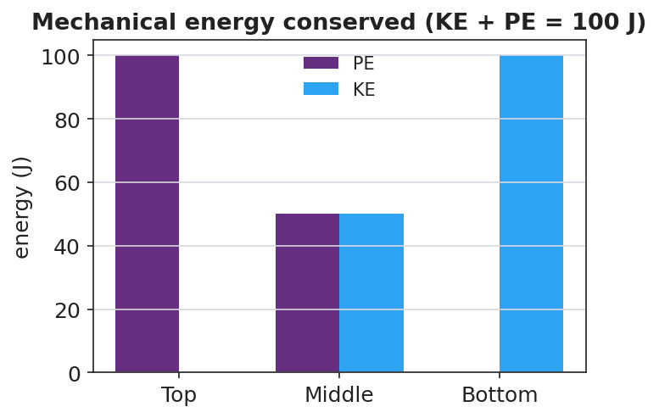
Energy bar chart: PE + KE = constant
Now turn friction ON and watch over time.
Key question: With friction off, what is true about the total (KE + PE)? With friction on, the total shrinks — energy is never destroyed, so where did it go?

Make It Make Sense
- A 2.0 kg ball is dropped from 5.0 m. Ignoring friction, what is its KE just before it lands? Use PE lost = KE gained, with g ≈ 9.81 m/s².
- At the bottom of a frictionless hill, is the cart’s PE maximum or minimum? Is its KE maximum or minimum? Explain.
- Why does a real pendulum eventually stop, even though energy is conserved?

Vocabulary in Action
Use each term in a sentence about today’s phenomenon.
- mechanical energy: _______________________________________________
- conservation of energy: _______________________________________________
- energy transformation: _______________________________________________

Revise Your Model
Plot KE and PE vs. position along the track. Where do the two curves cross, and what is true of their sum everywhere?
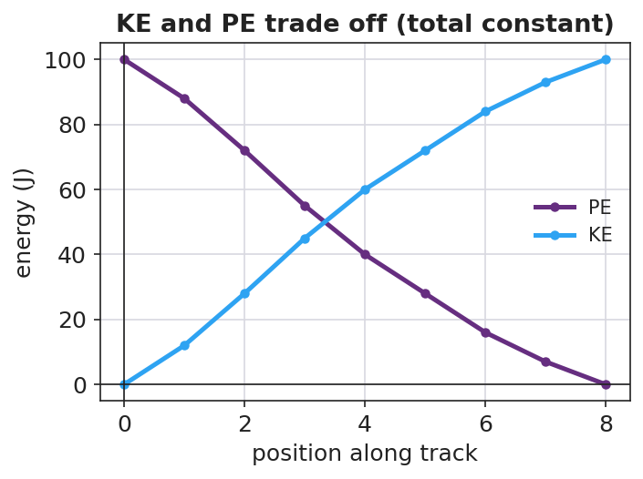
KE and PE vs position — cross-over
The curves cross where ____________ . Their sum everywhere is ____________ . The pendulum returns to almost the same height because _______________________________________________

Exit Ticket
A 0.50 kg cart starts at rest at the top of a frictionless track 2.0 m high. (Use g ≈ 9.81 m/s².)
- What is its PE at the top? Show PE = mgh.
- Using conservation of energy, what is its KE at the bottom? Explain.
- On a real track with friction, would the KE at the bottom be more, less, or equal? Where does the difference go?

